**Selection between differently scaled actions**

Henry S. Harrison, Devin Kwolek, & Tehran J. Davis

CESPA, University of Connecticut, Storrs, CT, 06269, USA.

According to the π-number approach to affordance perception (Warren, 1984), the perceivable distinction between possible and impossible actions is delineated by a dimensionless ratio of environmental dimensions to organism dimensions. Such scaling allows critical and optimal points to be understood as invariant across many of the differences between individual actors. For example, Warren showed that the affordance boundary for stair climbing is a fixed ratio of riser height to leg length.

Similar dimensionless, body-scaled ratios were applied to action-selection by Lopresti-Goodman, Turvey, and Frank (2011), who investigated transitions between one-handed and two-handed grasping as a function of the grasped object’s size. They found that transitions were driven by object size scaled by hand size. In their model, this π-number was associated with both one- and two-handed grasping. However, in everyday encounters with the world, we regularly select among actions associated with different environmental dimensions. For example, imagine a hiker encountering a fallen branch across a trail. Multiple means of circumventing the obstacle may be afforded, including stepping over it and walking around it. These affordances implicate different scaling metrics. The stepping-over affordance likely involves some scaling of obstacle height but not obstacle width, and vice-versa for the walking-around affordance.

The current study recreated this scenario in the laboratory. We aim to generalize the π-number account of action selection to accommodate the variety of affordances available in a naturalistic setting, including those associated with different environmental and actor dimensions.

**Method**

Twenty University of Connecticut undergraduates (ten males; ages 18-20) participated in exchange for course credit, after giving informed consent.

The obstacle consisted of a horizontal beam and two vertical supports. Its height was manipulated by the placement of the beam on the supports, and its width was manipulated by placing the supports at different distances from one another and using beams of different lengths. Start and stop locations were marked on the floor, 5 feet away from the obstacle on either side.

To establish a baseline for the relative-height conditions, we determined each participant's affordance boundary for stepping over the obstacle. Starting at a low obstacle height, we successively raised the horizontal beam in 2-inch increments until the participant could no longer step over the obstacle while keeping one foot on the ground (hopping over was not allowed) without touching the beam. We recorded this height as the participant's affordance boundary $h_{max}$.

For the experimental trials, we instructed participants to walk from the start location to the end location, stepping over or walking around the obstacle as was "comfortable, natural, or automatic." We told participants that it did not matter whether they stepped over or walked around the obstacle to return to the start location. However, we recorded their behavior on both phases of the trial. As six participants reported a belief that they were not permitted to step over the obstacle on the return, return-phase data from these participants was ignored.

The experiment included six obstacle widths (4.5, 6, 7.5, 9, 10.5, 12 ft.) crossed with seven obstacle heights (2 in. higher; 2, 4, 6, 8, 10, and 14 in. lower than the participant's affordance boundary). There were two trials of each condition, except for the +2 in. conditions which were not repeated, for a total of 78 trials. The order of trials was fully randomized.

**Results and Discussion**

Figure 1 shows the proportion of trials on which the participant stepped over the obstacle in each condition. The transition from stepping over to walking around the obstacle tended to occur at lower heights when the obstacle was narrower.

For each participant and each obstacle width, the critical transition height $h_{crit.}$ was estimated using logistic regression and scaled by the participant’s affordance boundary $h_{max}$. The means at each width are shown in Fig. 2. We fit a linear, mixed-effect regression of scaled critical heights with a fixed effect of width and a random intercept. Using a parametric bootstrap with 10,000 simulations, we estimated a 95% confidence interval for the width coefficient, 1.278 × 10-2 ± 3.150 × 10-3. Participants were more likely to step over the obstacle when it was wider. For every 1-foot increase in obstacle width, participants’ critical obstacle height, as a percentage of their stepping-over affordance boundaries, increased by an estimated 1.278 %.

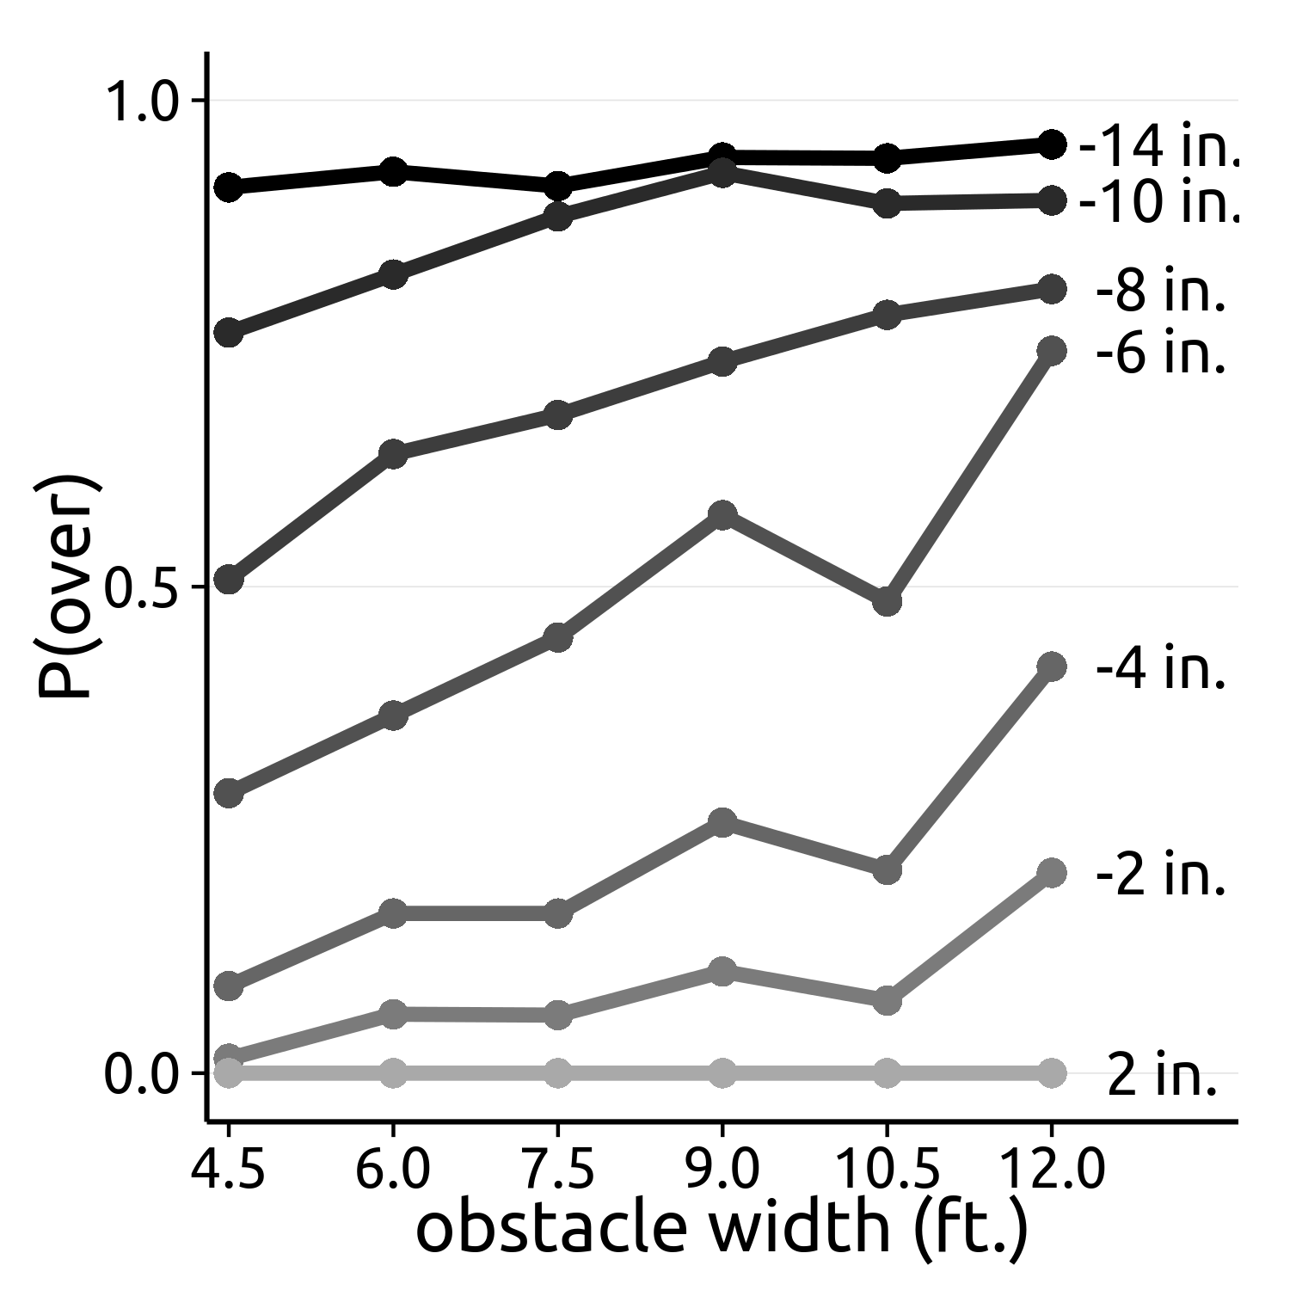

*Figure 1.* The proportion of trials on which the obstacle was stepped over as a function of obstacle width, for each relative-height condition. Relative height $h -h_{max}$ is labelled to the right of each line.

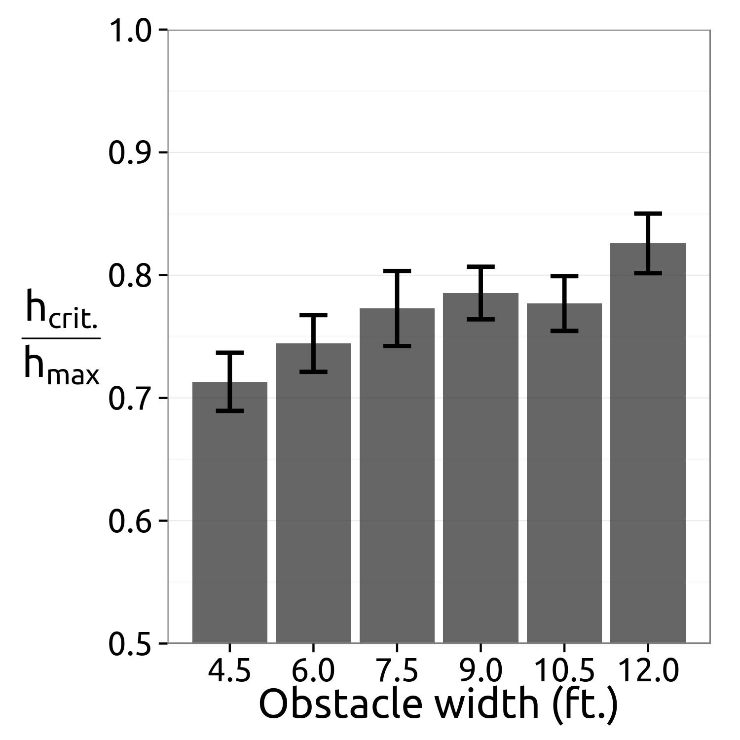

*Figure 2.* Mean critical obstacle height $h_{crit.}$ as a proportion of maximum afforded obstacle height $h_{max}$ for each obstacle width. Error bars show standard errors.

These results are consistent with a view of action selection as arising from competition between available actions, where each action has an associated attractiveness or valence. We propose that these valences are dimensionless ratios, like those implicated in the perception of affordance boundaries. In our main analysis, we used obstacle height divided by the maximum afforded obstacle height as a proxy for the valence of stepping over the obstacle. This can be thought of as a π-number that rescales the affordance-boundary π-number of the kind identified by Warren (1984). This rescaled π-number predicts whether the action will be selected rather than whether the action is afforded.

Similarly, we used obstacle width as a stand-in for the valence of walking around the obstacle. However, obstacle width is not a π-number. A candidate π-number for the valence of walking around the obstacle is the tangent of the angle between the obstacle’s center and edge. The tangent is associated with the deviation in path required to walk around the obstacle. This possibility predicts that manipulating the distance to the obstacle will have an inverse effect as the width manipulations presented here.

The next step is to develop an account of how an action is selected, given the π-number valences of the available actions. To that end, a model of competition between alternative outcomes is provided by the synergetic approach to multistable pattern formation. This model has yielded insights into behavioural transitions associated with body-scaled parameters (e.g., Frank, Richardson, Lopresti-Goodman, & Turvey, 2009). The methodology introduced here should allow us to extend that model to circumstances in which the alternative actions are characterized by different π-numbers. To illuminate the relationship between affordance perception and action selection, future investigation must determine the type and extent of hysteresis effects observed in the transition between walking around and stepping over the obstacle (Lopresti-Goodman, Turvey, & Frank, 2011, 2013).

**References**

Frank, T. D., Richardson, M. J., Lopresti-Goodman, S. M., and Turvey, M. T. (2009). Order parameter dynamics of body-scaled hysteresis and mode transitions in grasping behavior. *Journal of Biological Physics, 35*(2), 127-147.

Lopresti-Goodman, S. M., Turvey, M. T., & Frank, T. D. (2011). Behavioral dynamics of the affordance “graspable”. *Attention, Perception, & Psychophysics, 73*, 1948-1965.

Lopresti-Goodman, S. M., Turvey, M. T., & Frank, T. D. (2013). Negative hysteresis in the behavioral dynamics of the affordance “graspable”. *Attention, Perception, & Psychophysics, 75*, 1075-1091.

Warren, W. H. (1984). Perceiving affordances: Visual guidance of stair climbing. *Journal of Experimental Psychology: Human Perception and Performance, 10*(5), 683-703.

*Acknowledgements.* This research was supported by NSF Grant BCS-1344725 (INSPIRE Track 1).