Hayden Shelton

Problem Set 1 – CS4400

1. What is the email address that you used to subscribe? [**hayden.shelton@utah.edu**](mailto:hayden.shelton@utah.edu)

2. C Code for string length

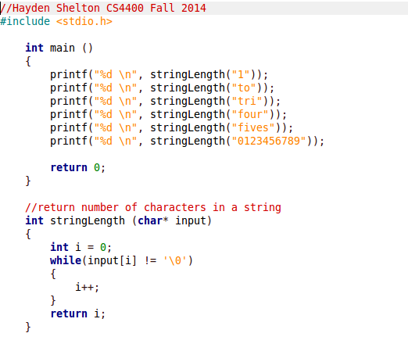

3. 2.61

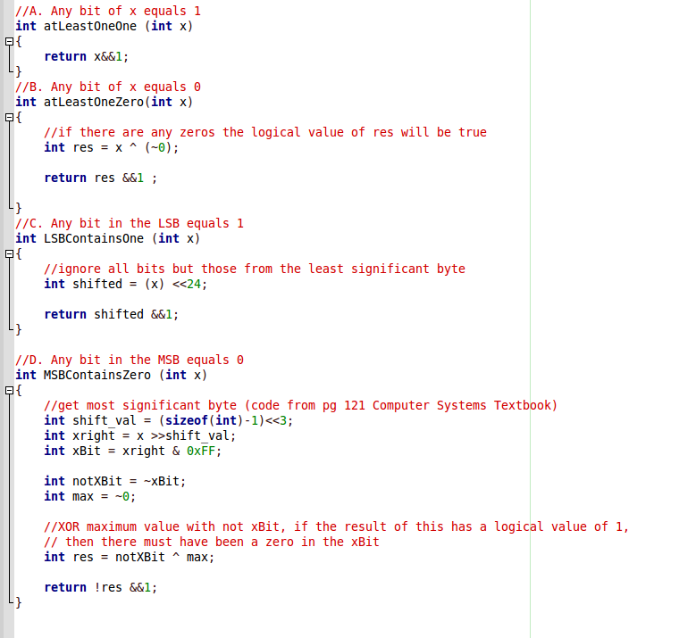

4. 2.62

