Hayden Shelton
CS 4400 Fall 2014

Problem Set 7

1.
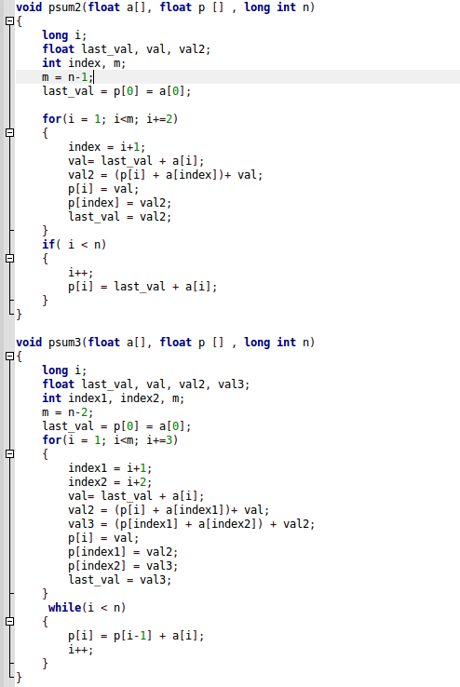

2.

3. Speeding up part B would result in an overall speedup factor of 1.25. Speeding up part C would result in an overall speedup factor of ~ 1.2. I would choose to speed up part B.

4.

