Hayden Shelton
CS4400
Fall '14

PS-4

1. Problem 3.5.6

A. %esi holds x
%ebx holds n
%edi holds result
%edx holds mask

B. result is -1. mask is 1

C. mask != 0

D. mask gets updated by a left shift with the first byte of n. ie mask = mask << (n%256)

E. result = result ^ (x & mask)
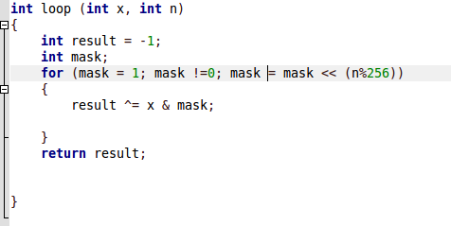

2. Problem 3.58

(see next page)

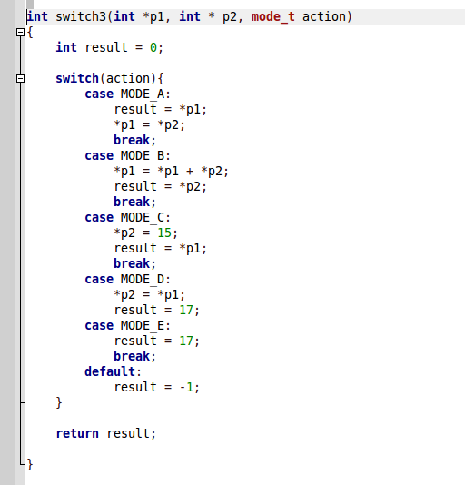

3. Problem 3.62
A. 13
B. edi and ecx respectively

C.
Couldn't figure out what was going on here.

