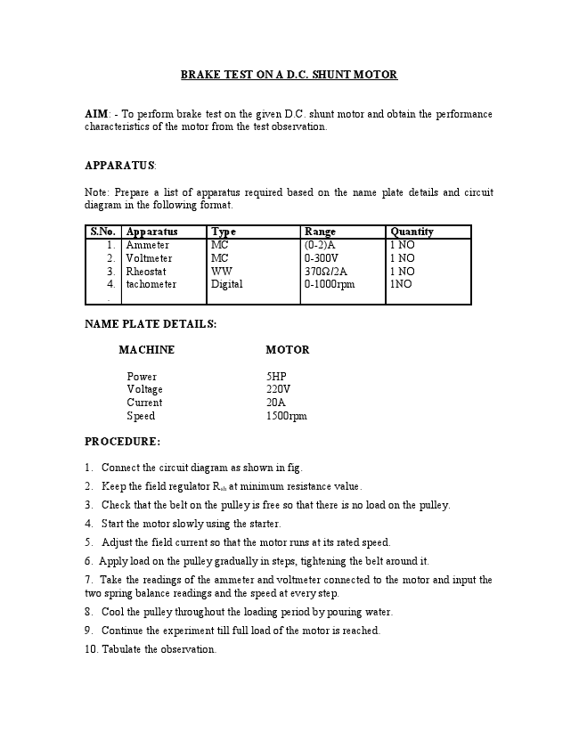
BRAKE TEST ON A D.C. SHUNT MOTOR
AIM: - To perform brake test on the given D.C. shunt motor and obtain the performance characteristics of the motor from the test observation.
APPARATUS:
Note: Prepare a list of apparatus required based on the name plate details and circuit diagram in the following format.
S.No. Apparatus Type Range Quantity
1. 2. 3. 4. .
Ammeter Voltmeter Rheostat tachometer
MC MC WW Digital
(0-2)A 0-300V 370Ω/2A 0-1000rpm
1 NO 1 NO 1 NO 1NO
NAME PLATE DETAILS:
MACHINE MOTOR
Power 5HP Voltage 220V Current 20A Speed 1500rpm
PROCEDURE:
1. Connect the circuit diagram as shown in fig. 2. Keep the field regulator R
sh
at minimum resistance value.
3. Check that the belt on the pulley is free so that there is no load on the pulley. 4. Start the motor slowly using the starter.
5. Adjust the field current so that the motor runs at its rated speed. 6. Apply load on the pulley gradually in steps, tightening the belt around it.
7. Take the readings of the ammeter and voltmeter connected to the motor and input the two spring balance readings and the speed at every step.
8. Cool the pulley throughout the loading period by pouring water. 9. Continue the experiment till full load of the motor is reached.
10. Tabulate the observation.
CIRCUIT DIAGRAM :-
TEST READINGS :
Radius of pulley R = ........m
S.No. Voltmeter
Reading “V”
SpringBalance Readings
S
1
Speed in RPM
(N)
TABULATE THE RESULTS:
S.No. Current
I
Ammeter
Reading “A”
Kg S
2
kG
Speed
Input
Output
B.H.P Efficiency N
VI(Watt
2IINT(Watts)
Output X 100 s)
60
Input
CALCULATIONS:-
NOTE: Radius of Drum Pulley R
Calculate for every load condition:-
The torque T= 9.81 R ( S1 - S2) N-m
Power output = 2IINT/60 Watts
2IINT 1 B.H.P. = X
60 735.5
GRAPHS: Plot the Graphs for BHP versus efficiency Plot the Graphs for BHP versus Torque
Plot the Graphs for BHP versus current Plot the Graphs for BHP versus speed
Note: All the graphs are shown in Fig,
PRECAUTIONS:
1. Cool the pulley while the experiment is performed. 2. While measuring the radius of the pulley effective radius must be considered.
RESULTS:
Draw the performance characteristics for the D.C. shunt motor on a graph sheet.
VIVA QUESTIONS:
1. What is the back emf of the motor?
2. Why the speed falls as load increases for a D.C. Shunt motor? 3. What are the applications of D.C. Shunt motor?
4. When is the efficiency of the motor maximum? 5. Define commutation.
6. How do you minimize reactance voltage for sparkles commutation? 7. What should be the position of rheostat in the field circuit while starting?
8. What is the nature of load connected across dc motor? 9. What will happen when dc shunt motor is started with load?
10. Give the expressions for various torques in dc motors. 11. What is the effect on speed if part of the field winding is shorted?
my
BRAKE TEST ON D.C. COMPOUND MOTOR.
AIM: To perform brake test on the given D.C. compound motor and determine the performance characteristics of the motor.
APPARATUS : Prepare a list of apparatus based on name plate and circuit diagram in the following format.
S.No. Apparatus Type Range Quantity 01
02 03
04
NAME PLATE DETAILS:
PROCEDURE:
1. Make the connections as shown in fig.5. 2. Keep the field rheostat in proper position.
3. Check that the belt is loose and the motor is not loaded. 4. Start the motor slowly with the starter.
5. Note the readings of the voltmeter and ammeter. 6. Load the motor in steps by tightening the rope around the brake drum and note the readings of the spring Balance voltmeter, ammeter and measure the speed. 7. Continue the experiment till full load is reached.
8. Slowly reduce the load and stop the motor. 9. Tabulate the observations
Ammeter
Voltmeter Rheostat
Ammeter
MC
MC WW
MC
0-2A
0-300V 370Ω/1.7A 0-20A
1NO 1NO
1NO 1NO
CIRCUIT DIAGRAM :
ig:BaeenD npdno
TEST READINGS:
Radius of Pulley:...................
S. No. S
1
S
2
V I N
CALCULATIONS TABLE:
S.No. V I N Input Output Efficiency
CALCULATIONS:
NOTE: Radius of Drum Pulley R.
Power input = VI watt
2IINT Power out put = 9.81 x R x (S1 – S2) Watts
60
2IINT 9.81 x Rx (S1 – S2) B.H.P. = X (Metric) 60 735.5
Output (Watts) Efficiency: X 100
Input (Watts)
GRAPH:
Plot the graphs for BHP versus Current I Plot the graphs for BHP versus Speed N
Plot the graphs for BHP versus Torque T
Plot the graphs for BHP versus Efficiencyη .
NOTE: All the graphs are shown in Fig
PRECAUTIONS:
1. Keep the field rheostat in minimum resistance position while starting the motor.
2. Start the motor slowly using the starter. 3. While loading, cool the pulley by pouring cold water
RESULT:
Brake test on the given D.C. compound motor is performed and the performance characteristics are plotted.
VIVA QUESTIONS:
1) Explain the difference between “long shunt” and “short Shunt” compounding? 2) What are the uses of different types of compound motors?
3) What is differential compounding? How is it different from cumulative
compounding?
4) How do you reverse the direction of motor? 5) Draw the speed – torque curve for differential. Compound motor
6) What is flat compounding? 7) In a dc M/C, windage losses vary with speed in the proportion of .....
8) Brake test on dc motors is usually restricted to ....HP motors 9) Why do we pour water in the brake draw during brake test? What is the effect on
speed of dc compound motor if the series field winding is shorted? 10) How do you minimize iron losses in a dc machine?
my
Field’s Test on dc series machine.
AIM: To Determine the efficiency of the two given dc series machines which are mechanically coupled.
Apparatus:
Name Range Quantity DC Voltmeter 0-300V 1 No.
DC Ammeter 0-20A 2 No. Tachometer 0-2000 rpm 1 No
Name Plate Details:
Motor Generator
Power = 5.0 hp. Power = 3.0 kW
Speed = 1500 rpm. Speed = 1500rpm Voltage = 230volts Voltage = 220 volts
Current = 20amps Current = 13.6 amps
Procedure
1. Note down the ratings of the DC Series motor and DC Series Generator. 2. Connect the circuit as shown in the circuit diagram.
3. Put a minimum load of 400 watt on the generator. 4. Switch on the DC supply and closed the DPST Switch and now vary the DC
Starter till it holds with current coil. 5. Now keep the input DC Voltage constant at 220 volt DC.
6. Now increase the load of the Generator up to the rated value of armature current
and take down the readings of all the meters connected in the circuit.
7. Reduce the loads one by one till the motor speed does not exceed 1800 rpm 8. Note down the readings on the instruments at different loads.
9. Gradually, reduce the armature voltage of the prime mover. Keep a minimum
load of 400 watt and then switch off the supply
CIRCUIT DIAGRAM :
C)
C)

