# ML Models & results

### Predict the number of deaths from accidents(classification.py)

I use classification to predict the number of deaths. By using the existing accident data as training data, the number of deaths has been used as the target value.

I have selected several classification models to test separately and then select the optimal model by comparing the accuracy

Here are results of these models:

Models Accuracy/The number of deaths predicted to be correct

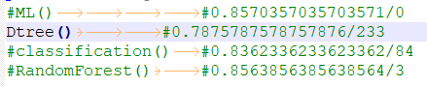

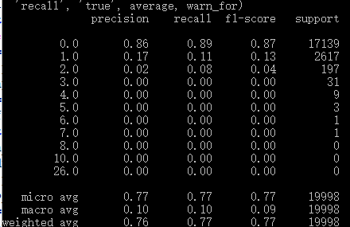

In this picture we can see that MLPClassifier() cannot predict the number of deaths, although he has the highest accuracy rate.

Although the decision tree has a slightly lower accuracy rate, he can better predict the deaths. The number of deaths predicted to be correct by Dtree() is the highest.

**Predict the probability of an accident(regression.py)**

I selected the four methods LinearRegression, BayesianRidge, SVR, and MLPRegressor to perform regression prediction. The data in the data set is marked as having an accident probability of 1, and the data set with no accidents is randomly generated and the probability of occurrence is set to 0. Use these four methods to predict and calculate the optimal model for MES selection.

Here are results of these models:

Models MSE error

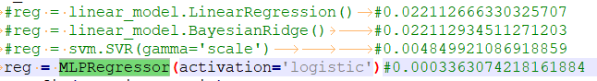



As can be seen from the figure, the MSE value of MLPRegressor is the smallest, so the regression prediction of MLPRegressor is the best.