|  |  |
| --- | --- |
| **Project: New Haven Urgent Care Team# 1** | |
|  | **Test Date: 12/8/2019** |
| **Test Case ID#: 9** | **Name(s) of Tester(s): Kyeongtak Han, Kun ki Lee, Eric Hwang, Dongha Kang** |
| **Test Description (What are you testing? – you must be specific):**  **Test if the system document what intake clerk collected the insurance information and the copay.** |  |
|  |  |

**NOTE: The following information must be provided to be given credit for any test.**

**Test Data (Provide the file name of the script used to insert data, provide a screen capture to reflect data, or provide script here):**

**Screen shot of the resutl:**

**Insurance_Request**

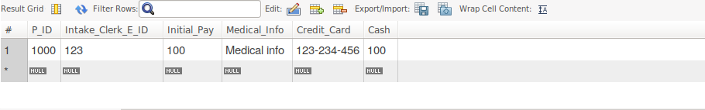

**The attributes of copay: credit_card and cash are documented in Insurance_Request table. The Intake_Clerk_E_ID references Intake_clerk’s E_ID.**

**Patient**

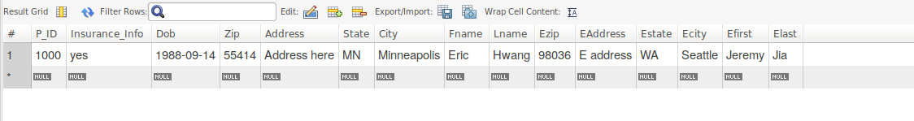

**The insurance info of a patient can be found in Patient table.**

**SQL Query(s) used for testing:**

insert into Department(Dno)

values (1);

insert into Employee(E_ID, Fname, Lname, Dno)

values (123, 'Jame', 'Moon', 1);

INSERT INTO Intake_Clerk (E_ID)

values (123);

INSERT INTO Patient(P_ID, Insurance_Info, Dob, Zip, Address, State, City, Fname, Lname, Ezip, EAddress, Estate, Ecity, Efirst, Elast)

values (1000, 'yes', '1988-09-14', 55414, 'Address here', 'MN', 'Minneapolis', 'Eric','Hwang', 98036, 'E address', 'WA', 'Seattle', 'Jeremy', 'Jia');

Insert into Insurance (P_ID)

values (1000);

insert into Insurance_Request(P_ID, Intake_Clerk_E_ID, Initial_Pay, Medical_Info, Credit_Card, Cash )

Values (1000, 123, 100, 'Medical info', '123-234-456', 100.00);

select * from Insurance_Request;

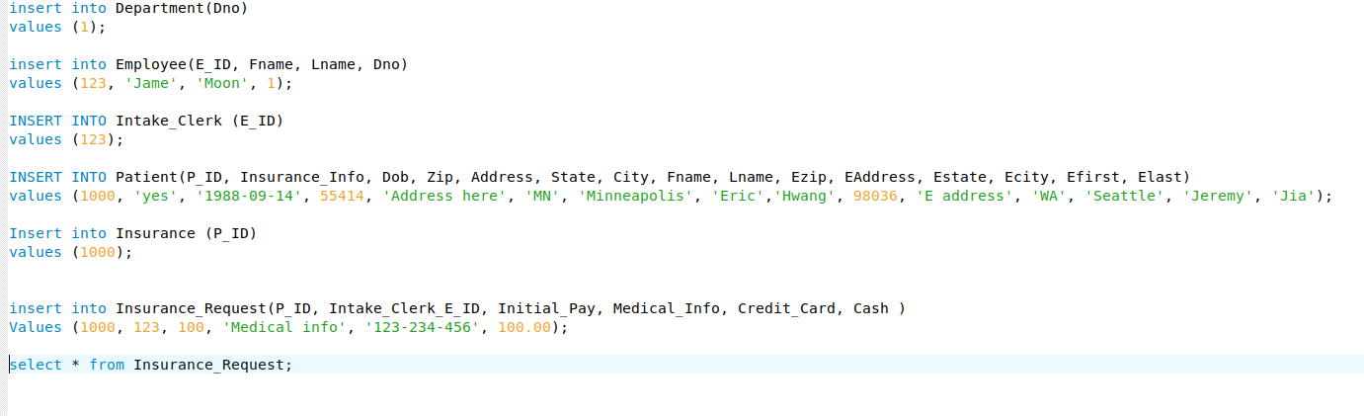Explain and discuss:

Result of the test shows that our current system does not properly document what intake clerk collected the insurance information and the copay. Only way to see the patient’s insurance Info is to look at the Patient table. To fix the problem, we can add patient’s insurance information in Insurance_Request table. That way, the system is documenting what intake clerk collected the insurance information and the copay corresponding to the patient.