|  |  |
| --- | --- |
| **Project: New Haven Urgent Care Team# 1** | |
|  | **Test Date: 12/8/2019** |
| **Test Case ID#: 6** | **Name(s) of Tester(s): Kun Ki Lee, Eric Hwang, Kyeongtak**  **Han, Dongha Kang** |
| **Test Description (What are you testing? – you must be specific):**  **Test if a patient can have more than one diagnosis per visit.**  **Create multiple diagnosis with the same patient ID per visit to see the result.** |  |
|  |  |

**NOTE: The following information must be provided to be given credit for any test.**

**Test Data (Provide the file name of the script used to insert data, provide a screen capture to reflect data, or provide script here):**

**Screen shot of the result:**

**Diagnosis**

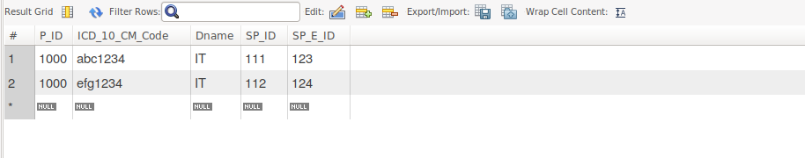

**SQL Query(s) used for testing:**

insert into Department(Dno)

values (1);

insert into Employee(E_ID, Fname, Lname, Dno)

values (123, 'Jame', 'Moon', 1);

insert into Employee(E_ID, Fname, Lname, Dno)

values (124, 'Mark', 'Kim', 1);

INSERT INTO Service_Provider (E_ID, SP_ID)

Values (123, 111);

INSERT INTO Service_Provider (E_ID, SP_ID)

Values (124, 112);

INSERT INTO Patient(P_ID, Insurance_Info, Dob, Zip, Address, State, City, Fname, Lname, Ezip, EAddress, Estate, Ecity, Efirst, Elast)

values (1000, 'yes', '1988-09-14', 55414, 'Address here', 'MN', 'Minneapolis', 'Eric','Hwang', 98036, 'E address', 'WA', 'Seattle', 'Jeremy', 'Jia');

insert into Seen(P_ID, SP_E_ID, SP_ID, Time_In, Time_Out)

values (1000, 123, 111, '12:30:00.00', '13:00:00');

insert into Seen(P_ID, SP_E_ID, SP_ID, Time_In, Time_Out)

values (1000, 124, 112, '12:30:00.00', '13:00:00');

insert into Diagnosis(P_ID, ICD_10_CM_Code, Dname, SP_ID, SP_E_ID)

values (1000, 'abc1234','IT', 111, 123);

insert into Diagnosis(P_ID, ICD_10_CM_Code, Dname, SP_ID, SP_E_ID)

values (1000, 'efg1234','IT', 112, 124);

Select *

From Diagnosis;

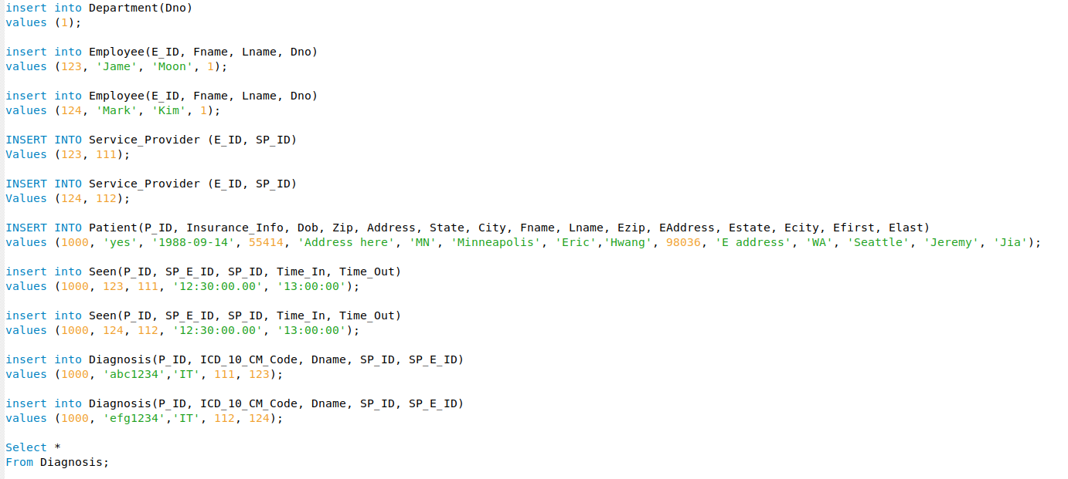

Explain and discuss:

A patient should have one diagnosis per visit, however, the result above shows that our current SQL allows a patient to have multiple diagnosis. One major issue is that we do not have visit entity which ensures “per visit” condition. So, we can not know when the diagnosis is created. That is why in current SQL, multiple diagnosis under the same patient could be created. One possible solution is to create Visit entity which has attributes of date/time, and P_ID, SP_ID etc, and use trigger to prevent letting a patient to have more than one diagnosis per visit.