|  |  |
| --- | --- |
| **Project: New Haven Urgent Care Team# 1** | |
|  | **Test Date: 12/8/2019** |
| **Test Case ID#: 10** | **Name(s) of Tester(s): Kun Ki Lee, Eric Hwang, Kyeongtak**  **Han, Dongha Kang** |
| **Test Description (What are you testing? – you must be specific):**  **Test if the system allow more than one initial assessment to be in the system at a time.** |  |
|  |  |

**NOTE: The following information must be provided to be given credit for any test.**

**Test Data (Provide the file name of the script used to insert data, provide a screen capture to reflect data, or provide script here):**

**Screen shot of the result:**

**Initial_Assessment**

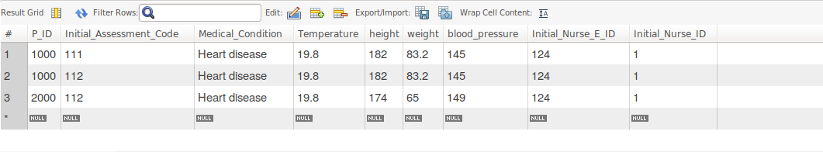

**Insert the same patient with different Initial_assessment_code, and insert different patient with the same initial assessment code.**

**SQL Query(s) used for testing:**

insert into Department(Dno)

values (1);

insert into Employee(E_ID, Fname, Lname, Dno)

values (123, 'Jame', 'Moon', 1);

insert into Employee(E_ID, Fname, Lname, Dno)

values (124, 'Mark', 'Kim', 1);

INSERT INTO Service_Provider (E_ID, SP_ID)

Values (123, 111);

INSERT INTO Service_Provider (E_ID, SP_ID)

Values (124, 112);

INSERT INTO Patient(P_ID, Insurance_Info, Dob, Zip, Address, State, City, Fname, Lname, Ezip, EAddress, Estate, Ecity, Efirst, Elast)

values (1000, 'yes', '1988-09-14', 55414, 'Address here', 'MN', 'Minneapolis', 'Eric','Hwang', 98036, 'E address', 'WA', 'Seattle', 'Jeremy', 'Jia');

INSERT INTO Patient(P_ID, Insurance_Info, Dob, Zip, Address, State, City, Fname, Lname, Ezip, EAddress, Estate, Ecity, Efirst, Elast)

values (2000, 'yes', '1998-09-14', 55414, 'Address here', 'MN', 'Minneapolis', 'Shine','Jang', 98036, 'E address', 'WA', 'Seattle', 'Jeremy', 'Jia');

insert into Seen(P_ID, SP_E_ID, SP_ID, Time_In, Time_Out)

values (1000, 123, 111, '12:30:00.00', '13:00:00');

insert into Seen(P_ID, SP_E_ID, SP_ID, Time_In, Time_Out)

values (1000, 124, 112, '12:30:00.00', '13:00:00');

insert into Nurses(E_ID, N_ID)

values (124, 001);

insert into Nurses(E_ID, N_ID)

values (123, 002);

insert into Initial_Nurse(E_ID, N_ID)

values (124, 001);

insert into Assist_Nurse(E_ID, N_ID)

values (123, 002);

insert into Initial_Assessment

values (1000, 111, 'Heart disease', 19.8, 182, 83.2, 145, 124, 001);

insert into Initial_Assessment

values (1000, 112, 'Heart disease', 19.8, 182, 83.2, 145, 124, 001);

insert into Initial_Assessment

values (2000, 112, 'Heart disease', 19.8, 174, 65, 149, 124, 001);

Select *

From Initial_Assessment;

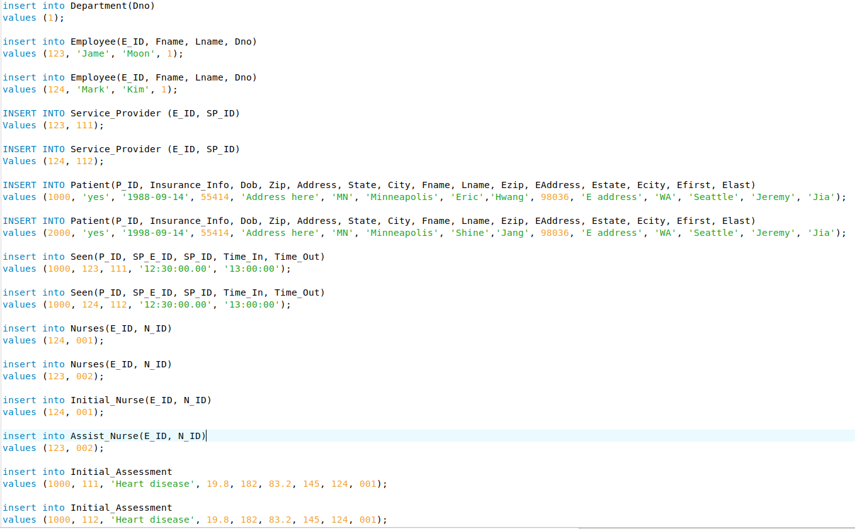

Explain and discuss:

The result above shows that the system allow more than one initial assessment to be in the system at a time for the same patient with different initial assessment code. It is possible when one patient visit multiple times, however, in our current system, we are not tracking the patient’s time_in & time_out for each initial assessment. To fix it, we can add tiem_in & time_out attribute in Initial_assessment and use trigger to prevent creating more than one initial assessment to be in the system at a time.