|  |  |
| --- | --- |
| **Project: New Haven Urgent Care** | **Team# 1** |
|  | **Test Date: 12/8/2019** |
| **Test Case ID#: 3** | **Name(s) of Tester(s): Kun Ki Lee, Eric Hwang, Kyeongtak Han, Dongha Kang** |
| **Test Description (What are you testing? – you must be specific): we are testing that if the patient has no insurance at the first visiting, the next time visiting the patient has the new insurance. The point of test is a recording the insurance and updating the patient from no insurance table to insurance table.** |  |

**NOTE: The following information must be provided to be given credit for any test**

**Test Data (Provide the file name of the script used to insert data, provide a screen capture to reflect data, or provide script here):**

**Patient Table after Insertion of insurance Information  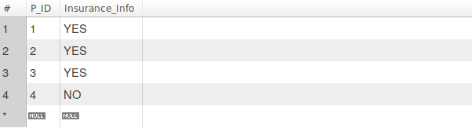No_insurance Table after Insertion Patient to No_insurance_table**

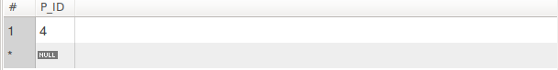

**Update patient has the insurance next visiting.**

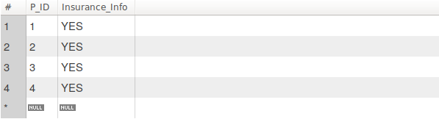

**After updating,the No_insurance table**

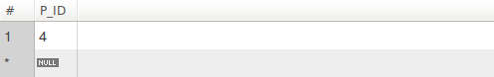**Insurance table**

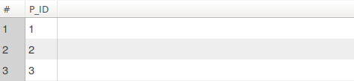**SQL Query(s) used for testing:**

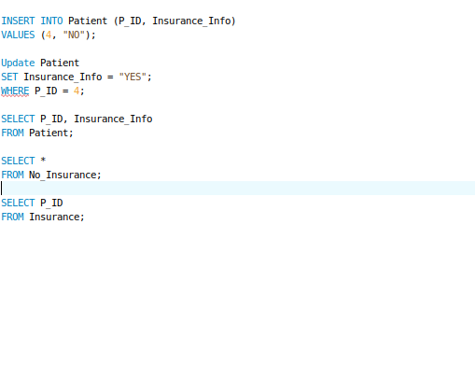Explanation: When the patient has no insurance before then get insurance next visiting, our data cannot update and insert the patient insurance information from no_insurance to insurance table.

So possible solution is to use the trigger in the Patient table. Whenever the patient insurance information is upated, database should check whether or not the patient’s insurance information is changed or not. If so, database should delete the patient from the no_insurance and insert the patient to insurance table.