|  |  |
| --- | --- |
| **Project: New Haven Urgent Care** | **Team# 1** |
|  | **Test Date: 12/8/2019** |
| **Test Case ID#: 4** | **Name(s) of Tester(s): Kun Ki Lee, Eric Hwang, Kyeongtak Han, Dongha Kang** |
| **Test Description (What are you testing? – you must be specific): we are testing whether or not we can store the patient’s old and new insurances when the patient changes the insurance information. Also, we distinguish what is the current active insurance that the patient has by the intake_clerk.** |  |

**NOTE: The following information must be provided to be given credit for any test**

**Test Data (Provide the file name of the script used to insert data, provide a screen capture to reflect data, or provide script here):**

**Patient table**

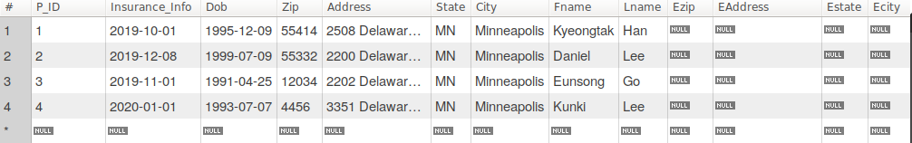

After update the Insurance information for P_ID = 1

UPDATE Patient SET Insurance_Info = "2020-03-01" WHERE P_ID = 1;

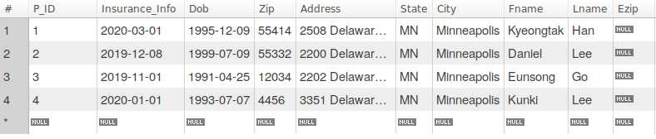

Insurance Request Table after Updating the Patient insurance

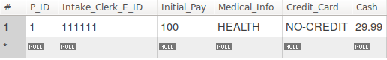

Check the P_ID Insurance Information by Intake clerk



**SQL Query(s) used for testing:**

INSERT INTO Insurance_Request VALUES (1, 111111, 100, "HEALTH", "NO-CREDIT", 29.99);

UPDATE Patient SET Insurance_Info = "2020-03-01" WHERE P_ID = 1;

SELECT *

FROM Insurance_Request JOIN Intake_Clerk ON Intake_Clerk.E_ID = Insurance_Request.Intake_Clerk_E_ID

WHERE P_ID = 1;

Explanation: We found that our data base wouldn’t be able to store the patient’s insurances (old and new) when the patient insurance information is updated. Also, when the intake clerk tries to get the information for specific patient, there is no data for insurance. Another problem that we found is an Intake clerk couldn’t distinguish the old and current insurance information.

So possible solution is to make more insurance columns to store the old and new insurance. Then if the update occurs on the patient insurance information, we should use the trigger in the Patient table to move the current insurance to old insurance and new insurance to current insurance. Further, we also trigger the insurance request table to insert the new insurance data when patient insurances update.