|  |  |
| --- | --- |
| **Project: New Haven Urgent Care Team# 1** | |
|  | **Test Date: 12/8/2019** |
| **Test Case ID#: 20** | **Name(s) of Tester(s): Kun Ki Lee, Eric Hwang, Kyeongtak**  **Han, Dongha Kang** |
| **Test Description (What are you testing? – you must be specific):**  **Test if a primary key function properly. Meaning that no duplicates can happen in a table.** |  |
|  |  |

**NOTE: The following information must be provided to be given credit for any test.**

**Test Data (Provide the file name of the script used to insert data, provide a screen capture to reflect data, or provide script here):**

**Screen shot of the result:**

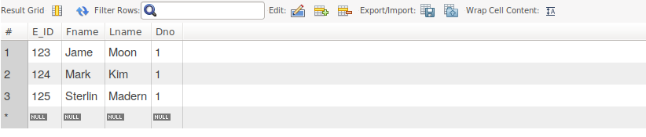

**When try to insert a new entry with the same E_ID = 124, error message shows up:**

**SQL Query(s) used for testing:**

insert into Employee(E_ID, Fname, Lname, Dno)

values (123, 'Jame', 'Moon', 1);

insert into Employee(E_ID, Fname, Lname, Dno)

values (124, 'Mark', 'Kim', 1);

insert into Employee(E_ID, Fname, Lname, Dno)

values (125, 'Sterlin', 'Madern', 1);

insert into Employee(E_ID, Fname, Lname, Dno)

values (124, 'Maxim', 'Wang', 1);

Select * from Employee;

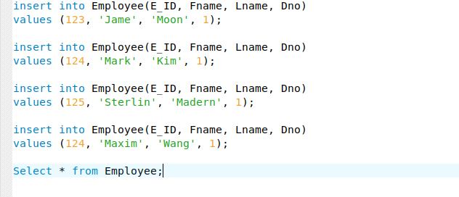

Explain and discuss:

Primary key of Employee function correctly since a duplicate can not insert into the table.