|  |  |
| --- | --- |
| **Project: New Haven Urgent Care Team# 1** | |
|  | **Test Date: 12/8/2019** |
| **Test Case ID#: 5** | **Name(s) of Tester(s): Kun Ki Lee, Eric Hwang, Kyeongtak**  **Han, Dongha Kang** |
| **Test Description (What are you testing? – you must be specific):**  **Test if a patient can be seen by only one service provider per visit.**  **Test to see if multiple service providers can seen the same patient in the same time_in, time_out.** |  |
|  |  |

**NOTE: The following information must be provided to be given credit for any test.**

**Test Data (Provide the file name of the script used to insert data, provide a screen capture to reflect data, or provide script here):**

**Screen shot of the Result**

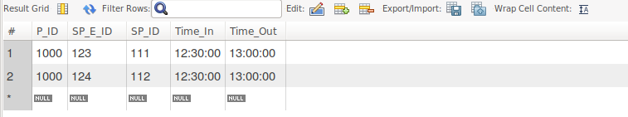

**SQL Query(s) used for testing:**

insert into Department(Dno)

values (1);

insert into Employee(E_ID, Fname, Lname, Dno)

values (123, 'Jame', 'Moon', 1);

insert into Employee(E_ID, Fname, Lname, Dno)

values (124, 'Mark', 'Kim', 1);

INSERT INTO Service_Provider (E_ID, SP_ID)

Values (123, 111);

INSERT INTO Service_Provider (E_ID, SP_ID)

Values (124, 112);

INSERT INTO Patient(P_ID, Insurance_Info, Dob, Zip, Address, State, City, Fname, Lname, Ezip, EAddress, Estate, Ecity, Efirst, Elast)

values (1000, 'yes', '1988-09-14', 55414, 'Address here', 'MN', 'Minneapolis', 'Eric','Hwang', 98036, 'E address', 'WA', 'Seattle', 'Jeremy', 'Jia');

insert into Seen(P_ID, SP_E_ID, SP_ID, Time_In, Time_Out)

values (1000, 123, 111, '12:30:00.00', '13:00:00');

insert into Seen(P_ID, SP_E_ID, SP_ID, Time_In, Time_Out)

values (1000, 124, 112, '12:30:00.00', '13:00:00');

Select *

From Seen;

Screen shot of the queris:

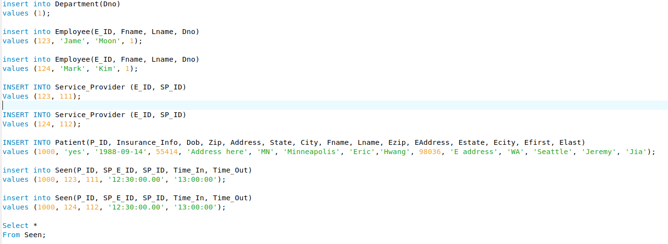

Explain and discuss:

A patient should be seen by only one service provider per visit, however, the result above shows that our current SQL allows a patient to have multiple service provider at the same time (time_in & time_out). Possible solution to this case might be using trigger. By using trigger, we can prevent inserting multiple service provider to one patient within a same time period.