|  |  |
| --- | --- |
| **Project: New Haven Urgent Care** | **Team# 1** |
|  | **Test Date: 12/8/2019** |
| **Test Case ID#: 8** | **Name(s) of Tester(s): Kun Ki Lee, Eric Hwang, Kyeongtak Han, Dongha Kang** |
| **Test Description (What are you testing? – you must be specific): We are testing that once diagnosis is concluded to the patient with proper code, we would be able to get the proper test or procedure.** |  |

**NOTE: The following information must be provided to be given credit for any test**

**Test Data (Provide the file name of the script used to insert data, provide a screen capture to reflect data, or provide script here):**

**Diagnosis**

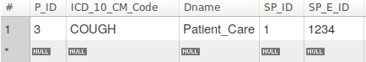

Conduct

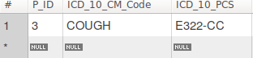

Treatment

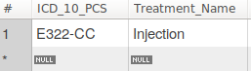

Required



Test_Procedure

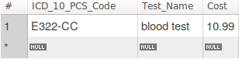

Result of Testing





**SQL Query(s) used for testing:**





Explanation: We are able to get proper tests or procedures with proper coding once the diagnosis is concluded to patient. As we can see, by using only the patient_id or the code on diagnosis, we successfully get the test_procedure name and which code the patient gets on diagnosis.