HW1 REPORT

謝翔丞, 109550025

*Abstract*—撰寫 profiling 電路同時使用 Integrated Logic Analyzer 為 benchmark-Coremark 之執行過程做函示分析與解剖，報告中會提及過程電路設計架構以及對於結果之探討總結。

Keywords—component; Coremark , ILA , Profile, Verilog (key words)

# Introduction

本次作業前提在以更換原先使用之 benchmark Dhrystone 為 Coremark 之前提下，撰寫一份 profiling 電路分析 Coremark 在執行過程中五個較常呼叫的 hotspot function ，同時學習利用 uart 與開發板作互動，傳入需要執行的程式與檔案，並且嘗試使用 Vivado 的內建工具 ILA 查看訊號執行結果。

# Profiling 電路設計與架構

## 概念

要進行程式分析，必須從 program counter下手。我們首先觀察*map 與 *.objdump從中獲得該函示執行時的pc值起始點與其範圍，接著利用抓取之pc訊號進行範圍判讀並設計counter累加計算cycle，以達到分析各函示使用時長之成果。

(圖一為以 .map 查找函示對應圖二.objdump之實例)

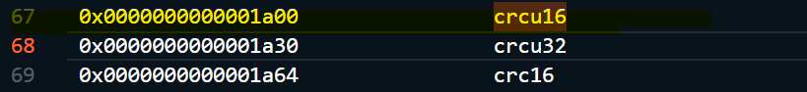

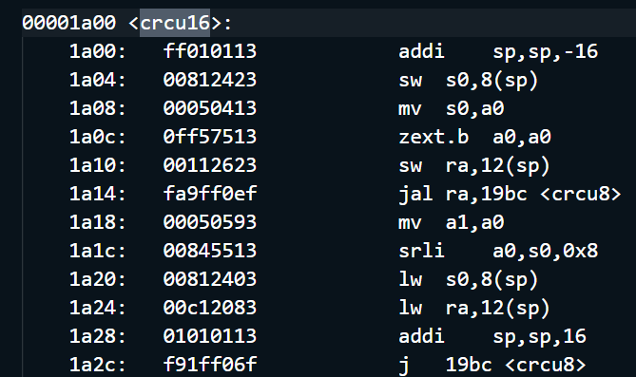

## 電路實作

接續前段所提，在這塊電路中我們必須利用到pc 訊號，同時為了考慮到計算memory computation的cycle數量，我們也需要使用instruction以及stall訊號作為input，因此我將這個profile module放置於coretop.v中，如此一來可以使用到現有設置好的 stall_pipeline 訊號。

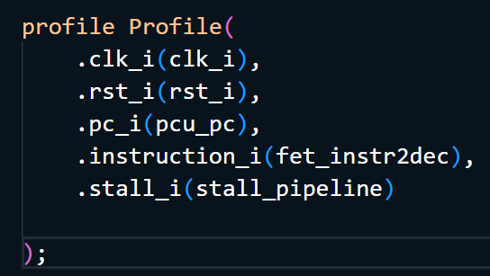

接著介紹profile module內部設計，首先我根據.map檔案設立計算cycle的起始點與結束點，也就是對應到c檔案的main()與exit()，並額外增設total_cycle_flag，唯有在這段時間內的cycle才會被計入total_cycle。另外針對五個欲檢測的function我都分別設立一個flag，這個flag的值是取決於當前pc值是否落於該函示的位址範圍(可於.objdump查找)內，一旦滿足前述條件且total_cycle_flag值為1時，便計入該函示之counter計算。(下圖為其一範例與部分截圖)

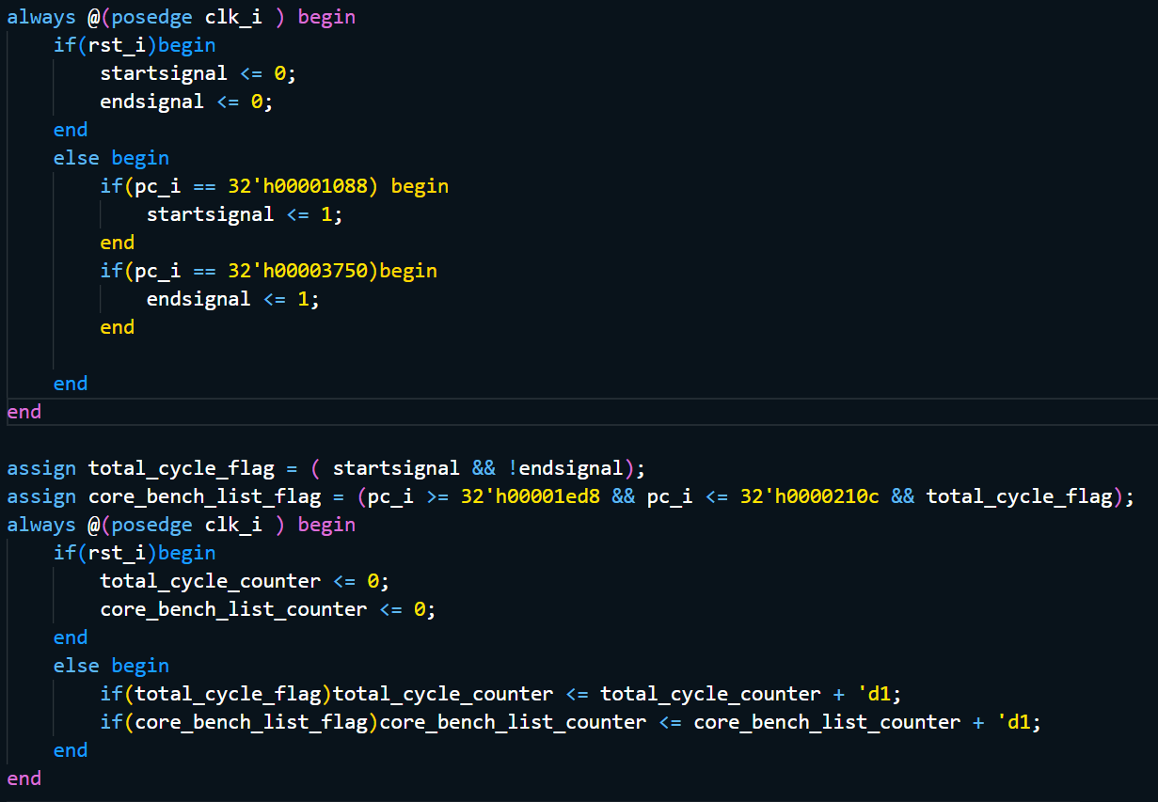



另外在計算是否為memory cycle時，則多利用一個memory flag，這個flag的判斷是利用opcode的[6:5]以及[4:2]來分辨，只要在上段的cycle counter再加上此flag就能計算出該函示的memory cyle 進而也能推出computation cycle。同理，在計算cycle是否stall時，也是利用早前input就拉入的stall_i作為flag計算。(例:在附圖之condition下，會計算出core_bench_list在computation cycle下的stall cycle數量。)

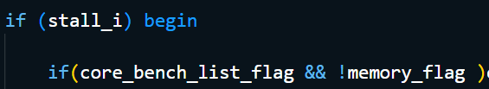

# Profiling結果之探討分析

由上圖我的計算結果可發現，coremark在Artix-7 XC7A100T FPGA 開發板上五個函示之執行cycle數量與在PC上有滿大的差異，原先佔有25%左右的core_bench_list竟下降至1.8% 附近，其餘函示也有極大的差異。

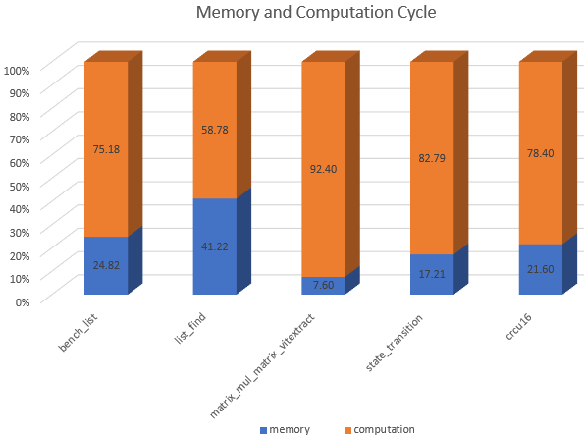

上圖是這五個函示分別進行memory 以及computation cycle的比例呈現。

下兩張附圖則是stall分別在computation以及memory cycle發生的分布狀況，以及在memory cycle內發生stall的比例。

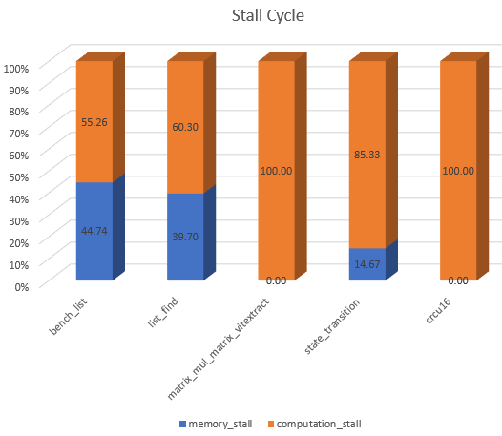

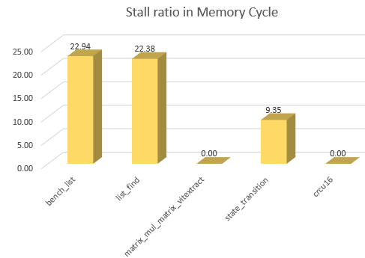

Finally, complete content and organizational editing before formatting. Please take note of the following items when proofreading spelling and grammar:

## Abbreviations and Acronyms

Define abbreviations and acronyms the first time they are used in the text, even after they have been defined in the abstract. Abbreviations such as IEEE, SI, MKS, CGS, sc, dc, and rms do not have to be defined. Do not use abbreviations in the title or heads unless they are unavoidable.

## Equations

The equations are an exception to the prescribed specifications of this template. You will need to determine whether or not your equation should be typed using either the Times New Roman or the Symbol font (please no other font). To create multileveled equations, it may be necessary to treat the equation as a graphic and insert it into the text after your paper is styled.

Number equations consecutively. Equation numbers, within parentheses, are to position flush right, as in (1), using a right tab stop. To make your equations more compact, you may use the solidus ( / ), the exp function, or appropriate exponents. Italicize Roman symbols for quantities and variables, but not Greek symbols. Use a long dash rather than a hyphen for a minus sign. Punctuate equations with commas or periods when they are part of a sentence, as in

*a*  *b*             

Note that the equation is centered using a center tab stop. Be sure that the symbols in your equation have been defined before or immediately following the equation. Use “(1),” not “Eq. (1)” or “equation (1),” except at the beginning of a sentence: “Equation (1) is ...”

## Reference

An excellent style manual for science writers is [7].

# Using the Template

After the text edit has been completed, the paper is ready for the template. Duplicate the template file by using the Save As command, and use the naming convention prescribed by your conference for the name of your paper. In this newly created file, highlight all of the contents and import your prepared text file. You are now ready to style your paper; use the scroll down window on the left of the MS Word Formatting toolbar.

## Authors and Affiliations

The template is designed so that author affiliations are not repeated each time for multiple authors of the same affiliation. Please keep your affiliations as succinct as possible (for example, do not differentiate among departments of the same organization).

## Identify the Headings

Headings, or heads, are organizational devices that guide the reader through your paper. There are two types: component heads and text heads.

Component heads identify the different components of your paper and are not topically subordinate to each other. Examples include ACKNOWLEDGMENTS and REFERENCES, and for these, the correct style to use is “Heading 5.” Use “figure caption” for your Figure captions, and “table head” for your table title. Run-in heads, such as “Abstract,” will require you to apply a style (in this case, italic) in addition to the style provided by the drop down menu to differentiate the head from the text.

Text heads organize the topics on a relational, hierarchical basis. For example, the paper title is the primary text head because all subsequent material relates and elaborates on this one topic. If there are two or more sub-topics, the next level head (uppercase Roman numerals) should be used and, conversely, if there are not at least two sub-topics, then no subheads should be introduced. Styles named “Heading 1,” “Heading 2,” “Heading 3,” and “Heading 4” are prescribed.

## Figures and Tables

### Positioning Figures and Tables: Place figures and tables at the top and bottom of columns. Avoid placing them in the middle of columns. Large figures and tables may span across both columns. Figure captions should be below the figures; table heads should appear above the tables. Insert figures and tables after they are cited in the text. Use the abbreviation “Fig. 1,” even at the beginning of a sentence.

1. Table Styles

| Table Head | Table Column Head | | |
| --- | --- | --- | --- |
| Table column subhead | Subhead | Subhead |
| copy | More table copya |  |  |

1. Sample of a Table footnote. *(Table footnote)*
2. Example of a figure caption. *(figure caption)*

Figure Labels: Use 8 point Times New Roman for Figure labels. Use words rather than symbols or abbreviations when writing Figure axis labels to avoid confusing the reader. As an example, write the quantity “Magnetization,” or “Magnetization, M,” not just “M.” If including units in the label, present them within parentheses. Do not label axes only with units. In the example, write “Magnetization (A/m)” or “Magnetization (A ( m(1),” not just “A/m.” Do not label axes with a ratio of quantities and units. For example, write “Temperature (K),” not “Temperature/K.”

##### Acknowledgment *(Heading 5)*

The preferred spelling of the word “acknowledgment” in America is without an “e” after the “g.” Avoid the stilted expression “one of us (R. B. G.) thanks ...”. Instead, try “R. B. G. thanks...”. Put sponsor acknowledgments in the unnumbered footnote on the first page.

##### References

The template will number citations consecutively within brackets [1]. The sentence punctuation follows the bracket [2]. Refer simply to the reference number, as in [3]—do not use “Ref. [3]” or “reference [3]” except at the beginning of a sentence: “Reference [3] was the first ...”

Number footnotes separately in superscripts. Place the actual footnote at the bottom of the column in which it was cited. Do not put footnotes in the reference list. Use letters for table footnotes.

Unless there are six authors or more give all authors’ names; do not use “et al.”. Papers that have not been published, even if they have been submitted for publication, should be cited as “unpublished” [4]. Papers that have been accepted for publication should be cited as “in press” [5]. Capitalize only the first word in a paper title, except for proper nouns and element symbols.

For papers published in translation journals, please give the English citation first, followed by the original foreign-language citation [6].

1. G. Eason, B. Noble, and I.N. Sneddon, “On certain integrals of Lipschitz-Hankel type involving products of Bessel functions,” Phil. Trans. Roy. Soc. London, vol. A247, pp. 529-551, April 1955. (*references*)
2. J. Clerk Maxwell, A Treatise on Electricity and Magnetism, 3rd ed., vol. 2. Oxford: Clarendon, 1892, pp.68-73.
3. I.S. Jacobs and C.P. Bean, “Fine particles, thin films and exchange anisotropy,” in Magnetism, vol. III, G.T. Rado and H. Suhl, Eds. New York: Academic, 1963, pp. 271-350.
4. K. Elissa, “Title of paper if known,” unpublished.
5. R. Nicole, “Title of paper with only first word capitalized,” J. Name Stand. Abbrev., in press.
6. Y. Yorozu, M. Hirano, K. Oka, and Y. Tagawa, “Electron spectroscopy studies on magneto-optical media and plastic substrate interface,” IEEE Transl. J. Magn. Japan, vol. 2, pp. 740-741, August 1987 [Digests 9th Annual Conf. Magnetics Japan, p. 301, 1982].
7. M. Young, The Technical Writer’s Handbook. Mill Valley, CA: University Science, 1989.