Review Generator

# Scenario

You love reading and are a member of ‘goodreads.com’. One of your personal goals last year was to dutifully review all of the books that you read so that you could connect with like-minded readers and also share your views.

Unfortunately, whilst you enjoy reading, writing the reviews has proved to be somewhat tedious so you decide to create a computer program that will allow you to generate the basic review which you can then edit a bit more if desired.

|  |
| --- |
| Possible Features Please try and create a review generator that goes beyond the basics. Here are some ideas…   * Ask the user a series of questions which they can answer on a scale (from 1 to 5), then based on their rating, offer a suitable adjective, chosen at random from a list * Allow users to either accept the adjective suggested by the program or input their own adjective * Ask users if the book is part of a series and if so, whether it works as a ‘stand-alone’ novel |

|  |
| --- |
| Alternate Scenarios If you prefer, you are welcome to create a review generator for movies, game, restaurants or travel destinations. To keep the task manageable, please choose **one** broad category (eg: movies rather than trying to make a generator for movies AND games). |

## Task

1. Decompose the problem.
2. Plan how you will tackle the problem (using a Kanban board for this is one option)
3. Write a test plan for your first component. Then create the code and test it using your plan.
4. Where necessary, refine your component and retest.
5. Explain which implications are relevant to your component and discuss how your component addresses the relevant implications
6. Repeat the above steps until you have a series of working components
7. Combine your components to create a working program
8. Test and debug your program to ensure that it works for expected, boundary and unexpected values
9. Ask a friend / parent to use your recipe moderniser. Watch them as they do this and make note of any changes that could be made to make the program easier to use
10. Make the changes identified in the previous step
11. Retest your program to ensure that it still works correctly

## Resources / Hints

*Here are some ideas that you can build on to create your review generator.*

Basic Inputs*.*

Here is a screenshot of a typical ‘Good Reads’ review. Getting the information that has been boxed / underlined from the users should be one of your priorities.

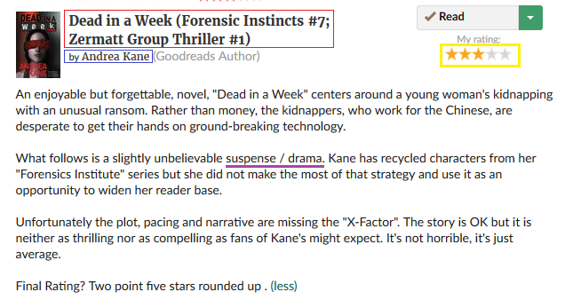

Review Skeletons

*To create a review, we want to a standard structure (skeleton) that can be populated based on user input. Ideally we need several alternate skeletons so that the reviews we generate are not too similar to each other. Our program could choose a ‘skeleton’ at random.*

**Intro sentences…**

|  |  |  |  |  |
| --- | --- | --- | --- | --- |
| Adjective  *Fun, entertaining, gripping* | but  and | Adjective,  *Compelling, charming, quaint* | Book, Title is… | Plot summary |

|  |  |  |  |
| --- | --- | --- | --- |
| Set in | Time / place | Title is the story of | Plot summary |

<if plot summary is blank>

|  |  |  |  |  |
| --- | --- | --- | --- | --- |
| Title | Is both | Adjective | And | adjective |

**Second sentences…**

|  |  |  |  |
| --- | --- | --- | --- |
| Adjective  *Unfortunately, sadly, happily*, | <author> has created a | Adjective  *Nail-biting, thrilling, tedious* | Genre  *Romance, suspense, adventure* |

|  |  |  |  |  |  |  |
| --- | --- | --- | --- | --- | --- | --- |
| Author | Has written a / an | Adjective  *Intense, mediocre, far-fetched* | Genre | Which will | Adjective  *Disappoint, delight, bore, excite* | Both <his / her> Fans and first-time readers |

**Third sentence (the writing / prose….)**

The writing style is <adjective> and this makes the book <adjective>.

**Fourth sentence (the plot)**

The underlying story is <adjective> and the ending is <adjective>

**Conclusion**

Overall, I <adjective> this book and would <recommend / not recommend> it to others.

<title> deserves a <rating> star rating. Ultimately it was a / an <adjective> novel which was <worth / not worth> reading

This is <rating.5> stars rounded <up / down> because <reason for rating>