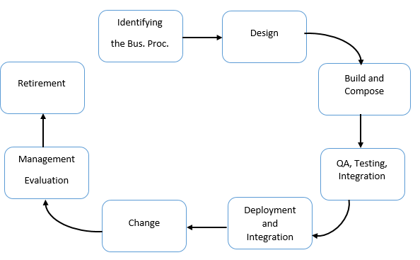

Retirement

Management

Evaluation

Change

Deployment and Integration

QA, Testing, Integration

Design

Identifying

the Bus. Proc.

Build and Compose

Standardized Service Contract

Autonomity

Loose Coupling

Reusability

Discoverability

Abstraction

Statelessness

Composability

Standardized Service Contract

Autonomity

Loose Coupling

Reusability

Discoverability

Abstraction

Statelessness

Composability

Standardized Service Contract

Autonomity

Loose Coupling

Reusability

Discoverability

Abstraction

Statelessness

Composability

Standardized Service Contract

Autonomity

Loose Coupling

Reusability

Discoverability

Abstraction

Statelessness

Composability

Standardized Service Contract

Autonomity

Loose Coupling

Reusability

Discoverability

Abstraction

Statelessness

Composability

Standardized Service Contract

Autonomity

Loose Coupling

Reusability

Discoverability

Abstraction

Statelessness

Composability

Standardized Service Contract

Autonomity

Loose Coupling

Reusability

Discoverability

Abstraction

Statelessness

Composability

Standardized Service Contract

Autonomity

Loose Coupling

Reusability

Discoverability

Abstraction

Statelessness

Composability

Standardized Service Contract

Autonomity

Loose Coupling

Reusability

Discoverability

Abstraction

Statelessness

Composability

Standardized Service Contract

Autonomity

Loose Coupling

Reusability

Discoverability

Abstraction

Statelessness

Composability

Standardized Service Contract

Autonomity

Loose Coupling

Reusability

Discoverability

Abstraction

Statelessness

Composability

WSDL

UDDI

WSDL

Registration

Find

Service Directory

Service Consumer

Service Provider

SOAP

Invokation

Reusability

Discoverability

Composability

Standardized Service Contract

Abstraction

Statelessness

Autonomity

Loose Coupling

**Service A**

**Service**

**Capability A**

**Capability B**

Strategic benefits

Strategic goals

Increased ROI

Increased Organisational Agility

Reduced IT Burden

Increased Vendor Diversity Options

Increased Federation

Increased Business and Technology Alignment

Increased Intrinsic Interoperability