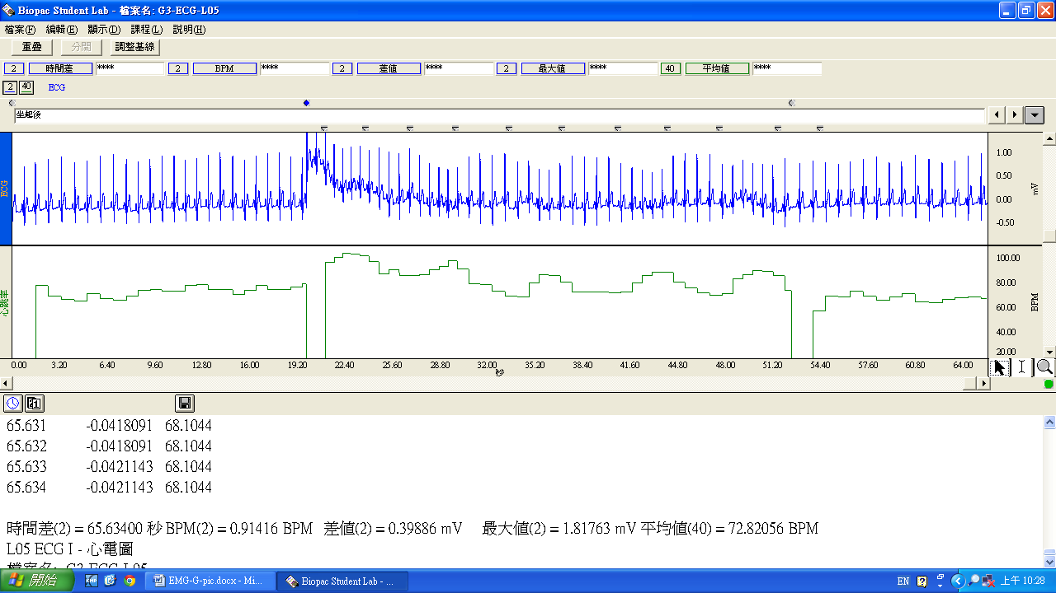Spine，Seated (deep breathing)，Sitting(regular breathing)

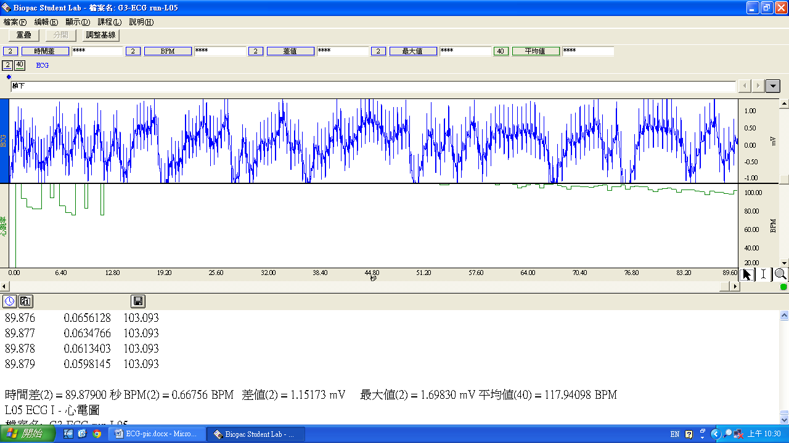After exercise