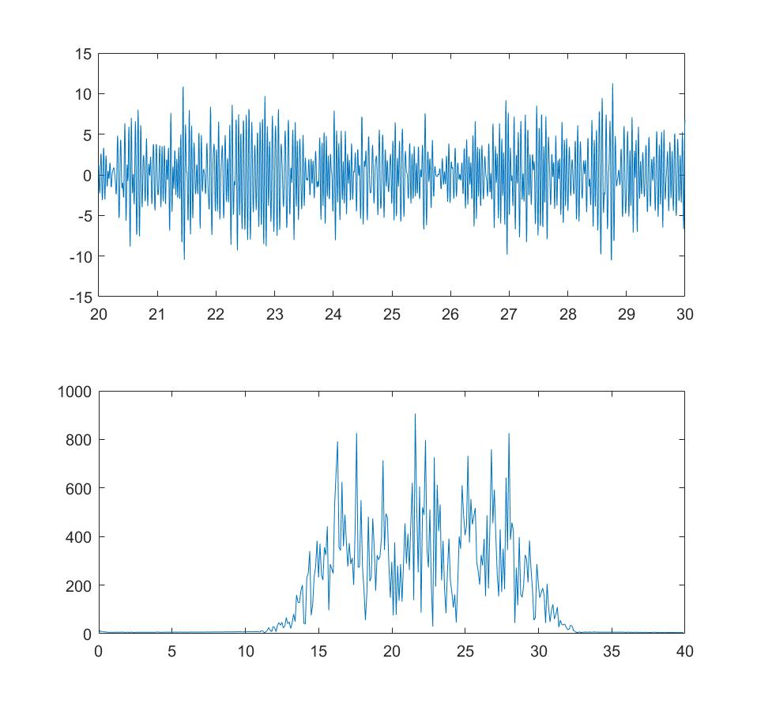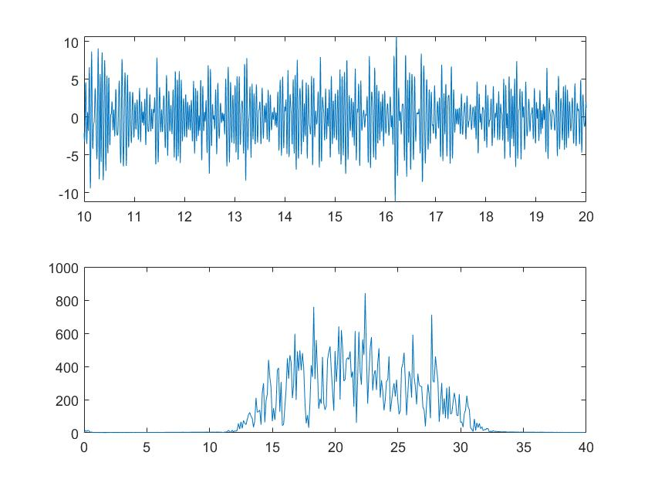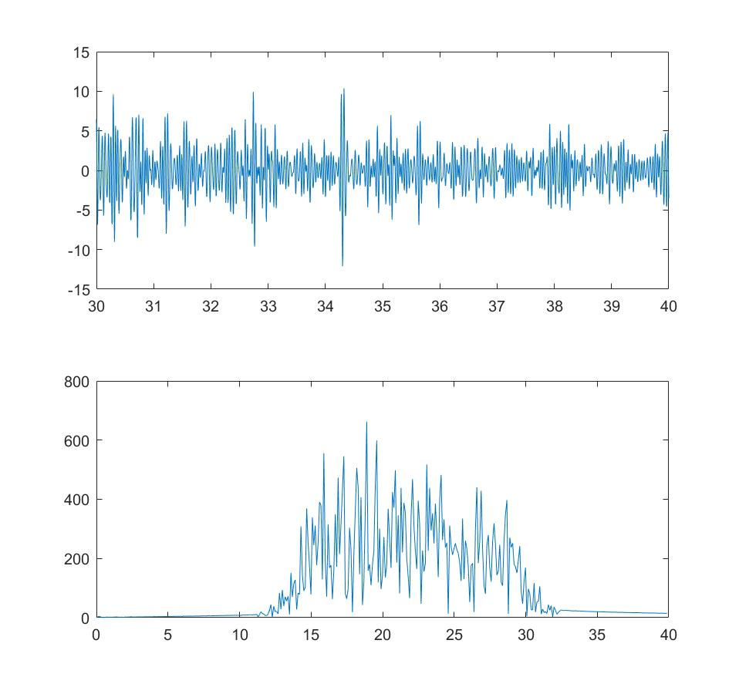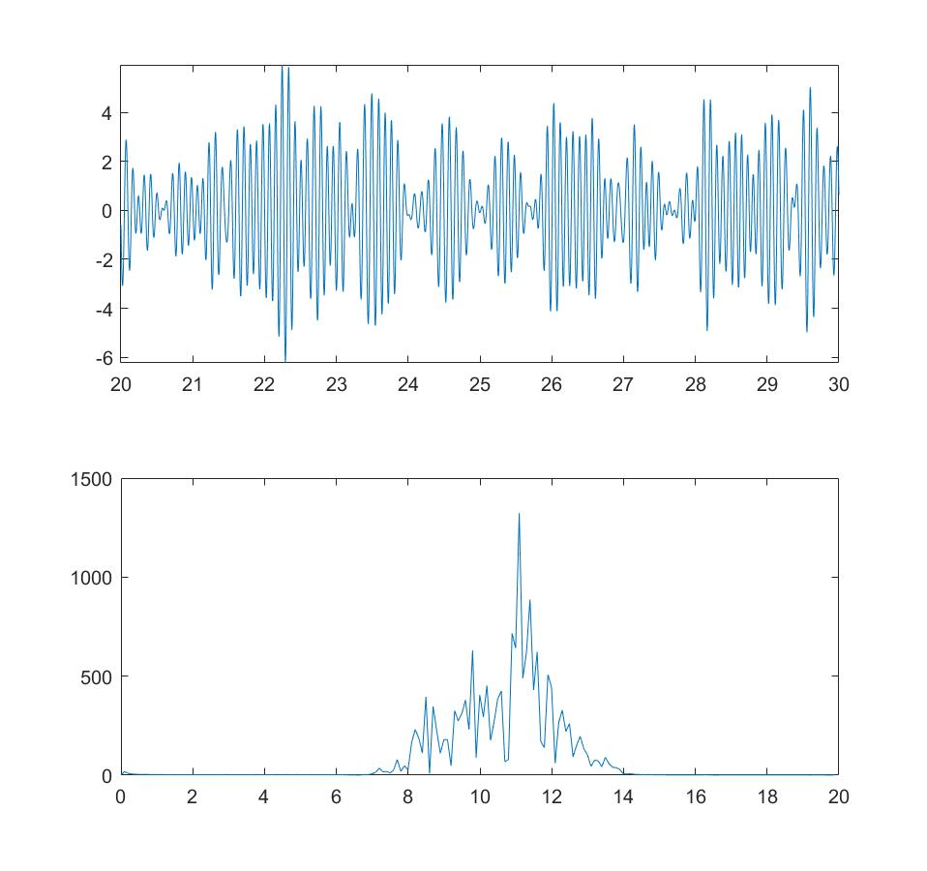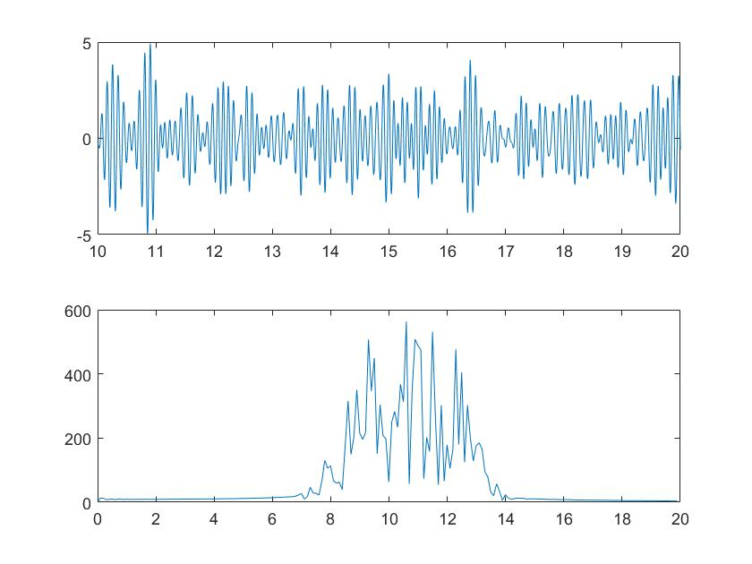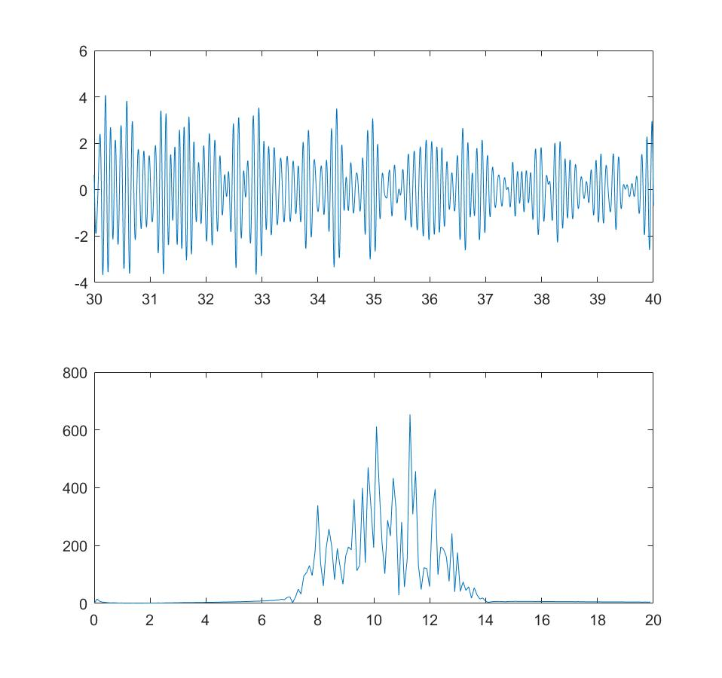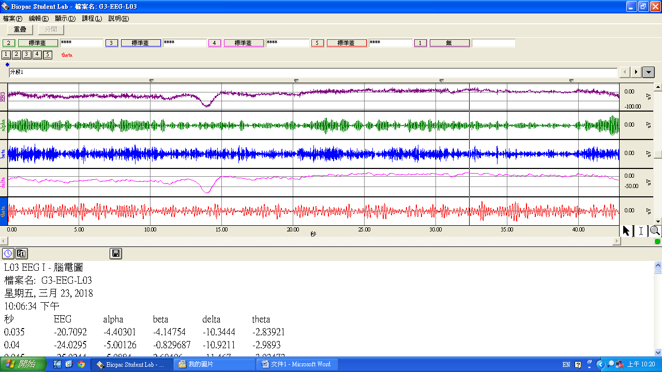

Alpha 30-40sec time and frequency domain

Beta 10-20sec time and frequency domain

Beta 30-40sec time and frequency domain

Beta 20-30sec time and frequency domain

Alpha 20-30sec time and frequency domain

Alpha 10-20sec time and frequency domain

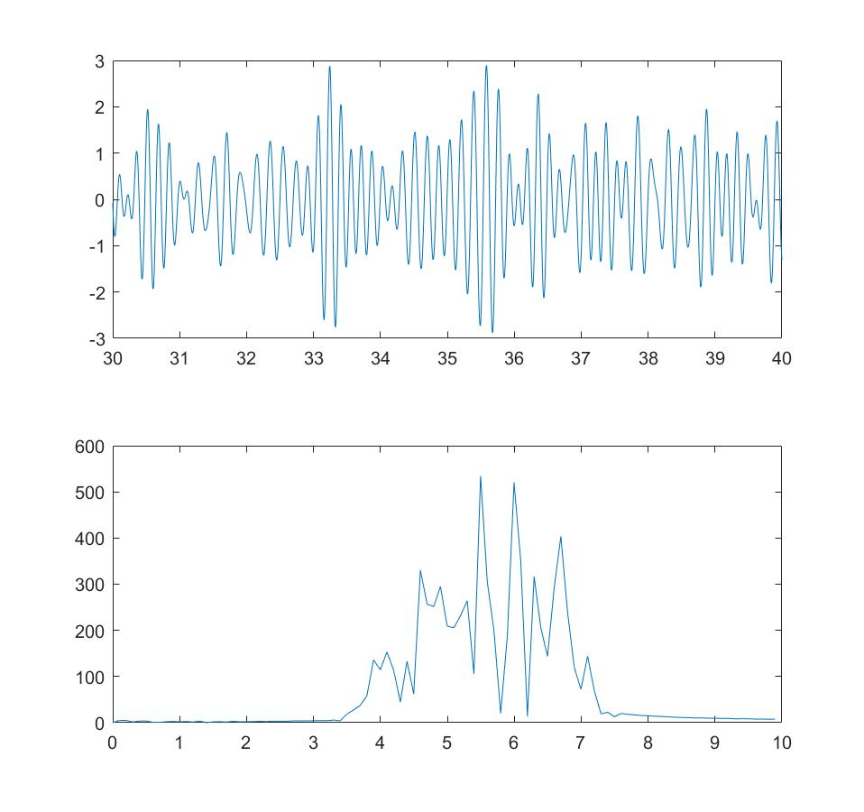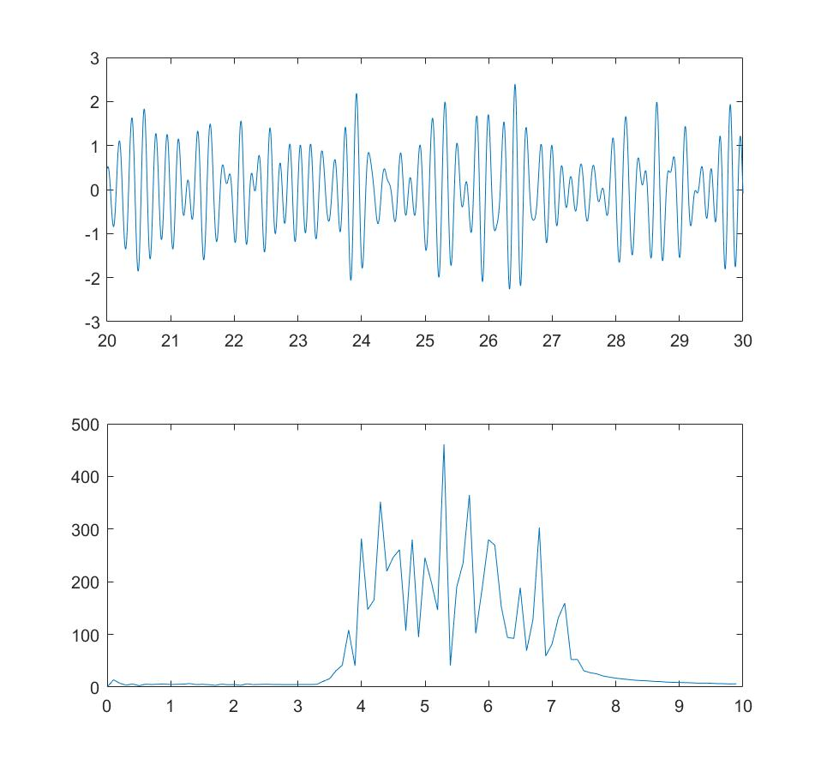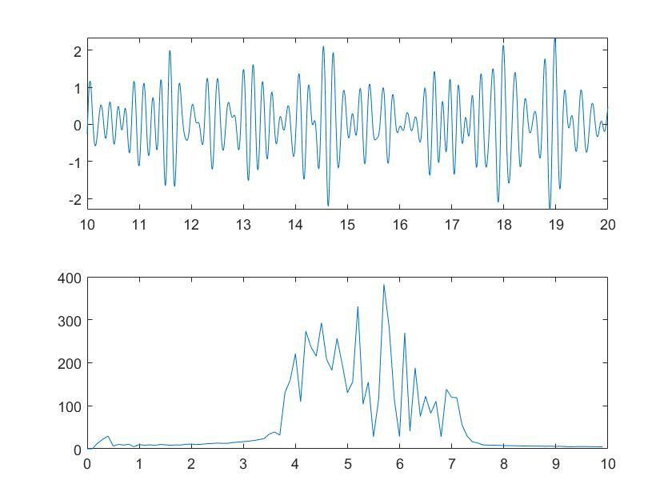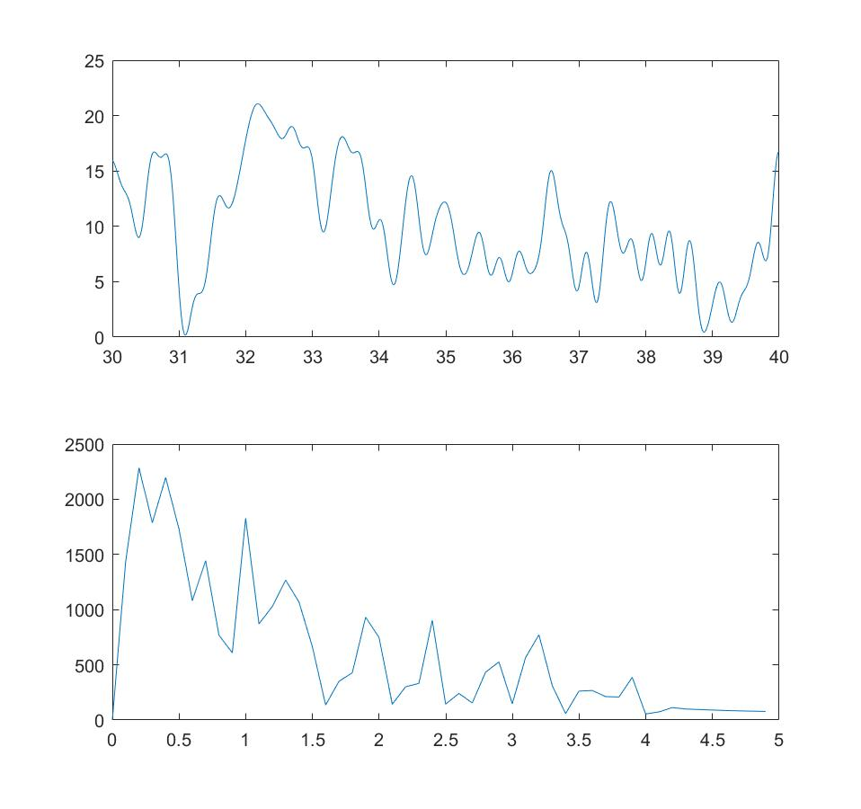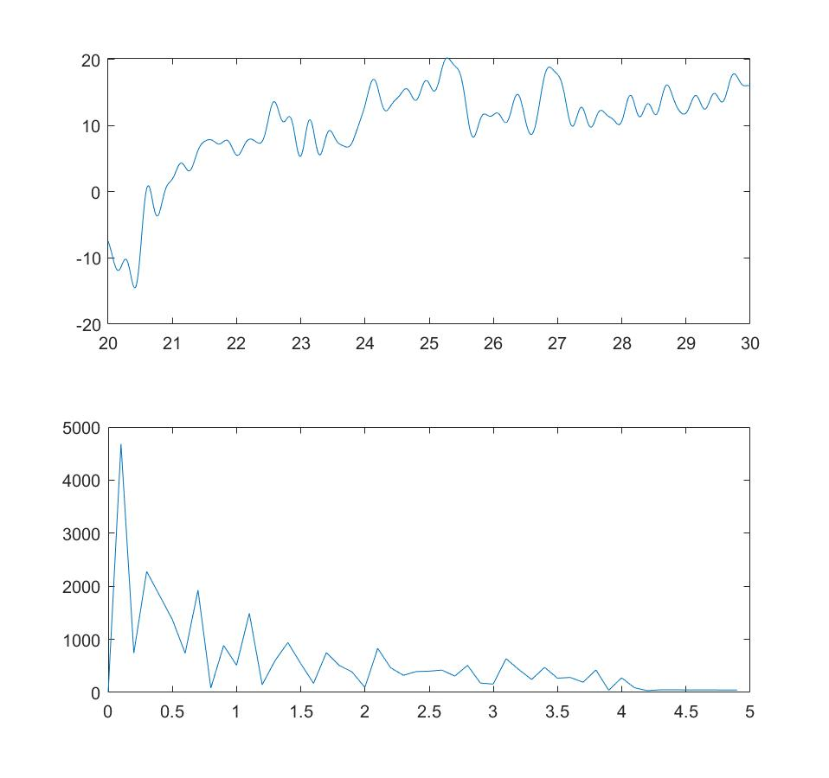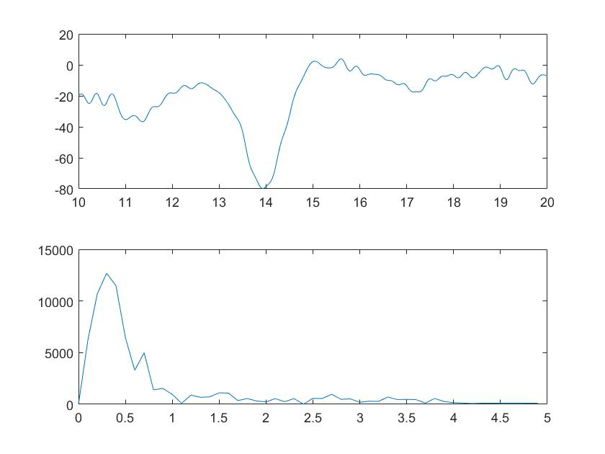

theta 30-40sec time and frequency domain

theta 20-30sec time and frequency domain

theta 10-20sec time and frequency domain

delta 30-40sec time and frequency domain

delta 20-30sec time and frequency domain

delta 10-20sec time and frequency domain