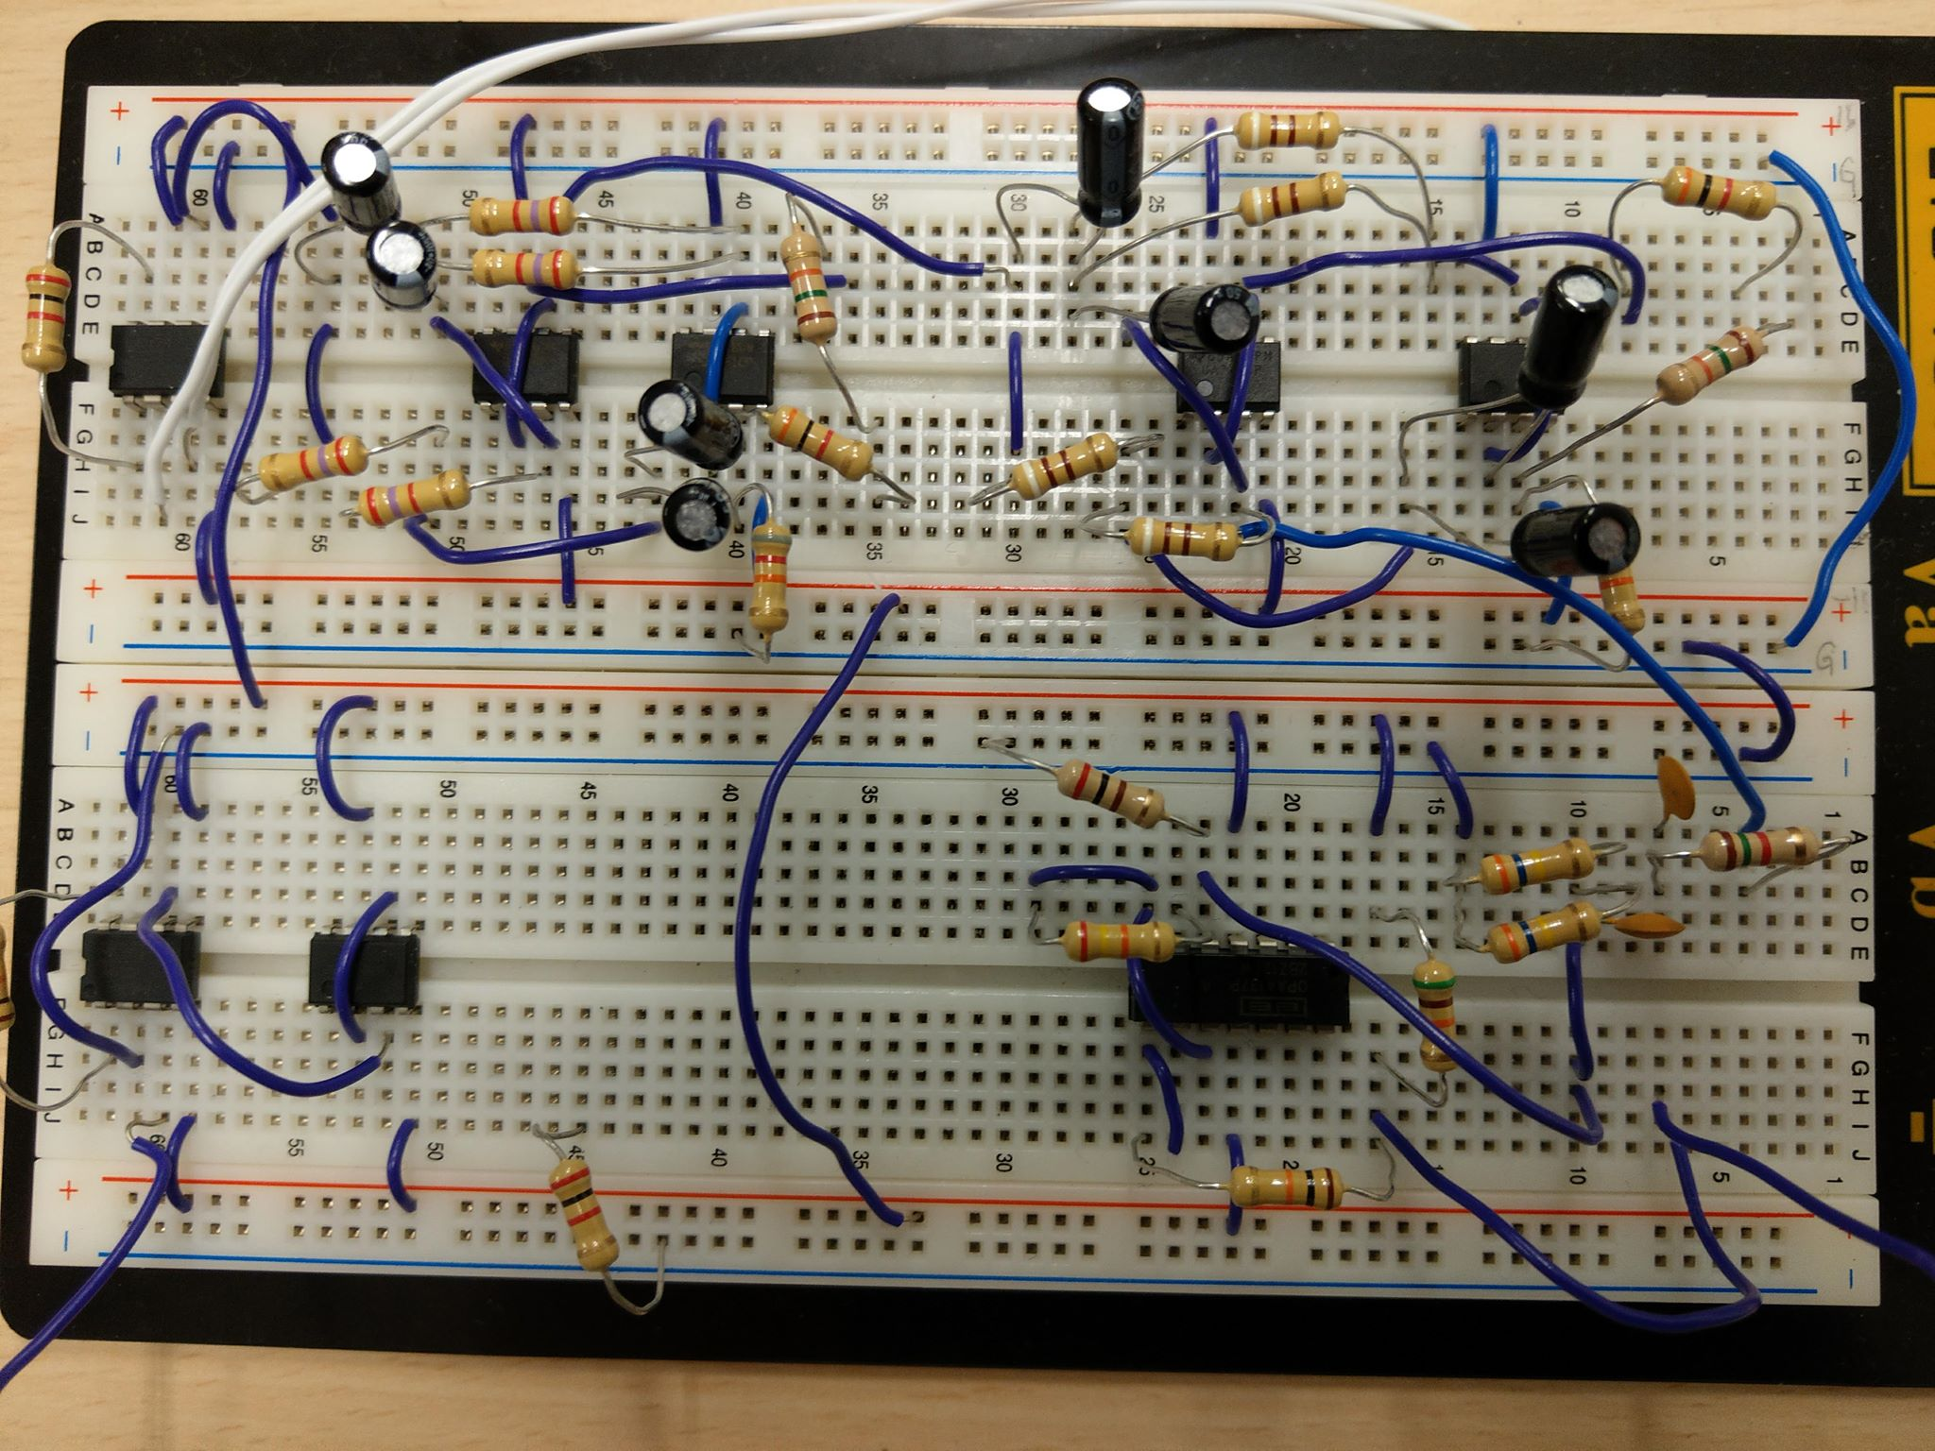

**Input +**

**Input -**

**Buffer**

**Post**

**Amplifier**

**3 order Notch Filter x2**

**Output**

**Level Shifter**

**Highpass Filter**

**Lowpass Filter**

**Pre**

**Amplifier**