READ ME FILE
NAME: HARMANJEET SINGH
STUDENT NUMBER: 43847953

- SOF File Directory:
"C:\Harmanjeet_Singh_43847953_lab_1\rtl\Basic_Organ_Solution.sof"
Name of file: Basic_Organ_Solution.sof
- Status : everything works perfectly fine on the de1-soc and I managed to finish simulations only for the LED Clock part
- Simulation for LED_Controller module:
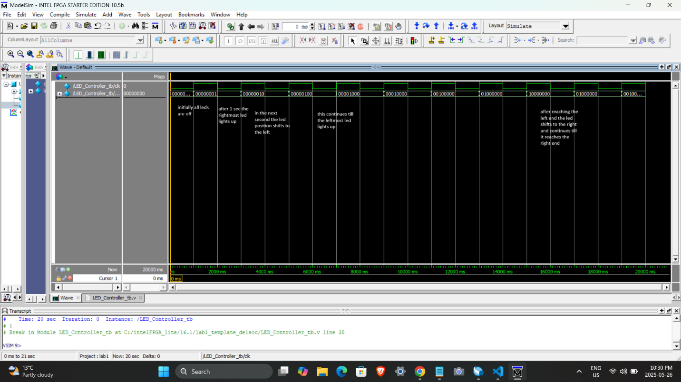

- Signal Tap annotations:
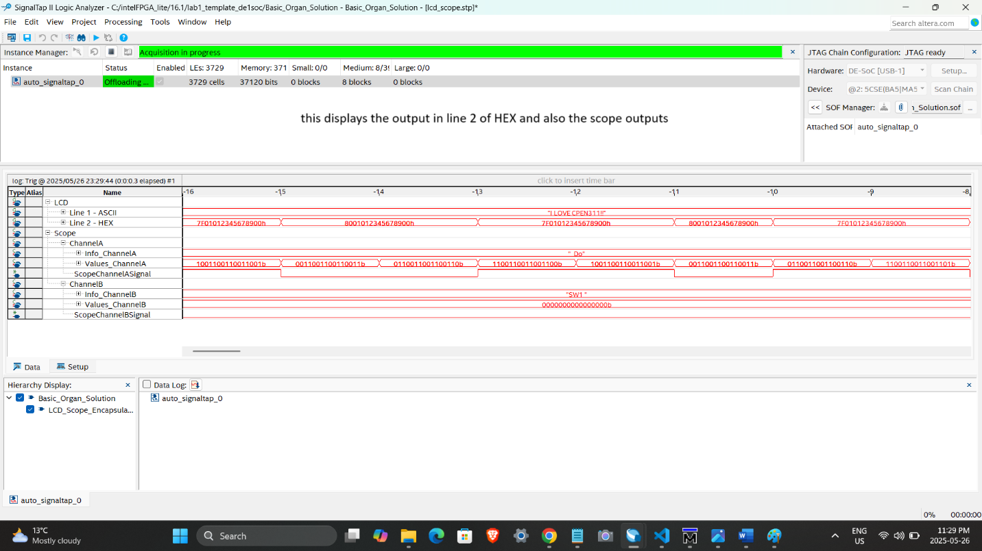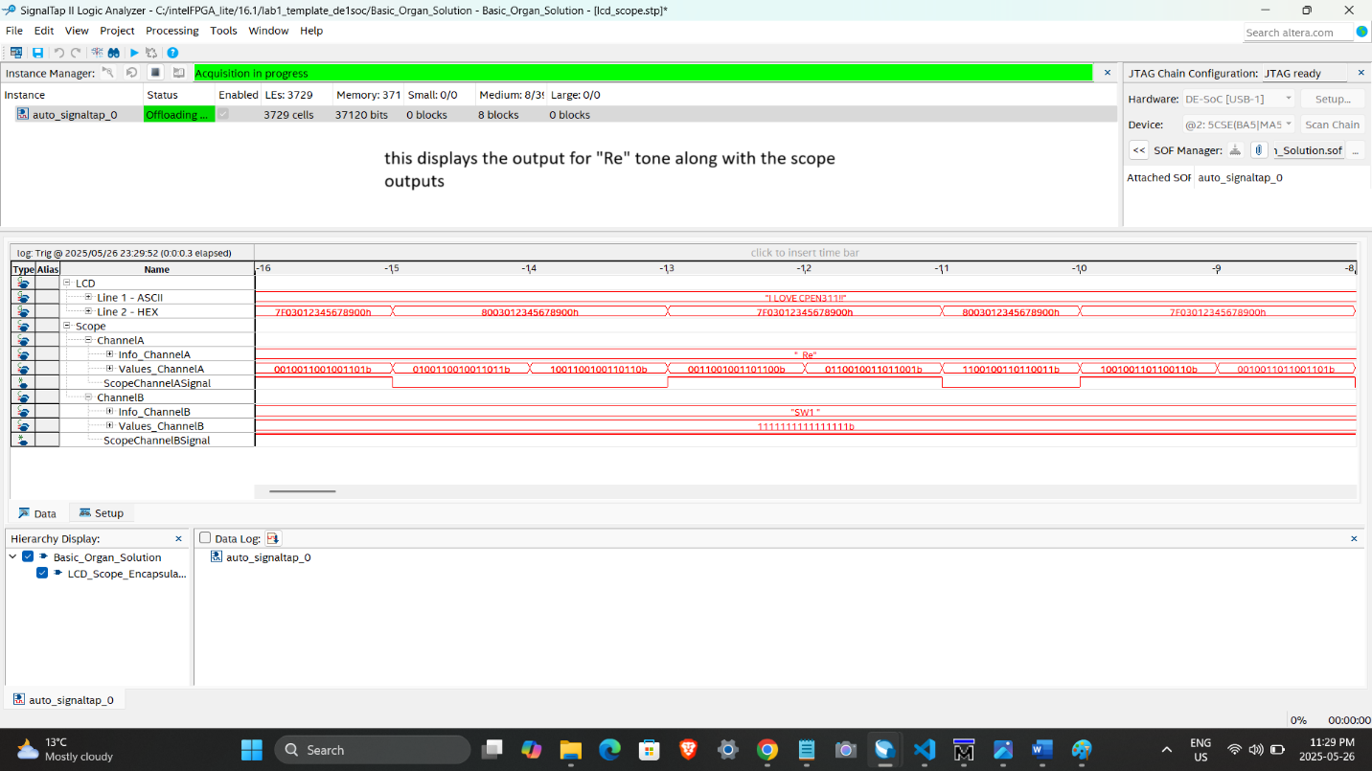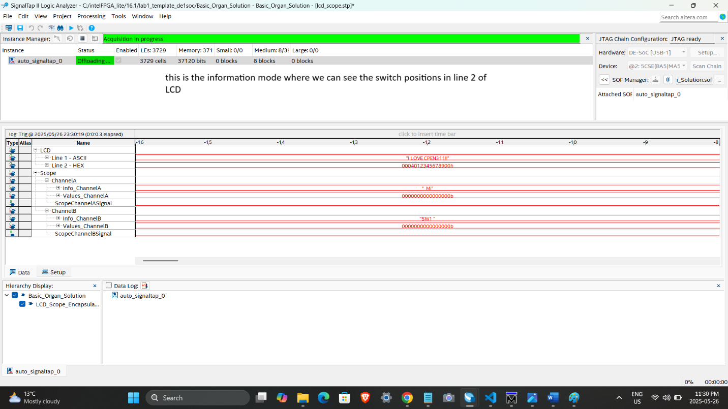

- For Simulations, I just created one simulation for LED_controller module which can be found in this directory:
"C:\Harmanjeet_Singh_43847953_lab_1\sim\LED_Controller_tb.v" and it can be run using modelsim.

