# **Team Name: Coursexchange**

Team Name:

Prem Preeti Patnala - Developer - 1218561448

Hsin-Jung Lee - Developer- 1216278531

Nabeel Khan- Scrum Master - 1215034821

## **Revision History**

+

|  |  |  |  |
| --- | --- | --- | --- |
| Name | Date | Reason for change | Version |
| Team | 3/24/2021 | Initial Draft | 1.0 |
| Team | 3/25/2021 | Updates | 1.1 |
| Team | 3/26/2021 | Updates | 1.2 |

# **Task- 1: As a user, I want to enroll in a course.**

## **Subtasks:**

1. Login.

1. Search course

1. Check if available.

1. Add course.

1. Logout.

### Survey Questions

1. I am

Left Handed

Right Handed

ambidextrous

1. My current age is...

18

19

20

21

22

23

24

25

>25

1. Are you an ASU student?

Yes

No

1. Are you an Undergraduate student?

Yes

No

4. What year are you in college?

* Freshman
* Sophomore
* Junior
* Senior
* Graduate Student

1. Are you a native English speaker?

* No
* Yes

1. Were you able to do this task easily? Yes No
2. How would you rate the layout of the application during this task?

Very good

Average

Very bad

1. How would you rate the reliability of the application during this task?

Very good

Average

Very bad

1. On a scale of 1 to 10, 10 being very good and 1 being very low, how much would you rate the application?
2. Application stimulated student interest.

Strongly Agree

Agree

Neutral

Disagree

Strongly disagree.

1. What aspects of the application were most useful?



1. Is there anything we could do to improve this application?
2. How complicated you thought this process was going to be before using the application?

Very much

Neutral

Not much

1. How complicated do you think it is after using the application?

Very much

Neutral

Not much

1. Would you like to use the application again?

Yes

No

Maybe

1. Would you refer your friend to use the application?

Yes

No

Maybe

1. What is your name? (First Last)
2. What is your ASU email?
3. What is your phone number?
4. Preferred method of contact?

* Email
* Call
* Text

1. May we contact you after a future application improvement?

* No
* Yes

# Task- 2: As a user, I want to withdraw a course.

## **Subtasks:**

## Login

1. Search Course.

1. Check last day for withdraw.

1. Withdraw Course.

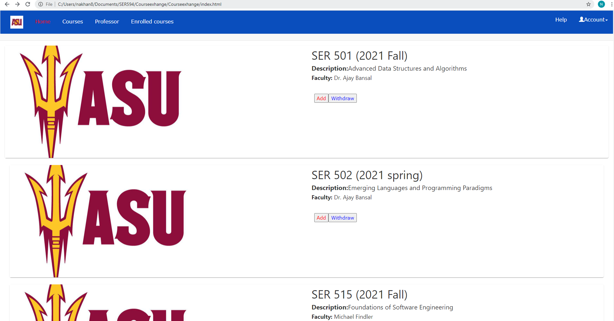

1. Logout.

### Survey Questions

1. I am

Left Handed

Right Handed

ambidextrous

1. My current age is...

18

19

20

21

22

23

24

25

>25

1. Are you an ASU student?

Yes

No

1. Are you an Undergraduate student?

Yes

No

1. What year are you in college?

* Freshman
* Sophomore
* Junior
* Senior
* Graduate Student

1. Are you a native English speaker?

* No
* Yes

1. Are you interested in learning more about the application and spending more time?

Yes

Maybe

No

1. Were you able to withdraw from the course easily?

Yes

No

1. Before withdrawing did you look for any other course to add?

Yes

No

1. How do you rate the efficiency of application during the execution of this task?

Very High

High

Neutral

Low

Very Low

1. What part of the application did you like the most?
2. What part of the application did you dislike the most?
3. Rate the application, 10 being very high and 1 being very low?
4. Reliability
5. Security
6. Availability
7. Readability
8. Uniqueness

14. Rate the ease of use for the application?

Very easy

Easy

Neutral

Hard

Very Hard

15. How quickly were you able to do the tasks and understand the process of the application?

Very quickly

Quickly

As expected.

Slow

Very Slow

16. How would you rate the responsiveness of the application?

Very Good

Good

Average

Bad

Very Bad

17. What is your name? (First Last)

18. What is your ASU email?

19. What is your phone number?

20. Preferred method of contact?

* Email
* Call
* Text

21. May we contact you after a future application improvement?

* No
* Yes

# Task- 3: As a user, I want to swap a course.

**Subtasks:**

1. **Login**

1. **Search course.**

1. **Withdraw course.**

1. **Search course.**

1. **Add course.**

1. **Logout**

### Survey Questions

1. I am

Left Handed

Right Handed

ambidextrous

1. My current age is...

18

19

20

21

22

23

24

25

>25

1. Are you an ASU student?

Yes

No

1. Are you an Undergraduate student?

Yes

No

1. What year are you in college?

* Freshman
* Sophomore
* Junior
* Senior
* Graduate Student

1. Are you a native English speaker?

* No
* Yes

1. After dropping the course, did you find the course to add that you were looking, or do you add a different course?

Yes, I found the course I was looking for.

No, I added a different course.

1. Did you check the syllabus after adding the course?

Yes

No

1. Did you look for the course material after adding the course?

Yes

No

1. Did the time of course impact your decision?

Yes

No

1. Would you prefer, separate swap button on each course to swap where a course is dropped if it is there in a list of added courses or added if not there in a list of added courses?

Yes

No

1. Did the professor of course impact your decision?

Yes

No

1. Did the mode (like Hybrid, Online, In-person) of course impact your decision?

Yes

No

1. What aspects (like layout, trust, ease, depth) of the application are more useful?

Short answer

1. How could we improve the application?

Short answer

1. What is your name? (First Last)
2. What is your ASU email?
3. What is your phone number?
4. Preferred method of contact?

* Email
* Call
* Text

1. May we contact you after a future application improvement?

* No
* Yes