**TRELLO**

<https://trello.com/b/We0wK1tP/geometry-shape-tool>

AGILE DEVELOPMENT

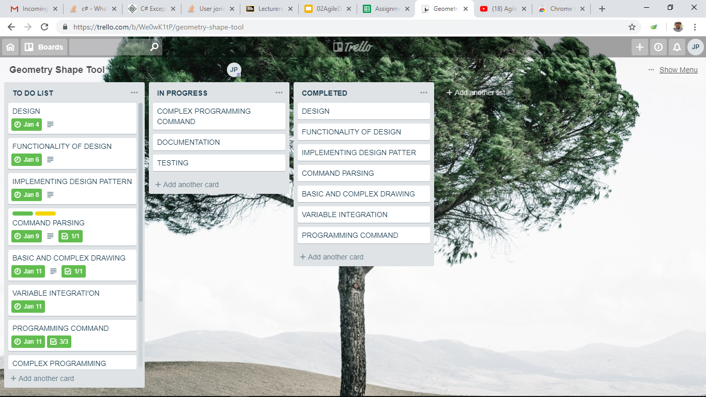

Agile software development is a set of principles for software development in which requirements and solutions evolve through collaboration between self-organizing, cross-functional teams. It promotes adaptive planning, evolutionary development, early delivery, and continuous improvement, and it encourages rapid and flexible response to change.

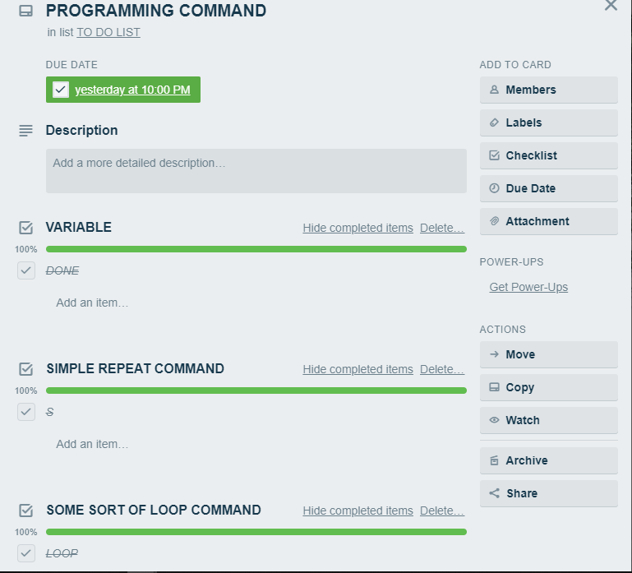

**VERSION CONTROL**

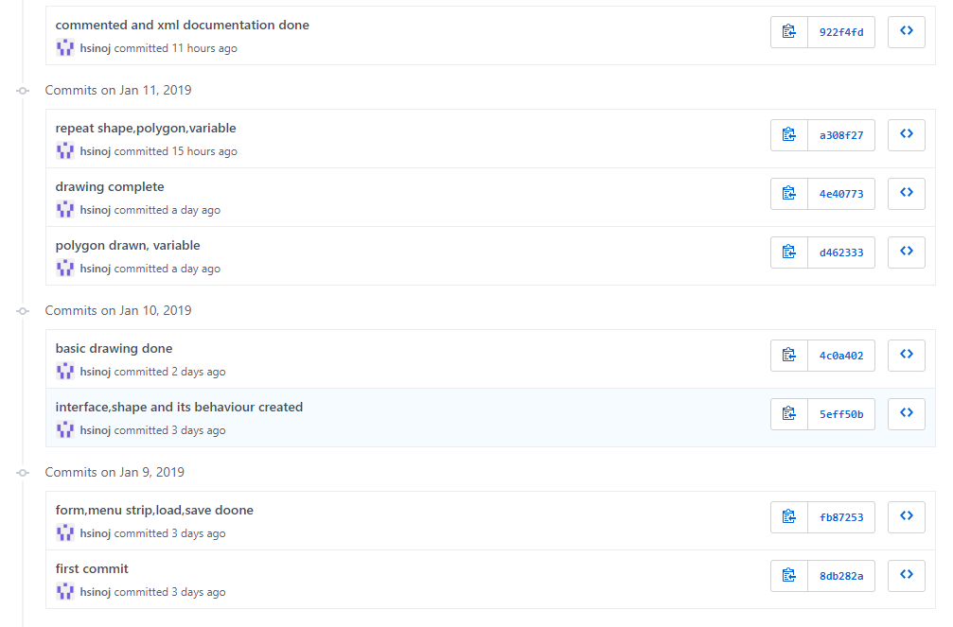

**Version control** is a system that records changes to a file or set of files over time so that you can recall specific versions later. For the examples in this book, you will use software source code as the files being **version** controlled, though in reality you can do this with nearly any type of file on a computer.

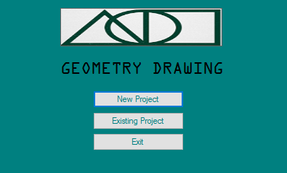

THIS IS PART WHERE APPLICATION IS STARTED. THE MAIN FOM OF APPLICATION WHICH CONTAINS OF NEW PROJECT, EXISTING PROEJECT AND EXIT BUTTON

**UNIT TESTING**

|  |  |  |  |  |
| --- | --- | --- | --- | --- |
| **Steps** | **Test Data** | **Expected result** | **Actual result** | **Pass/fail** |
|  |  |  |  |  |
|  |  |  |  |  |
|  |  |  |  |  |
|  |  |  |  |  |
|  |  |  |  |  |