**Hello guys!**

First of all, thank you! for supporting a humble Artist and please, feel

free to send me any feedback, or stuff that you would like to see, etc, because

I'm loving this, and I want to deliver top notch assets :)

diaz.flores.felipe @gmail.com

**The Notes:**

*A couple of things..*

**1)** Using the Smoke Trail fx.

If you add the prefab as a child to your projectile object, it should not work.

You need to, either, add a ParticleSystem component to your projectile object, then select the “fx-smoketrail” prefab and copy the ParticleSystem component values like this:

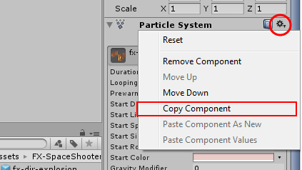

Then, select again your projectile object, open that same menu and click “Paste Component Values”.

OR.

Copy the “fx-smoketrail” prefab, and then add to it all the components you need to transform it into your projectile object (such as: your scripts, SpriteRenderer, etc). That should also work.

**2)** To use the HighLight Item fx.

As easy as just drag and drop the prefab into your item object, this will instantiate the fx as a child, just make sure that that child transform position parameters x,y,z are set to zero. (See the item in the TestScene).

**3)** Recommendation for mobile.

The prefabs are currently set to be used by Instantiating and self-destroying (with the SelfDestruct Script included in the pack), but this might be costly in terms of performance for mobile devices in some cases.

So, if needed, you should consider the following.

Start your game with the effect created somewhere in the scene, deselect the option “Play On Awake” in the ParticleSystem Component on the Inspector, here:

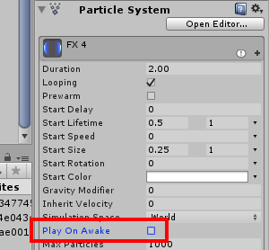

Disable or Remove the SelfDestruct script, then, to execute the fx move that fx-object to the position needed and set it to play (via script).

Check the Scripts in the TestScene, a similar approach is used, in the “_Player.js” script, the function “SecondaryFire()” calls a “glow_red” fx when the missiles are launched, which calls a function in the “M_FX.js” script (which stands for –manager fx-).