電通二乙微處理器實驗 實驗結報

實驗名稱 | Lab07
組別 | 29 | 組員 | 黎心榆

- 實驗目的
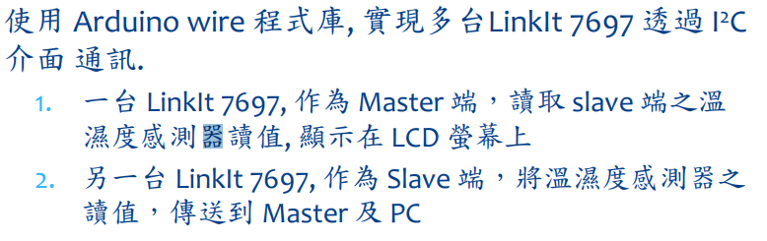
- 實驗步驟
- 程式碼

#include "DHT.h"
#define DHTPIN 2 // what digital pin we're connected to
#define DHTTYPE DHT11 // DHT 22 (AM2302), AM2321
DHT dht(DHTPIN, DHTTYPE);

void setup() {

Serial.begin(9600);
Serial.println("DHTxx test!");
dht.begin();

}

void loop() {
// Wait a few seconds between measurements.
delay(2000);
float h = dht.readHumidity();
float t = dht.readTemperature();
float f = dht.readTemperature(true);
if (isnan(h) || isnan(t) || isnan(f)) {
Serial.println("Failed to read from DHT sensor!");
return;
}

// Compute heat index in Fahrenheit (the default)
float hif = dht.computeHeatIndex(f, h);
// Compute heat index in Celsius (isFahreheit = false)
float hic = dht.computeHeatIndex(t, h, false);

Serial.print("Humidity: ");
Serial.print(h);
Serial.print(" %\t");
Serial.print("Temperature: ");
Serial.print(t);
Serial.print(" *C ");
Serial.print(f);
Serial.print(" *F\t");
Serial.print("Heat index: ");
Serial.print(hic);
Serial.print(" *C ");
Serial.print(hif);
Serial.println(" *F");
}
- 實驗結果及分析
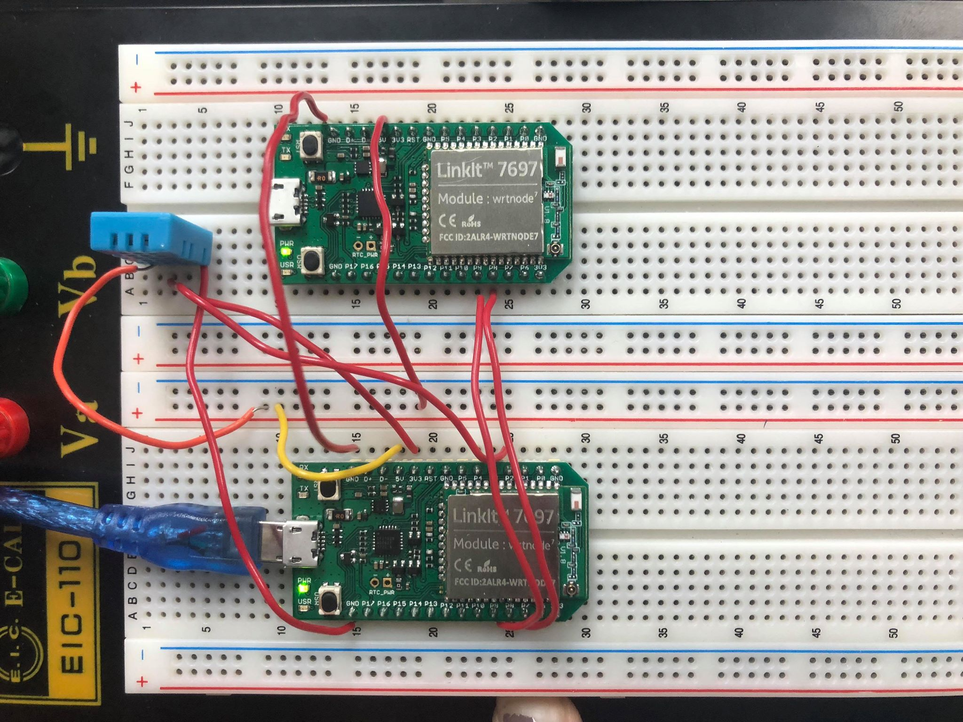
- 心得討論
這次的實驗很特別也很好玩，尤其看到別人在那邊吹就覺得很好笑
- 修正電路圖
- 修正程式碼

