電通二乙微處理器實驗 實驗結報

實驗名稱 | Lab04-四合一七段顯示器
組別 | 29 | 組員 | 黎心榆

- 實驗目的

- 實驗步驟
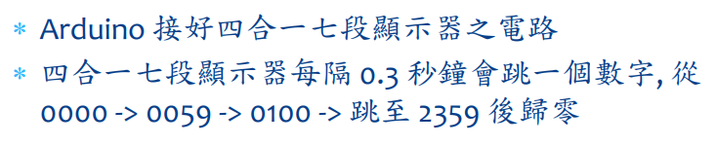
- 程式碼
#include "SevSeg.h"
SevSeg sevseg; //Instantiate a seven segment controller object
byte Hour=0;
byte Min=0;
void setup()
{
byte numDigits = 4;
byte digitPins[] = {2, 3, 4, 5};
byte segmentPins[] = { 8, 9, 10, 11, 12, 13,14};
bool resistorsOnSegments = false; // 'false' means resistors are on digit pins byte hardwareConfig = COMMON_CATHODE; // See README.md for options
bool updateWithDelays = false; // Default. Recommended
bool leadingZeros = false; // Use 'true' if you'd like to keep the leading zeros sevseg.begin(hardwareConfig, numDigits, digitPins, segmentPins, resistorsOnSegments, updateWithDelays, leadingZeros);
sevseg.setBrightness(90);
}

void loop()
{
static unsigned long timer = millis();
// static int deciSeconds = 0;

if (millis() - timer >= 100)
{
timer += 100;
sevseg.setNumber(Hour * 100 + Min, 3);
Min = Min + 1;
if (Min == 60)
{
Min = 0; if (Hour == 23) Hour=0;
else Hour++;

}
}
sevseg.refreshDisplay(); // Must run repeatedly
}

- 實驗結果及分析
數字都有按照設定的跑，從00跑到2359
- 心得討論
這次的實驗真的有夠難的，完全霧煞煞，希望期中考可以順利一點
- 修正電路圖
- 修正程式碼

