**Week 6**

**NAME:HASHIR KHAN**

**ID: TN/IN01/PY/007**

**DOMAIN:PYTHON**

**TASK 1**

**Step 1: Understand the Formula**

**The area of a circle is calculated using the formula:**

**Area=π×r2\text{Area} = \pi \times r^2Area=π×r2**

**Step 2: Import the math module**

**Python provides the value of π as math.pi in the math module.**

**So first, we need to import this module:**

**python**



**This gives us access to math.pi.**

**Step 3: Define the Function**

**In Python, we define a function using the def keyword.**

**We’ll define a function called calculate_area that takes one parameter: radius.**

**python**



**Step 4: Do the Calculation**

**Inside the function, calculate the area using the formula:**

**python**



**Output**



**Taskk 3**

**Step 1: Define the Function**

**We use the def keyword to define a function:**



**Step 2: Create a New List for Squares**

**We can use a list comprehension to square each number in the list:**

**Explanation:**

* **num ** 2 → square of each number.**
* **The loop goes through every number in the input list.**



**Step 3: Return the Result**

**Return the new list:**

**python**



**Output**



**Task 4**

**Step 1: Define the Function**

**We define the function using def and name it is_even_or_odd.**



**Step 2: Use Modulus Operator (%)**

**To check if a number is even:**

* **An even number has no remainder when divided by 2 → number % 2 == 0.**
* **Otherwise, it is odd.**

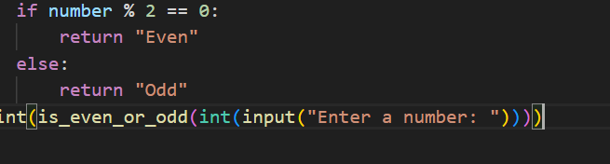

**Ouput**



**Task 5**

**Step 1: Understand Global Variables**

* **A global variable is created outside any function.**
* **It can be used anywhere in the program.**
* **But if you want to change it inside a function, you must use the global keyword.**

**Step 2: Declare the Global Variable**

**This creates a variable named counter and sets its value to 0.**



**Step 3: Define the Function**

**Now create a function named change_counter():**

**This function will change the value of the global variable counter.**



**Step 4: Use global Keyword**

**To modify the global variable inside the function, tell Python you're using the global version:**



**tep 5: Modify the Counter**

**Now change the counter (e.g., increase it by 1):**



**Ouput**



**Task 6**

**Step 1: Understand What a Module Is**

**A module is just a .py file that contains functions or variables you want to reuse.**

**💡 For example:  
Python already has built-in modules like math, random, etc.**

**In this task, you’ll make your own module.**

**Step 2: Create a File Named Task6.py**

**Step 3: Write the Multiply Function in the Module**

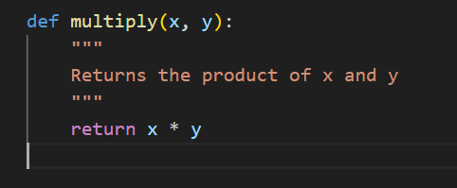

**Step 4: Create Another File Named .moduleimport.py**

**Step 5: Import the Module**



**Step 6: Use the Function from the Module**

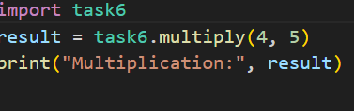

**Ouput**

