**Week 6**

**NAME:HASHIR KHAN**

**ID: TN/IN01/PY/007**

**DOMAIN:PYTHON**

Task 1

Step 1: Import Libraries



math is used for mathematical operations like square roots.

statistics helps with calculations like mean (average), median, etc.

Step 2: List of Numbers



These are the numbers we’ll use for both square root and average calculations.

**Step 3: Square Roots with math.sqrt()**

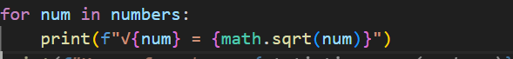• Loops through the list.

• Uses math.sqrt(num) to calculate the square root of each number.

Step 4: Average with statistics.mean()

Uses statistics.mean() to calculate the **mean (average)** of all numbers in the list

Ouput

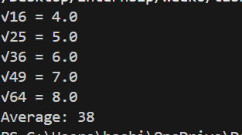

Task 2

Step 1: Create a Custom Package File

📝 **File name:** task2.py

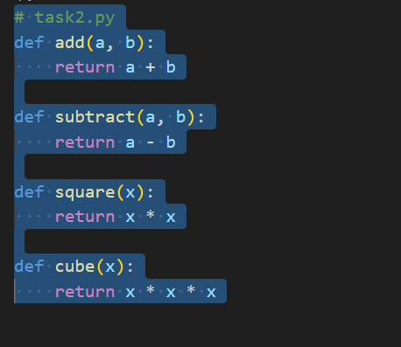`

**Step 2: Create Another Script to Use This Package**

📝 **File name:** tasktwomodule.py (this is your main program)

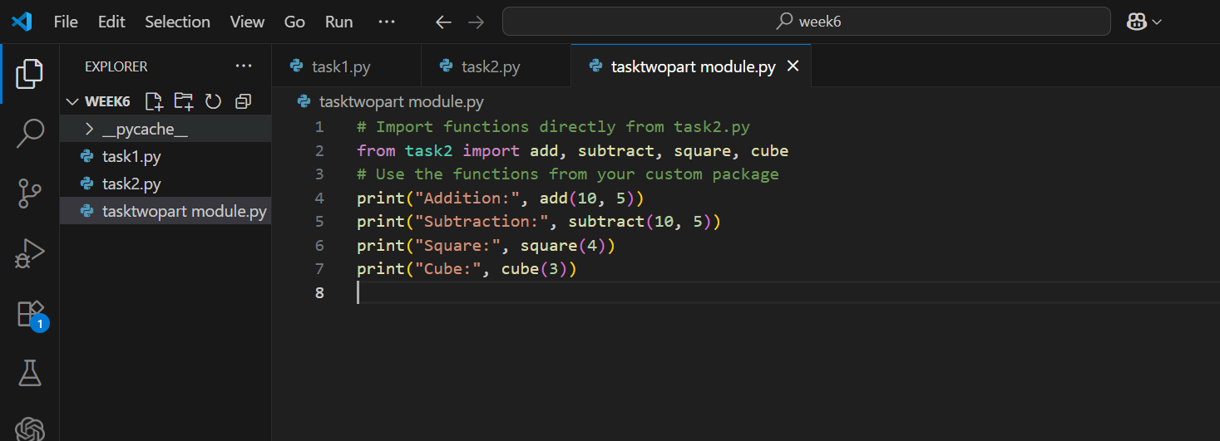

ouput

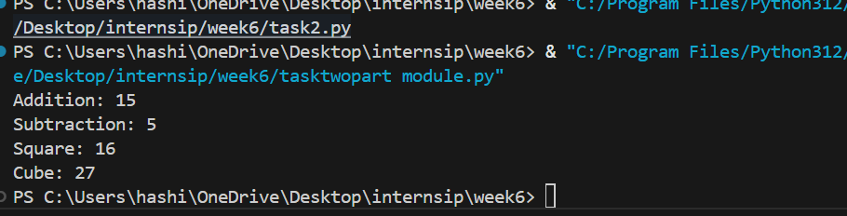

Task 3

Step 1: Create a Virtual Environment



This creates a folder called myenv which contains your isolated Python environment.

**Step 2: Activate the Virtual Environment**

**🔹 On Windows:**



**Step 3: Install requests and numpy**

Once the virtual environment is activated, run:

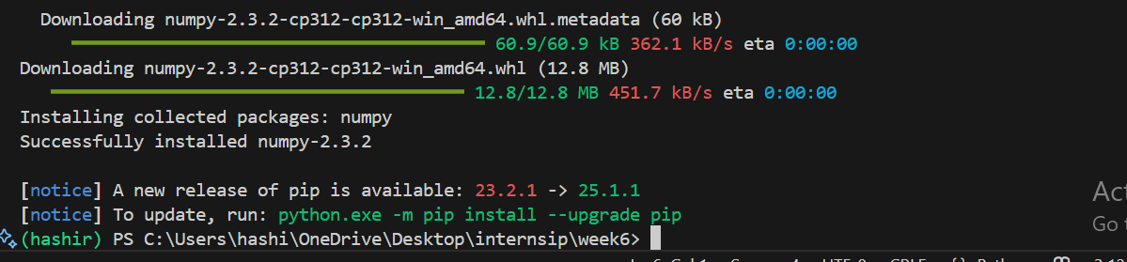

Step 4: Create a Python Script to Print Versions

📝 **Create a file called check_versions.py** and add this code:

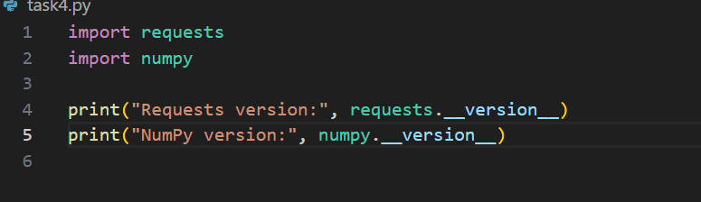

Output

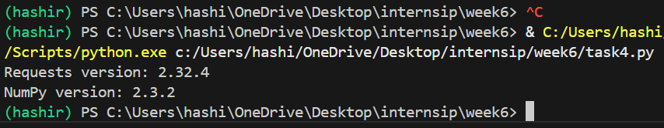

Task 4

Step we will write syntax pip list

Output

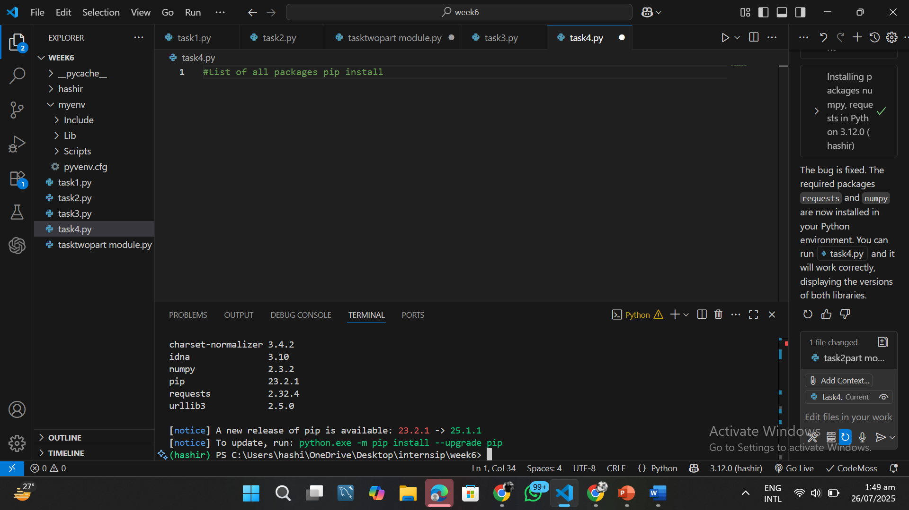

Task 5

Step 1: Define the Function

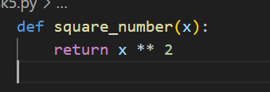

This function takes a number x and returns x squared.

Step 2: Gradio Interface



• fn: the function to call

• inputs: the type of input (here gr.Number)

• outputs: the type of output (also gr.Number)

• You can also add:

* title: Shown at the top of the app
* description: Brief instruction

**Step 3: Launch It**



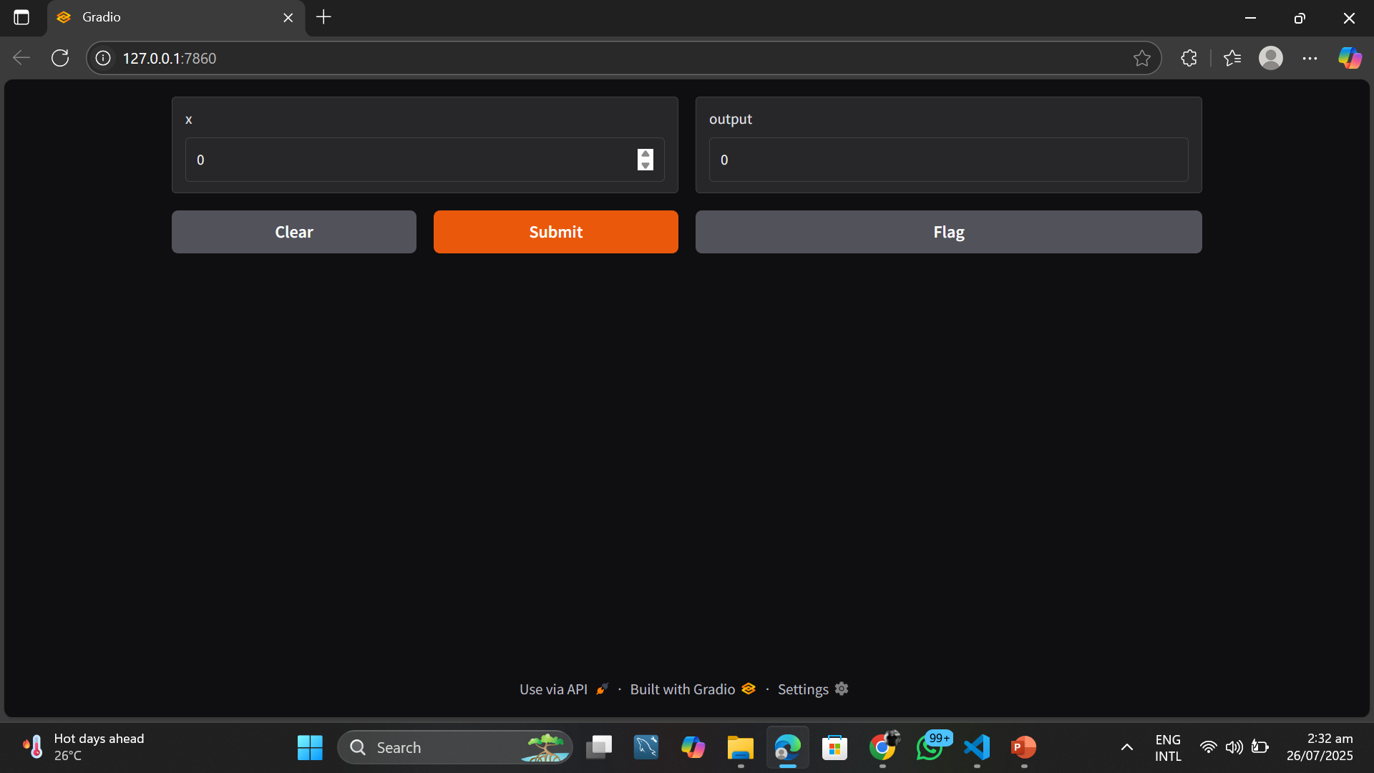

**Task 6**

**Step 1: Import Gradio**



* **This line imports the Gradio library.**
* **Gradio helps us create simple interfaces (UIs) for machine learning functions or basic Python apps without using HTML or CSS.**

**Step 2: Define the Function**

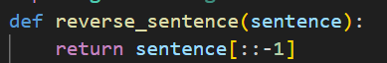

**• You create a Python function named reverse_sentence.**

**• sentence[::-1] is Python slicing:**

* **It means: start from the end (-1 step), move backwards.**
* **It reverses the string.**

**Step 3: Create the Interface**

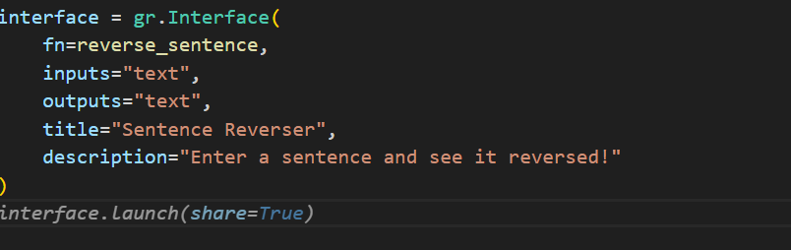

**This line tells Gradio:**

* **fn=reverse_sentence: Use the function you defined.**
* **inputs="text": Input box accepts text.**
* **outputs="text": Output box shows text.**
* **title: Sets a visible title at the top of the app.**
* **description: Adds a short instruction under the title.**

**Now Gradio knows what to do: when someone types a sentence, apply your function and return the result.**

**Step 4: Launch the App**



