DocChat – Technical Design Document (TDD)

1. Purpose
This Technical Design Document (TDD) describes the architecture, design decisions, and implementation details of DocChat, a document-centric conversational system based on Retrieval-Augmented Generation (RAG).

2. System Overview
DocChat allows users to upload PDF documents, process and embed their contents, and interact with them via a chat interface. All responses are grounded strictly in document content and include source citations.

3. Architecture Overview
- Frontend: React
- Backend: FastAPI
- Database: PostgreSQL with pgvector
- AI Services: OpenAI Chat & Embeddings
- Deployment: Docker & Docker Compose

4. Document Processing Pipeline
Steps:
- PDF upload
- Text extraction
- Chunking
- Embedding generation
- Vector storage

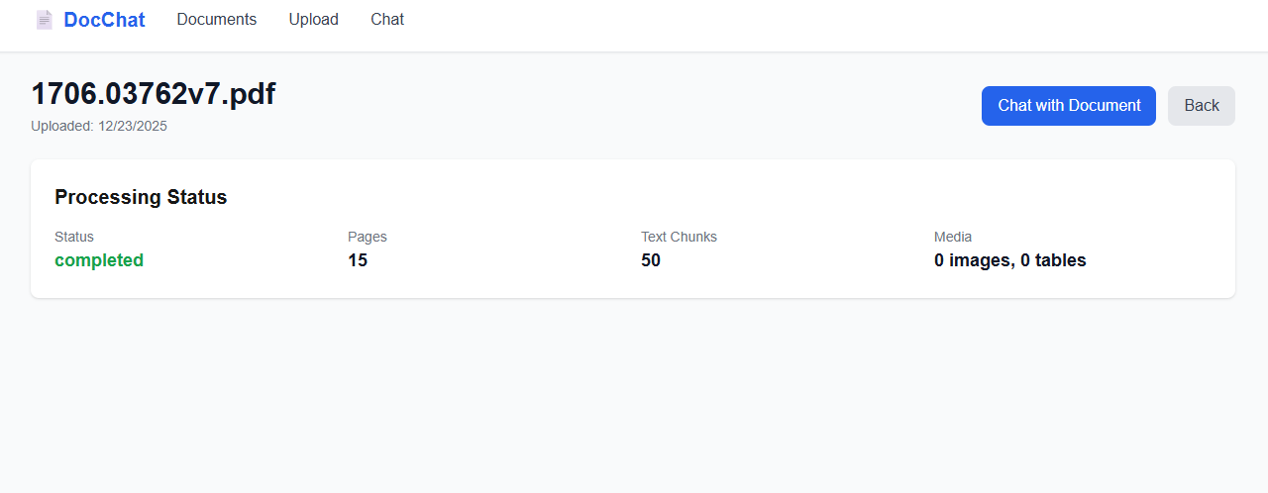

Observed Example:
Status: completed
Pages: 15
Text Chunks: 50
Images/Tables: 0

5. Chat with Document (RAG)
Process:
- User submits a question
- Vector similarity search retrieves top-k chunks
- LLM generates a grounded response
- UI displays answer with sources

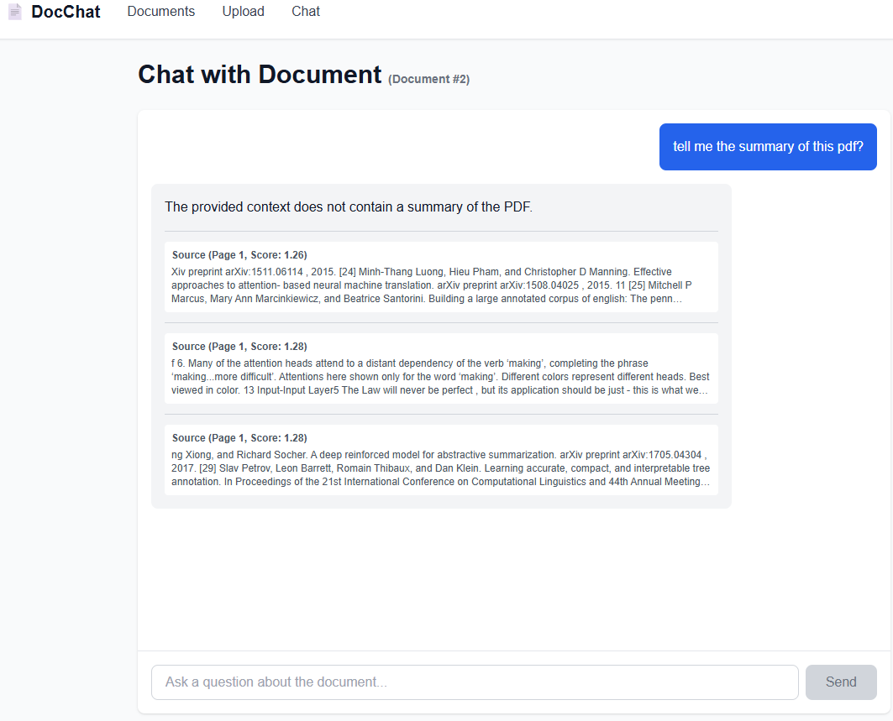

6. Document Management
Users can view uploaded documents and their processing metadata.

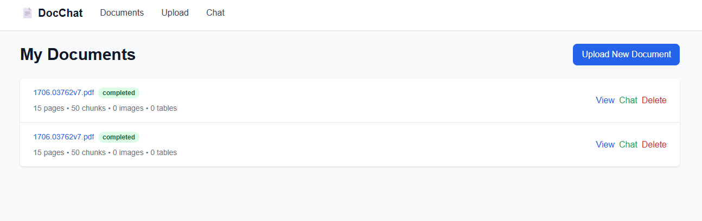

7. Sequence Diagram
User → UI → API → VectorStore → OpenAI → UI

8. Design Decisions
- Text-only first for stability
- Strict prompt grounding to prevent hallucinations
- Async OpenAI client usage
- pgvector distance casting

9. Reviewer Notes (Production Readiness)
- End-to-end working RAG pipeline
- Hallucination-safe responses
- Modular, extensible design
- Dockerized deployment

10. Conclusion
DocChat demonstrates a production-grade document chat system suitable for enterprise and technical use cases.

