Screen Capture Utility – Architecture
Oct 6, 2026 · @Madhusudan Siddalingachar
The utility ships as two editions built on one design: a Windows desktop app (Python + Tkinter, one 5,832-line main.py, packaged as a single .exe) and a no-install browser edition (one 2,969-line HTML file for Edge or Chrome). In both, every capture flows through the same path: capture → Review window (annotate, blur, crop) → output router → PNG file or a Word, Excel or PowerPoint document, kept in capture-time order.

At a glance
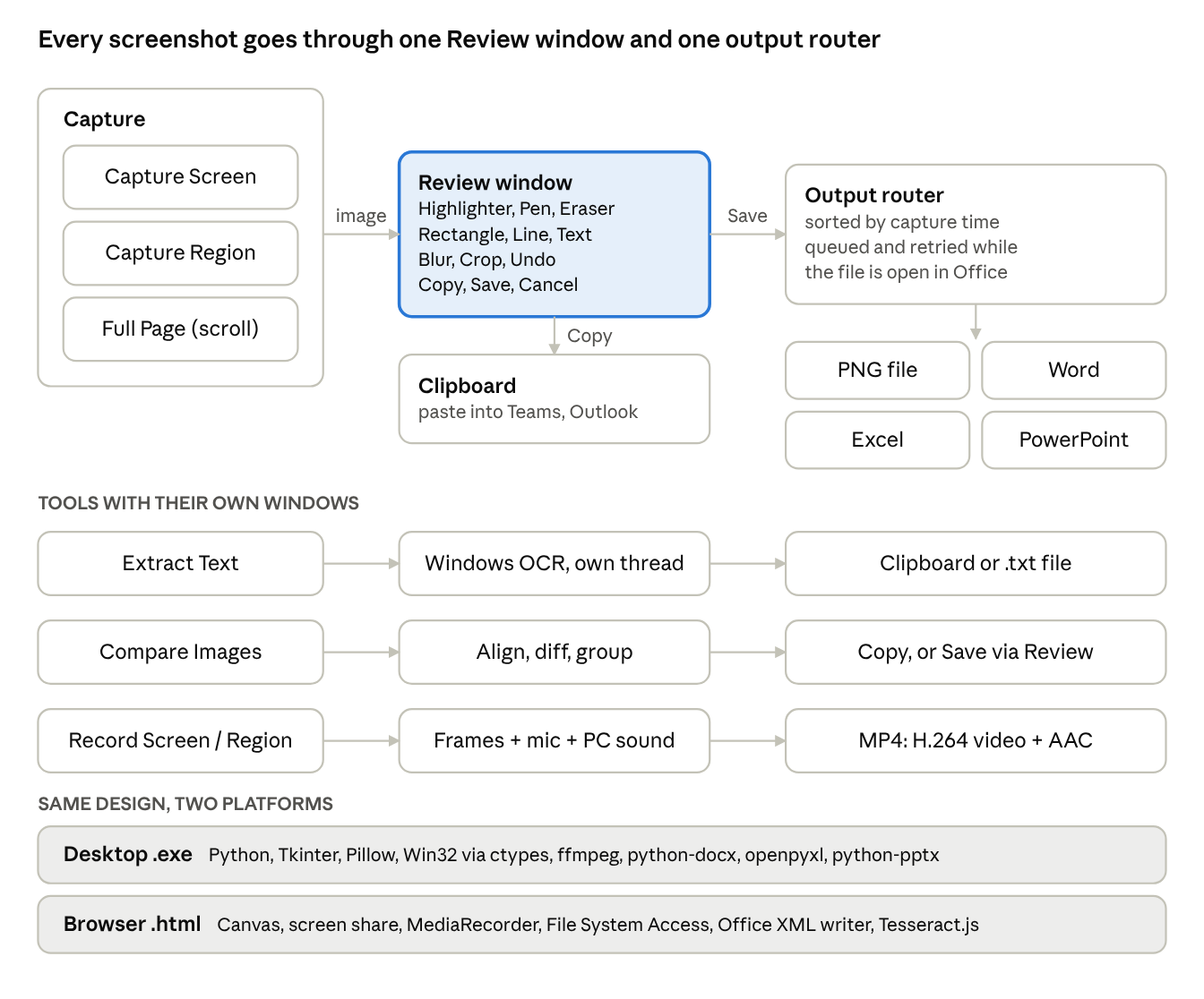
architecture overview · capture path, three tools, two platforms
Screenshots from any capture mode share one Review window and one output router; Extract Text, Compare Images and recording run in their own windows, and both editions implement the same design on their own platform.

Desktop app components
The desktop app is a single Python module organised into self-contained sections. A Tk main window drives everything, and long work (recording, OCR, comparing, saving video) runs on background threads so the window never freezes.
Component | Main code in main.py | Responsibility
Startup and environment | ensure_package, optional_import, DPI awareness | Installs missing packages on first run (not inside the .exe), enables per-monitor DPI so captures are pixel-exact, hides ffmpeg console windows
Save location | set_save_folder, ensure_save_folder, filename helpers | Required folder (red asterisk); timestamped, never-overwritten names for screenshots, recordings and text
Capture | capture_screen, start_region_selection, ScrollingCapture | Full screen, dragged region (shared overlay), and Full Page scrolling capture with stitching
Review window | AnnotateEditor | Opens after every capture: Highlighter, Pen, Eraser, Rectangle, Line, Text, Blur, Crop; Copy / Save / Cancel; resizable, min/max
Output router | handle_capture, flush_pending, append_captures | Sends the result to a .png or to the selected document; queues captures while the file is open in Office and retries every 3 s
Office writers | append_captures_to_docx / _xlsx / _pptx | Word via python-docx, Excel via openpyxl, PowerPoint via python-pptx; atomic save (temp file, then swap)
Text extraction | run_windows_ocr, OcrWindow | Windows' built-in OCR on a dedicated worker thread; editable result, language choice, copy, save .txt
Compare Images | compare_images, find_alignment, find_regions, CompareWindow | Pixel-level comparison with auto-align; numbered red boxes, differences list, zoom, Blink view
Screen recorder | ScreenRecorder, AudioCapture, AudioTrack, FfmpegVideoSink | Screen frames on a fixed clock into ffmpeg (H.264); microphone + computer sound mixed into AAC; pause/resume
Compact modes | enter_compact_mode, rec_bar, scroll_bar | Main window shrinks to a small Pause/Stop or Stop & Save bar, hidden from the recording itself
UI kit | FlatButton, Tile, Toggle, Card, icon() | Styled widgets, theme colours and fonts, Pillow-drawn icons scaled for Windows display scaling
Clipboard | copy_image_to_clipboard | Puts images on the Windows clipboard as bitmap and PNG via the Win32 API

Capture-to-save pipeline
Every screenshot, whatever the capture mode, follows the same five steps, so new features plug into one place.
- Capture. The main window hides itself, then Pillow's ImageGrab grabs the full screen, a dragged region, or a sequence of scrolled screens that are stitched into one tall image.
- Review. deliver_capture opens the image in the Review window. Edits are stored as an ordered list of operations, so Undo simply replays the list without the last one.
- Decide. Copy puts the result on the clipboard and keeps the window open. Cancel discards it. Save passes the final image on.
- Route. handle_capture checks whether a Word, Excel or PowerPoint file is selected. If not, the image is written as a timestamped .png; if so, it joins the pending queue (optionally also saved as .png).
- Write. flush_pending sorts the queue by capture time and appends it to the document. If Office has the file open (locked), the captures stay queued and are retried every 3 seconds; on exit the user can retry or save them as .png files instead.

Key algorithms
The hard parts are solved with plain Pillow and the standard library, so the app stays small and the .exe needs no NumPy or OpenCV.
Feature | How it works
Full Page capture | Scrolls the window under the selection with WM_MOUSEWHEEL messages (the mouse pointer stays free), grabs a screen after each step, and finds how far it moved by matching row signatures (a cheap greyscale fingerprint per row). Fixed headers and footers are detected and kept once; small animations are tolerated. Esc or Stop & Save keeps what was captured so far.
Recording with sound | One shared clock drives everything. Screen frames are grabbed at a fixed rate and each is placed at round(capture_time × fps) in an ffmpeg pipe (H.264). Microphone and computer sound (WASAPI loopback via PyAudioWPatch) are recorded as separate tracks aligned to the same clock; drift over 80 ms is corrected by inserting silence or dropping samples. ffmpeg mixes both into AAC and muxes the MP4. Measured sync: 8–16 ms.
Review window layers | The screenshot is the base (Blur changes it directly). Highlighter strokes go on a layer that is multiplied onto the base, so text stays dark like a real marker. Pen strokes sit on an ink layer; rectangles, lines and text notes on a shape layer. The Eraser clears only the highlight and ink layers. Crop is a view window over all layers, so Undo brings the full image back.
Compare Images | Image 1 is resized if it is a zoomed copy of Image 2. Auto-align searches small shifts coarse-to-fine (about 400 px, then 1,600 px, then full resolution on the four most detailed tiles). A pixel counts as changed only if it matches nothing in the other image's 3×3 neighbourhood by more than the tolerance, which ignores anti-aliasing and sub-pixel shifts. Changed pixels are grouped on a coarse grid, joined if close, and classed as Changed, Only in Image 1 or Only in Image 2.
Text extraction | Windows.Media.Ocr through PyWinRT on one worker thread (keeps COM away from Tk's file dialogs). Small selections are enlarged first for accuracy; paragraph breaks are rebuilt from line positions.
Office output | Word: images appended to the body, 3 blank paragraphs apart, tall images split into page-height slices. Excel: images anchored down a "Screenshots" sheet in column A, next free row worked out from existing cells and pictures, 3 rows apart. PowerPoint: a new slide per image on the "Blank" layout, centred and never enlarged; very tall images split over slides. Every write goes to a temp file first, then replaces the original.

Browser edition
The browser edition exists for PCs where running an .exe is blocked. It is one self-contained HTML file (markup, styles and JavaScript inline, about 217 KB) that mirrors the desktop design piece by piece, using browser APIs instead of Windows ones.
Desktop piece | Browser equivalent
ImageGrab screen capture | getDisplayMedia screen share (kept open between shots), frame grabbed with ImageCapture or a hidden <video>
Region overlay | A full-page canvas showing the grabbed frame; the user drags the area there
Full Page capture | Not possible (a web page cannot scroll other windows); the page points to Edge/Chrome's own full-page screenshot plus Annotate an image...
Review window (Pillow layers) | Canvas layers: highlight drawn with multiply, Eraser with destination-out; same tools except Blur, which is still the separate switch and Blur window (moving it into Review is pending)
Save folder and documents | File System Access API (showDirectoryPicker, showSaveFilePicker); handles remembered in IndexedDB; falls back to downloads in other browsers
python-docx / openpyxl / python-pptx | A built-in ZIP reader/writer (CompressionStream) that edits the Office XML directly; new Excel and PowerPoint files start from embedded blank templates made with openpyxl and python-pptx
Windows OCR | Tesseract.js, loaded from jsDelivr on first use (needs internet once)
ffmpeg + PyAudioWPatch recording | MediaRecorder (.webm or .mp4 by browser); microphone and shared-tab/system sound mixed in an AudioContext; region cropping with MediaStreamTrackProcessor/Generator; floating controls via Document Picture-in-Picture
Compare Images (Pillow) | The same algorithm ported to typed arrays over canvas ImageData; it returns identical regions on the same test images
Settings | localStorage (delay, toggles, OCR language)

Dependencies
Only Pillow is essential; every other package switches on one feature, and the app disables that feature cleanly (with a console hint) when it is missing.
Package | Used for | If missing
Python 3 + Tkinter | The app and its windows | Required
pillow | Capturing, editing, blur, icons, stitching, comparing | Required
python-docx | Word output | Word option disabled
openpyxl | Excel output | Excel option disabled
python-pptx | PowerPoint output | PowerPoint option disabled
imageio-ffmpeg | Bundled ffmpeg: H.264 video and audio mixing | Recording disabled (falls back to OpenCV only if already installed)
PyAudioWPatch | Microphone and computer sound (WASAPI loopback) | Recordings have no sound
winrt-* (7 packages) | Windows' built-in OCR for Extract Text | Extract Text disabled
pyinstaller | Building the .exe | Only needed by build.bat
Windows APIs are reached directly through ctypes: DPI awareness, window exclusion from recordings (SetWindowDisplayAffinity), monitor work areas, scrolling messages, Esc key polling and the clipboard.

Packaging and project files
The app runs three ways: from source (python main.py, which installs missing packages itself), as a single portable ScreenCaptureUtility.exe, or as the HTML file in a browser.
build.bat activates the project's virtual environment, installs the build requirements, and runs PyInstaller in one-file, windowed mode. Packages that main.py imports dynamically are named explicitly so PyInstaller bundles them (--hidden-import for docx, openpyxl, pptx, imageio_ffmpeg, pyaudiowpatch; --collect-all for ffmpeg, PyAudioWPatch and winrt; --collect-data for the docx and pptx templates). NumPy and OpenCV are excluded to keep the .exe small.
E:\ScreenCaptureUtility\
├─ main.py desktop app (5,832 lines)
├─ requirements.txt Python packages
├─ build.bat builds dist\ScreenCaptureUtility.exe
├─ icon.ico app icon
├─ ScreenCaptureUtility.html browser edition (2,969 lines)
├─ USER_MANUAL.md user manual (13 sections)
└─ docs\images\ manual screenshots

Testing and known limits
Each feature was tested in an automated harness before delivery; Windows-only behaviour was simulated and still needs a check on a real PC.
- Desktop app: run headless on Linux under a virtual display (Xvfb), with stand-ins for Windows-only parts: a fake audio device, a fake WinRT OCR module and a fake clipboard. Scripts drive the real windows with synthetic mouse and key events and check pixels, saved files and status messages.
- Office files: results are reopened with python-docx, openpyxl and python-pptx and rendered with LibreOffice to confirm layout and order.
- Browser edition: driven in headless Chromium (Playwright) with a fake screen share, fake microphone and mocked file pickers that write to the browser's private file system.
- Regression: earlier suites (Review window, Eraser, Line, Crop, Text, Compare, Office) are re-run after every change.
Not yet verified on real hardware: scrolling of real apps in Full Page, real audio devices, the Windows clipboard, Windows OCR, and Excel or PowerPoint opening the generated files. Known limits: Full Page needs content that scrolls with the mouse wheel; Compare marks everything below an inserted line as changed; the browser edition has no Full Page capture and its OCR needs internet the first time.

what's the Front end and Back end being used here?
This app has no server or cloud back end. Everything runs on your own computer, and no data leaves it. "Front end" and "back end" here just mean the screens versus the work done behind them, both running locally in one program.
Desktop edition (main.py, built into the .exe)
- Front end: Tkinter, Python's built-in toolkit for desktop windows. Everything on screen is built with it: the main window, the Review, Compare and Extracted Text windows, and the recording bar. The custom buttons, tiles and switches are styled Tkinter widgets, and the icons are drawn with Pillow.
- Back end: plain Python running on the same computer.
  - Pillow: capturing the screen, stitching full pages, blur and annotation, and comparing images.
  - ffmpeg and PyAudioWPatch: recording MP4 video with microphone and computer sound.
  - python-docx, openpyxl and python-pptx: writing Word, Excel and PowerPoint files.
  - Windows' built-in OCR (through PyWinRT): extracting text.
  - Direct Windows API calls (through ctypes): the clipboard, scrolling for full-page capture, display scaling, and keeping the control bar out of recordings.
Browser edition (ScreenCaptureUtility.html)
- Front end: HTML, CSS and plain JavaScript in one file, with no framework such as React. The Review and Compare windows draw on HTML canvas.
- Back end: none. The same JavaScript does the work inside Edge or Chrome:
  - Capture: the browser's screen-sharing feature.
  - Recording: MediaRecorder, with sound mixed in an AudioContext.
  - Saving files: the File System Access API, with downloads as the fallback.
  - Word, Excel and PowerPoint: its own built-in file writer.
  - Text extraction: Tesseract.js, downloaded once from the internet the first time you use it.
 | Front end | Back end
Desktop .exe | Tkinter (Python) | Python on your PC: Pillow, ffmpeg, Office libraries, Windows OCR and Windows APIs
Browser .html | HTML, CSS and JavaScript (canvas) | No server; JavaScript in the browser does it all
Having no server makes it simple to deploy, works offline, and keeps sensitive screenshots on your machine. The trade-off is that there's no central storage or sharing; files go wherever you choose to save them.

How to run this app on any system? what are the prerequisites needed to run this app?
How to run it on other machines depends on which edition you use.
Option 1: The .exe (simplest for Windows users)
What to do: build once on your PC with .\build.bat, then copy dist\ScreenCaptureUtility.exe to the other computer and double-click it. It's a single file with nothing to install, and Python isn't needed on the other machine.
What the other PC needs:
- Windows 10 or 11, 64-bit. If you build with 32-bit Python, the .exe will be 32-bit instead. A 64-bit Python build won't run on 32-bit Windows.
- Windows 10 version 2004 (May 2020 update) or later to keep the recording control bar out of videos. On older versions it may show up in the recording.
- Microsoft Office only to open the files. The app creates Word, Excel and PowerPoint files without Office installed.
- Extract Text uses Windows' own OCR. It reads the languages installed in Windows, which always includes your display language. For others, add the language under Settings → Time & language → Language.
- A microphone or speakers only if you want sound in recordings.
Things that can get in the way:
- Security warnings: the .exe isn't code-signed, so Windows SmartScreen may show "Windows protected your PC" (click More info → Run anyway), and some antivirus tools flag PyInstaller apps. To avoid both, your IT team can sign the .exe or whitelist it.
- Company policy: many organisations block unknown .exe files, as happened to you. In that case use Option 3.
Option 2: Run from source (for developers)
Prerequisites:
- Python 3.10 or newer, 64-bit, from python.org. The standard installer includes Tkinter. Tick "Add Python to PATH" during setup.
- Internet access to PyPI the first time, to install packages. Without it, copy the packages over as wheel files.
Steps:
- Copy main.py, requirements.txt and icon.ico to a folder.
- Open a terminal in that folder and run:
python -m venv venv
venv\Scripts\activate
pip install -r requirements.txt
python main.py
main.py also installs any missing package by itself on first run, but requirements.txt installs them all in one go.
3. To make your own .exe on that machine, run .\build.bat.
Option 3: The browser edition (no install, works almost anywhere)
What to do: copy ScreenCaptureUtility.html and double-click it.
What the other computer needs:
- Microsoft Edge or Google Chrome, a recent version. This is where everything works, including saving into a chosen folder and into Word, Excel and PowerPoint files.
- Floating recording controls need Edge or Chrome 116 or newer.
- Any operating system that runs those browsers: Windows, Mac, Linux or ChromeOS. This is the only edition that runs outside Windows.
- Internet access to cdn.jsdelivr.net the first time you use Extract Text, to download the OCR engine. Everything else works offline. If your network blocks that site, Extract Text won't work there.
- On a Mac, allow the browser under System Settings → Privacy & Security → Screen Recording.
Limits in other browsers (Firefox, Safari): files go to your Downloads folder instead of a chosen folder, and some features may be missing.
Quick comparison
 | .exe | From source | Browser .html
Install needed | None | Python + packages | None
Operating system | Windows 10/11 only | Windows 10/11 only | Any OS with Edge or Chrome
Full Page capture | Yes | Yes | No (use the browser's own full-page tool)
Works when .exe files are blocked | No | Usually yes, if Python is allowed | Yes
Internet needed | No | First install only | First use of Extract Text only
The desktop edition is Windows-only because it uses Windows features directly: the clipboard, Windows OCR and Windows' sound recording. On Mac or Linux, use the browser edition.
I can add a short "Installation & requirements" section like this to the user manual, or to the architecture doc, if you'd like it on record.

