DESIGN DOCUMENT
Evolutionary Learning System for Inorganic Industrial Chemistry
From elemental attributes and known inorganic compounds to evolving, revisable chemical knowledge
Item | Detail
Author | Conceived and directed by Himanshu Mazumdar, R&D Centre, Dharmsinh Desai University, Nadiad, Gujarat, India
Code | Code developed with AI assistance (public repository below)
Document | DesignEvolutionaryChemistryV04
Version | 04 — V03 content retained and updated with the V04 research experiments (Expt-01 to Expt-08, branch research-v04)
Date | 14 October 2026
Status | Draft for research discussion; V04 experiments completed and public; central contradiction-driven hypothesis not supported as implemented; not peer-reviewed
Scope | Inorganic chemistry (organic compounds excluded in this phase; POC-1 data are carbon-free); industrial-chemistry focus
Repository | https://github.com/hsmazumdar/Evolutionary-AI-Chemistry-Discovery  V04 experiments: https://github.com/hsmazumdar/Evolutionary-AI-Chemistry-Discovery/tree/research-v04

Revision note: V0.1 was a conversational record of the design discussion; V0.2 restructured it into a single validated design document. V03 keeps the validated V0.2 content and updates it with (i) the data feasibility study (Step 0) carried out on 13 October 2026 and (ii) the implemented, public POC-1 demonstration repository. New: Section 9 (POC-1 implementation and results); updated: data (Section 3), POC-1 design (Section 4), decisions (Section 10) and next steps (Section 11). Items answered by the feasibility study have moved from “unverified” to “resolved” (Appendix B). All V03 changes are listed in Appendix A.3. Conceived and directed by Himanshu Mazumdar, R&D Centre, Dharmsinh Desai University, Nadiad, Gujarat, India. Code developed with AI assistance. V04 adds the results of the pre-specified V04 research experiments on branch research-v04 (Expt-01 to Expt-07 run, Expt-08 deliberately not run). They tested the contradiction-driven and revisable-memory hypotheses, which were not supported as implemented; Sections 5–7, 9, 10 and 11 are updated accordingly, Section 12 discusses publication framing and Appendix C lists all V03 → V04 changes.

1. Purpose and scope
The goal is to build an evolutionary learning system that develops chemical knowledge from genuine data, rather than a conventional model trained to reproduce existing answers. The guiding idea is that we do not teach the system chemistry; we create an environment in which it can progressively discover, retain, revise and reuse chemical knowledge.
Status at V03. POC-1 (Section 4) has been implemented as a small, runnable and public demonstration (https://github.com/hsmazumdar/Evolutionary-AI-Chemistry-Discovery). It uses 91 experimentally observed Fe–Na–O–P formulas from the Materials Project. Section 9 reports its architecture, results and weaknesses; Sections 10 and 11 update the decisions and the open research problems.
Status at V04. The V04 research experiments (https://github.com/hsmazumdar/Evolutionary-AI-Chemistry-Discovery/tree/research-v04) tested the central hypothesis of this design, that reliable contradictions drive the evolution of specialist rules that generalise better, together with the revisable memory, transfer, emergent periodicity, focused data selection and existence discovery. The contradiction-driven and memory hypotheses were not supported as implemented; the positive findings are narrower (positive-unlabelled discovery ranking, robust emergent periodicity, low-data transfer to similar systems). Sections 6.5, 7.5 and 9.7 report the evidence; Sections 11 and 12 revise the research plan and the publication framing accordingly.
The system shall:
- start from all 118 known chemical elements and a curated set of inorganic compounds;
- use experimentally established attributes wherever they exist, and label every value with its source and evidence type (experimental, computed or estimated);
- exclude organic compounds in this phase, because of their complexity; organic chemistry is a later extension;
- evolve its own knowledge through comparison, observation, prediction and feedback;
- concentrate on industrial chemistry, so that discovered knowledge has practical applications (e.g. metallurgy, corrosion, ceramics, catalysis and electronic materials).
Organic/inorganic boundary. The boundary is not sharp. Before data collection we must fix an explicit inclusion rule for carbon-containing inorganic species (e.g. carbonates such as CaCO₃, carbides, cyanides, CO and CO₂) and for organometallic compounds, which are excluded from this phase unless decided otherwise. Decision for POC-1 (V03): every carbon-containing material was excluded, so the assembled data set is carbon-free. This avoids the boundary problem for POC-1; a finer inclusion rule (carbonates, carbides, cyanides) is still needed for later phases.

2. Design principles

2.1 Discovery rather than instruction
Conventional chemical rules (for example, that metals show characteristic oxidation behaviour) are not supplied. The system should identify regularities from observed examples and test whether they generalise. For instance, given that iron reacts with oxygen under stated conditions to form iron oxides, it could compare iron with other metals and progressively discover patterns associated with oxidation.

2.2 How much intelligence at “birth”?
Option | Initial capability | Implication
A. Primitive intelligence | Only basic comparison, association, memory and feedback mechanisms; chemical rules must emerge | Clearest test of whether genuinely new knowledge structures can emerge from data — preferred option
B. Guided intelligence | Elementary chemistry rules supplied; system evolves more complex knowledge | Faster progress, but harder to separate discovery from reproduction of supplied knowledge
C. Hybrid intelligence | Primitive learning first; verified chemical knowledge may guide later development | Practical fallback if A proves too data-hungry

Option A is preferred. The experiments must therefore distinguish real learning from memorisation, and scientific discovery from statistical coincidence (Sections 4 and 8). Because supplying oxidation states may leak chemical knowledge, POC-1 is run both with and without oxidation states.
Implemented (V03). In POC-1 the main runs receive element attributes only: no oxidation states, groups or chemical rules. Oxidation states (as charge-balance features) enter only the ablation arm. They helped on the random and four-element-held-out splits but hurt when whole stoichiometry families were held out (Section 9.4.1). That supplied knowledge can mislead outside its domain is one reason for preferring Option A.

2.3 All knowledge remains revisable
No acquired knowledge is permanently immune to revision, however well established. The Newton–Einstein case illustrates the subtlety: Newtonian mechanics stood for more than two centuries and remains highly accurate within its domain of validity; relativity provided a more general framework that explains where Newtonian predictions become inaccurate. Revision should therefore usually refine the domain of earlier knowledge rather than simply delete it.
Guiding principle: knowledge is a revisable representation of observed reality, not reality itself; intelligence is the process by which that representation is continuously constructed, tested and transformed.

2.4 Reliable contradictions drive new knowledge
When well-established knowledge is contradicted by sparse but reliable examples, those cases are especially valuable, because they can give birth to new domain knowledge. A rare, reliable contradiction may carry more scientific information than hundreds of further confirmations — provided it is distinguished from measurement error, incorrect data or an unusual experimental condition (Section 7).

2.5 Predictions are not facts
The system cannot establish a new chemical fact merely by predicting it. Every record distinguishes experimentally measured facts from computed values, predictions and hypotheses, and new predictions require independent experimental validation or trustworthy measurements.

3. Data foundation

3.1 Entity categories
Category | Examples | Role | Typical sources (Section 3.4)
Elements | Fe, Cu, Al, O, Si | Fundamental entities | Element-property references (IUPAC, NIST, handbooks)
Inorganic compounds | Fe₂O₃, NaCl, CaCO₃, H₂SO₄ | Known combinations | Crystalline solids: ICSD, COD, Materials Project, OQMD. Molecular/liquid species such as H₂SO₄ are generally outside crystal-structure databases and need thermochemical or handbook sources
Compound properties | Melting point, solubility, conductivity, density, band gap, formation / reaction enthalpy | Evidence for learning | Mixed: computed (DFT) databases cover formation energy, band gap, computed density; melting point, solubility and conductivity require experimental sources
Reactions and process data | Reaction observations, operating conditions (T, p, atmosphere), industrial processing information | Context for industrial relevance | Source not yet identified — see Appendix B

3.2 Element attributes supplied initially
Only experimentally established elemental attributes are supplied, not chemical rules. Each value carries its definition (scale, phase, conditions) and provenance. For the heaviest elements many attributes have not been measured, so “all 118 elements with experimentally established attributes” cannot be fully satisfied: missing or predicted values must be flagged rather than filled silently.
Element attribute | Supply in POC-1? | Validation note / definition to fix
Atomic number Z | Yes | Exact by definition
Atomic mass (standard atomic weight) | Yes | Use IUPAC values; for elements with no stable isotopes a mass number of the longest-lived isotope is conventional — flag as such
Ground-state electron configuration | Yes | For the heaviest elements configurations are largely theoretical; mark evidence type
Electronegativity | Yes | Choose one scale (e.g. Pauling) and record it; Pauling values are derived quantities and are undefined for He, Ne and Ar and unavailable for many heavy elements
Atomic and covalent radii | Yes | Several incompatible definitions exist (covalent, metallic, ionic, van der Waals, calculated); use one consistent scale per feature
First ionization energy | Yes | Well measured for most elements (e.g. NIST Atomic Spectra Database); heaviest elements mostly theoretical
Melting and boiling points | Yes | Specify pressure and allotrope; some elements sublime at 1 atm (e.g. arsenic) and helium does not solidify at 1 atm; values for most transactinides are unmeasured
Density | Yes | Depends on phase/allotrope and temperature; record both
Common oxidation states | Optional (ablation) | May leak chemical knowledge; run POC-1 with and without
Known compound formulas | No | Only the 60% learning partition is visible to the system

Implemented (V03). The element table elements_118.csv comes from the mendeleev Python package (MIT licence), with a source recorded for each column (elements_sources.csv): IUPAC standard atomic weights, Pauling electronegativity, Slater (1964) empirical atomic radii, Pyykkö and Atsumi (2009) covalent radii, NIST ASD first ionization energies, plus melting point, boiling point and density. Missing or predicted values are flagged rather than filled: 19 elements with Z ≥ 100 carry a superheavy_or_predicted_flag, and 44 elements list at least one missing field (for example Pauling electronegativity for He, Ne and Ar). Common oxidation states sit in a separate column so that they can be excluded. The POC-1 learner uses seven attributes: electronegativity, atomic radius, covalent radius, first ionization energy, mass, density, and a valence-electron count parsed from the electron configuration.

3.3 Compounds, structures and existence labels
- Count distinct chemical formulas first. One formula can correspond to several structures (polymorphs): Fe₂O₃ occurs, for example, as α-Fe₂O₃ (hematite) and γ-Fe₂O₃ (maghemite). POC-1 counts distinct formulas; distinct materials (formula + structure) are a later extension.
- Absence from a database is not proof of impossibility. Existence is scored against experimentally confirmed entries (e.g. entries linked to ICSD records) and, secondarily, against thermodynamic stability measured by energy above the convex hull (E_hull). Compositions that are neither confirmed nor refuted are labelled unknown, not negative.
- Stability is evidence, not proof. E_hull = 0 indicates computed thermodynamic stability at 0 K for the chosen method; many real compounds are metastable (E_hull > 0) — maghemite, for instance, is metastable with respect to hematite. Existence, stability and industrial synthesizability are evaluated separately.
- Conditions matter. Some compounds exist only at particular temperatures, pressures or phases, so predictions are evaluated under specified conditions.
- Negative examples. Use confirmed negative results only where they are documented; otherwise treat absent compositions as unknown.
- Existence label as implemented (V03). “Experimentally observed” means MP theoretical == False, i.e. the computed structure matches an ICSD or other experimental entry. ICSD identifiers and their number (n_icsd) are stored with each formula. Each distinct formula is represented by its lowest-E_hull observed polymorph. In the contradiction stage, n_icsd ≥ 2 serves as a simple proxy for a reliable observation.

3.4 Data sources
Materials Project and OQMD are valuable but mostly computed (DFT), not experimental. Their computed properties must not be presented as measurements; their links to experimental structure records are what make them useful for existence labels.
Source | Content relevant here | Evidence type | Access
Materials Project | Compositions, crystal structures, formation energies, E_hull, band gaps and other calculated properties; many entries reference ICSD IDs | Computed (DFT); ICSD link indicates an experimentally reported structure | Free account and API key; bulk summary data are also public on the AWS OpenData bucket materialsproject-build (no key). Used: release 2025-09-25, CC-BY-4.0
OQMD (Open Quantum Materials Database) | Large set of calculated inorganic structures and thermodynamic properties, including ICSD-derived structures and hypothetical prototypes | Computed (DFT) | Free; API and downloadable database. Not used: the REST API returned HTTP 502 on 13 Oct 2026
ICSD (FIZ Karlsruhe) | Experimentally determined inorganic crystal structures with literature references and publication years | Experimental | Licence required
COD (Crystallography Open Database) | Open experimental crystal structures (contains organics — filter required) | Experimental | Open
NIST-JANAF Thermochemical Tables | Evaluated thermochemical data for a limited set of species | Experimental / evaluated | Open
NIST Atomic Spectra Database; IUPAC (CIAAW) | Ionization energies; standard atomic weights | Experimental / evaluated | Open
mendeleev (Python package) | Element properties for Z = 1–118, compiled from IUPAC, NIST ASD, Pyykkö 2009, Slater 1964 and others | Experimental / evaluated; predicted values flagged | Open (MIT). Used
matminer datasets | expt_formation_enthalpy_kingsbury (measured ΔHf, 2,060 carbon-free rows); expt_gap (measured band gaps, 6,245 carbon-free rows) | Experimental | Open. Assembled for cross-checks; not yet used by the learner. The older expt_formation_enthalpy download failed its hash check

3.5 Provenance record (per attribute value)
Field | Content
value, unit, uncertainty | Numerical value with unit and stated or estimated uncertainty
conditions | Temperature, pressure, phase / polymorph, measurement method
evidence_type | experimental | computed (method, e.g. DFT functional) | estimated / predicted
source, source_id, version | Database or publication, record identifier (e.g. ICSD or MP ID), database release
retrieved, licence | Retrieval date and usage licence
visible_from_cycle | Learning cycle in which the value became visible to the system (supports leakage audits and knowledge tracking)

Implementation status (V03). Each assembled row records the source string (database, release, licence, DFT method), the MP material_id, the ICSD identifiers and the retrieval date given in the data README. Per-value uncertainty and the visible_from_cycle field have not yet been implemented.

3.6 Data assembled for POC-1 (V03)
The data were built on 13 October 2026 (IST) from the sources listed above. Every count below is taken from the data files or their README; nothing was estimated.
Table 3.6. Assembled data sets and counts
Data set / file | Content | Count
Materials Project summary, release 2025-09-25 (mp_inorganic_all.csv.gz) | Non-deprecated MP materials with no carbon | 189,775 materials
… of which experimentally observed | theoretical == False (structure matched to ICSD / experiment) | 44,686 entries; 38,844 distinct formulas
Feasibility ranking (feasibility_ranking_all.csv) | 3- and 4-element systems ranked by distinct experimentally observed formulas (sub-systems included) | 11,354 systems (1,830 ternary, 9,524 quaternary)
Industrial-pool ranking (feasibility_ranking_industrial.csv) | Same ranking, restricted to a 21-element industrial pool (Al, Ba, Ca, Cl, Cr, Cu, F, Fe, H, K, Li, Mg, Mn, N, Na, O, P, S, Si, Ti, Zn) | 1,473 systems
Fe–Na–O–P (selected POC-1 system) | Distinct experimentally observed formulas: 4 elements, 30 binary, 46 ternary, 11 quaternary | 91 formulas (191 incl. theoretical; 574 MP entries incl. polymorphs)
H–N–O–S (alternative system) | Distinct experimentally observed formulas: 4 elements, 26 binary, 43 ternary, 19 quaternary | 92 formulas (109 incl. theoretical; 357 MP entries)
Element table (elements_118.csv) | mendeleev attributes with per-column sources, flags and missing-field lists | 118 elements
matminer measured reference data | expt_formation_enthalpy_kingsbury and expt_gap, carbon-free rows | 2,060 and 6,245 rows
Fixed splits (splits_<system>/) | 10 seeded random 60/40 splits, a stoichiometry-family split and a quaternary split for each system | 12 split files per system

Caveats (from the data README): All MP properties (formation energy, E_hull, band gap, density) are DFT-computed (GGA/GGA+U/r2SCAN mixing), not measured. MP’s E_hull is computed with all phases and must be rebuilt from the training split to avoid leakage. The ICSD matching produces some odd entries (e.g. high-pressure or molecular-crystal phases such as SO12 or H30S2O21) that should be reviewed. Hydrates and H-containing phases are under-represented because MP needs an ordered structure. A compound missing from MP is unknown, not proven impossible.

4. Proof of concept POC-1: evolutionary discovery of inorganic compounds

4.1 Experimental idea
Take the minimum number of elements that yields the maximum number of known compounds — three or four elements forming 100–200 or more compounds. Split this database 60/40: the running system is exposed to 60% of the compounds and their known properties, and must then predict the possibility (existence) and properties of the withheld 40%. Withholding known compounds gives an objective test of whether the system has acquired transferable knowledge rather than memorised its examples.
Core research question: can an initially uninformed system discover useful relationships between elemental properties and the properties of their inorganic compounds, without being given conventional chemical rules?
Parameter | Value | As implemented (V03)
Known chemical elements available | 118 (attributes as in Section 3.2) | 118 in the element table; the learner uses 7 attributes (Section 3.2)
Selected elements | 3–4 (chosen by the feasibility study, Section 4.2) | Fe, Na, O, P (Section 4.2)
Target known compounds | 100–200+ distinct, experimentally confirmed formulas within the chosen element system | 91 formulas; 100 is not reached by any 3–4-element system in MP (maximum 97)
Split | 60% exposed to learning / 40% sealed test (illustration: of 200 compounds, 120 learned and 80 withheld) | 55 learned / 36 hidden in each random split (91 formulas)
Repetitions | ≥ 10 independent splits, plus group-held-out and time-held-out splits | 10 random splits + stoichiometry-family split (57/34) + quaternary split (80/11); time-held-out not implemented
Ablation | With and without oxidation states | Implemented (GP with 2 extra charge-balance features)

4.2 Step 0 — data feasibility study
Before any learning algorithm is designed, the experimental elements are selected objectively:
- Query a reliable inorganic database for all three- and four-element systems (including their binary and ternary sub-systems).
- Count distinct formulas with experimental confirmation; record computed-only entries separately.
- Rank systems by count and by completeness of the target properties; retain those with at least 100–200 usable records.
- Prefer systems with industrial relevance; metal–oxygen systems (metallurgy, corrosion, ceramics, catalysis, electronic materials) are the leading candidates.

Resolved (V03): The feasibility study was run on the Materials Project 2025-09-25 release (carbon-free materials). No 3- or 4-element system reaches 100 distinct experimentally observed formulas; the maximum is 97 (Ba–O–P–V). The best 3-element system overall is O–P–V with 51; the best in the industrial pool is Fe–O–P with 47. The V0.2 target of 100–200 formulas is therefore not attainable in MP, and POC-1 uses the 91 formulas of Fe–Na–O–P.

Table 4.2. Top-ranked systems by distinct experimentally observed formulas (MP 2025-09-25)
System | Pool | Observed formulas | Quaternary formulas | All formulas incl. theoretical
Ba–O–P–V | all | 97 | 8 | 153
K–O–P–V | all | 96 | 12 | 151
K–O–S–V | all | 94 | 10 | 132
Na–O–P–V | all | 93 | 10 | 181
H–N–O–S | industrial | 92 | 19 | 109
Fe–O–P–Ti | industrial | 92 | 2 | 215
Fe–Na–O–P | industrial | 91 | 11 | 191
Ba–Fe–O–P | industrial | 87 | 4 | 166
Fe–K–O–P | industrial | 87 | 10 | 166

Selection. Fe–Na–O–P was chosen as the POC-1 system. It has 91 formulas, all with complete target properties, and they are crystalline solids relevant to steelmaking, the phosphate industry and Na-ion cathodes (e.g. NaFePO₄). Among industrial-pool systems with more formulas, Fe–O–P–Ti contributes only 2 genuinely quaternary formulas (against 11 for Fe–Na–O–P). H–N–O–S (92 formulas: sulfuric- and nitric-acid chemistry and ammonium salts) is kept as the alternative; its data and splits are prepared, but its many molecular solids fit DFT crystal data less well.

4.3 What the system predicts
Target | Question | Scored against
Discovery A — existence | Given the selected elements, can the system propose formulas of real, experimentally established compounds it has never seen? | Hidden experimentally confirmed formulas; E_hull as secondary evidence; unconfirmed candidates reported as “unknown”
Discovery B — properties | Can it estimate physical or chemical properties (e.g. density, stability, electrical behaviour) of the proposed compounds? | Measured values where available; computed values reported separately and labelled
Stability / synthesizability | Is a predicted compound thermodynamically stable, or synthesizable industrially? | Evaluated separately from existence

Example: a system exposed to some iron–oxygen compounds might propose another iron oxide and predict its density, stability or electrical behaviour.
Implemented (V03). POC-1 implements Discovery A (ranking about 41,300 unseen candidate formulas for existence) and Discovery B for a single property, the DFT formation energy per atom. Band gap and density are present in the data files but have not yet been used as targets. Stability and synthesizability have not been assessed separately.

4.4 Splits and leakage safeguards
Safeguard | Implementation | Status in POC-1 (V03)
Sealed test set | The 40% is used once per split for final scoring only. It is never used to select or rank evolving learners; all internal learning, validation and evolutionary selection use the 60% partition. | Implemented. The hidden-40% error is computed per generation only for the teaching plot and is never used for selection
No indirect leakage | Hidden compounds must not appear through names, IDs, property tables or precomputed features. | Implemented: features are computed from element attributes and composition only
Hull-based features | If formation energies or E_hull are used as features or fitness during learning, the hull is recomputed from phases visible in the learning partition; hull values from the full database implicitly contain the hidden compounds. | Implemented: TrainingHull is built from training compounds plus elemental references; the domain-penalty weight λ is chosen by inner cross-validation on the training split
Multiple splits | At least ten independent random 60/40 splits; report mean and spread rather than a single result. | Implemented: 10 seeded random 60/40 splits, frozen as JSON files
Group-held-out splits | Withhold whole groups of related compositions (e.g. an entire sub-system or composition family) — a harder test of generalisation. | Implemented: stoichiometry-family split (28 formula_anonymous families, 34 compounds hidden) and quaternary split (train on 1–3-element formulas, test on the 11 quaternaries)
Time-held-out splits | Learn from compounds first reported before a cut-off year and test on later reports (e.g. using ICSD publication years). | Not implemented: the assembled data carry no publication years (ICSD access needed)
Oxidation-state ablation | Run with and without oxidation states to measure how much supplied chemical knowledge contributes. | Implemented

5. Learning architecture

5.1 Abilities required
A conventional neural network learns a mapping
(1)
but this mapping alone is not the intelligence sought. The architecture should support four abilities:
Ability | Meaning
Recognition | Identify patterns among observed compounds
Discovery | Propose previously unseen chemical combinations
Memory | Retain useful relationships and discard or archive misleading ones
Evolution | Modify the way the system learns, predicts and selects hypotheses, becoming progressively better through accumulated experience

5.2 What does evolution select?
Evolution requires variation, evaluation and selection; the key design question is what evolves:
- Knowledge rules — equations, associations and relationships;
- Neural structures — connections, neurons, architectures and learning parameters;
- Learning strategies — how the system explores, selects examples and allocates effort;
- All three, progressively — begin with simple rules, later permit network and strategy evolution.
Decision for POC-1: start with evolution of knowledge rules, because explicit rules let us examine exactly what the system has learned, while keeping the ability to evolve neural structures and learning strategies later.

5.3 Candidate technologies
No single technology is selected exclusively, but combining technologies intelligently differs from building an unnecessarily complicated hybrid. Assessment for this discovery task:
Technology | Role | Main strength | Main weakness | Assessment
Multilayer perceptron (MLP) | Baseline property estimator | Learns nonlinear relationships | Does not propose formulas by itself | Good baseline
Composition-based set/graph NN (Roost) | Surrogate estimator for unseen formulas | Needs stoichiometry only — usable before a structure is known | Data-hungry; limited interpretability | Very promising
Crystal-graph NNs (CGCNN, MEGNet) | Surrogate estimator when structures exist | Learns structural/relational patterns | Requires a crystal structure; cannot score a bare formula without first proposing one | Promising for later phases
Symbolic regression (GP, SISSO, PySR) | Compact explicit equations | Interpretable, reusable expressions | Search can be expensive; risk of superficial correlations | Particularly interesting
Grow-Prune higher-order-neuron networks (HONN, author’s method) | Compact equations via grown and pruned higher-order terms | Compact, equation-like models | Not yet benchmarked on this task | To be evaluated alongside SISSO/PySR
Rule induction / evolving expert system | Interpretable knowledge layer | Explicit, explainable reasoning | Classical expert systems rely on human-supplied rules; induced rules must be validated | Useful layer and comparator
Fuzzy logic / fuzzy rules | Graded, uncertain relationships | Handles approximate relationships | Hand-built fuzzy systems do not discover knowledge; data-driven fuzzy rule induction can, but membership must be calibrated (it is not a probability) | Useful supporting tool
Genetic algorithms / genetic programming | Variation and selection of candidate solutions, rules and expressions | Evolves explicit structures | Requires carefully designed fitness | Very promising
Neuroevolution (NEAT-style topology evolution) | Evolving network structure | Evolves both weights and topology | Computationally expensive | Later phase
Reinforcement / active learning | Choosing which candidates or examples to investigate next | Learns which actions lead to useful discoveries | Sparse rewards | Promising later
Bayesian learning | Confidence updating | Quantifies uncertainty and updates beliefs | Computational cost can grow | Strong supporting method
Associative (versioned) memory | Knowledge retention | Retains and retrieves learned relationships | Does not guarantee generalisation | Essential for evolutionary learning

Status (V03): POC-1 implements only genetic-programming symbolic regression, with a training-only convex hull, an analogy-based hypothesis generator and a rule memory. Its baselines are a mean predictor, ridge regression and a random forest. The MLP, Roost, CGCNN/MEGNet, SISSO, PySR, Grow-Prune HONN, fuzzy-rule, NEAT and Bayesian components have not yet been implemented or compared.

Status (V04): Expt-06 added an MLP, gradient boosting and a sparse Lasso on expanded features to the baselines (16 splits, Section 9.7.2). Ridge regression remains the most accurate model (0.197 eV/atom on random splits); all GP variants are interpretable (10–17 nodes) and fast but significantly less accurate. PySR and Roost were not run, because neither Julia nor PyTorch was available on the compute machine; SISSO, CGCNN/MEGNet, Grow-Prune HONN, fuzzy rules, NEAT and Bayesian components are still not compared.

5.4 Three candidate architectures
Architecture A — Conventional predictive neural network. Element properties and composition are fed into an MLP or graph model that predicts whether a candidate compound is plausible and estimates its properties. Advantage: simple, fast and measurable. Limitation: learning occurs mainly through parameter adjustment, with little explicit knowledge evolution.

Figure 1. Illustrative image of a neural network (Architecture A).
Architecture B — Evolutionary rule discovery. The system evolves mathematical relationships or decision rules by genetic programming; successful rules survive, unsuccessful ones are modified or discarded. Advantage: knowledge becomes explicit, inspectable and reusable. Limitation: evolution may converge on superficial correlations rather than meaningful chemical relationships.
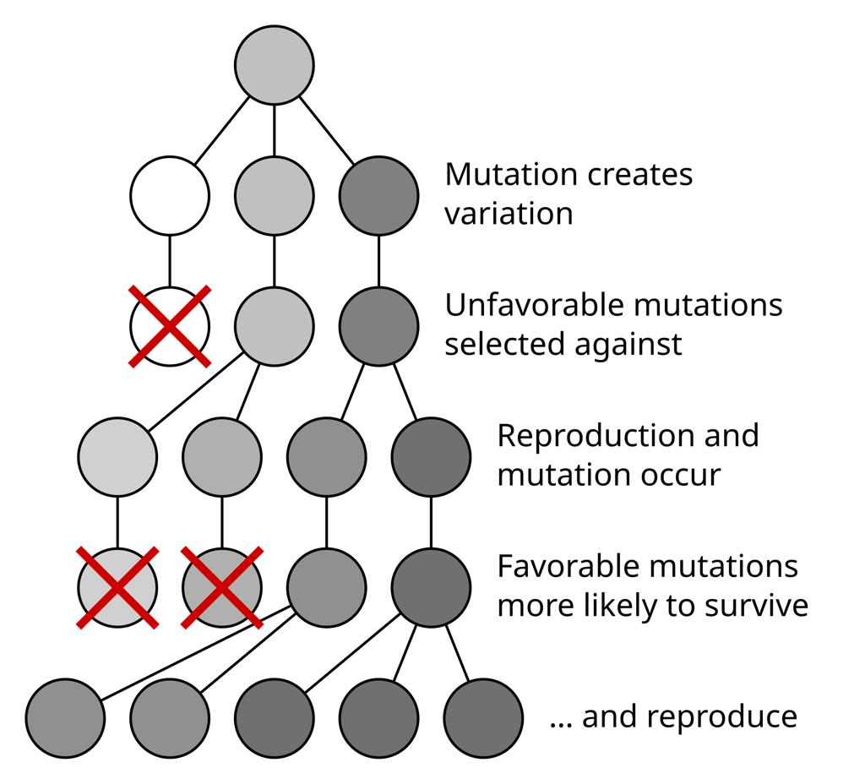
Figure 2. Variation and selection: mutation creates variation, unfavourable variants are selected against, favourable variants survive and reproduce (Architecture B).
Architecture C — Evolving knowledge graph. Elements, compounds, attributes and discovered relationships become nodes and edges; the system adds relationships and progressively reorganises its internal knowledge. Advantage: naturally supports cumulative knowledge and association. Limitation: graph expansion alone does not show that valid scientific rules have been discovered.
B and C are the most attractive for the research objective; a small neural network can be used inside either without becoming the centre of the system.

5.5 Proposed POC-1 system
Combination: composition-based neural surrogate + symbolic/equation discovery + interpretable rule memory + evolutionary selection, with the convex hull as referee. The neural surrogate handles nonlinear numerical relationships; equation discovery proposes explicit relationships; the rule memory retains useful discoveries; evolutionary selection decides which models and rules survive.
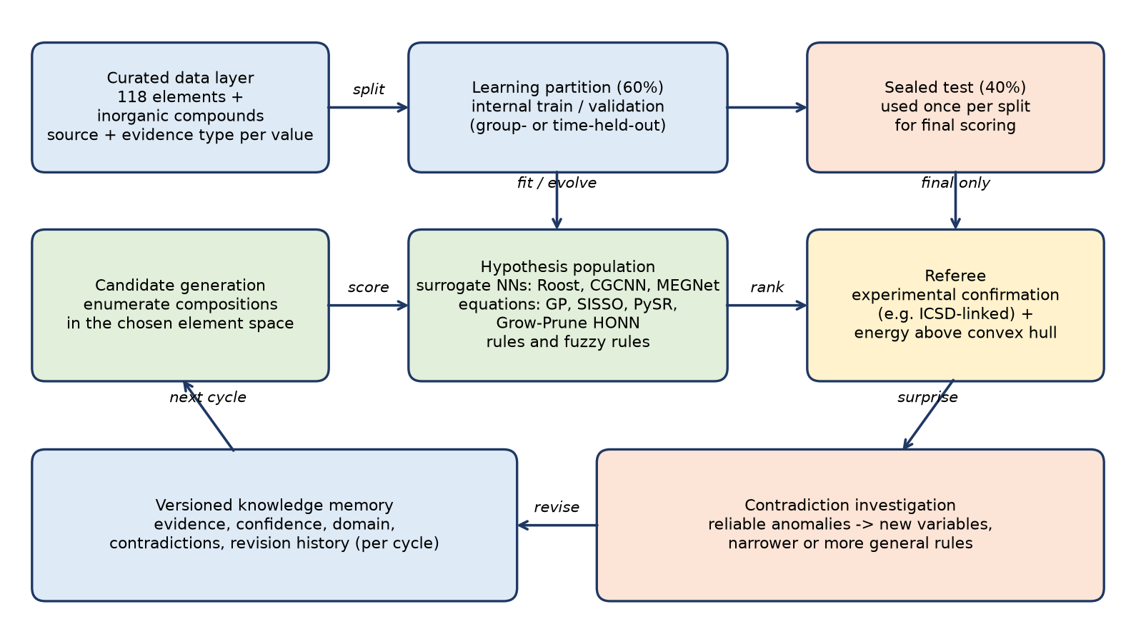
Figure 3. POC-1 learning cycle (new in V0.2, summarising Sections 4–7).

5.5.1 Enumerate-then-score generation
Candidate formulas are enumerated within the chosen element space (bounded stoichiometries) and scored by the surrogate models and rules. Candidates are then ranked for existence (Discovery A) and assessed for properties (Discovery B). Optionally, oxidation-state charge balance is used as a filter — only in the “with oxidation states” arm.
As implemented (V03). The candidate space is every formula Fe_a Na_b O_c P_d with a + b + c + d ≤ 30, at least two elements and reduced subscripts: 41,369 formulas. Of these, about 41,320 are not in the training set and are ranked in each split. Each candidate is scored by its predicted formation energy relative to the convex hull built from training compounds only, with an optional penalty for its distance outside the training feature domain:
(8)
where d_dom is the standardised nearest-neighbour distance to the training compounds in feature space and λ is selected by inner cross-validation on the training split. A second, analogical generator re-uses the stoichiometry templates seen in training compounds (e.g. the subscript multiset (1, 1, 4) of FePO₄) with every assignment of the four elements, giving about 730 candidates per split.

5.5.2 Composition representation
A simple model of Fe₂O₃ might receive a vector of elemental attributes and stoichiometry and learn a property estimate:
(2)
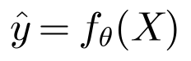 | (3)
where χ is electronegativity, r an atomic radius (one defined scale), and ŷ the predicted property. Two corrections apply: (i) raw integer counts make the input depend on how the formula is written (Fe₂O₃ vs Fe₄O₆), so normalised amounts (e.g. x_{Fe} = 0.4, x_{O} = 0.6) should be used, as in composition-based models such as Roost; (ii) a fixed-length vector suits one binary system, so variable numbers of elements need a set-based or padded representation.
A crystal-structure GNN becomes useful when atomic sites are known; for a proposed formula without a structure, a composition-based model is the practical starting point.
As implemented (V03). POC-1 follows both corrections. Normalised fractions xₑ weight the composition-weighted mean, the weighted mean absolute deviation (“dev”) and the range of each of the seven element attributes, and the number of elements is added: 22 features in all. Two charge-balance features (balanced yes/no, minimum net charge per atom) are added only in the oxidation-state ablation.

5.5.3 Compact equations: symbolic regression and Grow-Prune HONN
Instead of being given a rule, the system builds expressions from elemental attributes using a primitive vocabulary of operators:
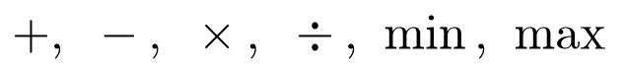 | (4)
Suppose it observes several metal oxides with their formation energies and elemental attributes. It might evolve a candidate expression such as
(5)
and test whether it helps predict a measured property or rank plausible compounds. Over generations expressions mutate and recombine, and successful ones are retained. Equation (5) is purely illustrative of what might be discovered — it is not an established chemical law and would have to survive independent tests. Genetic programming, SISSO, PySR and the author’s Grow-Prune HONN networks are compared as alternative generators of compact equations.
As implemented (V03). The GP in evochem/gp.py evolves prefix trees over the 22 features and random constants, using the operators +, −, ×, protected division, √|·|, square and negation. Population 300, 40 generations, ramped half-and-half initialisation, tournament size 5, crossover 0.7, mutation 0.25, elitism and maximum depth 5. Each tree f is linearly scaled (y ≈ a + b·f) and scored by the weighted absolute error plus a parsimony penalty per node:
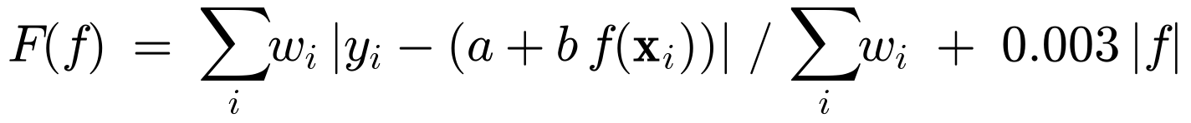 | (9)
The best rule evolved on random split 0 has 8 nodes and a hidden-40% MAE of 0.291 eV/atom:
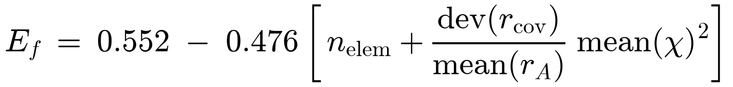 | (10)
Formation energy becomes more negative with more elements, a larger spread in covalent radius and a higher mean electronegativity. Like Eq. (5), Eq. (10) is not a chemical law. It is one of twelve different equations evolved on the twelve splits (Table 9.3), and that variation is itself a research question (Section 11).

5.5.4 Interpretable layer: rules and fuzzy rules
A discovered statistical relationship — e.g. “compounds whose elements differ in electronegativity within a certain range tend to show a particular range of properties” — is stored as a rule with a confidence score and evidence history. Fuzzy rules can represent graded tendencies (low, medium, high stability) instead of rigid yes/no decisions; memberships must be calibrated against evidence. A self-correcting rule memory is valuable for explainability.

5.5.5 Evolutionary computation and a population of small learners
Instead of one large network, a population of simple learners (equations, rules, small networks) competes and cooperates; each may specialise — one on electronegativity relationships, another on atomic-size effects, another on recurring composition patterns. Evolution thus selects learning strategies, not merely candidate compounds. Fitness rewards learners that:
- predict correctly on examples not used for their own fitting (internal validation within the 60%);
- make useful predictions from relatively few observations;
- produce simple, reusable knowledge;
- remain effective when new elements or compounds are introduced.
Mechanisms: genetic programming for expressions, NEAT-style topology evolution for networks (later phase), hypothesis populations with preserved diversity, and active learning to choose what to examine next. The convex hull acts as referee for thermodynamic plausibility during learning (computed from visible phases only, Section 4.4); final existence scoring is against experimental confirmation.

6. Knowledge memory and revision

6.1 Attributes of every discovered relationship
Attribute | Question answered
Evidence | What observations support it?
Confidence | How reliably does it predict observations?
Domain | Under which conditions is it applicable?
Contradictions | Which observations does it fail to explain?
Revision history | What earlier knowledge did it replace, refine or generalise — and in which learning cycle?

6.2 Knowledge evolves rather than accumulates
Illustration: after observing 20 compounds the system might consider an electronegativity–property relationship reliable; after 200 it might find exceptions; after 2,000 it might find that the relationship holds only for a particular class of compounds. The original knowledge has not become useless — its domain of applicability is better understood.
There is deliberately no permanent accepted/rejected distinction: a relationship can be strongly supported today and revised tomorrow if compelling new evidence arrives. A previously useful hypothesis is never deleted outright; it is archived with its evidence and limitations, available for reconsideration, so the system evolves without losing its intellectual history.
Note: The V0.1 figure “evolutionary knowledge-memory model” was not present in the source file (caption only) and has not been redrawn. Its intended states should be supplied by the author.

6.3 Mechanisms
- Bayesian updating — adjust confidence as evidence accumulates, without treating a high-confidence hypothesis as permanent truth.
- Genetic programming / symbolic regression — generate competing relationships and allow new formulations to supersede older ones.
- Versioned associative memory — preserve earlier knowledge, its evidence and the circumstances under which it worked, even after a better explanation emerges.
- Diversity preservation — keep competing hypotheses alive so that selection does not prematurely eliminate an unconventional explanation that later proves valuable.
Example: the system may first learn that a composition is unlikely to form a stable compound; later, high-pressure evidence may show that it is stable under specific conditions (unexpected Na–Cl stoichiometries such as Na₃Cl and NaCl₃ have been predicted and reported at high pressure; Zhang et al., 2013). The system should not merely change its prediction — it should find why the earlier prediction failed and whether the evidence calls for a narrower rule or a more general explanation.

6.4 Knowledge memory as implemented in POC-1 (V03)
evochem/memory.py stores every rule the evolving system adopts with its generation, phase (evolution or contradiction-driven), size, status, evidence (number of training compounds, training MAE), confidence, limits of validity, contradictions and revision history. A replaced rule is marked “superseded”, never deleted, which follows the archive principle of Section 6.2. On random split 0 the memory records 17 rules and 16 revisions: R000–R010 during evolution and R011–R016 during the contradiction cycle. On the family-held-out split it records 14 rules and 13 revisions.
For example, rule R010 (Eq. 10) carries the confidence “45.5% of training compounds within 0.15 eV/atom”, the limit “valid only inside the Fe–Na–O–P system and DFT (GGA/GGA+U/r2SCAN) energies” with a mean-electronegativity range of 0.93–3.44, and two reliable contradictions, NaO2 and P2O5. Limitations: the memory follows a single lineage (the best rule of each generation) rather than competing hypotheses. Confidence and limits are attached only at the end of the evolution phase, so the final active rule after the contradiction cycle (R016) has none. Bayesian updating and domain restriction are not yet implemented.

6.5 V04 test of the revisable memory (Expt-02)
V04 replaced the V03 log by a competing-hypothesis memory: each episode adds the 10 best distinct rules of the population as hypotheses, refits their coefficients on new data plus a reservoir buffer of 12 samples, logs revisions (coefficient changes > 0.02), retires dominated hypotheses (MAE > 1.5 × the best, or outside the top 5) and predicts with the confidence-weighted mean of the top 3 (weights ∝ exp(−MAE/τ)). It was compared over three episodes with retraining from scratch, sequential GP, replay GP with the same buffer and the V03 archive, on a distribution-shifting chemical stream (binaries → ternaries → quaternaries) and on a random stream (30 runs, Holm correction over 20 tests).
Table 6.1. Expt-02 final hidden-set MAE (eV/atom, DFT target) after three episodes (experiments_v04/expt02_evolutionary_memory/analysis.md)
Stream / method | Final MAE [95% CI] | Forgetting, domain 0 | 90% coverage | Memory items | Fitness evaluations
Chemical / scratch retrain | 0.311 [0.286, 0.341] | 0.133 | 0.80 | 55 samples | 5.0e5
Chemical / sequential GP | 0.813 [0.672, 0.990] | 1.318 | 0.18 | 1 rule | 2.2e5
Chemical / replay GP | 0.432 [0.359, 0.547] | 0.472 | 0.58 | 13 | 3.2e5
Chemical / V03 archive | 0.286 [0.261, 0.313] | 0.055 | 0.82 | 58 | 5.0e5
Chemical / proposed memory | 0.399 [0.351, 0.452] | 0.347 | 0.63 | 27 | 3.2e5
Random / scratch retrain | 0.311 | – | 0.80 | 55 | 4.4e5
Random / sequential GP | 0.379 | – | 0.67 | 1 | 2.2e5
Random / replay GP | 0.341 | – | 0.77 | 13 | 3.2e5
Random / V03 archive | 0.305 | – | 0.81 | 58 | 4.4e5
Random / proposed memory | 0.317 [0.304, 0.334] | – | 0.79 | 27 | 3.2e5

On the chemical stream the proposed memory beats naive sequential GP (−0.414, p < 1e-4) but ties replay with the same buffer (−0.033 [−0.153, +0.060], n.s.) and is worse than retraining from scratch (+0.089, Holm p = 0.002) and than the V03 archive (+0.113, Holm p < 1e-4). On the random stream it is better than sequential GP (−0.062, Holm p = 0.005) and indistinguishable from replay, scratch and the V03 archive after correction. Methods that keep all past data are best, at about twice the stored items and about 1.6 times the fitness evaluations, so the comparison is a memory/compute trade-off, not a win. The memory is active (about 10 revisions per run), but the revisions do not prevent forgetting, and its 90% intervals cover only 63% of hidden values under distribution shift, because the spread of similar GP rules underestimates uncertainty.
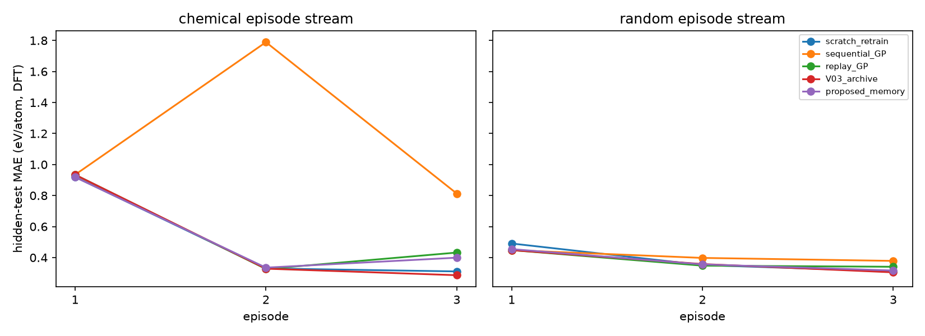
Figure 10. Expt-02: hidden-set MAE per episode for the chemical (left) and random (right) streams (experiments_v04/expt02_evolutionary_memory/figures/expt02_episode_mae.png).
Decision (V04): The revisable memory is kept as an interpretability and provenance device (every rule with its evidence, confidence, limits, contradictions and revision history in rules.json). No learning benefit is claimed: it ties plain replay, is worse than keeping the full data, and is poorly calibrated under shift (63% coverage of nominal 90%).

7. Contradiction-driven learning

7.1 Rationale
Consider a hypothetical rule: under certain conditions, compounds with property combination X and Y exhibit behaviour Z. Suppose it correctly predicts 990 of 1,000 observations. Instead of treating the remaining 10 as noise, the system investigates whether they share a previously unrecognised property — perhaps all occur at high pressure, share a crystal structure, or involve an interaction not yet represented. Those 10 examples may reveal a new knowledge domain. Data errors and unusual experimental conditions are ruled out first.

7.2 Learning objective
Most machine-learning systems minimise prediction error averaged over N examples:
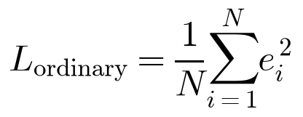 | (6)
The proposed system additionally assigns a discovery priority to each unexpected observation i:
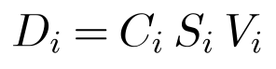 | (7)
where C_{i} is the confidence in the existing prediction before the result is observed, S_{i} the degree of surprise produced by the observation, and V_{i} the reliability of the experimental evidence. Equation (7) is a proposed heuristic, not an established law: a large D_{i} triggers investigation, not automatic acceptance of a new rule. An unexpected result supported by three independent measurements should rank far above a single anomalous database entry, and the weight given to outliers must be capped, because a learner that chases every anomaly becomes unstable.

7.3 Two interacting populations
Main learning population | Contradiction-investigation population
Learns common relationships | Investigates rare exceptions
Improves general prediction | Searches for missing explanatory variables
Builds broadly applicable rules | Develops specialised or more general rules
Rewards predictive reliability | Rewards independently verified explanatory improvement
Maintains established knowledge | Challenges established knowledge

A discovery from the second population enters the first only after independent testing. This also provides a mechanism for new knowledge domains: if several anomalous compounds behave similarly under extreme pressure, the system may identify pressure as a neglected explanatory variable and develop a separate relationship for that regime.
A further level of intelligence is to learn which contradictions are worth investigating — allocating its own attention to observations with the greatest potential for discovery.
Note: The V0.1 figure “contradiction-driven evolutionary architecture” was not present in the source file (caption only). Figure 3 summarises the loop; the author may wish to supply a dedicated diagram.

7.4 First implementation in POC-1 (V03)
POC-1 implements a deliberately simple version of the contradiction-driven idea. After 40 generations, training compounds that are reliable (at least two ICSD entries) and badly mispredicted are flagged:
(11)
The evolved population then continues for 20 generations with the flagged compounds weighted ×3; a control copy continues for 20 unweighted generations. In terms of Eq. (7), n_ICSD stands in for the reliability Vᵢ and the residual threshold for the surprise Sᵢ. The prior confidence Cᵢ and the second, investigative population of Section 7.3 have not yet been implemented. The flagged compounds are chemically interesting (NaO2 and NaO3, superoxide and ozonide; P2O5; Na3PO4; Na5P3O10), but re-weighting them gives no significant overall gain on hidden compounds (Section 9.4.3).

7.5 V04 test: contradiction-driven learning not supported as implemented
V04 implemented the two-population architecture of Section 7.3 and the priority idea of Eq. (7) in full and tested them against matched controls. The general population G (population 200, 40 generations) learns g(x) = a + b·φ_G(x); the 10 best distinct trees of its final population form an archive A whose disagreement gives a calibrated uncertainty σ̂. On the inner-fit part F (75%) of the training data, each compound receives a contradiction priority:
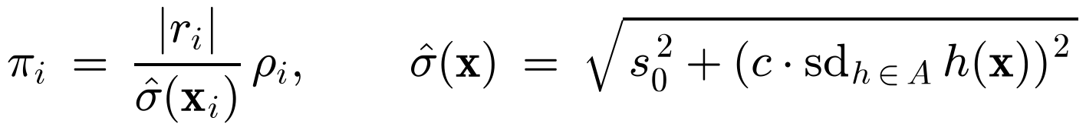 | (12)
with evidence reliability (repeated records of one structure are not counted as independent confirmations):
(13)
The top 15% (at least 4) of F by π are the contradictions. A depth-2 decision tree separating them from the rest of F defines the applicability domain D, and the specialist population S (population 200, 10 generations) is evolved on F ∩ D, with and without the candidate missing variables (charge-balanced flag and charge imbalance under normal oxidation states). The combined prediction and the acceptance gate on the inner-validation part V (25%) are:
(14)
(15)

7.5.1 Synthetic validation with known exception domains
Before using real data, the method was tested in synthetic environments with a planted exception domain and hidden variable (75 environment × seed pairs; SYNTHETIC, no chemical claim). Overall, the proposed method was no better than GP with matched extra generations (+0.002 [−0.004, +0.009], p = 0.64) and worse than a specialist trained on the plain highest-residual samples (+0.009 [+0.004, +0.015], p = 0.004; 19 vs 40 wins).
Table 7.1. Synthetic environments: test MAE against the noise-free truth, mean of 5 seeds (experiments_v04/validation/synthetic/metrics.csv and analysis.md)
Environment | GP, 60 generations | High-residual specialist | Proposed | Observation
Default (exception frequency 0.15) | 0.158 | 0.147 | 0.160 | Acceptance 1.0 vs 0.8; domain precision 0.60 vs 0.50
Exception frequency 0.30 | 0.234 | 0.177 | 0.220 | Domain precision 0.76 vs 0.68
Noise 0.01 | 0.164 | 0.125 | 0.150 | High-residual specialist used the hidden variable x4 in 4/5 seeds (precision 0.83)
No exceptions (frequency 0) | 0.037 | 0.062 | 0.062 | Spurious specialist accepted in 2/5 seeds by both (false discovery 0.4)
Corruption only (15%, no exceptions) | 0.059 | 0.096 | 0.095 | False discovery 0.6 / 0.4; contradiction sets 88–93% corrupted points
Corruption 15% with exceptions | 0.181 | 0.180 | 0.179 | Corrupted share of contradiction set 83% vs 61%, no error gain
Domain overlap 0.15 | 0.207 | 0.208 | 0.209 | Domain precision ≤ 0.39 for all

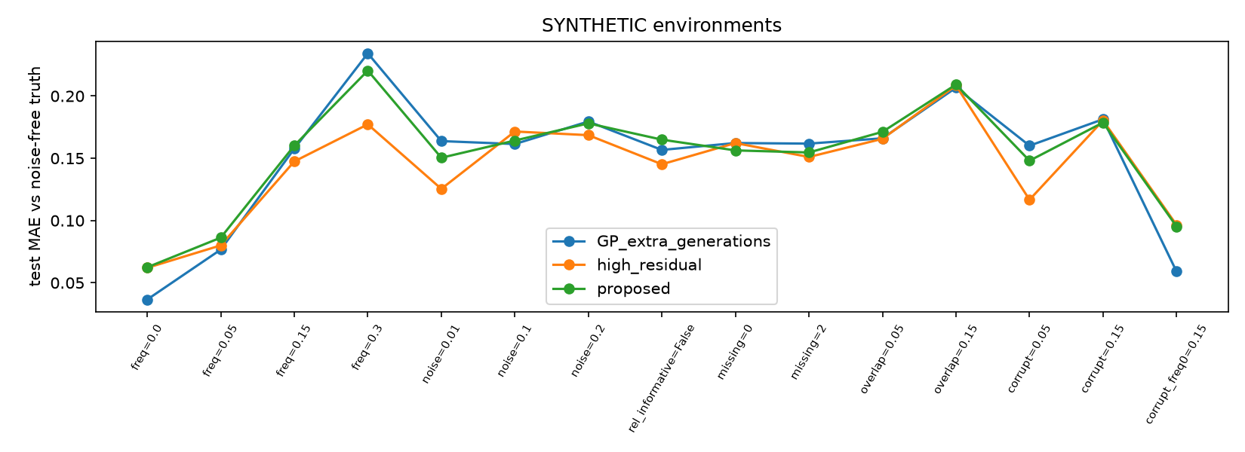
Figure 11. Synthetic environments: test MAE against the noise-free truth for GP with extra generations, the high-residual specialist and the proposed method (experiments_v04/validation/synthetic/figures/synthetic_mae.png). SYNTHETIC data, no chemical claim.
The architecture can recover a hidden exception domain and the missing variable under low noise and hard boundaries, but plain residual selection does so more reliably. The reliability term has one narrow, measurable benefit: it removes corrupted observations from the contradiction set (61% vs 83% corrupted), without lowering test error. The validation gate does not prevent false discoveries (about 0.2 overall, 0.4 when no exception exists).

7.5.2 Expt-01: contradiction-driven specialists on Fe–Na–O–P
Expt-01 used the 91 Fe–Na–O–P compounds (DFT formation energy), 10 random 60/40 splits and 6 group-held-out splits, 5 evolutionary seeds and matched budgets (60 generations × population 200 for all conditions except the 40-generation reference). “Exceptional” and “ordinary” test labels, used for evaluation only, come from a ridge reference model fitted on the training partition.
Table 7.2. Expt-01 mean test MAE (eV/atom) with 95% bootstrap CI over splits (experiments_v04/expt01_specialist_rules/analysis.md)
Method | Random 60/40 (10) | Group held-out (6) | Exceptional (random) | Ordinary (random)
Ordinary GP (40 generations) | 0.310 [0.290, 0.332] | 0.328 [0.286, 0.370] | 0.487 | 0.251
GP + extra generations | 0.304 [0.284, 0.325] | 0.335 [0.285, 0.381] | 0.488 | 0.242
V03 contradiction weighting | 0.302 [0.281, 0.327] | 0.306 [0.271, 0.336] | 0.473 | 0.245
Specialist, random samples | 0.331 [0.293, 0.373] | 0.296 [0.269, 0.324] | 0.469 | 0.285
Specialist, high-residual samples | 0.287 [0.278, 0.298] | 0.278 [0.247, 0.310] | 0.447 | 0.234
Proposed two-population | 0.288 [0.267, 0.307] | 0.282 [0.256, 0.302] | 0.450 | 0.233
GP + charge-balance features (60 g) | 0.229 [0.209, 0.252] | 0.302 [0.239, 0.369] | 0.319 | 0.199

Paired tests over all 80 runs (proposed − control, Holm-adjusted within metric):
- vs ordinary GP: −0.031 [−0.050, −0.013], p = 0.0004, d_z = −0.36, Holm p = 0.004; 13 of 16 splits better (split-level p = 0.009).
- vs GP + extra generations: −0.030 [−0.051, −0.009], Holm p = 0.018; vs V03 weighting: −0.018 [−0.038, +0.001], p = 0.06 (n.s.); vs random-sample specialist: −0.033 [−0.061, −0.009], Holm p = 0.046.
- vs high-residual specialist: +0.002 [−0.012, +0.016], p = 0.90 — no difference.
- vs GP given the same charge-balance features: +0.029 [+0.005, +0.052], p = 0.002 — the proposed method is worse.
- Ablations: removing the calibrated uncertainty (Δ −0.0004), the reliability (+0.0005) or the validation gate (−0.0007) changes nothing; removing the missing-variable search costs 0.020 eV/atom (p = 0.0004).
Specialists were accepted in 78% (random) and 83% (group) of runs, with 7.5 nodes on average; the total model has 16–17 nodes against 10–11 for plain GP. Applicability-domain precision for exceptional test items was 0.37 (base rate 0.25), recall 0.43. On the training contradictions themselves the error fell from 0.63 to 0.33 eV/atom, but on held-out exceptions only from 0.487 to 0.450.
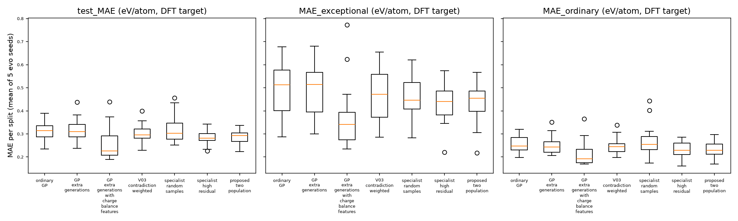
Figure 12. Expt-01: test MAE per split (mean of 5 seeds) overall, on exceptional and on ordinary hidden compounds (experiments_v04/expt01_specialist_rules/figures/expt01_mae_boxplots.png).

7.5.3 Why the hypothesis failed
- The specialist ties the plain high-residual specialist. Selecting contradictions by uncertainty × reliability gives the same result as selecting by residual (+0.002, p = 0.90); the gain over plain GP is not attributable to contradiction-specific information.
- The gain comes mostly from oxidation-state features. The only ablation that matters is the missing-variable search, which injects tabulated oxidation-state (charge-balance) priors (0.020 eV/atom). A plain GP given those features globally is better still (0.229 vs 0.288).
- Uncertainty works against the hypothesis. Archive disagreement is high exactly where exceptions are, so the surprise |r|/σ̂ down-weights the samples that should be specialised.
- The acceptance gate is too weak. Inner validation sets have about 14 samples, with 0–3 inside the domain, so improvements of 0.005 eV/atom are noise; spurious specialists were accepted on synthetic data without exceptions (false discovery 0.4) and with corruption only (0.4–0.6).
- Overfitting to contradictions. Training-contradiction error halves (0.63 → 0.33), held-out exceptional error improves by only about 8% (0.487 → 0.450).
- Small data and accuracy ceiling. 91 compounds (no 3–4-element system has ≥ 100 confirmed compounds) with a DFT target; symbolic GP is about 0.07–0.09 eV/atom behind linear and ensemble baselines.
Chemical case study. A typical accepted specialist (random split 0, seed 0) has the domain “mean Pauling electronegativity > 2.51 and valence-electron range ≤ 0.60”, i.e. oxygen-rich formulas, with Ef_S = −1.381 + 1.716·(−0.15/sqrt|dev_mass| + charge_imbalance) blended with G. The most frequently flagged contradictions over all runs were Na5P3O10, FePO6, Fe3(PO8)2, P2O5, Na3PO4, Fe4O13, P2O9, Na4P2O7, NaO3 and NaO2; several are oxygen-excess or peroxo/superoxo-type formulas whose database entries deserve scrutiny. The specialist effectively learns “charge imbalance under normal oxidation states → less stable”, which is textbook chemistry and is learned better by giving the general GP those features directly.
Verdict (V04): Hypothesis H1 (reliable contradictions → better-generalising specialist rules) is not supported as implemented. The contradiction idea is not abandoned, but it is reformulated as a missing-variable discovery problem with permutation-controlled acceptance (Section 11.2, problem 1).

8. Evaluation plan

8.1 Predictive performance
- Existence (Discovery A): ranked enumerated candidates vs hidden experimentally confirmed formulas (precision, recall, top-k hit rate); unconfirmed candidates reported as a separate “unknown” category, computed-only matches reported separately.
- Properties (Discovery B): error per property, in its units, against measured values where available; computed targets labelled as such.
- Robustness: mean and spread over ≥ 10 random splits, plus group- and time-held-out results; with vs without oxidation states.
- Baselines: a simple MLP, a random forest, a conventional rule-based system, and a composition-based NN (e.g. Roost). If the evolutionary system does not outperform them, no advantage is claimed.
- Status (V03): mean, ridge-regression and random-forest baselines are implemented on identical features and splits; the MLP, rule-based and Roost baselines are not yet.

8.2 Demonstrating evolution
The proposed experiment can demonstrate predictive learning; demonstrating evolutionary learning additionally requires showing how the system develops, retains, modifies and selects its own knowledge structures over successive learning cycles. Knowledge is therefore tracked per cycle:
- snapshot of the knowledge base (rules, equations, learners) with lineage and revision history;
- counts of rules created, refined, restricted in domain, superseded and archived;
- sample efficiency — performance as a function of the number of observations seen;
- contradictions detected, investigated and resolved, and the resulting new variables or domains.

8.3 Contradiction-handling capability
Measured using the exposed learning data only (never the hidden 40%): whether the system can
- recognise when established knowledge is contradicted;
- distinguish genuine exceptions from unreliable observations;
- identify common features among exceptions;
- construct improved hypotheses that explain both ordinary and exceptional cases;
- preserve earlier rules in the domains where they still work.
Comparative study: an ordinary neural learner, a conventional evolutionary learner and a contradiction-driven evolutionary learner on exactly the same inorganic database. Research question: can deliberately investigating rare, reliable contradictions achieve better scientific generalisation than optimising average accuracy alone?

8.4 Initial assessment of POC-1
Criterion | Assessment | Evidence from POC-1 (V03)
Experimental feasibility | High (subject to Step 0 data counts) | Demonstrated with 91 formulas, below the 100–200 target, which MP cannot supply (maximum 97)
Objectivity of evaluation | High | High: fixed split files, training-only hull, reproducible run (Section 9.6)
Computational complexity | Manageable | Manageable: full benchmark of 12 splits in 87 s (RESULTS.md); 104 s on the re-run of 14 Oct 2026
Industrial relevance | Potentially high | Fe–Na–O–P is relevant to steel, phosphates and Na-ion cathodes; no industrial validation yet
Demonstration of evolutionary intelligence | Not yet established — requires per-cycle tracking (8.2) | Not established: the rule lineage is logged, but the learning strategy is not evolved and the contradiction cycle gives no significant gain
Research novelty | Depends on the learning mechanism | Unchanged: depends on the learning mechanism

Simply collecting chemical data and training a model would not be novel. Novelty lies in a primitive evolutionary mechanism that discovers relationships without supplied chemical rules, retains them as long-term knowledge, combines them into new hypotheses, corrects them when contradicted, and improves its predictions while needing less evidence.
V04 update: The evidence column above reflects V03. After V04, demonstration of evolutionary intelligence is still not established (Expt-08, strategy evolution, was not run), and the novelty claim based on contradiction-driven learning is not supported by the experiments (Section 7.5). Objectivity of evaluation was strengthened by synthetic ground-truth environments, matched budgets, paired tests with Holm correction and a test-label poisoning unit test.

9. POC-1 implementation and results

9.1 Repository, credit and status
The POC-1 design of Sections 4–8 has been implemented as a small, public demonstration repository for prospective PhD scholars joining the research programme on evolutionary AI and autonomous scientific discovery at the R&D Centre, Dharmsinh Desai University:
https://github.com/hsmazumdar/Evolutionary-AI-Chemistry-Discovery
Conceived and directed by Himanshu Mazumdar, R&D Centre, Dharmsinh Desai University, Nadiad, Gujarat, India. Code developed with AI assistance. Code licence: MIT. Data: Materials Project (CC-BY-4.0) and mendeleev (MIT); see DATA_CREDITS.md. The repository is deliberately small: about 950 lines of Python (945 lines in the evochem package, run_demo.py and gui.py). Weak results are reported alongside good ones. All numbers in this section are copied from results/RESULTS.md and the result CSV/JSON files of the run of 13 October 2026; derived ratios are marked as such.

9.2 Architecture as implemented
Table 9.1. Modules of the POC-1 repository
Module / file | Role | Key implementation details
evochem/features.py | Feature layer | Element attributes only; composition-weighted mean, mean deviation and range of 7 attributes + n_elem = 22 features; optional charge-balance features (ablation only)
evochem/gp.py | Rule evolution | Readable numpy GP symbolic regressor; linear scaling, parsimony penalty, tournament selection, elitism (Eq. 9)
evochem/hull.py | Referee | Convex hull of formation energy from training compounds only (+ elemental references at 0 eV)
evochem/discovery.py | Discovery A | 41,369-formula candidate space; score of Eq. (8); λ by inner CV on training only; analogy-template generator; recall@k
evochem/memory.py | Knowledge memory | Rules with evidence, confidence, limits, contradictions, status and revision history; JSON + Markdown output
evochem/periodicity.py | Periodicity teaser | Element embeddings from co-occurrence (PPMI-SVD) and partner formation energies (SVD); clustering; adjusted Rand index vs IUPAC groups with a permutation null
run_demo.py | Benchmark (CLI) | Runs all 12 splits, baselines, contradiction cycle, Discovery A and periodicity; writes results/ (tables, figures, memory)
gui.py, Launch_Demo.bat, docs/Help.rtf | Interactive demo | Tkinter GUI; Windows launcher creates .venv, installs pinned requirements once and starts the GUI; RTF help
data/ | Self-contained data | Fe–Na–O–P formulas and entries, 12 split files, element table, MP observed subset (44,686 entries); nothing downloaded at run time

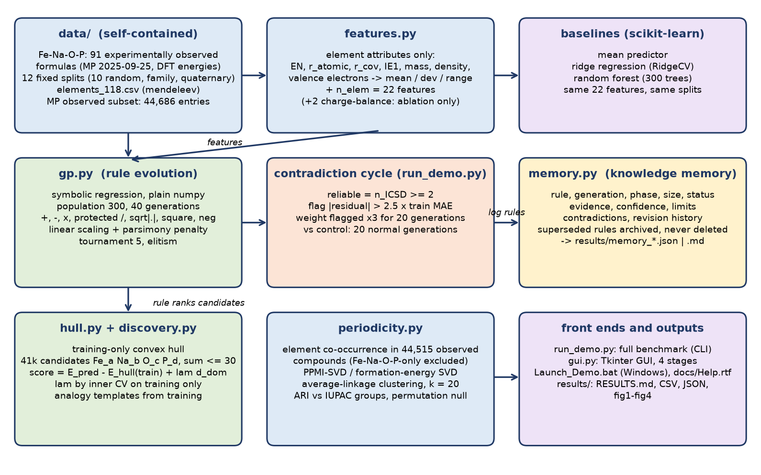
Figure 4. POC-1 as implemented (V03): modules, data flow and outputs of the public repository. Compare with the planned learning cycle in Figure 3.
GUI. On Windows, double-clicking Launch_Demo.bat creates a local virtual environment on first use (Python 3.10+ with Tcl/Tk; internet is needed once to install the pinned requirements: numpy 2.5.4, pandas 3.0.6, scipy 1.18.1, scikit-learn 1.9.1, matplotlib 3.11.2) and then opens the GUI. The user chooses a split, sets the GP population and generations, optionally ticks the oxidation-state ablation and runs four stages: (1) evolve rules live against the mean, linear and random-forest baselines; (2) Discovery A; (3) the contradiction cycle; (4) periodicity. Tabs show the live plot, the evolved equation and result tables, the knowledge memory and the saved figures. A “Full benchmark” button runs run_demo.py on all 12 splits, and a Help button opens docs/Help.rtf.
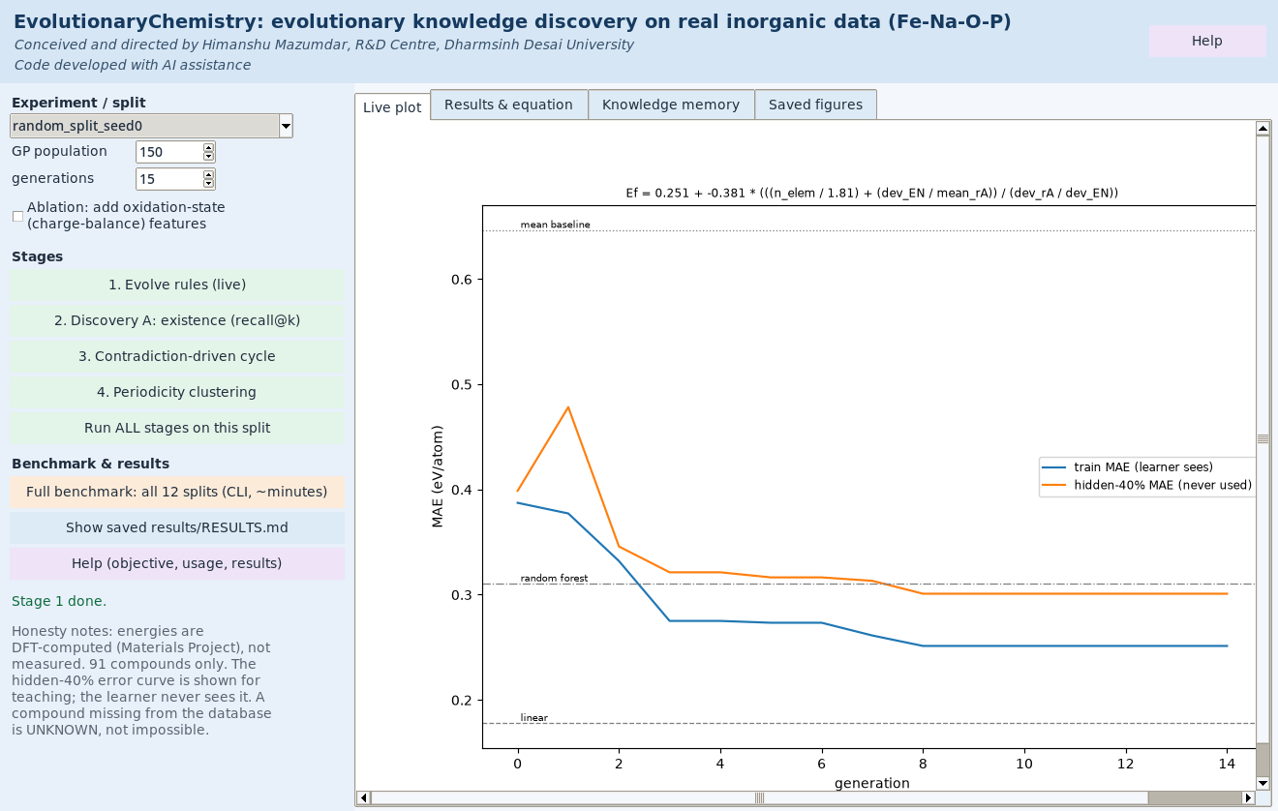
Figure 5. The POC-1 GUI (stage 1, live rule evolution on random split 0). The screenshot shows a short interactive run (population 150, 15 generations), so its numbers are not the benchmark results of Section 9.4. The banner carries the credit line.

9.3 Experimental protocol as run
- Data: 91 distinct experimentally observed Fe–Na–O–P formulas (Section 3.6); target = DFT formation energy per atom (eV/atom).
- Splits: 10 seeded random 60/40 splits (55 learned / 36 hidden); a stoichiometry-family split (57 / 34; 28 families hidden); a quaternary split (80 / 11). All splits are fixed JSON files in data/splits_Fe-Na-O-P/.
- Learners: mean predictor, ridge regression (RidgeCV on standardised features), random forest (300 trees), GP (Eq. 9; population 300, 40 generations), and GP with oxidation-state features (ablation).
- Contradiction cycle: Eq. (11), then 20 weighted generations against a 20-generation unweighted control.
- Discovery A: hidden multi-element compounds per split 34.9, of which 32.7 lie inside the candidate space; about 41,321 candidates ranked per split; recall counted at k = 10 to 1,000.
- Periodicity: element vectors learned only from 44,515 experimentally observed MP compounds (Fe–Na–O–P-only compounds excluded), for 81 elements; clustered into k = 20 clusters (the number of true groups present, with lanthanides and actinides as separate families).

9.4 Results

9.4.1 Evolutionary rule discovery: formation energy
Table 9.2. Formation-energy MAE on hidden compounds (eV/atom); best per row in bold
Split | n test | Mean | Linear (ridge) | Random forest | Evolved GP | GP + ox. states
10 random 60/40 (mean ± sd) | 36 | 0.624 ± 0.062 | 0.197 ± 0.018 | 0.239 ± 0.045 | 0.305 ± 0.049 | 0.206 ± 0.046
Families held out | 34 | 0.787 | 0.328 | 0.280 | 0.293 | 0.551
Quaternaries held out | 11 | 0.861 | 0.204 | 0.531 | 0.343 | 0.195

The evolved equations have 7–13 nodes and lower the error relative to the mean predictor by 51% (random), 63% (families) and 60% (quaternaries), ratios computed from Table 9.2. On random splits, however, they are not yet as accurate as plain linear regression on the same 22 features (0.305 vs 0.197 eV/atom). They hold up better than linear regression when whole families are hidden (0.293 vs 0.328), where the random forest is best (0.280). Supplying oxidation states helps on random (0.206) and quaternary (0.195) splits but hurts badly on the family split (0.551). Figure 6 shows evolution on split 0, and Figure 7 compares predictions on the hidden compounds.
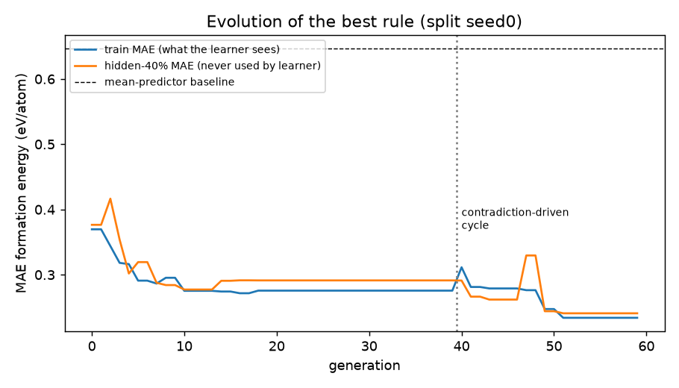
Figure 6. Evolution of the best rule on random split 0 (results/fig1_learning_curve.png). The training MAE is what the learner sees; the hidden-40% MAE is computed for teaching only and never used by the learner. The contradiction-driven cycle starts after generation 40.
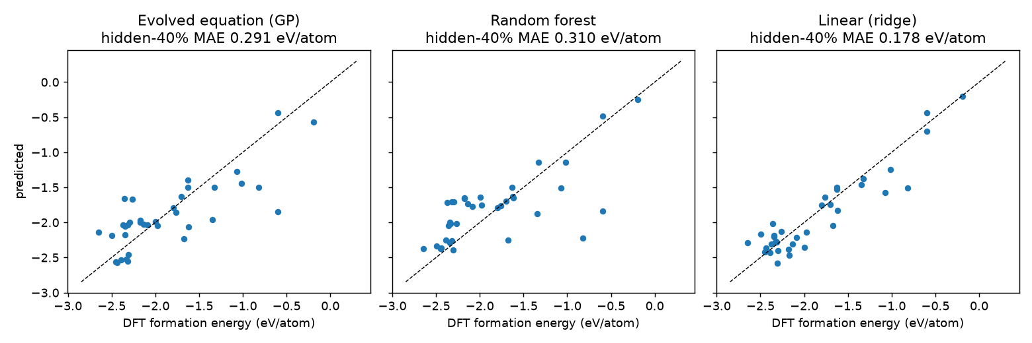
Figure 7. Predicted vs DFT formation energy for the 36 hidden compounds of split 0 (results/fig2_parity_seed0.png): evolved equation 0.291, random forest 0.310 and ridge 0.178 eV/atom MAE.
Table 9.3. Equations evolved on each split (RESULTS.md); dev = weighted mean absolute deviation, range = max − min
Split | Evolved equation
random seed 0 | Ef = 0.552 + -0.476 * (n_elem + ((dev_rCov / mean_rA) * (mean_EN)^2))
random seed 1 | Ef = 0.005 + -0.494 * (mean_EN * sqrt|(n_elem * (dev_rCov * mean_EN))|)
random seed 2 | Ef = 3.460 + -3.168 * sqrt|(-((range_nval * mean_rCov)) + ((dev_EN + n_elem) - range_nval))|
random seed 3 | Ef = 0.286 + -0.346 * (n_elem - ((range_EN / (dev_rCov - mean_rA)) / range_rA))
random seed 4 | Ef = 0.118 + -0.220 * (dev_EN * ((mean_EN * n_elem) / range_IE))
random seed 5 | Ef = 1.995 + -0.676 * (((n_elem - dev_EN) + (dev_EN / range_IE)) + (dev_EN / sqrt|dev_nval|))
random seed 6 | Ef = -0.206 + -0.405 * ((n_elem - (range_IE / dev_EN)) * (mean_EN - (range_nval / dev_EN)))
random seed 7 | Ef = 0.271 + 0.634 * ((((range_mass)^2 - (mean_IE / range_IE)) * n_elem) * dev_EN)
random seed 8 | Ef = 0.334 + -0.582 * ((dev_EN / (range_IE / n_elem)) / mean_rCov)
random seed 9 | Ef = 0.343 + -1.123 * sqrt|(((n_elem - (range_rA / dev_EN)) + (n_elem - 0.9)) / mean_rA)|
families held out | Ef = 1.853 + -0.872 * (mean_nval + (((dev_rCov / range_nval) / (dev_rCov / dev_rCov)) + n_elem))
quaternaries held out | Ef = 1.241 + -1.024 * ((n_elem - range_nval) + ((dev_rCov / mean_rA) * ((dev_rCov / range_nval) * n_elem)))

All twelve equations contain the number of elements and at least one electronegativity or covalent-radius dispersion term (dev_EN, range_EN or dev_rCov), but no two are the same. The search finds reproducible ingredients, not one stable law.

9.4.2 Discovery A: re-finding hidden real compounds
Table 9.4. Hidden compounds found in the top k of about 41,321 ranked candidates (mean over 10 random splits; about 32.7 hidden compounds in the space)
Method | top 10 | top 25 | top 50 | top 100 | top 200 | top 500 | top 1000 | median rank
GP + hull (raw) | 0.0 | 0.0 | 0.0 | 0.0 | 0.0 | 0.0 | 0.1 | 31132
GP + hull + domain (inner-CV λ) | 0.0 | 0.0 | 0.0 | 0.0 | 0.0 | 0.1 | 0.6 | 27811
GP_ox + hull (raw) | 0.2 | 0.4 | 0.4 | 0.4 | 0.5 | 0.7 | 0.9 | 19573
GP_ox + hull + domain (inner-CV λ) | 0.1 | 0.1 | 0.1 | 0.5 | 1.3 | 3.6 | 7.5 | 5595
RF + hull (raw) | 0.0 | 0.0 | 0.0 | 0.0 | 0.0 | 0.0 | 0.1 | 37760
RF + hull + domain (inner-CV λ) | 0.0 | 0.0 | 0.0 | 0.0 | 0.0 | 0.5 | 1.2 | 23973
Analogy templates, random order | 0.0 | 0.1 | 0.2 | 0.4 | 1.5 | 5.0 | 7.4 | 16083
Analogy templates ranked by GP + hull | 0.0 | 0.2 | 0.3 | 0.6 | 1.5 | 3.4 | 7.3 | 27621
Analogy templates ranked by GP_ox + hull | 0.4 | 0.7 | 1.1 | 2.0 | 3.0 | 5.9 | 7.4 | 18271
Charge balance only (uses ox. states) | 0.0 | 0.1 | 0.4 | 0.5 | 1.2 | 3.8 | 7.8 | 4880
Random guessing | 0.01 | 0.02 | 0.04 | 0.08 | 0.16 | 0.40 | 0.79 | –

An honest negative result: ranking the whole space by predicted energy above the training hull fails (0.0 hits in the top 100; median rank 31,132 of about 41,321, worse than the middle rank expected by chance). Rules learned only from real compounds extrapolate to absurd formulas such as NaO29, and an error of about 0.3 eV/atom is much larger than the energy differences that separate stable from unstable compounds. The analogical generator combined with the oxidation-state GP ranking gives 2.0 hits in the top 100, about 25 times random (0.08), but that is still only about 6% of the 32.7 hidden compounds (ratios derived from Table 9.4). The best existence results all use oxidation states, i.e. supplied chemical knowledge; charge balance alone has the best median rank (4,880) and the best top-1000 recall (7.8).
The top-ranked candidates for split 0 (analogy + GP_ox) are dominated by Na–P and Fe–Na–P compositions (FeNa3P2, Na13P4, Na5P2, FeNa5P3, …) and include oxygen-rich formulas such as FeO15 and FeNa3O12. These are “unknown”, not discoveries; a candidate missing from the database may simply never have been made, or may be implausible.
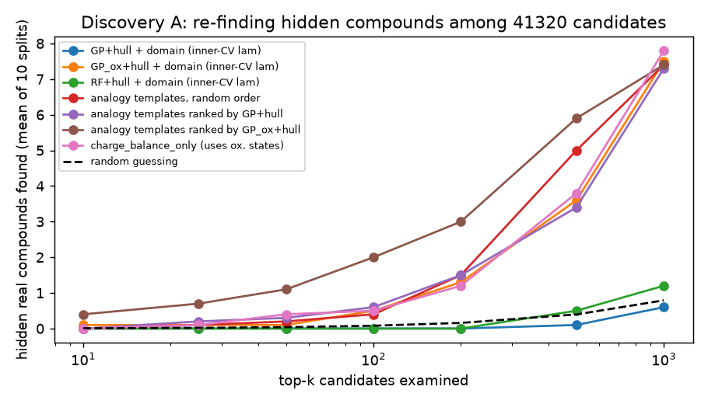
Figure 8. Discovery A: hidden real compounds found among the top-k candidates, mean of 10 random splits (results/fig3_recall_at_k.png). Raw whole-space rankings are omitted from the plot; see Table 9.4.

9.4.3 Contradiction-driven learning
Table 9.5. Contradiction cycle: hidden-set MAE (eV/atom) after 20 further generations
Split | Flagged (reliable) | Before cycle | Continue normally | Contradictions ×3 | Error on flagged: before → after
10 random (mean ± sd) | 2.2 per split | 0.305 ± 0.049 | 0.296 ± 0.042 | 0.300 ± 0.057 | 0.757 → 0.561
Families held out | Na3PO4 | 0.293 | 0.316 | 0.315 | 0.694 → 0.643
Quaternaries held out | Na2O, P2O5 | 0.343 | 0.387 | 0.293 | 0.643 → 0.338

Typical flagged compounds are NaO2 and NaO3 (superoxide and ozonide), P2O5, Na3PO4 and Na5P3O10. The system does learn them: their error falls from 0.757 to 0.561 eV/atom on average. On hidden compounds, however, the weighted run beats the control on only 6 of 10 random splits, and the means (0.300 vs 0.296) show no significant overall gain. The single quaternary split improves (0.293 vs 0.387), but one split is not evidence. Re-weighting fits the exceptions; it does not yet explain them. Turning contradictions into new variables or specialised rules (Section 7.3) remains open.

9.4.4 Knowledge memory
The memory files (results/memory_random_split_seed0.json|md, memory_family_heldout.json|md) show the history of the knowledge, not just the final model: 17 adopted rules and 16 dated revisions on split 0, each with its training MAE before and after. This meets the V0.2 requirement that superseded knowledge is archived with its evidence (Section 6.2). It does not yet meet the requirement for competing hypotheses or calibrated confidence (Section 6.4).

9.4.5 Periodicity teaser: no periodic table supplied
Table 9.6. Element families recovered from compound data alone (81 elements, k = 20)
Embedding | Adjusted Rand index | Random ARI (mean / 95th pct) | p (1,000 permutations) | Nearest neighbour in same group | Random
Co-occurrence (PPMI-SVD) | 0.528 | 0.001 / 0.034 | < 0.001 | 51% | 6%
Partner formation energy (SVD) | 0.222 | 0.000 / 0.032 | < 0.001 | 40% | 6%
Combined | 0.336 | 0.000 / 0.032 | < 0.001 | 51% | 6%

Clustering element vectors learned only from which elements co-occur in experimentally observed compounds recovers the IUPAC groups with an adjusted Rand index of 0.53, far above the random 95th percentile of 0.034. Halogens and chalcogens, lanthanides with Sc/Y, actinides, the Pt-group metals and Mo/W/Nb/Ta come out as families without any group information. The alkali metals are only partly grouped (K and Cs fall elsewhere). Co-occurrence statistics also reflect which compounds chemists chose to make and report, so this is evidence of learnable periodicity in the data, not proof of independent discovery.
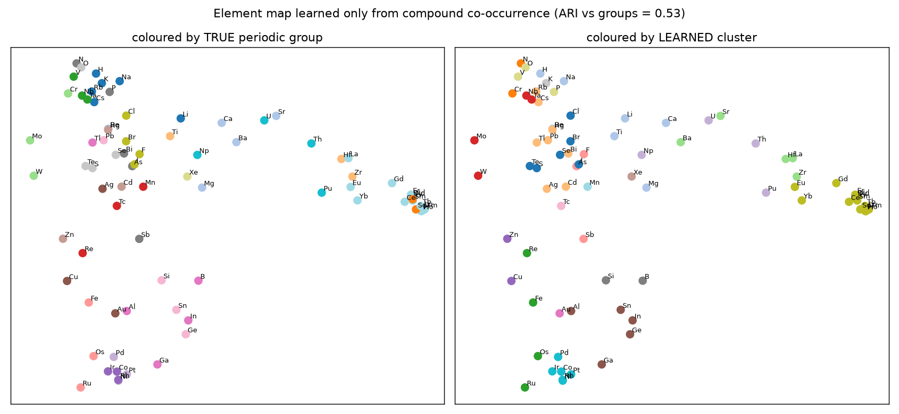
Figure 9. Element map learned only from compound co-occurrence, coloured by true periodic group (left) and by learned cluster (right); ARI vs groups = 0.53 (results/fig4_element_map.png).

9.5 Interpretation: strengths and weaknesses
What POC-1 shows
- An end-to-end, self-contained and reproducible pipeline exists. Leakage safeguards from Section 4.4 are implemented (training-only hull, inner-CV choice of λ, frozen splits, hidden set never used for selection).
- Evolution from element attributes alone produces compact, readable equations that are 51–63% more accurate than the mean predictor and degrade less than linear regression when whole stoichiometry families are hidden.
- Supplied chemical knowledge (oxidation states) helps inside the training domain but hurts on unseen families (0.551 vs 0.293 eV/atom), which supports testing Option A.
- A simple analogical hypothesis generator raises existence recall about 25-fold over random in the top 100.
- Reliable contradictions are detectable and chemically meaningful (superoxide, ozonide, phosphates), and the memory keeps a complete revision history.
- Element families emerge from compound statistics without a periodic table (ARI 0.53).
Weaknesses and threats to validity
- Accuracy: on random splits the evolved equations are worse than ridge regression (0.305 vs 0.197 eV/atom) and the random forest (0.239); no advantage over conventional learners can be claimed (Section 8.1).
- Instability: every split evolves a different equation, so the system has not yet converged on stable, transferable knowledge.
- Existence: whole-space energy ranking fails. The best existence results rely on oxidation states, and even the best method finds only about 6% of hidden compounds in its top 100.
- Contradictions: re-weighting gives no significant gain; the investigative population, missing-variable search and Eq. (7) are not implemented.
- Evolution: the “evolutionary” part is classical GP plus a memory log. Evolving the learning strategy itself (Section 5.2) has not been attempted, so evolutionary intelligence (Section 8.2) is not demonstrated.
- Data: 91 compounds give large split-to-split variation (see the ± values). Energies are DFT-computed, not measured; “experimentally observed” rests on MP’s ICSD matching; polymorphs, temperature and pressure are ignored; no time-held-out split.
- Researcher degrees of freedom: the learner never sees the hidden set, but design choices (thresholds, λ grid, generations) were made by people who have seen results across runs. Future claims need a pre-registered protocol or a fresh system such as H–N–O–S.
V04 update: Several V03 statements above were re-tested in V04 (Section 9.7): the contradiction cycle is now the full two-population design and is not supported (Section 7.5); existence ranking improved with a positive-unlabelled formulation that does not use evolved rules; learned element embeddings help the GP but a random embedding recovers most of the gain; ridge regression remains the most accurate model.

9.6 How to reproduce
- Clone or download https://github.com/hsmazumdar/Evolutionary-AI-Chemistry-Discovery (all data are in data/; nothing is downloaded at run time).
- Windows: double-click Launch_Demo.bat (Python 3.10+ with Tcl/Tk; the first run installs the pinned requirements, about 150 MB) to open the GUI.
- Any OS: python -m venv .venv, activate it, pip install -r requirements.txt, then python run_demo.py (full benchmark, about 1.5 min on an 8-core CPU, writes results/), python gui.py (GUI) or python run_demo.py --quick (30-second smoke test).
- Compare the regenerated results/RESULTS.md with the tables of this section.
Reproduction check (14 Oct 2026): For this document the full benchmark was re-run from a clean copy of the repository, with the pinned package versions, on an 8-core Linux machine. The regenerated RESULTS.md was identical to the published one in every table and equation; only the runtime line differed (104 s against 87 s).

9.7 V04 research experiments (branch research-v04)

9.7.1 Scope, protocol and reproduction
The V04 experiments are on the public branch research-v04 (https://github.com/hsmazumdar/Evolutionary-AI-Chemistry-Discovery/tree/research-v04), with checkpoint tags stage1-checkpoint, stage2-checkpoint and stage3-checkpoint, the stage go/no-go reports and the research report experiments_v04/reports/research_report_v04.md. All numbers in this section are taken from the experiments’ analysis.md, metrics.csv and summary.csv files. Test partitions were used only after all decisions were frozen; a unit test poisons test labels (1e6) and checks that the learned rule and acceptance decision do not change. Statistics are bootstrap 95% CIs over splits (seeds averaged within split), paired Wilcoxon tests, Cohen’s d_z and Holm correction within comparison families. Run-level tests (80 runs) treat seeds within a split as separate pairs, which overstates independence; split-level tests are reported for key comparisons.
V03 reproduction. The unchanged V03 code (commit a3b1daa) was re-run in a clean worktree: all V03 outputs were reproduced byte-for-byte or to ≤ 3.3e-16, with differences only in runtime (104 s vs 87 s) and timestamps.
Table 9.7. V04 experiments and verdicts (experiments_v04/reports)
Experiment | Question | Verdict
Synthetic validation | Does the method recover planted exceptions? | Worse than plain residual selection; false discoveries (Section 7.5.1)
Expt-01 specialist rules | Contradictions → better specialists (H1) | Not supported (Section 7.5.2)
Expt-02 evolutionary memory | Revisable memory reduces forgetting (H2) | Not supported; kept for interpretability (Section 6.5)
Expt-03 chemical transfer | Evolved rules transfer to other systems (H3) | Partly supported: low-shot, similar systems only (9.7.5)
Expt-04 emergent periodicity | Stable grouping with downstream value (H4) | Grouping robust; benefit over random embedding not proven (9.7.4)
Expt-05 statistical focusing | Focused selection speeds learning (H5) | Weak support for diversity; none for reliability (9.7.6)
Expt-06 baselines and ablations | How do GP variants compare? | Ridge best; GP interpretable but less accurate (9.7.2)
Expt-07 compound discovery | Better existence discovery (H7) | Positive: PU ranking; not due to evolved rules (9.7.3)
Expt-08 strategy evolution | Evolve the learning strategy | Not run; preconditions unmet (9.7.8)
Measured-property validation | Do conclusions hold on measured data? | RF beats GP; kept separate from DFT (9.7.7)

9.7.2 Baselines (Expt-06)
Table 9.8. Expt-06 DFT formation-energy MAE (eV/atom), 95% CI over splits (experiments_v04/expt06_baselines_ablations/analysis.md)
Model | Random 60/40 (10) | Group held-out (6) | Quaternary (1) | Runtime (s)
Ridge regression | 0.197 [0.186, 0.208] | 0.217 [0.163, 0.272] | 0.204 | 0.01
MLP | 0.217 [0.201, 0.232] | 0.215 [0.184, 0.243] | 0.217 | 2.7
Gradient boosting | 0.232 [0.210, 0.257] | 0.232 [0.202, 0.262] | 0.502 | 3.3
Random forest | 0.243 [0.218, 0.269] | 0.226 [0.193, 0.261] | 0.520 | 6.0
Proposed two-population GP | 0.277 [0.258, 0.294] | 0.267 [0.244, 0.290] | 0.363 | 0.6
V03 GP | 0.290 [0.275, 0.307] | 0.330 [0.280, 0.391] | 0.318 | 0.6
Sparse Lasso, expanded features | 0.314 [0.251, 0.374] | 0.305 [0.184, 0.480] | 0.236 | 8.4
Mean predictor | 0.624 | 0.654 | 0.861 | 0

Over 16 splits (quaternary excluded; Holm), the proposed method is worse than ridge (+0.068, p = 0.0004, d_z 1.33), MLP (+0.057, p < 1e-4), random forest (+0.036, Holm p = 0.038) and gradient boosting (+0.041, Holm p = 0.013), and better than the V03 GP (−0.032, Holm p = 0.038). The GP variants’ advantages are compactness (10–17 nodes) and speed, not accuracy. The V03 GP scores 0.290 here against 0.305 in V03 (same code, different seed protocol). PySR and Roost were not run (no Julia or PyTorch on the compute machine), so the comparison with modern symbolic regression and composition networks remains open.
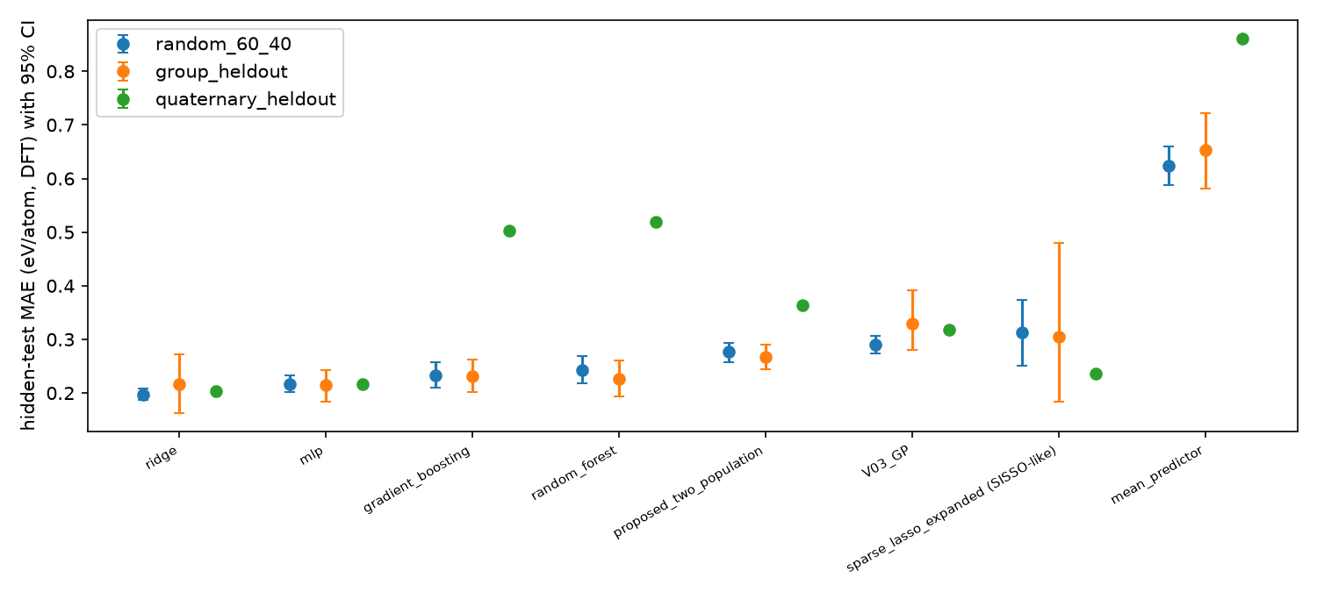
Figure 13. Expt-06: hidden-test MAE with 95% CI for each model on random, group-held-out and quaternary-held-out splits (experiments_v04/expt06_baselines_ablations/figures/expt06_baselines.png).

9.7.3 Existence discovery with positive-unlabelled ranking (Expt-07)
Expt-07 replaced V03’s ranking by predicted energy above a 55-compound training hull with a positive-unlabelled (PU) formulation: a bagged random forest learns to separate known compounds (positives) from enumerated candidates (unlabelled), optionally with the energy above the training hull, oxidation-state features or a restriction to V03’s analogy templates. About 41,300 candidates were ranked, with 32.7 hidden compounds in the space on average (random expectation 0.08 at 100 and 0.79 at 1,000).
Table 9.9. Expt-07 hidden real compounds found in the top k, mean of 10 random 60/40 splits (experiments_v04/expt07_compound_discovery/summary.csv)
Method | Top 10 | Top 100 | Top 1,000 | Median rank
Random | 0.0 | 0.0 | 0.0 | 17,015
Charge balance only (oxidation-state prior) | 0.0 | 0.5 | 7.8 | 4,880
V03 analogy + GP_ox + hull (recomputed) | 0.8 | 1.9 | 7.8 | 18,148
PU-RF, element attributes only | 0.1 | 1.6 | 13.7 | 1,549
PU-RF + energy above training hull | 0.1 | 2.4 | 16.2 | 1,110
PU-RF + oxidation-state features (prior) | 0.6 | 3.3 | 15.9 | 1,072
PU-RF (ox.) within analogy templates | 1.2 | 5.9 | 13.6 | 1,205

On the group-held-out folds (16.2 hidden compounds), PU-RF with oxidation-state features finds 1.6 in the top 100 and 8.2 in the top 1,000 (median rank 909), against 0.0, 0.4 and 27,701 for the V03 analogy ranking. Paired over 10 splits, PU-RF with element attributes only gains +5.9 hits at 1,000 [3.7, 8.3] (p = 0.002) and lowers the median rank by 16,600 (p = 0.002) relative to V03; hits at 100 do not differ. After Holm correction over all 36 tests the smallest adjusted p is 0.07, because 10 pairs give a minimum Wilcoxon p of 0.002, so individual comparisons are not significant at 0.05 even where every split agrees. The V03 analogy method recomputed here gives 1.9 at 100, against 2.0 reported in V03.
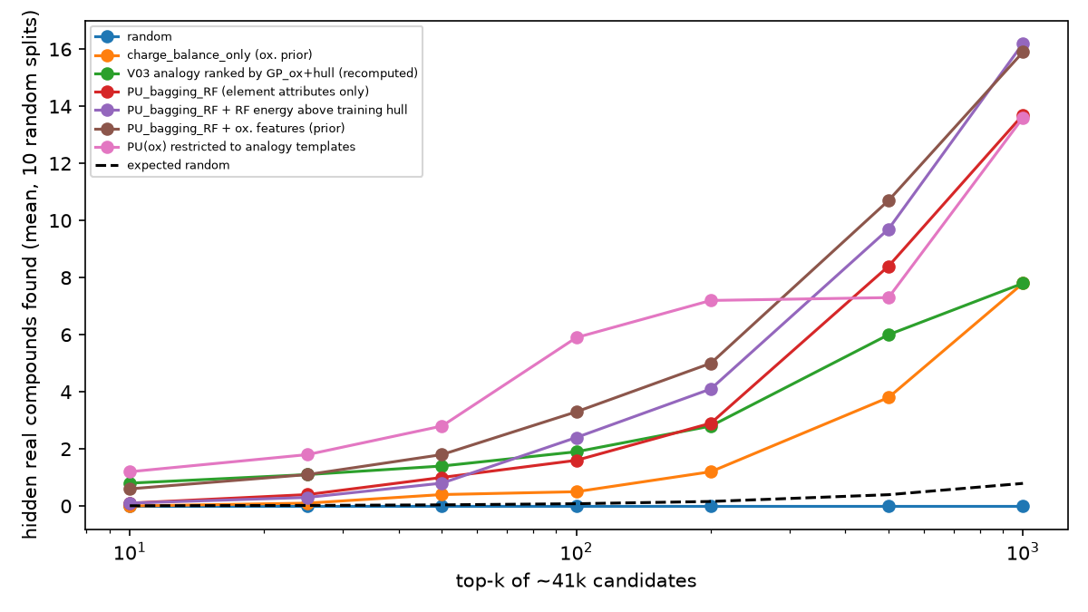
Figure 14. Expt-07: hidden real compounds found among the top k of about 41,000 candidates, mean of 10 random splits (experiments_v04/expt07_compound_discovery/figures/expt07_recall_at_k.png).
Interpretation: PU ranking is the strongest positive result of V04: median rank improves about 15-fold and the top 1,000 contains about half of the hidden compounds (about a quarter for V03). The credit belongs to the ranking method, not to the evolved rules: PU-RF does not use evolved rules at all. Precision at the very top remains low (best 5.9 of 32.7 in the top 100, about 75 × random, using oxidation-state priors and analogy templates; 1.6 without chemical priors).

9.7.4 Emergent periodicity (Expt-04)
The co-occurrence element grouping is robust: full-data ARI 0.528 against a null 95th percentile of 0.029; on 80% compound subsamples ARI 0.500 ± 0.034 (minimum 0.433), with the nearest neighbour in the same group 0.50 ± 0.03. The embedding dimension matters little above 8 (4 → 0.36, 8 → 0.49, 12 → 0.53, 24 → 0.55). Downstream use was tested by adding the learned embedding to the Fe–Na–O–P features:
Table 9.10. Expt-04 DFT formation-energy MAE (eV/atom), 16 splits, 95% CI (experiments_v04/expt04_emergent_periodicity/analysis.md)
Features | GP | Ridge
Base only | 0.320 [0.298, 0.345] | 0.205 [0.183, 0.228]
+ learned embedding | 0.210 [0.191, 0.231] | 0.208 [0.186, 0.234]
+ random Gaussian embedding | 0.231 [0.208, 0.257] | 0.209
+ element-shuffled embedding | 0.271 [0.251, 0.293] | 0.210

For the GP, the learned embedding beats the base features (−0.110, Holm p = 0.0003) and an element-shuffled embedding (−0.061, Holm p = 0.0015), but not a random embedding after correction (−0.021, p = 0.029, Holm 0.23). Ridge gains nothing. In zero-shot ridge transfer to 7 targets the learned embedding beats no embedding (−0.22, p = 0.006, Holm 0.057) and a random embedding (−1.59, Holm p < 1e-4); pooled 10-shot transfer shows no significant differences. Stable grouping is confirmed, but a downstream benefit beyond a random embedding is not proven: most of the GP gain is extra element-identity capacity rather than periodic-table structure.
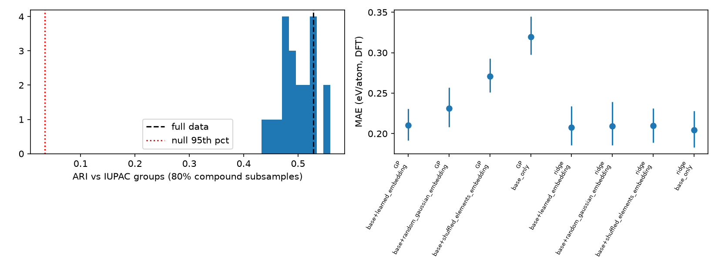
Figure 15. Expt-04: ARI against IUPAC groups over 80% compound subsamples (left) and downstream MAE with each embedding (right) (experiments_v04/expt04_emergent_periodicity/figures/expt04_periodicity.png).

9.7.5 Chemical transfer (Expt-03)
Rules evolved on all 91 Fe–Na–O–P compounds were applied to experimentally observed MP compounds of similar systems (K–Fe–O–P, n = 40; Li–Fe–O–P, 24; Na–Mn–O–P, 44), an intermediate system (Na–Fe–O–S, 46) and dissimilar systems (Ba–Ti–O–Si, 68; Al–Mg–O–Si, 48; H–N–O–S, 91), with 0, 5, 10 or 20 random target labels (5 draws, GP seeds 0–2).
Table 9.11. Expt-03 target MAE (eV/atom, DFT), mean over targets of each class (experiments_v04/expt03_chemical_transfer/analysis.md)
Class / shots | GP source refit | GP source + offset | GP target only | Ridge target only | Ridge pooled | RF source zero-shot | GP source zero-shot
Similar, 5 | 0.404 | 0.353 | 11.8 (unstable) | 0.600 | 0.401 | 0.318 | 0.387
Similar, 10 | 0.354 | 0.343 | 0.482 | 0.406 | 0.395 | 0.310 | 0.379
Similar, 20 | 0.325 | 0.317 | 0.312 | 0.328 | 0.288 | 0.320 | 0.393
Dissimilar, 5 | 0.771 | 0.774 | 1.106 | 1.384 | 0.834 | 0.732 | 1.038
Dissimilar, 10 | 0.588 | 0.742 | 0.768 | 0.551 | 0.585 | 0.728 | 1.043
Dissimilar, 20 | 0.556 | 0.724 | 0.369 | 0.431 | 0.431 | 0.726 | 1.026

Reusing the evolved structure with refitted coefficients beats target-only GP at 10 shots on similar targets (−0.128, Holm p = 0.024) and target-only ridge at 5 shots (−0.196, Holm p < 1e-4). On dissimilar targets at 20 shots it is worse than target-only GP (+0.188, Holm p < 1e-4) and target-only ridge (+0.125, Holm p = 0.012). Transfer is positive for similar systems with few labels and negative for dissimilar systems, the pattern of a genuine but narrow prior. A random forest trained on Fe–Na–O–P is as good or better zero-shot on similar systems, so the transferable content is not specific to evolved symbolic rules. (The repository figure expt03_transfer.png is not reproduced here: its scale is dominated by one unstable target-only GP fit.)

9.7.6 Active selection of training compounds (Expt-05)
Starting from 8 labelled compounds and acquiring up to 40, uncertainty + diversity acquisition gave the lowest learning-curve mean on random splits (0.397 vs 0.569 for random selection; final MAE 0.298 vs 0.336); uncertainty alone gave 0.415 / 0.318, uncertainty × reliability 0.419 / 0.307 and diversity 0.406 / 0.312. On group-held-out splits diversity was best (0.384 / 0.308 vs random 0.450 / 0.358). Against random selection, the learning-curve reductions are significant for uncertainty + diversity (−0.172, Holm p = 0.001) and diversity (−0.163, Holm p = 0.048); final-MAE differences are not significant after correction (best −0.038, Holm 0.087). Focused selection gives faster early learning but the same final error, mainly by avoiding unstable early GP fits; the reliability term adds nothing.
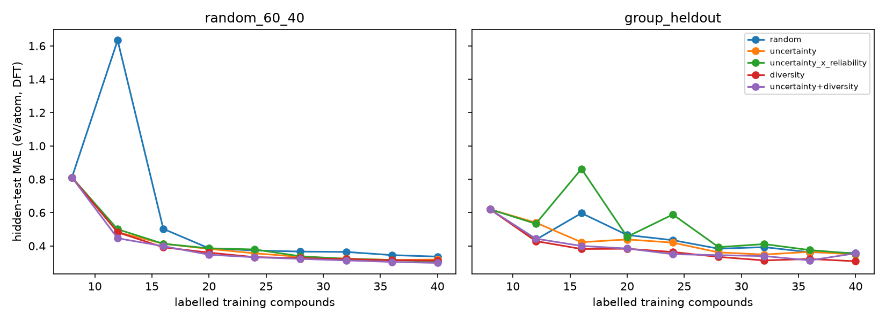
Figure 16. Expt-05: hidden-test MAE against the number of labelled training compounds for five acquisition strategies (experiments_v04/expt05_statistical_focusing/figures/expt05_learning_curves.png).

9.7.7 Measured-property validation (kept separate from DFT)
All results above use DFT formation energies. V04 therefore added a validation on measured data, reported separately and never pooled with the DFT results: matminer expt_formation_enthalpy_kingsbury (2,010 unique formulas after merging duplicates) and expt_gap (4,492 unique formulas), with 5-fold cross-validation grouped by chemical system.
Table 9.12. Measured-property validation, MAE (experiments_v04/validation/measured_properties/analysis.md)
Target (measured) | Random forest | Ridge | GP | Mean
Formation enthalpy, eV/atom (2,010 formulas) | 0.192 [0.182, 0.200] | 0.316 [0.308, 0.323] | 0.323 [0.300, 0.345] | 0.770
Band gap, eV (4,492 formulas) | 0.543 | 0.909 | 0.942 | 1.200

On measured formation enthalpy the GP is worse than the random forest in all 5 folds (+0.131); on large measured datasets the evolved symbolic regressor performs like a linear model. Inside Fe–Na–O–P, MP DFT formation energies differ from measured ΔHf by 0.080 eV/atom MAE on 13 formulas (largest FeO 0.34, P2O5 0.22), while models trained on the 91 DFT values score 0.180 (ridge) and 0.295 (GP) against measured values. Model error is therefore 2–4 times the DFT–experiment gap: the DFT-based conclusions are limited by model error, not by the DFT target.

9.7.8 Expt-08 (strategy evolution) not run
Expt-08 was conditional on Expt-01 to Expt-06 being stable, reproducible and justified, and was deliberately skipped (decision of 14 Oct 2026, Stage 3). The mechanism that strategy evolution would tune showed no contradiction-specific benefit (Expt-01, +0.002, p = 0.90; uncertainty, reliability and gate ablations null) and produced 40% false discoveries in synthetic environments without exceptions. Evolving meta-strategies over components with null effects would mostly search noise, and with 91 compounds and about 14-sample inner validation sets it would overfit the selection procedure. The two clearly active ingredients (charge-balance features, learned embeddings) are better studied directly. Preconditions to revisit: permutation-controlled specialist acceptance with a demonstrated low false-discovery rate on synthetic data; a contradiction component with a positive, significant ablation; a benchmark of at least several hundred compounds or multiple systems. Strategy evolution therefore remains untested, and evolutionary intelligence (Section 8.2) is still not demonstrated.

9.7.9 How to reproduce V04
- Check out branch research-v04 of https://github.com/hsmazumdar/Evolutionary-AI-Chemistry-Discovery.
- Run python experiments_v04/<expt>/reproduce.py for each experiment (each finishes in under 2 min on 8 CPU cores).
- Run pytest experiments_v04/tests (8 tests, including V03-unchanged and test-label poisoning).
- Each config.yaml records the Python and package versions (numpy 2.5.4, pandas 3.0.6, scipy 1.18.1, scikit-learn 1.9.1, matplotlib 3.11.2), git commit, dataset SHA-256 hashes and seeds; predictions are saved with sample and split IDs.

10. Decisions and open questions
Topic | Current position (V04) | Status
Initial intelligence | Option A (primitive) for main runs; oxidation-state features as an explicit, reported prior | Agreed; tested
Counting unit | Distinct formulas, each represented by its lowest-E_hull observed entry | Agreed; implemented
Knowledge permanence | No knowledge permanently immune to revision; superseded rules kept with history | Agreed; implemented
First evolving object | Knowledge rules (GP equations); learning strategy deferred (Expt-08 not run) | Agreed; implemented
Choice of 3–4 elements | Fe–Na–O–P (91 formulas); H–N–O–S used as a dissimilar transfer target in V04 | Decided (V03)
Primary data source | MP release 2025-09-25 via AWS OpenData; mendeleev elements; matminer measured sets | Decided (V03)
Organic/inorganic boundary rule | POC-1: all carbon-containing materials excluded | Decided for POC-1; open later
Contradiction as primary driver | Two-population specialist ties the high-residual specialist (+0.002, p = 0.90) and is worse than GP with the same features (Section 7.5) | Not supported as implemented; reformulate as missing-variable discovery
Role of the revisable memory | Interpretability and provenance; no learning benefit (Section 6.5) | Decided (V04)
Baseline to beat | Ridge regression, 0.197 eV/atom on random splits; PySR and Roost still to run | Decided (V04); open for PySR/Roost
Existence-discovery protocol | Positive-unlabelled ranking replaces energy-above-hull ranking (Section 9.7.3) | Decided (V04)
Computed vs measured targets | DFT–measured MAE 0.080 eV/atom on 13 formulas; measured validation run separately (Section 9.7.7) | Partly resolved; measured targets to become primary
Strategy evolution | Not run; preconditions in Section 9.7.8 | Deferred
Publication framing | Rigorous benchmark rather than contradiction-driven discovery (Section 12) | Proposed (V04)
E_hull threshold for “plausible” | Not fixed | Open
Time-held-out split | Not implemented: no publication years in the assembled data | Open
Source of reaction/industrial process data | Not identified | Open

11. Next steps and open research problems

11.1 Status of the V03 immediate steps
V03 immediate step | Status (V04)
1. Verify the references and review odd ICSD-matched entries | Open (Appendix B.2); V04 references added and also unverified
2. Run the unchanged benchmark on H–N–O–S | Not run as a full benchmark; H–N–O–S (91 compounds) used as a dissimilar transfer target in Expt-03
3. Add MLP and Roost baselines | MLP, gradient boosting and sparse Lasso added (Expt-06); Roost and PySR not run (no PyTorch or Julia)
4. Constant optimisation and Pareto selection for the GP | Not addressed in the V04 experiments; GP still 0.068 eV/atom behind ridge
5. Weak-negative existence training; specialist-rule contradiction investigation | Done: PU discovery (Expt-07, positive) and two-population specialists (Expt-01, not supported)
6. Confidence and limits on every adopted rule | Done in the competing-hypothesis memory (Expt-02); calibration poor under shift

11.2 Open PhD-level research problems (revised in V04)
V04 narrows the programme. The problems below are ordered by the strength of the V04 evidence and each names the result it starts from; all can use the research-v04 branch as a baseline.
- Contradictions as missing-variable discovery. The only active ingredient of the contradiction mechanism was the missing-variable channel (oxidation-state features, 0.020 eV/atom). Recast contradictions as evidence of an absent variable: search candidate variables (oxidation state, anion type such as peroxide/superoxide, coordination) that explain clustered residuals; use contradiction scores that do not shrink at exceptions (leave-one-out residuals, conformal scores); accept specialists only against a permutation null with false-discovery control, validated first on the synthetic environments.
- Existence discovery. PU ranking improved the median rank from 18,148 to 1,549 without evolved rules, but finds at most 5.9 of 32.7 hidden compounds in the top 100. Combine PU with weak negatives (MP theoretical entries), calibrated existence probabilities and evolved rules as features, and test whether evolved knowledge adds anything to the ranking method.
- Transfer across chemical systems. Evolved structures are a useful prior for similar systems with 5–10 labels but hurt dissimilar systems by 20 labels, and a random forest transfers as well. Develop a chemical-similarity measure that predicts when transfer helps, and test it on more source–target pairs.
- Beat linear regression with interpretable models. All GP variants trail ridge (0.277 vs 0.197 eV/atom). Run PySR/SISSO and Roost/CrabNet on a GPU machine, add constant optimisation and accuracy–size Pareto selection, and compare the Grow-Prune HONN networks.
- Periodicity beyond capacity. The learned embedding helps the GP (0.320 → 0.210) but a random embedding gives 0.231. Show a significant benefit over random and shuffled embeddings on larger and multiple systems before claiming that self-discovered periodicity is useful knowledge.
- Measured targets as primary endpoints. On measured enthalpy and band gap the GP behaves like a linear model and the random forest is best; repeat the core experiments with measured targets as the primary endpoint.
- A calibrated, useful memory. The memory’s 90% intervals cover 63% under shift. Improve uncertainty (e.g. conformal intervals) and test whether provenance and revision history aid human interpretation, the role the memory is kept for.
- From fits to knowledge. Each split still evolves a different equation; define stability criteria (sub-expression frequency, consensus rules) for when an evolved relationship counts as knowledge.
- Scale. Build multiple systems or a pooled benchmark of at least several hundred compounds, with identical feature sets in all controls, so that small effects can be detected.
- Strategy evolution (deferred). Revisit Expt-08 only when the preconditions of Section 9.7.8 are met.

11.3 Revised plan
The plan concentrates on the three directions with positive or diagnosable V04 results, followed by the benchmark work needed for any publication.
- Discovery (first). Establish PU ranking as the existence-discovery baseline; add weak negatives, calibrated probabilities and group-held-out evaluation; test whether evolved rules or learned embeddings add to it; prepare a short list of top-ranked unknown candidates for expert review.
- Transfer (second). Extend Expt-03 to more source–target pairs; define and test a similarity measure that predicts the sign of transfer; compare symbolic transfer with random-forest and embedding transfer at equal label budgets.
- Missing-variable approach to contradictions (third). Implement leave-one-out or conformal contradiction scores, a library of candidate chemical variables and permutation-null acceptance with false-discovery control; require low false-discovery rates on the synthetic environments before any real-data claim.
- Benchmark infrastructure. Pooled multi-system data set of several hundred compounds or more; identical feature sets in all controls; PySR/SISSO and Roost/CrabNet on a GPU machine; measured targets as primary endpoints.
- Housekeeping. Verify all references and review odd ICSD-matched and frequently flagged entries (e.g. FePO6, Fe4O13, P2O9) before external release.

12. Publication framing
The V04 research report is titled “Contradiction-Driven Evolutionary Knowledge Discovery with Revisable Rule Memory for Inorganic Materials”. That title is not supported by the evidence: the contradiction-driven specialist ties a plain high-residual specialist and is worse than GP given the same features, and the revisable memory ties replay. A paper with that title would claim a mechanism that the experiments falsified.
A defensible framing is a rigorous benchmark of evolutionary knowledge mechanisms on small inorganic systems, reporting positive and negative results with equal weight. A possible working title (a suggestion, not a decision) is “Do evolved symbolic rules learn chemistry? A leakage-controlled benchmark of contradiction, memory, transfer and discovery mechanisms on small inorganic data”. Its contributions would be:
- a leakage-controlled protocol: frozen splits, training-only hull, matched budgets, test-label poisoning test, synthetic environments with known ground truth, paired tests with Holm correction;
- clear negative results on contradiction-driven specialists and revisable memory, with the diagnosed reasons (uncertainty shrinking at exceptions, weak acceptance gate, feature confounding, small data);
- positive-unlabelled existence ranking as a discovery protocol (median rank 18,148 → 1,549), credited to the ranking method;
- robust emergent periodicity with a capacity control (random and shuffled embeddings), and low-data transfer limited to similar systems;
- a strict separation of DFT and measured targets.
Before submission to a high-impact venue the report itself lists what is needed: permutation-null specialist acceptance with measured false-discovery control; contradiction scores that do not shrink at exceptions; multiple systems or a pooled benchmark of at least several hundred compounds; identical feature sets in all controls; PySR/SISSO and Roost/CrabNet baselines; and measured targets as primary endpoints. PU discovery and learned element embeddings could alternatively be written up as their own, modest contributions. No framing should present V04 as evidence for contradiction-driven discovery.

Appendix A. Validation and editing notes (V0.2 and V03)

A.1 V0.2 corrections
- Experimental attributes for all 118 elements: V0.1 implied that every element has experimentally established attributes. For the heaviest elements many properties (melting point, density, electron configuration, electronegativity) are unmeasured or theoretical; V0.2 requires such values to be flagged.
- Data-source claims: Materials Project and OQMD are clarified as predominantly computed (DFT) resources; their ICSD links, not their computed properties, provide experimental existence evidence. ICSD, COD, NIST-JANAF, NIST ASD and IUPAC were added as experimental/evaluated sources with access conditions.
- Property coverage: Melting point, solubility and conductivity are not generally available from DFT databases; molecular/liquid species such as H₂SO₄ are generally outside crystal-structure databases. Noted in Table 3.1.
- Attribute definitions: Electronegativity scale, radius definition, phase/pressure for melting points and densities must be fixed; Pauling electronegativity is undefined for He, Ne, Ar; some elements sublime at 1 atm and He does not solidify at 1 atm.
- Existence scoring: Existence is scored against experimentally confirmed entries with E_hull as secondary evidence; unconfirmed compositions are “unknown”, not negative; metastable compounds (E_hull > 0) can exist (e.g. maghemite).
- Leakage: Added that hull/formation-energy features computed from the full database leak the hidden compounds; added group- and time-held-out splits.
- Composition vector (Eq. 2): Raw integer stoichiometry makes predictions depend on how the formula is written; normalised fractions recommended. Crystal-graph GNNs (CGCNN, MEGNet) need structures, while Roost works from composition alone.
- Fuzzy logic: V0.1 stated that fuzzy logic “does not independently discover knowledge”. Corrected: hand-built fuzzy systems do not, but data-driven fuzzy rule induction can.
- Newton–Einstein example: V0.1 said knowledge may revert “after hundred years”; Newtonian mechanics stood for more than two centuries before relativity, and was refined in domain rather than overturned.
- Methods: Candidate methods from later discussion (Roost, CGCNN, MEGNet, SISSO, PySR, Grow-Prune HONN, rule induction, fuzzy rules, GP, NEAT-style evolution, hypothesis populations, active learning, convex-hull referee) integrated into Sections 5.3 and 5.5.

A.2 V0.2 redundancy and artefacts removed
- Conversational framing (user prompts, “I think this is a very promising direction”, “My one question is…”) converted into design statements and decisions.
- Source-chip artefacts (“Materials Project Documentation”, “oqmd.org”, “+1”) and their two favicon images removed.
- Repeated restatements of the proposal (Sections “My understanding of your proposal”, “Consider our proposed experiment”, “My evolving view of our project”) merged into Sections 1 and 4.
- The leakage warning (hidden 40% must not be used for selection), stated three times in V0.1, consolidated into Table 4.4.
- The three overlapping algorithm recommendations (“current preference” hybrid, Bayesian + GP + versioned memory, two populations) merged into Sections 5.5, 6.3 and 7.3.
- Existence/stability/synthesizability distinction, repeated twice, consolidated in Sections 3.3 and 4.3.
- Numbered sub-sections restarting at 1 in each discussion turn replaced by one continuous numbering.
- Four figure captions without figures in the source (“Conceptual architecture”, “Conceptual population of learners”, “Evolutionary knowledge-memory model”, “Contradiction-driven evolutionary architecture”) replaced by text, tables and the new Figure 3; the two images present (neural-network illustration and selection diagram) are retained as Figures 1 and 2.

A.3 V03 changes
- Title page and credit: “Conceived and directed by Himanshu Mazumdar, R&D Centre, Dharmsinh Desai University, Nadiad, Gujarat, India” and “Code developed with AI assistance”; version 03, 14 October 2026; repository link.
- Section 1: status paragraph; carbon-free decision for the organic/inorganic boundary in POC-1.
- Section 3 (data): actual sources and counts (MP 2025-09-25: 189,775 carbon-free materials, 44,686 experimentally observed, 38,844 distinct formulas; mendeleev; matminer measured sets; OQMD unavailable); data-source table updated; new Section 3.6 and caveats.
- Section 4: implemented column added to the POC-1 parameter and safeguard tables; the Step 0 note replaced by the feasibility result (maximum 97 formulas) and the Fe–Na–O–P / H–N–O–S selection; implemented scope of Discovery A/B.
- Sections 5–8: “as implemented” notes; four new equations (8)–(11) for the discovery score, GP fitness, the evolved rule of split 0 and the contradiction flag; new Sections 6.4 and 7.4; baseline status; evidence column in the Section 8.4 assessment table.
- New Section 9 (POC-1 implementation and results): architecture, GUI, protocol, all result tables from RESULTS.md, Figures 4–9, honest interpretation and reproduction instructions, with an independent re-run check.
- Sections 10–11: decisions table updated; next steps rewritten as a status table, ten open PhD-level problems and immediate actions.
- Appendix B: items answered by the feasibility study moved to “resolved”; new unverified items added. References extended (data and software sources); all references still need verification.

A.4 V0.2 statements corrected in V03
- Materials Project access: V0.2 listed “free account and API key”. The bulk summary data used here are also public on the AWS OpenData bucket materialsproject-build without a key.
- Target of 100–200 experimentally confirmed formulas per 3–4-element system (Section 4.1): not attainable in MP 2025-09-25 (maximum 97).
- OQMD listed as a usable source: its REST API was unavailable (HTTP 502) on 13 Oct 2026, and it was not used.
- Time-held-out splits (Section 4.4): cannot be built from MP data alone, which carry no publication years.

Appendix B. Items resolved, still unverified or open

B.1 Resolved by the data feasibility study, POC-1 and the V04 experiments
- Whether any 3–4-element system contains 100–200+ distinct experimentally confirmed formulas. Answered: none does in MP 2025-09-25; the maximum is 97 (Ba–O–P–V). Fe–Na–O–P (91) was selected and H–N–O–S (92) kept as the alternative (Section 4.2).
- Completeness of target properties for the selected system. Answered: all 91 Fe–Na–O–P formulas (and all 92 H–N–O–S formulas) have complete target properties in the ranking file.
- Coverage of heavy-element attributes (partly resolved). The element table now flags 19 elements with Z ≥ 100 as largely predicted or absent and lists missing fields for 44 elements. Checking each value against primary references remains open (B.2).
- Choice of data source and access route. Resolved: MP release 2025-09-25 via AWS OpenData (CC-BY-4.0); OQMD unavailable at build time.
- Agreement of DFT targets with measured enthalpies for Fe–Na–O–P (V04). Checked for 13 formulas: MAE 0.080 eV/atom (largest FeO 0.34, P2O5 0.22), smaller than the model errors of 0.180 (ridge) and 0.295 (GP) against measured values (Section 9.7.7).
- Whether contradiction-driven specialists improve generalisation (V04). Tested: not supported as implemented (Section 7.5).
- Reproducibility of V03 (V04). All V03 outputs reproduced byte-for-byte or to ≤ 3.3e-16.

B.2 Still unverified or open
- Grow-Prune higher-order-neuron (HONN) networks are the author’s method; no publication reference was provided, so no citation is given.
- Source of reaction observations, operating conditions and industrial processing data — not identified in V0.1 or later discussion.
- Exact coverage of experimental element properties for heavy elements: partly addressed by the flags in the element table (B.1), but each attribute still needs checking against its primary reference, because the Z cut-off beyond which values are theoretical differs by property.
- E_hull threshold separating “plausible/metastable” from “implausible” — not specified; no value has been adopted.
- The discovery-priority formula (Eq. 7), the 990/1,000 and 20/200/2,000 examples, and Eq. (5) are illustrative heuristics, not validated results.
- Four V0.1 figures were referenced (caption only) but absent from the file; their original content could not be recovered.
- Bibliographic details in the References were added in V0.2 and V03 from standard references and software/data documentation; confirm them against publisher records before external release.
- The “experimentally observed” label relies on MP’s ICSD matching and has not been independently checked; odd ICSD-matched entries (e.g. SO12, H30S2O21 in H–N–O–S) still need review.
- The V03 contradiction rule (Eq. 11) has been superseded by the two-population design (Eqs. 12–15). Its settings (top 15% priority, depth-2 domain tree, acceptance margin 0.005 eV/atom) are design choices; V04 shows that the gate is too weak for about 14-sample validation sets.
- The interpretation of flagged compounds and of the learned element clusters is qualitative and has not been reviewed by a domain expert.
- V04 run-level paired tests (80 runs) treat seeds within a split as separate pairs, which overstates independence; split-level tests are reported only for key comparisons.
- Small inconsistencies between V04 files: the research report quotes Holm-adjusted p = 0.004 (proposed vs ridge) and 0.003 (missing-variable ablation), while the analysis files give unadjusted p = 0.0004 for both; the V03 GP scores 0.290 in Expt-06 vs 0.305 in V03 (different seed protocol); the recomputed V03 analogy method gives 1.9 hits at 100 vs 2.0 in V03.
- Measured data counts: V04 uses 2,010 and 4,492 unique formulas after merging duplicates, whereas V03 quoted 2,060 and 6,245 carbon-free rows; the two counts are on different bases and have not been reconciled.
- Exceptional/ordinary test labels in Expt-01 come from a ridge reference model, so “exceptional” means “badly predicted by ridge”, not a chemically verified exception.

Appendix C. Changes from V03 to V04
- Title page: Document V04, Version 04, 14 October 2026, status updated, link to the research-v04 branch; credit lines kept (“Conceived and directed by Himanshu Mazumdar, R&D Centre, Dharmsinh Desai University, Nadiad, Gujarat, India”; “Code developed with AI assistance”). Running header V04.
- Section 1: Status at V04 paragraph.
- Section 5.3: V04 baseline status (ridge best, GP less accurate, PySR/Roost not run).
- Section 6: new Section 6.5 (Expt-02, Table 6.1, Figure 10): memory kept for interpretability, no learning benefit.
- Section 7: new Section 7.5 with Eqs. (12)–(15), synthetic validation (Table 7.1, Figure 11), Expt-01 (Table 7.2, Figure 12), reasons for failure, chemical case study and verdict: not supported as implemented.
- Section 8.4: V04 update note on evolutionary intelligence and novelty.
- Section 9: V04 note in 9.5; new Section 9.7 with all V04 experiments (Tables 9.7–9.12, Figures 13–16): baselines, PU discovery, periodicity, transfer, active selection, measured-property validation, Expt-08 not run, reproduction.
- Section 10: decisions table rewritten for V04 (contradiction, memory, baseline, discovery protocol, measured targets, strategy evolution, publication framing).
- Section 11: status of the V03 immediate steps; ten revised PhD problems; revised plan (discovery, transfer, missing-variable approach to contradictions, benchmark infrastructure).
- New Section 12: publication framing (contradiction-driven title not supported; rigorous-benchmark framing).
- Appendix B updated (resolved and open items); references for statistical and PU methods added and marked “added in V04”.
- Layout: table rows kept together with their table so that no single row is left on a new page (the V03 decisions-table orphan is fixed).

References
Bibliographic details were compiled from standard references and, for V03 and V04 additions, from the data and software documentation. They still need verification against publisher records before external release (Appendix B).
Chen, C., Ye, W., Zuo, Y., Zheng, C., & Ong, S. P. (2019). Graph networks as a universal machine learning framework for molecules and crystals. Chemistry of Materials, 31(9), 3564–3572. (MEGNet)
Cranmer, M. (2023). Interpretable machine learning for science with PySR and SymbolicRegression.jl. arXiv:2305.01582.
Elkan, C., & Noto, K. (2008). Learning classifiers from only positive and unlabeled data. Proceedings of the 14th ACM SIGKDD International Conference on Knowledge Discovery and Data Mining, 213–220. (PU learning; added in V04)
Goodall, R. E. A., & Lee, A. A. (2020). Predicting materials properties without crystal structure: deep representation learning from stoichiometry. Nature Communications, 11, 6280. (Roost)
Holm, S. (1979). A simple sequentially rejective multiple test procedure. Scandinavian Journal of Statistics, 6(2), 65–70. (added in V04)
Hubert, L., & Arabie, P. (1985). Comparing partitions. Journal of Classification, 2, 193–218. (adjusted Rand index; added in V03)
Jain, A., et al. (2013). Commentary: The Materials Project: A materials genome approach to accelerating materials innovation. APL Materials, 1, 011002.
Kim, G., Meschel, S. V., Nash, P., & Chen, W. (2017). Experimental formation enthalpies for intermetallic phases and other inorganic compounds. Scientific Data, 4, 170162. (added in V03)
Koza, J. R. (1992). Genetic Programming: On the Programming of Computers by Means of Natural Selection. MIT Press.
Materials Project (2025). Summary data, database release 2025-09-25. AWS Open Data Registry, bucket materialsproject-build. Licence CC-BY-4.0. Downloaded 13 October 2026. (added in V03)
Mazumdar, H. (2026). EvolutionaryChemistry: can a simple evolving system learn real chemistry? (POC-1 demonstration and V04 research experiments; code developed with AI assistance). GitHub repository, https://github.com/hsmazumdar/Evolutionary-AI-Chemistry-Discovery; V04 experiments on branch research-v04, https://github.com/hsmazumdar/Evolutionary-AI-Chemistry-Discovery/tree/research-v04. (added in V03, updated in V04)
Mentel, Ł. M. mendeleev – A Python resource for properties of chemical elements, ions and isotopes. Software, https://github.com/lmmentel/mendeleev. (added in V03)
Mordelet, F., & Vert, J.-P. (2014). A bagging SVM to learn from positive and unlabeled examples. Pattern Recognition Letters, 37, 201–209. (PU bagging; added in V04)
Ouyang, R., Curtarolo, S., Ahmetcik, E., Scheffler, M., & Ghiringhelli, L. M. (2018). SISSO: A compressed-sensing method for identifying the best low-dimensional descriptor in an immensity of offered candidates. Physical Review Materials, 2, 083802.
Pyykkö, P., & Atsumi, M. (2009). Molecular single-bond covalent radii for elements 1–118. Chemistry – A European Journal, 15(1), 186–197. (added in V03)
Saal, J. E., Kirklin, S., Aykol, M., Meredig, B., & Wolverton, C. (2013). Materials design and discovery with high-throughput density functional theory: the Open Quantum Materials Database (OQMD). JOM, 65, 1501–1509.
Slater, J. C. (1964). Atomic radii in crystals. The Journal of Chemical Physics, 41(10), 3199–3204. (added in V03)
Stanley, K. O., & Miikkulainen, R. (2002). Evolving neural networks through augmenting topologies. Evolutionary Computation, 10(2), 99–127. (NEAT)
Wang, A., Kingsbury, R., McDermott, M., Horton, M., Jain, A., Ong, S. P., Dwaraknath, S., & Persson, K. A. A framework for quantifying uncertainty in DFT energy corrections. ChemRxiv preprint, doi:10.26434/chemrxiv.14593476.v1. (source of matminer expt_formation_enthalpy_kingsbury; added in V03)
Ward, L., Dunn, A., Faghaninia, A., Zimmermann, N. E. R., Bajaj, S., Wang, Q., Montoya, J., Chen, J., Bystrom, K., Dylla, M., Chard, K., Asta, M., Persson, K. A., Snyder, G. J., Foster, I., & Jain, A. (2018). Matminer: An open source toolkit for materials data mining. Computational Materials Science, 152, 60–69. (added in V03)
Wilcoxon, F. (1945). Individual comparisons by ranking methods. Biometrics Bulletin, 1(6), 80–83. (added in V04)
Xie, T., & Grossman, J. C. (2018). Crystal graph convolutional neural networks for an accurate and interpretable prediction of material properties. Physical Review Letters, 120, 145301. (CGCNN)
Zhang, W., Oganov, A. R., Goncharov, A. F., et al. (2013). Unexpected stable stoichiometries of sodium chlorides. Science, 342, 1502–1505.
Zhuo, Y., Mansouri Tehrani, A., & Brgoch, J. (2018). Predicting the band gaps of inorganic solids by machine learning. The Journal of Physical Chemistry Letters, 9(7), 1668–1673. (source of matminer expt_gap; added in V03)

