Success-Weighted Path-Unit Memory of Local Feel Sequences Improves Leave-One-Out Generalization on Procedural Terrain
Running title: Source-cell feel-memory LOO on procedural terrain
Manuscript front matter draft for Q1 venue targeting
Abstract
We study a lightweight feel-memory navigator that stores local terrain feel n-grams with the motor actions taken along successful teacher paths, then retrieves those units on held-out procedural worlds under honest leave-one-out (LOO) evaluation. The design question is which write rule admits path units into long-term memory. Promoting unique success-weighted units anchored at the source (departure) cell yields LOO goal-known energy gains of 75.2%, 80.8%, 71.5%, and 69.3% on four held-out procedural terrains across five seeds. Dest-cell anchoring and frequency-ranked replace weaken or collapse those gains; appending frequency-ranked signatures preserves goal-known scores without improving them. Destination-hidden LOO (goal coordinates withheld at test) remains mixed and is deeply negative on one high-relief terrain, a stated limit of feel-only memory without geometry. Claims are confined to write-rule comparisons within this lightweight architecture under honesty controls; external learned baselines are left to future work. Frozen code and evaluation logs accompany the paper.
Keywords
long-term memory; short-term memory; feel n-grams; success-weighted promotion; leave-one-out generalization; procedural terrain navigation; source-cell anchoring; energy-efficient path following; episodic path units; honest evaluation

1. Introduction
Animals and artificial agents navigate by combining immediate sensory cues with memories of where they have been and which actions previously succeeded. Classical accounts of cognitive maps emphasize an allocentric representation of space that supports flexible route selection [1][2]. Subsequent physiology has refined that picture: hippocampal place cells often encode routes and trajectories rather than destinations alone [3], can distinguish overlapping episodes at the same location [4], and participate in trajectory coding across hippocampus and entorhinal cortex [5]. These findings motivate computational models in which navigational memory is organized around path fragments and local context, not only around a static map of goals.
A complementary computational tradition frames hippocampal and related systems as predictive maps. The successor representation (SR) stores expected future occupancy under a policy, enabling generalization across goals that share predictive structure [6]. Later work has cast the hippocampus as a predictive map [7], clarified the computational logic and neural substrates of the SR [8], and positioned hippocampal control as a third way between model-free and full model-based planning [9]. Related planning architectures that approximate dynamic programming through learned models and replay [10] likewise treat stored experience as the substrate of flexible control. Across these lines, the open design question is not whether memory matters, but which write rule decides what enters long-term storage when experience is local, noisy, and only partially informative about future goals.
Replay provides a second constraint on that write rule. Hippocampal ensembles reactivate during sleep [11], support reverse replay of behavioural sequences in the awake state [12], and can depict future paths to remembered goals [13]. Normative accounts argue that memory access should be prioritized by expected value of planning [14], including when future goals are unknown [15]. In machine learning, prioritized experience replay similarly reweights stored transitions by learning progress [16]. Together, these literatures suggest that frequency of occurrence is a weak proxy for usefulness: units that co-occur with successful outcomes, or that carry high expected planning value, should displace units that are merely common.
Bio-inspired robotics and neuromimetic models push the same idea into sensory space. Hierarchical hippocampo-cortical associations support multiple navigation strategies [17]; view-cell and place-cell cascades learn cognitive maps from egocentric experience [18]; and rodent-inspired models ask when geometric modules are required for orientation [19]. Practical systems such as RatSLAM map outdoor suburbs from monocular vision [20], and SeqSLAM retrieves visual routes under severe appearance change [21]. Neuro-mimetic place-cell models likewise show that local sensory signatures can ground spatial codes without an explicit Cartesian map [22]. These systems succeed when route-like sensory sequences are stored and matched; they leave open how candidate sequences should be ranked for long-term retention when only local feel is available.
Experience replay in reinforcement learning (RL) offers a pragmatic counterpart. Early teaching and planning agents already reused stored transitions to improve reactive policies [23], and deep RL agents rely on large replay buffers to stabilize off-policy learning [24]. Yet standard RL replay stores transitions indiscriminately or reweights them by temporal-difference error, not by whether a short local sensory sequence co-occurred with a successful path unit. For lightweight navigators that lack deep value networks, the analogous question is concrete: given short feel n-grams collected along teacher trajectories, which promotion rule yields honest leave-one-out (LOO) transfer on held-out procedural worlds?
We address that gap in a controlled setting with four procedural terrains (Terrain-A..D; Figure 1; Table 1). An agent observes local eight-neighbour feel, maintains a short-term memory (STM) of recent feel n-grams, and promotes selected path units into long-term memory (LTM). Actions retrieved from LTM bias motion relative to a paired no-memory baseline under matched seeds. The champion write rule is success-weighted unique path-unit promotion of source-cell feel n-grams: each unique (feel signature, motor action) unit observed on a successful teacher path is scored by success and stored with its source-cell anchoring. We compare this champion against dest-cell feel anchoring, frequency-ranked replace, and a success-weighted plus frequency append hybrid, under teacher in-sample evaluation, honest LOO, train-on-A transfer, empty-LTM controls, and destination-hidden sensing (goal coordinates withheld at test).
Across cognitive-map, predictive-map, replay, and visual-route traditions, a recurring omission is an explicit comparison of write rules for short local sensory sequences under evaluation that forbids test-time memory rewriting and pairs every with-memory trial to a no-memory control. Without that discipline, apparent transfer can reflect STM leakage, teacher overfitting, or mismatched seeds rather than reusable LTM content. The present study isolates the write rule itself—success versus frequency, source-cell versus dest-cell anchoring—while holding worlds, teachers, and honesty controls fixed.
Significance is scoped deliberately. All claims concern write-rule comparisons within a lightweight local-feel memory architecture under honest LOO pairing; they are not claims of superiority versus modern deep RL agents on large simulators. External learned baselines (for example behaviour cloning or tabular learners over the same feel n-grams and teacher paths) are not reported here and are flagged as future work—an honest limitation foreshadowed by the small internal baseline set (greedy-diagonal, empty LTM, and mechanism ablations).
Our contributions are fourfold. (i) Under honest LOO goal-known (GK) evaluation, success-weighted unique path-unit promotion of source-cell feel yields strong energy gains on all four worlds (Section 3.3). (ii) Anchoring the same feel at the destination cell systematically weakens LOO GK transfer relative to source-cell anchoring, consistent with a named source-cell write-rule principle (Section 2.3). (iii) Replacing success weighting with frequency ranking collapses LOO GK gains, whereas appending frequency-ranked signatures to the success-weighted store neither helps nor substantially hurts GK scores. (iv) Dest-hidden LOO is mixed, with a clear negative regime on Terrain-C that we state as a constructive limit of feel-only memory without geometry, and with Terrain-B remaining the most stable dest-hidden gain—consistent with that world’s near-optimal greedy geometry (Table 1). All claims use locked evaluation logs; mechanism names in the main text avoid implementation codenames.

2. Methods

2.1 Worlds, energy, and reference paths
Primary evaluation uses four fixed procedural grids, Terrain-A..D (Figure 1). Each world has a locked start–goal pair. Agents move on an eight-neighbour lattice; per-step energy depends on local terrain cost. We report energy relative to a geodesic optimal computed by shortest-path search on the energy graph (Dijkstra-style optimal reference) [25], and contrast that optimum with a greedy-diagonal baseline that always steps toward the goal in coordinate space (Table 1). The greedy baseline is intentionally weak on high-relief maps so that memory-induced improvements remain interpretable against a simple reactive policy. Greedy over-optimality is mild on Terrain-B (7.19%) and severe on Terrain-A and Terrain-D (83.36% and 84.94%), with Terrain-C intermediate (37.43%).

2.2 Feel quantization and local sensing
Local terrain feel is quantized from continuous cell roughness into four categories used throughout sensing and memory: Smooth, Medium, Rough, and Obstacle. Thresholds are fixed: roughness at most 0.30 maps to Smooth, roughness at least 0.65 maps to Rough, and intermediate values map to Medium. A cell with an explicit obstacle is Obstacle regardless of roughness. At each decision cell the agent also reads an eight-neighbour relative sense vector whose neighbour labels use the same Smooth/Medium/Rough/Obstacle quantization (plus Edge and Goal markers). Path-unit feel n-grams, however, are sequences of the quantized feel category of visited cells along the trajectory, not the full eight-neighbour tuple itself.

2.3 Feel n-grams, uniqueness, and the source-cell anchoring principle
Consecutive quantized feel categories form feel n-grams in STM. The memory schema can represent n-gram lengths 0 through 5. In the champion promote path, contiguous feel windows of length 3 through 5 are extracted from successful tours; retrieval likewise skips obsolete rules shorter than length 3. Thus n-grams of length 1–5 can be stored, while the champion policy promotes and retrieves lengths 3–5 under exact key fields plus soft feel matching described below. A path unit pairs a feel n-gram with the preferred motor action (move direction) and two context fields: progress bin (progress along the start-goal line) and goal direction.
Uniqueness is defined on a unit key: the feel tuple together with world identifier, progress bin, goal direction, n-gram length, and the up-to-five feel-category slots. Duplicate keys do not add parallel rows; merging into LTM updates a strength score and a sighting count on the existing unit (and may revise the stored move when a stronger competing vote arrives). Success weighting accumulates strength on successful teacher tours only; failed teacher attempts are discarded and never written.
Source-cell anchoring principle. LTM is queried as: given the feel sequence just experienced at the departure cell, which move next? Therefore the feel n-gram must be anchored at the source (departure) cell at both write time and read time. Teacher ingestion records the feel category and cell coordinates from the pre-move source cell on each successful step. Dest-cell anchoring—associating the same promote rule with the arrival cell’s feel—misaligns the retrieval query relative to the decision context and is tested as a matched ablation (Section 3.8). We elevate this source-cell write/read alignment from an empirical finding to a named design principle for feel-path LTM.

2.4 LTM retrieval at test time
At test time the agent builds a recent feel n-gram from STM and scores LTM rules with a directional weight. Matching is not restricted to exact equality of the full feel window: a small Hamming distance on the feel sequence (at most one mismatch for lengths 3–4 and two for length 5), with a preference for suffix alignment, a soft penalty for adjacent progress-bin disagreement, and extra weight for goal-direction agreement when goal coordinates are known. Matched rules contribute a strength-scaled score for their preferred move; agreeing directions raise the directional weight, conflicting directions suppress it. When no LTM rule matches (zero hits), confidence is set to zero and the directional weight is a neutral factor of 1.0, so behaviour falls back to the reactive/greedy terrain-biased controller rather than an unmatched memory vote. Under dest-hidden sensing, goal nearness and goal direction are passed as unknown, removing the goal-direction term from the match score.

2.5 Ranking ablations: frequency replace and append hybrid
Frequency-ranked replace discards success weights and fills LTM by raw occurrence counts of feel n-grams along teacher paths (replace semantics). The append hybrid keeps the success-weighted store and additionally appends frequency-ranked signatures, testing whether extra high-frequency units improve or dilute transfer. Mechanism labels in tables and figures use only these descriptive names (not implementation identifiers).

2.6 Teacher protocol
Teachers generate goal-known trajectories used to populate LTM. For each training world the harness requests 250 noisy goal-seeking attempts plus one Dijkstra success path; only attempts that reach the goal are ingested. Locked paper logs for LOO holding out Terrain-A record 251 successes per train world (B/C/D) and zero failed attempts in that run (753 success paths total before unique merge into LTM). Exact per-seed success/failure counts can vary with the random stream; when unknown for a particular seed we still enforce the success-only write rule: failures are discarded and never promote units. After ingestion, unique feel n-gram units are merged into frozen LTM capacity.

2.7 Honesty protocol
Honest evaluation uses the following protocol. Between evaluated episodes the harness clears STM. The evaluated agent receives a clone of LTM only, with promotion suppressed so that test-time sensing cannot grow LTM. Every with-memory trial is paired to a no-memory baseline that shares seeds and start–goal pairs. Leave-one-out trains LTM on three worlds and evaluates on the held-out world. Train-on-A transfer trains only on Terrain-A and tests on A–D. Empty-LTM ablations run the same controller with no promoted units. Dest-hidden evaluation withholds goal coordinates at test so that only feel-driven memory can shape behaviour.

2.8 Metrics, statistics, and evaluation protocols
Primary metrics are energy-gain percent of the with-memory agent versus the paired no-memory baseline, goal rate (and goal-rate gain in percentage points, pp), and gaps of the with-memory and no-memory agents to the optimal reference energy. Table columns labelled brain and no-brain mean with-memory and no-memory, respectively. Energy gain is 100 × (no-memory energy score − with-memory energy score) / no-memory energy score, matching the locked leave-one-out summary logs. Unless noted, means and standard deviations use n = 5 seeds (n = 3 for train-on-A transfer). Displayed percentages use one decimal place. Protocols reported below are teacher in-sample goal-known and destination-hidden, honest LOO goal-known and destination-hidden, train-A transfer goal-known, empty LTM, and the four-mechanism ablation suite under LOO goal-known and destination-hidden.
In addition to mean±std, we report two-sided one-sample tests of per-seed energy-gain percent against zero for the champion LOO goal-known and destination-hidden arms (Section 3.9): a Student t-test and a Wilcoxon signed-rank test where the discrete n = 5 exact Wilcoxon remains valid to report. These tests reuse the same energy-gain definition as the locked summary logs; they do not introduce new world runs.

3. Results
Primary result. Under honest leave-one-out goal-known evaluation, success-weighted unique path-unit promotion of source-cell feel n-grams yields mean energy gains of 75.2±5.1%, 80.8±4.9%, 71.5±6.7%, and 69.3±4.0% on Terrain-A..D respectively (Section 3.3). Per-seed gains are uniformly positive; one-sample tests against zero are reported in Section 3.9. All percentages below are energy gain of the with-memory agent relative to a paired no-memory baseline under the same seeds and start–goal pairs, unless noted otherwise. Displayed means are rounded to one decimal place; raw CSV precision is retained in the accompanying evaluation logs.

3.1 Environments and reference baselines
Figure 1 shows the four Primary worlds. Locked start–goal pairs and geodesic versus greedy-diagonal energies appear in Table 1. Greedy over-optimality ranges from mild on Terrain-B (7.2%) to severe on Terrain-A and Terrain-D (83.4% and 84.9%), with Terrain-C intermediate (37.4%). This optimal-versus-greedy contrast clarifies why memory-assisted policies have headroom on A, C, and D while B already admits a relatively efficient greedy path.
Table 1. Optimal geodesic energy/steps vs greedy-diagonal baseline on Terrain-A..D (fixed start–goal pairs used throughout).
World | Start (x,y) | Goal (x,y) | Optimal energy | Optimal steps | Greedy energy | Greedy steps | Greedy over opt. (%)
Terrain-A | (5, 19) | (13, 0) | 5.6267 | 21 | 10.3169 | 19 | 83.4
Terrain-B | (0, 3) | (19, 17) | 6.7033 | 19 | 7.1852 | 19 | 7.2
Terrain-C | (3, 0) | (16, 19) | 6.6059 | 21 | 9.0786 | 19 | 37.4
Terrain-D | (17, 5) | (0, 13) | 5.2675 | 18 | 9.7420 | 17 | 84.9

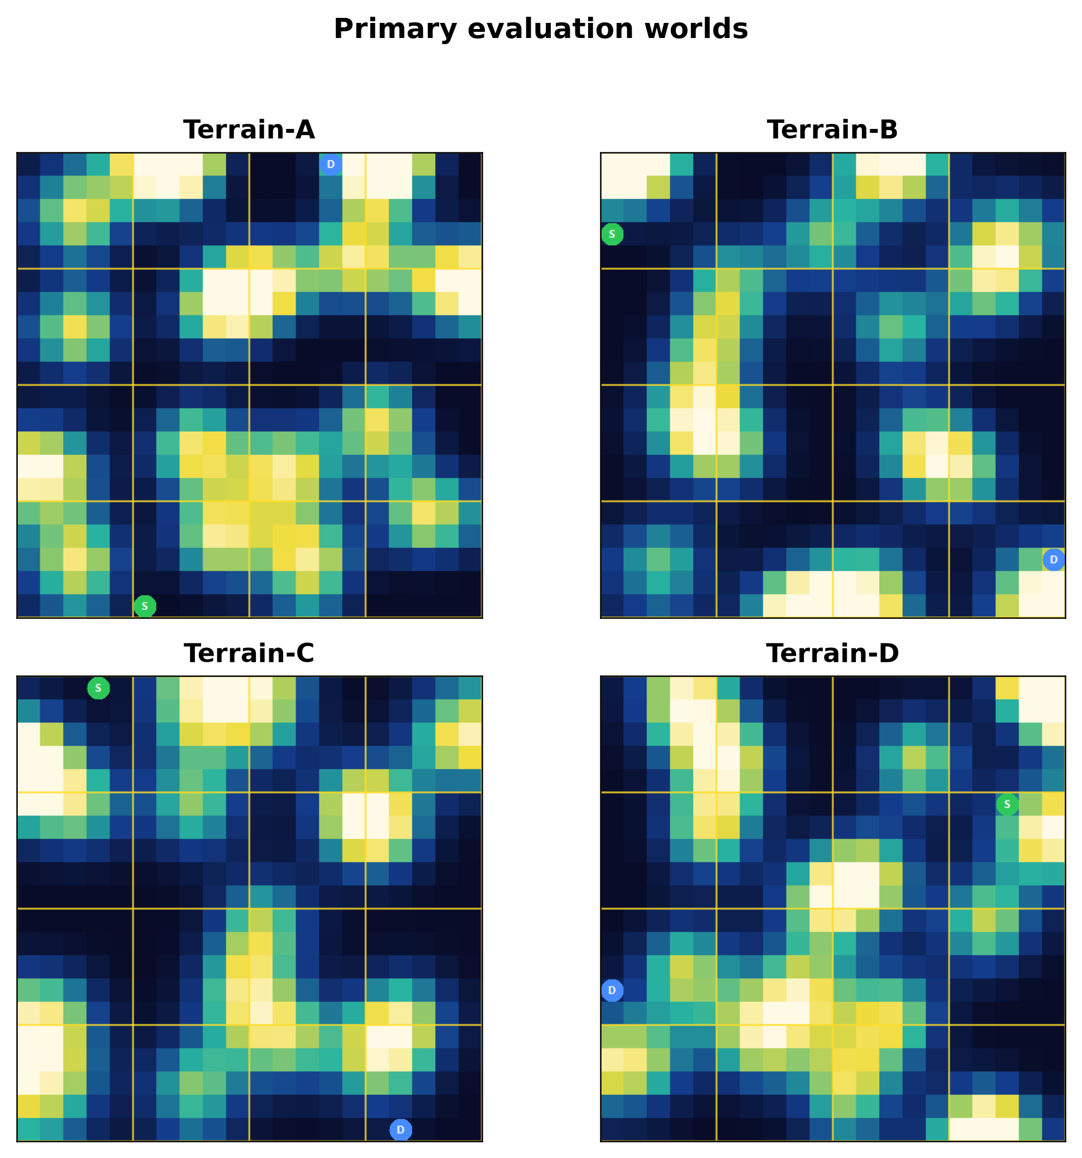
Figure 1. Procedural Terrain-A..D environments used for Primary evaluation (local 8-neighbour feel). Green S marks the start cell; blue D marks the destination (goal). Colour is local terrain cost (lighter = higher cost).

3.2 Teacher in-sample evaluation
When LTM is filled from teacher success on the same world used at test, goal-known energy gains remain high on A and B (78.6±4.3% and 78.1±2.4%) and substantial on C and D (61.3±11.4% and 61.0±6.4%; Table 2). Dest-hidden in-sample performance is already uneven (Table 3): Terrain-B retains a large positive gain (57.8±1.9%), Terrain-A is weakly positive with high variance, and Terrains C and D are negative on mean energy gain. These in-sample dest-hidden patterns foreshadow the LOO dest-hidden limit reported below.
Table 2. In-sample teacher success → LTM evaluation under goal-known sensing (success-weighted champion; n=5).
World | Energy gain % (mean±std) | Goal-rate gain (pp) | With-memory gap to opt. | No-memory gap to opt.
Terrain-A | 78.6 ± 4.3 | 0.0 ± 0.0 | 4.5 ± 1.0 | 21.1 ± 3.2
Terrain-B | 78.1 ± 2.4 | 0.0 ± 0.0 | 4.5 ± 0.9 | 20.6 ± 2.9
Terrain-C | 61.3 ± 11.4 | 0.0 ± 0.0 | 5.3 ± 1.1 | 13.9 ± 2.4
Terrain-D | 61.0 ± 6.4 | 0.0 ± 0.0 | 7.4 ± 1.1 | 19.0 ± 0.9

Table 3. Same teacher in-sample protocol with destination hidden (no goal coordinates at test; n=5).
World | Energy gain % (mean±std) | Goal-rate gain (pp) | With-memory gap to opt. | No-memory gap to opt.
Terrain-A | 11.9 ± 14.6 | 4.7 ± 1.8 | 46.6 ± 2.3 | 52.5 ± 7.3
Terrain-B | 57.8 ± 1.9 | 19.3 ± 6.4 | 30.6 ± 2.2 | 58.2 ± 1.2
Terrain-C | -5.3 ± 29.8 | 1.3 ± 5.1 | 35.6 ± 7.4 | 34.0 ± 4.8
Terrain-D | -31.6 ± 25.3 | -0.7 ± 1.5 | 54.2 ± 8.6 | 40.9 ± 3.4

3.3 Primary leave-one-out goal-known results
The primary claim is the honest LOO GK panel in Table 4 and Figure 2. Holding out each world in turn, the champion still recovers 69–81% mean energy gain across A–D, with standard deviations of roughly 4–7 percentage points (n=5). With-memory gaps to optimum shrink to about 3.9–5.4 while no-memory gaps remain near 14–22, confirming that promoted LTM—not seed luck—closes most of the suboptimality relative to the paired baseline. Goal-rate gains are near zero under GK because both agents typically reach the goal; the benefit is energetic. Section 3.9 reports per-seed one-sample tests: GK gains differ from zero on every world by t-test (all p < 10^{-4}); Wilcoxon exact p-values at n=5 equal 0.0625 whenever all five seeds are positive, the minimum attainable two-sided exact p-value for that sample size.
Table 4. Honest leave-one-out goal-known energy gain (%) of success-weighted unique path-unit promotion of source-cell feel n-grams on Terrain-A..D (n=5 seeds). Primary paper result.
World | Energy gain % (mean±std) | Goal-rate gain (pp) | With-memory gap to opt. | No-memory gap to opt.
Terrain-A | 75.2 ± 5.1 | 0.0 ± 0.0 | 5.3 ± 0.8 | 21.8 ± 2.6
Terrain-B | 80.8 ± 4.9 | 0.7 ± 1.5 | 3.9 ± 0.7 | 20.8 ± 4.2
Terrain-C | 71.5 ± 6.7 | 0.0 ± 0.0 | 3.9 ± 0.6 | 14.0 ± 2.1
Terrain-D | 69.3 ± 4.0 | 0.0 ± 0.0 | 5.4 ± 0.6 | 17.7 ± 2.2

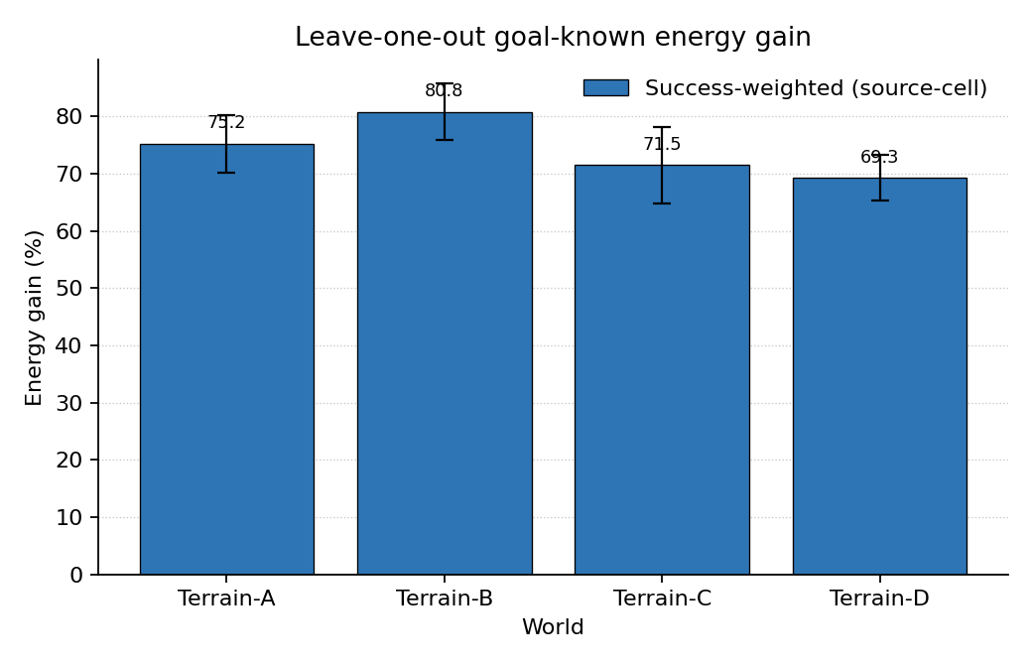
Figure 2. Honest leave-one-out goal-known energy gain of the champion success-weighted source-cell write rule (mean ± standard deviation, five seeds).

3.4 Dest-hidden leave-one-out
Table 5 and Figure 3 report LOO under dest-hidden sensing. Mean energy gains are positive on Terrain-A (19.7±25.6%) and Terrain-B (46.3±14.5%), near zero to mildly negative on Terrain-D (−5.0±26.8%), and deeply negative on Terrain-C (−24.5±32.3%). We state the Terrain-C dest-hidden regime as a limit of feel-only memory without geometry: local feel sequences that transfer under goal-known sensing can harm energy when the goal coordinate is withheld and the world affords misleading local matches. Variance is large on all four worlds, so dest-hidden claims are reported as qualitative limits rather than tight effect sizes (see also Section 3.9).
Table 5. Leave-one-out dest-hidden energy gain (%). Terrain-C is a stated limit of feel-only memory without geometry (n=5).
World | Energy gain % (mean±std) | Goal-rate gain (pp) | With-memory gap to opt. | No-memory gap to opt.
Terrain-A | 19.7 ± 25.6 | 5.3 ± 8.7 | 46.4 ± 13.3 | 57.1 ± 7.9
Terrain-B | 46.3 ± 14.5 | 22.7 ± 13.6 | 41.1 ± 5.4 | 59.0 ± 9.0
Terrain-C | -24.5 ± 32.3 | -0.7 ± 7.6 | 40.9 ± 3.4 | 33.7 ± 6.6
Terrain-D | -5.0 ± 26.8 | -2.0 ± 6.5 | 47.1 ± 7.8 | 43.1 ± 6.0

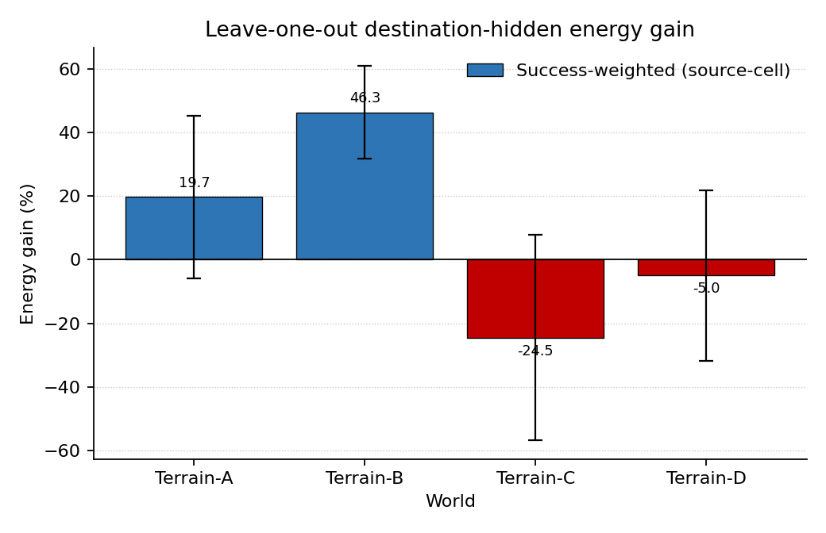
Figure 3. Leave-one-out destination-hidden energy gain (goal coordinates withheld at test); Terrain-C is a stated limit of feel-only memory without geometry.

3.5 Dest-hidden heterogeneity: why Terrain-B versus Terrain-C
Dest-hidden LOO is not uniformly weak: Terrain-B retains a large positive mean (46.3±14.5%; all five seeds positive), whereas Terrain-C is deeply negative (−24.5±32.3%; four of five seeds negative). Table 1 provides a geometry-linked reading without inventing feel-entropy tables. Terrain-B is the world where greedy-diagonal is already near-optimal (greedy over-optimality 7.19%), so residual feel-memory guidance operates near an already efficient reactive path and may remain stable when goal coordinates are hidden. Terrain-C has substantial greedy suboptimality (37.43%) yet remains a feel-only failure mode under dest-hidden: large negative mean and high variance indicate that source-cell feel matches retrieved from other worlds can steer away from efficient routes when goal direction cannot disambiguate. Terrain-A and Terrain-D, despite even larger greedy gaps (83.36% and 84.94%), show dest-hidden means closer to zero with wide seed scatter rather than B-like stability—consistent with high-relief geometry where feel reuse helps under GK but does not reliably substitute for goal geometry when the destination is hidden.
We do not report feel-entropy or LTM hit-rate tables here: those diagnostics were not precomputed in the locked evaluation logs, and fabricating them would violate the no-new-world-results constraint. Priority follow-ups are LTM hit rate, wrong-move rate under dest-hidden on Terrain-C, and simple feel-sequence entropy along teacher versus agent paths on B versus C.

3.6 Train-on-A transfer
Training LTM only on Terrain-A and testing under GK (n=3) yields strong transfer to B and C and retained benefit on D (Table 6): 83.9±4.0% (A), 81.7±2.2% (B), 73.8±1.5% (C), and 63.2±1.8% (D). Thus success-weighted source-cell units learned on a single world already support cross-world GK energy gains within this four-world library.
Table 6. Train-on-A transfer under goal-known sensing (n=3).
Test world | Energy gain % (mean±std) | Goal-rate gain (pp) | With-memory gap to opt. | No-memory gap to opt.
Terrain-A | 83.9 ± 4.0 | 0.0 ± 0.0 | 3.5 ± 0.6 | 22.0 ± 2.0
Terrain-B | 81.7 ± 2.2 | 1.1 ± 1.9 | 4.0 ± 0.6 | 22.1 ± 1.2
Terrain-C | 73.8 ± 1.5 | 0.0 ± 0.0 | 4.0 ± 0.7 | 15.4 ± 2.8
Terrain-D | 63.2 ± 1.8 | 0.0 ± 0.0 | 6.1 ± 0.2 | 16.5 ± 1.2

3.7 Empty-LTM control
With LTM emptied, energy gain collapses to 0.0±0.0 on every world (Table 7). Brain and no-brain gaps to optimum coincide, as required when no memory remains to differentiate the agents. Reported gains therefore require promoted path units rather than incidental controller differences.
Table 7. Ablation with empty LTM: energy gain collapses to zero, confirming gains require promoted memory (n=5). With-memory gap equals no-memory gap (sanity).
World | Energy gain % (mean±std) | Goal-rate gain (pp) | With-memory gap to opt. | No-memory gap to opt.
Terrain-A | 0.0 ± 0.0 | 0.0 ± 0.0 | 21.9 ± 2.9 | 21.9 ± 2.9
Terrain-B | 0.0 ± 0.0 | 0.0 ± 0.0 | 19.9 ± 1.1 | 19.9 ± 1.1
Terrain-C | 0.0 ± 0.0 | 0.0 ± 0.0 | 13.4 ± 0.9 | 13.4 ± 0.9
Terrain-D | 0.0 ± 0.0 | 0.0 ± 0.0 | 18.8 ± 3.5 | 18.8 ± 3.5

3.8 Ablations of anchoring and ranking
Table 8 summarizes four mechanisms under LOO GK and dest-hidden. Dest-cell feel with the same promote rule regresses GK means to 59.3 / 63.5 / 52.9 / 55.7 on A–D (Table 9), roughly 12–18 percentage points below the champion on each world. Frequency-ranked replace collapses GK means further to 22.3 / 30.3 / 13.9 / 13.6 (Table 10). The append hybrid stays within about ±1 percentage point of champion GK (75.3 / 81.1 / 71.3 / 69.2; Table 11) and does not rescue dest-hidden Terrain-C (−26.0±28.0). Figure 4 plots the GK ablation family; Figure 5 plots the dest-hidden ablation family.
Table 8. Ablation of memory promotion / feel anchoring / ranking mechanisms under honest LOO goal-known (GK) and dest-hidden (DH) energy gain % (mean; n=5). Column prefixes A–D are Terrain-A–D. Mechanism labels only.
Mechanism | A GK | B GK | C GK | D GK | A DH | B DH | C DH | D DH
Success-weighted unique path units (source-cell feel) | 75.2 | 80.8 | 71.5 | 69.3 | 19.7 | 46.3 | −24.5 | −5.0
Dest-cell feel (same promote, dest-cell signatures) | 59.3 | 63.5 | 52.9 | 55.7 | 17.0 | 40.0 | −26.9 | −4.0
Frequency-ranked replace of success-weighted champion | 22.3 | 30.3 | 13.9 | 13.6 | 5.1 | 32.6 | −23.7 | −9.7
Success-weighted + frequency append (hybrid) | 75.3 | 81.1 | 71.3 | 69.2 | 19.1 | 45.1 | −26.0 | −4.9

Table 9. Dest-cell feel LOO detail (mean±std energy gain %; same promote rule, destination-cell feel signatures; n=5).
World | Goal-known | Dest-hidden
Terrain-A | 59.3 ± 3.6 | 17.0 ± 18.1
Terrain-B | 63.5 ± 11.6 | 40.0 ± 17.7
Terrain-C | 52.9 ± 9.3 | -26.9 ± 33.7
Terrain-D | 55.7 ± 9.0 | -4.0 ± 24.7

Table 10. Frequency-ranked replace of the success-weighted champion, LOO detail (mean±std energy gain %; n=5).
World | Goal-known | Dest-hidden
Terrain-A | 22.3 ± 13.4 | 5.1 ± 11.1
Terrain-B | 30.3 ± 11.5 | 32.6 ± 17.7
Terrain-C | 13.9 ± 7.7 | -23.7 ± 34.0
Terrain-D | 13.6 ± 9.4 | -9.7 ± 21.5

Table 11. Success-weighted + frequency append (hybrid) LOO detail (mean±std energy gain %; n=5). Goal-known remains within about ±1 pp of the success-weighted champion. (If this table splits across pages in layout, read the continuation as the same Table 11.)
World | Goal-known | Dest-hidden
Terrain-A | 75.3 ± 5.3 | 19.1 ± 26.1
Terrain-B | 81.1 ± 4.6 | 45.1 ± 17.6
Terrain-C | 71.3 ± 7.0 | -26.0 ± 28.0
Terrain-D | 69.2 ± 4.1 | -4.9 ± 30.2

Figures 4 and 5 plot the goal-known and dest-hidden ablation families from Tables 8–11. Figure 6 contrasts teacher in-sample goal-known evaluation (Table 2) with honest LOO goal-known transfer (Table 4). Figure 7 visualizes the optimal-versus-greedy energy contrast of Table 1. Figure 8 places the empty-LTM null (Table 7) beside champion LOO goal-known bars, underscoring that reported gains require promoted path units.
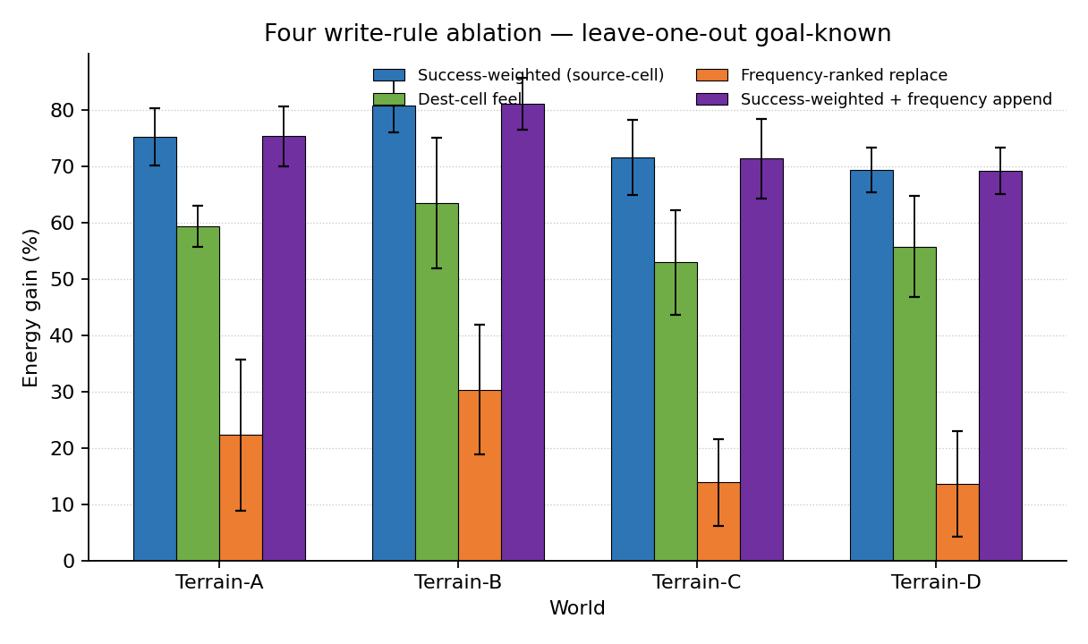
Figure 4. Ablation of feel anchoring and ranking mechanisms under honest leave-one-out goal-known evaluation. Legend names are the four write rules defined in Section 2.5.
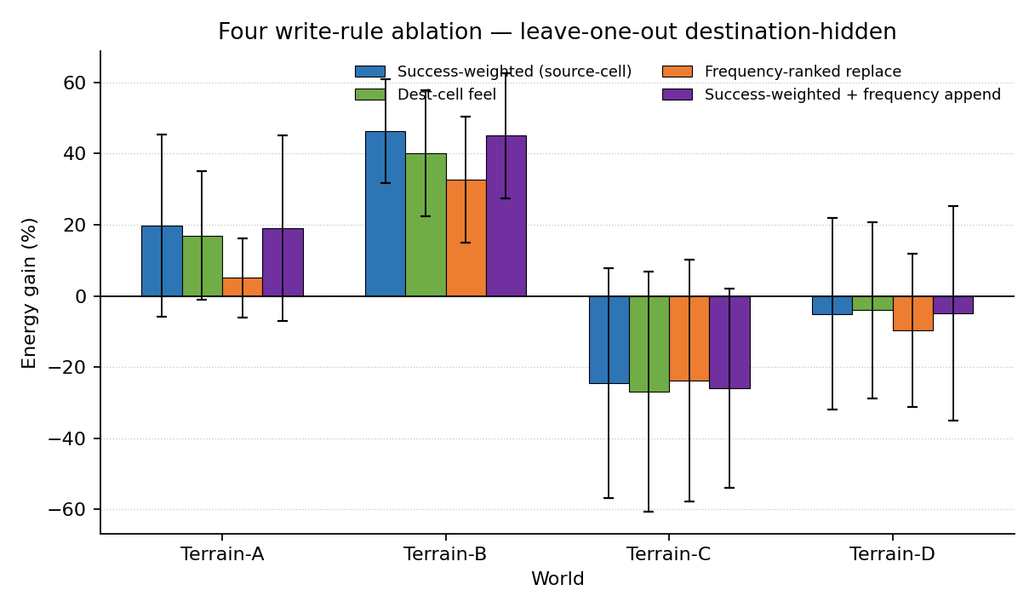
Figure 5. Same four write-rule ablation under destination-hidden leave-one-out evaluation (goal coordinates withheld).
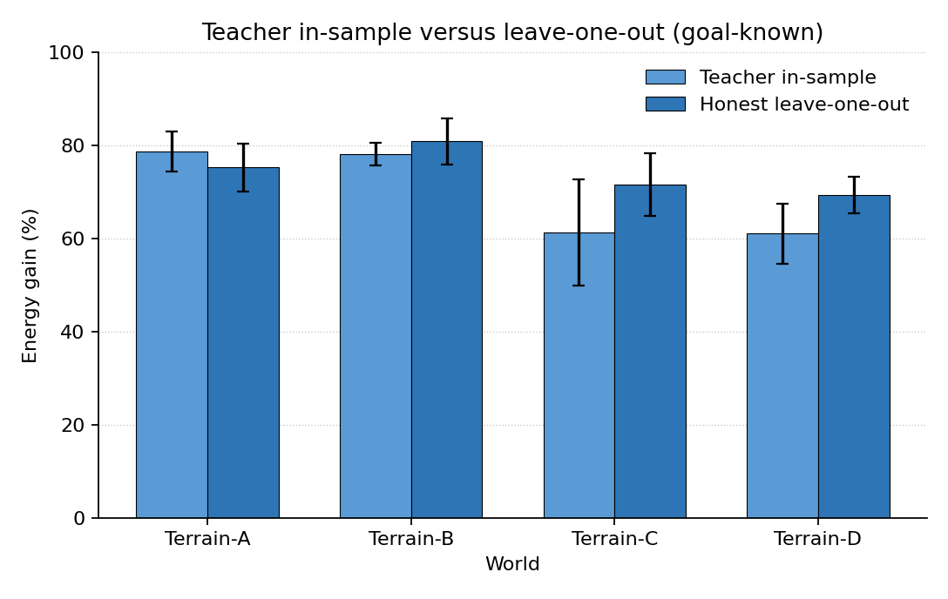
Figure 6. In-sample teacher evaluation versus honest leave-one-out under goal-known sensing.
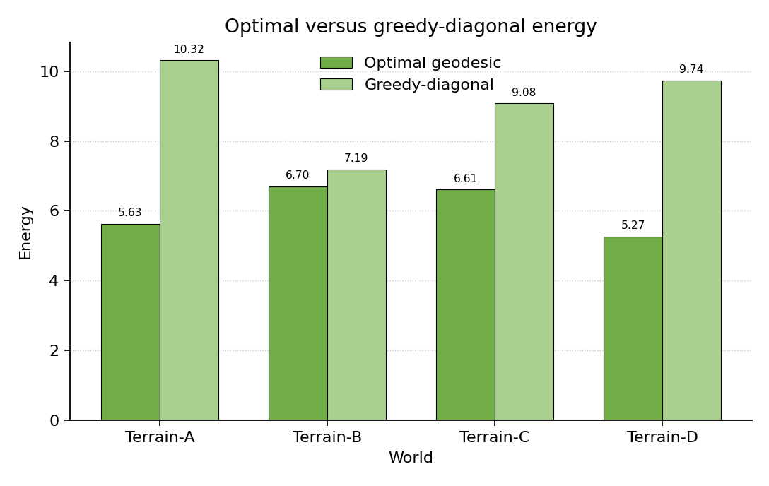
Figure 7. Optimal geodesic energy versus greedy-diagonal baseline on Terrain-A..D.
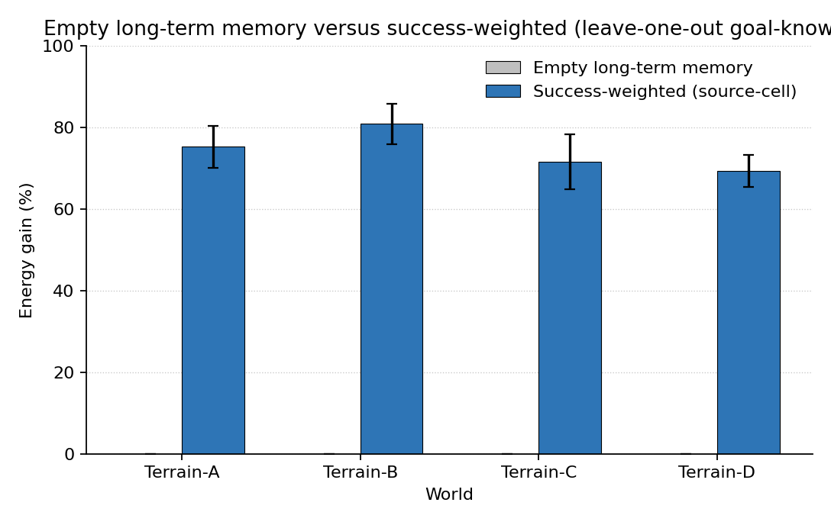
Figure 8. Empty long-term memory versus the champion success-weighted rule under leave-one-out goal-known evaluation (memory required for the reported gains).

3.9 Per-seed significance (champion LOO)
Table 12 lists per-world mean±std energy-gain percent together with two-sided one-sample t-tests versus 0 and Wilcoxon signed-rank tests on the five paired seeds, computed from the locked leave-one-out raw logs using the same energy-gain definition as the locked summary logs. Goal-known effects are large and stable. Dest-hidden effects reach conventional t-test significance only on Terrain-B among the four worlds; Terrain-C’s negative mean is not significant at n=5 but remains the constructive failure mode highlighted above.
Table 12. Champion LOO per-seed energy-gain percent tests vs 0 (n=5; two-sided). The first column is the sensing condition: goal-known or destination-hidden. Wilcoxon exact p=0.0625 is the minimum attainable when all five seeds share a sign.
Sensing | World | Mean±std % | t | p (t) | W | p (Wilcoxon)
Goal-known | Terrain-A | 75.2 ± 5.1 | 33.09 | 4.97e-06 | 0.0 | 0.0625
Goal-known | Terrain-B | 80.8 ± 4.9 | 37.12 | 3.14e-06 | 0.0 | 0.0625
Goal-known | Terrain-C | 71.5 ± 6.7 | 23.90 | 1.82e-05 | 0.0 | 0.0625
Goal-known | Terrain-D | 69.3 ± 4.0 | 39.08 | 2.56e-06 | 0.0 | 0.0625
Destination-hidden | Terrain-A | 19.7 ± 25.6 | 1.72 | 0.1614 | 2.0 | 0.1875
Destination-hidden | Terrain-B | 46.3 ± 14.5 | 7.14 | 0.0020 | 0.0 | 0.0625
Destination-hidden | Terrain-C | -24.5 ± 32.3 | -1.70 | 0.1649 | 2.0 | 0.1875
Destination-hidden | Terrain-D | -5.0 ± 26.8 | -0.42 | 0.6976 | 6.0 | 0.8125

Notes on results tables
Values displayed as mean ± std are rounded to one decimal for percentage gains (and related gap columns). Source-of-truth CSVs retain full floating-point precision under GitHub_mirror\EvalLogs\paper_results\ for Tables 1–7. Ablation artifacts (mechanism → folder): (1) Success-weighted source-cell feel → paper_results / LifeSim_V16.1 review; (2) Dest-cell feel → LifeSim_V16\EvalLogs\review_v16_20260925\; (3) Frequency-ranked replace → LifeSim_V16_TwoColumn\EvalLogs\review_v16twocol_20260925\twocolumn_full\; (4) Append hybrid → LifeSim_V20\EvalLogs\review_v20_20260925\union_full\. All ablation numbers in Tables 8–11 were read from the corresponding loo_goalknown_summary.csv / loo_desthidden_summary.csv on disk; none are approximate.

4. Discussion
The champion result aligns with route- and trajectory-centric views of navigational coding. Place-cell work showing route rather than destination encoding [3], episode discrimination at overlapping locations [4], and trajectory coding in hippocampus and entorhinal cortex [5] all suggest that what should be stored is a path unit tied to the decision context in which an action was taken. Source-cell feel implements that intuition at the level of local signatures: the n-gram that precedes an action is the retrieval key, so reuse fires when a similar local context recurs on a held-out world. The source-cell anchoring principle (Section 2.3) makes that alignment explicit.
Success weighting over frequency mirrors prioritized replay rather than uniform buffers. Normative accounts prioritize memories by expected planning value [14][16]; our frequency-ranked replace ablation shows that common feel n-grams, untethered from success, populate LTM with units that transfer poorly under honest LOO. The append hybrid further indicates that merely adding frequency-ranked signatures on top of a success-weighted store does not improve GK transfer and cannot repair the dest-hidden Terrain-C failure—selection, not capacity, is the binding constraint in this regime.
Relative to successor-representation and predictive-map theories [6][7], our agent does not maintain an explicit predictive occupancy map. Instead it stores sparse successful path units that can be read as a crude, experience-filtered policy fragment. The strong LOO GK transfer suggests that success-filtered local sequences capture reusable structure across procedural terrains even without a full SR. Dest-hidden collapse on Terrain-C, however, shows that feel sequences alone are not a substitute for geometry when goal coordinates are unavailable: predictive or geometric scaffolding would be required to stabilize behaviour in that regime. The B-versus-C contrast (Section 3.5) further ties dest-hidden heterogeneity to greedy geometry rather than to a uniform feel-memory failure.
Reviewer themes map onto three serious limits. First, baselines are internal (greedy-diagonal, empty LTM, and write-rule ablations): we do not yet report an external learned comparator trained on the same teacher paths, so absolute standing versus modern deep RL remains unknown. Second, the world library is small (four terrains); LOO within a four-world set can overstate generality. Third, dest-hidden variance is large, and Terrain-C remains a constructive failure mode rather than a solved case. Mechanism-to-folder mappings for independent rerun appear in the results-table note; main-text claims use mechanism names only.
Prioritized next experiments are therefore: (1) one external learner on the same teacher paths (behaviour cloning or a tabular policy over feel n-grams) evaluated under the same honesty protocol; (2) scale the world library beyond four procedural terrains; (3) dest-hidden Terrain-C failure diagnostics (LTM hit rate, wrong-move rate, and feel-sequence entropy along agent paths). Venue-neutral claims stay within the lightweight feel-memory architecture; we do not overclaim beyond honest LOO write-rule comparisons.

5. Conclusion
Within a lightweight local-feel memory architecture under honest leave-one-out evaluation, success-weighted unique path-unit promotion of source-cell feel n-grams delivers robust goal-known energy gains on four procedural terrains. The controlling write-rule principle is source-cell anchoring of success-weighted unique path units: LTM answers which move to take given the feel sequence just experienced at the departure cell. Dest-cell anchoring and frequency-ranked replace weaken or collapse transfer; frequency append adds no dest-hidden win on Terrain-C. Dest-hidden Terrain-C remains a stated limit of feel-only memory without geometry. External learners and larger world suites are the next honest tests of scope.

6. Data and code availability
Source code, frozen evaluation logs, reproduction scripts, and the figures used in this manuscript are available at https://github.com/hsmazumdar/LifeSim-FeelMemory. Locked leave-one-out and ablation CSVs that generate Tables 1–12 reside under EvalLogs/paper_results/ in that repository. The snapshot is intended for manuscript review and independent rerun of the honest evaluation protocol.

References
[1] Tolman, E. C. (1948). Cognitive maps in rats and men. Psychological Review, 55(4), 189–208. https://doi.org/10.1037/h0061626
[2] O'Keefe, J., & Nadel, L. (1978). The Hippocampus as a Cognitive Map. Oxford University Press.
[3] Grieves, R. M., Wood, E. R., & Dudchenko, P. A. (2016). Place cells on a maze encode routes rather than destinations. eLife, 5, e15986. https://doi.org/10.7554/eLife.15986
[4] Wood, E. R., Dudchenko, P. A., Robitsek, R. J., & Eichenbaum, H. (2000). Hippocampal neurons encode information about different types of memory episodes occurring in the same location. Neuron, 27(3), 623–633. https://doi.org/10.1016/S0896-6273(00)00071-4
[5] Frank, L. M., Brown, E. N., & Wilson, M. (2000). Trajectory encoding in the hippocampus and entorhinal cortex. Neuron, 27(1), 169–178. https://doi.org/10.1016/S0896-6273(00)00018-0
[6] Dayan, P. (1993). Improving generalization for temporal difference learning: The successor representation. Neural Computation, 5(4), 613–624. https://doi.org/10.1162/neco.1993.5.4.613
[7] Stachenfeld, K. L., Botvinick, M. M., & Gershman, S. J. (2017). The hippocampus as a predictive map. Nature Neuroscience, 20(11), 1643–1653. https://doi.org/10.1038/nn.4650
[8] Gershman, S. J. (2018). The successor representation: Its computational logic and neural substrates. Journal of Neuroscience, 38(33), 7193–7200. https://doi.org/10.1523/JNEUROSCI.0151-18.2018
[9] Lengyel, M., & Dayan, P. (2008). Hippocampal contributions to control: The third way. Advances in Neural Information Processing Systems, 20, 889–896.
[10] Sutton, R. S. (1990). Integrated architectures for learning, planning, and reacting based on approximating dynamic programming. Proceedings of the Seventh International Conference on Machine Learning, 216–224.
[11] Wilson, M. A., & McNaughton, B. L. (1994). Reactivation of hippocampal ensemble memories during sleep. Science, 265(5172), 676–679. https://doi.org/10.1126/science.8036517
[12] Foster, D. J., & Wilson, M. A. (2006). Reverse replay of behavioural sequences in hippocampal place cells during the awake state. Nature, 440(7084), 680–683. https://doi.org/10.1038/nature04587
[13] Pfeiffer, B. E., & Foster, D. J. (2013). Hippocampal place-cell sequences depict future paths to remembered goals. Nature, 497(7447), 74–79. https://doi.org/10.1038/nature12112
[14] Mattar, M. G., & Daw, N. D. (2018). Prioritized memory access explains planning and hippocampal replay. Nature Neuroscience, 21(11), 1609–1617. https://doi.org/10.1038/s41593-018-0232-z
[15] Antonov, G., & Mattar, M. G. (2023). Prioritizing replay when future goals are unknown. bioRxiv. https://doi.org/10.1101/2023.03.22.533870
[16] Schaul, T., Quan, J., Antonoglou, I., & Silver, D. (2016). Prioritized experience replay. International Conference on Learning Representations (ICLR).
[17] Banquet, J. P., Gaussier, P., Quoy, M., Revel, A., & Burnod, Y. (2005). A hierarchy of associations in hippocampo-cortical systems: Cognitive maps and navigation strategies. Neural Networks, 18(5–6), 525–534. https://doi.org/10.1016/j.neunet.2005.06.021
[18] Gaussier, P., Revel, A., Banquet, J. P., & Babeau, V. (2002). From view cells and place cells to cognitive map learning: Processing stages of the hippocampal system. Biological Cybernetics, 86(1), 15–28. https://doi.org/10.1007/s004220100269
[19] Sheynikhovich, D., Chavarriaga, R., Strässlin, T., Arleo, A., & Gerstner, W. (2009). Is there a geometric module for spatial orientation? Insights from a rodent navigation model. Psychological Review, 116(3), 540–566. https://doi.org/10.1037/a0016170
[20] Milford, M. J., & Wyeth, G. F. (2008). Mapping a suburb with a single camera using a biologically inspired SLAM system. IEEE Transactions on Robotics, 24(5), 1038–1053. https://doi.org/10.1109/TRO.2008.2004520
[21] Milford, M., & Wyeth, G. (2012). SeqSLAM: Visual route-based navigation for sunny summer days and stormy winter nights. IEEE International Conference on Robotics and Automation (ICRA), 1643–1649. https://doi.org/10.1109/ICRA.2012.6224623
[22] Arleo, A., & Gerstner, W. (2000). Spatial cognition and neuro-mimetic navigation: A model of hippocampal place cell activity. Biological Cybernetics, 83(3), 287–299. https://doi.org/10.1007/s004220000171
[23] Lin, L.-J. (1992). Self-improving reactive agents based on reinforcement learning, planning and teaching. Machine Learning, 8(3–4), 293–321. https://doi.org/10.1007/BF00992699
[24] Mnih, V., Kavukcuoglu, K., Silver, D., Rusu, A. A., Veness, J., Bellemare, M. G., Graves, A., Riedmiller, M., Fidjeland, A. K., Ostrovski, G., Petersen, S., Beattie, C., Sadik, A., Antonoglou, I., King, H., Kumaran, D., Wierstra, D., Legg, S., & Hassabis, D. (2015). Human-level control through deep reinforcement learning. Nature, 518(7540), 529–533. https://doi.org/10.1038/nature14236
[25] Dijkstra, E. W. (1959). A note on two problems in connexion with graphs. Numerische Mathematik, 1(1), 269–271. https://doi.org/10.1007/BF01386390
Author note
Abstract LOO goal-known means match Table 4 exactly (75.2 / 80.8 / 71.5 / 69.3) but the Abstract itself names neither tables nor figures. Dest-hidden Terrain-C (−24.5) is framed as a stated limit in Results. Verify DOIs on publisher pages before submission. Reference [15] (Antonov & Mattar preprint) should be updated to the final peer-reviewed citation when available. V6 is an integrity revision of V5: figure captions below images, sequential table/figure/reference numbering, standalone Abstract. External baseline learners and a larger world suite remain experimental follow-ups.

