On Nadir-Gap Filling for SWOT KaRIn Sea-Surface Height Anomaly
Theory, Papoulis–Gerchberg Algorithm, and 2024 Production Results
RespondSeeSurface / fill_nadir_gap · Technical report
Dataset year: 2024 (E:\SWOT2024 → E:\SWOT2024_Ok) · Method tag: papoulis_gerchberg_2d_aniso

Abstract
The Surface Water and Ocean Topography (SWOT) Ka-band Radar Interferometer (KaRIn) delivers wide-swath sea-surface height anomaly (SSHA) with a persistent along-track void at nadir where the interferometric baseline vanishes. Reconstructing this gap is required for continuous swath products used in downscaling and residual learning against Level-4 sea-level anomaly (SLA). This report formalizes the nadir-gap problem in the discrete Fourier domain, explains why magnitude-only spectral interpolation is scientifically inadequate, and derives the two-dimensional anisotropic Papoulis–Gerchberg (PG) algorithm used in production. On 10,038 SWOT L3 LR half-orbits from 2024, the pipeline successfully wrote 9,532 filled NetCDF twins (≈95% success) under the contract that all originally valid KaRIn samples are reinstated exactly. Quality scoring on 1,000 random 138×69 crops yields mean score 75.1 (median 77.9), with ringing and weak left–right correlation as the dominant residual failure modes. Results support PG as an operational reconstruction with uncertainty—not as new KaRIn measurements—and motivate a future hybrid spatial-residual AI with spectral guard.

1. Introduction
SWOT KaRIn Level-3 low-resolution (LR) Basic products provide SSHA on a swath grid with 69 across-track pixels. Near the satellite ground track, the KaRIn measurement geometry leaves a central band of missing or unreliable interferometric estimates (the nadir gap). Sparse secondary-instrument (nadir altimeter) hits may appear inside that band and must be cleared before gap filling so that the void is a clean reconstruction target rather than a mixture of incompatible instruments.
Scientifically, gap fill is an inverse problem: estimate unobserved SSHA from observed KaRIn flanks while preserving spectral energy (eddy scale content) and spatial phase (where that energy sits). The production choice for RespondSeeSurface 2024 is classical 2D PG with an anisotropic low-pass projector, initialized by across-track linear interpolation, followed by exact reinstatement of known samples.

2. Problem formulation

2.1 Discrete swath field and observation mask
Let the SSHA field on a half-orbit (or a crop) be the real array
u[n, p] ∈ ℝ, n = 0,…,N−1, p = 0,…,68 (1)
where n is the along-track index and p the across-track pixel. Define the binary observation mask m[n,p] ∈ {0,1} with m=1 on valid KaRIn ssha_filtered samples and m=0 on fill values, land, outer empty columns, and the cleared central nadir void. The observed field is
u_obs = m ⊙ u (2)
with ⊙ the Hadamard (element-wise) product. The reconstruction goal is to produce u_rec such that u_rec[n,p] = u_obs[n,p] whenever m[n,p]=1, and u_rec approximates the missing continuum on m=0.
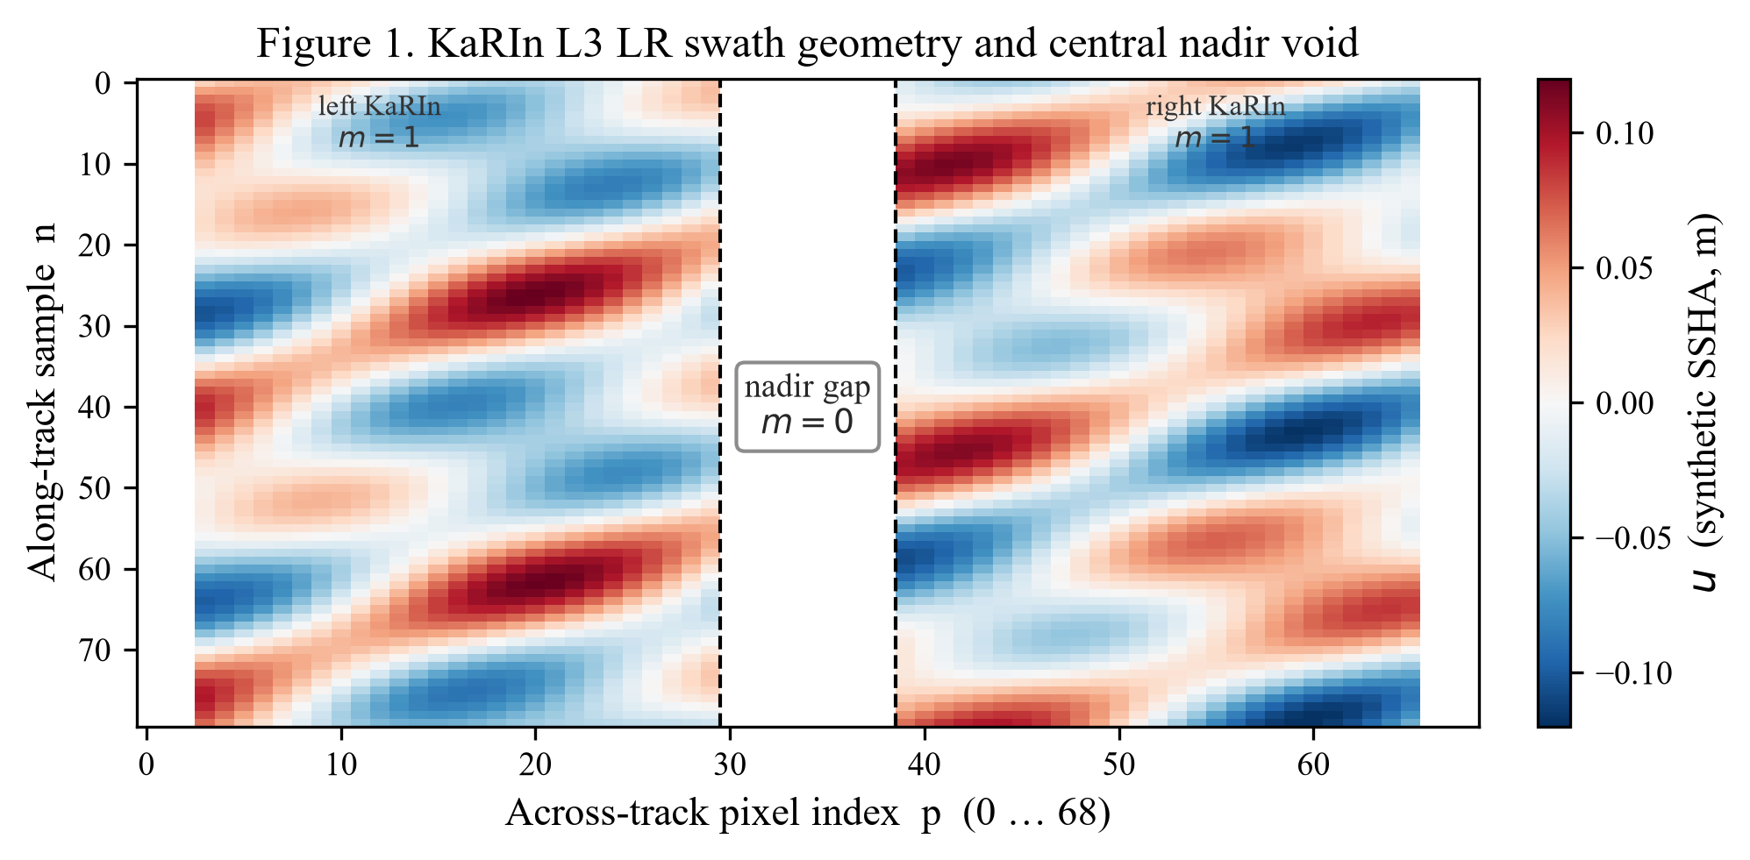
Figure 1. Schematic KaRIn LR swath (69 across-track pixels) with central nadir void (m=0). Outer edge columns may also be empty; they are not treated as the scientific nadir gap target.

2.2 Complex spectrum: magnitude and phase
The two-dimensional discrete Fourier transform (DFT) of a completed field v is
V̂(k_n, k_p) = Σ_{n,p} v[n,p] exp(−2πi (k_n n/N + k_p p/P)) (3)
In polar form,
V̂(k) = |V̂(k)| exp(i φ(k)) (4)
The magnitude |V̂| encodes the power spectral density (PSD) and thus the partition of variance across eddy scales. The phase φ encodes spatial placement: where ridges, fronts, and eddy cores sit in physical space. Consequently, magnitude-only interpolation in Fourier space followed by inverse DFT destroys structure even when the PSD looks plausible. Any primary method must act on complex coefficients or on the spatial field with a spectral constraint that preserves the phase of retained modes.

2.3 Why a naive FFT of gapped data fails
Masking is a multiplication in space and therefore a convolution in frequency:
Û_obs = M̂ ∗ Û (5)
Spectral leakage from the sharp nadir cut contaminates all wavenumbers. Zero-filling NaNs and taking an FFT without reinjecting observations is not a consistent estimator. Mask-aware iterative schemes (PG) or learning models that see m explicitly are required.

3. Methods

3.1 Candidate family
Table 1 summarizes methods considered in the design notes.
ID | Method | Frequency | Phase | Role
E0 | Across-track linear / spline | No | Implicit | Baseline init
E0b | Co-temporal L4 SLA blend | Low-pass | From L4 | Prior L
E1 | 2D Papoulis–Gerchberg | Yes | Yes (complex) | Production 2024
— | |FFT|-only → IFFT | Yes | Broken | Avoid
E2 | CNN/UNet spatial residual | Indirect | Learned | Strong w/ surgery
E2* | Hybrid: AI residual + H(k) + reinstate | Controlled | Preserved | Recommended next

Table 1. Method family for SWOT KaRIn nadir-gap reconstruction.

3.2 Across-track linear baseline (E0)
For each along-track row n, missing across-track samples are filled by linear interpolation in p using neighboring finite KaRIn values (row-wise). Rows with no finite samples fall back to a global finite mean. E0 provides a spatially smooth but spectrally uncontrolled estimate and serves as the PG initializer.

3.3 Papoulis–Gerchberg iteration (E1)
Classical Papoulis–Gerchberg alternates a band-limit projector P_B and a data consistency (mask) projector P_M:
v^(t+1) = P_M P_B v^(t) (6)
with initialization v^(0) = E0(u_obs). The band-limit projector is
P_B v = F⁻¹ ( H ⊙ F(v) ) (7)
where F is the 2D DFT (with fftshift centering), H is a binary keep mask in frequency, and the phase of retained coefficients is unchanged. The data projector reinstates observations:
P_M v = m ⊙ u_obs + (1 − m) ⊙ v (8)
After T iterations, the production field is u_rec = P_M v^(T), guaranteeing bit-level consistency with every originally valid KaRIn sample. One-dimensional along-track PG on an all-gap column is under-determined; the production code therefore uses full 2D PG on the (N × 69) ribbon (or 138 × 69 crops).
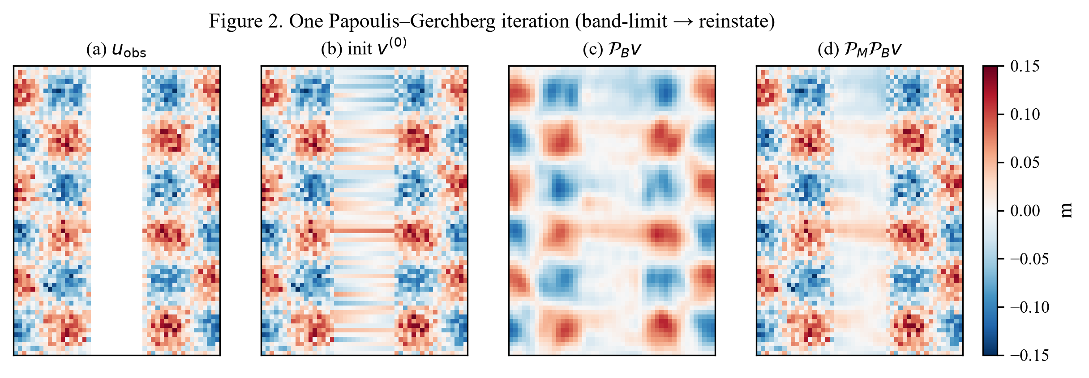
Figure 2. Schematic of one PG iteration: observed gap → E0 init → spectral band-limit P_B → reinstatement P_M.

3.4 Anisotropic spectral keep mask
Full half-orbits are tall (N ≫ 69). An isotropic keep fraction that is reasonable on square crops would over-smooth or under-constrain one axis. Production therefore uses an elliptical low-pass mask in the shifted frequency plane:
H(k_n, k_p) = 1 if ((k_n−c_n)/r_n)² + ((k_p−c_p)/r_p)² ≤ 1, else 0 (9)
with radii r_n = round(f_∥ N/2) and r_p = round(f_⊥ P/2). Default production parameters are f_∥ = 0.35 (along-track), f_⊥ = 0.55 (across-track), and T = 60 iterations. The method tag is papoulis_gerchberg_2d_aniso.
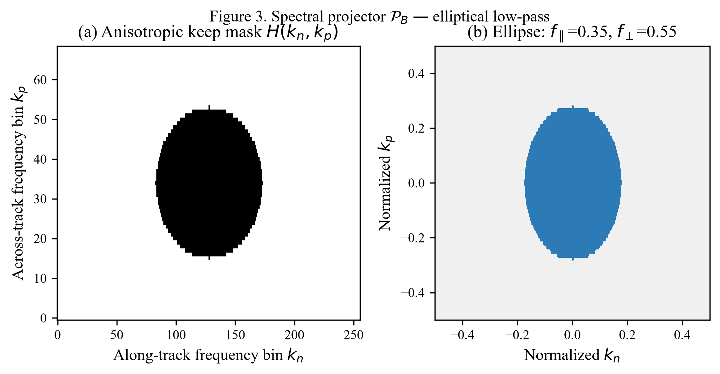
Figure 3. Elliptical keep mask H(k) implementing the anisotropic spectral projector P_B used for full-orbit fills.

3.5 Central nadir clearing
Before PG, clear_central_nadir_gap detects the contiguous low-validity column band in the swath interior (away from edge_guard columns) and sets that entire band to NaN. This removes secondary-instrument hits so that PG does not treat them as KaRIn anchors. Typical void columns on 69-pixel LR products lie near p ∈ [30, 38].

3.6 Production pipeline
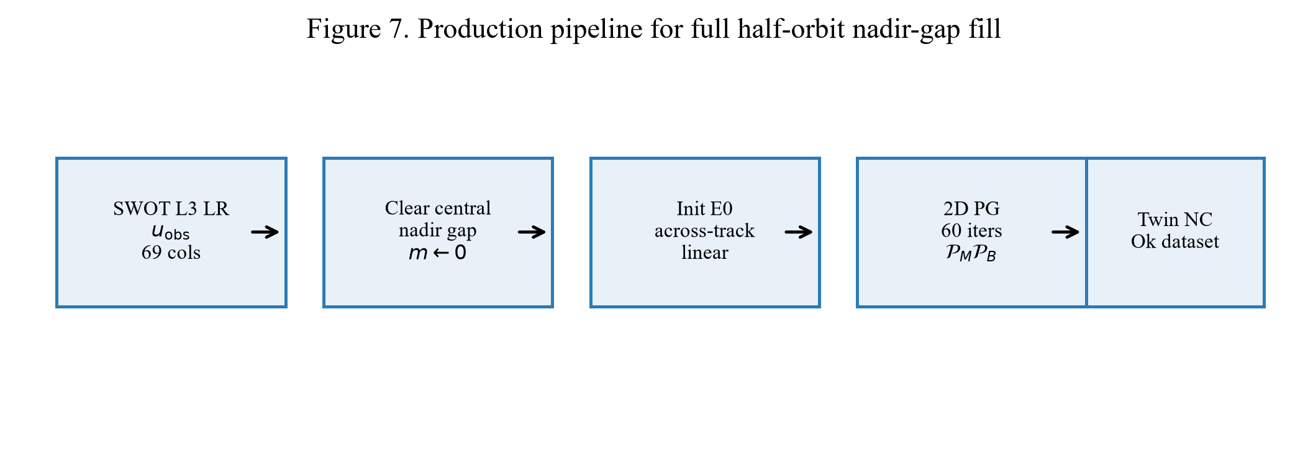
Figure 7. End-to-end pipeline from SWOT L3 LR Basic NetCDF to the Ok twin dataset with filled ssha_filtered.
Implementation: fill_nadir_gap/src/build_filled_69xfull.py. Source trees E:\SWOT2024 (and 2025); outputs E:\SWOT2024_Ok. Other variables are copied; only ssha_filtered is reconstructed in the gap.

3.7 Gap surgery validation (PoC)
Because true nadir SSHA is unavailable, quantitative PoC tests artificially widen the central gap by W additional known columns on each side (gap surgery), hold those samples out, run E0 and E1, and score hold-out MAE. Skill is
skill_MAE = 1 − MAE_E1 / MAE_E0 (10)
Positive skill means PG beats linear on the synthetic hold-out. Session notes for a 50-crop batch (seed 69, T=60, keep_frac=0.55, surgery=3) report mean skill ≈ −0.02, median ≈ +0.02, and fraction skill>0 ≈ 56%: PG helps often but not always, motivating quality filters and hybrid methods.

3.8 Composite quality score (crop audit)
On 1,000 random 138×69 visualization crops, fill_quality_score aggregates side_std, gap_std / side_std, left–right correlation across the gap, gradient ratio, and flags (invented variance, ringing, flat field, weak L–R, edge). Grades A–F summarize operational acceptability of the reconstruction appearance and continuity—not an absolute SSH error against truth.

4. Results (2024)

4.1 Full half-orbit production
From 10038 source NetCDF passes under E:\SWOT2024, the build wrote 9532 new Ok files to E:\SWOT2024_Ok in 3.14 h with 4 workers (T=60, f_∥=0.35, f_⊥=0.55). Completion accounting reports 9533 Ok files on disk and success rate 94.97%.
Quantity | Value
Source root | E:\SWOT2024
Output root | E:\SWOT2024_Ok
Source passes | 10,038
Successfully filled (new) | 9,532
Skipped (already present) | 1
Failed | 505
Success rate | 94.97%
Ok NetCDF on disk | 9,533
PG iterations T | 60
keep_frac_along (f_∥) | 0.35
keep_frac_across (f_⊥) | 0.55
Workers | 4
Wall time | 3.14 h (11306 s)
Method | clear_central_nadir_gap + papoulis_gerchberg_2d_aniso

Table 2. SWOT2024 full-orbit nadir-gap fill production summary.
Failure reason | Count | Share of failures
NetCDF/HDF error | 400 | 79.2%
too few known samples | 105 | 20.8%

Table 3. Failure taxonomy for the 2024 build (NetCDF/HDF I/O vs. insufficient known KaRIn samples).
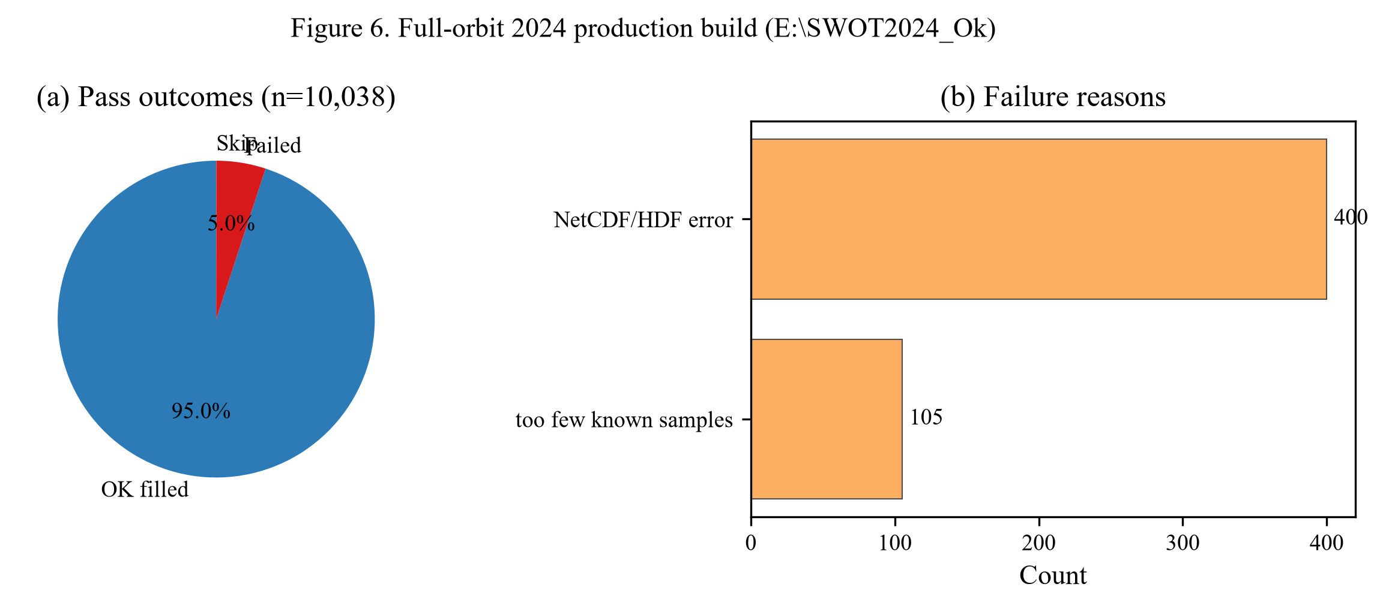
Figure 6. Production outcomes and failure reasons for the 2024 Ok dataset.

4.2 Qualitative reconstruction examples
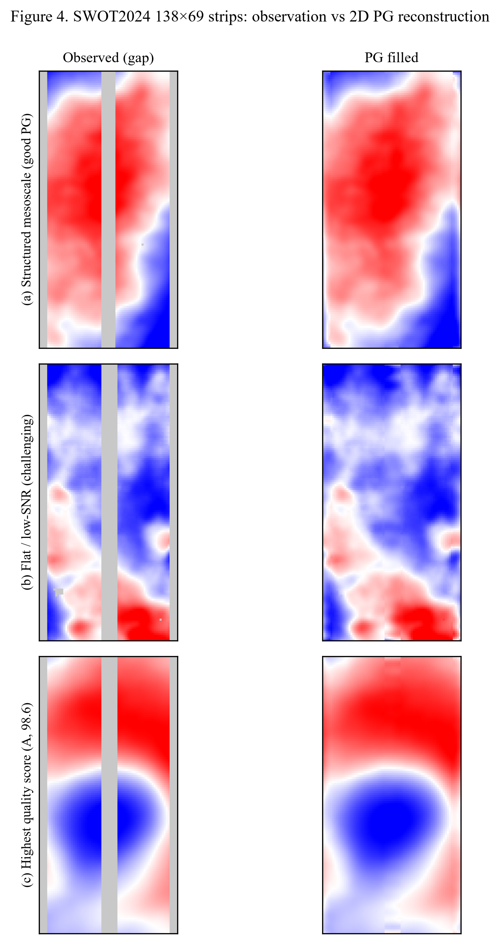
Figure 4. Example SWOT2024 crops (test_69x138 vs filled_69x138). (a) Coherent mesoscale continuation across the gap. (b) Low side variance / challenging case where percentile stretch amplifies residual ringing. (c) Highest composite score in the 1,000-crop audit.

4.3 Crop quality audit (n = 1,000)
Composite scores: mean 75.13, median 77.94, P10 56.43, P90 91.22. Grade counts: A=425, B=361, C=162, D=45, F=7.
Metric | Value
Crops scored | 1,000
Mean score | 75.13
Median score | 77.94
P10 / P90 | 56.43 / 91.22
Grade A | 425 (42.5%)
Grade B | 361 (36.1%)
Grade C | 162 (16.2%)
Grade D | 45 (4.5%)
Grade F | 7 (0.7%)
Flag: ringing | 591
Flag: weak L–R | 353
Flag: flat | 40
Flag: invent variance | 25

Table 4. Fill-quality summary on 1,000 random 138×69 SWOT2024 crops.
Rank | Image (abbrev.) | Score | Grade
1 | img_0000000653__c012_p425_L001529_20240321… | 98.60 | A
2 | img_0000000422__c015_p167_L002320_20240514… | 98.11 | A
3 | img_0000000863__c023_p014_L005336_20241022… | 97.83 | A
4 | img_0000000512__c015_p446_L008001_20240524… | 97.17 | A
5 | img_0000000481__c011_p079_L001274_20240217… | 97.05 | A

Table 5. Top-5 quality scores in the crop audit.
Rank | Image (abbrev.) | Score | Grade
996 | img_0000000553__c024_p242_L004239_20241120… | 32.15 | F
997 | img_0000000284__c025_p501_L009258_20241220… | 31.84 | F
998 | img_0000000781__c022_p571_L002813_20241021… | 27.95 | F
999 | img_0000000225__c019_p226_L006151_20240807… | 24.13 | F
1000 | img_0000000960__c023_p128_L000841_20241026… | 11.79 | F

Table 6. Bottom-5 quality scores (failure modes for follow-up).
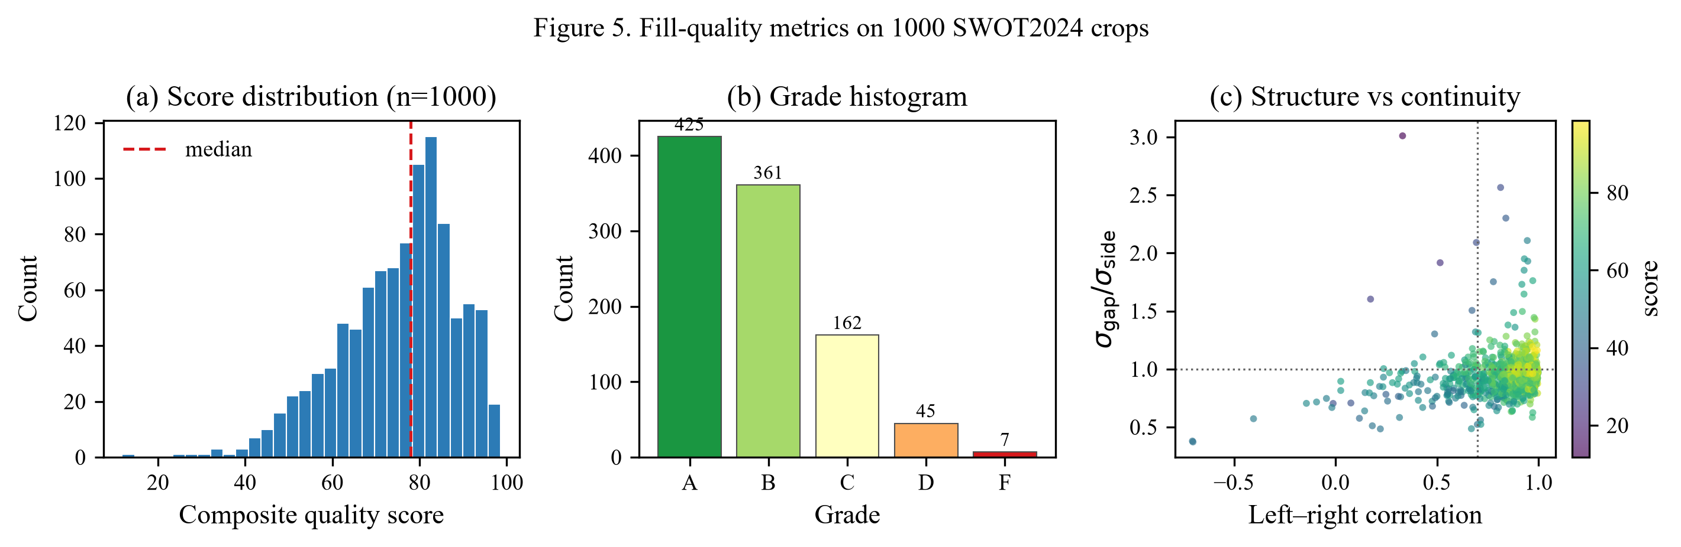
Figure 5. Score histogram, grade counts, and relationship between left–right correlation and gap/side standard-deviation ratio (colored by score).
Variable | Mean | Std | Min | P50 | Max
score | 75.1270 | 13.3578 | 11.7900 | 77.9400 | 98.6000
side_std | 0.0475 | 0.0373 | 0.0089 | 0.0365 | 0.4789
gap_std | 0.0448 | 0.0359 | 0.0068 | 0.0339 | 0.4691
gap_over_side | 0.9486 | 0.1842 | 0.3725 | 0.9362 | 3.0103
lr_corr | 0.8378 | 0.1964 | -0.7050 | 0.9054 | 0.9992

Table 7. Descriptive statistics of core quality variables (n=1000 crops).

5. Discussion
Production success near 95% establishes that anisotropic 2D PG is an operationally viable way to produce continuous 69-column SSHA ribbons for downstream SLA–SWOT pairing and residual CNN training. The hard contract out[known]=u_obs[known] prevents the fill from rewriting KaRIn observations—an essential scientific property for any product that will later be compared to SLA.
Limitations are equally clear. Gap-surgery skill is only marginally positive on average: when flanks are flat or left–right coherence is weak, a fixed keep mask can invent gap variance (ringing), which percentile visualization then exaggerates. Heuristic audits flagged ringing on a large fraction of crops; this is a property of band-limited extrapolation under low SNR, not a NetCDF write bug. High-latitude passes with empty outer columns further reduce constraints.
The recommended research path (E2*) is a hybrid: predict a spatial residual with a masked CNN/UNet (trained via gap surgery), apply a spectral guard H(k), inverse transform, then reinstate known samples. Co-temporal L4 SLA (E0b) can supply a low-pass prior L. Uncertainty maps should accompany any public-facing gap product: filled values are reconstructions, not new KaRIn measurements.
u_rec = L + F⁻¹( H · F(r̂_θ) ), r̂_θ = f_θ(u_obs, m, ST), then reinstate m=1 (11)

6. Conclusions
1. Nadir-gap fill must preserve complex spectral phase; magnitude-only FFT→IFFT is not an acceptable primary method.
2. The 2024 production algorithm is clear_central_nadir_gap + 2D anisotropic Papoulis–Gerchberg (T=60, f_∥=0.35, f_⊥=0.55) with exact KaRIn reinstatement.
3. Of 10,038 SWOT2024 passes, 9,532 were newly filled (≈95% success); failures are dominated by I/O errors and insufficient known samples.
4. On 1,000 audited crops, mean quality score is 75.1 with 78.6% graded A or B; ringing and weak L–R correlation remain the main quality flags.
5. Downstream use (e.g., E:\SWOT2024_Ok paired with E:\SLA2024 for SLA-H) should treat gap columns as reconstructed, optionally masked or down-weighted in loss.

7. Data and code pointers
Item | Path
Methods note | fill_nadir_gap/METHODS_NADIR_GAP.md
Full-orbit builder | fill_nadir_gap/src/build_filled_69xfull.py
PG PoC | fill_nadir_gap/src/pg_poc_test_69x138.py
2024 summary JSON | fill_nadir_gap/out/filled_69xfull/summary_2024.json
Completion report | fill_nadir_gap/out/filled_69xfull/COMPLETION_REPORT.json
Quality CSV | fill_nadir_gap/out/fill_quality/fill_quality_all.csv
Filled product 2024 | E:\SWOT2024_Ok
This report figures | fill_nadir_gap/docs/figures/

Table 8. Reproducibility paths for algorithm, metrics, and products.

Acknowledgments / framing
This document consolidates the RespondSeeSurface fill_nadir_gap design notes, PoC metrics, and the 2024 full-orbit build. Framing throughout: reconstruction with uncertainty—not a claim of new KaRIn measurements inside the nadir void.

