WORKING MANUSCRIPT DRAFT — not yet submitted
Working draft. Code, synthesizer and tabulated results: https://github.com/hsmazumdar/four-sample-pileup (README.md, RESULTS.md, synthesize_data.py). Companion WinForms tools: PileupNNBPTrainer/ and MCA4096/. Section VII reports a held-out split (seed-42 protocol). Remaining Q1 experiments (sample-count, Δt, SNR, baselines) are specified in Section VI.
Four-Sample Neural Classification of Pulse Pile-Up and Isolated-Pulse Peak-Height Estimation for Resource-Constrained Radiation Spectroscopy
Himanshu S. Mazumdar
Dharmsinh Desai University, Nadiad, INDIA
Corresponding author: hsmazumdar@ddu.ac.in
Abstract
Pulse pile-up at high count rates distorts amplitude estimates in nuclear spectroscopy and, if events are simply rejected, reduces throughput. Neural networks have already been applied to full-waveform pile-up correction, reconstruction, and FPGA inference; novelty therefore cannot rest on the use of an artificial neural network as such. This paper studies a much narrower question: whether a compact multilayer perceptron can identify pile-up, and estimate the peak height of isolated pulses, from only four post-trigger samples of a shaped radiation source counter pulse. The accompanying GitHub repository trains two parallel 4–5–1 networks (31 weights each, 62 in total) on the same four post-trigger samples: one head outputs a pile-up flag, the other estimates the true first-pulse amplitude A1. A public data synthesizer (synthesize_data.py) writes seeded train / validation / test CSVs; RESULTS.md holds the tables. On a held-out test of 1000 synthetic events (seed-42 protocol, 122 pile-up), pile-up classification reaches accuracy 0.969, precision 1.000, recall 0.746 and F1 0.854 (zero false positives). Peak-height MAE versus A1 is 93.7 channels on isolated pulses and 143.5 channels on all events (4096-channel scale). These are software results on RC-smoothed rectangles, not HPGe/NaI data and not measured FPGA latency. The laboratory C# trainer (PileupNNBPTrainer) remains a GUI reference and reports a different, easier target (shaped waveform maximum, same-set, isolated pulses only). Remaining Q1 experiments (sample-count ablation, pulse-separation and amplitude-ratio maps, SNR, conventional baselines) are specified in Section VI. The intended contribution is an accuracy–complexity statement for sparse sampling, not a claim that neural pile-up processing is new.
Index Terms—Digital pulse processing, multi-channel analyzer, neural network, pile-up, radiation source counter, radiation spectroscopy, sparse sampling, resource-constrained electronics.
Target venues: IEEE Transactions on Nuclear Science; Nuclear Instruments and Methods in Physics Research A.

I. Introduction
In a radiation spectrometer the analog pulse height after shaping is proportional to the energy deposited in the detector [1]. A multi-channel analyzer (MCA) histograms those heights. When the mean inter-arrival time becomes comparable to the pulse width, successive events overlap (pile-up). The recorded amplitude is then no longer a faithful energy estimate, photopeaks broaden and sprout sum peaks, and quantitative analysis degrades [1], [2].
The classical remedy is pile-up inspection and rejection: a second threshold or retrigger discards overlapping events. Rejection is simple and unbiased for the surviving counts, but live time and throughput collapse as the input rate rises. Digital alternatives include trapezoidal and cusp filtering [3], deconvolution, and matched or Wiener filtering. These methods typically operate on a dense stream of analog-to-digital converter (ADC) samples.
Neural networks have been used for pile-up correction since at least the work of Kafaee and Saramad, who compared a genetic algorithm with an artificial neural network on NaI/60Co waveforms [4]. Subsequent work has reconstructed piled-up calorimeter pulses with dense, convolutional and recurrent networks on FPGA [5]–[7], classified neutron/photon piled-up events in real time [8], [9], and, most recently, deployed physics-guided pile-up rejection on system-on-chip FPGAs [10]. Full-waveform 1-D convolutional networks have also been embedded in muon-spectrometer digitizers [11].
Against that literature, “we used a neural network for pile-up detection” is not a publishable claim. The research question addressed here is different and narrower:
Can an extremely small neural network identify pulse pile-up, and estimate the peak height of an isolated event, from only a few strategically placed samples of a shaped pulse, instead of processing the complete digitized waveform?
If four samples prove nearly as informative as several tens or hundreds of samples over a defined operating region, the result is an accuracy–complexity trade-off that matters for microcontrollers, low-power ASICs, and small FPGAs, where storing and multiplying a full trace is expensive. Two software layers support the study. The original laboratory trainer is a C# Windows Forms application (PileupNNBPTrainer/) together with a 4096-channel MCA display (MCA4096/). The primary, reproducible artifact is a Python dual-head proof of concept at https://github.com/hsmazumdar/four-sample-pileup: synthesize_data.py writes seeded CSVs, run_poc.py trains two 4–5–1 networks, and RESULTS.md tabulates a held-out test. The present manuscript reports those held-out numbers, states honestly what the C# GUI does and does not do, and defines the remaining experiments required before journal submission. The public repository is https://github.com/hsmazumdar/four-sample-pileup.

A. Contributions
1) Sparse-sample formulation. Pile-up classification and isolated-pulse peak estimation are posed as inference from four uniformly spaced post-trigger amplitudes, not from the full 500-sample record used only to generate those amplitudes.
2) Compact parameterization. The Python proof of concept uses two 4–5–1 multilayer perceptrons (31 trainable weights each, 62 in total, including biases). The C# trainer uses one 4–5–2 network (37 weights) in mutually exclusive Peak or Pileup mode. The paper treats that arithmetic budget as the engineering object of study.
3) Two-task dual-head architecture. Both heads see the same four samples on every event. The pile-up head is a binary classifier; the peak head estimates the true first-pulse amplitude A1, including on overlapping events. Recovering a fully unfolded A2, or a spectroscopic FWHM on a physical detector, remains out of scope for Paper 1.
4) Reproducible software and remaining Q1 protocol. Seeded train / validation / test files, frozen weights, a confusion matrix and F1 are already in RESULTS.md. Sample-count ablation, Δt and A2/A1 maps, SNR, and conventional baselines remain to be completed (Section VI). FPGA resource counts are not reported, because they have not been measured.

B. What this paper does not claim
The pulses are synthetic RC-smoothed rectangular excitations with MCA-like Gaussian line intensities; they are not HPGe, NaI or SiPM physics. Arrivals are a controlled Bernoulli overlap, not a Poisson high-rate stream. In the C# trainer the two network heads are trained separately and the field name “FFT” stored with the weight file is unused. The Python dual-head PoC trains both heads and draws both pile-up amplitudes from the MCA lines. No sampling frequency in hertz is attached to the present simulator, so time is reported in samples until that calibration is added. Invented FPGA figures (DSP/LUT counts, 50 ns latency, 10^6 events/s) that appeared in informal discussion notes are excluded from this manuscript.

II. Related Work
Hardware pile-up inspectors and digital pulse processors are reviewed in standard texts [1] and in the digital-shaping literature [3]. Software correction of spectral distortion has a long history, including Monte Carlo unfolding of pile-up-affected pulse-height spectra [12].
Intelligent full-waveform methods began with off-line genetic algorithms and ANNs on real detector traces [4]. FPGA pulse-shape analysis with neural networks was demonstrated for heavy-ion identification [13]. High-luminosity calorimetry has driven a second wave: deep networks for ATLAS TileCal-like reconstruction under pile-up [5], dense/CNN/RNN energy reconstruction under FPGA size and latency caps [6], and compact multilayer models compared with optimal filtering [7]. Organic-scintillator work has used ANNs both to recover piled-up neutron/photon combinations [9] and to classify them in a pipelined FPGA at >10^6 pulses/s [8]. A 2026 IEEE TNS paper describes a physics-guided dual-head network for pile-up rejection on a Zynq-7000 with fixed-point quantization and pruning [10].
The gap relative to that body of work is not accuracy on a dense waveform. It is the information content of a handful of samples. Most published networks ingest tens to hundreds of ADC values (for example, nine samples in [5] or 128-sample windows in [11]). Whether four post-trigger amplitudes suffice, and at what separation, amplitude ratio and SNR they fail, is the measurement this paper is designed to make.

III. Measurement Model and Sparse Sampling

A. Discrete pulse model
Let n be the sample index. An isolated event of amplitude A arriving at sample t0 produces a shaped waveform A p(n − t0), where p(·) is a unit-height pulse shape. Two-event pile-up is written
s(n) = A1 p(n − t1) + A2 p(n − t2) + η(n), t2 = t1 + Δt,
with η(n) the additive noise. The scientific tasks are (i) to decide whether A2 = 0 (single) or A2 > 0 (pile-up), and (ii) for isolated pulses, to estimate A1 and the peak location. Recovering A1 in the presence of a comparable A2 is a third task and is deferred.

B. Shaping used in the present software
The laboratory generator does not implement a textbook CR–RC analog shaper. It deposits a rectangular current of width tw = 15 samples and height equal to the event amplitude, then applies three passes of a discrete leaky integrator
Vc ← Vc + (x − Vc) ρ, ρ = 0.01, 10 inner steps per sample.
The result is a unipolar, detector-like pulse with a finite rise and a long tail, adequate for algorithm development but not a substitute for measured HPGe or NaI traces. First-pulse amplitudes are drawn from a set of Gaussian photopeak lines defined in an MCA configuration file (centroid, relative intensity, width on a 4096-channel scale), matching the companion MCA4096 display. In the 2016 C# generator the second pulse of a pile-up pair is drawn from Uniform(0.1, 1.0). The Python synthesizer (synthesize_data.py, sparse_pileup/pulse_sim.py) draws both amplitudes from the same MCA lines (config/mca_lines.csv). A controlled A2/A1 sweep is still required for Section VI.

C. Trigger and the four samples
A leading-edge trigger fires at the first sample whose amplitude exceeds channel 100 of 4096 (~2.4% of full scale). Four amplitudes are then read at
n_k = n_trig + k Δs, k = 0, 1, 2, 3, Δs = 15 samples.
Each amplitude is quantized onto the 4096-channel grid and presented to the network as yi ∈ [0, 1]. The peak sample of the waveform is recorded as a label, not as an input. An earlier visualization path used three points; the live training path uses four. The code does not increase the sample count to five or six when pile-up is present. Adaptive 3–6 sample windows remain a future option, not a present result.
Pile-up is injected independently with probability 1/10. The gap between the trailing edge of the first rectangle and the leading edge of the second is drawn uniformly from {2, …, 9} samples. This is a controlled overlap, not a Poisson process of rate λ; Pd versus input rate will require a revised generator.

IV. Neural Network

A. Topology
The classifier/regressor is a fully connected three-layer perceptron with bias neurons at the input and hidden layers (NnBP). Default sizes are ii = 4 inputs, jj = 5 hidden units, kk = 2 outputs. Let yi (i = 0…ii−1) be the four samples and yi=ii ≡ 1 the input bias. Hidden pre-activations and activations are
xj = Σ_i yi wij , yj = σ(clip(xj , ±10)), j = 0…jj−1, yj=jj ≡ 1,
xk = Σ_j yj wjk , yk = σ(clip(xk , ±10)), k = 0…kk−1,
with σ(z) = 1/(1+e^(−z)). The clip at ±10 is a numerical guard against sigmoid saturation during early training. Weight counts are (ii+1)×jj = 25 for the first layer and (jj+1)×kk = 12 for the second, altogether 37 parameters. Training uses online gradient descent with learning rate η = 0.5. The hidden- and output-layer updates are the standard sigmoid–MSE back-propagation formulae implemented in update_and_correct_error(). The reported scalar error UpdateNet() is an L1 sum |yk − tk|; that mismatch between displayed metric and training loss should be replaced by binary cross-entropy (classification) and squared error (regression) in the submission version.

B. Head 1 — pile-up classification
Targets are t = (1, 0) for a labelled pile-up pulse and t = (0, 1) for an isolated pulse. The two sigmoids are not constrained to sum to one. A decision currently requires y0 > 0.5 and y1 < 0.5 (pile-up) or the reverse (single); the ambiguous quadrants are undefined. For submission the second output should be dropped, or a softmax used, and ROC-AUC / F1 reported against a single threshold.

C. Head 2 — isolated-pulse peak estimation
On pulses with isPileup = 0 the targets are a normalized peak index (nmax − npeak)/(nmax − nmin) and the observed peak height peak.Y ∈ (0, 1). Pile-up pulses are skipped. Consequently this head estimates the peak of a clean shaped pulse from four samples; it does not unfold a composite peak into the true first-event amplitude. Informal discussion that “the network recovers piled-up energy” overstates the software.

D. Why two heads are not one network
The graphical trainer exposes mutually exclusive Peak and Pileup modes. The same C# weight file cannot simultaneously mean “pile-up probability” and “peak height.” The Python proof of concept therefore trains two networks that share the four samples (Section IV.E). A concatenated four-input → {pile-up logit, peak height} product detector remains a follow-on option.

E. Dual-head Python proof of concept (GitHub tree)
The reviewer-facing implementation is the package sparse_pileup/. Two SmallMLP objects of size 4–5–1 (31 weights each, 62 total) share the four normalized taps. DualHeadDetector.infer() returns a pile-up probability (threshold 0.5) and a peak height in full-scale units. The peak target is the true first-event amplitude A1 on every labelled event, including pile-up, not the shaped waveform maximum. Training is 40 epochs of online gradient descent with η = 0.5, matching the C# learning-rate default. Frozen weights are written to weights/dual_head.json and weights/dual_head_weights.h (C header for a later FPGA port). Reproduce with:
python tests/test_sanity.py
python synthesize_data.py # seeds 42 / 43 / 44 → data/synth_*.csv
python run_poc.py # train both heads, refresh RESULTS.md
python -m sparse_pileup.report # rebuild tables from frozen weights
Tabulated numbers for this manuscript are taken from RESULTS.md (held-out test seed 44 = 42+2). Machine-readable copies are artifacts/pileup_confusion.csv and artifacts/peak_metrics.csv [14].

V. Software System

A. PileupNNBPTrainer
The trainer is a Windows Forms (.NET 2.0) application. It generates pulses, optionally writes them to text, loads batches, trains on a 1 ms timer, and exports HeightFor4096.csv (true height, predicted height, after a ×1.8 display scale). Weights are stored as a small ASCII .net file: three integers (ii, jj, kk), row-major wjk and wij, and an unused type tag. Forward evaluation is UpdateNet() / UpdateNetErrors(); that path, not the GUI, is what would later be ported.

B. MCA4096
MCA4096 is a 4096-bin spectrum display, not a pile-up detector. In Monte Carlo mode it samples the same Gaussian lines used to set first-pulse heights. In Import mode it reads HeightFor4096.csv and increments mcaBuf[⌊htrue × 4095⌋]. The predicted column is loaded and not histogrammed; an overlay of NN versus true spectra is therefore a one-line change still to be made. Together the two programs close the loop: lines → pulses → four samples → network → pulse heights → spectrum.

C. Reproducibility gaps in the 2016 trainer
Training iterates over every loaded example on every timer tick; testing uses the same array (no split, no seed protocol). Epoch count is wall-clock, not deterministic. Random is seeded from DateTime.Now.Millisecond. Pulse geometry in an unused Energy2Array path is coupled to the PictureBox size. These are laboratory-tool defects. They are closed in the Python tree (synthesize_data.py + run_poc.py), not by rewriting the WinForms GUI.

D. Software availability (GitHub)
A publish-ready copy of the project is https://github.com/hsmazumdar/four-sample-pileup. It contains README.md, RESULTS.md, LICENSE, the Python package sparse_pileup/, the synthesizer entry point synthesize_data.py, frozen weights, generated CSVs under data/, and the C# sources PileupNNBPTrainer/ and MCA4096/ [14]. Session notes, bin/obj build trees, and the original discussion document are excluded. Reviewers can rebuild the Section VII tables without the Windows GUI.

VI. Experimental Design Required for Submission
The following four figures are the paper. Architecture changes should wait until they exist. All metrics are to be computed on files generated with a seed distinct from training. Classification metrics: confusion matrix, precision, recall, F1, ROC-AUC, with binomial confidence intervals. Regression metrics: MAE, RMSE and a 4096-channel error histogram, separately for held-out isolated pulses.

A. Figure 1 — accuracy versus number of samples
Train the same MLP family with N ∈ {4, 8, 16, 32} uniformly spaced post-trigger samples, and a full-trace baseline (all 500 samples, or a small 1-D CNN). Plot F1 and ROC-AUC against N. The central scientific result is whether N = 4 remains close to N = 32 and to the CNN. Complexity should be stated as input count and multiply–accumulate count, not as “125× faster,” unless wall-clock or FPGA latency is measured.

B. Figure 2 — detection versus pulse separation
Sweep Δt from 1 sample through more than one pulse width. Convert to time only after a sampling frequency fs is declared. Mark the region in which the two peaks are visually unresolved. The present rnd.Next(2, 10) gap must become this controlled axis.

C. Figure 3 — amplitude-ratio map
Draw both amplitudes from the same MCA lines. Sweep A2/A1 over {0.1, 0.25, 0.5, 1, 2, 4, 10}. Two equal pulses are the easy case; a small pulse on the tail of a large one is the case reviewers will demand.

D. Figure 4 — SNR and baselines
Add Gaussian noise to the waveform at several SNR values (not ±0.5/4096 on the four NN inputs, which is ~1 LSB). Overlay at least: (i) second-threshold / retrigger inspector; (ii) derivative or slope inspector; (iii) matched-template or correlation detector; (iv) the dual 4–5–1 network. Optional fifth series: the same weights in 8-, 12- and 16-bit fixed point versus double precision.

E. Spectrum-level test
After classification is quantified, histogram accepted isolated-pulse heights in MCA4096 (using the predicted column) versus a reject-all-pile-up MCA, as a function of input rate. Report FWHM of a designated photopeak and the fraction of events retained. This is the figure that connects the four-sample detector to spectroscopy.
Experiment | Status in GitHub PoC | Required for Q1 submission
Train / test split | Done in Python PoC (seeds 42 / 43 / 44) | Keep; C# GUI remains same-set
Pile-up metric | Held-out F1 0.854; confusion in RESULTS.md | ROC-AUC and binomial CIs
Sample-count sweep | Fixed N = 4 | N = 4, 8, 16, 32, full trace
Δt sweep | Random gap 2–9 | Controlled Pd vs Δt
A2 source | Python: both pulses from MCA lines | Controlled A2/A1 map still open
SNR | ~1 LSB on NN inputs | Waveform SNR in dB
Baselines | None | Retrigger, slope, matched filter, CNN
Poisson rate | Bernoulli p = 0.1 | Pd and FWHM vs λ
FPGA | Forward pass + dual_head_weights.h | Measured LUT/DSP/latency, or omit

TABLE I. Gap between the present GitHub proof of concept and a Q1 experimental section.

VII. Software Results
Primary numbers are the held-out Python proof of concept (RESULTS.md, reproduced by python run_poc.py). The C# same-set peak export is kept only as a comparison with a different target. Pulses are synthetic RC-smoothed rectangles. They are not HPGe/NaI data and not a journal claim.

A. Held-out dual-head proof of concept
Train / validation / test files contain 4000 / 1000 / 1000 events with independent RNG seeds 42 / 43 / 44. Both 4–5–1 heads are trained for 40 epochs (η = 0.5). The test set has 1000 events of which 122 are pile-up. Peak target is true first-pulse amplitude A1 in 4096-channel units.
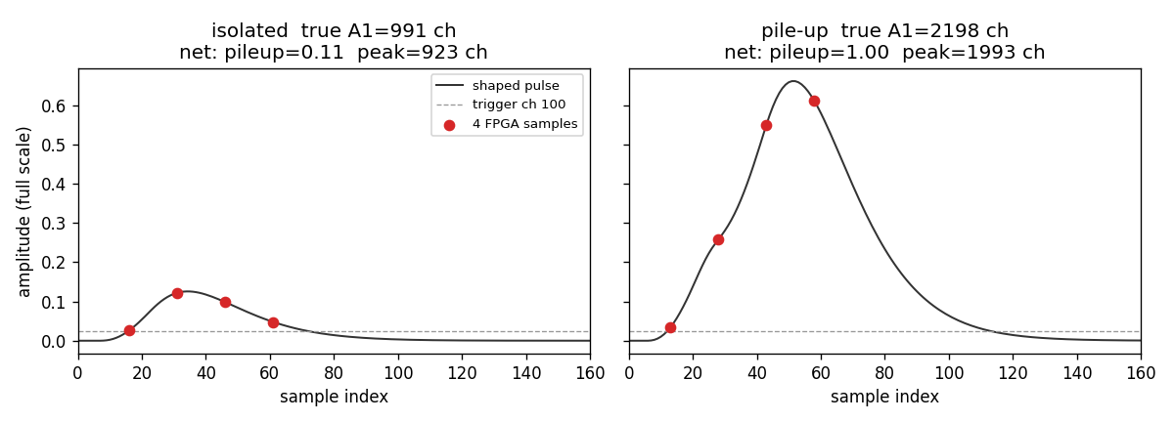
Fig. 1. Four post-trigger samples (stride 15) on an isolated pulse and a pile-up pair. Source: artifacts/sparse_samples.png in the GitHub tree.
Metric | Value
Events | 1000
True pile-up | 122
Accuracy | 0.969
Precision | 1.000
Recall | 0.746
F1 | 0.854

TABLE II. Held-out pile-up classification (threshold pileup_prob ≥ 0.5). Source: RESULTS.md.
 | Predicted single | Predicted pile-up
True single | 878 | 0
True pile-up | 31 | 91

TABLE III. Confusion matrix on the same 1000-event test file (TN 878, FP 0, FN 31, TP 91). Machine-readable: artifacts/pileup_confusion.csv.
Zero false positives at this threshold is the intended conservative veto: isolated events are not discarded, at the cost of missing 31 of 122 pile-up pairs (recall 0.746). ROC-AUC and a threshold sweep are still required before submission.
Subset | n | MAE (ch) | RMSE (ch) | Max (ch)
Isolated pulses | 878 | 93.7 | 95.6 | 210.8
All events (incl. pile-up) | 1000 | 143.5 | 391.8 | 3737.5

TABLE IV. Peak height versus true A1 (4096-channel units). Source: RESULTS.md.
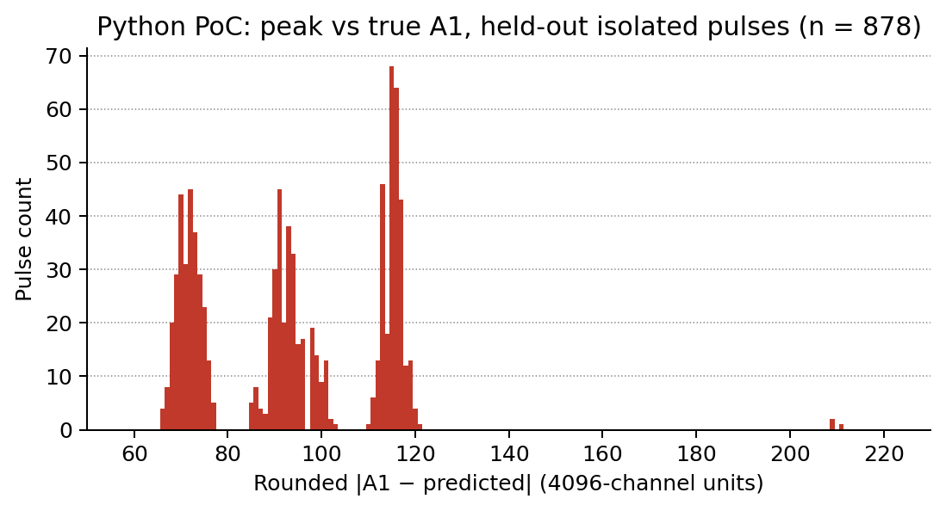
Fig. 2. Held-out isolated-pulse |A1 − predicted| histogram (n = 878). MAE = 93.7 ch. Source: artifacts/peak_error_hist.csv.
Interpretation permitted: a 62-weight dual-head MLP can tag pile-up from four samples on this synthetic mix with high precision, and can estimate A1 on isolated events to roughly one photopeak-width scale (tens of channels, not one channel). Interpretation not permitted: spectroscopic FWHM on a physical detector, or unfolding of the second amplitude A2. The all-event max error of 3737 channels shows that some piled-up traces still map to a grossly wrong A1.

B. C# trainer same-set comparison (different target)
The WinForms Peak-mode export HeightFor4096.csv contains 10 000 (true, predicted) pairs against the shaped waveform maximum, isolated pulses only, evaluated on the same array used for training. Converted to 4096-channel units the MAE is 0.89 channels and the RMSE is 1.41 channels (maximum 7.6 channels; 83% within one channel). That is not comparable to Table IV: the label is max(waveform), not A1, and the split is not held-out. It shows only that the 4–5–2 GUI network can interpolate the MCA line heights it was trained on.
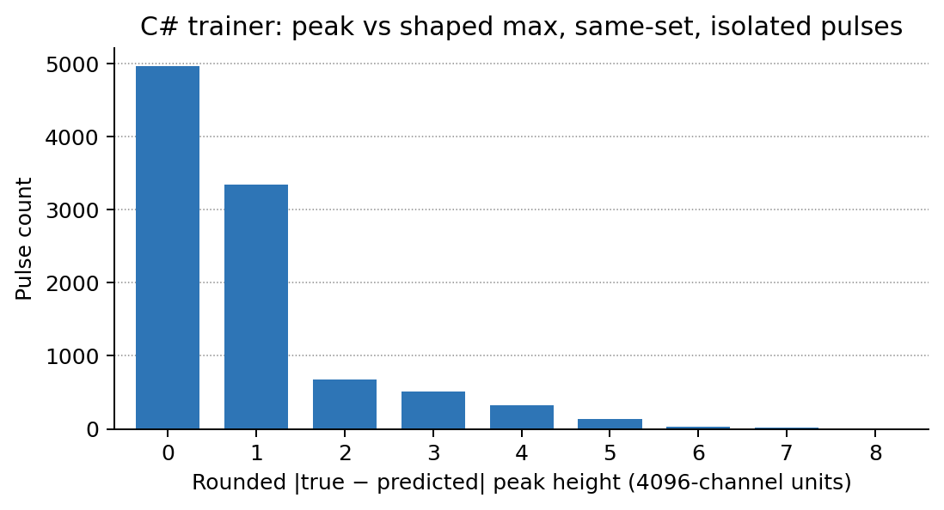
Fig. 3. C# trainer: rounded |shaped-max − predicted| on 10 000 isolated synthetic pulses (same-set). Do not cite as the paper’s peak result.
|error| (channels) | Count | Fraction (%) | Cumulative (%)
0 | 4966 | 49.66 | 49.66
1 | 3342 | 33.42 | 83.08
2 | 680 | 6.80 | 89.88
3 | 510 | 5.10 | 94.98
4 | 323 | 3.23 | 98.21
5 | 133 | 1.33 | 99.54
6 | 32 | 0.32 | 99.86
7 | 13 | 0.13 | 99.99
8 | 1 | 0.01 | 100.00

TABLE V. Error distribution corresponding to Fig. 3. MAE = 0.89 ch, RMSE = 1.41 ch. Different target from Table IV.

C. Parameter and arithmetic budget
Each 4–5–1 head uses (4+1)×5 + (5+1)×1 = 31 weights. Both heads: 62 multiply–accumulates per event and ten clipped sigmoids (or fewer if the output sigmoid is replaced by a threshold on the pre-activation [5], [6], [10]). The C# 4–5–2 network is 37 weights and is not run in dual-task mode. Fully parallel FPGA MACs would be 31 per head; do not publish LUT/DSP/ns figures until weights/dual_head_weights.h is synthesised.

VIII. Hardware Outlook
The intended online architecture is offline training on a PC and a forward-only engine on the spectrometer. The FPGA or microcontroller does not need back-propagation, the Windows GUI, or the training set. It needs the four triggered samples, the frozen weights in weights/dual_head_weights.h, a sigmoid lookup table or a hard sigmoid, a one-bit pile-up flag, and a peak word (height × 4096).
Fixed-point width (8 / 12 / 16 bits versus IEEE-754 double) is an experimental axis, not a specification. Resource and latency numbers will be inserted only from a synthesis report or a bench measurement. Until then this section is a plan: Python proof of concept → minimum N → minimum hidden width → minimum bit width → bit-true FPGA/MCU port. Informal HLS snippets that used exp(+x) instead of exp(−x) are incorrect relative to NnBP and must not be reused.

IX. Discussion
The laboratory code already encodes a distinctive hypothesis: four numbers, a few tens of weights, two spectroscopy tasks. The discussion document that preceded this manuscript split into a generic “ANN pile-up detector” outline and a correctly narrower sparse-sample programme. This draft follows the latter. Prior art [4]–[11] makes the former a desk-reject risk at IEEE TNS and NIM A. The GitHub tree is the software that reviewers should run, not the WinForms timer loop.
The principal scientific risk is that four fixed post-trigger samples miss the second pulse when Δt is large, or become linearly dependent when Δt is small and A2/A1 is extreme. Fig. 2 and Fig. 3 of Section VI exist to map that failure surface. If they show a wide, useful region where F1 stays close to a full-trace CNN, the paper is strong. If they show that N = 4 works only for nearly equal, well-separated pulses, the honest result is still publishable as an operating-region study, provided the region is stated.
A second risk is simulation fidelity. RC-smoothed rectangles lack ballistic deficit, pole-zero cancellation, and detector-specific noise coloring. Either the generator must be upgraded to a documented CR–RC or trapezoidal model with a stated fs, or a short campaign of digitizer traces must be added as Test D (unseen real pulses). Q1 reviewers in nuclear instrumentation will expect one of those two upgrades.
Language that will not survive review, and that has been removed from this draft, includes: real-time FPGA mitigation at 10^6 s^−1; recovery of piled-up spectroscopy resolution; “realistic HPGe/NaI pulses”; FFT or compressive-sensing features; and speed-up factors inferred from sample-count ratios alone.

X. Conclusion
A compact pair of 4–5–1 perceptrons (62 weights) can be trained, in software, to map four post-trigger samples of a shaped synthetic pulse onto (i) a pile-up flag and (ii) the true first-pulse amplitude A1. On a held-out test of 1000 events, pile-up F1 is 0.854 (precision 1.000, recall 0.746) and isolated-pulse A1 MAE is 93.7 channels of 4096. That is a proof of concept for sparse-sample digital pulse processing, not yet a completed instrumentation result. The code, synthesizer and tables are at https://github.com/hsmazumdar/four-sample-pileup [14].
The completed paper should answer one sentence: over what region of pulse separation, amplitude ratio and SNR do four samples and 62 weights match a full-waveform detector closely enough to justify the hardware saving. FPGA implementation and true pile-up unfolding are the natural second paper, after that sentence has a figure.

Acknowledgment
The C# trainer and MCA display were developed as an R&D laboratory testbed (form title: Pileup Neural Network Trainer — R&D, DDU). The Python dual-head proof of concept, data synthesizer and RESULTS.md tables are the public software artifact (https://github.com/hsmazumdar/four-sample-pileup). This manuscript was assembled from that codebase and from an internal discussion note, then rewritten to the experimental standard of IEEE TNS / NIM A.

References
[1] G. F. Knoll, Radiation Detection and Measurement, 4th ed. Hoboken, NJ, USA: Wiley, 2010.
[2] W. Guo, S. H. Lee, and R. P. Gardner, “The Monte Carlo approach MCPUT for correcting pile-up distorted pulse-height spectra,” Nucl. Instrum. Methods Phys. Res. A, vol. 531, no. 3, pp. 520–529, 2004.
[3] V. T. Jordanov and G. F. Knoll, “Digital synthesis of pulse shapes in real time for high resolution radiation spectroscopy,” Nucl. Instrum. Methods Phys. Res. A, vol. 345, no. 2, pp. 337–345, 1994.
[4] M. Kafaee and S. Saramad, “Pile-up correction by Genetic Algorithm and Artificial Neural Network,” Nucl. Instrum. Methods Phys. Res. A, vol. 607, no. 3, pp. 652–658, Aug. 2009.
[5] B. S. Acharya et al., “FPGA implementation of a deep learning algorithm for real-time signal reconstruction in radiation detectors under high pile-up conditions,” presented at the 21st IEEE Real Time Conf., 2019, arXiv:1903.02439.
[6] ATLAS Liquid Argon Calorimeter Group, “Optimised neural networks for online processing of ATLAS calorimeter data on FPGAs,” Eur. Phys. J. C, 2026, doi: 10.1140/epjc/s10052-026-15321-y.
[7] “FPGA performance for signal reconstruction of the ATLAS Tile Calorimeter in the HL-LHC environment,” EPJ Web Conf., vol. 338, p. 01004, 2025.
[8] C. Fu et al., “Real-time classification of radiation pulses with piled-up recovery using an FPGA-based artificial neural network,” IEEE Access, vol. 11, pp. 78721–78735, 2023.
[9] C. A. Norsworthy et al., “An artificial neural network system for photon-based active interrogation applications,” IEEE Access, vol. 9, pp. 119734–119747, 2021.
[10] R. Molina, M. Ballina, M. L. Crespo, and S. Carrato, “Physics-guided neural network for pile-up rejection on SoC-FPGAs,” IEEE Trans. Nucl. Sci., 2026, doi: 10.1109/TNS.2026.3681873.
[11] Nuclear Instruments, “Neural network pile-up resolution (Super-MuSR / ISIS),” project note, 1-D CNN on FPGA via hls4ml. [Online]. Available: https://www.nuclearinstruments.eu/projects/ai-pileup/
[12] See [2]; also later comparative surveys of pile-up correction algorithms, e.g. Nucl. Instrum. Methods Phys. Res. A, 2020, doi: 10.1016/j.nima.2019.163013.
[13] J. Jiménez et al., “Implementation of a neural network for digital pulse shape analysis on a FPGA for on-line identification of heavy ions,” Nucl. Instrum. Methods Phys. Res. A, vol. 674, pp. 99–104, 2012.
[14] H. S. Mazumdar, Four-sample dual-head MLP for pulse pile-up and peak height: Python package sparse_pileup, synthesizer synthesize_data.py, RESULTS.md, and C# sources PileupNNBPTrainer/ and MCA4096/, 2026. [Online]. Available: https://github.com/hsmazumdar/four-sample-pileup.

Appendix A. Suggested Paper-1 Title Variants
Preferred: Four-Sample Neural Classification of Pulse Pile-Up for Resource-Constrained Radiation Spectroscopy.
If peak estimation is kept in the same article: Four-Sample Neural Pile-Up Classification and Isolated-Pulse Peak Estimation for Low-Complexity Radiation Spectroscopy.
Avoid: “Neural Network-Based Pulse Pile-up Detection and Correction for Radiation Spectroscopy” — too close to [4]–[10] and likely to be read as claiming novelty for the use of an ANN.

Appendix B. Checklist Before Submission
1. Seeded train / validation / test files committed (synthesize_data.py; seeds 42/43/44).
2. F1 and confusion matrix for pile-up on the test file (RESULTS.md; ROC-AUC still open).
3. Fig. 1–4 of Section VI populated; no empty tables (sample-count, Δt, A2/A1, SNR).
4. At least three non-neural baselines on the same waveforms.
5. Physical units: fs and a shaping time, or a statement that all axes remain in samples.
6. MCA overlay of true versus predicted heights (fix Import to use column 1).
7. No FPGA resource or latency number without a synthesis or bench source.
8. Peak-on-pile-up language limited to the A1 head; A2 unfolding not claimed.
9. GitHub tree with README.md, RESULTS.md, frozen weights and a non-GUI infer().

