WORKING MANUSCRIPT DRAFT V2 — not submitted. Shape-calibrated synthesizer and measured SDD + Fe-55 traces added. Pile-up F1 remains synthetic. Section VI maps are still open.
Four-Sample Neural Classification of Pulse Pile-Up and Isolated-Pulse Peak-Height Estimation for Resource-Constrained Radiation Source Counting
Himanshu S. Mazumdar
Dharmsinh Desai University, Nadiad, INDIA
Corresponding author: hsmazumdar@ddu.ac.in
Software, synthetic files and measured traces: https://github.com/hsmazumdar/four-sample-pileup
Abstract
Pulse pile-up at high count rates distorts amplitude estimates in nuclear spectroscopy and, if overlapping events are simply rejected, reduces throughput. Neural networks have already been applied to full-waveform pile-up correction, reconstruction, and FPGA inference, so novelty cannot rest on the use of a neural network as such. This paper asks a narrower question: whether a compact multilayer perceptron can identify pile-up, and estimate first-pulse height, from only four post-trigger samples of a shaped radiation source counting pulse. Two parallel 4–5–1 networks (31 weights each, 62 in total) share those four samples. The synthesizer is a CR–RC^8 kernel fitted to 2 898 isolated Fe-55 pulses from a silicon drift detector digitized at 10 MSPS with 1 µs peaking (Physical Research Laboratory). Four taps are spaced by 4 samples (400 ns), not the 15-sample stride of an earlier laboratory trainer, which does not cover a 1 µs pulse. On a held-out set of 1000 synthetic events (103 pile-up) the pile-up head reaches accuracy 0.949, precision 1.000, recall 0.505 and F1 0.671, with no false positives. Isolated-pulse A1 mean absolute error is 34.9 channels on a 4096-channel scale. Those metrics are synthetic: pile-up is injected on the fitted kernel. The measured campaign contains isolated Fe-55 Kα/Kβ lines and only a handful of close pairs (none with Δt below the 1.7 µs pulse width). FPGA latency is not reported. The contribution is an accuracy–complexity statement for sparse sampling on a shape-calibrated pulse, not a claim that neural pile-up processing is new.
Index Terms—Digital pulse processing, multi-channel analyzer, neural network, pile-up, radiation source counting, radiation spectroscopy, silicon drift detector, sparse sampling, resource-constrained electronics.

I. Introduction
In radiation source counting the analog pulse height after shaping is proportional to the energy deposited in the detector [1]. A multi-channel analyzer (MCA) histograms those heights. When the mean inter-arrival time becomes comparable to the pulse width, successive events overlap (pile-up). The recorded amplitude is then no longer a faithful energy estimate, photopeaks broaden and sprout sum peaks, and quantitative analysis degrades [1], [2].
The classical remedy is pile-up inspection and rejection. Rejection is simple and unbiased for the surviving counts, but live time and throughput collapse as the input rate rises. Digital alternatives include trapezoidal and cusp filtering [3], deconvolution, and matched or Wiener filtering, typically on a dense analog-to-digital converter (ADC) stream. A complementary line of work recovers pulse peak height from a low-sampling-rate ADC by interpolation [4]–[6]. Those methods estimate the peak of an isolated pulse; they do not classify pile-up from four samples.
Neural networks have been used for pile-up correction since at least Kafaee and Saramad on NaI/60Co waveforms [7]. Subsequent work has reconstructed piled-up calorimeter pulses on FPGA [8]–[10], classified neutron/photon piled-up events in real time [11], [12], and deployed physics-guided pile-up rejection on system-on-chip FPGAs [13]. Full-waveform 1-D convolutional networks have been embedded in muon-spectrometer digitizers [14]. Against that literature, “we used a neural network for pile-up detection” is not a publishable claim. The question addressed here is narrower:
Can an extremely small neural network identify pulse pile-up, and estimate the first-pulse height, from only a few strategically placed samples of a shaped pulse whose shape is taken from a measured detector, instead of processing the complete digitized waveform?
If four samples remain informative over a stated operating region, the result is an accuracy–complexity trade-off for microcontrollers, low-power ASICs and small FPGAs. Two software layers support the study. A laboratory C# trainer (PileupNNBPTrainer) and a 4096-channel MCA display (MCA4096) originated the four-sample idea. The reproducible artifact is the Python package sparse_pileup [17]: a CR–RC^8 synthesizer fitted to measured silicon-drift-detector (SDD) Fe-55 traces, seeded train/validation/test files, two 4–5–1 networks, and a public pulse viewer for the real traces. FPGA resource counts are omitted because they have not been measured.

A. Contributions
1) Sparse-sample formulation. Pile-up classification and first-pulse height estimation are posed as inference from four uniformly spaced post-trigger amplitudes. At 10 MSPS the stride is 4 samples (400 ns), chosen so the taps lie on a 1 µs SDD pulse. The 2016 trainer stride of 15 samples is retained only as a negative control: it samples the baseline of this pulse.
2) Shape-calibrated synthesizer. The default generator is a documented CR–RC^8 kernel (τ = 1.2606 samples, peaking 1.01 µs) fitted to 2 898 isolated Fe-55 pulses, with measured baseline noise (σ ≈ 9.9 channels) and Fe-55 line intensities. It replaces the 2016 width-15 rectangle and three leaky integrators. Pile-up in the tables is still injected on that kernel.
3) Compact dual-head network. Two 4–5–1 multilayer perceptrons (31 weights each, 62 in total) share the four samples. The pile-up head is a binary classifier; the peak head estimates the true first-pulse amplitude A1, including on overlapping synthetic events. Unfolding A2, or a spectroscopic FWHM on a physical detector, remains out of scope.
4) Measured SDD campaign. Sixty-one 12-bit, 10 MSPS segments (3.198 s live) from an SDD and an Fe-55 source are released with a reviewer viewer [17]. They calibrate the kernel and support isolated-pulse inspection. They do not yet support a measured pile-up F1.

B. What this paper does not claim
Held-out F1 and A1 errors are computed on synthetic pile-up added to the fitted kernel. They are not HPGe or NaI physics and not a hardware result. The measured Fe-55 set is isolated-pulse dominated (~1 kcps). No same-envelope overlap (Δt less than the 1.7 µs pulse width) was found. A periodic family near 3650 channels (~69 Hz) is excluded from the photopeak and from the shape fit. FPGA DSP, LUT, latency and throughput figures are omitted because they have not been measured.

II. Related Work
Hardware pile-up inspectors and digital pulse processors are reviewed in standard texts [1] and in the digital-shaping literature [3]. Software correction of spectral distortion includes Monte Carlo unfolding of pile-up-affected pulse-height spectra [15]. Peak-height recovery from sparsely sampled shaped pulses by Lagrange and related interpolators is treated in [4]–[6]. The present network uses the same sparse-sample premise and adds a pile-up decision on the same four taps.
Intelligent full-waveform methods began with off-line genetic algorithms and ANNs on real detector traces [7]. FPGA pulse-shape analysis with neural networks was demonstrated for heavy-ion identification [16]. High-luminosity calorimetry has driven a second wave [8]–[10]. Organic-scintillator work has used ANNs to recover or classify piled-up neutron/photon combinations [11], [12]. A 2026 IEEE TNS paper describes a physics-guided dual-head network for pile-up rejection on a Zynq-7000 [13].
The gap relative to that body of work is not accuracy on a dense waveform. It is the information content of a handful of samples on a pulse whose shape is taken from a measured SDD. Most published networks ingest tens to hundreds of ADC values. Whether four post-trigger amplitudes suffice, and at what separation, amplitude ratio and SNR they fail, remains the measurement this paper is designed to complete (Section VI).

III. Measurement Model and Sparse Sampling

A. Discrete pulse model
Let n be the sample index at fs = 10 MHz (Ts = 100 ns). An isolated event of amplitude A arriving with peak at sample t0 produces a shaped waveform A p(n − t0), where p(·) is a unit-height pulse. Two-event pile-up is written
s(n) = A1 p(n − t1) + A2 p(n − t2) + b + η(n), t2 = t1 + Δt,
with b a small pedestal and η(n) additive noise, both taken from the measured SDD baseline (b ≈ 7.1 channels, ση ≈ 9.9 channels). The tasks are (i) to decide whether A2 = 0 (single) or A2 > 0 (pile-up), and (ii) to estimate A1. Recovering A2 is deferred.

B. Shaping: CR–RC^8 fitted to SDD Fe-55
The 2016 laboratory generator deposited a rectangular current of width 15 samples and applied three discrete leaky integrators (α = 0.01). That pulse has a long tail and no sampling frequency. It is not used for the numbers in Section VII.A.
The present synthesizer uses the causal CR–RC^n kernel p(u) ∝ u^n exp(−u), u = t/τ, with integer n and time constant τ fitted to the mean of 2 898 isolated Fe-55 pulses (peak-aligned, local baseline subtracted, unit height; periodic ~3650-channel pulses excluded). The minimum residual at the operator peaking time of 1 µs is n = 8, τ = 1.2606 samples (Tpeak = nτ = 1.01 µs). Unit-height RMSE versus the mean measured pulse is 0.030. The fitted tail is slightly longer than the measured return to baseline; that residual is left visible in Fig. 2. Amplitudes are drawn from an Fe-55 line table (Si escape, Mn Kα, Mn Kβ) on the 4096-channel scale.
Pile-up is still synthetic: a second kernel is injected with probability 1/10 and a peak-to-peak gap drawn uniformly from 3 to 20 samples (0.3–2.0 µs). That is a controlled overlap, not a Poisson stream of the measured 1 kcps rate. Pd versus input rate remains a Section VI experiment.

C. Trigger and the four samples
A leading-edge trigger fires at the first sample whose amplitude exceeds channel 100 of 4096. Four amplitudes are then read at
n_k = n_trig + k Δs, k = 0, 1, 2, 3, Δs = 4 samples = 400 ns.
Each amplitude is quantized onto the 4096-channel grid and presented as yi ∈ [0, 1]. On a typical measured Fe-55 event, stride 15 (1.5 µs) yields taps on the baseline; stride 3–4 places taps on the rise, peak and fall. The live path uses four taps. Adaptive 3–6 sample windows remain a future option.

IV. Neural Network

A. Topology
Each head is a fully connected 4–5–1 perceptron with bias neurons (NnBP). Let yi (i = 0…3) be the four samples and yi=4 ≡ 1 the input bias. Hidden and output activations are
xj = Σ_i yi wij , yj = σ(clip(xj , ±10)), j = 0…4, yj=5 ≡ 1,
xk = Σ_j yj wjk , yk = σ(clip(xk , ±10)),
with σ(z) = 1/(1+e^(−z)). Each head has (4+1)×5 + (5+1)×1 = 31 weights. Both heads: 62 parameters. Training is 40 epochs of online gradient descent with η = 0.5. The 2016 C# trainer used one 4–5–2 network in mutually exclusive Peak or Pileup mode (37 weights). That GUI path is not the source of Section VII.A.

B. Dual-head Python proof of concept
The public implementation [17] trains two 4–5–1 networks on every labelled event. The pile-up target is 1 if a second kernel was injected. The peak target is true A1, including on pile-up, not the shaped waveform maximum. Inference returns a pile-up probability (threshold 0.5) and a peak height. The protocol is 4000 / 1000 / 1000 events with independent seeds 42 / 43 / 44. Frozen weights are exported as JSON and as a C header.

V. Software and Measured Data

A. Laboratory C# tools
PileupNNBPTrainer is a Windows Forms (.NET 2.0) trainer that originated the four-sample idea. MCA4096 is a 4096-bin spectrum display. Their reproducibility defects (same-set testing, wall-clock epochs, DateTime seed) are closed in the Python package, not by rewriting the GUI.

B. Measured SDD + Fe-55 campaign
Arpit Patel (Senior Engineer, Physical Research Laboratory, Ahmedabad) acquired 61 ASCII segments from an SDD and an Fe-55 source with a 12-bit ADC at 10 MSPS and a shaping peaking time of 1 µs (mail of 21 August 2026). Each segment has 524 288 samples (2^19). Live time is 3.198 s. Below 50 channels is noise, as stated by the operator. Reviewer files live in real_data/sdd_fe55 with names sdd_fe55_12bit_10msps_seg001.txt … seg061.txt [17]. A Tkinter viewer (real_data_viewer.py) steps, scans and pauses through extracted pulses.
A threshold of 200 channels yields 3 218 pulses at about 1 006 s^−1. Of these, 2 918 lie in the Fe-55 window 1100–1400 channels: Mn Kα centroid 1197.4 channels (n = 2031) and Mn Kβ centroid 1316.6 channels (n = 802). The energy ratio 1.0996 matches 6.490/5.895 = 1.1009. About 221 pulses near 3650 channels repeat at ~69 Hz and are treated as a periodic artifact, not a photopeak. Among Fe-55 events, 20 pairs have Δt < 8 µs and three have Δt < 3 µs (closest 2.1 µs). Zero pairs have Δt less than the ~1.7 µs pulse width. Those close pairs may be shown as examples. They are not a pile-up test set.

C. Software and data availability
Source, synthesizer, seeded CSVs, frozen weights, measured traces, the pulse viewer, and this draft are at https://github.com/hsmazumdar/four-sample-pileup [17]. Reproduction: python tests/test_sanity.py; python synthesize_data.py; python run_poc.py; python real_data_viewer.py.

VI. Remaining Experiments
Architecture changes should wait until the following maps exist on the fitted kernel, with a seed distinct from training. Classification: confusion matrix, precision, recall, F1, ROC-AUC, binomial confidence intervals. Regression: MAE, RMSE and a 4096-channel error histogram on held-out isolated pulses.
A. Accuracy versus number of samples. Train the same MLP family with N ∈ {4, 8, 16, 32} and a full-trace baseline. State complexity as input count and multiply–accumulate count.
B. Detection versus pulse separation. Sweep Δt from 0.1 µs through more than one pulse width. Mark the unresolved-peak region.
C. Amplitude-ratio map. Sweep A2/A1 over {0.1, 0.25, 0.5, 1, 2, 4, 10} on the Fe-55 line table.
D. SNR and baselines. Overlay a second-threshold inspector, a slope inspector, a matched-template detector, a Lagrange interpolator on the same four taps [4]–[6], and the dual 4–5–1 network.
E. Spectrum-level test and a later high-rate source (Am-241 was promised by the PRL engineer). Until that set exists, no measured pile-up F1 will be quoted.
Experiment | Status in this draft | Still required
Train / test split | Done (seeds 42 / 43 / 44) | Keep
Pulse shape | CR–RC^8 fit to 2898 Fe-55 pulses | Show residual (Fig. 2)
Physical units | fs = 10 MHz, Tpeak = 1.01 µs | Keep
Measured traces | SDD + Fe-55, 3.198 s, viewer | Am-241 / high-rate pile-up
Pile-up metric | Held-out F1 0.671 (synthetic) | ROC-AUC, CIs; real F1 later
Sample-count sweep | Fixed N = 4, stride 4 | N = 4, 8, 16, 32, full trace
Δt sweep | Random gap 0.3–2.0 µs | Controlled Pd vs Δt
A2/A1 map | Both pulses from Fe-55 lines | Controlled ratio map
SNR + baselines | Measured noise in the synth | Retrigger, slope, Lagrange, CNN
FPGA | Forward pass + C header | Measured LUT/DSP/latency, or omit

TABLE I. Completed measurements versus remaining experiments.

VII. Results
Primary numbers are the held-out Python proof of concept on the SDD-fitted kernel [17]. The measured campaign in VII.B calibrates that kernel and does not replace the synthetic pile-up table. The C# same-set export in VII.C uses a different pulse, stride and label.

A. Held-out dual-head proof of concept (synthetic pile-up)
Train / validation / test files contain 4000 / 1000 / 1000 events with independent seeds 42 / 43 / 44. Both 4–5–1 heads are trained for 40 epochs (η = 0.5). The test set has 1000 events of which 103 are pile-up. Peak target is true A1 in 4096-channel units.
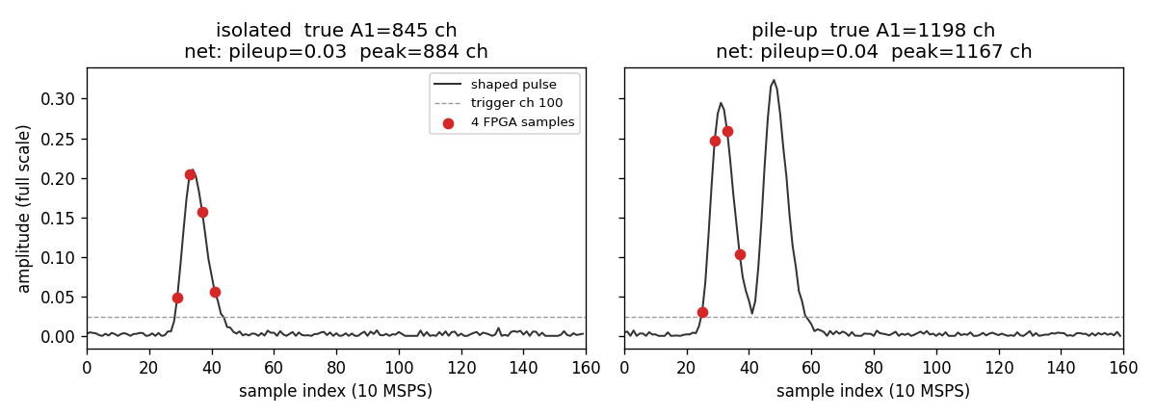
Fig. 1. Four post-trigger samples (stride 4, 400 ns) on a CR–RC^8 isolated pulse and a synthetic pile-up pair [17].
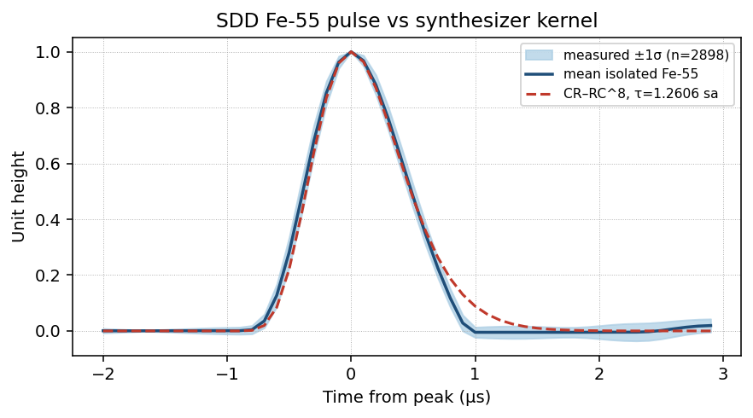
Fig. 2. Mean isolated Fe-55 SDD pulse (n = 2898, ±1 σ) and the frozen CR–RC^8 synthesizer kernel (Tpeak = 1.01 µs). Unit-height RMSE = 0.030. The model tail is slightly long; that residual is not hidden.
Metric | Value
Events | 1000
True pile-up | 103
Accuracy | 0.949
Precision | 1.000
Recall | 0.505
F1 | 0.671

TABLE II. Held-out pile-up classification (threshold 0.5), CR–RC^8 synthesizer [17].
 | Predicted single | Predicted pile-up
True single | 897 | 0
True pile-up | 51 | 52

TABLE III. Confusion matrix on the same 1000-event test file (TN 897, FP 0, FN 51, TP 52) [17].
Zero false positives at this threshold is a conservative veto: isolated events are not discarded, at the cost of missing 51 of 103 synthetic pile-up pairs (recall 0.505). Relative to an earlier cartoon synthesizer (three leaky integrators, stride 15) F1 fell from 0.854 to 0.671. That drop is expected on a 1 µs pulse: four taps miss more of the second event when Δt is large. ROC-AUC remains open (Section VI).
Subset | n | MAE (ch) | RMSE (ch) | Max (ch)
Isolated pulses | 897 | 34.9 | 38.2 | 73.0
All events (incl. pile-up) | 1000 | 42.3 | 61.0 | 538.6

TABLE IV. Peak height versus true A1 (4096-channel units) [17].
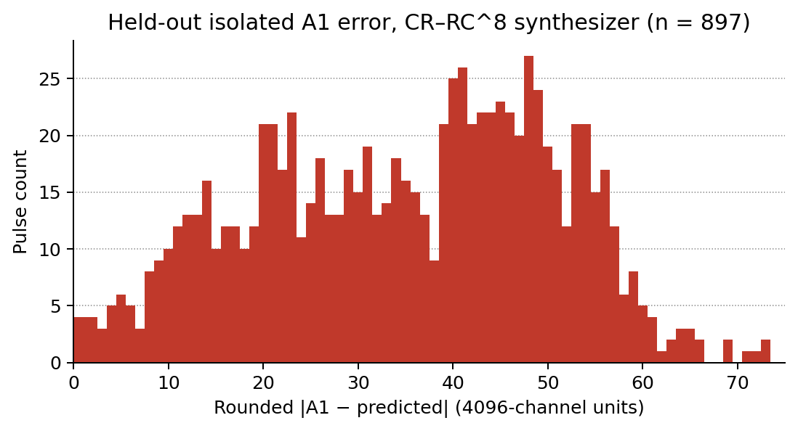
Fig. 3. Held-out isolated-pulse |A1 − predicted| histogram (n = 897). MAE = 34.9 ch [17].
Interpretation permitted: a 62-weight dual-head MLP can tag synthetic pile-up from four 400 ns taps on this SDD-fitted mix with high precision, and can estimate isolated A1 to a few tens of channels. Isolated MAE improved from 93.7 channels on the cartoon, stride-15 engine to 34.9 channels here because the taps now sit on the pulse. Interpretation not permitted: spectroscopic FWHM on a physical detector, unfolding of A2, or a measured pile-up F1.

B. Measured SDD + Fe-55 traces (no pile-up F1)
The measured campaign supplies the kernel in Fig. 2 and a public isolated-pulse archive. It does not supply a pile-up confusion matrix. Fe-55 Kα and Kβ are resolved at this gain. A reviewer can inspect every extracted pulse with real_data_viewer.py. Close-pair mode lists the 20 Fe-55 pairs with Δt < 8 µs. Those pairs are two resolved (or barely resolved) peaks, not sum peaks. Am-241 data were not included in this drop.

C. C# trainer same-set comparison (different target)
The WinForms Peak-mode export HeightFor4096.csv contains 10 000 pairs against the shaped waveform maximum, isolated pulses only, same-set. Converted to 4096-channel units the MAE is 0.89 channels (83% within one channel). That is not comparable to Table IV: the label is max(waveform), the pulse is the 2016 rectangle, and the split is not held-out. It is kept only so the laboratory tool is not silently discarded.
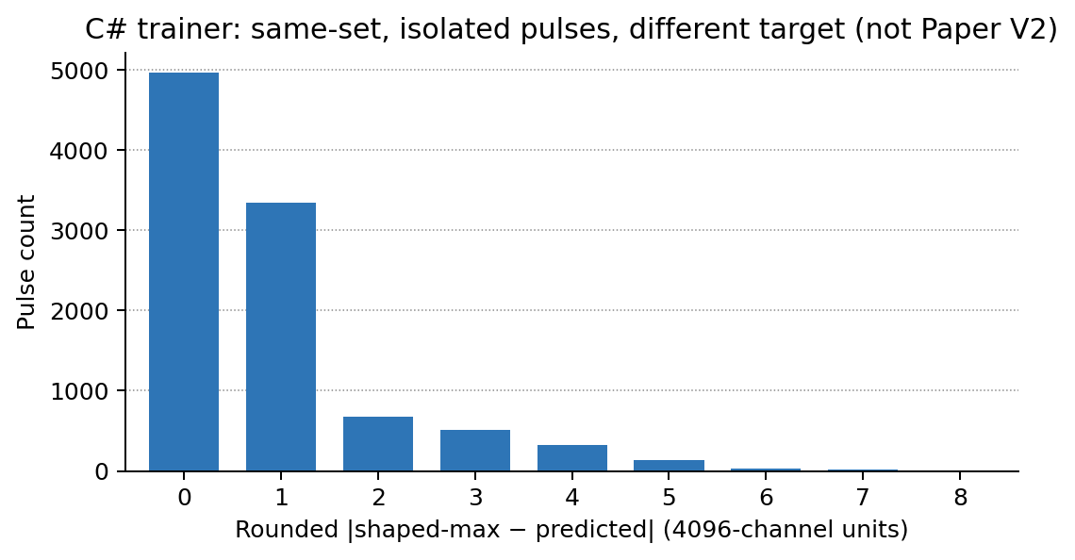
Fig. 4. C# trainer: rounded |shaped-max − predicted| on 10 000 isolated synthetic pulses (same-set, 2016 pulse). Different target from Table IV; not the V2 result.

D. Parameter and arithmetic budget
Each 4–5–1 head uses 31 weights. Both heads: 62 multiply–accumulates per event and ten clipped sigmoids. Fully parallel FPGA MACs would be 31 per head. Do not publish LUT/DSP/ns figures until weights/dual_head_weights.h is synthesised.

VIII. Hardware Outlook
The intended online architecture is offline training on a PC and a forward-only engine on the spectrometer. The FPGA or microcontroller needs the four triggered samples, the frozen weights, a sigmoid lookup or a hard sigmoid, a one-bit pile-up flag, and a peak word (height × 4096). Fixed-point width is an experimental axis, not a specification. Informal HLS snippets that used exp(+x) instead of exp(−x) are incorrect relative to NnBP and must not be reused.

IX. Discussion
The distinctive hypothesis is that four post-trigger amplitudes and 62 weights can carry two spectroscopy tasks on a pulse taken from a measured SDD. Prior full-waveform networks [7]–[14] already occupy the generic “ANN for pile-up” claim. Draft V1 used a cartoon RC tail and a 15-sample stride that does not transfer to 1 µs shaping. Draft V2 replaces that engine and reports the new, lower F1 without adjustment.
The principal scientific risk is unchanged: four fixed taps miss the second pulse when Δt is large, or become linearly dependent when Δt is small and A2/A1 is extreme. The recall of 0.505 already shows that failure on the fitted 1 µs pulse. Section VI exists to map the surface. If N = 4 works only in a narrow region, the honest result is still an operating-region study.
Simulation fidelity is improved but not closed. The kernel matches isolated Fe-55 shape and measured noise. It does not reproduce ballistic deficit, reset transients, or a Poisson high-rate stream. A later Am-241 campaign is the correct place for a measured pile-up F1, not the present 20 close pairs.
Claims that are not supported, and are not made here, include real-time FPGA mitigation at 10^6 s^−1, recovery of piled-up spectroscopic resolution, realistic HPGe or NaI pulses, FFT or compressive-sensing features, and speed-up factors inferred from sample-count ratios alone.

X. Conclusion
A compact pair of 4–5–1 perceptrons (62 weights) can be trained to map four 400 ns post-trigger samples of a CR–RC^8 pulse — the kernel fitted to measured SDD Fe-55 traces — onto a pile-up flag and the true first-pulse amplitude A1. On a held-out synthetic test of 1000 events, pile-up F1 is 0.671 (precision 1.000, recall 0.505) and isolated-pulse A1 MAE is 34.9 channels of 4096. The measured campaign calibrates the shape and is released with a viewer [17]; it does not yet provide a pile-up F1. Code, synthesizer, traces and tables are in [17].
The remaining question is over what region of pulse separation, amplitude ratio and SNR four samples and 62 weights match a full-waveform detector closely enough to justify the hardware saving. FPGA implementation and true pile-up unfolding belong to a later study, after that region is mapped and after a high-rate measured set exists.

Acknowledgment
The measured SDD + Fe-55 traces were acquired by Arpit Patel, Senior Engineer, Physical Research Laboratory (PRL), Ahmedabad (arpitp@prl.res.in), with a 12-bit, 10 MSPS setup and 1 µs peaking, and shared with the author on 21 August 2026. The C# trainer and MCA display were developed as an R&D laboratory testbed at Dharmsinh Desai University. The public software release is [17].

References
[1] G. F. Knoll, Radiation Detection and Measurement, 4th ed. Hoboken, NJ, USA: Wiley, 2010.
[2] W. Guo, S. H. Lee, and R. P. Gardner, “The Monte Carlo approach MCPUT for correcting pile-up distorted pulse-height spectra,” Nucl. Instrum. Methods Phys. Res. A, vol. 531, no. 3, pp. 520–529, 2004.
[3] V. T. Jordanov and G. F. Knoll, “Digital synthesis of pulse shapes in real time for high resolution radiation spectroscopy,” Nucl. Instrum. Methods Phys. Res. A, vol. 345, no. 2, pp. 337–345, 1994.
[4] A. R. Patel, H. S. Mazumdar, and B. Patel, “A new approach for pulse amplitude measurement using Lagrange’s interpolation for radiation or particle detectors,” Adv. Space Res., vol. 71, no. 2, pp. 1319–1330, 2022, doi: 10.1016/j.asr.2022.01.020.
[5] A. Patel and B. Patel, “Pulse amplitude measurement using low sampling ADC and interpolation technique,” Qeios, 2024, doi: 10.32388/UFBEFX.
[6] A. R. Patel, H. S. Mazumdar, and B. Patel, “A new approach in pulse amplitude measurement technique for radiation or particle detectors,” in Proc. IEEE Nucl. Sci. Symp. Med. Imag. Conf. Room Temperature Semicond. Detector Conf. (NSS/MIC/RTSD), 2024, doi: 10.1109/NSS/MIC/RTSD57108.2024.10656055.
[7] M. Kafaee and S. Saramad, “Pile-up correction by Genetic Algorithm and Artificial Neural Network,” Nucl. Instrum. Methods Phys. Res. A, vol. 607, no. 3, pp. 652–658, Aug. 2009.
[8] B. S. Acharya et al., “FPGA implementation of a deep learning algorithm for real-time signal reconstruction in radiation detectors under high pile-up conditions,” presented at the 21st IEEE Real Time Conf., 2019, arXiv:1903.02439.
[9] ATLAS Liquid Argon Calorimeter Group, “Optimised neural networks for online processing of ATLAS calorimeter data on FPGAs,” Eur. Phys. J. C, 2026, doi: 10.1140/epjc/s10052-026-15321-y.
[10] “FPGA performance for signal reconstruction of the ATLAS Tile Calorimeter in the HL-LHC environment,” EPJ Web Conf., vol. 338, p. 01004, 2025.
[11] C. Fu et al., “Real-time classification of radiation pulses with piled-up recovery using an FPGA-based artificial neural network,” IEEE Access, vol. 11, pp. 78721–78735, 2023.
[12] C. A. Norsworthy et al., “An artificial neural network system for photon-based active interrogation applications,” IEEE Access, vol. 9, pp. 119734–119747, 2021.
[13] R. Molina, M. Ballina, M. L. Crespo, and S. Carrato, “Physics-guided neural network for pile-up rejection on SoC-FPGAs,” IEEE Trans. Nucl. Sci., 2026, doi: 10.1109/TNS.2026.3681873.
[14] Nuclear Instruments, “Neural network pile-up resolution (Super-MuSR / ISIS),” project note, 1-D CNN on FPGA via hls4ml. [Online]. Available: https://www.nuclearinstruments.eu/projects/ai-pileup/
[15] See [2]; also later comparative surveys of pile-up correction algorithms, e.g. Nucl. Instrum. Methods Phys. Res. A, 2020, doi: 10.1016/j.nima.2019.163013.
[16] J. Jiménez et al., “Implementation of a neural network for digital pulse shape analysis on a FPGA for on-line identification of heavy ions,” Nucl. Instrum. Methods Phys. Res. A, vol. 674, pp. 99–104, 2012.
[17] H. S. Mazumdar, “Four-sample pile-up: dual-head MLP, SDD-fitted CR–RC^8 synthesizer, and measured Fe-55 traces,” GitHub repository, 2026. [Online]. Available: https://github.com/hsmazumdar/four-sample-pileup

