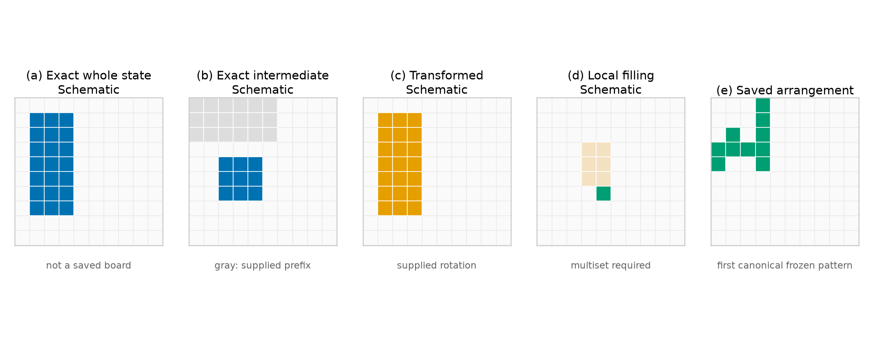
Figure S1. Illustrations of the representations used for memory reuse. Panels (a)–(d) are schematics, not saved boards: the evaluation files do not store the coordinates needed to redraw an experimental case. Gray cells stand for a supplied prefix. Panel (c) is a supplied rotation. Panel (d) ties a local filling to a piece multiset. Panel (e) plots the saved cells of the lexicographically first frozen arrangement in Expt-17 after the declared translation normalisation. A geometric fit does not establish a beneficial commitment.
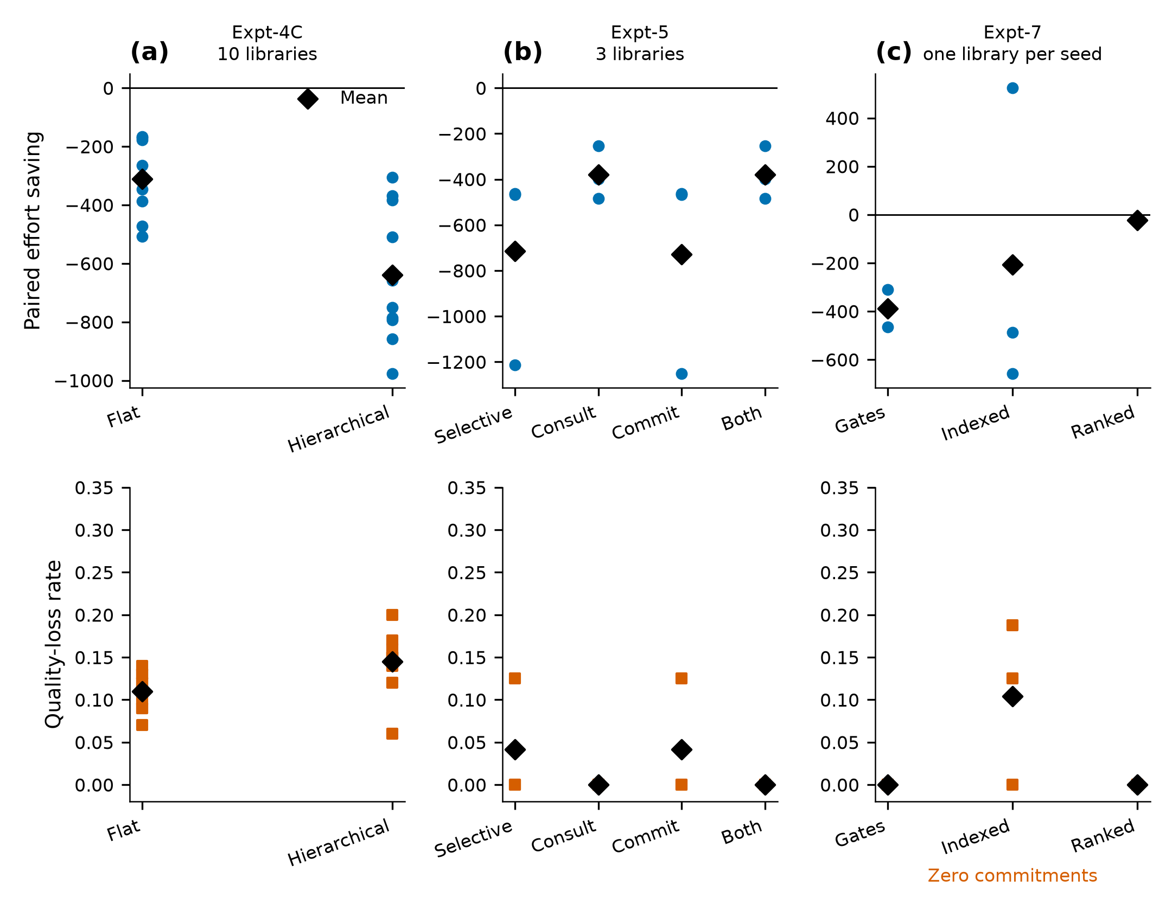
Figure S2. Selective operation reuse on held-out boxes. Each column uses that experiment’s own primitive baseline. Upper panels are paired effort saving. Lower panels are the quality-loss rate, quality more than one cell below the paired primitive. (a) Expt-4C, 100 tasks by 10 libraries. (b) Expt-5, 16 evaluation tasks by 3 libraries. (c) Expt-7, 16 tasks by 3 seeds, run 20260929_220030. Each seed uses its own frozen library. The snapshot hashes for seeds 11, 22, and 33 differ. The indexed ranker made zero commitments, and its near-baseline effort is consultation cost. These panels are not one shared task set.
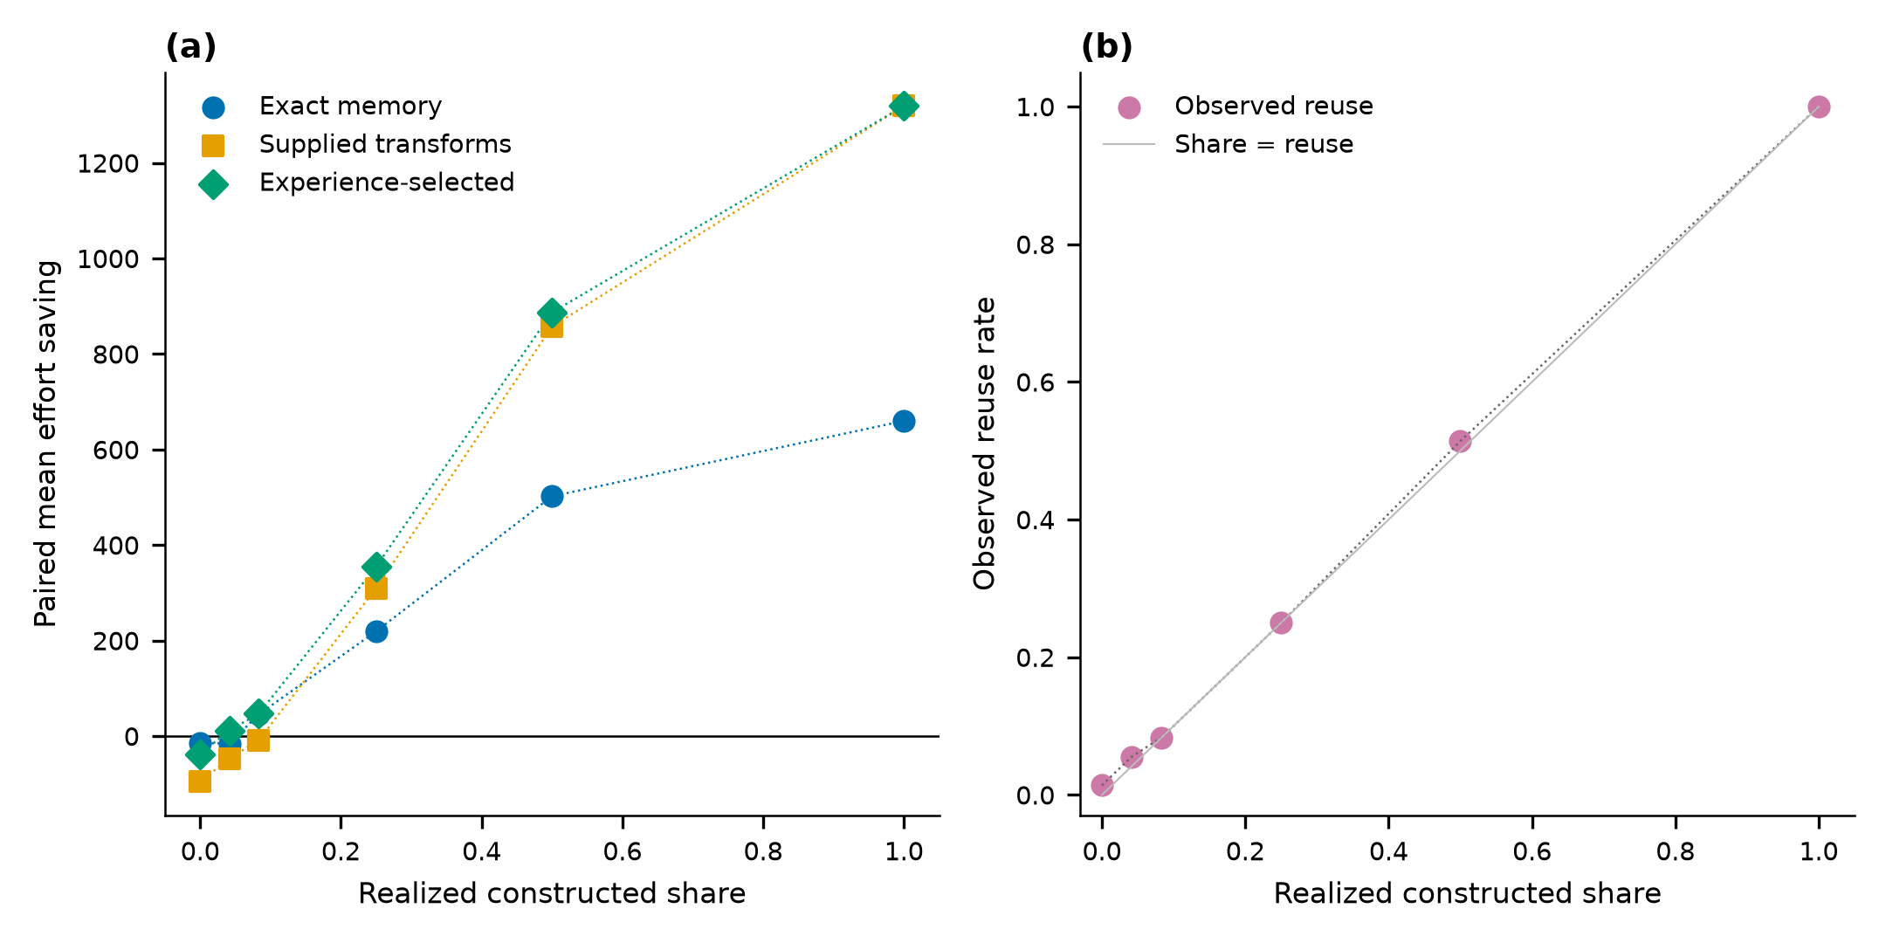
Figure S3. Expt-12 constructed mixtures. (a) Paired mean recorded effort saving against the realized share of slots whose hidden category was an exact recurrence or a valid transform. Dotted lines connect measured settings. The smallest positive learned saving is one measured point, not a general break-even. (b) Observed reuse can exceed the constructed share because a later hit can occur. Task difficulty differs across settings. Twenty-four slots by three seeds are not 72 independent memories.
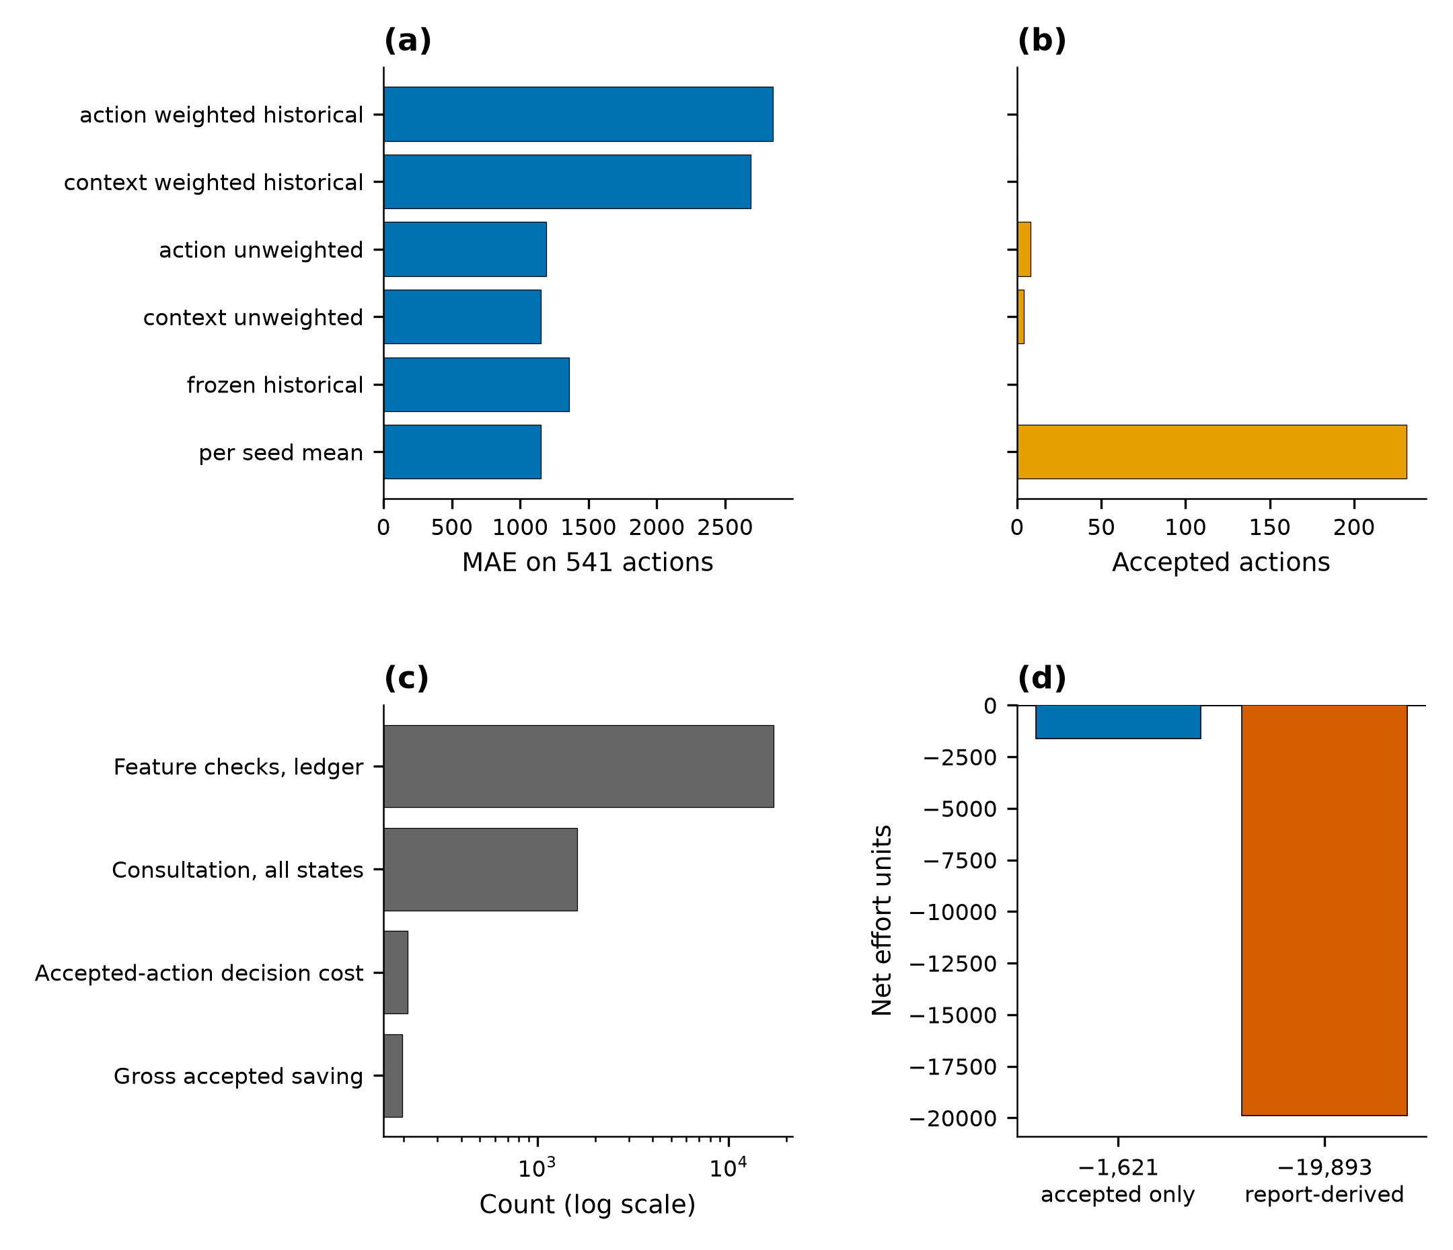
Figure S4. Expt-8C action-level diagnostics on 541 unseen first-legal actions. (a) Mean absolute error. (b) Accepted actions. Acceptances for the unweighted models and the per-seed mean occurred on seed 33 only. (c) Cost components for the action model, on a logarithmic axis. Feature checks are the ledger total of 17,167. (d) Two nets that stay separate: the saved offline net of −1,621 bills accepted feature checks only; the report-derived net of −19,893 also subtracts rejected feature checks and rejected site checks. The −19,893 identity is report-derived. These are not whole-box deployment savings.
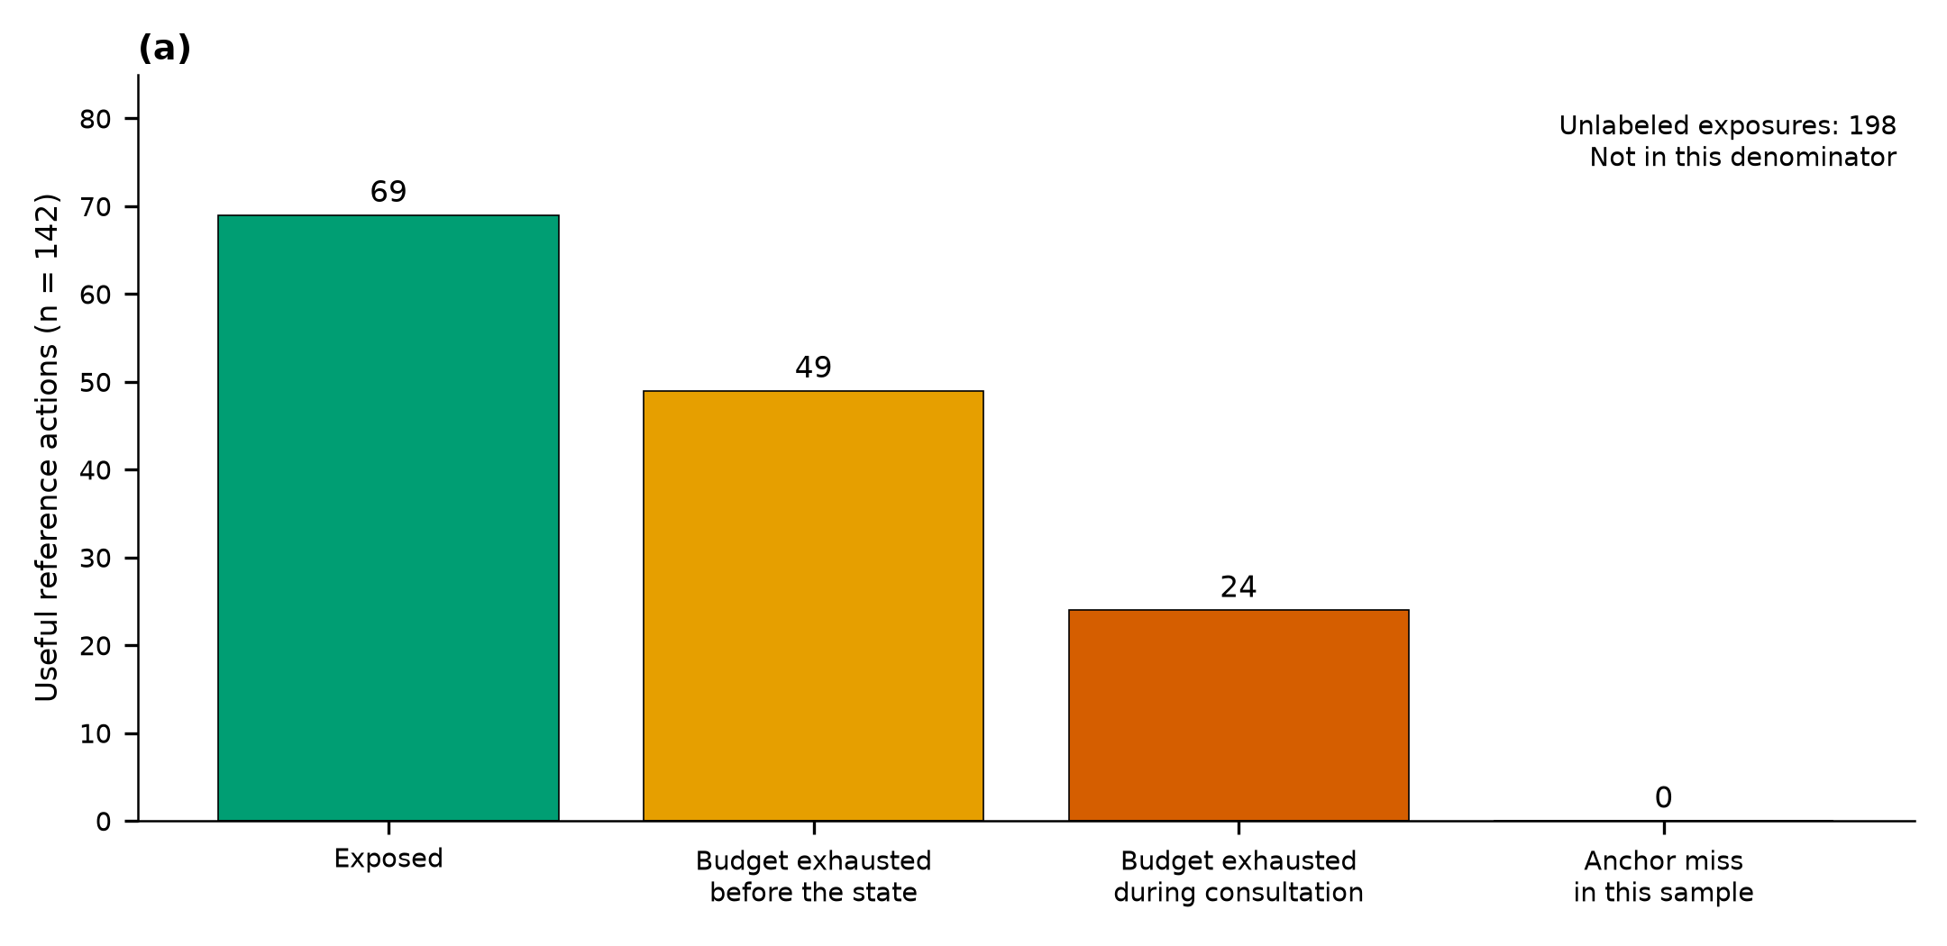
Figure S5. Expt-19 classified useful reference actions on the fresh validation set. Of 142 useful actions, 69 were exposed, 49 were missed because the budget was exhausted before the audited state, and 24 were missed during the consultation. Anchor misses in this sampled reference were zero. That statement does not show that the anchor set covers every useful placement. The 198 unlabeled exposures are outside this denominator.
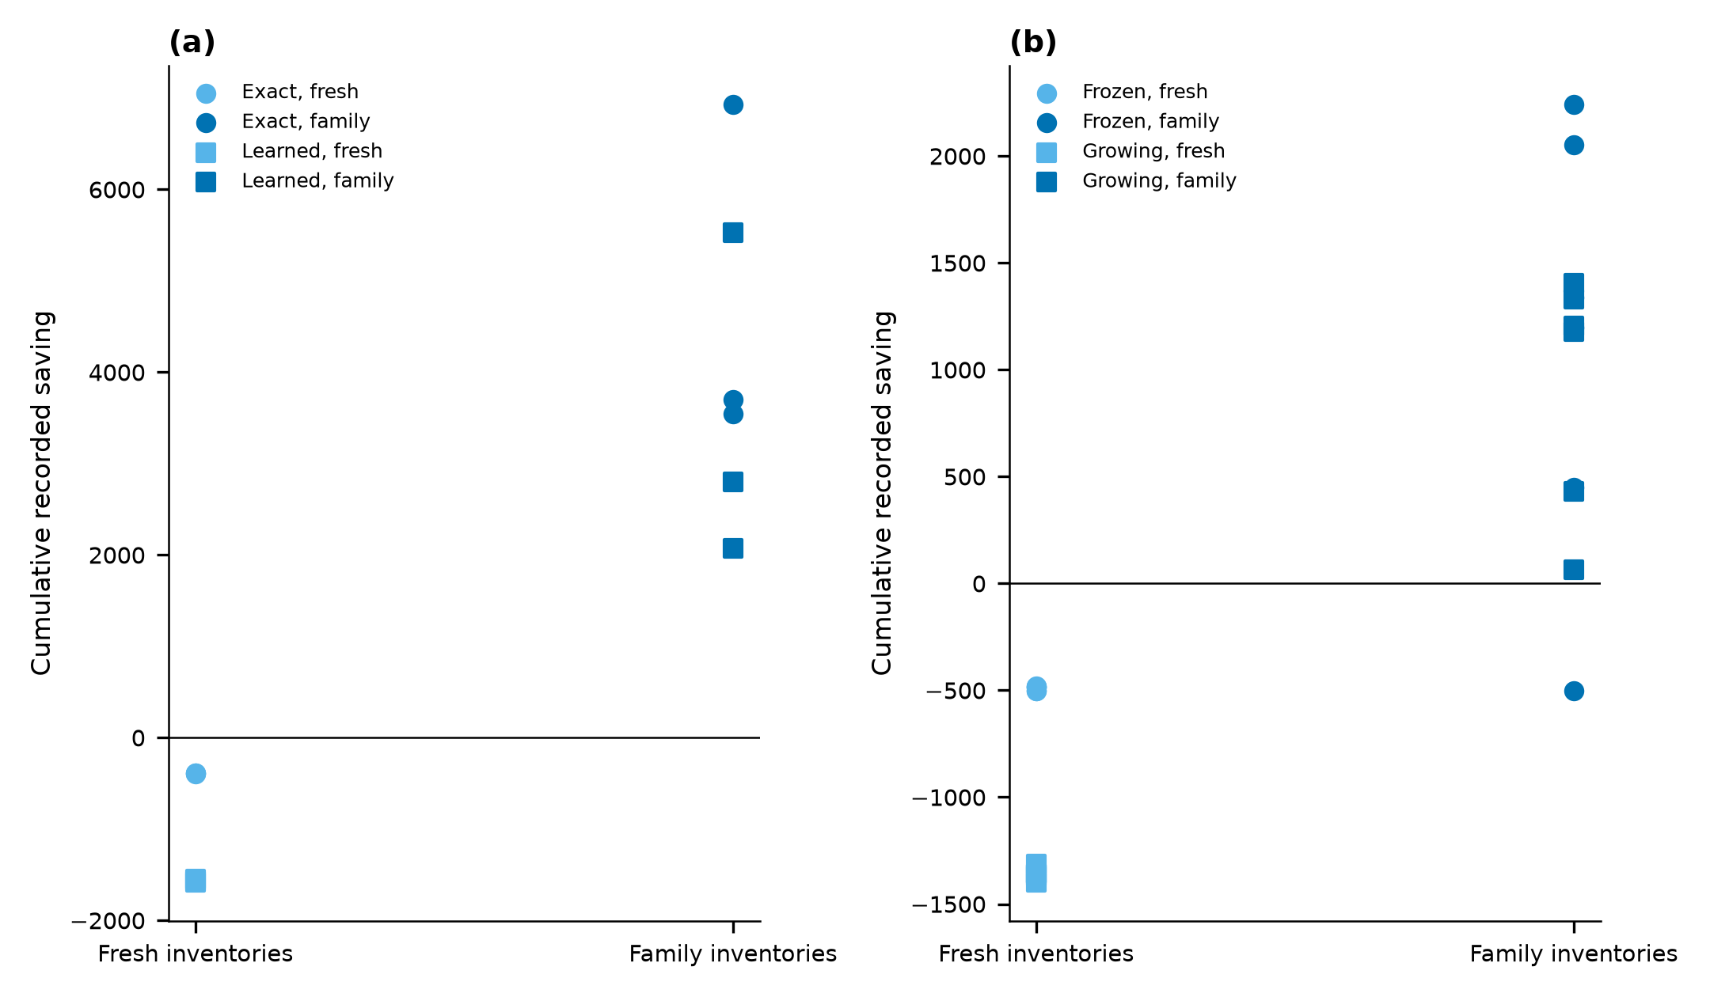
Figure S6. Per-stream recorded effort saving. (a) Expt-13, three streams. (b) Expt-14, six streams. Points are stream totals. Seeds that share one table are not independent memories. The Expt-14 inventory split is in the accompanying data file from the full figure archive.
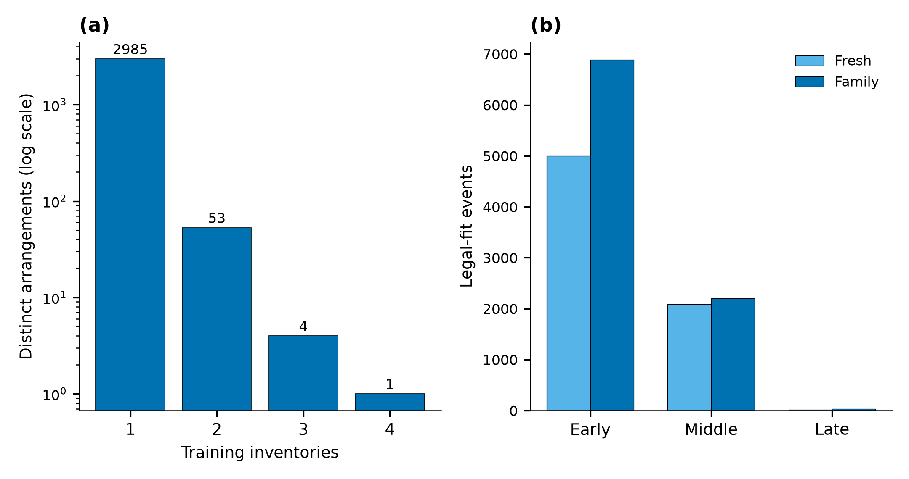
Figure S7. Arrangement census details omitted from the main text. (a) Expt-17 training support of all 3,043 distinct arrangements, counted by inventories. The vertical axis is logarithmic and labelled with the counts. (b) Legal-fit events on fresh and family applicability boxes, by stage. An event is a prefix and a pattern with a translation. It is not a commitment.
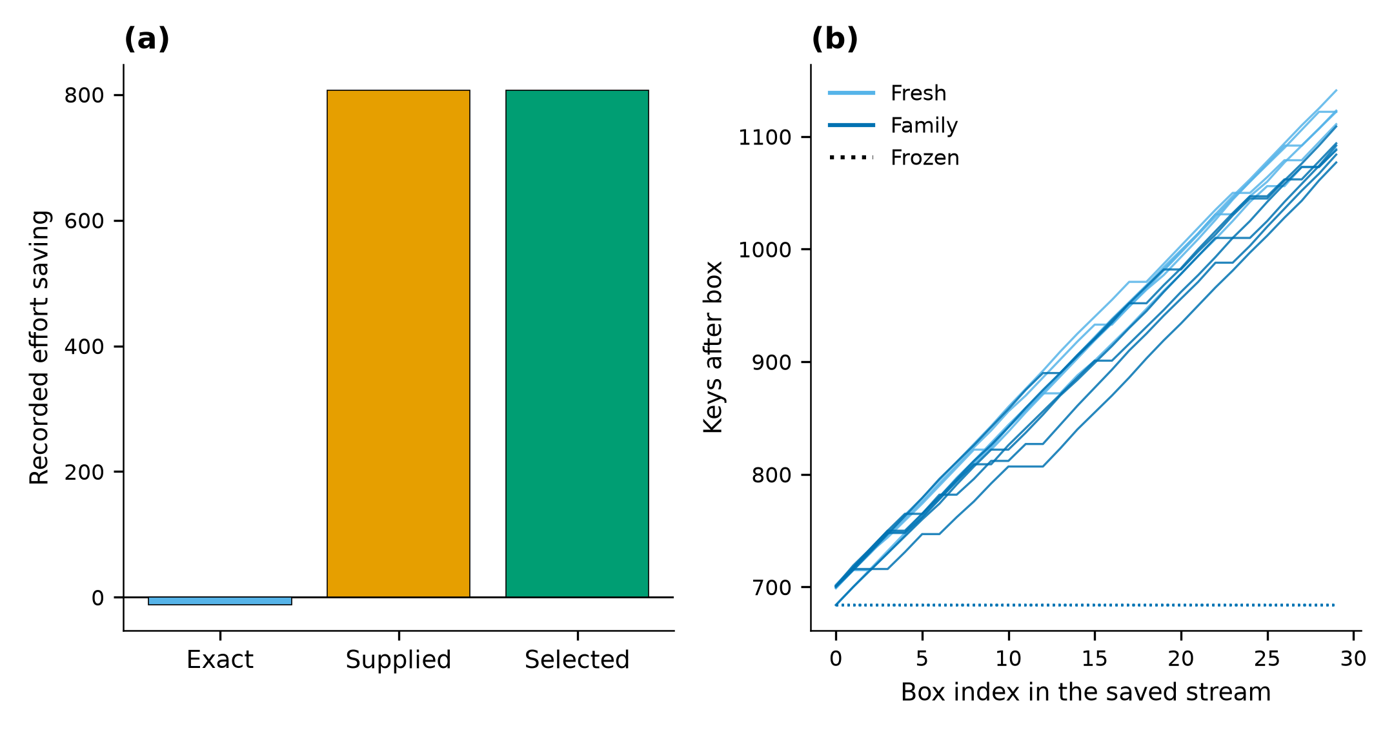
Figure S8. Recall detail omitted from main Figure 2. (a) Expt-11 transformed test remainders, 11 tasks by 3 seeds. Supplied and experience-selected transforms matched each other. Saving is the recorded effort_saving column. (b) Expt-14 keys after each saved box. Frozen memory stays at 684 keys. Growing memory is drawn from the saved index order.

