Project Report: Nelson Acres and Four Seasons Bakery, Heather Smith, 19 Jul 2020

Link to website: http://mason.gmu.edu/~hsmith42/finalproject/index.html

Purpose: My original concept for this, as stated in my proposal, was to: “set up a future website for our farm. It will also contain a subsite for my daughter’s website, Four Seasons Bakery. As it is for a future farm, it will contain our philosophy, farm plan to include intended products, as well as some additional information for the self-sufficient customer. My daughter’s website will highlight examples of her baking as well as her current experience. As we continue to work towards obtaining our farm, we will already have a base website prepared.” I also decided code the website from scratch instead of using a template. I found through the course that I didn’t like coding from someone else’s code as there was too much in the code that I didn’t understand. If I wrote my own, I would at least know the thought process behind it.

Preparation: Upon reviewing my current draft project, I feel that I met my stated purpose for the website. I focused on the Rehobeth Farm website to pattern mine, found at: <https://rehoboth-farm.myshopify.com/>. Here is a screenshot of their front page for comparison to mine:

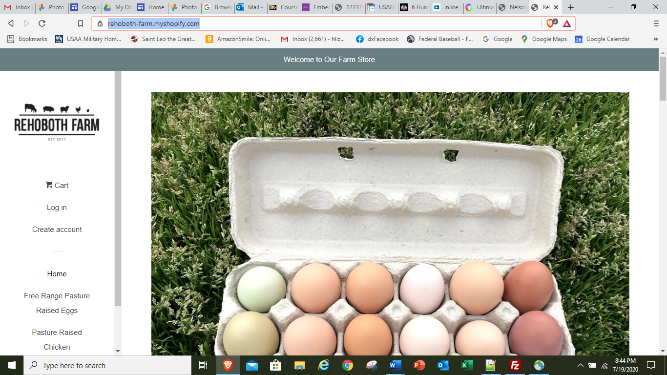

I liked the simplistic design. For a farm website, I felt it should be fairly simplistic to focus on the products. The adjustment I had to make is that my website is as much my farm plan as well as a basis to use as my farm website once the farm is up and running. This translated to my website being more text than pictures and no need for a shopping cart or anything along those lines. I also thought the navigation along the side was interesting and worth trying, as I had done two different types of navigation bars in the exercises already. Similar Pages: <https://rehoboth-farm.myshopify.com/> Rehoboth Farm. Their site is a farm store, which mine will not be yet. Their website displays their different meat collections with photos and shopping links, along with contact information and a welcome to visit their farm in person. It also contains updates to the status of their farm and availability of products. It contains way to pay, a way to open an account, and a cart for products. It also links to other social media platforms for their farm. Pretty simple site, but has some capabilities I won’t have yet as our farm is only in planning stages (and I don’t believe we learn how to do carts and payment in this course).

Other sites I looked at for ideas:

<https://www.redrangefarm.com/>

<https://meadowcreekpa-com.webnode.com/>

<http://www.gilliardfarms.com/>

For my daughter’s subsite: <https://www.magnoliabakery.com/>

<https://billysbakerynyc.com/>

One of the lab exercises for the videos in the course suggested we find a website to try and model with a fixed layout. I decided that was a great time to start my website design and see if I could replicate the Rehoboth Farm Website. This was a little bit unfortunate as we hadn’t learned responsive layouts yet, but I liked the layout I came up with and stuck by it even though I did consider starting over again as responsive layout.

Original Design: My design included four pages. The first page is a welcome page to the farm and quickly introduces the philosophy and management team of Nelson Acres, as well as an introduction to Four Seasons Bakery’s owner. Each page has a consistent header where I utilized some of the styles we learned: background-image, shadow-text, gradient, Google fonts, and rounded corners.

Along the left side is the navigation bar. It starts out with the logo for Nelson Acres, and I will address the issue with the picture and most of the other pictures as well. This is the actual photo for the logo:

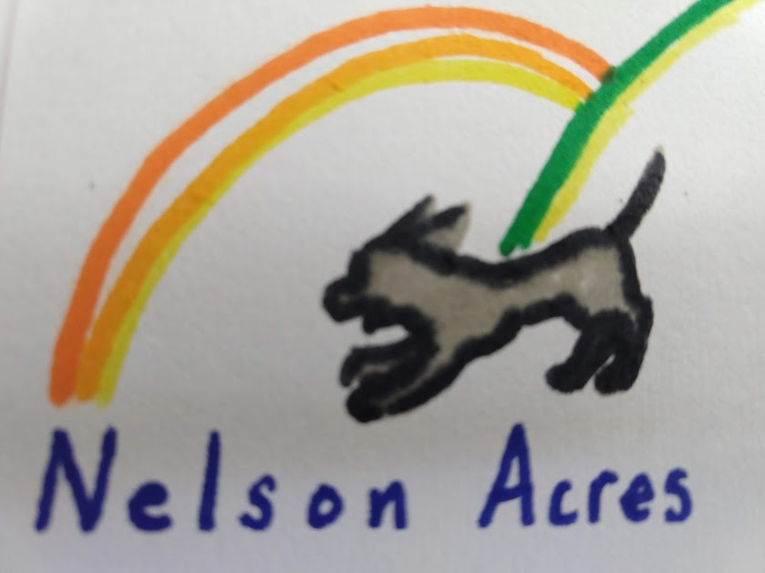

On the website, the top and most importantly the bottom with the name are cut off, so it is difficult to tell that it is actually the logo for the farm. This happens to several photos and I just couldn’t find anything in my code to account for it. I wonder if it is a hiccup of using Embed for Google Photos. I did end up adding a hover over these images, page 3 images, and Four Seasons Bakery images on the desktop setting, which I think does help them look better.

Underneath the logo is the navigation bars to the four different pages: the Home page, the Farm Plan Page, and the Self-sufficiency Page, and the Four Seasons Bakery. As a note, when I did adapt the page at the end from a fixed layout to a responsive one, I decided against making the navigation bar a fixed element, as well as the header or footer. I did not feel the design of the website necessitated such an approach as I thought it would make it distracting to read the text. Where the content is longer, I used “Return to Top” links instead, such as the Farm Plan Page and Four Seasons Bakery.

Of note, this website really showed me the difference in control from fixed layout to responsive layout. I kept it in a fixed layout until I had pretty much finished, then put in the media queries, the positioning, and watched my layout fall apart. The instructor on the Lynda videos had warned this was a bad approach, but it really was interesting as I struggled to put it back together to see the changes in the format and especially the spacing between my elements. I have only relative positioning right now as that seemed to work best for each element, and I didn’t want any fixed elements.

The second page, the Farm Plan, follows the same basic layout. It has the mission of the farm as the first paragraph, and then has a split element beneath it. This portion is to help organize the farm plan for future planning and potential grant writing or loan requests. Over the next three to five years in particular, we are looking for the property so identifying the needs for the farm based on our products and goal will be very helpful.

The photo on the Farm Plan page is one of the few that came in at its normal size. I have image style in the global portions of my CSS: img {

border: 2px solid orange;

margin: 0 0 1em 1em;

max-width: 100%;

max-height: 100%;

float: right;

object-fit: contain;

}

My photos are all from Google Photos, where I created a link and used the website Embed Google Photos (<https://www.labnol.org/embed/google/photos/>) to create the link to put in the HTML. In the HTML, I have an image tag surrounded by a figure tag, and are set at a width and height at 100% except for the photos on Four Seasons Bakery. This page will continue to expand. There is more to the plan, and as we make more decisions and those impact the plan, we’ll be able to provide more specifics. At the end of the mission statement paragraph, I did include a link to a PDF of the current plan.

The Self-sufficiency page is really an expansion into our farm’s mission. I had a blog for the farm years ago when we first started growing seedlings for our yard, and I wanted to incorporate that into the design. I think we can capture some vital information. I chose to do a simple element describing why self-sufficiency is so important to the farm plan, and also identify another external resource for the curious reader, Biodynamics. Below that, I did another two-column element where I floated a picture to the right and the blog itself to the left. I chose to use overflow: auto to create the scroll. I do not believe this is the most efficient way to establish a blog. I’ll continue to research and update the page as I create future blog posts. As a note, the Rehoboth site did not have a blog, but I have noticed that several farm pages I’ve reviewed over the years tend to do so as a way to communicate with potential customers.

The final page is Four Seasons Bakery. I made sure to keep the general layout from the rest of the website to tie it visually to the farm, while also adding and changing elements so it stood out on its own. Another feature I added was to ensure when Four Seasons Bakery was mentioned, I included a link to the page to allow for easy navigation. In the same vein, Four Seasons Bakery has a link back to the Nelson Acres Home Page. I targeted the header as an easy and visual way to maintain the basic format but change the colors to distinguish it. My daughter loves watermelons, so a lot of her things are a bright pink with a limey green. I used the W3Schools reference page to get the right colors.

One other way to distinguish the page, I changed the Nelson Acres logo for the Four Seasons Bakery Logo:

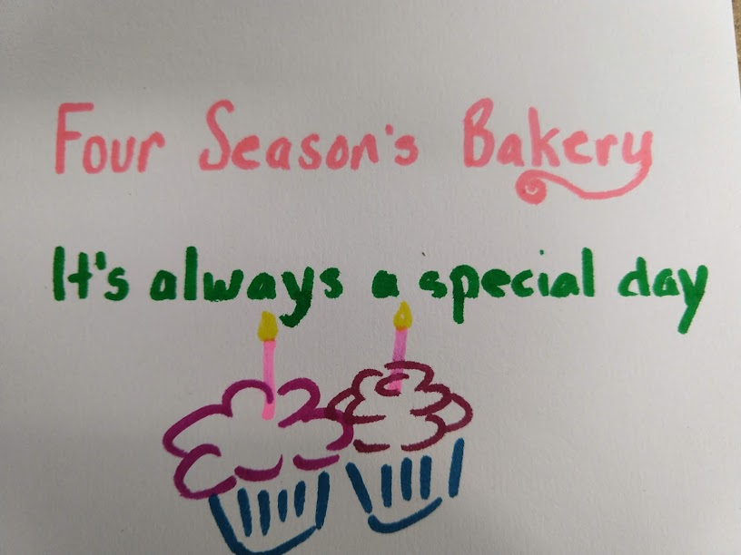

Again, the logo is cut off although the words are at least legible. Again, I will continue to work towards a solution. Additionally, I changed the second navigation section to include her products, with each one linking to the paragraph for that product. At the bottom of each of those paragraphs is a Return to Top.

For this page, the images are the most disappointing. The photos are cut off which especially fails to convey the skills she is using. These two photos in particular are not well-represented:

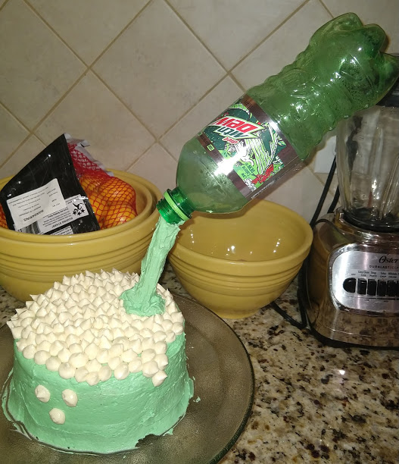 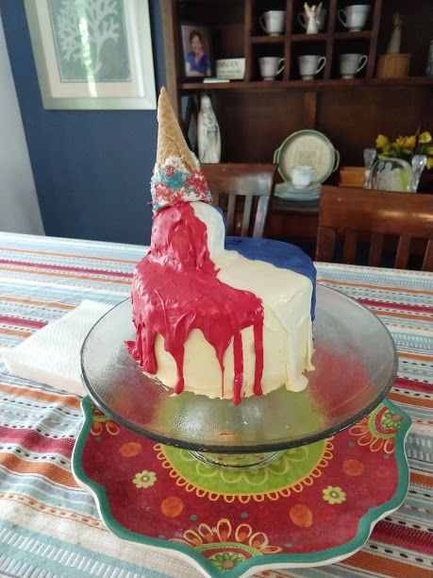

I know there is a lot of white (or in this case, pink) space on this page. I originally intended for more images of her work displayed in an inline-block, but I could not get it to work. I will keep working on that with these photos.

I did use this page to try another visual effect mentioned in the videos on the right side elements. I put a lighter pink for the container element, and then did a darker pink for the content element for the first element describing Four Seasons Bakery. For the subsequent elements with her different products, I switched the colors to see how the effect would look. I liked both so kept it that way. It will look even better as I get the images spaced, sized, and positioned better.

Responsive Website: I built the website as a fixed layout based on where I was in the training when I started it. I continued with that format as I worked out bugs and added content. I had the website just as I wanted in a fixed layout and with a lot of control over the elements in each page. I first added the code to make the page responsive to different browsers as I’ve written it completely in Brave.

\* {

-webkit-box-sizing: border-box;

-moz-box-sizing: border-box;

box-sizing: border-box;

}

This initially threw off my website, but I was able to rework the code and fix it. I then added the meta tag to each of my page’s html to cover the different sizes of devices: <meta name="viewport" content="width=device-width, initial-scale=1.0">.

After adding those, I recalculated my pixel sizes into percentages for the widths of my elements. I experimented with absolute and relative positioning and found that relative worked best for my design. As I resized my site, I could see the difference with how this reacted and how my fixed version reacted. I continued with media queries and was able to simplify my design even further for the tablet and mobile sizes. Initially, I had a lot of trouble with one page and could not figure out why it looked different from the other three. I finally realized that two of my elements had widths as “77%px” and those two extra letters I forgot to erase destroyed the entire layout. Once they were identified and removed, the layout fell into place as the other three pages had.

I did take the recommendations from my peer reviews. One felt my colors were a bit too much, which I did realize. She suggested I use some white, so I compromised and used lighter yellows. I find white a bit glaring. My other classmate suggested my words were too close together, so I used line-height to spread them out, and he was definitely correct. I did have product links in the original navigation area, but I couldn’t get them to link properly to the products on page 2. I did not have time to develop additional pages for these, so I removed them for now. I did leave the product links on Four Seasons Bakery as those always worked. This will allow for adding more images of her work in the future as well.

The websites I relied the most to learn techniques such as having the links show up in new tabs, the images hovering, and other ones are the W3School, Stackeoverflow.com, CSS-Tricks.com; and color-zilla.com color gradient generator.

Conclusion: I feel that I was able to meet the objective in my proposal. That being said, there is still room for improvement by better use of white-space and fixing the images to display better. The Home Page has two elements with far too much white space, and Four Seasons Bakery also has too much white space between the descriptions and the images. The footer could also use more aesthetically-pleasing design. The footer actually kicked off to the right for a large amount of time I worked on the website. I finally sound that I had failed to close a section tag, but when I closed that tag, the layout of each page went askew. After more trial and error, I found that my section was too large and the format returned with the footer in the correct position if I broke up the section into four or five sections and removed extraneous div tags. Overall, I think the website meets my original proposal except that I did not include a video. However, I believe I used many different techniques from the course and have a coherent if not perfect website. I definitely feel that I can continue to build on this website as noted throughout this report to use it as an aid to our farm and my daughter’s bakery.