Genetic Algorithm for Road Alignment Problem: Report

# 1. Introduction

The road alignment problem is a complex optimization challenge involving the determination of the optimal layout and orientation of a road network. Balancing factors such as terrain, environmental impact, and cost makes it a challenging task. In this assignment, a genetic algorithm is implemented to address a simplified road alignment problem using a surface roughness map.

# 2. Problem Statement

The task involves finding an optimal path with minimum cost from the right side to the left side of a given surface roughness map. The map, as depicted in Figure 1, represents the roughness levels of the terrain. Darker colors indicate higher roughness. The fitness function is based on the cost associated with constructing a road from any y-axis coordinate on the left side to any y-axis coordinate on the right side.

# 3. Approach and Methodology

## 3.1 Representation

Each individual (chromosome) is represented as a sequence of coordinates (y) in length of map weight, defining a road. If two coordinates are not in square adjacency, a bridge or tunnel is required.

## 3.2 Genetic Operations

- **Mutation**: Two mutation methods (`mutation` and `mutation2`) are implemented, altering individual chromosomes to explore different paths. In mutation2 gene can only decrease or increase by 1.

- **Crossover**: Two crossover methods (`crossover` and `crossover2`) are employed, creating offspring by combining genetic material from selected parents. In crossover2, crossover is on of junction of two path by random.

- **Selection**: Roulette wheel selection is used to choose parents based on inverse fitness.

## 3.3 Fitness Evaluation

The fitness function calculates the cost of constructing a road based on roughness levels. If coordinates are in square adjacency, the roughness value is used as the cost; otherwise, the squared Euclidean distance is considered for tunnels or bridges.

# 4. Implementation

The code is organized into three main components:

## 4.1 `map` Class

Handles the surface roughness map and provides methods for distance calculation and path visualization.

## 4.2 `create_map` Function

Generates a new map with specified dimensions and roughness probability levels.

## 4.3 `GA` Class

Represents the Genetic Algorithm with methods for initialization, selection, crossover, mutation, and running the algorithm.

## 4.4 `plot_fitness` Function

Visualizes the average and best fitness values over multiple runs of the genetic algorithm.

# 5. Experimental Setup

Three different setups are implemented, introducing variations in mutation, crossover. The implemented setups are compared based on their performance in finding optimal paths.

# 6. Results and Analysis

The results are visualized through plots showcasing best fitness values and average fitness values per generation for each run. Patterns, differences between setups, and the overall effectiveness of the genetic algorithm are discussed.

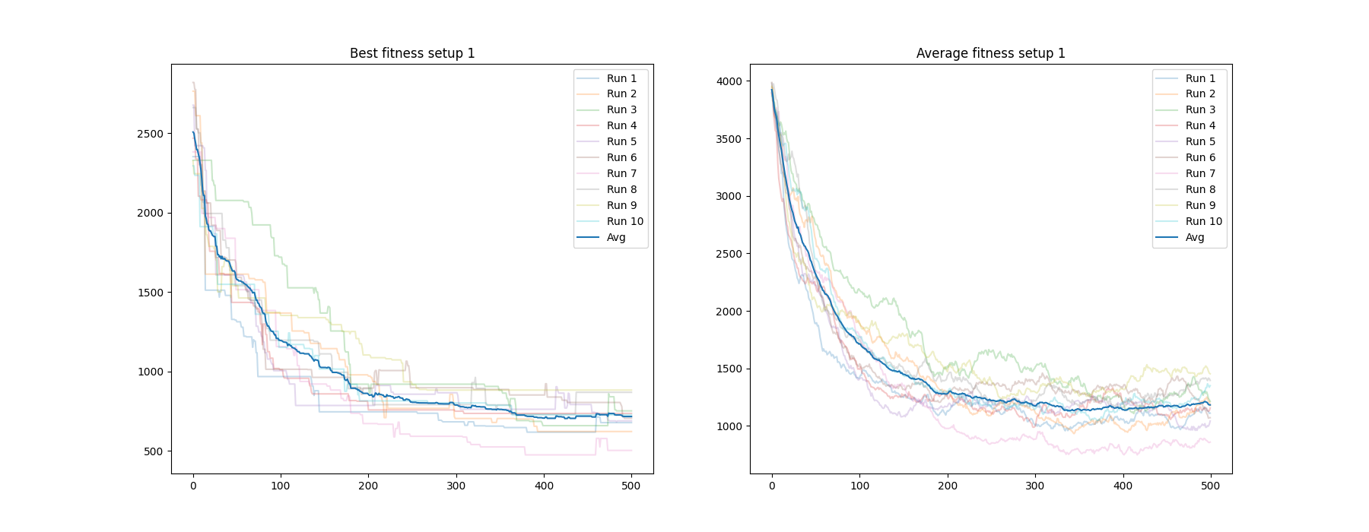

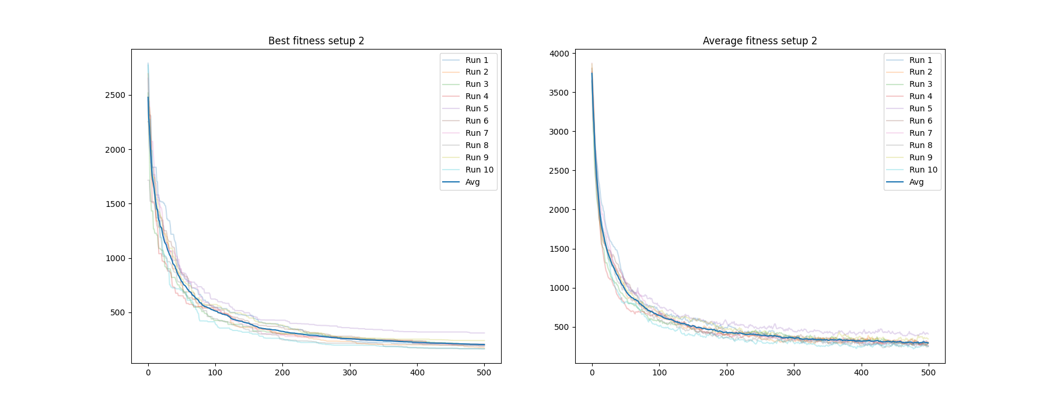

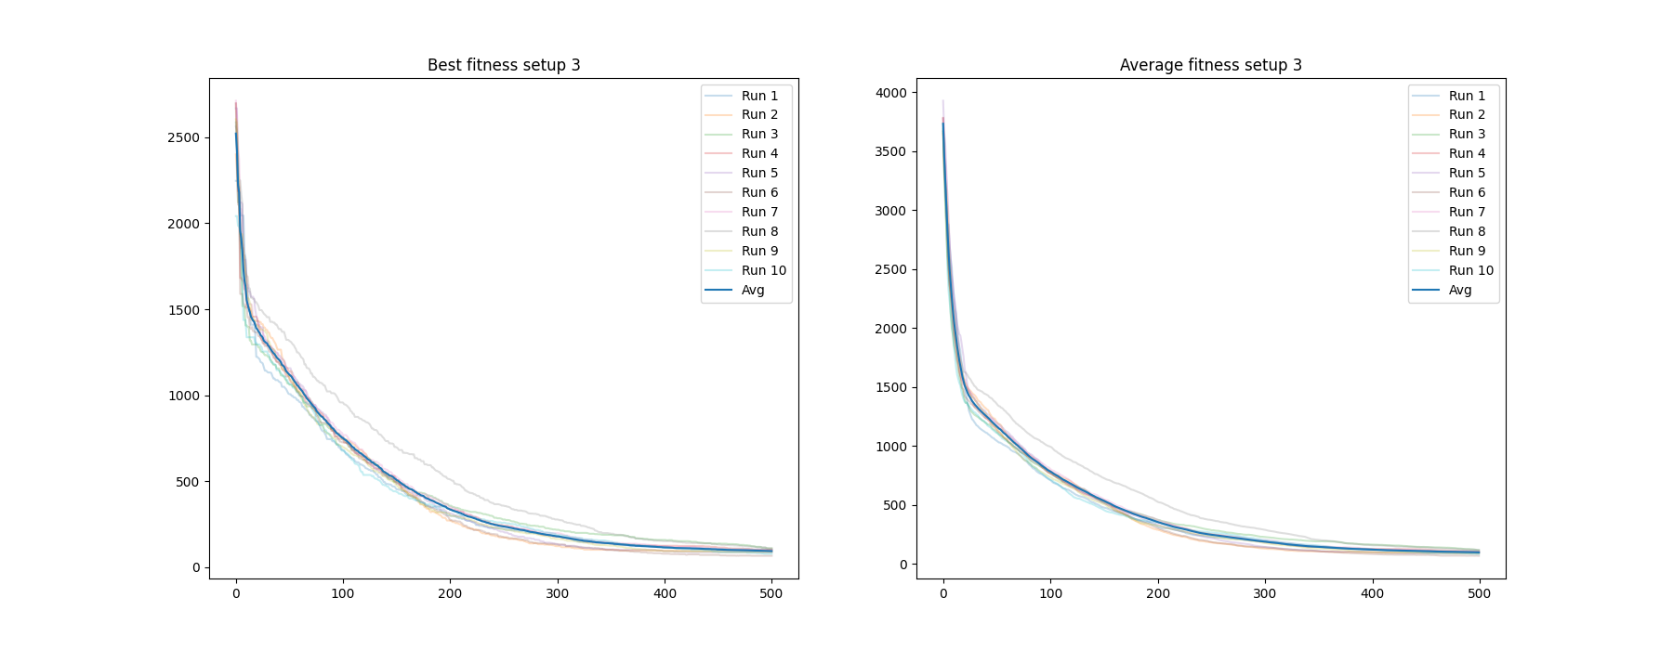

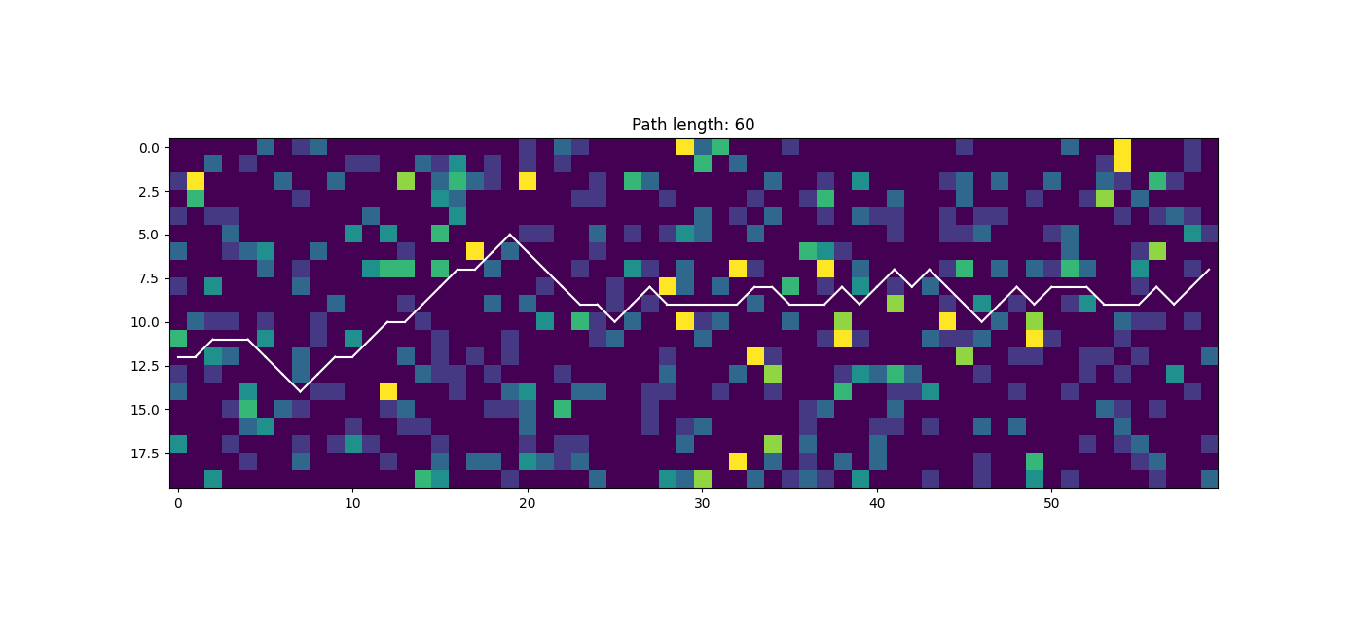

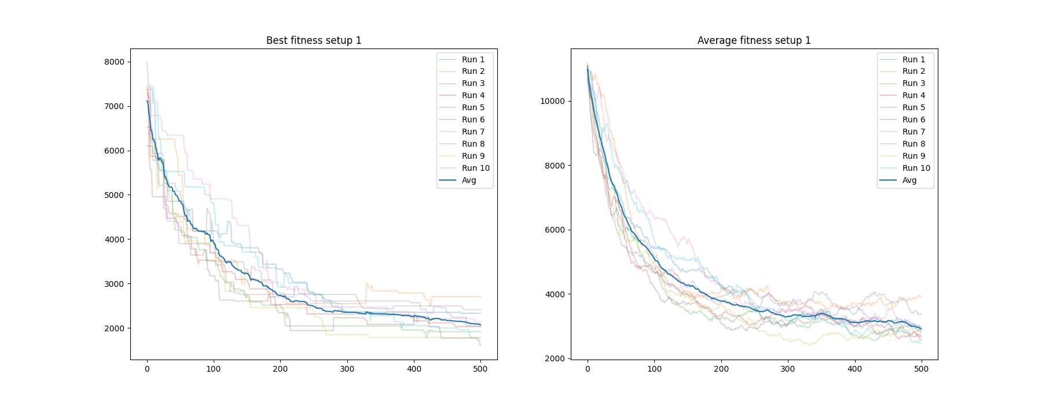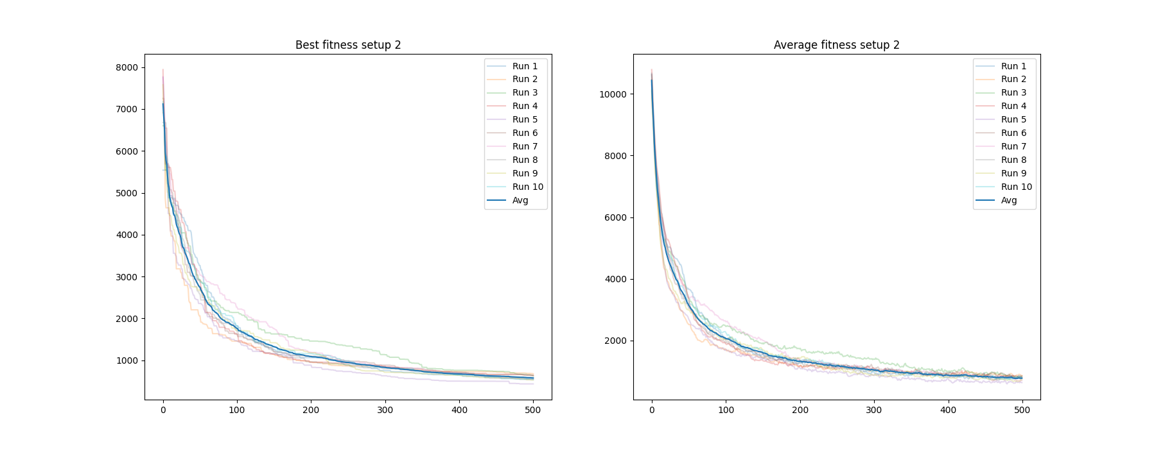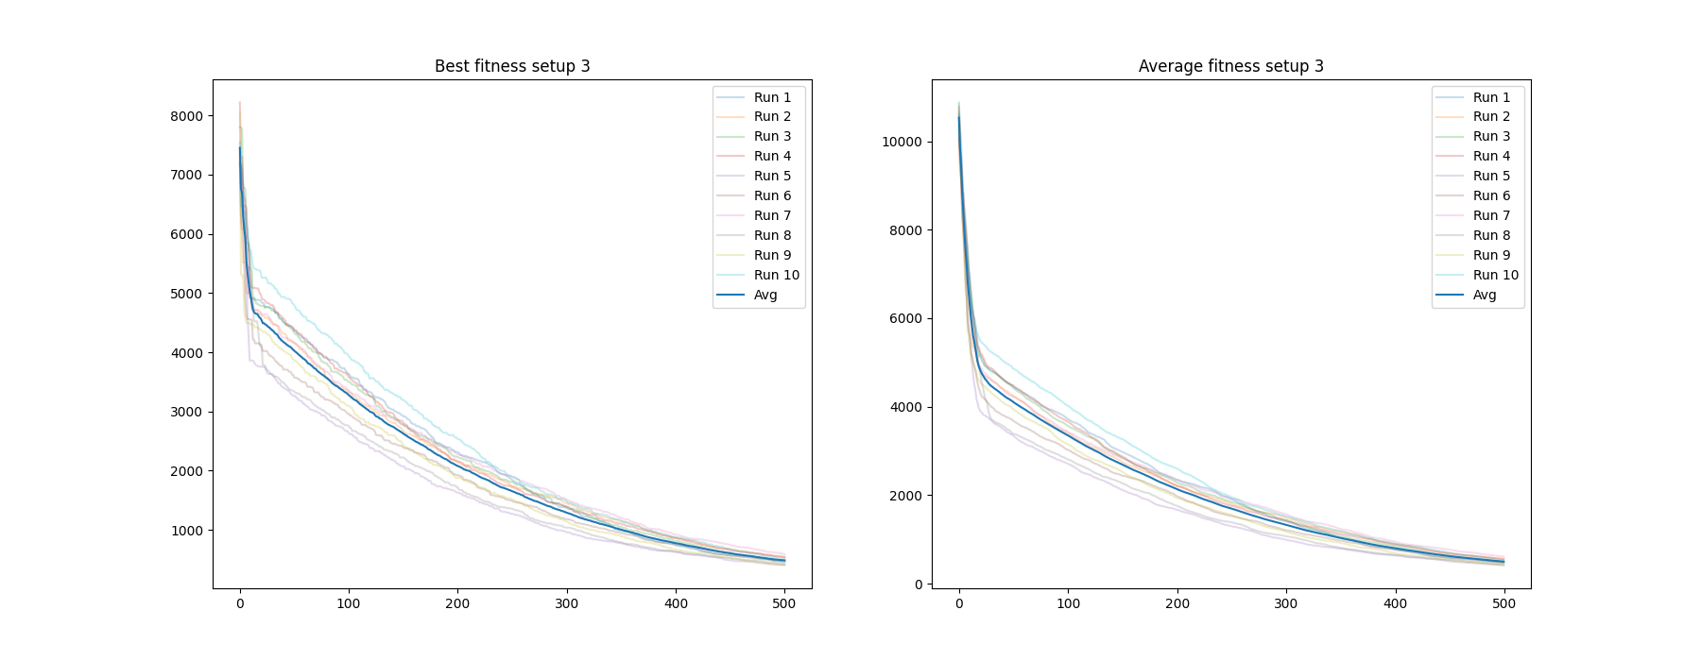

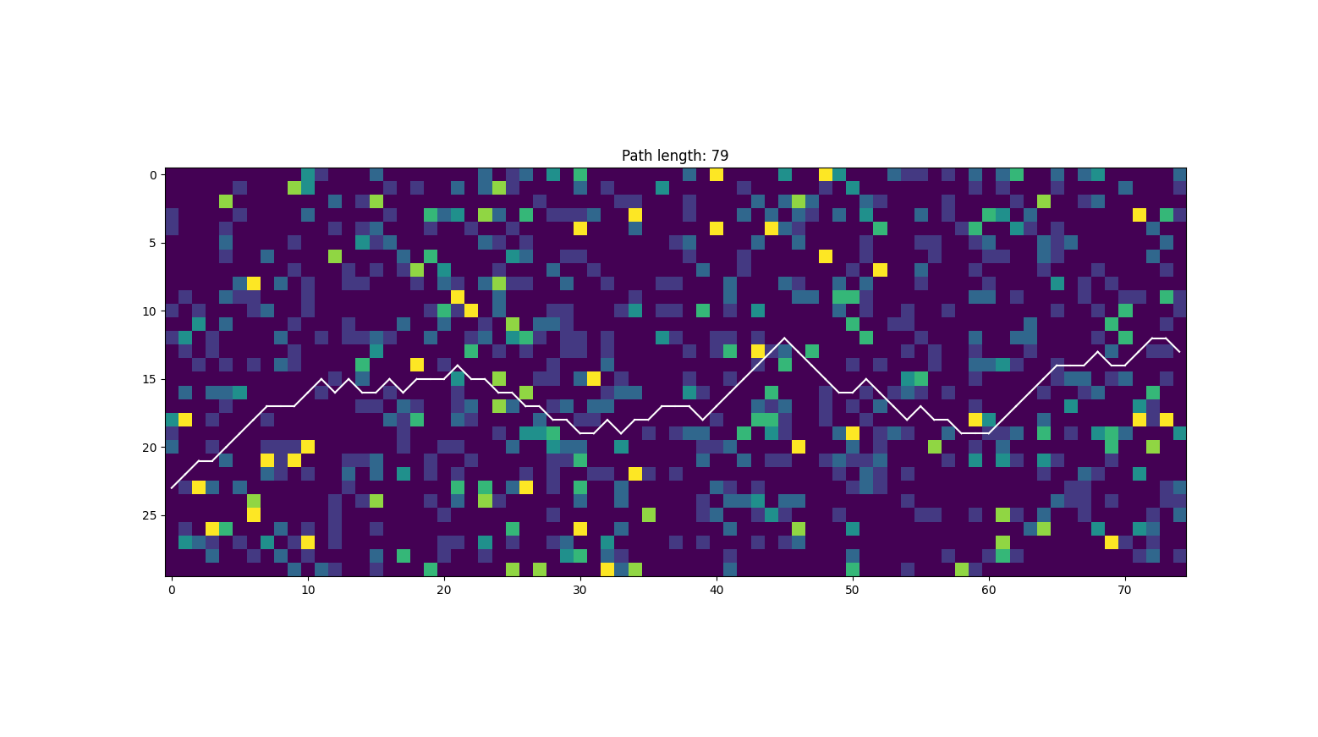

Also including Traditional GA

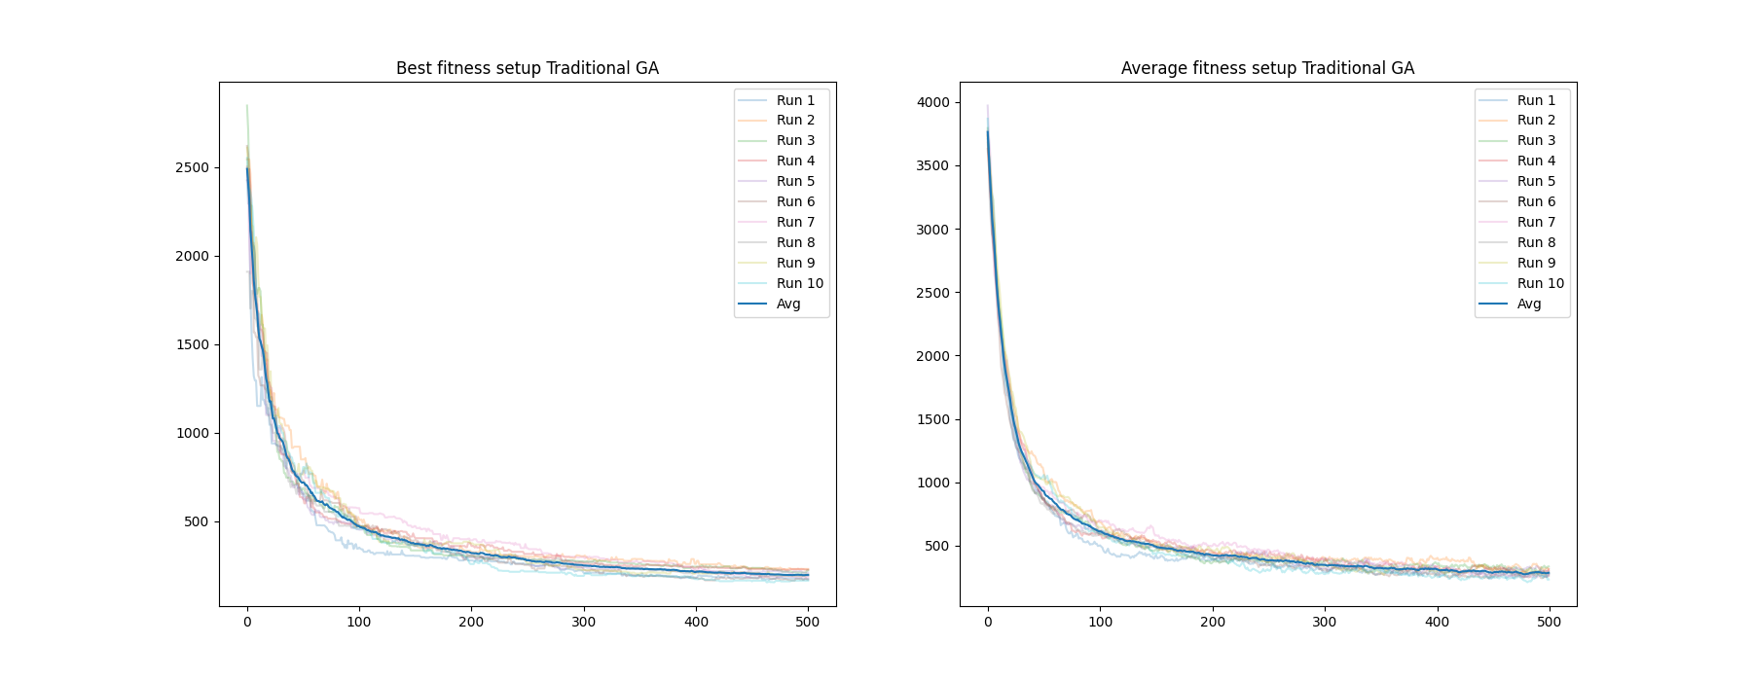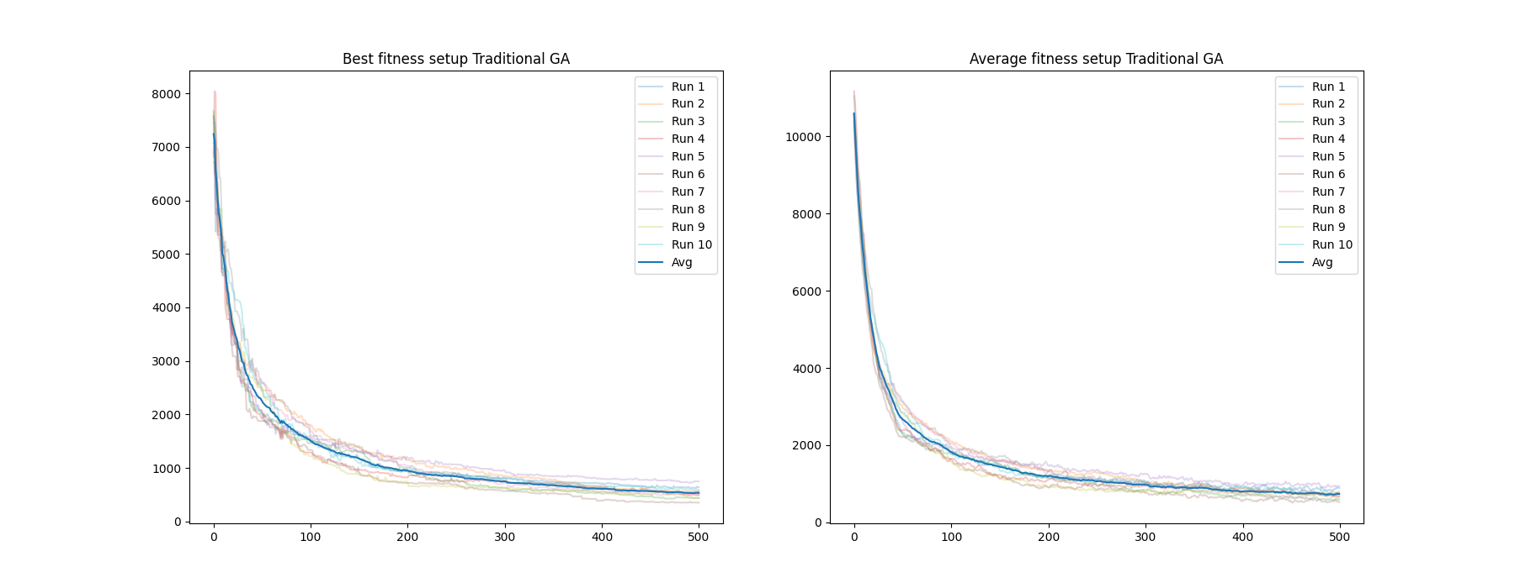

# 7. Conclusion

The implemented genetic algorithm demonstrates its ability to find optimal road alignments on surface roughness maps. The effectiveness of different setups indicates the algorithm's adaptability to various problem configurations.

# 8. Future Work

Potential areas for improvement include exploring additional mutation and crossover strategies, refining the fitness function, and conducting experiments on more diverse maps.