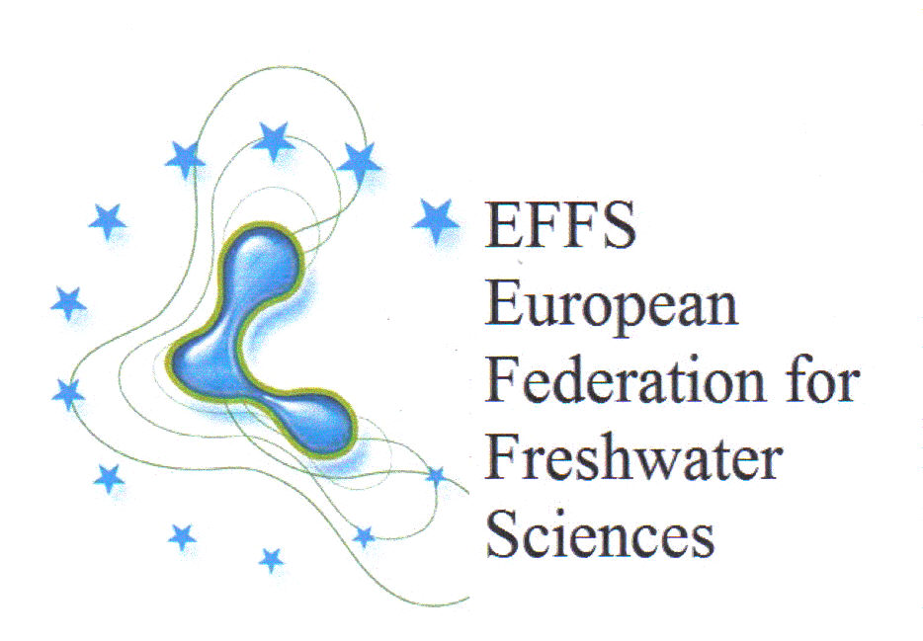

Certificate of Membership

Limnoloji Derneği

is hereby registered as the body representing the interests
of Turkish limnologists and freshwater scientists of
in the European Federation for Freshwater Sciences

C.S.Reynolds
Honorary Convener, EFFS
28 September 2009

