**Instructions for execution of Code:**

There are 2 files that I sent you,

1. Final Code.ipynb
2. Neural-style-tf.zip

**Final Code.ipynb**

1. Open your Chrome browser
2. Search Google Collab
3. Sign in with your google Account
4. Click on File from upper left menu
5. Select Upload a notebook
6. Choose from your laptop (Final Code.ipynb)

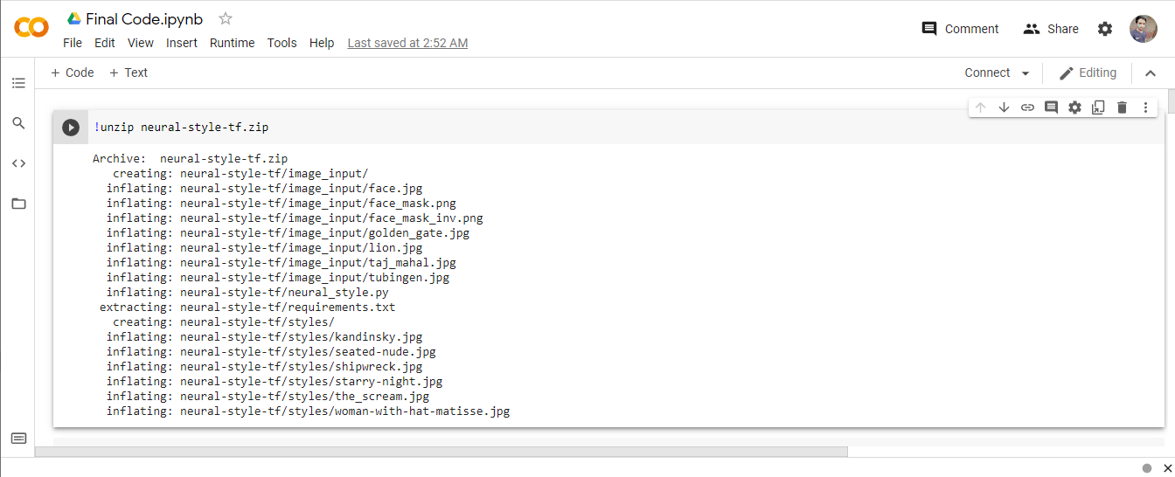

**Neural-style-tf.zip**

1. Click on Left Menu (Three hyphens)
2. And then click on Folder Icon (below Search and <> from left menu)
3. Drag and Drop neural-style-tf.zip
4. Neural-style-tf.zip Contains Image_input, Styles, neural_style.py and requirements.txt files/Folders
5. You can drag your Input Images to this folder (input_image)
6. Styles Contains Your target styles (you can add your styles)
7. Neural_style.py contains python code, on google collab you don’t need to open this file. I’ve written code in Google Collab which is using this python file.

**Execution**

Start running each cell and wait for cell to complete it’s execution and then move to other cells.

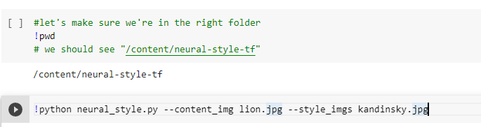

In the second cell of above image, you can replace your image’s name(added in input image by yourself) with lion image and add style target with Kandinsky.jpg

You will see your results.



In the above cell, you can add multiple style images to add 3 elements of images into 1. After (--style_imgs)