**CSE 471 – Assignment 2**

**1.**

**metin içeren bir resim

Açıklama otomatik olarak oluşturuldu**

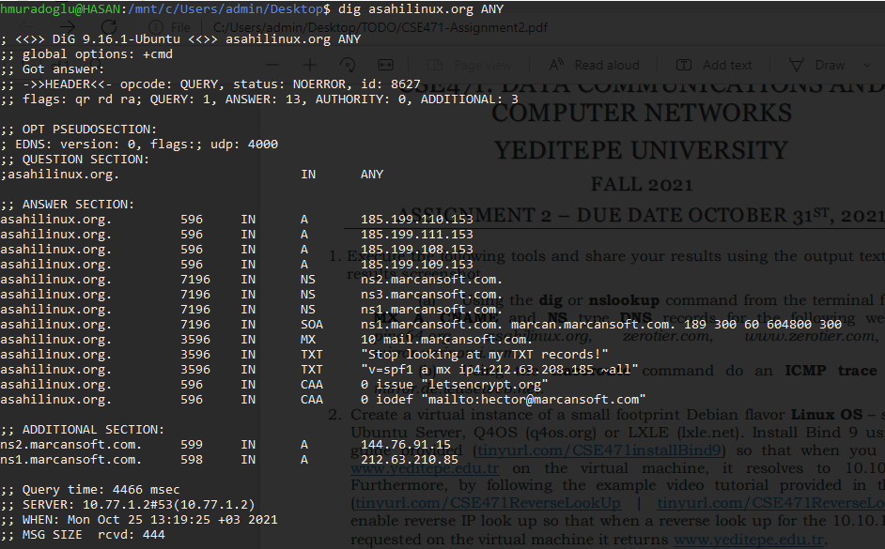

**metin içeren bir resim

Açıklama otomatik olarak oluşturuldu**

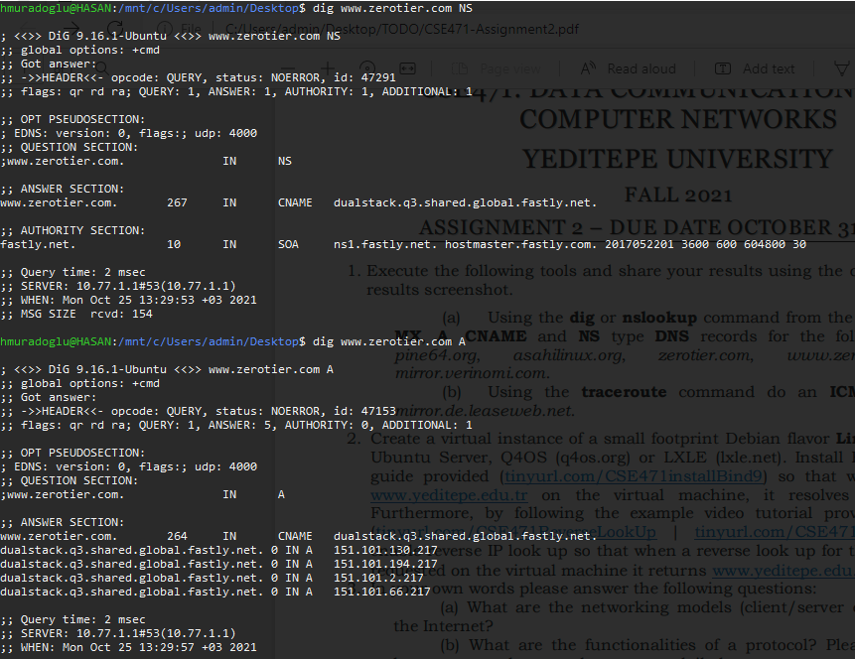

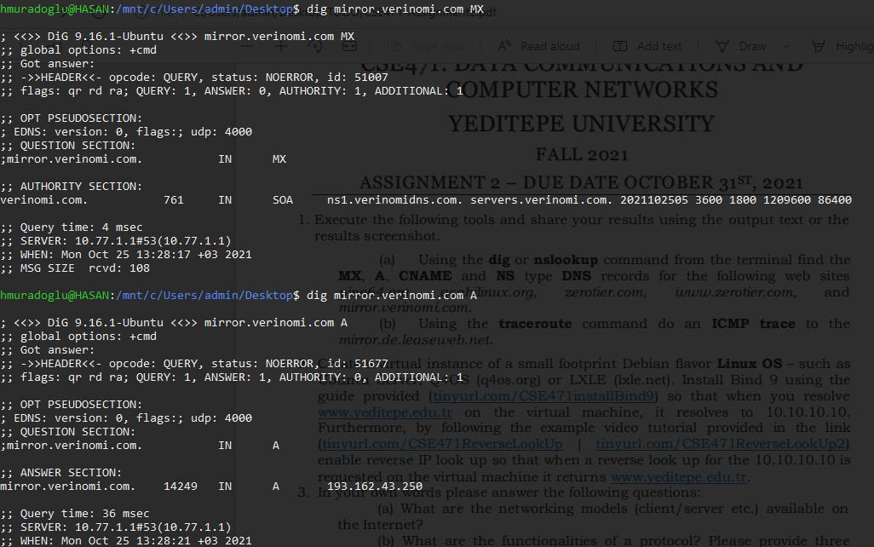

**2.** 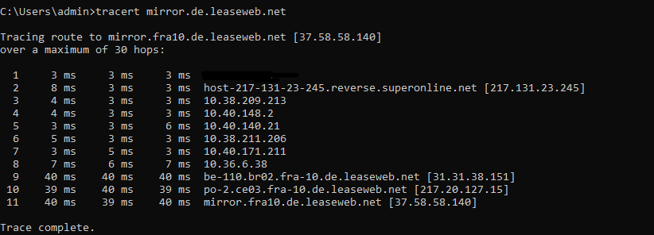

**3. a.** End Systems (Hosts), Client/Server Model, P2P Model

**b.** Protocols allows devices that connected to network, communicates with rules and with a proper way. We use HTTP(S), POP3 and IMAP protocols in our daily life mostly. HTTP for browsing on internet but generally HTTPS for secure browsing. POP3 and IMAP for mail communication.

**c.** Shared media stands for commonly using connection type and it stands for users share same network and connection can be change by usage of network. That means bandwidth split among connected devices and users. For example, if there is over usage in our local area there will be slower connection.

Dedicated media is private network for user and other users cannot use that network. This also provide better connection and connection speed regardless from usage. For example, business networks generally dedicated and it is not affected by local networks.

**d.** Ethernet cable input, router switch, antenna for wireless connection (optional) and cable outputs.

**e.** Circuit switching is referred to as the technology of data transfer that utilizes sending messages from one point to another. This involves sending messages from the receiver to the sender and back simultaneously. A physical connection gets established during this process along with the receiver; a dedicated circuit is always present to handle data transmissions, through which data is sent. Packet switching can be used as an alternative to circuit switching. In the packet-switched networks, data is sent in discrete units that have variable length.

**4. Nodal Delay** amount of time used to process the packet headers, check for bit errors and determine the destination host. **Queuing Delay** amount of time a packet is waiting in the queue (buffer) before it can be pushed on the link. **Transmission Delay**amount of time necessary to push all the bits on the link. **Propagation Delay** amount of time it takes the signal’s header to travel from the sender to the receiver.

**5.** Throughput is the name given to the amount of data that can be sent and received within a specific timeframe. Bottleneck is difference bandwidth on connection and affect the speed of connection. For example if we have 50mbps bandwidth coming our router but our cable that link between router and computer doesn’t support 50mbps and only gives 20mbps, there will occurs bottleneck between router and computer. Thus, we can’t receive fully 50mbps on our connection.

**6.** The problem is that in doing routing at the network layer, you wish to insulate the internal complexity of the WAN from the internetwork layer. In other words, you wish to make the internal topological complexity of the WAN disappear, and have it appear like a simple object to the internetwork layer routing. However, this is often in direct conflict with the goals of the internetwork routing, if the WAN cannot reasonably be modeled this way. If the WAN does not have the service characteristics of a LAN, but a more complex pairwise behavior, then you can't do anything about dealing with that behavior if it looks like a LAN to the routing.

**“…**my model of the future is that the internetwork layer will have a strong "flow" component, and the actual switches will likely look like ATM switches, but be under the control of associated "internetwork control nodes”

**Source**: [Network Layer Routing Considered Harmful (mit.edu)](http://mercury.lcs.mit.edu/~jnc/tech/atm_flame.html) `http://mercury.lcs.mit.edu/~jnc/tech/atm_flame.html`

**Hasan Çağlar MURADOĞLU - 20160702053**