**CSE 471 – Assignment 5**

**1.** When we connect the url ([www.neverssl.com](http://www.neverssl.com)) we can see the HTTP connection with 200 OK information. And then other sending and receiving packages can bee seen below. Since this url doesnt have SSL sertification we are not connect with HTTPS protocol but HTTP protocol.

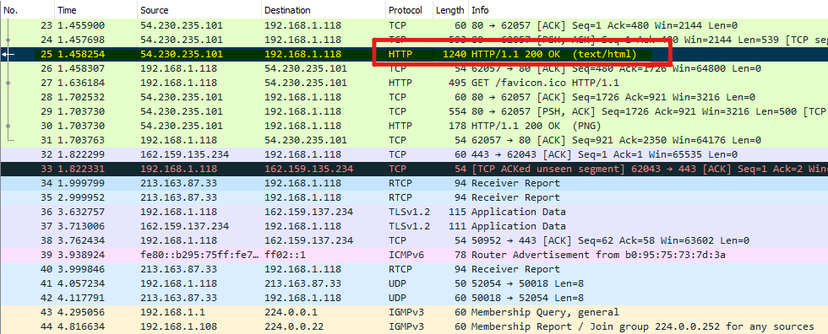

If we examine the same frame (No.25) we can see other package information below like Frame information, TCP Segment header, HTTP Response and HTML data. On this screenshot we can see TCP Header and informations about destination IP/port and source IP/port informations.

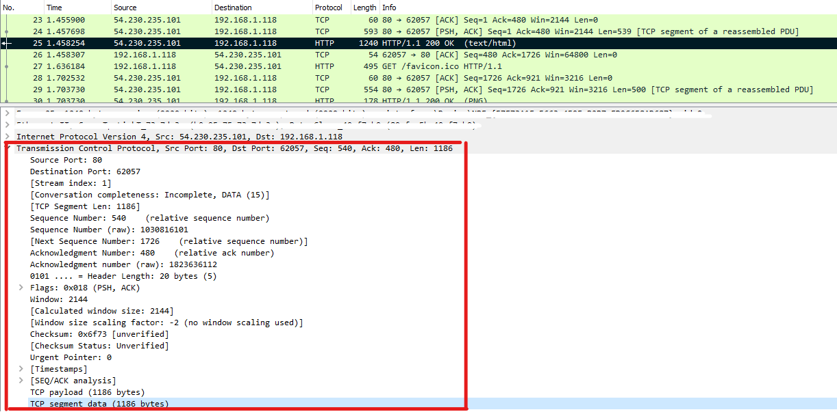

We can also see HTTP Response screenshot in below.

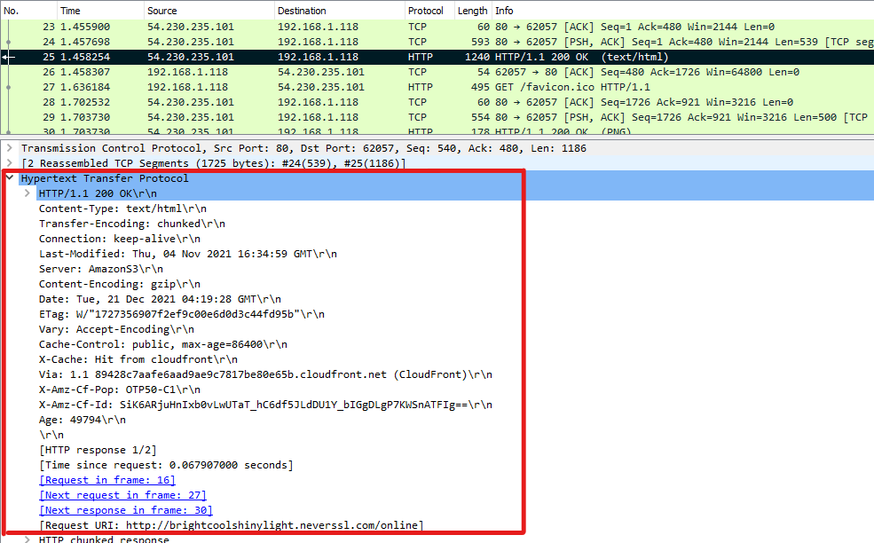

**2.** We can see source/destination IP since the connection establish. When the packages send from host or server side this values trade between and packages send in an order like host –> router -> server and comes back again to host.

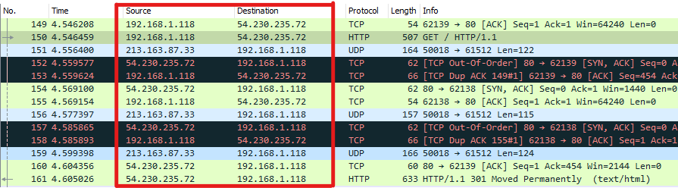

**3.** When we run this command the output is like below.

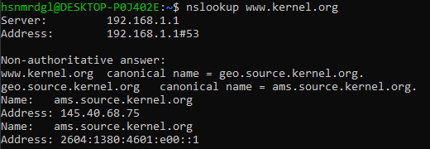

**4.** DCHP is automatically gives an IP to hosts dynamically. For example when we start a host our router which has DHCP, gives an IP address that is not using by another host in the network IP range.