**Colors:**

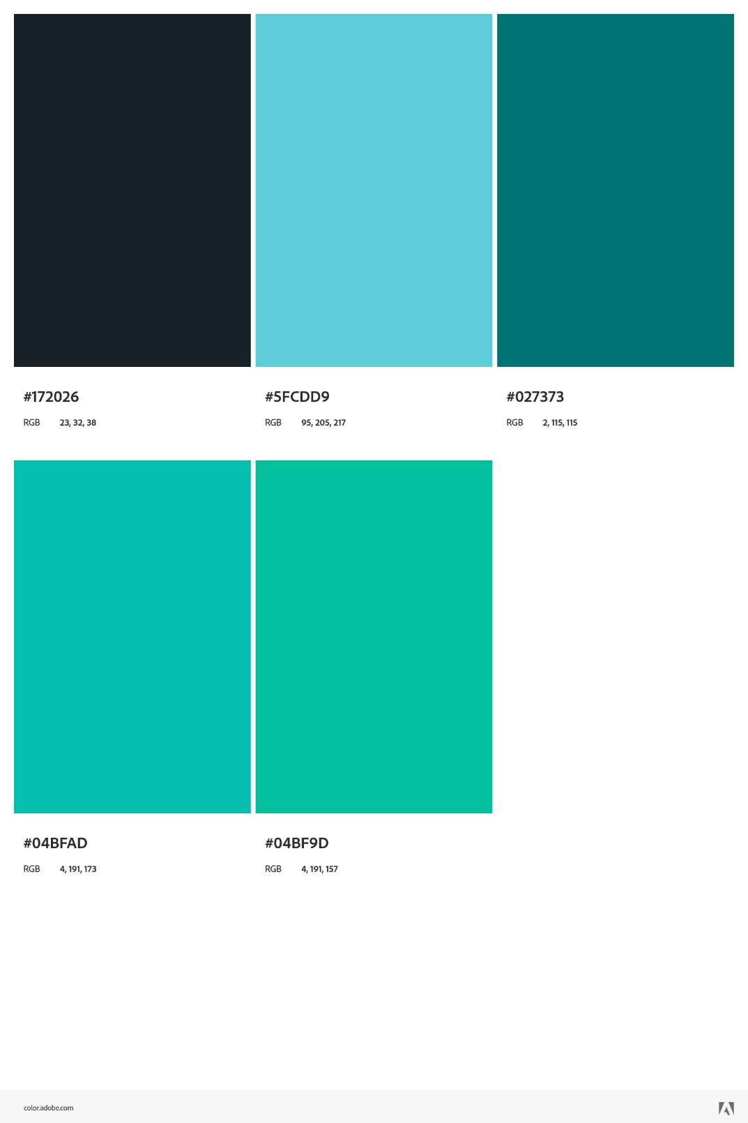

**Example Image:**

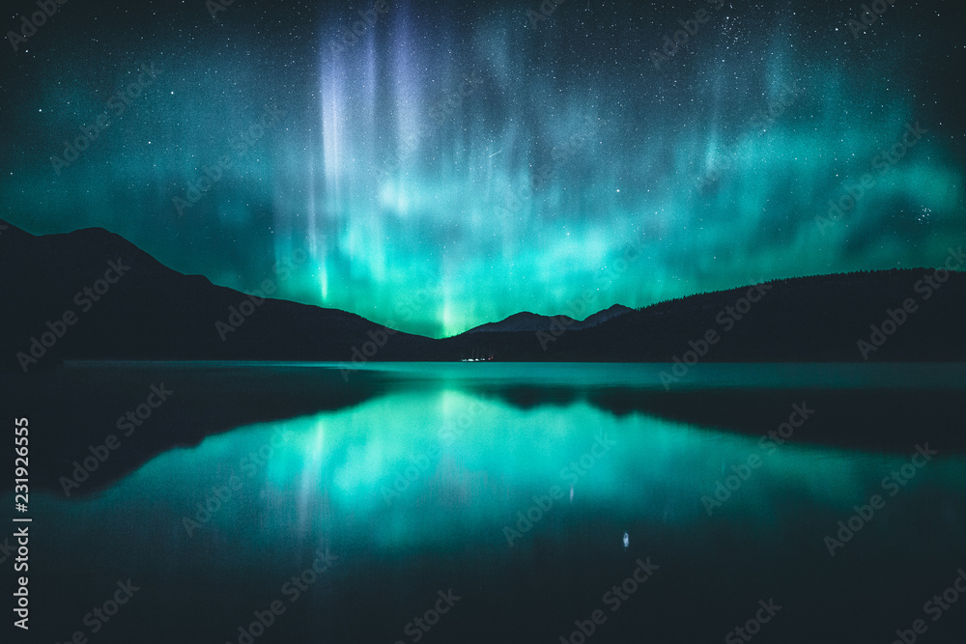

**Font:**

***Roboto Condensed***