Generate code in output folder, you need to make sure the wsdl and schema is in the right location so map can be opened correctly.

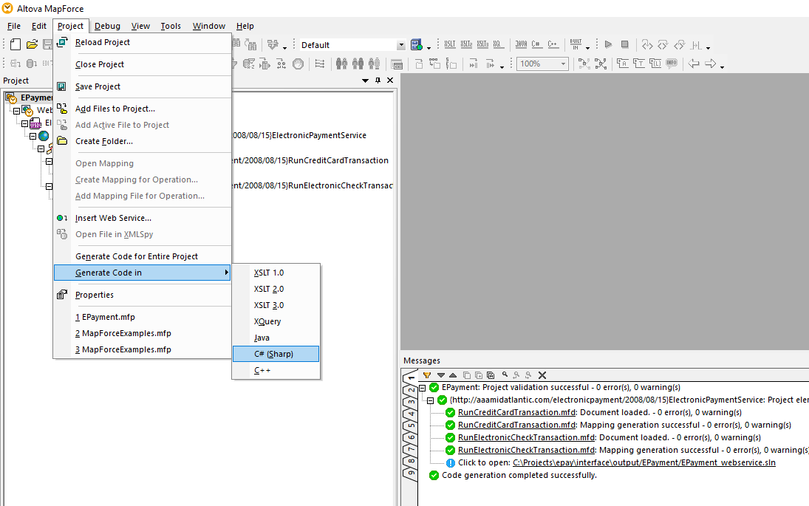

Open the solution file under EPayment folder and Remove the web site project. Close visual studio so the solution file can be saved.

Reopen the solution file so there is no reference to the EPayment folder in solution. But the EPayment folder still exists.

Add new project

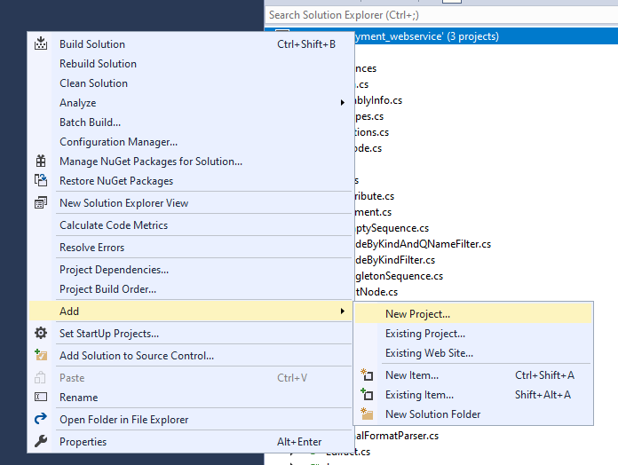

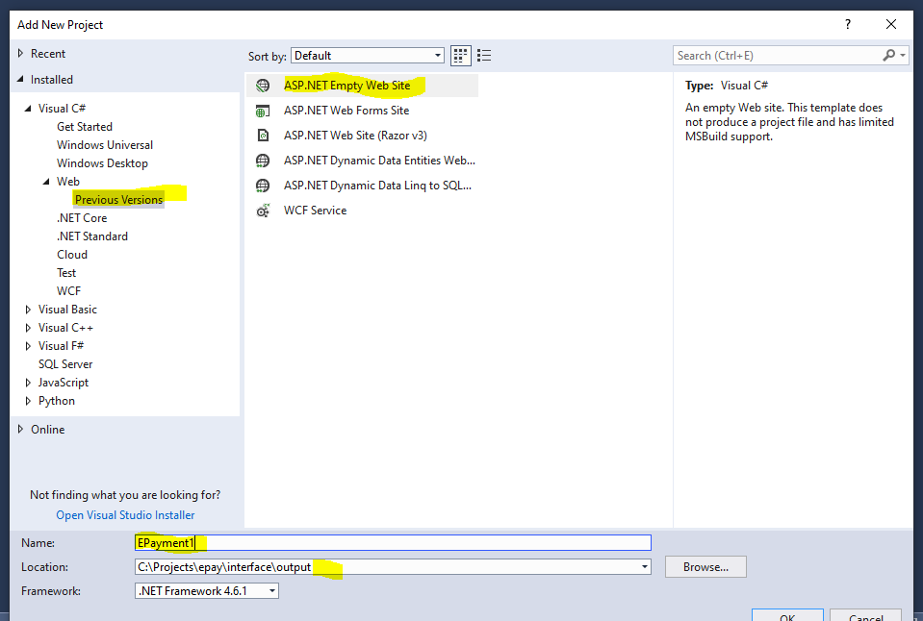

Copy content generated in EPayment1 to EPayment, then delete Epayment1 folder.

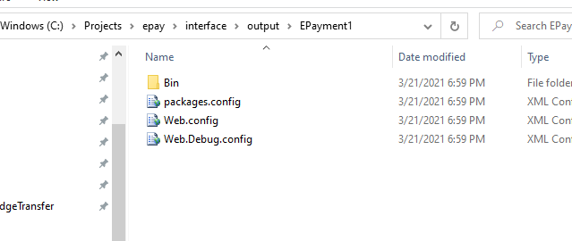

Open solution file in text editor and replace all EPayment1 -->EPayment

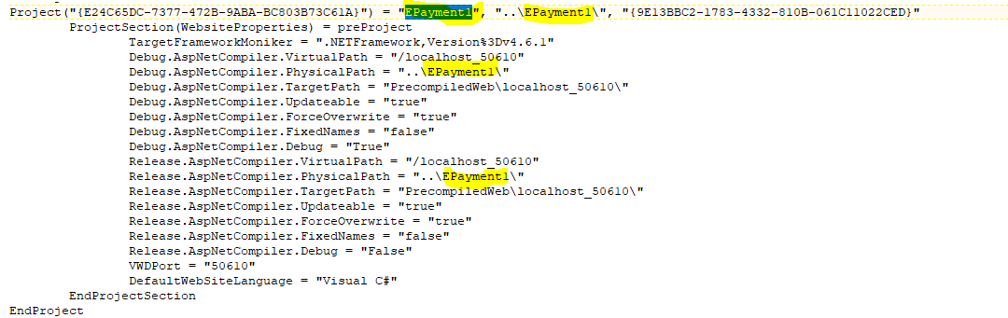

Change the port number as well to 55596.

Open solution file with Visual Studio:

Change the startup project as EPayment:

Add reference to the EPayment project.

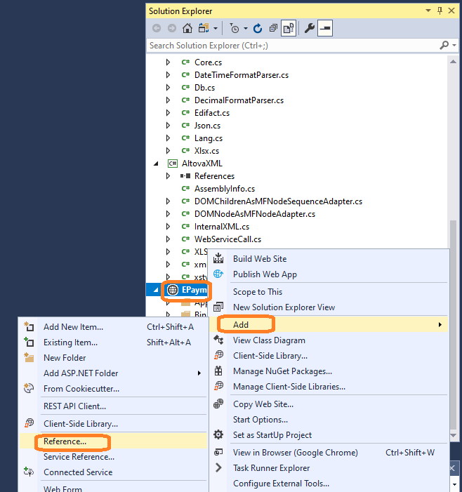

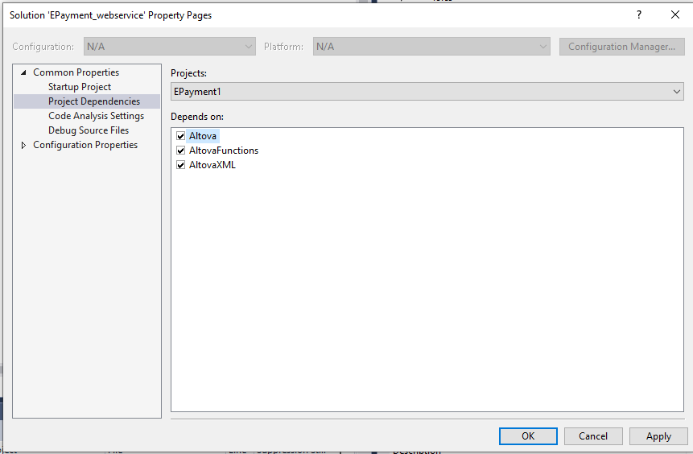

you will see the dlls generated in bin folder. If not try to build the solution

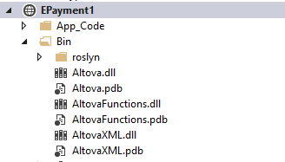

Now run in debug mode, the link [http://localhost:55596/ElectronicPaymentService.asmx](http://localhost:50610/ElectronicPaymentService.asmx) should be available.

**Can make the impl endpoint configurable:**

Web.config:

<appSettings>

    <!-- MerchantPartners Web Service Reference -->

    <add key="ImplServiceEndPoint" value="http://localhost:8003/epay.asmx"/>

  </appSettings>

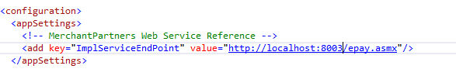

Then use code in MappingMapToRunCreditCardTransaction.cs file and MappingMapToRunElectronicCheckTransaction.cs file

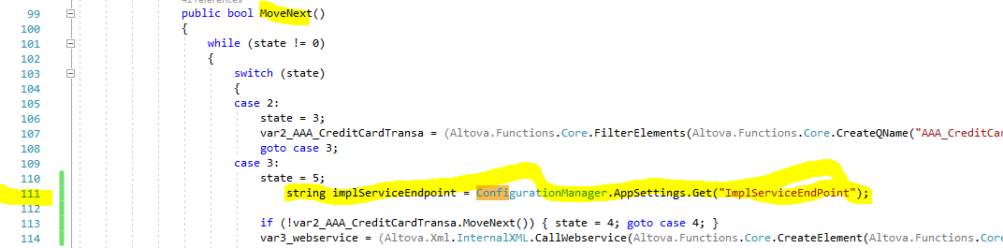

Need to find the hard code endpoint value "8003" in line 114 and replace it with the variable **implServiceEndpoint**.

C:\Users\yhu\AppData\Local\Microsoft\Windows\INetCache\Content.MSO\59EDAD9A.tmp

This is the final structure of the solution

