

**Machine learning approach to test the normality of the data**

**Prepared by:**

Hussein Soboh

1185061

**Committee:**

|  |  |
| --- | --- |
| Dr. Hassan Abu Hassan | Advisor |
| Dr. Tareq Sadeq | Member |
| Dr. Radi Jarrar | Member |

***Submitted in partial fulfillment of the requirements of the “Master Degree in Applied Statistic and Data Science” from the faculty of Graduate Studies at Birzeit University - Palestine***

Table of Content

Table of Content I

List of Tables III

List of Figures IV

Abstract V

ملخص VI

Chapter One 1

Introduction 1

1.1 Background 2

1.2 Problem definition 4

1.3 Research Objectives 5

1.4 Limitations of the study 5

Chapter Two 7

Literature review 7

2.1 Normality tests 7

2.1.1 Visual tests 7

2.1.2 Statistical tests 7

2.2 Previous comparisons 9

2.3 Limitations of the statistical tests 11

Chapter Three 12

Methodology 12

3.1 Alternative Distributions 12

3.1.1 Beta Distribution 13

3.1.2 Student t-distribution 14

3.1.3 Chi-squared Distribution 15

3.1.4 Log-normal Distribution 16

3.1.5 Weibull Distribution: 17

3.1.6 Tukey Distribution 18

3.1.7 Laplace Distribution 19

3.1.8 Uniform (Rectangular) Distribution 20

3.1.9 Truncated Normal Distribution 21

3.2 Model construction 22

3.2.1 Process 22

3.2.2 Classification Techniques 23

3.2.3 Data set 27

3.2.4 Training 27

3.2.5 Evaluation 28

3.3 Power comparison test 29

3.4 Toolbox 29

Chapter Four 30

Simulation and Results 30

4.1 Classification model 30

4.1.1 Data generation 30

4.1.2 Exploring data 31

4.1.3 Splitting data (train, validate, test, unseen) 39

4.1.4 Training 40

4.1.5 Quality evaluation 43

4.1.6 Error analysis 48

4.2 Power comparison 50

4.2.1 Procedure 51

4.2.2 Results 53

Chapter Five 59

Discussion and conclusion 59

5.1 Results summary 59

5.2 Future research 59

References 61

Appendix 1: Code 64

Appendix 2: Figures 76

Appendix 3: Tables 80

List of Tables

Table 1: Alternative distributions used in the research 12

Table 2 Features descriptive statistics per dist_type 34

Table 3 Data distribution after splitting 39

Table 4: Model parameters 41

Table 5: Best thresholds based on validation set 42

Table 6: Quality statistic of the models on applied_threshold 46

Table 7: Summary instance report 49

Table 8: Sensitivity errors (FN) per alternative family 50

Table 9: List of normality tests used in the power comparison 52

Table 10: "new_test" Threshold used on each significance level 52

Table 11: Tests power per alternative family on 1% level of significance 55

Table 12: Tests power per alternative family on 5% level of significance 56

Table 13: Tests power per alternative family on 10% level of significance 57

Table 14 Sample sizes 80

Table 15: FN instances with lowest score from validation set on rf model 81

Table 16: Overall tests power on 1% significance level 82

Table 17: Overall tests power on 5% significance level 82

Table 18: Overall tests power on 10% significance level 82

Table 19: Tests power per distribution at 1% significance level 82

Table 20: Tests power per distribution at 5% significance level 89

Table 21: Tests power per distribution at 10% significance level 95

List of Figures

Figure 1: PDF of Normal distribution (Normal distribution, 2020) 2

Figure 2: Probability density function for Beta variate **β**: v, ω 14

Figure 3: Probability density function for Student’s t variate, **t: $v$**  15

Figure 4: Probability density function for the Chi-Squared variate $2: v$ 16

Figure 5: Probability density function for the Log-normal variate **L**: $m,$ $σ$ 17

Figure 6: Probability density function for Weibull variate $W: η, β$ 18

Figure 7: PDF of Tukey lambda distribution (Tukey lambda distribution, 2019) 19

Figure 8: Probability density function for the Laplace variate $L:a, b$ 20

Figure 9: Probability density function for the rectangular variate $R: a, b$ 21

Figure 10: Probability density function for the truncated normal variate $X: μ, σ, a, b$ 22

Figure 11 Support vectors and margin representation 26

Figure 12: Density plot for "size" 35

Figure 13: Density plot for "median" 36

Figure 14: Density plot for "skewness" 36

Figure 15: Density plot for "kurtosis" 37

Figure 16: Density plot for "sigma_1_ratio" 37

Figure 17: Density plot for "sigma_2_ratio" 38

Figure 18: Density plot for "sigma_3_ratio" 38

Figure 19: Accuracy on each threshold 42

Figure 20: ROC on Test set 44

Figure 21: ROC on Unseen set 44

Figure 22: Feature importance in "rf” model 47

Figure 23: Feature importance in "gbm” model 47

Figure 24: Feature importance in "svmRadial” model 48

Figure 25: Frequency of FN errors per size 50

Figure 26: Overall power comparison on 1% significance level 54

Figure 27: Overall power comparison on 5% significance level 54

Figure 28: Overall power comparison on 10% significance level 55

Figure 29 Boxplot for size per dist_type 73

Figure 30 Boxplot for median per dist_type 73

Figure 31 Boxplot for kurtosis per dist_type 74

Figure 32 Boxplot for skewness per dist_type 74

Figure 33 Boxplot for sigma_1_ratio per dist_type 75

Figure 34 Boxplot for sigma_2_ratio per dist_type 75

Figure 35 Boxplot for sigma_3_ratio per dist_type 76

Abstract

Normality tests are very important in statistical inference; their purpose is to know if the data is sampled from Normal population. The normality of the data is a prerequisite for several parametric statistics such as t-test, ANOVA, and regression analysis. Violation to the normality assumption may yield to incorrect results and wrong decisions. There are many normality tests exist that can be used to detect if the sample data comes from “non-normal” underlying distribution. But these tests sometimes lead to contradicting results and some of them can be applied under certain conditions. The main goal of this research is to use the machine leaning techniques to create a model based test that could be of a good quality compared to the existing tests.

This research tries to build a machine learning classification model to predict the “normality” of the data using three classification techniques: Random Forest (RF), Gradient Boosting Machines (GBM), and Support Vector Machines (SVM). Size, skewness, kurtosis, median, and percentage of data lies within 1, 2, and 3 standard deviations are the features used in training. The evaluation phase showed similar results for the three models with high accuracy and ROC_AUC values on different test sets with few points in favor for “RF” model.

The new normality test generated with “RF” was compared with seven popular normality tests: Shapiro-Wilk (SW), Anderson-Darling (AD), Jarque-Bera (JB), Shapiro-Francia (SF), Kolmogorov-Smirnov (KS), Cramer-von Mises (CVM), and Lilliefors (Lillie). Monte Carlo simulation on 25 alternative distributions on different sample sizes concluded and the results showed significantly the higher power for the model comparing to the other normality tests.

ملخص

تعد اختبارات التوزيع الطبيعي (Normal distributions tests)مهمة للغاية في الاستدلال الاحصائي، والغرض منها هو معرفة ما إذا كانت البيانات مأخوذه من مجتمع توزيعه يتبع للتوزيع الطبيعي. التوزيع الطبيعي للبيانات هو شرط أساسي لعدة إحصاءات حدوديه. توجد العديد من االاختبارات التي تستخدم لهذا الغرض ولكن فعاليتها مشروطة على ظروف عدة للعينة مثل حجم العينة. الهدف الرئيس من هذا البحث هو استخدام تقنيات تعلم الالة لبناء نموذج يمكن أن يكون ذا جوده جيدة مقارنة باالاختبارات الحالية. يحاول هذا البحث إنشاء نموذج تصنيف باستخدام صفات عدة للبيانات مثل (moments) ، ويقارن جودة هذا النموذج مع الاختبارات الاخرى وفقًا لقوة الأختبار (Test power). سيتم خلق البيانات لهذا البحث من توزيعات مختلفة باستخدام محاكاة . MonteCarlo

Chapter One

Introduction

The normal distribution is an underlying assumption of many statistical procedures. Parametric tests such as correlation, regression, t tests, and analysis of variance are based on the assumption that the data follows a normal distribution. When the assumption does not hold, it is hard to draw accurate and reliable conclusions about the data (Ghasemi & Zahediasl, 2012). Visual plots such as P-P plot and statistical tests such as Shapiro-Wilk, Chi-square, D’Agostino-Pearson, Jarque-Bera, and others are the classical methods usually used to detect non-normality (Das & Imon, 2016).

Some of the existing normality tests can only be applied under certain conditions. For example, Shapiro-Wilk test has limitation on the size of the sample where it does not perform well on samples with size more than 50 (Shapiro, Wilk, & Chen, 1968). Moreover, different tests of normality often produce different results[1]. The contradicting results are misleading and often confuse statisticians.

In this research we try to leverage the power of machine learning techniques to build a new test that could be with comparable performance with the existing tests. The machine learning offers the ability to build a model that learns from past experience. By providing examples of normal (negative) and non-normal (positive) examples, the model can learn the characteristics of each of these classes to a level that it can classify correctly new examples to the correct normality class.

* 1. Background

Normal distribution, also known as Gaussian distribution is one type of continues probability distributions. It appears as a bell curve (**Figure 1**) where it is symmetric about its mean, which is identical to its mode and median. 68%, 95%, and 99% of the data falls within 1, 2, and 3 standard deviations respectively (Patel & Read, 1996).

(Forbes, Evans, Hasting, & Peacock, 2011) The normal distributions has the following density function, usually noted as $N(μ, σ^{2})$:

$f\left(x; μ, σ^{2}\right)= \frac{1}{σ\sqrt{2π}}e^{-\frac{1}{2}{\left(\frac{x-μ}{σ}\right)}^{2}}, -∞≤x≤∞$

Where $μ$ is the mean, and $σ$ is the standard deviation. **Figure 1** shows the p.d.f of the distribution of multiple examples of $μ$ and $σ^{2}$.

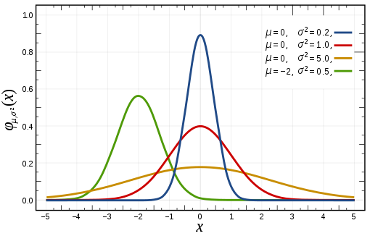

Figure 1: PDF of Normal distribution (Normal distribution, 2020)

Normal distribution is special as its two parameters ( $μ$ and $σ^{2}$) are mutually independent and provide us with complete information of the shape and location of the distribution (Casella & Berger, 2001). The independence of the two parameters characterize the normal distribution from other distributions (Lukas, 1942). Normal distribution is unimodal and it has two inflection points located 1 standard deviation from the mean (Patel & Read, 1996).

If $X\sim N\left(μ,σ^{2}\right)$, then the random variable $Z=\frac{X-μ}{σ}$ has a N(0,1) distribution, known as standard normal distribution and it is described by p.d.f

$$φ\left(x\right)= \frac{1}{\sqrt{2π}}e^{-\frac{1}{2}x^{2}}$$

This function is symmetric around $x=0$, where it attains its maximum value $1/\sqrt{2π}$ and has inflection points at $x=1$ and $x=-1$ (Casella & Berger, 2001).

Normal distributions is the most importantly used in natural and social sciences to represent random variables. Quantities such as examination grades, snowflakes sizes, and other phenomena are approximated by of number of normal probability density functions (Lyon, 2014). The importance is mainly due to the central limit theorem, which states that the sum of independent and identically distributed random variables converges to normal distribution as number of samples increases regardless of the type of distribution of the sampled variables. This theorem provide theoretical bases for why so many variables we see in the nature appear to have approximately a normal probability distribution (Hazewinkel, 1994).

Normality tests are used to determine if the data is sampled from Normal distribution. The normality of the data is an assumption need to be verified before applying several parametric statistics such as t-test, linear regression analysis, discernment analysis and analysis of Variance (ANOVA). When the assumption is violated, the accuracy of the conclusions about the data is questionable and not reliable (Ghasemi & Zahediasl, 2012).

The normality test assess the likelihood that a given data set {$x_{1},…,x_{n}$} comes from normal distribution. The null hypothesis $H_{0}$ is that the observations are distributed normally versus the alternative $H_{a}$ that the observations are not distributed normally. There are two set of methods can be used to examine the normality, visual methods and statistical tests methods (Ghasemi & Zahediasl, 2012).

Visual plots such as P-P plot are useful to visualize the distribution of the data but they usually not enough to conclude decisions about the normality of the data. Hence, variety of statistical tests have been developed in this area such as Shapiro-Wilk, Anderson Darling, Kolmogorov-Smirnov tests and others. These tests are parametric tests aim to measure the probability of departure from normality for the data set on different significant levels.

* 1. Problem definition

The departure from normality is very critical in statistical inference. Biased interpretation can be inferred if the normality assumption is violated. Normality tests have traditionally been designed as classical statistical hypothesis testing procedures and, to the best of our knowledge, this has been the only way used so far to find departure from normality.

The long list of tests developed in the literature can make it hard for statisticians to select the appropriate test to use[2]. Moreover, these statistical tests are sensitive to the size of the data as shown in the study of (Oztuna, Elhan, & Tuccar, 2006).

In this research, we are proposing a new approach in testing normality. In this approach we use the Machine Learning tools to develop a classification model that can classify the sample data to the correct underlying distribution with less sensitivity to the nature of the underlying distribution of the data.

* 1. Research Objectives

In this research, we propose a new approach of testing the normality of the data using Machine Leaning (ML). Machine learning algorithms build a mathematical model based on sample data, known as "training data", in order to make predictions or decisions without being explicitly programmed to do so. This approach is known as supervised machine learning. Classification is one type of supervised machine learning where the human provides the algorithm with pairs of inputs and desired outputs, and the algorithm learn a general rule to produce the desired output given an input it has never seen before (Mueller & Guido, S, 2016).

The idea of using the machine learning in testing the normality was not explored in previous literatures we read as of the date of writing this paper. In this research we build a model that learns the properties and the characteristics of both the normal and the alternative distributions by providing examples of both classes. We expect the model to get enough experience to be able to correctly classify the normality of the data regardless the sample size and the underlying distribution. One advantage of this approach comparing to the classical tests is that it can provide us with additional measures to the power of the test. The power measures the ability to detect one type of the classes – the non-normality- while in the classification models, additional quality metrics are available to measure the performance on detecting the two classes, such as Accuracy, Specificity, and Sensitivity.

* 1. Limitations of the study

Results and conclusions from a Monte Carlo simulation in comparing powers across various distributions are seriously limited in generalizability beyond those distributions. Generalizability of the results depends on the design and how much coverage of different probability distributions is included in the study. In chapter 3, we show a wide range of alternative distributions added to the scope of the research by which we expect this offers a greater potential for generalizing results comparing to the distributions used in previous studies.

Related to that, generalizability of the proposed model could be questionable; results and conclusions of any classification model is limited to the data set it trained with (Cai, et al., 2020). In chapter 3 we try to overcome this limitation by having enough representations of the distributions in the training and by building a model from set of features resilience to the change in the type of the distribution such as skewness and kurtosis.

Another limitation of this study is the choice of the power as the base measure to compare our model against other statistical tests. This comparison is limited to only one of the two sides of the quality of any classification model. The Power which stands for “Recall” in machine learning terminology, evaluates the performance of detecting the positive class –alternative class in our use case-, and do not evaluate how the model performs in detecting negative class -normal class in our use case. This is because the classical normality tests are statistical tests; if the test does not have an evidence to reject the null hypothesis (sample has normal distribution), it does not mean it accept it. This limitation prevents us from using other quality measures such as Accuracy and F-Measure to compare the quality of the classifier against other tests on both normal and alternative classes.

Chapter Two

Literature review

1. 1. Normality tests

Large number of methods and tests available to detect departure from normality where each test has its own characteristics and power. We can look for departure from normality using two ways: Visual methods of normal plots or significant tests (Ghasemi & Zahediasl, 2012).

* + 1. Visual tests

The researcher can validate the normality of the data using graphical methods such as P-P plot, Q-Q plot, histogram, box plot, or stem-and-leaf plot. These plots are useful to visualize the distribution of the data but they often do not provide reliable evidence about the normality of the data. The plots are subjective, a plot can be interpreted into different levels of “normality” by different people. Moreover, judging using these visual methods required enough statistical experience of the researcher in order to take a correct decision. These implies to use more formal and reliable tests (Yap & Sim, 2011).

* + 1. Statistical tests

The effort of developing normality tests was initiated by (Pearson, 1895) who used the skewness and kurtosis as indicators of departure from normality. The number of different tests for normality seems to be boundless. The researchers classified the tests by different ways. In this section we present the tests by classifying them into four main groups as following:

* **Empirical Distribution Function (EDF) tests**: These tests involve measuring the discrepancy between the cumulative distribution function of the normal distribution and the empirical distribution function of the sample (D’Agostino & Stephens, 1986). The most popular tests of this type: Kolmogorov-Smirnov (KS) test (1933), Cramer-von Mises (CVM) test, and Anderson-Darling (AD) test. The Anderson-Darling (AD) test(1974)is the recommend one in this family (D’Agostino & Stephens, 1986). KS test is high sensitive to extreme values, and it has low power and it should not be used in testing normality (Throde, 2002).
* **Moments tests**: These tests use the skewness and the kurtosis (the second and the third moments respectively) of the sample to calculate the test statistic (D’Agostino & Stephens, 1986). Popular tests are Jarque-Bera (JB) test (1975) and D’Agostino-Pearson Omnibus test (DP) (1973).
* **Regression and correlation tests**: The tests are based on the correlation between the empirical data and corresponding scores under normality (D’Agostino & Stephens, 1986). Shapiro-Wilk (SW) (1965) test is the popular one in this family. It has good power for sample sizes up to 50. For large samples, the computation of its test statistic is much complicated (Das & Imon, 2016). Other tests in this group are Shapiro-Francia (SF) test and Ryan-Joiner test
* **Chi-Squared test**: It is not recommended for continuous distributions as it computes the number of observations instead of the observations themselves when calculating the test statistic. Chi-Squared test should not be used (D’Agostino & Stephens, 1986).
  1. Previous comparisons

The literature shows many attempts to compare different normality tests trying to find the best performing one. Most of the comparisons are based on comparing the power of the tests on the alternative distributions using Monte Simulation on different alternatives with different sample size and level of significance. The results have a lot of variation.

(Shapiro, Wilk, & Chen, 1968) Indicates that SW (Shapiro and Wilk 1965) has the best power comparing to $\sqrt{b_{1}}$ (statndard third moment), $b_{2}$ (standard fourth moment), Kolmogorov-Smirnov, Cramer-Von Mises, Weighted CM, Modified KS, chi-squared, and $u$ (Studentized range) on alternatives of sample size (10, 15, 20, 35, 50).

In (Muyombya, 2017) study that examined the power of the tests on large sample sizes, Kolmogorov-Smirnov was the most powerful normality test regardless of the nature of the distribution. Followed by Shapiro-Wilk, Shapiro-Francia, Anderson-Darling, Jaque-Bera, and D’Agostino-Pearson.

(Alizadeh & Arghami, 2011) Compared the power of several tests and concluded that Jaque-Bera is the most powerful test for symmetric distributions and Shapiro-Wilk is the most powerful for asymmetric distributions with support $(-∞,∞)$. It also reveal Kolmogorov-Smirnov and Shapiro-Wilk have best power for alternatives supported by $(0,∞)$

A study by (Islam, Normality Testing- A New Direction, 2011) compared tests for the purpose of ensuring the validity of the t-statistic used to assessing the significance of the regressors. It shows that Anderson-Darling is the best option comparing to Jarque-Bera, D'Agostino and Pearson, and Lilliefors (a modification of Kolmogorov-Samirnov test).

(Razali & Wah, 2011) Compared the power of Shapiro-Wilk, Kolmogorov-Smirnov, Lilliefors, and Anderson-Darling. Shapiro-Wilk was the most powerful test then Anderson-Darling, Lilliefors, and Kolmogorov-Smirnov on both symmetric and asymmetric alternatives. This research also reveals that these tests have low power in small sample size (less than 30).

(Islam, Ranking of Normality Tests: An Appraisal through Skewed Alternative Space, 2019) Evaluated the performance of several tests by using a proposed stringency framework of comparing tests. The research compares Kolmogorov-Smirnov, Anderson-Darling, Jaque-Bera, Shapiro-Wilk, D’Agostino, Coin (COIN), Bonett and Seier test (Tw). And he recommends to use Tw test for slightly skewed, Anderson-Darling and Shapiro-Wilk for moderately skewed, and all except COIN and Tw for highly skewed alternatives.

(Afeez, 2018) Compared several tests on five classes of alternatives: Near Normal, Symmetric long-tailed, Symmetric short-tailed, Asymmetric long-tailed, and Asymmetric short-tailed. SW had good power in a wide range of alternatives comparing to Anderson-Darling, Cramer–von Mises, Jaque-Bera, Chi-Square tests. Jaque-Bera was poor for symmetric short tails, but it is appropriate for symmetric long-tailed distributions.

(Seier, 2002) Claimed that Tests based on skewness and kurtosis are not powerful against symmetric alternative distributions where the kurtosis is close to that of the normal distribution. These tests are more powerful when the alternative is more peaked than normal.

Some of the studies and investigations share similar results. For example Shaipro-Wilk was in a good rank in some of them, but it was not recommended in others. Having a clear answer to the best performing test seems a very complicated task.

* 1. Limitations of the statistical tests

The large number of comparisons with different results confuse the researcher on which normality test to apply where dozens of tests are available to use. Based on what we show from some of the previous literatures, no single test is uniformly more powerful than others.

Comparing the tests based on their power using simulation didn’t succeed having an answer on what is the best test to use, as each test has its area of strengths and weaknesses. The power of the tests depend critically on two factors: The alternative, which can’t be specified when doing the test and as we saw that the same test has different powers when applied on different distributions. The other factor is the sample size, which is critical as well since the normality tests will always reveal non-normality as the sample size grows. (Oztuna, Elhan, & Tuccar, 2006) Show that for small sample size, the normality tests have small power to reject the null hypothesis when it should be rejected. And for large sample size, the normality tests become much sensitive and the test can be significant even in case of a small deviation from normality.

Chapter Three

Methodology

In this research, we propose a new approach of testing normality using state of the art ML techniques. In this chapter, we will start explaining the different steps to be executed in order to build and evaluate the classification model. Then we describe the method that is used in comparing the quality of the “new test” against other popular statistical tests of normality.

1. 1. Alternative Distributions

Alternative distributions can be classified into five major families based on the distribution skewness and kurtosis: asymmetric long-tailed (ALT), asymmetric short-tailed (AST), symmetric long-tailed (SLT), symmetric short-tailed (SST), and close to normal (CTN) (Shapiro, S. & Wilk, B. & Chen, J. 1968). The alternative distributions used in this study were selected from these families on different levels of parameters in order to cover a wide range of the data. Five instances from each family are chosen as shown on **Table 1**, and an overview of the corresponding probability distributions is provided later in this section. The alternatives will be used in the proposed model as positive examples, and also used in the later phase of comparing the power of the new test against other statistical tests.

Table 1: Alternative distributions used in the research

| **Family** | **Alternatives** | | | | |
| --- | --- | --- | --- | --- | --- |
| Asymmetric_Long_Tailed (ALT) | Weibull(0.5, 1) | Weibull(2, 1) | LogNormal  (0, 1) | $${}^{2}(4)$$ | $${}^{2}(10)$$ |
| Asymmetric_Short_Tailed (AST) | Beta(2, 1) | Beta(3, 2) | LogNormal  (0, 0.15) | LogNormal  (0, 0.25) | LogNormal  (0, 0.35) |
| Symmetric_Long_Tailed (SLT) | t(1) | t(2) | t(4) | t(7) | Tukey (10) |
| Symmetric_Short_Tailed (SST) | Uniform(0,1) | Beta(1.3, 1.3) | Beta(1.5, 1.5) | Tukey(1.5) | Truncated normal (-2, 2) |
| Close_To_Normal (CTN) | Tukey (0.1) | Tukey (0.2) | Tukey (5) | t (10) | Laplace(0, 10) |

* + 1. Beta Distribution

(Walck, 2007) (Forbes, Evans, Hasting, & Peacock, 2011) The Beta distribution denoted by $Beta(α,β)$ is a continuous distribution given by:

$$f\left(x;v, ω\right)= \frac{x^{v-1}{\left(1-x\right)}^{ω-1}}{B\left(v,ω\right)} 0≤x≤1$$

Where the quality $B(v,ω)$ is the Beta function defined in terms of Gamma function as:

$$B\left(v,ω\right)=\frac{Γ(v)Γ(ω)}{Γ(v+ω)}$$

For v = $ω$ = 1, the Beta distribution simply becomes a uniform distribution between zero and one. The mean and the variance of the Beta distribution given by

$$E\left(X\right)= \frac{v}{v+ω}$$

$$Var\left(X\right)= \frac{vω}{{\left(v+ω\right)}^{2}(v+ω+1)}$$

**Figure 2** shows the Beta distribution on different levels of $v$ and $ω$.

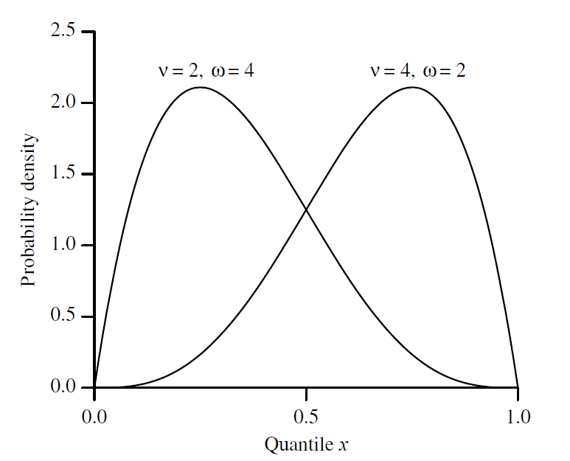

Figure 2: Probability density function for Beta variate **β**: v, ω

* + 1. Student t-distribution

(Walck, 2007) (Forbes, Evans, Hasting, & Peacock, 2011) The Student’s t-distribution (or simply the t-distribution) denoted by $t(v)$ is given by

$$f\left(t;v\right)= \frac{Γ\left(\frac{v+1}{2}\right)}{\sqrt{vπ}Γ\left(\frac{v}{2}\right)}{(1+\frac{x^{2}}{v})}^{-\frac{v+1}{2}};v>0$$

Where $v=n-1$ is the degrees of freedom and t is a real number. The functions Γ and β are the usual Gamma and Beta functions. The mean of t-distribution is 0 for $v>1$, otherwise undefined. The variance is given by

$$Var\left(X\right)=\left\{\begin{aligned}\frac{v}{v-2}, &v>2 \\ ∞, &1<v≤2 \\ undefined, &otherwise\end{aligned}\right.$$

**Figure 3** shows the t distribution on different values of $v$.

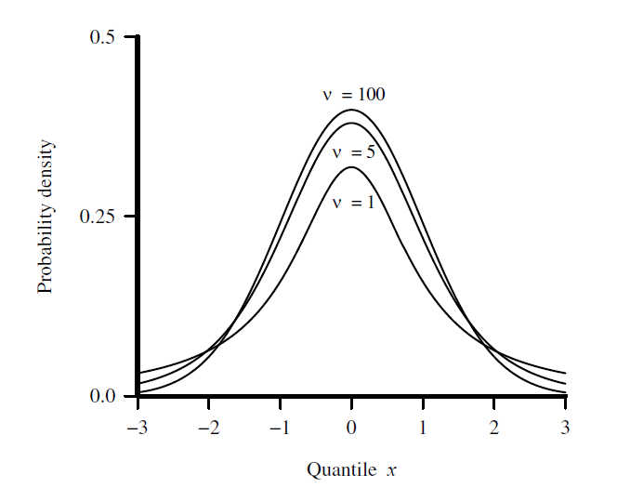

Figure 3: Probability density function for Student’s t variate, **t:**

* + 1. Chi-squared Distribution

(Walck, 2007) (Forbes, Evans, Hasting, & Peacock, 2011) The chi-squared distribution denoted by ${}^{2}(v)$ with $v$ degrees of freedom is the distribution of a sum of the squares of $v$ independent standard normal random variables. Where a set of data is represented by a theoretical model, the chi-squared distribution can be used to test the goodness of fit between the observed data points and the values predicted by the model, subject to the differences being normally distributed. It is given by

$$f\left(x;v\right)= \frac{{\left(\frac{x}{2}\right)}^{\frac{v}{2}-1}e^{-\frac{x}{2}}}{2Γ\left(\frac{v}{2}\right)};x≥0$$

The mean of chi-squared distribution is equal to the degrees of freedom $v$, and the variance is double the mean = $2v$. **Figure 4** shows the distribution on different values of $v$.

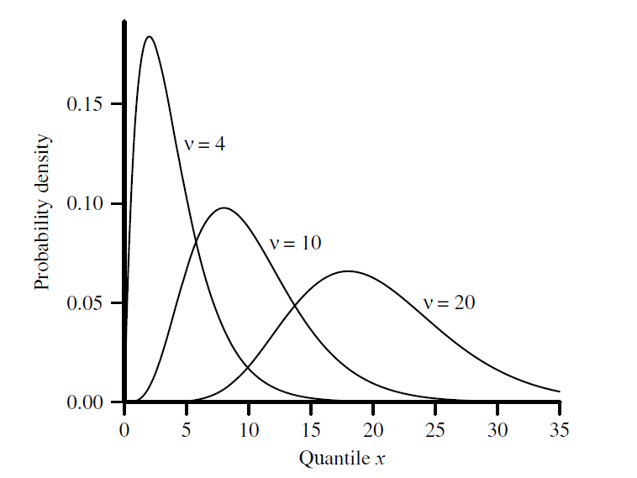

Figure 4: Probability density function for the Chi-Squared variate

* + 1. Log-normal Distribution

(Walck, 2007) (Forbes, Evans, Hasting, & Peacock, 2011) The Log-normal distribution denoted by $Lognormal(µ,σ^{2})$ is a continuous distribution of a random variable whose logarithm is normally distributed. The lognormal distribution is applicable to random variables that are constrained by zero but have a few very large values. The resulting distribution is asymmetrical and positively skewed. It is given by

$$f\left(x;μ,σ\right)= \frac{1}{xσ\sqrt{2π}}e^{-\frac{1}{2} {\left(\frac{\ln{x-μ}}{σ}\right)}^{2}}; x, μ, σ>0$$

An Alternative parameter of scale is $m$ where $m=e^{μ}.$ The mean and the variance of the Log-normal distribution are given by

$$E\left(X\right)=e^{μ+\frac{σ^{2}}{2}}$$

$$Var\left(X\right)={(e}^{σ^{2}}-1)e^{2μ+σ^{2}}$$

**Figure 5** shows the Log-normal distribution on different values $m$ and $σ$.

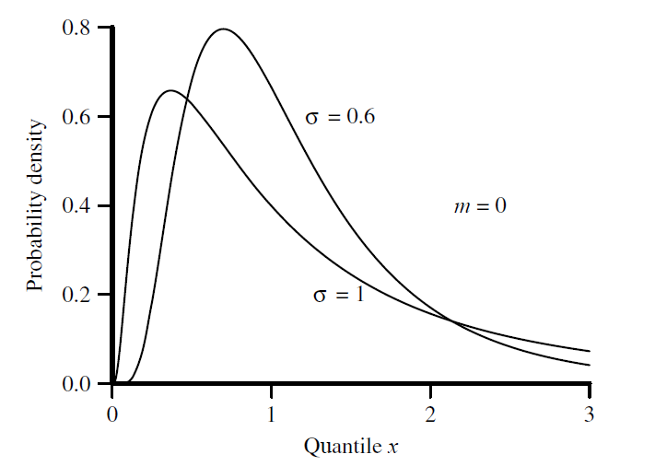

Figure 5: Probability density function for the Log-normal variate **L**:

* + 1. Weibull Distribution:

(Walck, 2007) (Forbes, Evans, Hasting, & Peacock, 2011) The Weibull distribution denoted by $weibull\left(k, λ\right)$ is named after the Swedish physicist Waloddi Weibull (1887-1979) who described it in details in 1951. Weibull variate is commonly used as a lifetime distribution in reliability applications. The two-parameter Weibull distribution can represent decreasing, constant, or increasing failure rates. The $β$ parameter is the shape parameter, and $η$ is simply a scale parameter and the variable $y=x/η$ has distribution

$$g\left(y\right)=βy^{β-1}e^{{-y}^{β}}$$

The Weibull distribution is given by

$$f\left(x;β,η\right)=\frac{β}{η}{\left(\frac{x}{η}\right)}^{β-1}e^{{-\left(\frac{x}{η}\right)}^{β}};x≥0$$

The mean and the variance of the Weibull distribution are given by

$$E\left(X\right)= η Γ\left(1+\frac{1}{β}\right)$$

$$Var\left(X\right)= η^{2}\left[Γ\left(1+\frac{2}{β}\right)-{\left(Γ\left(1+\frac{1}{β}\right)\right)}^{2}\right]$$

**Figure 6** shows the Weibull distribution on different levels of $β$ and $η.$

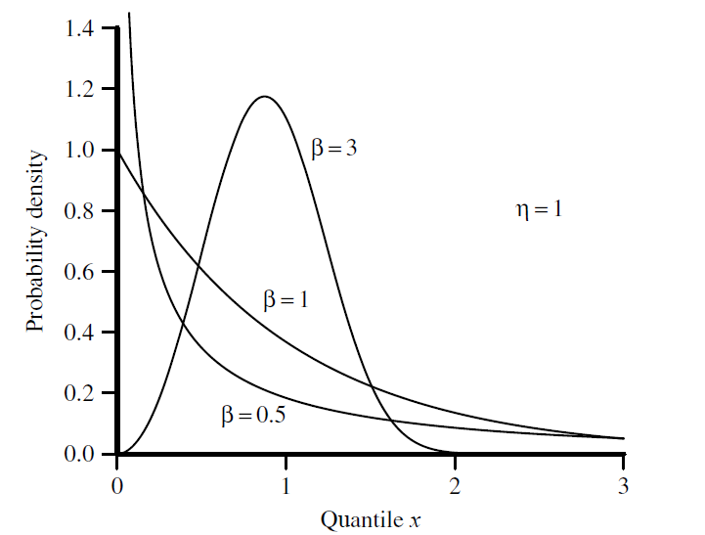

Figure 6: Probability density function for Weibull variate

* + 1. Tukey Distribution

(Stephanie, 2015) (Joiner & Rosenblatt, 1971) Tukey lambda distribution denoted by $Tukey\left(λ\right)$ is a continuous symmetric probability distributed defined in terms of its quantile function, named after the American mathematician John Wilder Tukey (1915-2000). Unlike most other probability distributions, there isn’t a “one size fits all” formula for probability density function. It is defined in terms of quantiles where the quantile function $Q\left(p\right)$ (i.e. the inverse of the cumulative distribution function) and the quantile density function ($q=dQ/dp$) are $:$

$$Q\left(p;λ\right)=\left\{\begin{aligned}\frac{1}{λ}\left[p^{λ}-{\left(1-p\right)}^{λ}\right], &λ ≠ 0 \\ \log\left(\frac{p}{1-p}\right), &λ=0\end{aligned}\right.$$

$$q\left(p;λ\right)= p^{λ-1}+{(1-p)}^{λ-1 }$$

**Figure 7** shows the Tukey lambda distribution on different levels parameters $.$

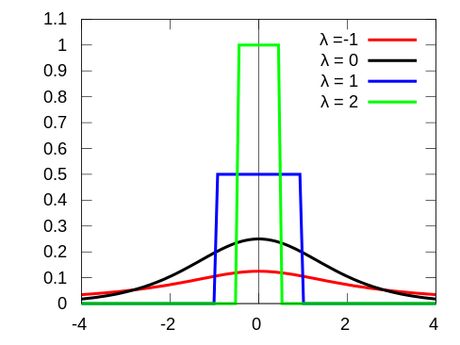

Figure 7: PDF of Tukey lambda distribution (Tukey lambda distribution, 2019)

* + 1. Laplace Distribution

(Walck, 2007) (Forbes, Evans, Hasting, & Peacock, 2011) Laplace distribution sometimes called double exponential distribution is a continuous probability distribution named after Pierre-Simon Laplace (1749-1827). It is a symmetric distribution whose tails fall off less sharply than the Gaussian distribution but faster than the Cauchy distribution. The distribution has an interesting feature as the best estimator for the mean µ is the median and not the sample mean. The distribution is given by

$$f\left(x;a,b\right)=\frac{1}{2b}\left\{\begin{aligned}\exp\left(-\frac{a-x}{b}\right), &x<μ \\ \exp\left(-\frac{x-a}{b}\right), &x≥μ\end{aligned}\right.$$

Where $a$ is the location parameter, and b > 0 is the scale parameter. The variance of the distribution is $2b^{2}.$**Figure 8** shows the Laplace distribution on different levels of $a$ and b $.$

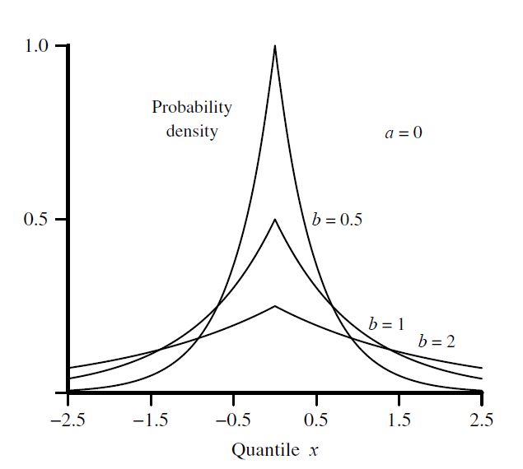

Figure 8: Probability density function for the Laplace variate

* + 1. Uniform (Rectangular) Distribution

(Walck, 2007) (Forbes, Evans, Hasting, & Peacock, 2011) Uniform distribution denoted by $U(a, b)$ is a symmetric probability distribution defined by two parameters $a$ and $b$ where $a$ the location parameter is and $(b-a)$ is the scale parameter. It is widely used as the basis for the generation of random numbers for other statistical distributions. Where every value in the range of the distribution is equally likely to occur. This is the distribution taken by uniform random numbers. It is given by

$$f\left(x;a,b\right)=\frac{1}{b-a }; a≤x≤b$$

The mean and the variance of the Uniform distribution are given by:

$$E\left(X\right)=\frac{1}{2}\left(a+b\right)$$

$$Var\left(X\right)=\frac{1}{12}{(b-a)}^{2}$$

**Figure 9** shows the p.d.f of the Uniform distribution.

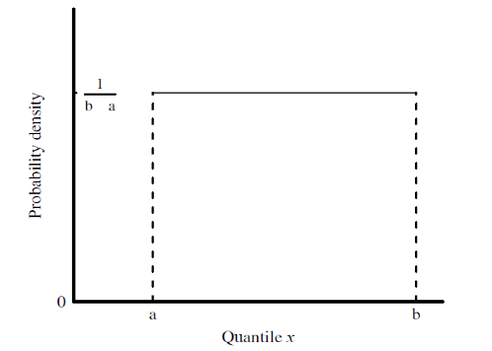

Figure 9: Probability density function for the rectangular variate

* + 1. Truncated Normal Distribution

(Burkardt, 2014)The truncated normal probability density function is defined in two steps. We choose a general normal PDF by specifying parameters µ and ${ σ}^{2}$, and then a truncation range (a, b). The p.d.f associated with the general normal distribution is modified by setting values outside the range to zero, and uniformly scaling the values inside the range so that the total integral is 1. Suppose X has a normal distribution with mean $μ$ and variance $σ^{2}$ and lies within the interval $\left(a, b\right),$ with $-∞≤a≤b≤ ∞.$ Then the p.d.f of X truncated on $a<X<b$ is given by:

$$f\left(x; μ, σ, a, b\right)=\frac{1}{σ}\frac{∅\left(\frac{x-μ}{σ}\right)}{∅\left(\frac{b-μ}{σ}\right)-∅\left(\frac{a-μ}{σ}\right)};a≤x≤$$

**Figure 10** shows the p.d.f of the Truncated normal distribution on different levels of $a$ and $b$.

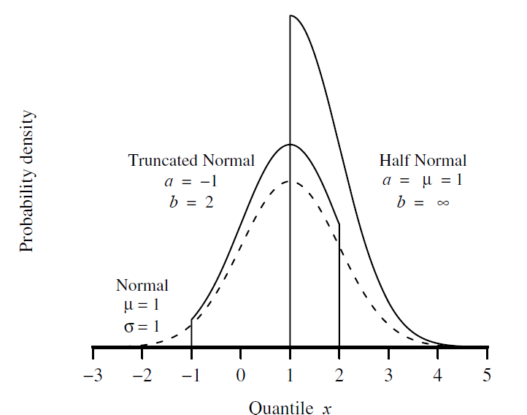

Figure 10: Probability density function for the truncated normal variate

* 1. Model construction

In this section we describe the process of building the classification model of testing the normality. We start by describing the normality test as classification problem. Then we describe the data that we will use for this purpose and the steps of training and evaluating the model.

* + 1. Process

This problem is a binary classification problem, we predict if the sample data has departure from normality based on some properties such as skewness and kurtosis. The target variable in this classification problem is the type of the distribution where “alternative” represent the positive class and “normal” represent the negative class. We did not choose the positive class to represent the normality – which could make more sense for others– because we need to compare the power of this model with other tests which tries to check if the sample is significantly depart from normality and not vice versa.

In the process of creating the model, we are following the steps of Train-Validate-Test. In the training phase we train a model using training data from positive and negative classes. Where in the validate stage we run the model on the validate data set and tune the model parameters to yield the best quality that can be achieved by the model. In this stage we set in the model the threshold (cut off) points that have optimal quality. The tuned model is then tested on different test sets and the quality of this test represents the final quality of the model.

* + 1. Classification Techniques

In this research we aim to find the best classification technique that has the best performance in our use case, so we tend to build models using several methods and choose the one with best quality. There are plenty of classification algorithms available to use. For example, [caret](http://topepo.github.io/caret/index.html) (Classification And REgression Training) package in R has more than 180 classification techniques from different families. It is hard examine all of the techniques to find the best one that fits our data, and it is not straight forward to select from this long list. So, in this research I refer to previous studies that compared these techniques and evaluated their quality on several data sets.

(Fernandez-Delgado, Cernadas, Barro, & Amorim, 2014) Compared 179 classifiers from 17 families in 121 data sets, and (Wainer, 2016) compared 14 techniques on 115 binary datasets. The two studies show that Random Forest (RF), Gradient Boosting Machines (GBM), and Support Vector Machines (SVM) classifiers are the most performing ones and they are not significantly different from each other. As a result, we will build three models from these classifier types and compare their quality as part of this research. In the sub sections below, we are providing a brief explanation of these classifiers.

* + - 1. Random forest (RF)

(Rebala, Ravi, & Churiwala, 2019) Random forest is an effective model for both classification and regression problems. In classification learning, it is an ensemble classifier constructed from a collection of decision trees that improve the prediction over single decision tree. The data set is split randomly with replacement into different bags – this is called data bagging- each one represents a decision tree. For each bag, different set of features with size $\sqrt{n}$ or $\frac{n}{3}$ is selected from feature set n and cross validation is used to select which feature set is most appropriate for this specific bag – this is called Feature Bagging. So each data bag will have a different set of features chosen for creating the Decision Tree.

For a new data point, prediction of its class is the aggregation of the predicted classes from all trees. The final result is aggregated using general voting technique as shown in below equation:

$$f=\frac{1}{B}\sum_{n=1}^{B}{f_{n}(x)}$$

Where:

$f$ = the final prediction from RF

$B$ = number of trees

$n$ = the index of decision tree

$f_{n}$ = the result from decision tree $n$

$x$ = the vector of the new data point to predict

Random Forest enables us to see which features are important of the variable to the decision. The intuitive notion in determining the variable importance is that if the variable is important, then rearranging the values of the variable in constructing the trees will not reduce the prediction accuracy.

* + - 1. Gradient boosting machines (GBM)

(Ayyadevara, 2018) Gradient boosting is a machine learning classification technique based on creating an ensemble model from different models built sequential as following. It start by creating an initial model using tree or linear regression that fit the data. The second model is built and its objective is to accurately predicting the cases where the first model performs poorly. The combination of these two models should have higher performance than either model alone. This booting process repeated many times until reaching the minimum prediction error. Gradient refers to the error, or residual, obtained after building a model. Boosting refers to improving. The technique is known as gradient boosting machine, or GBM. Gradient boosting is a way to gradually improve (reduce) error.

* + - 1. Support vector machines with Radial Basis Function Kernel (RBF SVM)

(Rebala, Ravi, & Churiwala, 2019) Support vector machines (SVM) is a binary classifier, it classifies the data points by creating the optimal hyperplane boundary that have the maximum margin for the data points as shown in **Figure 11**. SVM can handle linear separable data points as shown in the previous figure and can handle data points that are not linear separable by mapping data points into higher dimensional space using “kernel” functions. SVM classifier create a hyperplane of N-1 dimensions for n-dimensional feature vectors to separate the data into two classes. For example, for feature vector of size 2 the hyperplane is a line and can be represented by the following equation:

$$y=w.f\left(x\right)+b$$

Where:

$f(x)$ = the feature vector

$w$ = the weight assigned to feature vector

$b$ = the bias term

All values of y greater than the function value are classified as class 1, and all other values are classified as class 2.

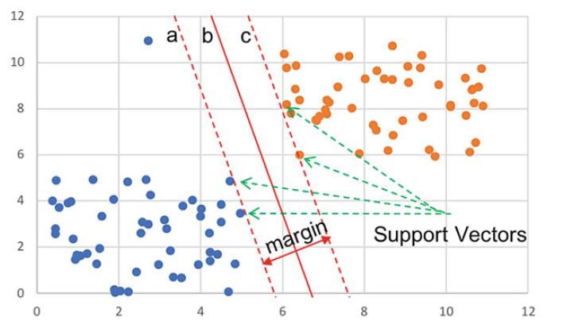

Figure 11 Support vectors and margin representation

Many kernels exist such as Polynomial and sigmoid functions. It is not obvious which kernel works best. Radial bias kernel (RBF) is one of the commonly used kernel in SVM and can be represented by below equation:

* + 1. Data set

First stage of building a classification model is to prepare a data set for training and testing. We used simulation code to generate samples from alternative and normal distributions, where each generated sample represents a data point in our data set. Several statistics and features calculated on each sample, where the features and the sample underlying distribution represent the data point/vector. The samples to be scaled before calculating the features in order to improve the scalability of the model and avoid biasedness toward specific set of sample sizes or distributions.

Data set of 10,000 data points to be generated from both alternative and normal distributions having 1:1 ratio between positives and negatives aiming to a balanced data sets. The positive labels generated from the alternatives are listed in **Table 1**. The negative labels to be generated from the normal distribution on different levels of mean and standard deviation. Both set of labels will be generated from 200 different sample sizes randomly selected from the range of [5, 2000].

We will divide the data set into “seen” and “unseen” sets. The “unseen” data represents samples from specific distributions that will not be used in the process of building the model. This set will be kept as hold out data to measure the quality of the model on data that it didn’t see before which can gives us an indicator on the generalizability of the model.

* + 1. Training

Different models will be trained using the three techniques: Random Forest (RF), Gradient Descent Boosting (GBM), and Support vector machines with Radial Basis Function Kernel (RBF SVM). Each model will be evaluated and the best performing one will be considered and used in later stage of comparing against statistical normality tests. The features of the model are calculated from each sample and saved in csv format. The features to be used in the model are properties of the sample data such as mean, median, variance, skewness, kurtosis, sample size, outliers’ ratio. This is an initial set of features we can start with to build a baseline. Other features probably will be added during the time of building the model.

Feature selection techniques could be applied on the model to find the most significant features and drop the non-important ones. Techniques such as Feature Importance of Random Forest, Recursive Feature Elimination (RFE), and ANOVA F-test could be used in this study. The goal is to keep the model with minimal set of features that gives the highest possible quality.

* + 1. Evaluation

Several metrics available to use for evaluating the quality of a classification model. We prefer to use the Accuracy measure in this problem more than other measures like F-Measure. The Accuracy represents the combination of Specificity (1- α) and Sensitivity (Power) which are the measures we will use in comparing the quality of the model with other statistical tests.

Validation data set will be used to evaluate quality of the models from several classification techniques. The models will be tuned by applying different model parameters such as number of trees in Random Forest classifier and sigma in SVM classifier. The model with the best performance to be chosen for next steps.

The selected model will be evaluated on the test set and on the unseen data sets. Different quality measures and charts to be used to report and analyze the performance of the proposed test.

* 1. Power comparison test

A power comparison test to be concluded between different normality tests including the new proposed model using Monte Carlo simulation. The alternative distributions considered are the ones listed in **Table 1**. The comparison will be on three levels of significance α = 0.01, α = 0.05, and α=0.10 to investigate the effect of the significance level on the power of the test. Corresponding thresholds of the proposed test on each level of significance can be calculated by choosing the thresholds that give specificity of 0.99, 0.95, and 0.90 for 0.01, 0.05, and 0.10 level of significance respectively. Samples of size n = 10, 20, 30, 50, 100, 200, 500, and 1000will be used in the simulation from each alternative with 1,000 repetitions.

* 1. Toolbox

We will use R as the main programming language in this research. It offers to data scientists and statisticians a vast toolbox and libraries for data loading, modeling, visualization, and analysis. RStudio with R 3.6.2 is used. We use [caret](http://topepo.github.io/caret/index.html) package to build and evaluate the classification models as it provides the data scientists with simple interface for executing many classifiers with automatic parameter tuning for the models. This enables the researcher to use the state of the art classification techniques with minimal knowledge of the underlying algorithms (Kuhn, 2008). We will use caret package to train and tune the models, feature selection, and variable importance estimation. [MonteCarlo](https://cran.r-project.org/web/packages/MonteCarlo/vignettes/MonteCarlo-Vignette.html) library will be used to simulate the power of the model and the statistical normality tests.

Chapter Four

Simulation and Results

1. 1. Classification model

In this section we show the process of building the normality classification model. We start by describing the data and the set of features used in training. Then we describe the training process and give insights of

* + 1. Data generation

Data set of size 10,000 data points to be used in training and evaluation was simulated using R code from both normal and alternative distributions. Each data point represents a sample of size n generated from alternative (positive) or normal (negative) distribution. 50% of the data points are simulated from the positive class (“class_1”) and the other 50% are simulated from the negative class (“class_2”). The data intended to have 1:1 ratio between positives and negatives aiming to a balanced data sets.

The positive labels were generated from the alternatives are listed in **Table 1**. The negative labels were generated from the normal distribution on different levels of mean and standard deviation. Both set of labels generated from 200 different sample sizes selected from the range [5, 2000] listed in **Table 14** in appendix. Total of 50 samples sampled from each size, 25 created from the alternative distributions and another 25 samples created from normal distribution. The negative 25 labels on each size generated as following: Five means were randomly selected from the range [-1000, 1000]. For each mean, five samples generated from normal distribution with coefficient of variation equals to 0.01, 0.1, 0.3, 0.6, and 1.0. Using different levels of variation aims to train the model on representative data set to decrease the biasedness to specific distributions. **Code snippet 1** in appendix shows the code used to generate the data.

* + 1. Exploring data

Features are calculated on each data point and examined during training. Many features were examined and the following set are the ones that selected to build the model. Function **calc_stats()** in **Code snippet 1** shows how these features are calculated in R

* **Size**: The size of the sample. The smallest sample has size 8, and the largest sample has size 1998. See **Table 14** in appendix.
* **Median**: The midpoint of the values that divide the set into two groups after they have been ordered from the smallest to the largest, or the largest to the smallest (Mulholland & Jones, 1968). The median for the normal distribution should be equal to the mean (Patel & Read, 1996). And because we scaled the samples, the median should be 0 for normal samples. The bigger the departure of the median from 0, the more likely the sample has departure from normality.
* **Skewness**: It is the measure of the symmetry of a probability distribution. A data set is symmetric if it looks the same to the left and the right of center point. The skewness for a sample of size n is calculated using formula:

$$skewness= \frac{\sum_{i=1}^{n}{{{(x}_{i}-\overline{x})}^{3} /n }}{s^{3}}$$

Where $\overline{x}$ = mean, $s$ = standard deviation.

The skewness for normal distribution is zero. Negative values for skewness indicate the data is skewed to the left, and positive value indicates a skewness to the right (Hazewinkel, 1994).

* **Kurtosis**: It is a measure of weather the data is heavy-tailed or light-tailed relative to the normal distribution. Distributions with large kurtosis exhibit tail data exceeding the tails of the normal distribution. The formula for calculating the kurtosis is:

$$kurtosis= \frac{\sum_{i=1}^{n}{{{(x}_{i}-\overline{x})}^{4} /n }}{s^{4}}$$

Where $\overline{x}$ = mean, $s$ = standard deviation.

The kurtosis for the normal distribution is 3, it is less or greater than 3 for other distributions (Hazewinkel, 1994).

* **Sigma_1_ratio**: The percentage of the data that is located within 1 standard deviation. Normal distribution should have 68% of the data falls within 1 standard deviation (Patel & Read, 1996).
* **Sigma_2_ratio**: The percentage of the data that is located within 2 standard deviation. Normal distribution should have 95% of the data falls within 2 standard deviation (Patel & Read, 1996).
* **Sigma_3_ratio**: The percentage of the data that is located within 2 standard deviation. Normal distribution should have 99% of the data falls within 3 standard deviation (Patel & Read, 1996).

The target variable is **“dist_type”**, it has two possible values:

* **“class_1”**: The positive class; the class of the alternative distribution
* **“class_0”**: The negative class; the class of the normal distribution

As we see from the explanations above, the features are expected to be highly correlated with the target variable **“dist_type”**. **Table 2** shows the descriptive statistic for the features for each class of the target variable. **Figure 12** to **Figure 18** show density plot for each feature by **dist_type**. **Figure 29** to **Figure 35** in Appendix show also the box plots for these variables. By looking at the statistics we can observe:

* The **size** has same statistic for class_0 and class_1 as expected and it is uniformly distributed according to the density plot.
* **Median** feature has similar statistic of minimum, median, mean, and maximum for both classes. But the density plot shows that the median for class_0 is more dense around zero where it is more flatten on the range of the distribution for class_1.
* **Skewness** has different range of values in the classes. Skewness ranges from -1.3, 1.25] for class_0 while its range for class_1 is much bigger [-30.22, 29.26].
* **Kurtosis** has very low values for class_0 comparing to class_1. The maximum value in class_1 is 4.83 while it span from 1.36 to 986 for class_1.
* The density plots for **sigma_1_ratio**, **sigma_2_ratio,** and **sigma_3_ratio** show different distributes of these features between class_0 and class_1. Range of the values is almost similar but the values are significantly dense around the expected ratios - explained in the section above - in class_0 more than class_1.

These observations clearly indicate that these features are very good candidates to be used in the model and predict the distribution type of a sample. In the next section we will start the process of building the model.

Table 2 Features descriptive statistics per dist_type

| **Feature** | **class_0 (normal)** | **class_1 (alternative)** |
| --- | --- | --- |
| **size (sample size)** |  | |
| minimum | 8 | 8 |
| median (IQR) | 1,007.00 (459.25, 1,462.50) | 1,007.00 (459.25, 1,462.50) |
| mean (sd) | 993.25 ± 593.97 | 993.25 ± 593.97 |
| maximum | 1,998 | 1,998 |
| **median** |  | |
| minimum | -0.59 | -0.51 |
| median (IQR) | 0.00 (-0.02, 0.02) | -0.02 (-0.11, 0.02) |
| mean (sd) | -0.00 ± 0.05 | -0.05 ± 0.12 |
| maximum | 0.45 | 0.35 |
| **skewness** |  | |
| minimum | -1.30 | -30.22 |
| median (IQR) | -0.02 (-0.07, 0.05) | 0.05 (-0.07, 0.78) |
| mean (sd) | -0.01 ± 0.12 | 0.60 ± 3.95 |
| maximum | 1.25 | 29.26 |
| **kurtosis** |  | |
| minimum | 1.43 | 1.36 |
| median (IQR) | 2.96 (2.87, 3.07) | 3.55 (2.58, 5.62) |
| mean (sd) | 2.96 ± 0.21 | 28.95 ± 104.02 |
| maximum | 4.83 | 985.85 |
| **sigma_1_ratio** |  | |
| minimum | 0.50 | 0.38 |
| median (IQR) | 0.68 (0.68, 0.69) | 0.70 (0.66, 0.76) |
| mean (sd) | 0.68 ± 0.02 | 0.72 ± 0.11 |
| maximum | 0.88 | 1.00 |
| **sigma_2_ratio** |  | |
| minimum | 0.87 | 0.88 |
| median (IQR) | 0.95 (0.95, 0.96) | 0.96 (0.95, 0.97) |
| mean (sd) | 0.95 ± 0.01 | 0.96 ± 0.02 |
| maximum | 1.00 | 1.00 |
| **sigma_3_ratio** |  | |
| minimum | 0.98 | 0.94 |
| median (IQR) | 1.00 (1.00, 1.00) | 0.99 (0.99, 1.00) |
| mean (sd) | 1.00 ± 0.00 | 0.99 ± 0.01 |
| maximum | 1.00 | 1.00 |
| **dist_type** |  | |
| class_0 | 5,000 (100) | 0 (0) |
| class_1 | 0 (0) | 5,000 (100) |

Figure 12: Density plot for "size"

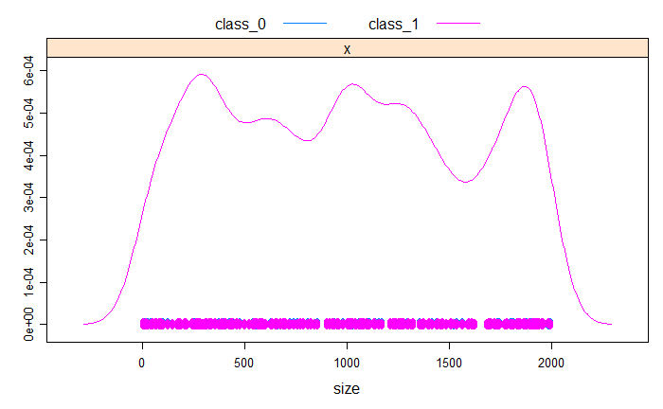

Figure 13: Density plot for "median"

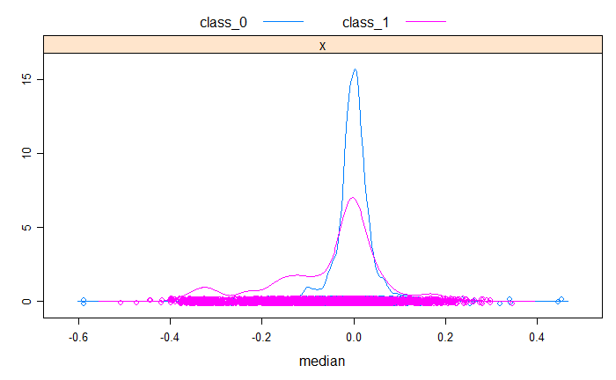

Figure 14: Density plot for "skewness"

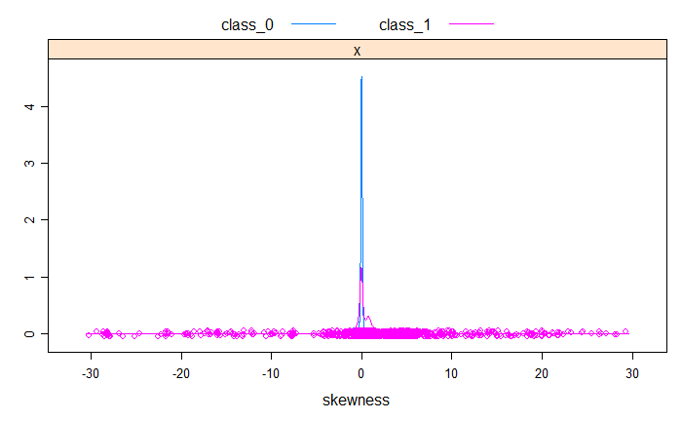

Figure 15: Density plot for "kurtosis"

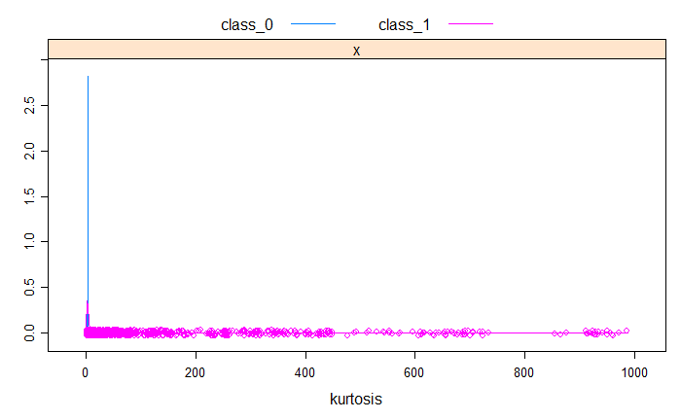

Figure 16: Density plot for "sigma_1_ratio"

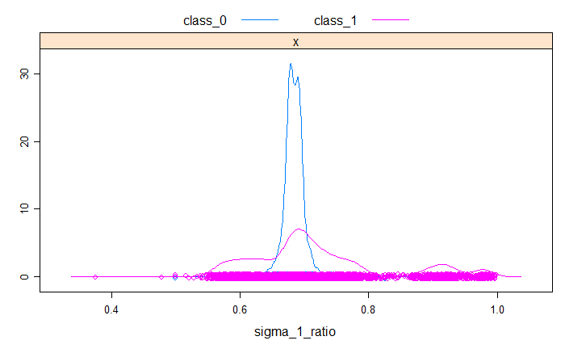

Figure 17: Density plot for "sigma_2_ratio"

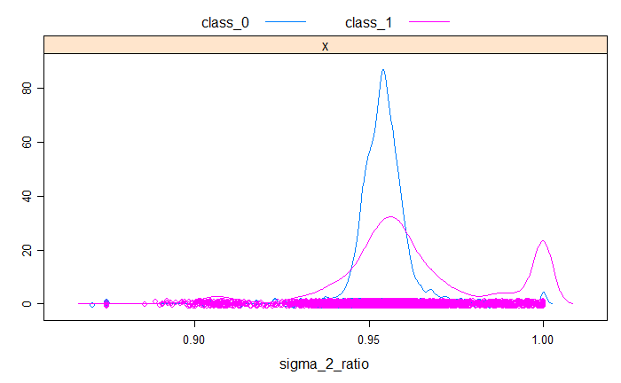

Figure 18: Density plot for "sigma_3_ratio"

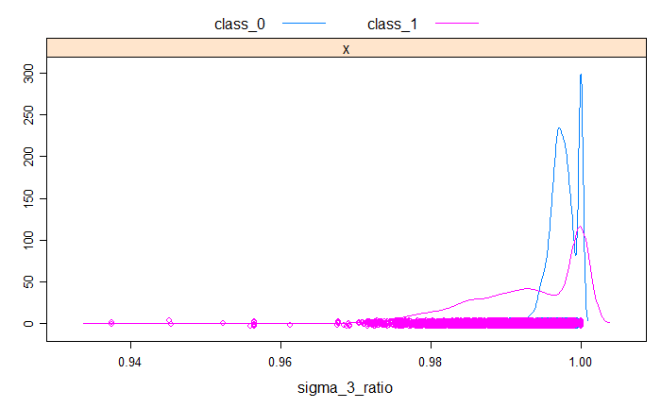

* + 1. Splitting data (train, validate, test, unseen)

“Unseen” data set were created by selecting one distribution for each of the five alternative families and all samples generated from 0.6 coefficient of variation normal family. These represent 20% of the data in which it split the data into so this process result into 8,000 “seen” and 2,000 “unseen” data sets. The reason of having the unseen data is to test the final model on distributions that the model didn’t see before, to validate the scalability of the model and its ability to generalize to new data by predicting how our model will perform on other distributions not included in this research. The remaining data points of the other four types of both alternative and normal distributions represent the data set that will be used in training and testing, they are randomly divided into 60% train, 20% validate, 20% test. **Table 3** shows the distribution of the data sets after splitting.

Table 3 Data distribution after splitting

|  |  |  |
| --- | --- | --- |
| **Seen**  **Size = 8000**  **Train = 4800**  **Validate = 1600**  **Test = 1600** | Close_To_Normal | tukey(0.2), tukey(5), t(10), laplace(0, 10) |
| Symmetric_Long_Tailed | t(2), t(4), t(7), tukey(10) |
| Symmetric_Short_Tailed | beta(1.3, 1.3), beta(1.5, 1.5), tukey(1.5), truncatednormal(2, 2) |
| Asymmetric_Long_Tailed | weibull(2, 1), lognormal(0, 1), chisq (4), chisq (10) |
| Asymmetric_Short_Tailed | beta(3, 2), lognormal(0, 0.15), lognormal(0, 0.25), lognormal(0, 0.35) |
| Normal c.o.v = 0.01 | All samples |
| Normal c.o.v = 0.1 | All samples |
| Normal c.o.v = 0.3 | All samples |
| Normal c.o.v = 1.0 | All samples |
| **Unseen**  **Size = 2000** | Close_To_Normal | tukey(0.1) |
| Symmetric_Long_Tailed | t(1) |
| Symmetric_Short_Tailed | uniform(0, 1) |
| Asymmetric_Long_Tailed | weibull(0.5, 1) |
| Asymmetric_Short_Tailed | beta(2, 1) |
| Normal c.o.v = 0.6 | All samples |

* + 1. Training

In this section we describe the stage of training the classification models and tuning them using the validation set in order to find the appropriate parameters, mainly the optimal cutoff point. In later sections we will evaluate the tuned models on different test sets.

* + - 1. Model generation

We tried to train three models using different classification techniques: Random Forest (RF), Gradient Boosting Machines (GBM), and Support Vector Machines (SVM). The goal as we stated earlier is to find the best technique that can fit our data. “craret” package used to train the three models. The **x** vector consist of the seven features we described above: **size**, **median**, **skewness**, **kurtosis**, **sigma_1_ratio**, **sigma_2_ratio**, and **sigma_3_ratio**. The binary variable **dist_type** is the y target variable which has two possible values: class_1 (the positive class/alternative), class_0 (the negative class/normal).

To train a model using “caret“, we can pass different options to the training process through “train” and “trainControl” APIs to enable finding optimal parameters for the models. The main options we set in training are:

* “**Method**”: the resampling method. It specifies which technique “caret” will use for resampling the training data while it searches for the best tuning parameters. We choose “cv” with 10 number of folds as the resampling method.
* “**Metric**”: The summary metric to use in selecting the optimal model. Possible values are “Accuracy" and "Kappa", we choose “Accuracy”.
* Other options can be found at **Code Snippet 2** that show the source code used to train the three modes.

Three models (rf, gbm, and svmRadial) were generated and the best parameters found by “caret” tuning for each of the can be found in **Table 4**.

Table 4: Model parameters

| **Model** | **Parameter** | **Value** |
| --- | --- | --- |
| **rf** | mry | 2 |
| n.trees | 500 |
| **gbm** | n.trees | 400 |
| Interaction.depth | 10 |
| shrinkage | 0.1 |
| n.minobsinnode | 10 |
| **svmRadial** | sigma | 0.5257 |
| C | 64 |

* + - 1. Model validation

Classification models by default apply 0.5 as threshold, where prediction scores above this threshold considered as positive and predictions below this threshold considered negative. In order to find the optimal quality, the “validation” set is used to find the threshold that produce the highest accuracy of the models. **Table 5** and **Figure 19** show the best thresholds found at each model. We will use these thresholds to evaluate the quality of the models using the “**test**” and “**unseen**” data sets. We will refer to it as “**applied_threshold**” in following text in this document.

Table 5: Best thresholds based on validation set

| **model** | **best threshold** | **accuracy** |
| --- | --- | --- |
| rf | 0.6290000 | 0.940000 |
| gbm | 0.6952947 | 0.934375 |
| svmRadial | 0.3833224 | 0.919375 |

Figure 19: Accuracy on each threshold

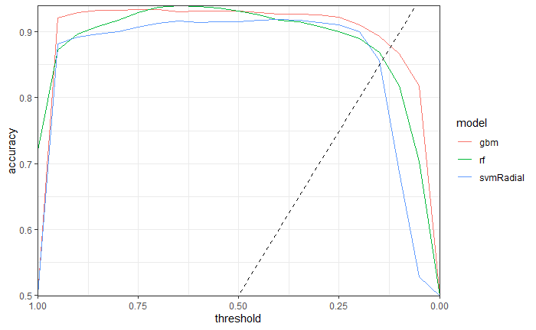

The next section is to evaluate the quality of the models using different techniques, one of them is “Accuracy” metric in which we will use the “applied_threshold” as cut-off point to assign positive and negative tag for each prediction.

* + 1. Quality evaluation

ROC (Receiver Operating Characteristics) is a graph that shows the performance of a classification model at all classification thresholds. The ROC curve is created by plotting the true positive rate (TPR) against false positive rate (FPR). Below formulas show the calculation of these rates.

$$TPR=Recall=Sensitivity=Power =\frac{TP}{TP+ FN}$$

$$FPR=1-Specificity=\frac{FP}{TN+FP}$$

$$Specificity=TNR=\frac{TN}{TN+FP}$$

ROC-AUC (Area under the ROC Curve) is a metric that represents degree or measure of separability that tells how much the model is able to distinguish between classes. AUC ranges from 0 to 1. The closest the AUC toward 1, the better the performance of the model. A poor model has AUC near to 0. **Figure 20** and **Figure 21** show the ROC-AUC graphs of each model on the “test” and “unseen” sets. It is clear that ROC-AUC is very high and close to 1 for the three models on the “test” set and a bit lower on the “unseen” set than the “test” set. **Table 6** indicates that the ROC-AUC on the “test” set is 0.978, 0.966, and 0.957 for **rf**, **gbm**, and **svmRadial** models respectively.

Figure 20: ROC on Test set

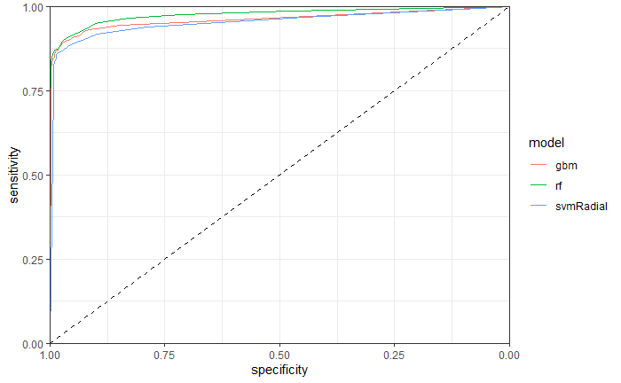

Figure 21: ROC on Unseen set

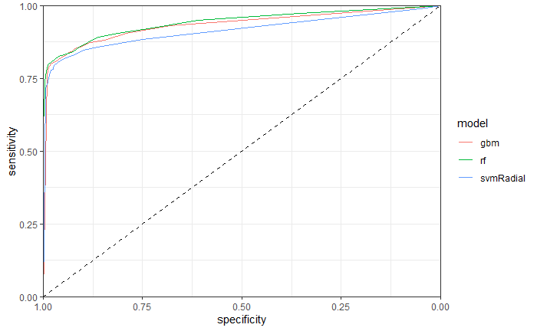

Using the “applied_threshold” of each model found in validation step, we calculated the accuracy of the models on the test set and also on the “unseen” set. The reason behind choosing the threshold on a data set (“validation”) and test the model on a different set (“test”) is to make sure the threshold chosen is not biased toward specific set and keeps valid in other data. The “unseen” set is useful to examine how the model behaves on predicting new data points not seen in training nor validation. **Table 6** contains statistics of each model on “validation”, “test”, and “unseen” sets. We can notice that the three models have high “Accuracy” and “ROC-AUC”. And also we can observe from this table the following:

* The “Accuracy” is almost identical for both “validation” and “test” set. This means the “applied_threshold” does not over-fit the “validation” set.
* The “Accuracy” on “unseen” data is not significantly different from what is reported for the “validation” and “test” sets. This implies that the models are reasonably valid to make predictions on new data sets not included in the process.
* ROC-AUC is high and almost the same in “validation” and “test” sets. It is less by 2-3 points in “unseen” set but it is a very minor degradation.
* Models are “specificity” oriented. The specificity is higher than the sensitivity by 12-20 points on different data sets. This implies that the model ability to avoid predicting alternative data as normal is higher than its power/recall to correctly recognize alternative data set. This is important as the impact of making a mistake of assigning “alternative” class to a “normal” data set could be worse than missing an “alternative” instance. We aim to decrease the former error as much as possible as many statistical analysis tools assume normality of the underlying distribution of the data.
* Random Forest (“rf”) has a bit higher quality than the other two classifiers. We will nominate it as the final model we choose to represent our solution of predicating normality.

Table 6: Quality statistic of the models on applied_threshold

| **Model** | **test_set** | **applied_threshold** | **roc_auc** | **sensitivity** | **specificity** | **accuracy** |
| --- | --- | --- | --- | --- | --- | --- |
| rf | validation | 0.6290000 | 0.9736311 | 0.8872180 | 0.9925187 | 0.940000 |
| rf | test | 0.6290000 | 0.9777190 | 0.8694030 | 0.9899497 | 0.929375 |
| rf | unseen | 0.6290000 | 0.9437715 | 0.7960000 | 0.9880000 | 0.892000 |
| gbm | validation | 0.6952947 | 0.9672998 | 0.8922306 | 0.9763092 | 0.934375 |
| gbm | test | 0.6952947 | 0.9659413 | 0.8706468 | 0.9824121 | 0.926250 |
| gbm | unseen | 0.6952947 | 0.9401380 | 0.8090000 | 0.9650000 | 0.887000 |
| svmRadial | validation | 0.3833224 | 0.9552716 | 0.8872180 | 0.9513716 | 0.919375 |
| svmRadial | test | 0.3833224 | 0.9570052 | 0.8681592 | 0.9723618 | 0.920000 |
| svmRadial | unseen | 0.3833224 | 0.9165810 | 0.8100000 | 0.9580000 | 0.884000 |

(Quality evaluation code can be found in **Code Snippet 3** in Appendix.)

In order to find the important features in the model, feature importance plots generated in **Figure 22**, **Figure 23**, and **Figure 24** for the three models that show the importance score on a scale of 0 to 100. The Feature importance is useful to assess the features used in the model by identifying the predictive power of the features. A score assigned to each of them that indicates the relative importance of the feature when making a prediction.

We can observe that the most important feature in predicting the normality at the three models is “kurtosis”. “Skewness” is also at the top three features at all models which indicates its significance in prediction. The importance of other features varies from model to model. This is expected as each model applies different techniques in learning the problem.

Figure 22: Feature importance in "rf” model

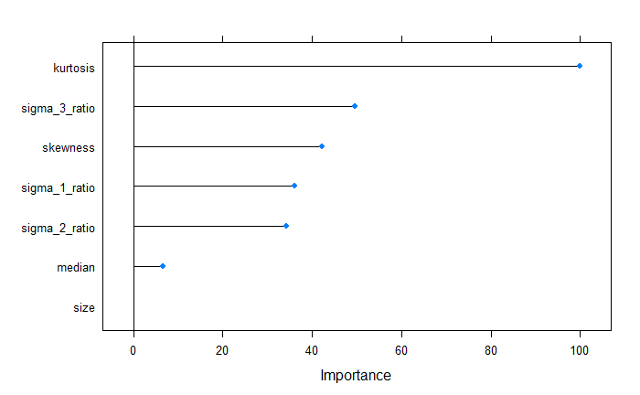

Figure 23: Feature importance in "gbm” model

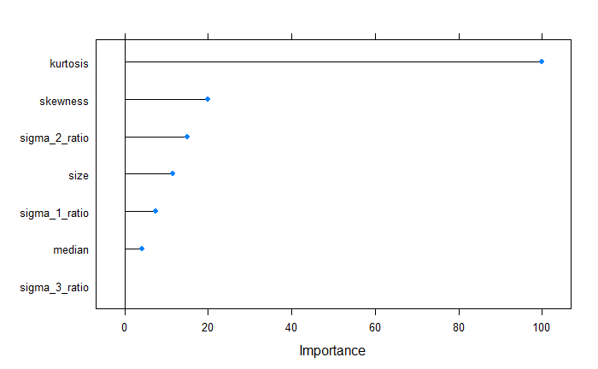

Figure 24: Feature importance in "svmRadial” model

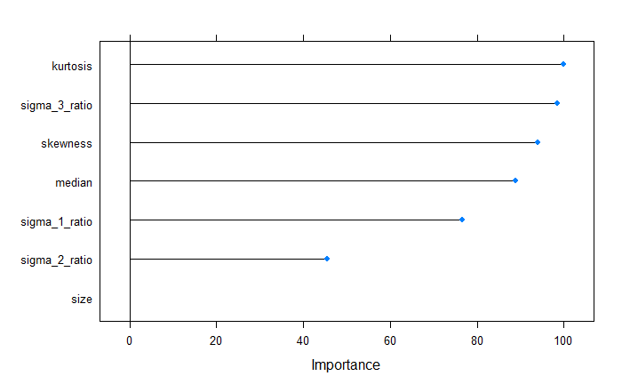

* + 1. Error analysis

Error analysis is an important stage in evaluating a classification model. We summarize the errors generated by the model trying to understand more the areas we can improve. We generated an instance report that contains the status of each instance in the “validation” set as following:

* **TP**: The instance is labeled positive (alternative), and correctly classified by the model as positive (alternative)
* **TN**: The instance is labeled negative (normal), and correctly classified by the model as negative (normal)
* **FP**: The instance is labeled negative (normal), and incorrectly classified by the model as positive (alternative)
* **FN**: The instance is labeled positive (alternative), and incorrectly classified by the model as negative (normal)

FP and FN are the specificity and sensitivity errors respectively. We are executing error analysis on the “validation” set so that any further improvement in the model can be tested on another test (the test set) to avoid biasedness. **Table 7** shows the summary of the instances on the three models. As we can notice, most of the errors are sensitivity errors where the models did classify incorrectly alternative distributions as normal class. **Table 8** show the sensitivity errors for the models at each alternative distributing family. We can observe that the majority of the errors happen on Symmetric_Short_Tailed and Close_To_Normal distributions. **Figure 25** shows the distribution of FN errors per sample size. The errors are distributed almost uniformly with a little skewness to the right that may indicate less power in small size but it is not clear enough to induce such conclusion. **Table 15** in appendix shows 10 instances that got lowest score by RF model, these instances have features similar to what we can expect for normal distributions. These findings points to the areas that we can start investigating if more improvement is required for the quality of the model.

Table 7: Summary instance report

|  |  |  |  |  |
| --- | --- | --- | --- | --- |
| **Classifier** | **TP** | **FP** | **FN** | **TN** |
| Rf | 710 | 8 | 88 | 794 |
| Gbm | 713 | 19 | 85 | 783 |
| svmRadial | 711 | 40 | 87 | 762 |

Table 8: Sensitivity errors (FN) per alternative family

|  |  |  |  |
| --- | --- | --- | --- |
| **Alternative family** | **rf** | **gbm** | **svmRadial** |
| Asymmetric_Long_Tailed | 2 | 2 | 1 |
| Asymmetric_Short_Tailed | 5 | 6 | 5 |
| Symmetric_Long_Tailed | 1 | 1 | 4 |
| Symmetric_Short_Tailed | 46 | 44 | 44 |
| Close_To_Normal | 34 | 32 | 33 |

Figure 25: Frequency of FN errors per size

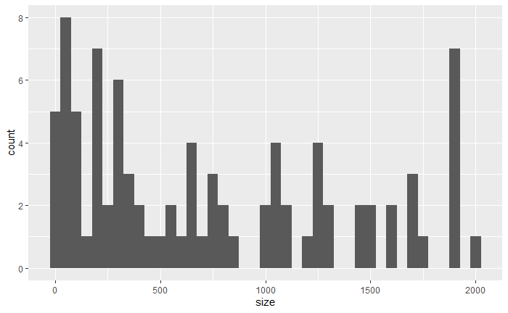

* 1. Power comparison

In previous sections, we showed how we generated classification model to predict the “non-normality” of a sample data. In the evaluation step we tested the models on different test sets and the results indicate a high quality (accuracy) of the models. In this section, we will evaluate the classification model in terms of “normality test” and will examine its quality by comparing its power with other statistic tests. We choose in this comparison the “rf” model to represent the new machine learning approach of testing normality. It was the one with highest performance as we saw in the evaluation steps before. For next sections we will call the created classification model (rf) as “new_test” when we compare it with other tests.

* + 1. Procedure

Power comparison test was concluded between the “new_test” model and other statistical tests using Monte Carlo simulation procedure. Monte Carlo is a method to estimate probability and expected value of a random variable by repeating a random process many times. If we find that we are unable to compute a probability or an expected value exactly with mathematics, we can still attempt to estimate it by making the computer repeat the random experiment many times, keeping track of the result of the experiment each time. This technique is known as Monte Carlo simulation, after the famous [Monte Carlo casino](https://en.wikipedia.org/wiki/Monte_Carlo_Casino) in the Principality of Monaco. For example, in order to find the integral between 3 and 6 in a normal distribution of mean 1 and standard deviation 10, one could use the probability tables. But it can be simulated by sampling from that distribution 100,000 times and see how many values are between 3 and 6.

Related to our problem, we will run Monte Carlo simulation to estimate the power of the normality tests. The power of the test is the probability that the test rejects the null hypothesis ($H_{0}:Sample is normal$) when it should be rejected (sample is actually “not-normal”). We will estimate the power of the tests participating in this comparison by letting each test to detect the departure from normality on a set of samples from “alternative” distributions. We repeat this process many times and the ratio of detected samples out of all examined samples represents the power of the test.

Statistical normality tests were chosen to be in this comparison based on their popularity. Seven tests included in this research are listed in **Table 9**. We used a wide range of alternative distributions in this comparison. Total of 25 different distributions chosen from the main five families shown in **Table 1**. The power was estimated on three levels of significance: α = 0.01, α = 0.05, and α=0.10. Samples of size 10, 20, 30, 50, 100, 200, 500, and 1000 used in the simulation from each alternative with 1,000 repetitions.

Table 9: List of normality tests used in the power comparison

|  |  |
| --- | --- |
| Shapiro-Wilk (SW) | Anderson-Darling (AD) |
| Jarque-Bera (JB) | Shapiro-Francia (SF) |
| Kolmogorov-Smirnov (KS) | Cramer-von Mises (CVM) |
| Lilliefors (Lillie) |  |

The “new_test” is a binary classification model that was tuned in “validation” stage with a fixed threshold of 0.629 in which a prediction above this threshold considered as “alternative” a prediction below this threshold as “normal”. The question is how we will run this model on three different level of significance. We can answer this question simply if we know that:

$$α=FPR=1-Specificity$$

So, to run the model on $α=0.05$ level of significance, we need to apply the threshold that gives $specificity=1-0.05=0.95$. **Table 10** shows the thresholds used in the “new_test” – “rf” model - on each significance level using the “validation” set.

Table 10: "new_test" Threshold used on each significance level

|  |  |  |
| --- | --- | --- |
| $α$ | **Specificity** | **Threshold** |
| 0.01 | 0.99 | 0.65 |
| 0.05 | 0.95 | 0.45 |
| 0.1 | 0.9 | 0.35 |

[MonteCarlo](https://cran.r-project.org/web/packages/MonteCarlo/vignettes/MonteCarlo-Vignette.html) R package used to run the simulation, complete code can be found in **Code Snippet 4** in Appendix.

* + 1. Results

In this section we discuss the results of the power of normality tests including the “new_test” we propose in this research. We will show the power of the tests from different perspectives. First, we calculate the overall power of each test on all alternative distribution per each sample size. Then, we calculate the power of each test per each alternative family. And finally, we show the power of each test on each of the 25 alternative distributions.

By looking on **Figure 26**, **Figure 27**, and **Figure 28** that show the overall power of the tests on 0.01, 0.05, and 0.1 significance levels, we can see that the “new_test” is the most powerful comparing to other statistical tests on all level of significance. It has high power on small sample size especially on 0.05 and 0.1 significance levels. **Table 16**, **Table 17**, and **Table 18** in Appendix show the power in tabular format.

**Table 11**, **Table 12**, and **Table 13** show the power of the tests per alternative family on the three level of significance. The three tables indicate that the “new_test” is significantly has higher power than other tests in every family. It is different than other tests where it gives high power on small sample sizes. On the other hand, it is consistent with other tests that they are most powerful on detecting Asymmetric-Long-Tailed alternatives and they give the lowers power on Close-To-Normal distributions. But the “new_test” has relatively high power on all families comparing with other tests. Power results on every distribution can be found at **Table 19**, **Table 20**, and **Table 21** in Appendix.

Figure 26: Overall power comparison on 1% significance level

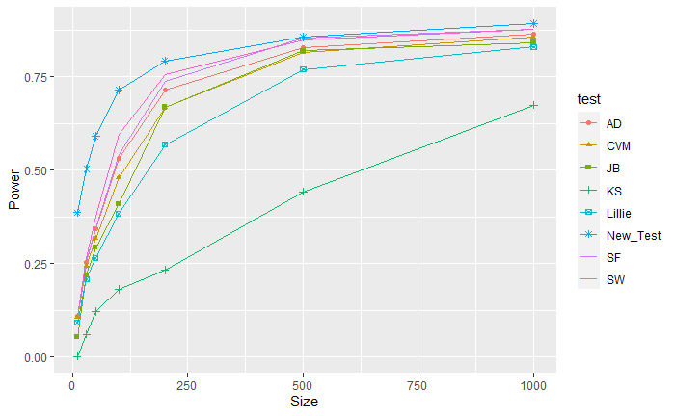

Figure 27: Overall power comparison on 5% significance level

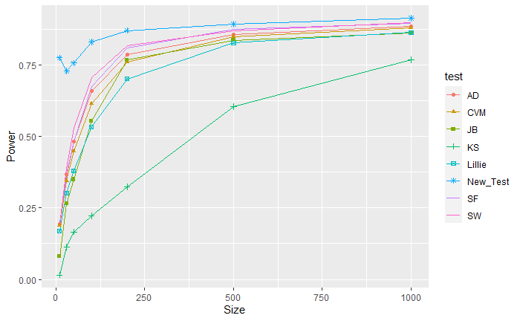

Figure 28: Overall power comparison on 10% significance level

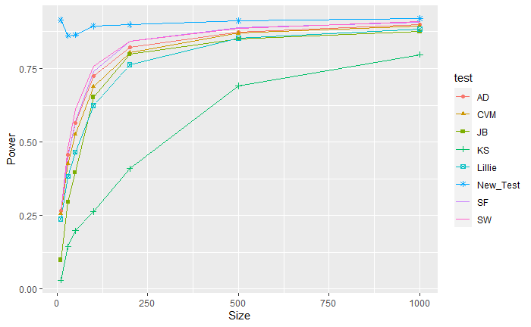

Table 11: Tests power per alternative family on 1% level of significance

| Family | Size | new_test | SW | AD | CVM | JB | KS | Lillie | SF |
| --- | --- | --- | --- | --- | --- | --- | --- | --- | --- |
| CTN | 10 | **0.29** | 0.02 | 0.02 | 0.03 | 0.01 | 0 | 0.02 | 0.03 |
| 30 | **0.26** | 0.06 | 0.05 | 0.06 | 0.08 | 0 | 0.05 | 0.07 |
| 50 | **0.27** | 0.1 | 0.1 | 0.1 | 0.11 | 0 | 0.07 | 0.1 |
| 100 | **0.33** | 0.19 | 0.2 | 0.21 | 0.19 | 0 | 0.15 | 0.19 |
| 200 | **0.41** | 0.34 | 0.36 | 0.34 | 0.26 | 0.02 | 0.28 | 0.31 |
| 500 | **0.54** | 0.51 | 0.47 | 0.45 | 0.35 | 0.18 | 0.42 | 0.52 |
| 1000 | **0.66** | 0.59 | 0.53 | 0.51 | 0.41 | 0.38 | 0.45 | 0.59 |
|  | | | | | | | | | |
| ALT | 10 | **0.5** | 0.27 | 0.25 | 0.23 | 0.11 | 0 | 0.19 | 0.25 |
| 30 | **0.69** | 0.55 | 0.52 | 0.49 | 0.47 | 0.15 | 0.43 | 0.53 |
| 50 | **0.82** | 0.67 | 0.62 | 0.59 | 0.6 | 0.3 | 0.53 | 0.65 |
| 100 | **0.95** | 0.87 | 0.78 | 0.74 | 0.77 | 0.4 | 0.67 | 0.83 |
| 200 | **0.99** | **0.99** | 0.94 | 0.91 | 0.93 | 0.51 | 0.83 | 0.98 |
| 500 | **1** | **1** | **1** | **1** | **1** | 0.73 | 0.98 | **1** |
| 1000 | **1** | **1** | **1** | **1** | **1** | 0.94 | **1** | **1** |
|  | | | | | | | | | |
| AST | 10 | **0.33** | 0.03 | 0.03 | 0.03 | 0.01 | 0 | 0.02 | 0.03 |
| 30 | **0.36** | 0.13 | 0.1 | 0.09 | 0.09 | 0 | 0.06 | 0.11 |
| 50 | **0.44** | 0.28 | 0.22 | 0.17 | 0.15 | 0 | 0.11 | 0.24 |
| 100 | **0.64** | 0.56 | 0.47 | 0.4 | 0.31 | 0 | 0.28 | 0.49 |
| 200 | **0.8** | **0.8** | 0.71 | 0.64 | 0.66 | 0.04 | 0.54 | 0.76 |
| 500 | 0.94 | 0.97 | 0.94 | 0.92 | 0.97 | 0.4 | 0.83 | **0.98** |
| 1000 | 0.99 | **1** | **1** | 0.99 | **1** | 0.64 | 0.96 | **1** |
|  | | | | | | | | | |
| SLT | 10 | **0.45** | 0.21 | 0.24 | 0.24 | 0.13 | 0.01 | 0.22 | 0.23 |
| 30 | **0.68** | 0.52 | 0.53 | 0.53 | 0.46 | 0.15 | 0.48 | 0.55 |
| 50 | **0.79** | 0.64 | 0.61 | 0.61 | 0.6 | 0.31 | 0.57 | 0.67 |
| 100 | **0.89** | 0.76 | 0.72 | 0.7 | 0.78 | 0.5 | 0.66 | 0.78 |
| 200 | **0.95** | 0.86 | 0.81 | 0.79 | 0.89 | 0.59 | 0.74 | 0.87 |
| 500 | **0.99** | 0.96 | 0.92 | 0.91 | 0.98 | 0.67 | 0.85 | 0.97 |
| 1000 | **1** | 0.99 | 0.99 | 0.98 | **1** | 0.78 | 0.93 | **1** |
|  | | | | | | | | | |
| SST | 10 | **0.38** | 0.01 | 0.01 | 0.01 | 0 | 0 | 0.01 | 0.01 |
| 30 | **0.53** | 0.06 | 0.05 | 0.04 | 0 | 0 | 0.02 | 0.02 |
| 50 | **0.64** | 0.2 | 0.16 | 0.11 | 0 | 0 | 0.05 | 0.07 |
| 100 | **0.76** | 0.61 | 0.49 | 0.35 | 0.01 | 0 | 0.16 | 0.43 |
| 200 | **0.81** | 0.8 | 0.75 | 0.66 | 0.6 | 0 | 0.46 | 0.77 |
| 500 | **0.81** | 0.8 | 0.8 | 0.8 | 0.8 | 0.24 | 0.77 | 0.8 |
| 1000 | **0.81** | 0.8 | 0.8 | 0.8 | 0.8 | 0.64 | 0.8 | 0.8 |

Table 12: Tests power per alternative family on 5% level of significance

| Family | Size | new_test | SW | AD | CVM | JB | KS | Lillie | SF |
| --- | --- | --- | --- | --- | --- | --- | --- | --- | --- |
| CTN | 10 | **0.69** | 0.08 | 0.09 | 0.08 | 0.02 | 0 | 0.08 | 0.1 |
| 30 | **0.5** | 0.13 | 0.14 | 0.15 | 0.11 | 0 | 0.12 | 0.15 |
| 50 | **0.47** | 0.18 | 0.19 | 0.2 | 0.15 | 0 | 0.17 | 0.2 |
| 100 | **0.54** | 0.31 | 0.33 | 0.32 | 0.24 | 0.02 | 0.27 | 0.3 |
| 200 | **0.59** | 0.47 | 0.45 | 0.43 | 0.31 | 0.08 | 0.39 | 0.45 |
| 500 | **0.65** | 0.57 | 0.54 | 0.52 | 0.39 | 0.31 | 0.49 | 0.59 |
| 1000 | **0.75** | 0.67 | 0.62 | 0.6 | 0.49 | 0.4 | 0.55 | 0.66 |
|  | | | | | | | | | |
| ALT | 10 | **0.87** | 0.38 | 0.37 | 0.36 | 0.17 | 0.02 | 0.3 | 0.39 |
| 30 | **0.89** | 0.67 | 0.63 | 0.6 | 0.55 | 0.27 | 0.55 | 0.64 |
| 50 | **0.93** | 0.79 | 0.74 | 0.7 | 0.68 | 0.38 | 0.64 | 0.77 |
| 100 | **0.99** | 0.94 | 0.88 | 0.85 | 0.85 | 0.49 | 0.79 | 0.91 |
| 200 | **1** | **1** | 0.99 | 0.96 | 0.99 | 0.63 | 0.92 | **1** |
| 500 | **1** | **1** | **1** | **1** | **1** | 0.87 | **1** | **1** |
| 1000 | **1** | **1** | **1** | **1** | **1** | 0.99 | **1** | **1** |
|  | | | | | | | | | |
| AST | 10 | **0.76** | 0.1 | 0.09 | 0.09 | 0.02 | 0 | 0.08 | 0.1 |
| 30 | **0.68** | 0.29 | 0.25 | 0.21 | 0.13 | 0 | 0.17 | 0.26 |
| 50 | **0.72** | 0.48 | 0.41 | 0.36 | 0.23 | 0.01 | 0.27 | 0.42 |
| 100 | **0.84** | 0.7 | 0.64 | 0.57 | 0.52 | 0.04 | 0.48 | 0.66 |
| 200 | **0.93** | 0.91 | 0.83 | 0.79 | 0.83 | 0.21 | 0.71 | 0.88 |
| 500 | **0.99** | **0.99** | 0.97 | 0.96 | **0.99** | 0.57 | 0.92 | **0.99** |
| 1000 | **1** | **1** | **1** | **1** | **1** | 0.83 | 0.99 | **1** |
|  | | | | | | | | | |
| SLT | 10 | **0.75** | 0.33 | 0.35 | 0.35 | 0.18 | 0.05 | 0.33 | 0.36 |
| 30 | **0.8** | 0.62 | 0.61 | 0.61 | 0.53 | 0.29 | 0.57 | 0.64 |
| 50 | **0.86** | 0.71 | 0.69 | 0.68 | 0.67 | 0.44 | 0.64 | 0.73 |
| 100 | **0.93** | 0.81 | 0.78 | 0.77 | 0.83 | 0.56 | 0.73 | 0.84 |
| 200 | **0.98** | 0.9 | 0.87 | 0.85 | 0.91 | 0.64 | 0.81 | 0.92 |
| 500 | **1** | 0.98 | 0.96 | 0.95 | 0.99 | 0.74 | 0.92 | 0.98 |
| 1000 | **1** | **1** | **1** | 0.99 | **1** | 0.84 | 0.97 | **1** |
|  | | | | | | | | | |
| SST | 10 | **0.8** | 0.06 | 0.06 | 0.06 | 0 | 0 | 0.05 | 0.05 |
| 30 | **0.77** | 0.25 | 0.21 | 0.16 | 0.01 | 0 | 0.1 | 0.11 |
| 50 | **0.79** | 0.49 | 0.38 | 0.3 | 0.01 | 0 | 0.18 | 0.3 |
| 100 | **0.85** | 0.76 | 0.66 | 0.56 | 0.33 | 0 | 0.39 | 0.66 |
| 200 | **0.86** | 0.81 | 0.8 | 0.77 | 0.8 | 0.07 | 0.67 | 0.81 |
| 500 | **0.83** | 0.81 | 0.81 | 0.81 | 0.81 | 0.53 | 0.81 | 0.81 |
| 1000 | **0.81** | **0.81** | **0.81** | **0.81** | **0.81** | 0.78 | **0.81** | **0.81** |

Table 13: Tests power per alternative family on 10% level of significance

| Family | Size | new_test | SW | AD | CVM | JB | KS | Lillie | SF |
| --- | --- | --- | --- | --- | --- | --- | --- | --- | --- |
| CTN | 10 | **0.86** | 0.13 | 0.15 | 0.14 | 0.04 | 0 | 0.14 | 0.16 |
| 30 | **0.71** | 0.2 | 0.22 | 0.22 | 0.13 | 0.01 | 0.2 | 0.22 |
| 50 | **0.69** | 0.26 | 0.28 | 0.27 | 0.19 | 0.02 | 0.25 | 0.28 |
| 100 | **0.68** | 0.39 | 0.4 | 0.4 | 0.25 | 0.05 | 0.37 | 0.38 |
| 200 | **0.67** | 0.53 | 0.51 | 0.5 | 0.34 | 0.15 | 0.47 | 0.53 |
| 500 | **0.72** | 0.63 | 0.59 | 0.58 | 0.45 | 0.37 | 0.54 | 0.64 |
| 1000 | **0.78** | 0.73 | 0.68 | 0.66 | 0.55 | 0.42 | 0.61 | 0.71 |
|  | | | | | | | | | |
| ALT | 10 | **0.97** | 0.48 | 0.45 | 0.43 | 0.21 | 0.06 | 0.4 | 0.47 |
| 30 | **0.96** | 0.73 | 0.7 | 0.67 | 0.59 | 0.33 | 0.62 | 0.72 |
| 50 | **0.97** | 0.85 | 0.8 | 0.77 | 0.73 | 0.43 | 0.71 | 0.84 |
| 100 | **1** | 0.97 | 0.93 | 0.9 | 0.91 | 0.54 | 0.85 | 0.95 |
| 200 | **1** | **1** | 0.99 | 0.98 | 0.99 | 0.71 | 0.95 | 1 |
| 500 | **1** | **1** | **1** | **1** | **1** | 0.94 | **1** | **1** |
| 1000 | **1** | **1** | **1** | **1** | **1** | **1** | **1** | **1** |
|  | | | | | | | | | |
| AST | 10 | **0.92** | 0.17 | 0.18 | 0.16 | 0.03 | 0 | 0.13 | 0.17 |
| 30 | **0.85** | 0.4 | 0.37 | 0.32 | 0.18 | 0.01 | 0.27 | 0.37 |
| 50 | **0.86** | 0.57 | 0.51 | 0.45 | 0.31 | 0.03 | 0.38 | 0.51 |
| 100 | **0.93** | 0.8 | 0.72 | 0.67 | 0.64 | 0.11 | 0.6 | 0.75 |
| 200 | **0.96** | 0.94 | 0.89 | 0.85 | 0.91 | 0.33 | 0.79 | 0.93 |
| 500 | 0.99 | **1** | 0.98 | 0.98 | 0.99 | 0.68 | 0.96 | 0.99 |
| 1000 | **1** | **1** | **1** | **1** | **1** | 0.9 | **1** | **1** |
|  | | | | | | | | | |
| SLT | 10 | **0.89** | 0.39 | 0.43 | 0.41 | 0.21 | 0.08 | 0.41 | 0.44 |
| 30 | **0.9** | 0.66 | 0.67 | 0.65 | 0.57 | 0.37 | 0.62 | 0.7 |
| 50 | **0.92** | 0.76 | 0.73 | 0.72 | 0.72 | 0.5 | 0.69 | 0.79 |
| 100 | **0.96** | 0.84 | 0.83 | 0.81 | 0.86 | 0.59 | 0.78 | 0.87 |
| 200 | **0.98** | 0.92 | 0.9 | 0.89 | 0.94 | 0.67 | 0.86 | 0.94 |
| 500 | **1** | 0.99 | 0.98 | 0.97 | 0.99 | 0.79 | 0.95 | 0.99 |
| 1000 | **1** | **1** | **1** | **1** | **1** | 0.87 | 0.99 | **1** |
|  | | | | | | | | | |
| SST | 10 | **0.93** | 0.15 | 0.13 | 0.13 | 0.01 | 0 | 0.11 | 0.1 |
| 30 | **0.89** | 0.41 | 0.33 | 0.28 | 0.01 | 0 | 0.21 | 0.24 |
| 50 | **0.88** | 0.62 | 0.5 | 0.42 | 0.03 | 0.01 | 0.3 | 0.44 |
| 100 | **0.9** | 0.8 | 0.74 | 0.66 | 0.6 | 0.03 | 0.52 | 0.74 |
| 200 | **0.88** | 0.82 | 0.81 | 0.8 | 0.81 | 0.19 | 0.74 | 0.82 |
| 500 | **0.84** | 0.82 | 0.81 | 0.82 | 0.82 | 0.67 | 0.82 | 0.82 |
| 1000 | **0.82** | **0.82** | **0.82** | **0.82** | **0.82** | 0.8 | **0.82** | **0.82** |

Chapter Five

Discussion and conclusion

1. 1. Results summary

The results showed that using Machine Learning techniques is a valid solution for the problem of detecting departure from normality for a data sample. We managed to build a classification model using minimal number of features that had high ability to predict departure from normality on all families of alternative probability distributions with high resilience to the sample size. The “Accuracy” of the three classification models built in this research was high on all data sets, including the “unseen” data which is a set of probability distributions held out from the process in order to assess the ability of the model to generalize to new data sets not seen before. The performance of the classification model as a normality test (“new_test”) was validated by comparing its power against the state of the art statistical normality tests. The results showed that the “new_test” has significantly better power than the other tests on different levels of significance and sample sizes.

* 1. Future research

The work done in this research could be a starting point for further development in the direction of using machine learning models to solve statistical problems we used to solve by classical statistical tests. Learning from data seems very promising approach that could help in solving problems related to the characteristics of the data. Future research in this topic could be:

* Improve the quality -mainly sensitivity- of the models by doing thorough error analysis. We can examine the areas that had low accuracy and try to understand the characteristics of these areas aiming to find more features that could decrease the number of errors and improve the quality.
* It is important to assess the applicability of converging a theory into real life applications. The next step is to encapsulate the model in a new R library published to the public to let this functionality available for use by statisticians and data scientists as a new method for testing the normality.
* The model created in this research can be extended from binary (normal, alternative) to multiclass classification model to classify the sample into its underlying probability distributions.

References

Afeez, B. (2018). Selection and Validation of Comparative Study of Normality Test. *American Journal of Mathematics and Statistics, 8*(6), 190-201.

Alizadeh, H., & Arghami, N. (2011). Monte Carlo comparison of seven normality tests. *Journal of Statistical Computation and Simulation, 81*(8), 965-972.

Ayyadevara, V. K. (2018). *Pro Machine Learning Algorithms.* Apress. doi:10.1007/978-1-4842-3564-5

Burkardt, J. (2014, October 17). The Truncated Normal Distribution. Retrieved May 9, 2020, from http://people.sc.fsu.edu/∼jburkardt/presentations/truncated normal.pdf

Cai, X.‐L., Xie, D.‐J., Madsen, K., Wang, Y., Bogemann, S., Cheung, E., . . . Chan, R. (2020). Generalizability of machine learning for classification of schizophrenia based on resting‐state functional MRI data. *Human Brain Mapping, 41*(1), 172-184. doi:https://doi.org/10.1002/hbm.24797

Casella, L., & Berger, R. (2001). *Statistical inference* (2nd ed.). Cengage Learning.

D’Agostino, B., & Stephens, A. (1986). *Goodness-of-fit Techniques.* Marcel Dekker.

Das, R., & Imon, M. (2016). A Brief Review of Tests for Normality. *American Journal of Theoretical and Applied Statistics, 5*(1), 5-12. doi:10.0.45.128/j.ajtas.20160501.12

Fernandez-Delgado, M., Cernadas, E., Barro, S., & Amorim, D. (2014). Do we Need Hundreds of Classifiers to Solve Real WorldClassification Problems? *Journal of Machine Learning Research*(15), 3133-3181.

Forbes, C., Evans, M., Hasting, N., & Peacock, B. (2011). *Statistical Distributions* (4th ed.). Hoboken, New Jersey: John Wiley & Sons, Inc.

Ghasemi , A., & Zahediasl, S. (2012). Normality Tests for Statistical Analysis: A Guide for Non-Statisticians. *International Journal of Endocrinology and Metabolism, 10*(2), 486-489. doi:10.5812/ijem.3505

H, M., & C, J. (1968). *Fundamentals of statistics.* Boston: Springer. doi:10.1007/978-1-4899-6507-3

Hazewinkel, M. (1994). *Encyclopedia of Mathematics.* Springer.

Islam, T. (2011). Normality Testing- A New Direction. *International Journal of Business and Social Sciences, 2*, 115-118.

Islam, T. (2019). Ranking of Normality Tests: An Appraisal through Skewed Alternative Space. *Symmetry, 11*(827). doi:10.20944/preprints201905.0190.v1

Joiner, B., & Rosenblatt, J. (1971). Some Properties of the Range in Samples from Tukey's Symmetric Lambda Distributions. *Journal of the American Statistical Association, 66*(334), 394–399.

Kuhn, M. (2008). Building predictive models in R using the caret package. *Journal of Statistical Software, 28*(5), 1-26.

Lukas, E. (1942). A characterization of the normal distribution. *Annals of Mathematical statistics, 13*, 91-83.

Lyon, A. (2014). Why are Normal Distributions Normal. *The British Journal for The Philosophy of Science, 65*, 621-649.

Mueller, C., & Guido, S, S. (2016). *Introduction to Machine Learning with Python.* O’Reilly Media.

Muyombya, M. (2017). On empirical power of univariate normality tests under symmetric, asymmetric and scaled distributions. *International Journal of Scientific and Engineering Research, 8*(3).

*Normal distribution*. (2020, April 29). Retrieved May 9, 2020, from Wikipedia: https://en.wikipedia.org/w/index.php?title=Normal_distribution&oldid=953810074

Oztuna, D., Elhan, A., & Tuccar, E. (2006). Investigation of four different normality tests in terms of type 1 error rate and power under different distributions. *Turkish Journal of Medical Sciences, 36*(3), 171-176.

Patel, K., & Read, B. (1996). *Handbook of the Normal Distribution* (2nd ed.). CRC Press.

Pearson, K. (1895). Contributions to the Mathematical Theory of Evolution. II. Skew Variation in Homogeneous. *Philosophical Transactions of the Royal Society of London. A, 186*, 343-414. Retrieved from https://www.jstor.org/stable/90649

Razali, N., & Wah, Y. (2011). Power Comparisons of Shapiro-Wilk, Kolmogorov-Smirnov, Lilliefors and Anderson-Darling Tests. *Journal of Statistical Modeling and Analytics, 2*(1), 21-33.

Rebala, G., Ravi, A., & Churiwala, S. (2019). *An introduction to machine learning.* Springer. doi:10.1007/978-3-030-15729-6

Seier, E. (2002). Comparison of tests of univariate normality. *InterStat Statistical Journal, 1*, 1-17.

Shapiro, S., Wilk, B., & Chen, J. (1968). Acomparison study. *Journal of American, 63*(324), 1343-1372.

Stephanie. (2015, August 6). *Tukey Lambda Distribution: Definition*. Retrieved May 9, 2020, from Statistics How To: https://www.statisticshowto.com/tukey-lambda-distribution/

Throde, C. (2002). *Testing For Normality.* Marcel Dekker.

*Tukey lambda distribution*. (2019, June 6). Retrieved May 9, 2020, from Wikipedia: https://en.wikipedia.org/w/index.php?title=Tukey_lambda_distribution&oldid=900491544

Wainer, J. (2016). Comparison of 14 different families of classification.

Walck, C. (2007, September 10). Hand-book on statistical distributions for expirements. University of Stockholms. Retrieved May 9, 2020, from http://www.stat.rice.edu/~dobelman/textfiles/DistributionsHandbook.pdf

Yap, W., & Sim, H. (2011). Comparison of various types of normality tests. *Journal of Statistical Computation and Simulation, 81*(12), 2141-2155. doi:10.1080/00949655.2010.520163

Appendix 1: Code

Code snippet 1: Data generation

|  |
| --- |
| library**(**"extraDistr"**)** #rtlambda  library**(**"truncnorm"**)** #rtruncnorm  library**(**"moments"**)**#skewness and kurtosis  #"Generate samples"  set.seed**(**666**)**  population **<-** unique**(**as.integer**(**runif**(**n **=** 1000000, min **=** 5, max **=** 2000**)))**  sizes **<-** sort**(**sample**(**x**=** population, size **=** 200, replace **=** **FALSE))**  generate_samples**(**sizes**)**  generate_samples**<-function(**sizes**){**    process_sample**<-function(**s, family, dist, alternative**){**    #Calc features  scaled_s **<-** scale**(**s**)**    size **<-** length**(**scaled_s**)**    stats **=** calc_stats**(**s, scaled_s**)**    #sample_id  sample_id **<-** paste**(**family, dist, size, sep **=** "-"**)**    data_set**[**nrow**(**data_set**)** **+** 1, **]** **=** c**(**sample_id, family, dist, stats, alternative**)**    write**(**x **=** scaled_s, file **=** paste**(**data_files_dir, "/", sample_id, "_scaled", sep **=** ""**)**, ncolumns **=** 1**)**  write**(**x **=** s, file **=** paste**(**data_files_dir, "/", sample_id, sep **=** ""**)**, ncolumns **=** 1**)**    return**(**data_set**)**  **}**      data_set **<-** data.frame**(**sample_id**=**character**(**0**)**, dist_family**=**character**(**0**)**, dist**=**character**(**0**)**, size**=**integer**(**0**)**, mean**=**numeric**(**0**)**, median**=**numeric**(**0**)**, mean_median_diff**=**numeric**(**0**)**, sd**=**numeric**(**0**)**, skewness**=**numeric**(**0**)**, kurtosis**=**numeric**(**0**)**, outliers_minor_ratio**=**integer**(**0**)**, outliers_extream_ratio**=**integer**(**0**)**, sigma_1_ratio**=**numeric**(**0**)**, sigma_2_ratio**=**numeric**(**0**)**, sigma_3_ratio**=**numeric**(**0**)**, alternative**=**integer**(**0**)**, stringsAsFactors **=** **FALSE)**      **for(**size **in** sizes**){**  print**(**paste**(**"Processing samples of size ", size, sep **=** ""**))**    ############ Close to normal  family **<-** "close_normal"    **for(**dist **in** dist_ctn**){**  s **<-** create_alternative_sample**(**dist, size**)**  data_set **<-** process_sample**(**s, family, dist, 1**)**  **}**      ############ Symmetric long-tailed  family **<-** "sym_long_tail"    **for(**dist **in** dist_slt**){**  s **<-** create_alternative_sample**(**dist, size**)**  data_set **<-** process_sample**(**s, family, dist, 1**)**  **}**    ############# Symmetric short-tailed  family **<-** "sym_short_tail"  **for(**dist **in** dist_sst**){**  s **<-** create_alternative_sample**(**dist, size**)**  data_set **<-** process_sample**(**s, family, dist, 1**)**  **}**      ############# Asymmetric long-tailed  family **<-** "asym_long_tail"    **for(**dist **in** dist_alt**){**  s **<-** create_alternative_sample**(**dist, size**)**  data_set **<-** process_sample**(**s, family, dist, 1**)**  **}**      ############# Asymmetric short-tailed  family **<-** "asym_short_tail"    **for(**dist **in** dist_ast**){**  s **<-** create_alternative_sample**(**dist, size**)**  data_set **<-** process_sample**(**s, family, dist, 1**)**  **}**      ############ Normal    #To make sure we get in all runs the same means and sd  #I don't why the set.seed out the loop does not work here  set.seed**(**666**)**  norm_mean **=** as.integer**(**runif**(**5, **-**1000, 1000**))**    norm_cov **<-** c**(**0.01, 0.1, 0.3, 0.6, 1.0**)** #coeffienent of variation  **for(**mu **in** norm_mean**){**  **for(**cov **in** norm_cov**){**  family **<-** paste**(**"normal(", cov, ")", sep **=** ""**)**    sd **=** round**(**abs**(**cov**\***mu**)**, 3**)**    s **<-** rnorm**(**n **=** size, mean **=** mu, sd **=** sd**)**    data_set **<-** process_sample**(**s, family, paste**(**"Normal", mu, sd, sep **=** "_"**)**, 0**)**  **}**  **}**  **}**      write.csv**(**data_set, file**=**data_file**)**  **}**  do_scaling **<-** **TRUE**  calc_stats**<-function(**sample, scaled_sample **=** **NULL){**  **if(**do_scaling **==** **TRUE){**  **if(**is.null**(**scaled_sample**)){**  s **<-** scale**(**sample**)**  **}else{**  s **<-** scaled_sample  **}**  **}else{**  s **<-** sample  **}**  #Calc features  size **<-** length**(**s**)**  mean_ **<-** round**(**mean**(**s**)**, 5**)**  median_ **<-** round**(**median**(**s**)**,5**)**  sd_ **<-** sd**(**s**)**  skewness_ **<-** round**(**skewness**(**s**)**, 5**)**  kurtosis_ **<-** round**(**kurtosis**(**s**)**, 5**)**  outliers **<-** find_outliers**(**s**)**    sigma_1_ratio **<-** length**(**which**(**abs**(**s **-** mean_**)** **<=** 1**\***sd_ **))/**size  sigma_2_ratio **<-** length**(**which**(**abs**(**s **-** mean_**)** **<=** 2**\***sd_ **))/**size  sigma_3_ratio **<-** length**(**which**(**abs**(**s **-** mean_**)** **<=** 3**\***sd_ **))/**size    outliers_minor_ratio **<-** length**(**outliers**$**minor**)** **/** size  outliers_extream_ratio **<-** length**(**outliers**$**extreme**)** **/** size    stats **<-** list**(**"size" **=** size,  "mean" **=** mean_,  "median" **=** median_,  "mean_median_diff" **=** abs**(**mean_ **-** median_**)** **/** sd_,  "sd" **=** sd_,  "skewness" **=** skewness_,  "kurtosis" **=** kurtosis_,  "outliers_minor_ratio" **=** outliers_minor_ratio,  "outliers_extream_ratio" **=** outliers_extream_ratio,  "sigma_1_ratio" **=** sigma_1_ratio,  "sigma_2_ratio" **=** sigma_2_ratio,  "sigma_3_ratio" **=** sigma_3_ratio**)**  return**(**stats**)**  **}**  find_outliers**<-function(**data**){**  lowerq **=** quantile**(**data**)[**2**]**  upperq **=** quantile**(**data**)[**4**]**  iqr **=** upperq **-** lowerq #Or use IQR(data)    minor_threshold_upper **=** **(**iqr **\*** 1.5**)** **+** upperq  minor_threshold_lower **=** lowerq **-** **(**iqr **\*** 1.5**)**    extreme_threshold_upper **=** **(**iqr **\*** 3**)** **+** upperq  extreme_threshold_lower **=** lowerq **-** **(**iqr **\*** 3**)**    outliers **=** list**()**  outliers**[[**"minor"**]]** **=** data**[(**data **<** minor_threshold_lower**)** **|** **(**data **>** minor_threshold_upper **)]**  outliers**[[**"extreme"**]]** **=** data**[(**data **<** extreme_threshold_lower**)** **|** **(**data **>** extreme_threshold_upper **)]**    return**(**outliers**)**  **}**  create_alternative_sample**<-function(**dist, size**){**  #Close to normal dist  **if(**dist **==** "tukey(0.1)"**){**  return**(**rtlambda**(**n **=** size, lambda **=** 0.1**))**  **}**  **if(**dist **==** "tukey(0.2)"**){**  return**(**rtlambda**(**n **=** size, lambda **=** 0.2**))**  **}**  **if(**dist **==** "tukey(5)"**){**  return**(**rtlambda**(**n **=** size, lambda **=** 5**))**  **}**  **if(**dist **==** "t(10)"**){**  return**(**rt**(**n **=** size, df **=** 10**))**  **}**  **if(**dist **==** "laplace(0,10)"**){**  return**(**rlaplace**(**n **=** size, mu **=** 0, sigma **=** 10**))**  **}**      #Sym Long Tail  **if(**dist **==** "t(1)"**){** #Cachy  return**(**rt**(**n **=** size, df **=** 1**))**  **}**  **if(**dist **==** "t(2)"**){**  return**(**rt**(**n **=** size, df **=** 2**))**  **}**  **if(**dist **==** "t(4)"**){**  return**(**rt**(**n **=** size, df **=** 4**))**  **}**  **if(**dist **==** "t(7)"**){**  return**(**rt**(**n **=** size, df **=** 7**))**  **}**  **if(**dist **==** "tukey(10)"**){**  return**(**rtlambda**(**n **=** size, lambda **=** 10**))**  **}**    #Sym Short Tail  **if(**dist **==** "uniform(0,1)"**){**  return**(**runif**(**n **=** size, min **=** 0, max **=** 10**))**  **}**  **if(**dist **==** "beta(1.3,1.3)"**){** #alpa=1.3, beta=1.3  return**(**rbeta**(**n **=** size, shape1 **=** 1.3, shape2 **=** 1.3**))**  **}**  **if(**dist **==** "beta(1.5,1.5)"**){** #alpa=1.5, beta=1.5  return**(**rbeta**(**n **=** size, shape1 **=** 1.5, shape2 **=** 1.5**))**  **}**  **if(**dist **==** "tukey(1.5)"**){**  return**(**rtlambda**(**n **=** size, lambda **=** 1.5**))**  **}**  **if(**dist **==** "truncatednormal(2,2)"**){**  return**(**rtruncnorm**(**n **=** size, mean **=** **-**2, sd **=** 2**))**  **}**      #Asym Long Tail  **if(**dist **==** "Weibull(0.5,1)"**){** # shape = k  return**(**rweibull**(**n **=** size, shape **=** 0.5, scale **=** 1**))**  **}**  **if(**dist **==** "Weibull(2,1)"**){** # shape = k  return**(**rweibull**(**n **=** size, shape **=** 2, scale **=** 1**))**  **}**  **if(**dist **==** "lognormal(0,1)"**){**  return**(**rlnorm**(**n **=** size, meanlog **=** 0, sdlog **=** 1**))**  **}**  **if(**dist **==** "chisquared(4)"**){**  return**(**rchisq**(**n **=** size, df **=** 4**))**  **}**  **if(**dist **==** "chisquared(10)"**){**  return**(**rchisq**(**n **=** size, df **=** 10**))**  **}**    #Asym Short Tail  **if(**dist **==** "beta(2,1)"**){** #alpa=2, beta=1  return**(**rbeta**(**n **=** size, shape1 **=** 2, shape2 **=** 1**))**  **}**  **if(**dist **==** "beta(3,2)"**){**  return**(**rbeta**(**n **=** size, shape1 **=** 3, shape2 **=** 2**))**  **}**  **if(**dist **==** "lognormal(0,0.15)"**){**  return**(**rlnorm**(**n **=** size, meanlog **=** 0, sdlog **=** 0.15**))**  **}**  **if(**dist **==** "lognormal(0,0.25)"**){**  return**(**rlnorm**(**n **=** size, meanlog **=** 0, sdlog **=** 0.25**))**  **}**  **if(**dist **==** "lognormal(0,0.35)"**){**  return**(**rlnorm**(**n **=** size, meanlog **=** 0, sdlog **=** 0.35**))**  **}**    stop**(**paste**(**"Not handled dist:", dist, sep **=** " "**))**  **}**  dist_ctn **<-** list**(**"tukey(0.1)", "tukey(0.2)", "tukey(5)", "t(10)", "laplace(0,10)"**)**  dist_slt **<-** list**(**"t(1)", "t(2)", "t(4)", "t(7)", "tukey(10)"**)**  dist_sst **<-** list**(**"uniform(0,1)", "beta(1.3,1.3)", "beta(1.5,1.5)", "tukey(1.5)", "truncatednormal(2,2)"**)**  dist_alt **<-** list**(**"Weibull(0.5,1)", "Weibull(2,1)", "lognormal(0,1)", "chisquared(4)", "chisquared(10)"**)**  dist_ast **<-** list**(**"beta(2,1)", "beta(3,2)", "lognormal(0,0.15)", "lognormal(0,0.25)", "lognormal(0,0.35)"**)**  dist_alternatives **=** c**(**dist_ctn, dist_slt, dist_sst, dist_alt, dist_ast**)** |

Code Snippet 2: Training Code

|  |
| --- |
| # Define the control  trControl **<-** trainControl**(**method **=** "cv",  number **=** 10,  classProbs **=** **TRUE**,  savePredictions **=** "all",  search **=** "grid",  allowParallel **=** **TRUE)**  # Run training  models **<-** caretList**(**dist_type **~**  size  **+** median  **+** skewness  **+** kurtosis  **+** sigma_1_ratio  **+** sigma_2_ratio  **+** sigma_3_ratio,  data **=** train_data,  methodList **=** c**(**"rf", "gbm", "svmRadial"**)**,  metric **=** "Accuracy",  tuneLength **=** 10,  continue_on_fail **=** **FALSE**,  trControl **=** trControl**)** |

Code Snippet 3: Models evaluation code

|  |
| --- |
| library**(**"ggplot2"**)**  library**(**"pROC"**)**  library**(**dplyr**)**  predict_score**<-function(**model, sample**){**  x **<-** calc_stats**(**sample**)**  pred **<-** predict**(** model, type **=** "prob", newdata **=** x**)**  return**(**pred**$**class_1**)**  **}**  get_power_threshold**<-function(**model, alpha**){**  thr **<-** power_thresholds_df**[**power_thresholds_df**$**model**==**model**$**method **&** power_thresholds_df**$**test_set**==**"dev" , c**(**paste**(**"th_", alpha, sep **=** ""**))]**  return**(**thr**)**  **}**  n_grid**<-**c**(**10, 30, 50, 100, 200, 500, 1000**)**  alph_grid**<-**c**(**0.01, 0.05, 0.1**)**  test_grid**<-**c**(**model_names, "SW", "KS","AD", "CVM", "Lillie", "SF", "JB"**)**  #Function to caclulate the sensitivity, specificity, accuracy  calc_statistics**<-function(**actual_classes, predictions**){**    df **<-** data.frame**(**threshold **=** numeric**(**0**)**, tp **=** numeric**(**0**)**, fp **=** numeric**(**0**)**, fn **=** numeric**(**0**)**, tn **=** numeric**(**0**)**, sensitivity **=** numeric**(**0**)**, specificity **=** numeric**(**0**)**, accuracy **=** numeric**(**0**)**, stringsAsFactors **=** **FALSE** **)**    #Create sequence of thresholds  thresholds**<-**seq**(**0.0,1,by**=**0.05**)**    **for(**threshold **in** thresholds**){**  tp**<-**0  fp**<-**0  tn**<-**0  fn**<-**0  **for(**i **in** 1**:**length**(**predictions**)){**  pred**<-**predictions**[**i**]**  actual **<-** actual_classes**[**i**]**  **if(**actual **==** "class_1"**){**  **if(**pred **>=** threshold**){**  tp **=** tp **+** 1  **}else{**  fn **=** fn **+** 1  **}**  **}else{**  **if(**pred **>=** threshold**){**  fp **=** fp **+** 1  **}else{**  tn **=** tn **+** 1  **}**  **}**  **}**  sensitivity**<-**ifelse**(**tp**+**fn**==**0,0,tp**/(**tp**+**fn**))**  specificity**<-**ifelse**(**tn**+**fp**==**0,0,tn**/(**tn**+**fp**))**  accuracy**<-(**tp**+**tn**)/(**tp**+**fp**+**tn**+**fn**)**    df**[**nrow**(**df**)** **+** 1, **]** **=** c**(**threshold, tp, fp, fn, tn, sensitivity, specificity, accuracy**)**  **}**  return**(**df**)**    **}**  calc_power_thresholds**<-function(**statistics**){**  #Calculate thresholds for 0.1, 0.05, 0.01 alpha  # alpha = fpr = 1 - Specificity => we search for Specificity 0.99, 0.95, 0.90  # power = recall = sensitivity = tpr  thr_0.10 **<-** statistics**[**which.min**(**abs**(**0.90 **-** statistics**$**specificity**))**, c**(**"threshold"**)]**  thr_0.05 **<-** statistics**[**which.min**(**abs**(**0.95 **-** statistics**$**specificity**))**, c**(**"threshold"**)]**  thr_0.01 **<-** statistics**[**which.min**(**abs**(**0.99 **-** statistics**$**specificity**))**, c**(**"threshold"**)]**  thresholds **<-** list**(**"th_0.1" **=** thr_0.10, "th_0.05" **=** thr_0.05, "th_0.01" **=** thr_0.01**)**  return**(**thresholds**)**  **}**  run_test**<-function(**test_set, test_set_name, model, applied_threshold**){**  pred **<-** predict**(**model, newdata **=** test_set, type **=** "prob"**)**  pred**$**class **<-** apply**(**pred, MARGIN**=**1, FUN **=** **function(**x**)** ifelse**(**x**[**"class_1"**]** **>=** applied_threshold, "class_1", "class_0"**))**  pred**$**class **<-** as.factor**(**pred**$**class**)**    matrix **<-**confusionMatrix**(**pred**$**class, test_set**$**dist_type, positive **=** "class_1"**)**  print**(**matrix**)**    # Compute roc  test.roc **<-** roc**(**test_set**$**dist_type, pred**$**class_1 **)**  stats **<-** calc_statistics**(**test_set**$**dist_type, pred**$**class_1**)**  stats**$**model **<-** model**$**method  stats**$**test_set **<-** test_set_name    instance_report_df **<-** test_set  instance_report_df**$**model **<-** model**$**method  instance_report_df**$**test_set **<-** test_set_name  instance_report_df**$**actual **<-** instance_report_df**$**dist_type  instance_report_df **<-** instance_report_df**[**, **!(**names**(**instance_report_df**)** %in% c**(**"dist_type"**))]**  instance_report_df**$**predicted **<-** pred**$**class  instance_report_df**$**score **<-** pred**$**class_1  instance_report_df**$**threshold **<-** applied_threshold    determine_error_type**<-function(**row**){**  actual_class **<-** row**[**"actual"**]**  predicted_class**<-**row**[**"predicted"**]**    **if(**actual_class **==** "class_1"**){**  **if(**predicted_class **==** "class_1"**){**  return**(**"TP"**)**  **}else{**  return**(**"FN"**)**  **}**  **}else{**  **if(**predicted_class **==** "class_1"**){**  return**(**"FP"**)**  **}else{**  return**(**"TN"**)**  **}**  **}**  **}**    instance_report_df**$**type **<-** apply**(**instance_report_df, MARGIN**=**1, FUN **=** **function(**x**)** determine_error_type**(**x**))**  return**(**list**(**stats**=**stats, roc_auc **=** test.roc**$**auc, instance_report **=** instance_report_df**))**  **}**  all_summary_df **<-** data.frame**(**model**=**character**(**0**)**, test_set**=**character**(**0**)**, threshold**=**numeric**(**0**)**, roc_auc **=** numeric**(**0**)**, sensitivity **=** numeric**(**0**)**, specificity **=** numeric**(**0**)**, accuracy **=** numeric**(**0**)**, stringsAsFactors **=** **FALSE)**  all_statistics_df **<-** data.frame**(**model**=**character**(**0**)**, test_set **=** character**(**0**)**, threshold **=** numeric**(**0**)**, tp **=** numeric**(**0**)**, fp **=** numeric**(**0**)**, fn **=** numeric**(**0**)**, tn **=** numeric**(**0**)**, sensitivity **=** numeric**(**0**)**, specificity **=** numeric**(**0**)**, accuracy **=** numeric**(**0**)**, stringsAsFactors **=** **FALSE** **)**  ##### Test models  power_thresholds_df **<-** data.frame**(**model**=**character**(**0**)**, test_set **=** character**(**0**)**, "th_0.1" **=** numeric**(**0**)**, "th_0.05" **=** numeric**(**0**)**, "th_0.01" **=** numeric**(**0**)**, stringsAsFactors **=** **FALSE)**  power_thresholds_matrix **<-** matrix**(**ncol**=** 5, **)**  **for(**model **in** model_list**){**  model_name **<-** model**$**method  print**(**paste**(**"Calculating quality on model", model_name, sep **=** " "**))**    #Retrieve best threshold based on dev set  predDev_prob **<-** predict**(**model, newdata **=** dev_set, type **=** "prob"**)**  dev.roc **<-** roc**(**dev_set**$**dist_type, predDev_prob**$**class_1**)**  applied_threshold **<-** coords**(**dev.roc, "best", ret **=** "threshold"**)$**threshold  print**(**paste**(**"Best threshold ", applied_threshold**))**    #Calculate quality on dev, test, unseen data  sets **<-** list**(**"dev"**=**dev_set, "test"**=**test_set, "unseen"**=**unseen_set**)**  **for(**set_name **in** names**(**sets**)){**  print**(**paste**(**"Calculating quality on", set_name, "set", sep **=** " "**))**  set **<-**sets**[[**set_name**]]**    #Run test and get back statistics  stats_and_roc **<-** run_test**(**set, set_name, model, applied_threshold**)**  all_statistics_df **<-** rbind**(**all_statistics_df, stats_and_roc**$**stats**)**  instance_report **<-** stats_and_roc**$**instance_report  write.csv**(**x **=** instance_report, file **=** paste**(**stats_dir, "/instance_report-", model_name, "-", set_name, ".csv", sep **=** ""**))**    #Calculate thresholds on severals alpha  power_thresholds**<-**calc_power_thresholds**(**stats_and_roc**$**stats**)**  power_thresholds_df **<-** rbind**(**power_thresholds_df, data.frame**(**model **=** model_name, test_set**=**set_name, "th_0.1"**=**power_thresholds**$**th_0.1, "th_0.05"**=**power_thresholds**$**th_0.05, "th_0.01"**=**power_thresholds**$**th_0.01**))**    #Calculate quality on applied threshold  stat **<-** stats_and_roc**$**stats**[**which.min**(**abs**(**applied_threshold **-** stats_and_roc**$**stats**$**threshold**))** ,**]**  all_summary_df **<-** rbind**(**all_summary_df, data.frame**(**model**=**model_name, test_set**=**set_name, threshold**=**applied_threshold, roc_auc**=**stats_and_roc**$**roc_auc, sensitivity**=**stat**$**sensitivity, specificity**=**stat**$**specificity, accuracy**=**stat**$**accuracy**))**  **}**  **}**  dev_stats**<-** all_statistics_df**[**all_statistics_df**$**test_set**==**"dev",**]**  ggplot**(**dev_stats, aes**(**specificity, sensitivity**))** **+**  geom_path**(**aes**(**color **=** model**))+**  scale_x_reverse**(**expand **=** c**(**0,0**))+**  scale_y_continuous**(**expand **=** c**(**0,0**))+**  geom_abline**(**intercept **=** 1, slope **=** 1, linetype **=** "dashed"**)+**  ggtitle**(**paste**(**"ROC of dev set"**))** **+**  theme_bw**()**  test_stats**<-** all_statistics_df**[**all_statistics_df**$**test_set**==**"test",**]**  ggplot**(**test_stats, aes**(**specificity, sensitivity**))** **+**  geom_path**(**aes**(**color **=** model**))+**  scale_x_reverse**(**expand **=** c**(**0,0**))+**  scale_y_continuous**(**expand **=** c**(**0,0**))+**  geom_abline**(**intercept **=** 1, slope **=** 1, linetype **=** "dashed"**)+**  ggtitle**(**paste**(**"ROC of test set"**))** **+**  theme_bw**()**  unseen_stats**<-** all_statistics_df**[**all_statistics_df**$**test_set**==**"unseen",**]**  ggplot**(**unseen_stats, aes**(**specificity, sensitivity**))** **+**  geom_path**(**aes**(**color **=** model**))+**  scale_x_reverse**(**expand **=** c**(**0,0**))+**  scale_y_continuous**(**expand **=** c**(**0,0**))+**  geom_abline**(**intercept **=** 1, slope **=** 1, linetype **=** "dashed"**)+**  ggtitle**(**paste**(**"ROC of unseen data"**))** **+**  theme_bw**()**  print**(**power_thresholds_df**)**  print**(**all_summary_df**)**  print**(**all_statistics_df**)**  ggplot**(**dev_stats, aes**(**threshold, accuracy**))** **+**  geom_path**(**aes**(**color **=** model**))+**  scale_x_reverse**(**expand **=** c**(**0,0**))+**  scale_y_continuous**(**expand **=** c**(**0,0**))+**  geom_abline**(**intercept **=** 1, slope **=** 1, linetype **=** "dashed"**)+**  theme_bw**()**  write.csv**(**x **=** power_thresholds_df, file **=** power_thresholds_file**)**  write.csv**(**x **=** all_summary_df, file **=** summary_stats_file**)**  write.csv**(**x **=** all_statistics_df, file **=** stats_file**)** |

Code Snippet 4: MonteCarlo simulation code

|  |
| --- |
| library**(**MonteCarlo**)**  library**(**"nortest"**)** #AD, cvm, lillie #https://cran.r-project.org/web/packages/nortest/nortest.pdf  library**(**"extraDistr"**)** #rtlambda  library**(**"truncnorm"**)** #rtruncnorm  library**(**"tseries"**)** #jarque.bera.test  library**(**parallel**)**  library**(**MASS**)**  test_is_alternative**<-function(**model, sample, alpha**){**  pred **<-** predict_score**(**model, sample**)**  thr **<-** get_power_threshold**(**model, alpha**)**  return**(**pred **>** thr**)**  **}**  normality_test**<-function(**n, dist, test, alpha, family**){**  sample **<-** create_alternative_sample**(**dist **=** dist, size **=** n**)**  **if(**test **==** "SW"**){** #Shapiro  test_result **<-** shapiro.test**(**sample**)**  decision **<-** test_result**$**p.value **<=** alpha  **}else** **if** **(**test **==** "KS"**){**#KS  test_result **<-** ks.test**(**sample, "pnorm", mean**=**mean**(**sample**)**, sd **=** sd**(**sample**))**  decision **<-** test_result**$**p.value **<=** alpha  **}else** **if** **(**test **==** "AD"**){** #Anderson Darling  test_result **<-** ad.test**(**sample**)**  decision **<-** test_result**$**p.value **<=** alpha  **}else** **if(**test **==** "CVM"**){**#Cramer-von Mises Test  test_result **<-** cvm.test**(**sample**)**  decision **<-** test_result**$**p.value **<=** alpha  **}else** **if(**test **==** "Lillie"**){** #Lilliefors  test_result **<-** lillie.test**(**sample**)**  decision **<-** test_result**$**p.value **<=** alpha  **}else** **if(**test **==** "SF"**){** "Shapiro-Francia"  test_result **<-** sf.test**(**sample**)**  decision **<-** test_result**$**p.value **<=** alpha  **}else** **if(**test **==** "JB"**){** #Jarque-Bera  test_result **<-** jarque.bera.test**(**sample**)**  decision **<-** test_result**$**p.value **<=** alpha  **}else** **if(**test %in% model_names**){** #Proposed tests  decision **=** test_is_alternative**(**model_list**[[**test**]]**, sample, alpha**)** **==** 1  **}else** **{**  stop**(**paste**(**"normality_test: Not handled test", test**))**  **}**    # return result:  return**(**list**(**"power"**=**decision**))**  **}**  run_test**<-function(**family, dists**){**  set.seed**(**100**)**    dist_grid**<-**dists  family_grid **<-** list**(**family**)**    param_list**=**list**(**"n"**=**n_grid, "dist"**=**dist_grid, "test"**=**test_grid, "alpha"**=**alph_grid, "family"**=**family_grid**)**    system.time**({**  MC_result**<-**MonteCarlo**(**func**=**normality_test, nrep**=**1000, param_list**=**param_list, ncpus **=**1, max_grid **=** 5000**)**  saveRDS**(**MC_result, paste**(**power_dir, "/",family, ".rds", sep **=** ""**))**    df**<-**MakeFrame**(**MC_result**)**  write.csv**(**df, paste**(**power_dir, "/",family, ".csv", sep **=** ""**))**  **})**  **}**  run_test**(**"ctn", dist_ctn**)**  run_test**(**"alt", dist_alt**)**  run_test**(**"slt", dist_slt**)**  run_test**(**"ast", dist_ast**)**  run_test**(**"sst", dist_sst**)** |

Appendix 2: Figures

Figure 29 Boxplot for size per dist_type

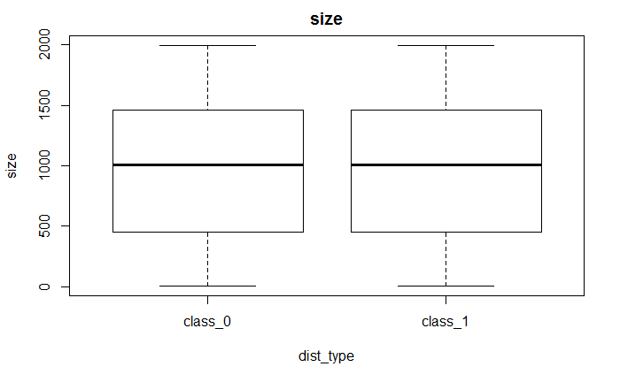

Figure 30 Boxplot for median per dist_type

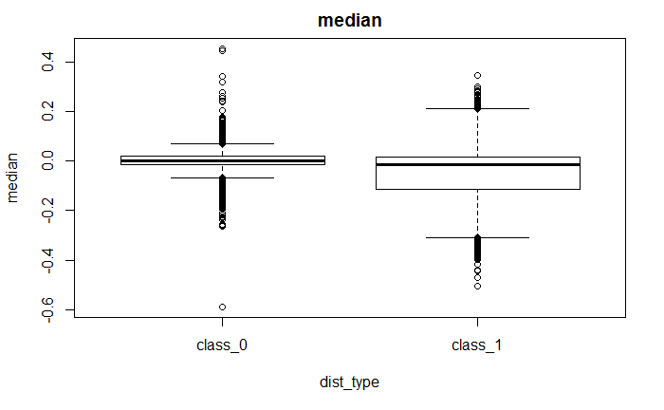

Figure 31 Boxplot for kurtosis per dist_type

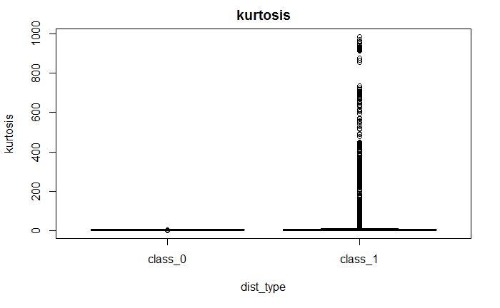

Figure 32 Boxplot for skewness per dist_type

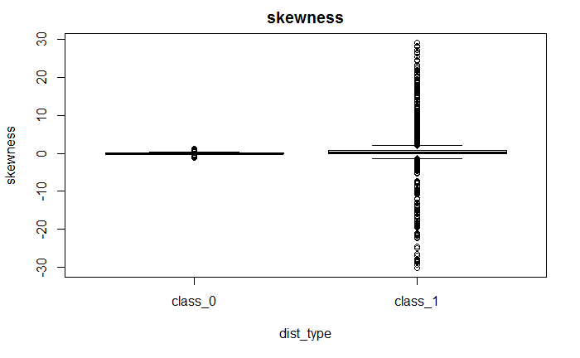

Figure 33 Boxplot for sigma_1_ratio per dist_type

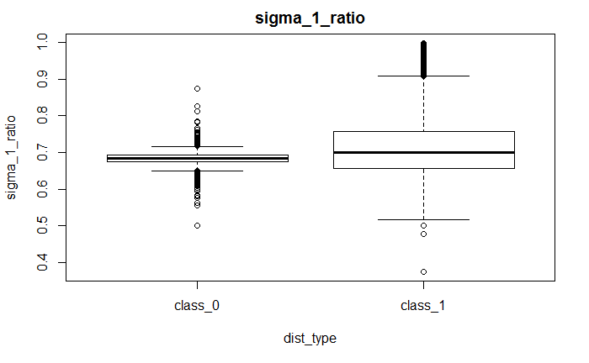

Figure 34 Boxplot for sigma_2_ratio per dist_type

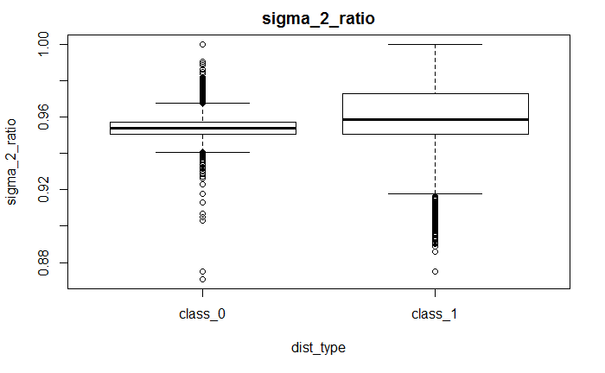

Figure 35 Boxplot for sigma_3_ratio per dist_type

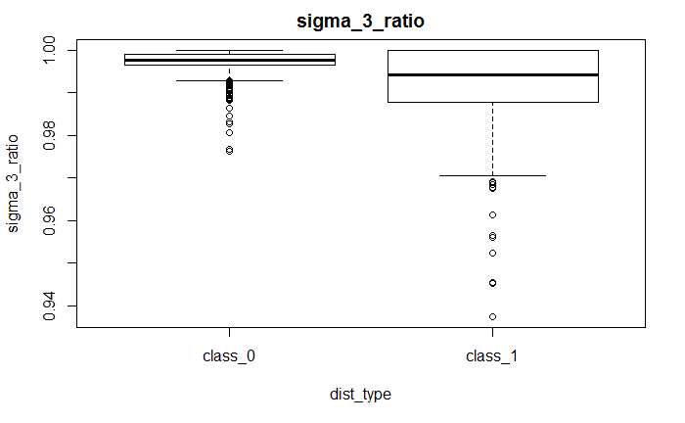

Appendix 3: Tables

Table 14 Sample sizes

|  |  |  |  |  |  |  |  |  |
| --- | --- | --- | --- | --- | --- | --- | --- | --- |
| 8 | 16 | 23 | 31 | 42 | 55 | 65 | 72 | 73 |
| 86 | 91 | 95 | 103 | 129 | 151 | 173 | 178 | 185 |
| 194 | 212 | 214 | 215 | 219 | 246 | 247 | 257 | 265 |
| 266 | 272 | 282 | 284 | 292 | 298 | 306 | 310 | 317 |
| 330 | 332 | 338 | 339 | 360 | 376 | 382 | 390 | 394 |
| 406 | 409 | 428 | 436 | 445 | 464 | 480 | 503 | 504 |
| 525 | 543 | 549 | 552 | 563 | 568 | 578 | 580 | 591 |
| 593 | 602 | 631 | 634 | 654 | 657 | 659 | 664 | 679 |
| 693 | 702 | 718 | 723 | 744 | 761 | 762 | 773 | 775 |
| 788 | 790 | 811 | 825 | 844 | 859 | 902 | 906 | 917 |
| 920 | 933 | 937 | 943 | 954 | 959 | 962 | 963 | 981 |
| 1005 | 1009 | 1010 | 1016 | 1023 | 1024 | 1028 | 1045 | 1047 |
| 1060 | 1064 | 1077 | 1081 | 1087 | 1099 | 1106 | 1113 | 1135 |
| 1137 | 1138 | 1157 | 1174 | 1216 | 1230 | 1231 | 1242 | 1243 |
| 1244 | 1254 | 1256 | 1263 | 1265 | 1269 | 1275 | 1279 | 1297 |
| 1302 | 1317 | 1323 | 1358 | 1361 | 1369 | 1376 | 1398 | 1404 |
| 1405 | 1420 | 1440 | 1444 | 1445 | 1460 | 1470 | 1489 | 1512 |
| 1525 | 1536 | 1565 | 1594 | 1599 | 1613 | 1621 | 1625 | 1688 |
| 1697 | 1698 | 1703 | 1721 | 1724 | 1730 | 1738 | 1746 | 1773 |
| 1783 | 1800 | 1811 | 1815 | 1833 | 1841 | 1845 | 1847 | 1867 |
| 1870 | 1881 | 1892 | 1895 | 1901 | 1904 | 1907 | 1908 | 1910 |
| 1914 | 1924 | 1929 | 1933 | 1942 | 1955 | 1959 | 1960 | 1987 |
| 1995 | 1998 |  |  |  |  |  |  |  |

Table 15: FN instances with lowest score from validation set on rf model

|  |  |  |  |  |  |  |  |  |  |
| --- | --- | --- | --- | --- | --- | --- | --- | --- | --- |
| **Distribution family** | **distribution** | **size** | **median** | **skewness** | **kurtosis** | **Sigma 1 ratio** | **Sigma 2 ratio** | **Sigma 3 ratio** | **score** |
| sym_short_tail | truncatednormal (2,2) | 1895 | 0.009 | 0.008 | 2.982 | 0.678 | 0.955 | 0.998 | 0.014 |
| sym_short_tail | truncatednormal (2,2) | 1724 | -0.004 | 0.025 | 2.958 | 0.684 | 0.955 | 0.997 | 0.026 |
| sym_short_tail | truncatednormal (2,2) | 1892 | 0.018 | -0.002 | 3.010 | 0.683 | 0.954 | 0.996 | 0.028 |
| sym_short_tail | truncatednormal (2,2) | 844 | -0.014 | 0.068 | 2.914 | 0.692 | 0.953 | 0.999 | 0.032 |
| sym_short_tail | truncatednormal (2,2) | 1243 | -0.010 | 0.061 | 2.990 | 0.683 | 0.957 | 0.998 | 0.032 |
| sym_short_tail | truncatednormal (2,2) | 543 | 0.008 | -0.117 | 3.080 | 0.680 | 0.948 | 0.998 | 0.034 |
| sym_short_tail | truncatednormal (2,2) | 552 | 0.000 | -0.042 | 2.853 | 0.672 | 0.951 | 1.000 | 0.038 |
| sym_short_tail | truncatednormal (2,2) | 1525 | 0.019 | -0.078 | 2.971 | 0.679 | 0.950 | 0.997 | 0.042 |
| sym_short_tail | truncatednormal (2,2) | 1621 | 0.011 | -0.050 | 2.995 | 0.682 | 0.958 | 0.998 | 0.042 |
| sym_short_tail | truncatednormal (2,2) | 1077 | 0.032 | -0.080 | 3.011 | 0.685 | 0.948 | 0.998 | 0.048 |
| sym_short_tail | truncatednormal (2,2) | 1995 | 0.010 | -0.024 | 2.960 | 0.695 | 0.951 | 0.999 | 0.05 |
| sym_short_tail | truncatednormal (2,2) | 679 | 0.017 | 0.075 | 3.199 | 0.700 | 0.951 | 0.996 | 0.052 |
| sym_short_tail | truncatednormal (2,2) | 1323 | -0.007 | -0.115 | 3.091 | 0.683 | 0.953 | 0.996 | 0.052 |
| sym_short_tail | truncatednormal (2,2) | 654 | -0.009 | -0.038 | 2.948 | 0.680 | 0.951 | 1.000 | 0.054 |
| close_normal | tukey(0.2) | 409 | 0.054 | -0.145 | 2.914 | 0.675 | 0.963 | 0.998 | 0.058 |
| close_normal | tukey(0.2) | 811 | -0.012 | 0.030 | 3.022 | 0.692 | 0.956 | 0.998 | 0.064 |
| sym_short_tail | truncatednormal (2,2) | 1698 | -0.013 | 0.078 | 2.975 | 0.674 | 0.953 | 0.998 | 0.068 |
| sym_short_tail | truncatednormal (2,2) | 1064 | 0.025 | 0.001 | 3.054 | 0.685 | 0.949 | 0.997 | 0.074 |
| sym_short_tail | truncatednormal (2,2) | 360 | -0.059 | 0.014 | 3.041 | 0.681 | 0.953 | 0.997 | 0.082 |
| sym_short_tail | truncatednormal (2,2) | 659 | 0.020 | 0.035 | 2.889 | 0.684 | 0.959 | 0.998 | 0.084 |

Table 16: Overall tests power on 1% significance level

|  |  |  |  |  |  |  |  |  |
| --- | --- | --- | --- | --- | --- | --- | --- | --- |
| Size | new_test | SW | AD | CVM | JB | KS | Lillie | SF |
| 10 | **0.39** | 0.11 | 0.11 | 0.11 | 0.05 | 0 | 0.09 | 0.11 |
| 30 | **0.5** | 0.26 | 0.25 | 0.24 | 0.22 | 0.06 | 0.21 | 0.26 |
| 50 | **0.59** | 0.38 | 0.34 | 0.32 | 0.29 | 0.12 | 0.27 | 0.35 |
| 100 | **0.71** | 0.6 | 0.53 | 0.48 | 0.41 | 0.18 | 0.38 | 0.54 |
| 200 | **0.79** | 0.76 | 0.71 | 0.67 | 0.67 | 0.23 | 0.57 | 0.74 |
| 500 | **0.86** | 0.85 | 0.83 | 0.81 | 0.82 | 0.44 | 0.77 | 0.85 |
| 1000 | **0.89** | 0.88 | 0.86 | 0.86 | 0.84 | 0.67 | 0.83 | 0.88 |

Table 17: Overall tests power on 5% significance level

|  |  |  |  |  |  |  |  |  |
| --- | --- | --- | --- | --- | --- | --- | --- | --- |
| Size | new_test | SW | AD | CVM | JB | KS | Lillie | SF |
| 10 | **0.78** | 0.19 | 0.19 | 0.19 | 0.08 | 0.02 | 0.17 | 0.2 |
| 30 | **0.73** | 0.39 | 0.37 | 0.34 | 0.26 | 0.11 | 0.3 | 0.36 |
| 50 | **0.76** | 0.53 | 0.48 | 0.45 | 0.35 | 0.17 | 0.38 | 0.48 |
| 100 | **0.83** | 0.71 | 0.66 | 0.62 | 0.55 | 0.22 | 0.53 | 0.67 |
| 200 | **0.87** | 0.82 | 0.79 | 0.76 | 0.77 | 0.32 | 0.7 | 0.81 |
| 500 | **0.89** | 0.87 | 0.86 | 0.85 | 0.84 | 0.6 | 0.83 | 0.87 |
| 1000 | **0.91** | 0.9 | 0.88 | 0.88 | 0.86 | 0.77 | 0.86 | 0.89 |

Table 18: Overall tests power on 10% significance level

|  |  |  |  |  |  |  |  |  |
| --- | --- | --- | --- | --- | --- | --- | --- | --- |
| Size | new_test | SW | AD | CVM | JB | KS | Lillie | SF |
| 10 | **0.91** | 0.26 | 0.27 | 0.26 | 0.1 | 0.03 | 0.24 | 0.27 |
| 30 | **0.86** | 0.48 | 0.46 | 0.43 | 0.3 | 0.14 | 0.38 | 0.45 |
| 50 | **0.86** | 0.61 | 0.56 | 0.52 | 0.4 | 0.2 | 0.46 | 0.57 |
| 100 | **0.89** | 0.76 | 0.72 | 0.69 | 0.65 | 0.26 | 0.62 | 0.74 |
| 200 | **0.9** | 0.84 | 0.82 | 0.8 | 0.8 | 0.41 | 0.76 | 0.84 |
| 500 | **0.91** | 0.89 | 0.87 | 0.87 | 0.85 | 0.69 | 0.85 | 0.89 |
| 1000 | **0.92** | 0.91 | 0.9 | 0.89 | 0.88 | 0.8 | 0.88 | 0.91 |

Table 19: Tests power per distribution at 1% significance level

| Family | Distribution | Size | new_test | SW | AD | CVM | JB | KS | Lillie | SF |
| --- | --- | --- | --- | --- | --- | --- | --- | --- | --- | --- |
| CTN | laplace(0,10) | 10.00 | **0.32** | 0.05 | 0.07 | 0.06 | 0.02 | 0.00 | 0.05 | 0.07 |
|  |  | 30.00 | **0.55** | 0.19 | 0.18 | 0.20 | 0.27 | 0.00 | 0.15 | 0.25 |
|  |  | 50.00 | **0.68** | 0.35 | 0.35 | 0.33 | 0.38 | 0.00 | 0.22 | 0.39 |
|  |  | 100.00 | **0.88** | 0.66 | 0.66 | 0.67 | 0.68 | 0.01 | 0.46 | 0.68 |
|  |  | 200.00 | **0.98** | 0.92 | 0.95 | 0.93 | 0.93 | 0.08 | 0.84 | 0.94 |
|  |  | 500.00 | **1.00** | **1.00** | **1.00** | **1.00** | **1.00** | 0.68 | **1.00** | **1.00** |
|  |  | 1000.00 | **1.00** | **1.00** | **1.00** | **1.00** | **1.00** | **1.00** | **1.00** | **1.00** |
|  |  | Size | new_test | SW | AD | CVM | JB | KS | Lillie | SF |
| CTN | t(10) | 10.00 | **0.28** | 0.01 | 0.02 | 0.02 | 0.01 | 0.00 | 0.01 | 0.02 |
|  |  | 30.00 | **0.29** | 0.06 | 0.03 | 0.03 | 0.09 | 0.00 | 0.02 | 0.07 |
|  |  | 50.00 | **0.34** | 0.08 | 0.04 | 0.04 | 0.14 | 0.00 | 0.02 | 0.07 |
|  |  | 100.00 | **0.44** | 0.14 | 0.06 | 0.06 | 0.21 | 0.00 | 0.03 | 0.16 |
|  |  | 200.00 | **0.58** | 0.20 | 0.11 | 0.08 | 0.32 | 0.00 | 0.04 | 0.28 |
|  |  | 500.00 | **0.80** | 0.47 | 0.27 | 0.19 | 0.64 | 0.00 | 0.10 | 0.54 |
|  |  | 1000.00 | 0.88 | 0.79 | 0.57 | 0.46 | **0.89** | 0.00 | 0.22 | 0.84 |
|  |  | Size | new_test | SW | AD | CVM | JB | KS | Lillie | SF |
| CTN | tukey(0.1) | 10.00 | **0.29** | 0.02 | 0.01 | 0.01 | 0.00 | 0.00 | 0.01 | 0.01 |
|  |  | 30.00 | **0.20** | 0.02 | 0.02 | 0.01 | 0.02 | 0.00 | 0.02 | 0.02 |
|  |  | 50.00 | **0.19** | 0.01 | 0.01 | 0.01 | 0.04 | 0.00 | 0.02 | 0.02 |
|  |  | 100.00 | **0.22** | 0.02 | 0.02 | 0.01 | 0.04 | 0.00 | 0.01 | 0.04 |
|  |  | 200.00 | **0.22** | 0.03 | 0.02 | 0.01 | 0.06 | 0.00 | 0.02 | 0.02 |
|  |  | 500.00 | **0.20** | 0.04 | 0.04 | 0.02 | 0.10 | 0.00 | 0.02 | 0.06 |
|  |  | 1000.00 | **0.11** | 0.08 | 0.04 | 0.04 | 0.12 | 0.00 | 0.03 | 0.07 |
|  |  | Size | new_test | SW | AD | CVM | JB | KS | Lillie | SF |
| CTN | tukey(0.2) | 10.00 | **0.27** | 0.01 | 0.00 | 0.00 | 0.00 | 0.00 | 0.01 | 0.01 |
|  |  | 30.00 | **0.14** | 0.00 | 0.01 | 0.01 | 0.00 | 0.00 | 0.00 | 0.00 |
|  |  | 50.00 | **0.08** | 0.01 | 0.01 | 0.01 | 0.00 | 0.00 | 0.00 | 0.00 |
|  |  | 100.00 | **0.06** | 0.00 | 0.01 | 0.01 | 0.00 | 0.00 | 0.00 | 0.00 |
|  |  | 200.00 | **0.04** | 0.01 | 0.01 | 0.01 | 0.00 | 0.00 | 0.01 | 0.00 |
|  |  | 500.00 | **0.04** | 0.03 | 0.03 | 0.03 | 0.00 | 0.00 | 0.01 | 0.01 |
|  |  | 1000.00 | **0.46** | 0.11 | 0.06 | 0.04 | 0.05 | 0.00 | 0.02 | 0.03 |
|  |  | Size | new_test | SW | AD | CVM | JB | KS | Lillie | SF |
| CTN | tukey(5) | 10.00 | **0.27** | 0.03 | 0.02 | 0.03 | 0.00 | 0.00 | 0.01 | 0.02 |
|  |  | 30.00 | **0.11** | 0.01 | 0.04 | 0.06 | 0.01 | 0.00 | 0.04 | 0.02 |
|  |  | 50.00 | 0.06 | 0.02 | 0.08 | **0.12** | 0.00 | 0.00 | 0.06 | 0.01 |
|  |  | 100.00 | 0.05 | 0.12 | 0.27 | **0.29** | 0.00 | 0.00 | 0.22 | 0.06 |
|  |  | 200.00 | 0.23 | 0.53 | **0.69** | **0.69** | 0.00 | 0.00 | 0.52 | 0.32 |
|  |  | 500.00 | 0.66 | **1.00** | **1.00** | **1.00** | 0.00 | 0.21 | 0.97 | 0.99 |
|  |  | 1000.00 | 0.85 | **1.00** | **1.00** | **1.00** | 0.00 | 0.87 | **1.00** | **1.00** |
|  |  | Size | new_test | SW | AD | CVM | JB | KS | Lillie | SF |
| CTN | Average CTN | 10.00 | **0.29** | 0.02 | 0.02 | 0.02 | 0.01 | 0.00 | 0.02 | 0.03 |
|  |  | 30.00 | **0.26** | 0.06 | 0.06 | 0.06 | 0.08 | 0.00 | 0.05 | 0.07 |
|  |  | 50.00 | **0.27** | 0.09 | 0.10 | 0.10 | 0.11 | 0.00 | 0.06 | 0.10 |
|  |  | 100.00 | **0.33** | 0.19 | 0.20 | 0.21 | 0.19 | 0.00 | 0.14 | 0.19 |
|  |  | 200.00 | **0.41** | 0.34 | 0.36 | 0.34 | 0.26 | 0.02 | 0.29 | 0.31 |
|  |  | 500.00 | **0.54** | 0.51 | 0.47 | 0.45 | 0.35 | 0.18 | 0.42 | 0.52 |
|  |  | 1000.00 | **0.66** | 0.60 | 0.53 | 0.51 | 0.41 | 0.37 | 0.45 | 0.59 |
|  |  | Size | new_test | SW | AD | CVM | JB | KS | Lillie | SF |
| ALT | chisquared(10) | 10.00 | **0.37** | 0.04 | 0.04 | 0.03 | 0.01 | 0.00 | 0.03 | 0.04 |
|  |  | 30.00 | **0.50** | 0.19 | 0.14 | 0.11 | 0.14 | 0.00 | 0.08 | 0.17 |
|  |  | 50.00 | **0.69** | 0.38 | 0.25 | 0.20 | 0.29 | 0.00 | 0.15 | 0.32 |
|  |  | 100.00 | **0.93** | 0.78 | 0.60 | 0.50 | 0.61 | 0.00 | 0.35 | 0.73 |
|  |  | 200.00 | **1.00** | 0.99 | 0.94 | 0.88 | 0.95 | 0.03 | 0.71 | 0.98 |
|  |  | 500.00 | **1.00** | **1.00** | **1.00** | **1.00** | **1.00** | 0.51 | **1.00** | **1.00** |
|  |  | 1000.00 | **1.00** | **1.00** | **1.00** | **1.00** | **1.00** | 0.98 | **1.00** | **1.00** |
|  |  | Size | new_test | SW | AD | CVM | JB | KS | Lillie | SF |
| ALT | chisquared(4) | 10.00 | **0.47** | 0.10 | 0.09 | 0.07 | 0.03 | 0.00 | 0.05 | 0.10 |
|  |  | 30.00 | **0.65** | 0.52 | 0.44 | 0.37 | 0.35 | 0.00 | 0.25 | 0.46 |
|  |  | 50.00 | **0.90** | 0.83 | 0.74 | 0.66 | 0.62 | 0.01 | 0.44 | 0.78 |
|  |  | 100.00 | **1.00** | **1.00** | 0.99 | 0.96 | 0.95 | 0.07 | 0.83 | **1.00** |
|  |  | 200.00 | **1.00** | **1.00** | **1.00** | **1.00** | **1.00** | 0.50 | 0.99 | **1.00** |
|  |  | 500.00 | **1.00** | **1.00** | **1.00** | **1.00** | **1.00** | **1.00** | **1.00** | **1.00** |
|  |  | 1000.00 | **1.00** | **1.00** | **1.00** | **1.00** | **1.00** | **1.00** | **1.00** | **1.00** |
|  |  | Size | new_test | SW | AD | CVM | JB | KS | Lillie | SF |
| ALT | lognormal(0,1) | 10.00 | **0.61** | 0.43 | 0.38 | 0.37 | 0.19 | 0.00 | 0.30 | 0.38 |
|  |  | 30.00 | 0.92 | **0.97** | 0.95 | 0.94 | 0.81 | 0.14 | 0.81 | 0.95 |
|  |  | 50.00 | 0.99 | **1.00** | **1.00** | **1.00** | 0.98 | 0.50 | 0.98 | **1.00** |
|  |  | 100.00 | **1.00** | **1.00** | **1.00** | **1.00** | **1.00** | 0.95 | **1.00** | **1.00** |
|  |  | 200.00 | **1.00** | **1.00** | **1.00** | **1.00** | **1.00** | **1.00** | **1.00** | **1.00** |
|  |  | 500.00 | **1.00** | **1.00** | **1.00** | **1.00** | **1.00** | **1.00** | **1.00** | **1.00** |
|  |  | 1000.00 | **1.00** | **1.00** | **1.00** | **1.00** | **1.00** | **1.00** | **1.00** | **1.00** |
|  |  | Size | new_test | SW | AD | CVM | JB | KS | Lillie | SF |
| ALT | Weibull(0.5,1) | 10.00 | 0.70 | **0.78** | 0.74 | 0.69 | 0.33 | 0.00 | 0.56 | 0.69 |
|  |  | 30.00 | 0.98 | **1.00** | **1.00** | **1.00** | 0.97 | 0.60 | **1.00** | **1.00** |
|  |  | 50.00 | **1.00** | **1.00** | **1.00** | **1.00** | **1.00** | 0.98 | **1.00** | **1.00** |
|  |  | 100.00 | **1.00** | **1.00** | **1.00** | **1.00** | **1.00** | **1.00** | **1.00** | **1.00** |
|  |  | 200.00 | **1.00** | **1.00** | **1.00** | **1.00** | **1.00** | **1.00** | **1.00** | **1.00** |
|  |  | 500.00 | **1.00** | **1.00** | **1.00** | **1.00** | **1.00** | **1.00** | **1.00** | **1.00** |
|  |  | 1000.00 | **1.00** | **1.00** | **1.00** | **1.00** | **1.00** | **1.00** | **1.00** | **1.00** |
|  |  | Size | new_test | SW | AD | CVM | JB | KS | Lillie | SF |
| ALT | Weibull(2,1) | 10.00 | **0.34** | 0.02 | 0.02 | 0.01 | 0.00 | 0.00 | 0.02 | 0.02 |
|  |  | 30.00 | **0.39** | 0.07 | 0.07 | 0.05 | 0.06 | 0.00 | 0.04 | 0.08 |
|  |  | 50.00 | **0.52** | 0.16 | 0.11 | 0.10 | 0.11 | 0.00 | 0.06 | 0.15 |
|  |  | 100.00 | **0.84** | 0.57 | 0.31 | 0.26 | 0.28 | 0.00 | 0.17 | 0.43 |
|  |  | 200.00 | **0.95** | **0.95** | 0.78 | 0.65 | 0.70 | 0.01 | 0.43 | 0.90 |
|  |  | 500.00 | **1.00** | **1.00** | **1.00** | 0.99 | **1.00** | 0.14 | 0.92 | **1.00** |
|  |  | 1000.00 | **1.00** | **1.00** | **1.00** | **1.00** | **1.00** | 0.71 | **1.00** | **1.00** |
|  |  | Size | new_test | SW | AD | CVM | JB | KS | Lillie | SF |
| ALT | Average ALT | 10.00 | **0.50** | 0.27 | 0.25 | 0.23 | 0.11 | 0.00 | 0.19 | 0.25 |
|  |  | 30.00 | **0.69** | 0.55 | 0.52 | 0.49 | 0.47 | 0.15 | 0.44 | 0.53 |
|  |  | 50.00 | **0.82** | 0.67 | 0.62 | 0.59 | 0.60 | 0.30 | 0.53 | 0.65 |
|  |  | 100.00 | **0.95** | 0.87 | 0.78 | 0.74 | 0.77 | 0.40 | 0.67 | 0.83 |
|  |  | 200.00 | **0.99** | **0.99** | 0.94 | 0.91 | 0.93 | 0.51 | 0.83 | 0.98 |
|  |  | 500.00 | **1.00** | **1.00** | **1.00** | **1.00** | **1.00** | 0.73 | 0.98 | **1.00** |
|  |  | 1000.00 | **1.00** | **1.00** | **1.00** | **1.00** | **1.00** | 0.94 | **1.00** | **1.00** |
|  |  | Size | new_test | SW | AD | CVM | JB | KS | Lillie | SF |
| AST | beta(2,1) | 10.00 | **0.30** | 0.02 | 0.03 | 0.03 | 0.00 | 0.00 | 0.03 | 0.03 |
|  |  | 30.00 | **0.26** | 0.22 | 0.18 | 0.16 | 0.02 | 0.00 | 0.09 | 0.12 |
|  |  | 50.00 | 0.28 | **0.52** | 0.44 | 0.34 | 0.03 | 0.00 | 0.20 | 0.34 |
|  |  | 100.00 | 0.44 | **0.98** | 0.91 | 0.78 | 0.17 | 0.00 | 0.56 | 0.90 |
|  |  | 200.00 | 0.67 | **1.00** | **1.00** | 0.99 | 0.99 | 0.11 | 0.96 | **1.00** |
|  |  | 500.00 | 0.87 | **1.00** | **1.00** | **1.00** | **1.00** | 0.95 | **1.00** | **1.00** |
|  |  | 1000.00 | **1.00** | **1.00** | **1.00** | **1.00** | **1.00** | **1.00** | **1.00** | **1.00** |
|  |  | Size | new_test | SW | AD | CVM | JB | KS | Lillie | SF |
| AST | beta(3,2) | 10.00 | **0.29** | 0.01 | 0.01 | 0.01 | 0.00 | 0.00 | 0.01 | 0.01 |
|  |  | 30.00 | **0.21** | 0.02 | 0.02 | 0.02 | 0.00 | 0.00 | 0.02 | 0.01 |
|  |  | 50.00 | **0.21** | 0.04 | 0.05 | 0.03 | 0.00 | 0.00 | 0.02 | 0.02 |
|  |  | 100.00 | **0.39** | 0.20 | 0.16 | 0.12 | 0.00 | 0.00 | 0.08 | 0.08 |
|  |  | 200.00 | 0.65 | **0.73** | 0.54 | 0.37 | 0.10 | 0.00 | 0.22 | 0.51 |
|  |  | 500.00 | 0.94 | **1.00** | 0.99 | 0.95 | **1.00** | 0.02 | 0.73 | **1.00** |
|  |  | 1000.00 | **1.00** | **1.00** | **1.00** | **1.00** | **1.00** | 0.29 | 0.99 | **1.00** |
|  |  | Size | new_test | SW | AD | CVM | JB | KS | Lillie | SF |
| AST | lognormal(0,0.15) | 10.00 | **0.30** | 0.02 | 0.02 | 0.01 | 0.00 | 0.00 | 0.02 | 0.01 |
|  |  | 30.00 | **0.31** | 0.04 | 0.04 | 0.04 | 0.06 | 0.00 | 0.02 | 0.04 |
|  |  | 50.00 | **0.36** | 0.10 | 0.05 | 0.05 | 0.09 | 0.00 | 0.03 | 0.08 |
|  |  | 100.00 | **0.59** | 0.19 | 0.12 | 0.08 | 0.18 | 0.00 | 0.07 | 0.18 |
|  |  | 200.00 | **0.71** | 0.39 | 0.25 | 0.20 | 0.36 | 0.00 | 0.17 | 0.38 |
|  |  | 500.00 | **0.90** | 0.87 | 0.73 | 0.65 | 0.85 | 0.01 | 0.46 | 0.88 |
|  |  | 1000.00 | 0.97 | **1.00** | 0.98 | 0.96 | **1.00** | 0.08 | 0.83 | 0.99 |
|  |  | Size | new_test | SW | AD | CVM | JB | KS | Lillie | SF |
| AST | lognormal(0,0.25) | 10.00 | **0.37** | 0.02 | 0.04 | 0.03 | 0.01 | 0.00 | 0.02 | 0.04 |
|  |  | 30.00 | **0.46** | 0.13 | 0.10 | 0.07 | 0.14 | 0.00 | 0.06 | 0.12 |
|  |  | 50.00 | **0.59** | 0.25 | 0.19 | 0.14 | 0.21 | 0.00 | 0.09 | 0.27 |
|  |  | 100.00 | **0.84** | 0.55 | 0.42 | 0.36 | 0.44 | 0.00 | 0.23 | 0.48 |
|  |  | 200.00 | **0.97** | 0.90 | 0.78 | 0.69 | 0.85 | 0.01 | 0.47 | 0.88 |
|  |  | 500.00 | **1.00** | **1.00** | **1.00** | 0.99 | **1.00** | 0.22 | 0.95 | **1.00** |
|  |  | 1000.00 | **1.00** | **1.00** | **1.00** | **1.00** | **1.00** | 0.82 | **1.00** | **1.00** |
|  |  | Size | new_test | SW | AD | CVM | JB | KS | Lillie | SF |
| AST | lognormal(0,0.35) | 10.00 | **0.38** | 0.06 | 0.05 | 0.04 | 0.02 | 0.00 | 0.03 | 0.05 |
|  |  | 30.00 | **0.57** | 0.25 | 0.17 | 0.16 | 0.24 | 0.00 | 0.12 | 0.27 |
|  |  | 50.00 | **0.78** | 0.47 | 0.38 | 0.30 | 0.41 | 0.00 | 0.22 | 0.48 |
|  |  | 100.00 | **0.97** | 0.87 | 0.75 | 0.67 | 0.77 | 0.01 | 0.48 | 0.80 |
|  |  | 200.00 | **1.00** | **1.00** | 0.99 | 0.96 | 0.99 | 0.09 | 0.87 | **1.00** |
|  |  | 500.00 | **1.00** | **1.00** | **1.00** | **1.00** | **1.00** | 0.78 | **1.00** | **1.00** |
|  |  | 1000.00 | **1.00** | **1.00** | **1.00** | **1.00** | **1.00** | **1.00** | **1.00** | **1.00** |
|  |  | Size | new_test | SW | AD | CVM | JB | KS | Lillie | SF |
| AST | Average AST | 10.00 | **0.33** | 0.03 | 0.03 | 0.02 | 0.01 | 0.00 | 0.02 | 0.03 |
|  |  | 30.00 | **0.36** | 0.13 | 0.10 | 0.09 | 0.09 | 0.00 | 0.06 | 0.11 |
|  |  | 50.00 | **0.44** | 0.28 | 0.22 | 0.17 | 0.15 | 0.00 | 0.11 | 0.24 |
|  |  | 100.00 | **0.65** | 0.56 | 0.47 | 0.40 | 0.31 | 0.00 | 0.28 | 0.49 |
|  |  | 200.00 | **0.80** | **0.80** | 0.71 | 0.64 | 0.66 | 0.04 | 0.54 | 0.75 |
|  |  | 500.00 | 0.94 | **0.97** | 0.94 | 0.92 | **0.97** | 0.40 | 0.83 | 0.98 |
|  |  | 1000.00 | 0.99 | **1.00** | **1.00** | 0.99 | **1.00** | 0.64 | 0.96 | **1.00** |
|  |  | Size | new_test | SW | AD | CVM | JB | KS | Lillie | SF |
| SLT | t(1) | 10.00 | **0.67** | 0.44 | 0.50 | 0.47 | 0.36 | 0.03 | 0.43 | 0.48 |
|  |  | 30.00 | **0.98** | 0.94 | 0.93 | 0.94 | 0.90 | 0.55 | 0.89 | 0.95 |
|  |  | 50.00 | **1.00** | 0.99 | **1.00** | **1.00** | 0.99 | 0.83 | 0.99 | **1.00** |
|  |  | 100.00 | **1.00** | **1.00** | **1.00** | **1.00** | **1.00** | 0.99 | **1.00** | **1.00** |
|  |  | 200.00 | **1.00** | **1.00** | **1.00** | **1.00** | **1.00** | **1.00** | **1.00** | **1.00** |
|  |  | 500.00 | **1.00** | **1.00** | **1.00** | **1.00** | **1.00** | **1.00** | **1.00** | **1.00** |
|  |  | 1000.00 | **1.00** | **1.00** | **1.00** | **1.00** | **1.00** | **1.00** | **1.00** | **1.00** |
|  |  | Size | new_test | SW | AD | CVM | JB | KS | Lillie | SF |
| SLT | t(2) | 10.00 | **0.45** | 0.17 | 0.19 | 0.20 | 0.12 | 0.00 | 0.17 | 0.21 |
|  |  | 30.00 | **0.79** | 0.58 | 0.57 | 0.54 | 0.61 | 0.09 | 0.43 | 0.60 |
|  |  | 50.00 | **0.92** | 0.78 | 0.76 | 0.75 | 0.81 | 0.21 | 0.65 | 0.83 |
|  |  | 100.00 | **0.99** | 0.97 | 0.96 | 0.95 | 0.97 | 0.49 | 0.91 | 0.97 |
|  |  | 200.00 | **1.00** | **1.00** | **1.00** | **1.00** | **1.00** | 0.88 | **1.00** | **1.00** |
|  |  | 500.00 | **1.00** | **1.00** | **1.00** | **1.00** | **1.00** | **1.00** | **1.00** | **1.00** |
|  |  | 1000.00 | **1.00** | **1.00** | **1.00** | **1.00** | **1.00** | **1.00** | **1.00** | **1.00** |
|  |  | Size | new_test | SW | AD | CVM | JB | KS | Lillie | SF |
| SLT | t(4) | 10.00 | **0.33** | 0.06 | 0.04 | 0.05 | 0.03 | 0.00 | 0.06 | 0.07 |
|  |  | 30.00 | **0.51** | 0.20 | 0.15 | 0.14 | 0.26 | 0.00 | 0.10 | 0.24 |
|  |  | 50.00 | **0.64** | 0.34 | 0.24 | 0.24 | 0.41 | 0.02 | 0.17 | 0.37 |
|  |  | 100.00 | **0.86** | 0.57 | 0.49 | 0.45 | 0.69 | 0.02 | 0.32 | 0.64 |
|  |  | 200.00 | **0.97** | 0.86 | 0.80 | 0.72 | 0.92 | 0.08 | 0.58 | 0.88 |
|  |  | 500.00 | **1.00** | **1.00** | **1.00** | 0.99 | **1.00** | 0.36 | 0.94 | **1.00** |
|  |  | 1000.00 | **1.00** | **1.00** | **1.00** | **1.00** | **1.00** | 0.85 | **1.00** | **1.00** |
|  |  | Size | new_test | SW | AD | CVM | JB | KS | Lillie | SF |
| SLT | t(7) | 10.00 | **0.30** | 0.03 | 0.03 | 0.02 | 0.01 | 0.00 | 0.02 | 0.03 |
|  |  | 30.00 | **0.33** | 0.08 | 0.07 | 0.04 | 0.12 | 0.00 | 0.04 | 0.11 |
|  |  | 50.00 | **0.44** | 0.13 | 0.08 | 0.07 | 0.19 | 0.00 | 0.04 | 0.16 |
|  |  | 100.00 | **0.58** | 0.23 | 0.15 | 0.10 | 0.34 | 0.00 | 0.08 | 0.27 |
|  |  | 200.00 | **0.78** | 0.44 | 0.25 | 0.22 | 0.53 | 0.00 | 0.12 | 0.48 |
|  |  | 500.00 | **0.96** | 0.81 | 0.62 | 0.53 | 0.88 | 0.00 | 0.30 | 0.84 |
|  |  | 1000.00 | **1.00** | 0.97 | 0.94 | 0.89 | 0.99 | 0.02 | 0.65 | 0.99 |
|  |  | Size | new_test | SW | AD | CVM | JB | KS | Lillie | SF |
| SLT | tukey(10) | 10.00 | **0.48** | 0.36 | 0.42 | 0.46 | 0.14 | 0.00 | 0.41 | 0.36 |
|  |  | 30.00 | 0.80 | 0.81 | 0.95 | **0.97** | 0.40 | 0.13 | 0.91 | 0.85 |
|  |  | 50.00 | 0.93 | 0.98 | **1.00** | **1.00** | 0.60 | 0.50 | 0.99 | 0.98 |
|  |  | 100.00 | 0.99 | **1.00** | **1.00** | **1.00** | 0.88 | 0.99 | **1.00** | **1.00** |
|  |  | 200.00 | **1.00** | **1.00** | **1.00** | **1.00** | **1.00** | **1.00** | **1.00** | **1.00** |
|  |  | 500.00 | **1.00** | **1.00** | **1.00** | **1.00** | **1.00** | **1.00** | **1.00** | **1.00** |
|  |  | 1000.00 | **1.00** | **1.00** | **1.00** | **1.00** | **1.00** | **1.00** | **1.00** | **1.00** |
|  |  | Size | new_test | SW | AD | CVM | JB | KS | Lillie | SF |
| SLT | Average SLT | 10.00 | **0.45** | 0.21 | 0.24 | 0.24 | 0.13 | 0.01 | 0.22 | 0.23 |
|  |  | 30.00 | **0.68** | 0.52 | 0.53 | 0.53 | 0.46 | 0.15 | 0.47 | 0.55 |
|  |  | 50.00 | **0.79** | 0.64 | 0.62 | 0.61 | 0.60 | 0.31 | 0.57 | 0.67 |
|  |  | 100.00 | **0.88** | 0.75 | 0.72 | 0.70 | 0.78 | 0.50 | 0.66 | 0.78 |
|  |  | 200.00 | **0.95** | 0.86 | 0.81 | 0.79 | 0.89 | 0.59 | 0.74 | 0.87 |
|  |  | 500.00 | **0.99** | 0.96 | 0.92 | 0.90 | 0.98 | 0.67 | 0.85 | 0.97 |
|  |  | 1000.00 | **1.00** | 0.99 | 0.99 | 0.98 | 1.00 | 0.77 | 0.93 | 1.00 |
|  |  | Size | new_test | SW | AD | CVM | JB | KS | Lillie | SF |
| SST | beta(1.3,1.3) | 10.00 | **0.36** | 0.00 | 0.00 | 0.01 | 0.00 | 0.00 | 0.01 | 0.00 |
|  |  | 30.00 | **0.56** | 0.03 | 0.04 | 0.02 | 0.00 | 0.00 | 0.02 | 0.01 |
|  |  | 50.00 | **0.69** | 0.12 | 0.12 | 0.10 | 0.00 | 0.00 | 0.04 | 0.02 |
|  |  | 100.00 | **0.88** | 0.69 | 0.46 | 0.26 | 0.00 | 0.00 | 0.12 | 0.32 |
|  |  | 200.00 | 0.99 | **1.00** | 0.93 | 0.78 | 0.68 | 0.00 | 0.41 | 0.97 |
|  |  | 500.00 | **1.00** | **1.00** | **1.00** | **1.00** | **1.00** | 0.05 | 0.97 | **1.00** |
|  |  | 1000.00 | **1.00** | **1.00** | **1.00** | **1.00** | **1.00** | 0.77 | **1.00** | **1.00** |
|  |  | Size | new_test | SW | AD | CVM | JB | KS | Lillie | SF |
| SST | beta(1.5,1.5) | 10.00 | **0.38** | 0.01 | 0.01 | 0.01 | 0.00 | 0.00 | 0.01 | 0.01 |
|  |  | 30.00 | **0.46** | 0.02 | 0.03 | 0.03 | 0.00 | 0.00 | 0.01 | 0.00 |
|  |  | 50.00 | **0.57** | 0.06 | 0.06 | 0.04 | 0.00 | 0.00 | 0.03 | 0.01 |
|  |  | 100.00 | **0.79** | 0.44 | 0.27 | 0.18 | 0.00 | 0.00 | 0.07 | 0.18 |
|  |  | 200.00 | 0.96 | **0.98** | 0.79 | 0.56 | 0.36 | 0.00 | 0.26 | 0.85 |
|  |  | 500.00 | **1.00** | **1.00** | **1.00** | **1.00** | **1.00** | 0.02 | 0.86 | **1.00** |
|  |  | 1000.00 | **1.00** | **1.00** | **1.00** | **1.00** | **1.00** | 0.45 | **1.00** | **1.00** |
|  |  | Size | new_test | SW | AD | CVM | JB | KS | Lillie | SF |
| SST | truncatednormal(2,2) | 10.00 | **0.30** | 0.01 | 0.01 | 0.01 | 0.00 | 0.00 | 0.01 | 0.01 |
|  |  | 30.00 | **0.18** | 0.01 | 0.01 | 0.01 | 0.02 | 0.00 | 0.01 | 0.01 |
|  |  | 50.00 | **0.14** | 0.01 | 0.01 | 0.01 | 0.02 | 0.00 | 0.01 | 0.01 |
|  |  | 100.00 | **0.14** | 0.01 | 0.01 | 0.01 | 0.02 | 0.00 | 0.01 | 0.01 |
|  |  | 200.00 | **0.10** | 0.01 | 0.01 | 0.01 | 0.01 | 0.00 | 0.01 | 0.01 |
|  |  | 500.00 | **0.05** | 0.01 | 0.01 | 0.02 | 0.02 | 0.00 | 0.01 | 0.01 |
|  |  | 1000.00 | **0.04** | 0.01 | 0.01 | 0.01 | 0.01 | 0.00 | 0.00 | 0.01 |
|  |  | Size | new_test | SW | AD | CVM | JB | KS | Lillie | SF |
| SST | tukey(1.5) | 10.00 | **0.42** | 0.01 | 0.01 | 0.02 | 0.00 | 0.00 | 0.01 | 0.01 |
|  |  | 30.00 | **0.75** | 0.14 | 0.10 | 0.09 | 0.00 | 0.00 | 0.04 | 0.03 |
|  |  | 50.00 | **0.90** | 0.46 | 0.36 | 0.23 | 0.00 | 0.00 | 0.10 | 0.21 |
|  |  | 100.00 | **1.00** | 0.99 | 0.88 | 0.70 | 0.01 | 0.00 | 0.35 | 0.88 |
|  |  | 200.00 | **1.00** | **1.00** | **1.00** | 0.98 | 0.99 | 0.02 | 0.85 | **1.00** |
|  |  | 500.00 | **1.00** | **1.00** | **1.00** | **1.00** | **1.00** | 0.66 | **1.00** | **1.00** |
|  |  | 1000.00 | **1.00** | **1.00** | **1.00** | **1.00** | **1.00** | **1.00** | **1.00** | **1.00** |
|  |  | Size | new_test | SW | AD | CVM | JB | KS | Lillie | SF |
| SST | uniform(0,1) | 10.00 | **0.42** | 0.02 | 0.01 | 0.02 | 0.00 | 0.00 | 0.01 | 0.00 |
|  |  | 30.00 | **0.69** | 0.09 | 0.08 | 0.07 | 0.00 | 0.00 | 0.04 | 0.03 |
|  |  | 50.00 | **0.87** | 0.36 | 0.27 | 0.16 | 0.00 | 0.00 | 0.09 | 0.12 |
|  |  | 100.00 | **0.99** | 0.93 | 0.80 | 0.59 | 0.00 | 0.00 | 0.24 | 0.75 |
|  |  | 200.00 | **1.00** | **1.00** | **1.00** | 0.97 | 0.97 | 0.01 | 0.75 | **1.00** |
|  |  | 500.00 | **1.00** | **1.00** | **1.00** | **1.00** | **1.00** | 0.44 | **1.00** | **1.00** |
|  |  | 1000.00 | **1.00** | **1.00** | **1.00** | **1.00** | **1.00** | **1.00** | **1.00** | **1.00** |
|  |  | Size | new_test | SW | AD | CVM | JB | KS | Lillie | SF |
| SST | Average SST | 10.00 | **0.38** | 0.01 | 0.01 | 0.01 | 0.00 | 0.00 | 0.01 | 0.01 |
|  |  | 30.00 | **0.53** | 0.06 | 0.05 | 0.04 | 0.00 | 0.00 | 0.02 | 0.02 |
|  |  | 50.00 | **0.63** | 0.20 | 0.16 | 0.11 | 0.00 | 0.00 | 0.05 | 0.07 |
|  |  | 100.00 | **0.76** | 0.61 | 0.48 | 0.35 | 0.01 | 0.00 | 0.16 | 0.43 |
|  |  | 200.00 | **0.81** | 0.80 | 0.75 | 0.66 | 0.60 | 0.01 | 0.46 | 0.77 |
|  |  | 500.00 | **0.81** | 0.80 | 0.80 | 0.80 | 0.80 | 0.23 | 0.77 | 0.80 |
|  |  | 1000.00 | **0.81** | 0.80 | 0.80 | 0.80 | 0.80 | 0.64 | 0.80 | 0.80 |

Table 20: Tests power per distribution at 5% significance level

| Family | Distribution | Size | new_test | SW | AD | CVM | JB | KS | Lillie | SF |
| --- | --- | --- | --- | --- | --- | --- | --- | --- | --- | --- |
| CTN | laplace(0,10) | 10 | **0.68** | 0.16 | 0.18 | 0.16 | 0.06 | 0.00 | 0.13 | 0.17 |
|  |  | 30 | **0.69** | 0.35 | 0.37 | 0.36 | 0.36 | 0.02 | 0.28 | 0.43 |
|  |  | 50 | **0.80** | 0.51 | 0.53 | 0.50 | 0.52 | 0.02 | 0.45 | 0.59 |
|  |  | 100 | **0.94** | 0.80 | 0.83 | 0.81 | 0.79 | 0.09 | 0.71 | 0.86 |
|  |  | 200 | **1.00** | 0.97 | 0.99 | 0.98 | 0.97 | 0.33 | 0.94 | 0.99 |
|  |  | 500 | **1.00** | **1.00** | **1.00** | **1.00** | **1.00** | 0.95 | **1.00** | **1.00** |
|  |  | 1000 | **1.00** | **1.00** | **1.00** | **1.00** | **1.00** | **1.00** | **1.00** | **1.00** |
|  |  | Size | new_test | SW | AD | CVM | JB | KS | Lillie | SF |
| CTN | t(10) | 10 | **0.73** | 0.06 | 0.08 | 0.06 | 0.02 | 0.00 | 0.07 | 0.10 |
|  |  | 30 | **0.51** | 0.12 | 0.09 | 0.09 | 0.13 | 0.00 | 0.09 | 0.15 |
|  |  | 50 | **0.49** | 0.14 | 0.11 | 0.12 | 0.17 | 0.00 | 0.08 | 0.20 |
|  |  | 100 | **0.63** | 0.24 | 0.15 | 0.13 | 0.30 | 0.00 | 0.10 | 0.28 |
|  |  | 200 | **0.76** | 0.36 | 0.24 | 0.21 | 0.46 | 0.00 | 0.16 | 0.42 |
|  |  | 500 | **0.87** | 0.64 | 0.48 | 0.42 | 0.75 | 0.00 | 0.29 | 0.73 |
|  |  | 1000 | 0.92 | 0.90 | 0.76 | 0.69 | **0.95** | 0.03 | 0.51 | 0.91 |
|  |  | Size | new_test | SW | AD | CVM | JB | KS | Lillie | SF |
| CTN | tukey(0.1) | 10 | **0.69** | 0.06 | 0.06 | 0.06 | 0.01 | 0.00 | 0.05 | 0.07 |
|  |  | 30 | **0.46** | 0.07 | 0.06 | 0.06 | 0.06 | 0.00 | 0.06 | 0.07 |
|  |  | 50 | **0.43** | 0.07 | 0.05 | 0.05 | 0.06 | 0.00 | 0.05 | 0.08 |
|  |  | 100 | **0.44** | 0.10 | 0.07 | 0.07 | 0.10 | 0.00 | 0.05 | 0.09 |
|  |  | 200 | **0.43** | 0.09 | 0.08 | 0.07 | 0.12 | 0.00 | 0.06 | 0.11 |
|  |  | 500 | **0.34** | 0.11 | 0.12 | 0.10 | 0.16 | 0.00 | 0.08 | 0.16 |
|  |  | 1000 | 0.23 | 0.18 | 0.15 | 0.12 | **0.25** | 0.00 | 0.11 | 0.24 |
|  |  | Size | new_test | SW | AD | CVM | JB | KS | Lillie | SF |
| CTN | tukey(0.2) | 10 | **0.70** | 0.05 | 0.05 | 0.04 | 0.01 | 0.00 | 0.04 | 0.05 |
|  |  | 30 | **0.44** | 0.03 | 0.05 | 0.05 | 0.00 | 0.00 | 0.04 | 0.03 |
|  |  | 50 | **0.30** | 0.05 | 0.04 | 0.05 | 0.01 | 0.00 | 0.04 | 0.03 |
|  |  | 100 | **0.30** | 0.04 | 0.05 | 0.05 | 0.00 | 0.00 | 0.06 | 0.02 |
|  |  | 200 | **0.26** | 0.05 | 0.06 | 0.04 | 0.01 | 0.00 | 0.05 | 0.02 |
|  |  | 500 | **0.28** | 0.11 | 0.09 | 0.09 | 0.07 | 0.00 | 0.07 | 0.05 |
|  |  | 1000 | **0.65** | 0.29 | 0.20 | 0.17 | 0.27 | 0.00 | 0.11 | 0.17 |
|  |  | Size | new_test | SW | AD | CVM | JB | KS | Lillie | SF |
| CTN | tukey(5) | 10 | **0.66** | 0.06 | 0.09 | 0.10 | 0.02 | 0.00 | 0.10 | 0.09 |
|  |  | 30 | **0.40** | 0.07 | 0.15 | 0.17 | 0.02 | 0.00 | 0.13 | 0.07 |
|  |  | 50 | **0.34** | 0.13 | 0.24 | 0.27 | 0.01 | 0.00 | 0.23 | 0.11 |
|  |  | 100 | 0.37 | 0.36 | 0.53 | **0.56** | 0.00 | 0.01 | 0.43 | 0.26 |
|  |  | 200 | 0.53 | **0.89** | 0.88 | 0.86 | 0.00 | 0.08 | 0.77 | 0.74 |
|  |  | 500 | 0.77 | **1.00** | **1.00** | **1.00** | 0.00 | 0.61 | **1.00** | **1.00** |
|  |  | 1000 | 0.96 | **1.00** | **1.00** | **1.00** | 0.00 | 0.99 | **1.00** | **1.00** |
|  |  | Size | new_test | SW | AD | CVM | JB | KS | Lillie | SF |
| CTN | Average CTN | 10 | **0.69** | 0.08 | 0.09 | 0.08 | 0.02 | 0.00 | 0.08 | 0.10 |
|  |  | 30 | **0.50** | 0.13 | 0.14 | 0.15 | 0.11 | 0.00 | 0.12 | 0.15 |
|  |  | 50 | **0.47** | 0.18 | 0.19 | 0.20 | 0.15 | 0.00 | 0.17 | 0.20 |
|  |  | 100 | **0.54** | 0.31 | 0.33 | 0.32 | 0.24 | 0.02 | 0.27 | 0.30 |
|  |  | 200 | **0.60** | 0.47 | 0.45 | 0.43 | 0.31 | 0.08 | 0.40 | 0.46 |
|  |  | 500 | **0.65** | 0.57 | 0.54 | 0.52 | 0.40 | 0.31 | 0.49 | 0.59 |
|  |  | 1000 | **0.75** | 0.67 | 0.62 | 0.60 | 0.49 | 0.40 | 0.55 | 0.66 |
|  |  | Size | new_test | SW | AD | CVM | JB | KS | Lillie | SF |
| ALT | chisquared(10) | 10 | **0.82** | 0.12 | 0.10 | 0.10 | 0.04 | 0.00 | 0.08 | 0.11 |
|  |  | 30 | **0.80** | 0.36 | 0.33 | 0.28 | 0.24 | 0.00 | 0.20 | 0.32 |
|  |  | 50 | **0.88** | 0.56 | 0.47 | 0.40 | 0.44 | 0.02 | 0.33 | 0.57 |
|  |  | 100 | **0.99** | 0.90 | 0.80 | 0.73 | 0.80 | 0.06 | 0.61 | 0.88 |
|  |  | 200 | **1.00** | **1.00** | 0.99 | 0.96 | 0.99 | 0.20 | 0.89 | **1.00** |
|  |  | 500 | **1.00** | **1.00** | **1.00** | **1.00** | **1.00** | 0.86 | **1.00** | **1.00** |
|  |  | 1000 | **1.00** | **1.00** | **1.00** | **1.00** | **1.00** | **1.00** | **1.00** | **1.00** |
|  |  | Size | new_test | SW | AD | CVM | JB | KS | Lillie | SF |
| ALT | chisquared(4) | 10 | **0.87** | 0.22 | 0.22 | 0.23 | 0.07 | 0.00 | 0.16 | 0.25 |
|  |  | 30 | **0.94** | 0.76 | 0.67 | 0.59 | 0.48 | 0.02 | 0.49 | 0.68 |
|  |  | 50 | **0.97** | 0.96 | 0.90 | 0.83 | 0.75 | 0.08 | 0.71 | 0.92 |
|  |  | 100 | **1.00** | **1.00** | **1.00** | 0.99 | 0.99 | 0.36 | 0.96 | **1.00** |
|  |  | 200 | **1.00** | **1.00** | **1.00** | **1.00** | **1.00** | 0.87 | **1.00** | **1.00** |
|  |  | 500 | **1.00** | **1.00** | **1.00** | **1.00** | **1.00** | **1.00** | **1.00** | **1.00** |
|  |  | 1000 | **1.00** | **1.00** | **1.00** | **1.00** | **1.00** | **1.00** | **1.00** | **1.00** |
|  |  | Size | new_test | SW | AD | CVM | JB | KS | Lillie | SF |
| ALT | lognormal(0,1) | 10 | **0.91** | 0.59 | 0.58 | 0.54 | 0.27 | 0.03 | 0.47 | 0.59 |
|  |  | 30 | **1.00** | 0.99 | 0.97 | 0.98 | 0.92 | 0.41 | 0.93 | 0.99 |
|  |  | 50 | **1.00** | **1.00** | **1.00** | **1.00** | 0.99 | 0.80 | **0.99** | **1.00** |
|  |  | 100 | **1.00** | **1.00** | **1.00** | **1.00** | **1.00** | **1.00** | **1.00** | **1.00** |
|  |  | 200 | **1.00** | **1.00** | **1.00** | **1.00** | **1.00** | **1.00** | **1.00** | **1.00** |
|  |  | 500 | **1.00** | **1.00** | **1.00** | **1.00** | **1.00** | **1.00** | **1.00** | **1.00** |
|  |  | 1000 | **1.00** | **1.00** | **1.00** | **1.00** | **1.00** | **1.00** | **1.00** | **1.00** |
|  |  | Size | new_test | SW | AD | CVM | JB | KS | Lillie | SF |
| ALT | Weibull(0.5,1) | 10 | **0.96** | 0.89 | 0.86 | 0.86 | 0.44 | 0.09 | 0.75 | 0.89 |
|  |  | 30 | **1.00** | **1.00** | **1.00** | **1.00** | 0.99 | 0.90 | **1.00** | **1.00** |
|  |  | 50 | **1.00** | **1.00** | **1.00** | **1.00** | **1.00** | **1.00** | **1.00** | **1.00** |
|  |  | 100 | **1.00** | **1.00** | **1.00** | **1.00** | **1.00** | **1.00** | **1.00** | **1.00** |
|  |  | 200 | **1.00** | **1.00** | **1.00** | **1.00** | **1.00** | **1.00** | **1.00** | **1.00** |
|  |  | 500 | **1.00** | **1.00** | **1.00** | **1.00** | **1.00** | **1.00** | **1.00** | **1.00** |
|  |  | 1000 | **1.00** | **1.00** | **1.00** | **1.00** | **1.00** | **1.00** | **1.00** | **1.00** |
|  |  | Size | new_test | SW | AD | CVM | JB | KS | Lillie | SF |
| ALT | Weibull(2,1) | 10 | **0.79** | 0.08 | 0.08 | 0.07 | 0.02 | 0.00 | 0.06 | 0.09 |
|  |  | 30 | **0.72** | 0.22 | 0.18 | 0.14 | 0.12 | 0.00 | 0.12 | 0.19 |
|  |  | 50 | **0.80** | 0.42 | 0.34 | 0.27 | 0.22 | 0.00 | 0.19 | 0.34 |
|  |  | 100 | **0.97** | 0.80 | 0.62 | 0.51 | 0.48 | 0.01 | 0.40 | 0.68 |
|  |  | 200 | **1.00** | 0.99 | 0.94 | 0.86 | 0.94 | 0.06 | 0.73 | 0.98 |
|  |  | 500 | **1.00** | **1.00** | **1.00** | **1.00** | **1.00** | 0.51 | 0.99 | **1.00** |
|  |  | 1000 | **1.00** | **1.00** | **1.00** | **1.00** | **1.00** | 0.96 | **1.00** | **1.00** |
|  |  | Size | new_test | SW | AD | CVM | JB | KS | Lillie | SF |
| ALT | Average ALT | 10 | **0.87** | 0.38 | 0.37 | 0.36 | 0.17 | 0.02 | 0.30 | 0.39 |
|  |  | 30 | **0.89** | 0.67 | 0.63 | 0.60 | 0.55 | 0.27 | 0.55 | 0.64 |
|  |  | 50 | **0.93** | 0.79 | 0.74 | 0.70 | 0.68 | 0.38 | 0.64 | 0.77 |
|  |  | 100 | **0.99** | 0.94 | 0.88 | 0.85 | 0.85 | 0.49 | 0.79 | 0.91 |
|  |  | 200 | **1.00** | **1.00** | 0.99 | 0.96 | 0.99 | 0.63 | 0.92 | **1.00** |
|  |  | 500 | **1.00** | **1.00** | **1.00** | **1.00** | **1.00** | 0.87 | **1.00** | **1.00** |
|  |  | 1000 | **1.00** | **1.00** | **1.00** | **1.00** | **1.00** | 0.99 | **1.00** | **1.00** |
|  |  | Size | new_test | SW | AD | CVM | JB | KS | Lillie | SF |
| AST | beta(2,1) | 10 | **0.72** | 0.13 | 0.14 | 0.13 | 0.01 | 0.00 | 0.11 | 0.10 |
|  |  | 30 | **0.62** | 0.48 | 0.44 | 0.34 | 0.04 | 0.00 | 0.27 | 0.36 |
|  |  | 50 | 0.68 | **0.86** | 0.74 | 0.63 | 0.12 | 0.01 | 0.45 | 0.71 |
|  |  | 100 | 0.78 | 0.99 | 0.98 | 0.94 | 0.74 | 0.08 | 0.82 | **1.00** |
|  |  | 200 | 0.91 | **1.00** | **1.00** | **1.00** | **1.00** | 0.50 | 0.99 | **1.00** |
|  |  | 500 | 0.99 | **1.00** | **1.00** | **1.00** | **1.00** | **1.00** | **1.00** | **1.00** |
|  |  | 1000 | **1.00** | **1.00** | **1.00** | **1.00** | **1.00** | **1.00** | **1.00** | **1.00** |
|  |  | Size | new_test | SW | AD | CVM | JB | KS | Lillie | SF |
| AST | beta(3,2) | 10 | **0.74** | 0.04 | 0.04 | 0.05 | 0.00 | 0.00 | 0.05 | 0.04 |
|  |  | 30 | **0.59** | 0.10 | 0.10 | 0.08 | 0.00 | 0.00 | 0.07 | 0.06 |
|  |  | 50 | **0.54** | 0.20 | 0.19 | 0.16 | 0.01 | 0.00 | 0.13 | 0.11 |
|  |  | 100 | **0.69** | 0.50 | 0.38 | 0.30 | 0.05 | 0.00 | 0.23 | 0.33 |
|  |  | 200 | 0.88 | **0.95** | 0.79 | 0.66 | 0.64 | 0.01 | 0.50 | 0.84 |
|  |  | 500 | 0.99 | **1.00** | **1.00** | 0.99 | **1.00** | 0.21 | 0.93 | **1.00** |
|  |  | 1000 | **1.00** | **1.00** | **1.00** | **1.00** | **1.00** | 0.79 | **1.00** | **1.00** |
|  |  | Size | new_test | SW | AD | CVM | JB | KS | Lillie | SF |
| AST | lognormal(0,0.15) | 10 | **0.75** | 0.08 | 0.07 | 0.06 | 0.02 | 0.00 | 0.05 | 0.09 |
|  |  | 30 | **0.60** | 0.12 | 0.11 | 0.11 | 0.07 | 0.00 | 0.09 | 0.14 |
|  |  | 50 | **0.64** | 0.19 | 0.15 | 0.14 | 0.16 | 0.00 | 0.11 | 0.20 |
|  |  | 100 | **0.77** | 0.33 | 0.29 | 0.23 | 0.31 | 0.00 | 0.19 | 0.33 |
|  |  | 200 | **0.85** | 0.62 | 0.46 | 0.44 | 0.55 | 0.01 | 0.36 | 0.60 |
|  |  | 500 | **0.96** | **0.96** | 0.86 | 0.83 | 0.94 | 0.07 | 0.70 | 0.95 |
|  |  | 1000 | **1.00** | **1.00** | **1.00** | 0.99 | **1.00** | 0.36 | 0.94 | **1.00** |
|  |  | Size | new_test | SW | AD | CVM | JB | KS | Lillie | SF |
| AST | lognormal(0,0.25) | 10 | **0.80** | 0.10 | 0.10 | 0.08 | 0.04 | 0.00 | 0.07 | 0.11 |
|  |  | 30 | **0.75** | 0.26 | 0.21 | 0.21 | 0.20 | 0.00 | 0.17 | 0.27 |
|  |  | 50 | **0.83** | 0.44 | 0.34 | 0.31 | 0.33 | 0.00 | 0.25 | 0.42 |
|  |  | 100 | **0.96** | 0.74 | 0.64 | 0.56 | 0.65 | 0.02 | 0.45 | 0.72 |
|  |  | 200 | **0.99** | 0.97 | 0.91 | 0.86 | 0.94 | 0.11 | 0.77 | 0.96 |
|  |  | 500 | **1.00** | **1.00** | **1.00** | **1.00** | **1.00** | 0.61 | 0.99 | **1.00** |
|  |  | 1000 | **1.00** | **1.00** | **1.00** | **1.00** | **1.00** | 0.98 | **1.00** | **1.00** |
|  |  | Size | new_test | SW | AD | CVM | JB | KS | Lillie | SF |
| AST | lognormal(0,0.35) | 10 | **0.81** | 0.16 | 0.13 | 0.14 | 0.05 | 0.00 | 0.11 | 0.15 |
|  |  | 30 | **0.86** | 0.46 | 0.39 | 0.33 | 0.32 | 0.01 | 0.26 | 0.47 |
|  |  | 50 | **0.93** | 0.70 | 0.62 | 0.54 | 0.55 | 0.02 | 0.43 | 0.66 |
|  |  | 100 | **1.00** | 0.95 | 0.90 | 0.83 | 0.87 | 0.10 | 0.73 | 0.94 |
|  |  | 200 | **1.00** | **1.00** | **1.00** | 0.98 | **1.00** | 0.40 | 0.95 | **1.00** |
|  |  | 500 | **1.00** | **1.00** | **1.00** | **1.00** | **1.00** | 0.97 | **1.00** | **1.00** |
|  |  | 1000 | **1.00** | **1.00** | **1.00** | **1.00** | **1.00** | **1.00** | **1.00** | **1.00** |
|  |  | Size | new_test | SW | AD | CVM | JB | KS | Lillie | SF |
| AST | Average AST | 10 | **0.76** | 0.10 | 0.10 | 0.09 | 0.02 | 0.00 | 0.08 | 0.10 |
|  |  | 30 | **0.68** | 0.28 | 0.25 | 0.21 | 0.13 | 0.00 | 0.17 | 0.26 |
|  |  | 50 | **0.72** | 0.48 | 0.41 | 0.36 | 0.23 | 0.01 | 0.27 | 0.42 |
|  |  | 100 | **0.84** | 0.70 | 0.64 | 0.57 | 0.52 | 0.04 | 0.48 | 0.66 |
|  |  | 200 | **0.93** | 0.91 | 0.83 | 0.79 | 0.83 | 0.21 | 0.71 | 0.88 |
|  |  | 500 | **0.99** | **0.99** | 0.97 | 0.96 | 0.99 | 0.57 | 0.92 | 0.99 |
|  |  | 1000 | **1.00** | **1.00** | **1.00** | **1.00** | **1.00** | 0.83 | 0.99 | **1.00** |
|  |  | Size | new_test | SW | AD | CVM | JB | KS | Lillie | SF |
| SLT | t(1) | 10 | **0.83** | 0.61 | 0.61 | 0.60 | 0.43 | 0.18 | 0.58 | 0.64 |
|  |  | 30 | **0.99** | 0.96 | 0.96 | 0.96 | 0.94 | 0.74 | 0.96 | 0.97 |
|  |  | 50 | **1.00** | **1.00** | **1.00** | **1.00** | 0.99 | 0.91 | 0.99 | **1.00** |
|  |  | 100 | **1.00** | **1.00** | **1.00** | **1.00** | **1.00** | **1.00** | **1.00** | **1.00** |
|  |  | 200 | **1.00** | **1.00** | **1.00** | **1.00** | **1.00** | **1.00** | **1.00** | **1.00** |
|  |  | 500 | **1.00** | **1.00** | **1.00** | **1.00** | **1.00** | **1.00** | **1.00** | **1.00** |
|  |  | 1000 | **1.00** | **1.00** | **1.00** | **1.00** | **1.00** | **1.00** | **1.00** | **1.00** |
|  |  | Size | new_test | SW | AD | CVM | JB | KS | Lillie | SF |
| SLT | t(2) | 10 | **0.75** | 0.29 | 0.32 | 0.30 | 0.18 | 0.03 | 0.24 | 0.34 |
|  |  | 30 | **0.88** | 0.69 | 0.67 | 0.68 | 0.66 | 0.18 | 0.58 | 0.72 |
|  |  | 50 | **0.96** | 0.87 | 0.85 | 0.85 | 0.87 | 0.36 | 0.79 | 0.88 |
|  |  | 100 | **1.00** | 0.98 | 0.98 | 0.99 | 0.99 | 0.72 | 0.95 | 0.99 |
|  |  | 200 | **1.00** | **1.00** | **1.00** | **1.00** | **1.00** | 0.97 | **1.00** | **1.00** |
|  |  | 500 | **1.00** | **1.00** | **1.00** | **1.00** | **1.00** | **1.00** | **1.00** | **1.00** |
|  |  | 1000 | **1.00** | **1.00** | **1.00** | **1.00** | **1.00** | **1.00** | **1.00** | **1.00** |
|  |  | Size | new_test | SW | AD | CVM | JB | KS | Lillie | SF |
| SLT | t(4) | 10 | **0.72** | 0.13 | 0.14 | 0.14 | 0.06 | 0.00 | 0.14 | 0.17 |
|  |  | 30 | **0.66** | 0.34 | 0.31 | 0.27 | 0.32 | 0.02 | 0.22 | 0.37 |
|  |  | 50 | **0.78** | 0.48 | 0.43 | 0.40 | 0.51 | 0.04 | 0.29 | 0.52 |
|  |  | 100 | **0.92** | 0.71 | 0.66 | 0.61 | 0.76 | 0.07 | 0.52 | 0.79 |
|  |  | 200 | **0.99** | 0.93 | 0.89 | 0.86 | 0.93 | 0.20 | 0.75 | 0.95 |
|  |  | 500 | **1.00** | **1.00** | **1.00** | **1.00** | **1.00** | 0.66 | 0.98 | **1.00** |
|  |  | 1000 | **1.00** | **1.00** | **1.00** | **1.00** | **1.00** | 0.98 | **1.00** | **1.00** |
|  |  | Size | new_test | SW | AD | CVM | JB | KS | Lillie | SF |
| SLT | t(7) | 10 | **0.69** | 0.08 | 0.09 | 0.08 | 0.04 | 0.00 | 0.07 | 0.10 |
|  |  | 30 | **0.56** | 0.16 | 0.14 | 0.14 | 0.17 | 0.00 | 0.12 | 0.20 |
|  |  | 50 | **0.61** | 0.22 | 0.19 | 0.18 | 0.26 | 0.00 | 0.12 | 0.26 |
|  |  | 100 | **0.74** | 0.38 | 0.27 | 0.26 | 0.45 | 0.01 | 0.19 | 0.42 |
|  |  | 200 | **0.90** | 0.58 | 0.48 | 0.40 | 0.64 | 0.01 | 0.29 | 0.63 |
|  |  | 500 | **0.98** | 0.90 | 0.82 | 0.77 | 0.94 | 0.04 | 0.62 | 0.92 |
|  |  | 1000 | 0.99 | **1.00** | 0.98 | 0.96 | **1.00** | 0.20 | 0.86 | **1.00** |
|  |  | Size | new_test | SW | AD | CVM | JB | KS | Lillie | SF |
| SLT | tukey(10) | 10 | **0.74** | 0.55 | 0.61 | 0.63 | 0.19 | 0.04 | 0.63 | 0.57 |
|  |  | 30 | 0.91 | 0.94 | 0.98 | **0.99** | 0.54 | 0.52 | 0.98 | 0.96 |
|  |  | 50 | 0.98 | **1.00** | **1.00** | **1.00** | 0.74 | 0.87 | **1.00** | **1.00** |
|  |  | 100 | **1.00** | **1.00** | **1.00** | **1.00** | 0.95 | **1.00** | **1.00** | **1.00** |
|  |  | 200 | **1.00** | **1.00** | **1.00** | **1.00** | **1.00** | **1.00** | **1.00** | **1.00** |
|  |  | 500 | **1.00** | **1.00** | **1.00** | **1.00** | **1.00** | **1.00** | **1.00** | **1.00** |
|  |  | 1000 | **1.00** | **1.00** | **1.00** | **1.00** | **1.00** | **1.00** | **1.00** | **1.00** |
|  |  | Size | new_test | SW | AD | CVM | JB | KS | Lillie | SF |
| SLT | Average SLT | 10 | **0.75** | 0.33 | 0.35 | 0.35 | 0.18 | 0.05 | 0.33 | 0.36 |
|  |  | 30 | **0.80** | 0.62 | 0.61 | 0.61 | 0.53 | 0.29 | 0.57 | 0.64 |
|  |  | 50 | **0.87** | 0.71 | 0.69 | 0.69 | 0.67 | 0.44 | 0.64 | 0.73 |
|  |  | 100 | **0.93** | 0.81 | 0.78 | 0.77 | 0.83 | 0.56 | 0.73 | 0.84 |
|  |  | 200 | **0.98** | 0.90 | 0.87 | 0.85 | 0.91 | 0.64 | 0.81 | 0.92 |
|  |  | 500 | **1.00** | 0.98 | 0.96 | 0.95 | 0.99 | 0.74 | 0.92 | 0.98 |
|  |  | 1000 | **1.00** | **1.00** | **1.00** | 0.99 | **1.00** | 0.84 | 0.97 | **1.00** |
|  |  | Size | new_test | SW | AD | CVM | JB | KS | Lillie | SF |
| SST | beta(1.3,1.3) | 10 | **0.82** | 0.05 | 0.06 | 0.06 | 0.00 | 0.00 | 0.04 | 0.04 |
|  |  | 30 | **0.84** | 0.22 | 0.18 | 0.14 | 0.00 | 0.00 | 0.10 | 0.07 |
|  |  | 50 | **0.87** | 0.45 | 0.35 | 0.26 | 0.00 | 0.00 | 0.14 | 0.24 |
|  |  | 100 | **0.98** | 0.94 | 0.73 | 0.57 | 0.21 | 0.00 | 0.36 | 0.73 |
|  |  | 200 | **1.00** | **1.00** | 0.99 | 0.94 | 0.99 | 0.02 | 0.76 | **1.00** |
|  |  | 500 | **1.00** | **1.00** | **1.00** | **1.00** | **1.00** | 0.47 | **1.00** | **1.00** |
|  |  | 1000 | **1.00** | **1.00** | **1.00** | **1.00** | **1.00** | 0.99 | **1.00** | **1.00** |
|  |  | Size | new_test | SW | AD | CVM | JB | KS | Lillie | SF |
| SST | beta(1.5,1.5) | 10 | **0.81** | 0.04 | 0.05 | 0.04 | 0.00 | 0.00 | 0.05 | 0.04 |
|  |  | 30 | **0.74** | 0.16 | 0.13 | 0.10 | 0.00 | 0.00 | 0.06 | 0.04 |
|  |  | 50 | **0.80** | 0.32 | 0.26 | 0.19 | 0.00 | 0.00 | 0.09 | 0.14 |
|  |  | 100 | **0.94** | 0.81 | 0.59 | 0.44 | 0.08 | 0.00 | 0.27 | 0.54 |
|  |  | 200 | **1.00** | **1.00** | 0.95 | 0.86 | 0.95 | 0.01 | 0.60 | 0.99 |
|  |  | 500 | **1.00** | **1.00** | **1.00** | **1.00** | **1.00** | 0.25 | 0.98 | **1.00** |
|  |  | 1000 | **1.00** | **1.00** | **1.00** | **1.00** | **1.00** | 0.93 | **1.00** | **1.00** |
|  |  | Size | new_test | SW | AD | CVM | JB | KS | Lillie | SF |
| SST | truncatednormal(2,2) | 10 | **0.69** | 0.06 | 0.05 | 0.06 | 0.01 | 0.00 | 0.05 | 0.06 |
|  |  | 30 | **0.43** | 0.05 | 0.05 | 0.04 | 0.02 | 0.00 | 0.04 | 0.06 |
|  |  | 50 | **0.36** | 0.05 | 0.05 | 0.05 | 0.04 | 0.00 | 0.05 | 0.04 |
|  |  | 100 | **0.35** | 0.06 | 0.05 | 0.04 | 0.06 | 0.00 | 0.05 | 0.06 |
|  |  | 200 | **0.28** | 0.05 | 0.05 | 0.04 | 0.04 | 0.00 | 0.05 | 0.04 |
|  |  | 500 | **0.14** | 0.03 | 0.04 | 0.06 | 0.06 | 0.00 | 0.05 | 0.05 |
|  |  | 1000 | **0.07** | 0.05 | 0.04 | 0.05 | 0.05 | 0.00 | 0.05 | 0.05 |
|  |  | Size | new_test | SW | AD | CVM | JB | KS | Lillie | SF |
| SST | tukey(1.5) | 10 | **0.86** | 0.08 | 0.09 | 0.06 | 0.00 | 0.00 | 0.06 | 0.06 |
|  |  | 30 | **0.93** | 0.46 | 0.36 | 0.27 | 0.00 | 0.00 | 0.16 | 0.22 |
|  |  | 50 | **0.98** | 0.85 | 0.66 | 0.55 | 0.00 | 0.00 | 0.33 | 0.60 |
|  |  | 100 | **1.00** | **1.00** | 0.98 | 0.90 | 0.71 | 0.02 | 0.68 | 0.99 |
|  |  | 200 | **1.00** | **1.00** | **1.00** | **1.00** | **1.00** | 0.18 | 0.98 | **1.00** |
|  |  | 500 | **1.00** | **1.00** | **1.00** | **1.00** | **1.00** | 0.98 | **1.00** | **1.00** |
|  |  | 1000 | **1.00** | **1.00** | **1.00** | **1.00** | **1.00** | **1.00** | **1.00** | **1.00** |
|  |  | Size | new_test | SW | AD | CVM | JB | KS | Lillie | SF |
| SST | uniform(0,1) | 10 | **0.84** | 0.08 | 0.07 | 0.08 | 0.00 | 0.00 | 0.06 | 0.05 |
|  |  | 30 | **0.91** | 0.39 | 0.32 | 0.24 | 0.00 | 0.00 | 0.15 | 0.17 |
|  |  | 50 | **0.96** | 0.76 | 0.56 | 0.44 | 0.00 | 0.00 | 0.26 | 0.46 |
|  |  | 100 | **1.00** | **1.00** | 0.95 | 0.85 | 0.57 | 0.01 | 0.57 | 0.96 |
|  |  | 200 | **1.00** | **1.00** | **1.00** | **1.00** | **1.00** | 0.13 | 0.95 | **1.00** |
|  |  | 500 | **1.00** | **1.00** | **1.00** | **1.00** | **1.00** | 0.92 | **1.00** | **1.00** |
|  |  | 1000 | **1.00** | **1.00** | **1.00** | **1.00** | **1.00** | **1.00** | **1.00** | **1.00** |
|  |  | Size | new_test | SW | AD | CVM | JB | KS | Lillie | SF |
| SST | Average SST | 10 | **0.80** | 0.06 | 0.06 | 0.06 | 0.00 | 0.00 | 0.05 | 0.05 |
|  |  | 30 | **0.77** | 0.26 | 0.21 | 0.16 | 0.00 | 0.00 | 0.10 | 0.11 |
|  |  | 50 | **0.79** | 0.49 | 0.38 | 0.30 | 0.01 | 0.00 | 0.17 | 0.30 |
|  |  | 100 | **0.85** | 0.76 | 0.66 | 0.56 | 0.33 | 0.01 | 0.39 | 0.66 |
|  |  | 200 | **0.86** | 0.81 | 0.80 | 0.77 | 0.80 | 0.07 | 0.67 | 0.81 |
|  |  | 500 | **0.83** | 0.81 | 0.81 | 0.81 | 0.81 | 0.52 | 0.81 | 0.81 |
|  |  | 1000 | **0.81** | **0.81** | **0.81** | **0.81** | **0.81** | **0.78** | **0.81** | **0.81** |

Table 21: Tests power per distribution at 10% significance level

| Family | Distribution | Size | new_test | SW | AD | CVM | JB | KS | Lillie | SF |
| --- | --- | --- | --- | --- | --- | --- | --- | --- | --- | --- |
| CTN | laplace(0,10) | 10 | **0.84** | 0.21 | 0.23 | 0.24 | 0.10 | 0.00 | 0.22 | 0.31 |
|  |  | 30 | **0.82** | 0.45 | 0.49 | 0.46 | 0.39 | 0.05 | 0.42 | 0.53 |
|  |  | 50 | **0.89** | 0.60 | 0.63 | 0.61 | 0.56 | 0.07 | 0.55 | 0.70 |
|  |  | 100 | **0.96** | 0.87 | 0.89 | 0.88 | 0.79 | 0.21 | 0.81 | 0.90 |
|  |  | 200 | **1.00** | 0.99 | 0.99 | **1.00** | 0.97 | 0.55 | 0.97 | 0.99 |
|  |  | 500 | **1.00** | **1.00** | **1.00** | **1.00** | **1.00** | 0.99 | **1.00** | **1.00** |
|  |  | 1000 | **1.00** | **1.00** | **1.00** | **1.00** | **1.00** | **1.00** | **1.00** | **1.00** |
|  |  | Size | new_test | SW | AD | CVM | JB | KS | Lillie | SF |
| CTN | t(10) | 10 | **0.86** | 0.12 | 0.13 | 0.12 | 0.03 | 0.00 | 0.12 | 0.14 |
|  |  | 30 | **0.74** | 0.17 | 0.16 | 0.16 | 0.15 | 0.00 | 0.13 | 0.22 |
|  |  | 50 | **0.74** | 0.24 | 0.18 | 0.17 | 0.25 | 0.00 | 0.15 | 0.28 |
|  |  | 100 | **0.75** | 0.28 | 0.25 | 0.22 | 0.34 | 0.01 | 0.18 | 0.38 |
|  |  | 200 | **0.76** | 0.45 | 0.38 | 0.31 | 0.53 | 0.01 | 0.26 | 0.53 |
|  |  | 500 | **0.91** | 0.72 | 0.59 | 0.58 | 0.80 | 0.03 | 0.41 | 0.80 |
|  |  | 1000 | **0.96** | 0.94 | 0.85 | 0.80 | **0.96** | 0.07 | 0.67 | 0.95 |
|  |  | Size | new_test | SW | AD | CVM | JB | KS | Lillie | SF |
| CTN | tukey(0.1) | 10 | **0.87** | 0.09 | 0.11 | 0.11 | 0.02 | 0.00 | 0.10 | 0.11 |
|  |  | 30 | **0.67** | 0.12 | 0.10 | 0.11 | 0.08 | 0.00 | 0.10 | 0.13 |
|  |  | 50 | **0.62** | 0.10 | 0.13 | 0.10 | 0.12 | 0.00 | 0.11 | 0.14 |
|  |  | 100 | **0.60** | 0.14 | 0.14 | 0.11 | 0.11 | 0.00 | 0.12 | 0.15 |
|  |  | 200 | **0.53** | 0.15 | 0.15 | 0.14 | 0.15 | 0.00 | 0.11 | 0.18 |
|  |  | 500 | **0.42** | 0.20 | 0.17 | 0.16 | 0.25 | 0.00 | 0.15 | 0.25 |
|  |  | 1000 | 0.26 | 0.28 | 0.24 | 0.24 | **0.33** | 0.00 | 0.19 | 0.31 |
|  |  | Size | new_test | SW | AD | CVM | JB | KS | Lillie | SF |
| CTN | tukey(0.2) | 10 | **0.90** | 0.10 | 0.10 | 0.09 | 0.01 | 0.00 | 0.09 | 0.10 |
|  |  | 30 | **0.66** | 0.08 | 0.10 | 0.09 | 0.02 | 0.00 | 0.11 | 0.06 |
|  |  | 50 | **0.60** | 0.09 | 0.10 | 0.09 | 0.02 | 0.00 | 0.11 | 0.07 |
|  |  | 100 | **0.55** | 0.08 | 0.10 | 0.13 | 0.02 | 0.00 | 0.11 | 0.05 |
|  |  | 200 | **0.42** | 0.11 | 0.11 | 0.12 | 0.04 | 0.00 | 0.12 | 0.07 |
|  |  | 500 | **0.45** | 0.22 | 0.18 | 0.17 | 0.19 | 0.00 | 0.13 | 0.13 |
|  |  | 1000 | **0.71** | 0.44 | 0.33 | 0.24 | 0.46 | 0.00 | 0.19 | 0.29 |
|  |  | Size | new_test | SW | AD | CVM | JB | KS | Lillie | SF |
| CTN | tukey(5) | 10 | **0.85** | 0.13 | 0.16 | 0.16 | 0.02 | 0.00 | 0.17 | 0.15 |
|  |  | 30 | **0.66** | 0.16 | 0.25 | 0.27 | 0.02 | 0.01 | 0.23 | 0.18 |
|  |  | 50 | **0.57** | 0.25 | 0.38 | 0.40 | 0.02 | 0.01 | 0.32 | 0.21 |
|  |  | 100 | 0.57 | 0.59 | 0.63 | **0.65** | 0.00 | 0.05 | 0.60 | 0.43 |
|  |  | 200 | 0.65 | **0.96** | 0.94 | 0.92 | 0.00 | 0.20 | 0.88 | 0.89 |
|  |  | 500 | 0.83 | **1.00** | **1.00** | **1.00** | 0.00 | 0.85 | **1.00** | **1.00** |
|  |  | 1000 | 0.98 | **1.00** | **1.00** | **1.00** | **0.01** | **1.00** | **1.00** | **1.00** |
|  |  | Size | new_test | SW | AD | CVM | JB | KS | Lillie | SF |
| CTN | Average CTN | 10 | **0.86** | 0.13 | 0.15 | 0.14 | 0.04 | 0.00 | 0.14 | 0.16 |
|  |  | 30 | **0.71** | 0.20 | 0.22 | 0.22 | 0.13 | 0.01 | 0.20 | 0.22 |
|  |  | 50 | **0.68** | 0.26 | 0.28 | 0.27 | 0.19 | 0.02 | 0.25 | 0.28 |
|  |  | 100 | **0.69** | 0.39 | 0.40 | 0.40 | 0.25 | 0.05 | 0.36 | 0.38 |
|  |  | 200 | **0.67** | 0.53 | 0.51 | 0.50 | 0.34 | 0.15 | 0.47 | 0.53 |
|  |  | 500 | **0.72** | 0.63 | 0.59 | 0.58 | 0.45 | 0.37 | 0.54 | 0.64 |
|  |  | 1000 | **0.78** | 0.73 | 0.68 | 0.66 | 0.55 | 0.41 | 0.61 | 0.71 |
|  |  | Size | new_test | SW | AD | CVM | JB | KS | Lillie | SF |
| ALT | chisquared(10) | 10 | **0.94** | 0.21 | 0.18 | 0.15 | 0.05 | 0.00 | 0.18 | 0.20 |
|  |  | 30 | **0.94** | 0.46 | 0.41 | 0.39 | 0.28 | 0.02 | 0.31 | 0.45 |
|  |  | 50 | **0.96** | 0.72 | 0.62 | 0.55 | 0.51 | 0.05 | 0.46 | 0.69 |
|  |  | 100 | **1.00** | 0.95 | 0.90 | 0.84 | 0.86 | 0.12 | 0.74 | 0.93 |
|  |  | 200 | **1.00** | **1.00** | 0.99 | 0.98 | **1.00** | 0.42 | 0.94 | **1.00** |
|  |  | 500 | **1.00** | **1.00** | **1.00** | **1.00** | **1.00** | 0.96 | **1.00** | **1.00** |
|  |  | 1000 | **1.00** | **1.00** | **1.00** | **1.00** | **1.00** | **1.00** | **1.00** | **1.00** |
|  |  | Size | new_test | SW | AD | CVM | JB | KS | Lillie | SF |
| ALT | chisquared(4) | 10 | **0.98** | 0.35 | 0.29 | 0.30 | 0.09 | 0.01 | 0.26 | 0.36 |
|  |  | 30 | **0.97** | 0.82 | 0.80 | 0.71 | 0.58 | 0.07 | 0.59 | 0.80 |
|  |  | 50 | **1.00** | 0.98 | 0.94 | 0.90 | 0.84 | 0.19 | 0.80 | 0.97 |
|  |  | 100 | **1.00** | **1.00** | **1.00** | **1.00** | **1.00** | 0.55 | 0.98 | **1.00** |
|  |  | 200 | **1.00** | **1.00** | **1.00** | **1.00** | **1.00** | 0.96 | **1.00** | **1.00** |
|  |  | 500 | **1.00** | **1.00** | **1.00** | **1.00** | **1.00** | **1.00** | **1.00** | **1.00** |
|  |  | 1000 | **1.00** | **1.00** | **1.00** | **1.00** | **1.00** | **1.00** | **1.00** | **1.00** |
|  |  | Size | new_test | SW | AD | CVM | JB | KS | Lillie | SF |
| ALT | lognormal(0,1) | 10 | **0.99** | 0.72 | 0.70 | 0.67 | 0.36 | 0.07 | 0.56 | 0.70 |
|  |  | 30 | **1.00** | **1.00** | 0.99 | 0.99 | 0.95 | 0.59 | 0.96 | 1.00 |
|  |  | 50 | **1.00** | **1.00** | **1.00** | **1.00** | **1.00** | 0.90 | **1.00** | **1.00** |
|  |  | 100 | **1.00** | **1.00** | **1.00** | **1.00** | **1.00** | **1.00** | **1.00** | **1.00** |
|  |  | 200 | **1.00** | **1.00** | **1.00** | **1.00** | **1.00** | **1.00** | **1.00** | **1.00** |
|  |  | 500 | **1.00** | **1.00** | **1.00** | **1.00** | **1.00** | **1.00** | **1.00** | **1.00** |
|  |  | 1000 | **1.00** | **1.00** | **1.00** | **1.00** | **1.00** | **1.00** | **1.00** | **1.00** |
|  |  | Size | new_test | SW | AD | CVM | JB | KS | Lillie | SF |
| ALT | Weibull(0.5,1) | 10 | **1.00** | 0.95 | 0.91 | 0.90 | 0.52 | 0.24 | 0.86 | 0.93 |
|  |  | 30 | **1.00** | **1.00** | **1.00** | **1.00** | **1.00** | 0.96 | **1.00** | **1.00** |
|  |  | 50 | **1.00** | **1.00** | **1.00** | **1.00** | **1.00** | **1.00** | **1.00** | **1.00** |
|  |  | 100 | **1.00** | **1.00** | **1.00** | **1.00** | **1.00** | **1.00** | **1.00** | **1.00** |
|  |  | 200 | **1.00** | **1.00** | **1.00** | **1.00** | **1.00** | **1.00** | **1.00** | **1.00** |
|  |  | 500 | **1.00** | **1.00** | **1.00** | **1.00** | **1.00** | **1.00** | **1.00** | **1.00** |
|  |  | 1000 | **1.00** | **1.00** | **1.00** | **1.00** | **1.00** | **1.00** | **1.00** | **1.00** |
|  |  | Size | new_test | SW | AD | CVM | JB | KS | Lillie | SF |
| ALT | Weibull(2,1) | 10 | **0.95** | 0.16 | 0.16 | 0.14 | 0.02 | 0.00 | 0.13 | 0.15 |
|  |  | 30 | **0.90** | 0.36 | 0.28 | 0.26 | 0.16 | 0.01 | 0.23 | 0.33 |
|  |  | 50 | **0.92** | 0.55 | 0.44 | 0.38 | 0.29 | 0.02 | 0.30 | 0.53 |
|  |  | 100 | **0.99** | 0.88 | 0.76 | 0.65 | 0.68 | 0.05 | 0.53 | 0.83 |
|  |  | 200 | **1.00** | **1.00** | 0.97 | 0.90 | 0.97 | 0.18 | 0.81 | **1.00** |
|  |  | 500 | **1.00** | **1.00** | **1.00** | **1.00** | **1.00** | 0.75 | 0.99 | **1.00** |
|  |  | 1000 | **1.00** | **1.00** | **1.00** | **1.00** | **1.00** | **1.00** | **1.00** | **1.00** |
|  |  | Size | new_test | SW | AD | CVM | JB | KS | Lillie | SF |
| ALT | Average ALT | 10 | **0.97** | 0.48 | 0.45 | 0.43 | 0.21 | 0.06 | 0.40 | 0.47 |
|  |  | 30 | **0.96** | 0.73 | 0.70 | 0.67 | 0.59 | 0.33 | 0.62 | 0.72 |
|  |  | 50 | **0.98** | 0.85 | 0.80 | 0.77 | 0.73 | 0.43 | 0.71 | 0.84 |
|  |  | 100 | **1.00** | 0.97 | 0.93 | 0.90 | 0.91 | 0.54 | 0.85 | 0.95 |
|  |  | 200 | **1.00** | **1.00** | 0.99 | 0.98 | 0.99 | 0.71 | 0.95 | **1.00** |
|  |  | 500 | **1.00** | **1.00** | **1.00** | **1.00** | **1.00** | 0.94 | **1.00** | **1.00** |
|  |  | 1000 | **1.00** | **1.00** | **1.00** | **1.00** | **1.00** | **1.00** | **1.00** | **1.00** |
|  |  | Size | new_test | SW | AD | CVM | JB | KS | Lillie | SF |
| AST | beta(2,1) | 10 | **0.89** | 0.23 | 0.24 | 0.22 | 0.02 | 0.00 | 0.15 | 0.20 |
|  |  | 30 | **0.84** | 0.68 | 0.61 | 0.50 | 0.08 | 0.02 | 0.40 | 0.55 |
|  |  | 50 | 0.87 | **0.94** | 0.83 | 0.74 | 0.26 | 0.05 | 0.61 | 0.83 |
|  |  | 100 | 0.93 | **1.00** | **1.00** | 0.97 | 0.95 | 0.25 | 0.91 | **1.00** |
|  |  | 200 | 0.97 | **1.00** | **1.00** | **1.00** | **1.00** | 0.73 | **1.00** | **1.00** |
|  |  | 500 | **1.00** | **1.00** | **1.00** | **1.00** | **1.00** | **1.00** | **1.00** | **1.00** |
|  |  | 1000 | **1.00** | **1.00** | **1.00** | **1.00** | **1.00** | **1.00** | **1.00** | **1.00** |
|  |  | Size | new_test | SW | AD | CVM | JB | KS | Lillie | SF |
| AST | beta(3,2) | 10 | **0.88** | 0.11 | 0.10 | 0.10 | 0.00 | 0.00 | 0.09 | 0.10 |
|  |  | 30 | **0.78** | 0.19 | 0.20 | 0.17 | 0.02 | 0.00 | 0.14 | 0.14 |
|  |  | 50 | **0.74** | 0.36 | 0.26 | 0.23 | 0.02 | 0.00 | 0.19 | 0.20 |
|  |  | 100 | **0.85** | 0.71 | 0.58 | 0.46 | 0.21 | 0.01 | 0.40 | 0.54 |
|  |  | 200 | 0.92 | **0.99** | 0.90 | 0.78 | 0.88 | 0.05 | 0.65 | 0.95 |
|  |  | 500 | **1.00** | **1.00** | **1.00** | **1.00** | **1.00** | 0.40 | 0.98 | **1.00** |
|  |  | 1000 | **1.00** | **1.00** | **1.00** | **1.00** | **1.00** | 0.94 | **1.00** | **1.00** |
|  |  | Size | new_test | SW | AD | CVM | JB | KS | Lillie | SF |
| AST | lognormal(0,0.15) | 10 | **0.92** | 0.14 | 0.14 | 0.11 | 0.03 | 0.00 | 0.12 | 0.14 |
|  |  | 30 | **0.81** | 0.18 | 0.18 | 0.17 | 0.14 | 0.00 | 0.15 | 0.20 |
|  |  | 50 | **0.79** | 0.26 | 0.23 | 0.22 | 0.22 | 0.01 | 0.21 | 0.26 |
|  |  | 100 | **0.86** | 0.47 | 0.36 | 0.34 | 0.37 | 0.01 | 0.28 | 0.45 |
|  |  | 200 | **0.93** | 0.71 | 0.60 | 0.57 | 0.67 | 0.04 | 0.50 | 0.70 |
|  |  | 500 | **0.98** | **0.98** | 0.92 | 0.90 | 0.97 | 0.20 | 0.82 | 0.97 |
|  |  | 1000 | **1.00** | **1.00** | **1.00** | 0.99 | **1.00** | 0.57 | 0.98 | **1.00** |
|  |  | Size | new_test | SW | AD | CVM | JB | KS | Lillie | SF |
| AST | lognormal(0,0.25) | 10 | **0.92** | 0.18 | 0.18 | 0.17 | 0.05 | 0.00 | 0.13 | 0.16 |
|  |  | 30 | **0.86** | 0.39 | 0.32 | 0.29 | 0.26 | 0.01 | 0.26 | 0.36 |
|  |  | 50 | **0.90** | 0.53 | 0.49 | 0.44 | 0.41 | 0.03 | 0.36 | 0.50 |
|  |  | 100 | **0.99** | 0.83 | 0.73 | 0.68 | 0.75 | 0.06 | 0.59 | 0.80 |
|  |  | 200 | **1.00** | 0.98 | 0.95 | 0.92 | 0.98 | 0.24 | 0.84 | 0.97 |
|  |  | 500 | **1.00** | **1.00** | **1.00** | **1.00** | **1.00** | 0.79 | **1.00** | **1.00** |
|  |  | 1000 | **1.00** | **1.00** | **1.00** | **1.00** | **1.00** | **1.00** | **1.00** | **1.00** |
|  |  | Size | new_test | SW | AD | CVM | JB | KS | Lillie | SF |
| AST | lognormal(0,0.35) | 10 | **0.96** | 0.21 | 0.25 | 0.20 | 0.06 | 0.00 | 0.17 | 0.22 |
|  |  | 30 | **0.94** | 0.58 | 0.52 | 0.48 | 0.39 | 0.03 | 0.41 | 0.58 |
|  |  | 50 | **0.98** | 0.78 | 0.71 | 0.65 | 0.66 | 0.07 | 0.52 | 0.76 |
|  |  | 100 | **1.00** | 0.97 | 0.94 | 0.91 | 0.93 | 0.21 | 0.82 | 0.96 |
|  |  | 200 | **1.00** | **1.00** | **1.00** | **1.00** | **1.00** | 0.60 | 0.98 | **1.00** |
|  |  | 500 | **1.00** | **1.00** | **1.00** | **1.00** | **1.00** | **1.00** | **1.00** | **1.00** |
|  |  | 1000 | **1.00** | **1.00** | **1.00** | **1.00** | **1.00** | **1.00** | **1.00** | **1.00** |
|  |  | Size | new_test | SW | AD | CVM | JB | KS | Lillie | SF |
| AST | Average AST | 10 | **0.91** | 0.17 | 0.18 | 0.16 | 0.03 | 0.00 | 0.13 | 0.16 |
|  |  | 30 | **0.85** | 0.40 | 0.37 | 0.32 | 0.18 | 0.01 | 0.27 | 0.37 |
|  |  | 50 | **0.86** | 0.57 | 0.50 | 0.46 | 0.31 | 0.03 | 0.38 | 0.51 |
|  |  | 100 | **0.93** | 0.80 | 0.72 | 0.67 | 0.64 | 0.11 | 0.60 | 0.75 |
|  |  | 200 | **0.96** | 0.94 | 0.89 | 0.85 | 0.91 | 0.33 | 0.79 | 0.92 |
|  |  | 500 | **1.00** | **1.00** | 0.98 | 0.98 | 0.99 | 0.68 | 0.96 | 0.99 |
|  |  | 1000 | **1.00** | **1.00** | **1.00** | **1.00** | **1.00** | 0.90 | **1.00** | **1.00** |
|  |  | Size | new_test | SW | AD | CVM | JB | KS | Lillie | SF |
| SLT | t(1) | 10 | **0.93** | 0.64 | 0.67 | 0.66 | 0.46 | 0.26 | 0.66 | 0.66 |
|  |  | 30 | **0.99** | 0.97 | 0.98 | 0.98 | 0.95 | 0.79 | 0.96 | 0.98 |
|  |  | 50 | **1.00** | **1.00** | **1.00** | **1.00** | **1.00** | 0.97 | **1.00** | **1.00** |
|  |  | 100 | **1.00** | **1.00** | **1.00** | **1.00** | **1.00** | **1.00** | **1.00** | **1.00** |
|  |  | 200 | **1.00** | **1.00** | **1.00** | **1.00** | **1.00** | **1.00** | **1.00** | **1.00** |
|  |  | 500 | **1.00** | **1.00** | **1.00** | **1.00** | **1.00** | **1.00** | **1.00** | **1.00** |
|  |  | 1000 | **1.00** | **1.00** | **1.00** | **1.00** | **1.00** | **1.00** | **1.00** | **1.00** |
|  |  | Size | new_test | SW | AD | CVM | JB | KS | Lillie | SF |
| SLT | t(2) | 10 | **0.88** | 0.34 | 0.36 | 0.34 | 0.22 | 0.04 | 0.33 | 0.41 |
|  |  | 30 | **0.93** | 0.74 | 0.75 | 0.72 | 0.70 | 0.28 | 0.68 | 0.78 |
|  |  | 50 | **0.99** | 0.89 | 0.90 | 0.89 | 0.90 | 0.51 | 0.83 | 0.91 |
|  |  | 100 | **1.00** | 0.99 | 0.99 | 0.99 | 0.99 | 0.79 | 0.98 | 0.99 |
|  |  | 200 | **1.00** | **1.00** | **1.00** | **1.00** | **1.00** | 0.98 | **1.00** | **1.00** |
|  |  | 500 | **1.00** | **1.00** | **1.00** | **1.00** | **1.00** | **1.00** | **1.00** | **1.00** |
|  |  | 1000 | **1.00** | **1.00** | **1.00** | **1.00** | **1.00** | **1.00** | **1.00** | **1.00** |
|  |  | Size | new_test | SW | AD | CVM | JB | KS | Lillie | SF |
| SLT | t(4) | 10 | **0.87** | 0.20 | 0.22 | 0.19 | 0.08 | 0.00 | 0.20 | 0.25 |
|  |  | 30 | **0.84** | 0.40 | 0.39 | 0.35 | 0.37 | 0.03 | 0.31 | 0.46 |
|  |  | 50 | **0.87** | 0.57 | 0.52 | 0.47 | 0.57 | 0.07 | 0.42 | 0.63 |
|  |  | 100 | **0.96** | 0.76 | 0.75 | 0.72 | 0.82 | 0.13 | 0.63 | 0.83 |
|  |  | 200 | **0.99** | 0.94 | 0.93 | 0.90 | 0.96 | 0.33 | 0.86 | 0.96 |
|  |  | 500 | **1.00** | **1.00** | **1.00** | **1.00** | **1.00** | 0.84 | 0.99 | **1.00** |
|  |  | 1000 | **1.00** | **1.00** | **1.00** | **1.00** | **1.00** | **1.00** | **1.00** | **1.00** |
|  |  | Size | new_test | SW | AD | CVM | JB | KS | Lillie | SF |
| SLT | t(7) | 10 | **0.88** | 0.14 | 0.13 | 0.13 | 0.05 | 0.00 | 0.13 | 0.18 |
|  |  | 30 | **0.78** | 0.24 | 0.22 | 0.20 | 0.21 | 0.01 | 0.17 | 0.30 |
|  |  | 50 | **0.77** | 0.32 | 0.26 | 0.22 | 0.29 | 0.01 | 0.20 | 0.39 |
|  |  | 100 | **0.85** | 0.43 | 0.41 | 0.34 | 0.50 | 0.02 | 0.28 | 0.54 |
|  |  | 200 | **0.90** | 0.68 | 0.59 | 0.54 | 0.73 | 0.03 | 0.43 | 0.72 |
|  |  | 500 | **0.99** | 0.93 | 0.90 | 0.83 | 0.96 | 0.12 | 0.75 | 0.95 |
|  |  | 1000 | **1.00** | **1.00** | 0.99 | 0.98 | **1.00** | 0.37 | 0.95 | **1.00** |
|  |  | Size | new_test | SW | AD | CVM | JB | KS | Lillie | SF |
| SLT | tukey(10) | 10 | **0.89** | 0.61 | 0.75 | 0.73 | 0.24 | 0.12 | 0.75 | 0.70 |
|  |  | 30 | 0.96 | 0.96 | **0.99** | 0.99 | 0.61 | 0.72 | 0.98 | 0.98 |
|  |  | 50 | 0.99 | **1.00** | **1.00** | **1.00** | 0.84 | 0.96 | **1.00** | **1.00** |
|  |  | 100 | **1.00** | **1.00** | **1.00** | **1.00** | 0.97 | **1.00** | **1.00** | **1.00** |
|  |  | 200 | **1.00** | **1.00** | **1.00** | **1.00** | **1.00** | **1.00** | **1.00** | **1.00** |
|  |  | 500 | **1.00** | **1.00** | **1.00** | **1.00** | **1.00** | **1.00** | **1.00** | **1.00** |
|  |  | 1000 | **1.00** | **1.00** | **1.00** | **1.00** | **1.00** | **1.00** | **1.00** | **1.00** |
|  |  | Size | new_test | SW | AD | CVM | JB | KS | Lillie | SF |
| SLT | Average SLT | 10 | **0.89** | 0.39 | 0.43 | 0.41 | 0.21 | 0.08 | 0.41 | 0.44 |
|  |  | 30 | **0.90** | 0.66 | 0.67 | 0.65 | 0.57 | 0.37 | 0.62 | 0.70 |
|  |  | 50 | **0.92** | 0.76 | 0.74 | 0.72 | 0.72 | 0.50 | 0.69 | 0.79 |
|  |  | 100 | **0.96** | 0.84 | 0.83 | 0.81 | 0.86 | 0.59 | 0.78 | 0.87 |
|  |  | 200 | **0.98** | 0.92 | 0.90 | 0.89 | 0.94 | 0.67 | 0.86 | 0.94 |
|  |  | 500 | **1.00** | 0.99 | 0.98 | 0.97 | 0.99 | 0.79 | 0.95 | 0.99 |
|  |  | 1000 | **1.00** | **1.00** | **1.00** | **1.00** | **1.00** | 0.87 | 0.99 | **1.00** |
|  |  | Size | new_test | SW | AD | CVM | JB | KS | Lillie | SF |
| SST | beta(1.3,1.3) | 10 | **0.94** | 0.14 | 0.12 | 0.13 | 0.01 | 0.00 | 0.11 | 0.07 |
|  |  | 30 | **0.93** | 0.36 | 0.33 | 0.24 | 0.00 | 0.00 | 0.18 | 0.21 |
|  |  | 50 | **0.93** | 0.66 | 0.50 | 0.37 | 0.00 | 0.01 | 0.30 | 0.37 |
|  |  | 100 | **0.98** | **0.98** | 0.86 | 0.72 | 0.64 | 0.02 | 0.55 | 0.88 |
|  |  | 200 | **1.00** | **1.00** | **1.00** | 0.98 | **1.00** | 0.12 | 0.87 | **1.00** |
|  |  | 500 | **1.00** | **1.00** | **1.00** | **1.00** | **1.00** | 0.79 | **1.00** | **1.00** |
|  |  | 1000 | **1.00** | **1.00** | **1.00** | **1.00** | **1.00** | **1.00** | **1.00** | **1.00** |
|  |  | Size | new_test | SW | AD | CVM | JB | KS | Lillie | SF |
| SST | beta(1.5,1.5) | 10 | **0.94** | 0.11 | 0.11 | 0.10 | 0.01 | 0.00 | 0.09 | 0.08 |
|  |  | 30 | **0.89** | 0.30 | 0.23 | 0.21 | 0.00 | 0.00 | 0.17 | 0.14 |
|  |  | 50 | **0.88** | 0.50 | 0.38 | 0.33 | 0.00 | 0.00 | 0.22 | 0.28 |
|  |  | 100 | **0.97** | 0.89 | 0.74 | 0.60 | 0.42 | 0.01 | 0.40 | 0.75 |
|  |  | 200 | **1.00** | **1.00** | 0.98 | 0.93 | 0.99 | 0.05 | 0.78 | **1.00** |
|  |  | 500 | **1.00** | **1.00** | **1.00** | **1.00** | **1.00** | 0.56 | **1.00** | **1.00** |
|  |  | 1000 | **1.00** | **1.00** | **1.00** | **1.00** | **1.00** | 0.99 | **1.00** | **1.00** |
|  |  | Size | new_test | SW | AD | CVM | JB | KS | Lillie | SF |
| SST | truncatednormal(2,2) | 10 | **0.88** | 0.11 | 0.09 | 0.10 | 0.01 | 0.00 | 0.08 | 0.11 |
|  |  | 30 | **0.68** | 0.11 | 0.10 | 0.12 | 0.05 | 0.00 | 0.10 | 0.11 |
|  |  | 50 | **0.60** | 0.11 | 0.09 | 0.09 | 0.06 | 0.00 | 0.10 | 0.10 |
|  |  | 100 | **0.55** | 0.11 | 0.11 | 0.12 | 0.07 | 0.00 | 0.11 | 0.10 |
|  |  | 200 | **0.40** | 0.11 | 0.10 | 0.11 | 0.08 | 0.00 | 0.10 | 0.09 |
|  |  | 500 | **0.22** | 0.09 | 0.07 | 0.09 | 0.08 | 0.00 | 0.09 | 0.09 |
|  |  | 1000 | 0.09 | 0.08 | 0.09 | 0.10 | **0.11** | 0.00 | **0.11** | 0.12 |
|  |  | Size | new_test | SW | AD | CVM | JB | KS | Lillie | SF |
| SST | tukey(1.5) | 10 | **0.95** | 0.21 | 0.17 | 0.18 | 0.00 | 0.00 | 0.13 | 0.12 |
|  |  | 30 | **0.98** | 0.69 | 0.53 | 0.46 | 0.00 | 0.00 | 0.32 | 0.43 |
|  |  | 50 | **1.00** | 0.93 | 0.80 | 0.68 | 0.05 | 0.01 | 0.48 | 0.78 |
|  |  | 100 | **1.00** | **1.00** | 0.99 | 0.96 | 0.96 | 0.07 | 0.82 | **1.00** |
|  |  | 200 | **1.00** | **1.00** | **1.00** | **1.00** | **1.00** | 0.45 | 0.99 | **1.00** |
|  |  | 500 | **1.00** | **1.00** | **1.00** | **1.00** | **1.00** | **1.00** | **1.00** | **1.00** |
|  |  | 1000 | **1.00** | **1.00** | **1.00** | **1.00** | **1.00** | **1.00** | **1.00** | **1.00** |
|  |  | Size | new_test | SW | AD | CVM | JB | KS | Lillie | SF |
| SST | uniform(0,1) | 10 | **0.95** | 0.17 | 0.16 | 0.14 | 0.00 | 0.00 | 0.12 | 0.12 |
|  |  | 30 | **0.96** | 0.59 | 0.48 | 0.36 | 0.00 | 0.00 | 0.27 | 0.32 |
|  |  | 50 | **0.98** | 0.88 | 0.72 | 0.61 | 0.04 | 0.01 | 0.41 | 0.68 |
|  |  | 100 | **1.00** | **1.00** | 0.98 | 0.91 | 0.91 | 0.04 | 0.75 | 0.99 |
|  |  | 200 | **1.00** | **1.00** | **1.00** | **1.00** | **1.00** | 0.30 | 0.98 | **1.00** |
|  |  | 500 | **1.00** | **1.00** | **1.00** | **1.00** | **1.00** | 0.99 | **1.00** | **1.00** |
|  |  | 1000 | **1.00** | **1.00** | **1.00** | **1.00** | **1.00** | **1.00** | **1.00** | **1.00** |
|  |  | Size | new_test | SW | AD | CVM | JB | KS | Lillie | SF |
| SST | Average SST | 10 | **0.93** | 0.15 | 0.13 | 0.13 | 0.01 | 0.00 | 0.11 | 0.10 |
|  |  | 30 | **0.89** | 0.41 | 0.33 | 0.28 | 0.01 | 0.00 | 0.21 | 0.24 |
|  |  | 50 | **0.88** | 0.62 | 0.50 | 0.42 | 0.03 | 0.01 | 0.30 | 0.44 |
|  |  | 100 | **0.90** | 0.80 | 0.74 | 0.66 | 0.60 | 0.03 | 0.53 | 0.74 |
|  |  | 200 | **0.88** | 0.82 | 0.82 | 0.80 | 0.81 | 0.18 | 0.74 | 0.82 |
|  |  | 500 | **0.84** | 0.82 | 0.81 | 0.82 | 0.82 | 0.67 | 0.82 | 0.82 |
|  |  | 1000 | **0.82** | **0.82** | **0.82** | **0.82** | **0.82** | 0.80 | **0.82** | **0.82** |

1. Several comparisons between the normality test described in section 2.2
2. The tests and their details are explained in section 2.1 in this document