**Tutorial 3**

Syntax Analysis 1

*Name: Huỳnh Nhất Long*

*ID: 1852522*

**Question 1:**

* assign → id "=" expr
* id → "A" | "B" | "C"
* expr → expr "+" term | term
* term → term "*" factor | factor
* factor → "(" expr ")" | id

1. A = A*(B+C)

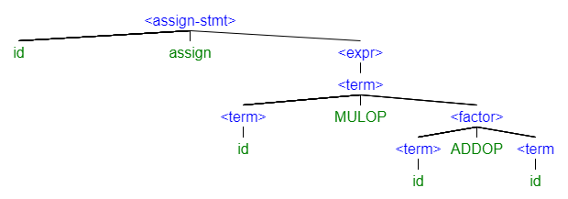

Assign => id “=” expr => A = expr => A = term => A = term * factor => A = factor * factor => A = id * factor => A = A * factor => A = A * (expr) => A = A * (expr + term) => A = A * (term + term) => A = A *(factor +term) => A = A * (id + term) => A = A * (B + term) => A = A * (B + factor) => A = A *(B + id) => A = A * (B + C).

1. A = A * B + C

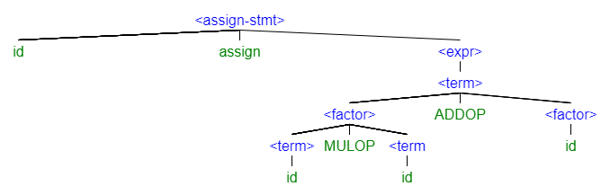

Assign => id = expr => A = expr => A = expr + term => A = term + term => A = term * factor + term => A = factor * factor + term => A = id * factor + term => A = A*factor + term => A = A * id + term => A = A * B + term => A = A * B + factor => A = A * B + id => A = A * B + C.

1. A = (A + C) * (A + B)

Assign => id = expr => A = expr => A = term => A = term * factor => A = factor * factor => A = (expr) * factor => A = (expr + term) * factor => A = (term + term) * factor => A = (factor + term) * factor => A = (id + term) * factor => A = (A + term) * factor => A = (A +factor) * factor => A = (A + id) * factor => A = (A + C) * factor => A = (A + C) * (expr) => A = (A + C) * (expr + term) => A = (A + C) * (term + term) => A = (A + C) * (factor + term) => A = (A +C) * (id + term) => A = (A + C) * (A + term) => A = (A + C) * (A + factor) => A = (A +C) * (A + id) => A = (A +C) * (A + B).

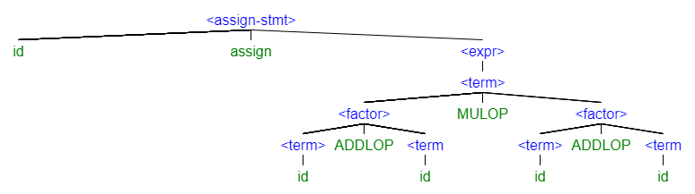

**Question 2:**

main : stmt EOF

;

expr:

<assoc=right> ‘!’expr // 1, highest

| expr “==” expr // 2

|expr “!=” expr

|expr “<” expr // 3

|expr “<=” expr

|expr “>” expr

|expr “>=” expr

|expr “||” expr // 4 , left-assoc

|expr “&&” expr // 5, left-assoc

| INT

|ID

;

stmt : other

IF expr THEN stmt (ELSE stmt)?

;

**Question 3:**

s → a (Ba)*

a → A (B)? a

Convert:

s → s B a

| a

a → a B a

| A

**Question 4:**

a)

s → a (1)

a → a + a | id (2)

id → A | B | C (3)

We can see in (2) that the non-ternimal element a exist in the left and the right side of the operator “+” or ADDOP, that makes the grammar ambiguous.

b) Left Recursion elimination: from (2) we change based on the formula:

A 🡪 beta A’

A’ 🡪 ϵ | alpha A’

Where A 🡪 A alpha | beta, thus:

a → id a’

a’ → ϵ | + a a’

**Question 5:**

stmt → IF expr THEN { stmt } ELSE { stmt }

| IF expr THEN { stmt }

| other

expr → TRUE | FALSE

Left factoring:

stmt 🡪 IF expr THEN stmt’

| other

stmt’ 🡪 ELSE stmt | ϵ

expr 🡪 TRUE | FALSE

**Question 6:**

**\***Question 4:

s 🡪 id a {a’}

a’ 🡪 {a}?

id 🡪 A | B | C

*Question 5: