Introduction
Sudoku is a number placement puzzle that has achieved remarkable popularity in the past few
years. The rule is making sure all “boxes”, “column”, “row” don’t have any duplicate values. Traditional generate-and-test solution strategies work very well for the classic form of the
puzzle, but break down for puzzle sizes larger than 9x9. An alternative approach is the use of
genetic algorithms (GAs). GAs have proved effective in attacking a number of NP-complete
problems, particularly optimization problems such as the Travelling Salesman Problem.
However, GAs prove remarkably ineffective in solving Sudoku. GA performance in Sudoku
suffers from slow convergence, inability to escape from local minima, and a variety of other
problems. Our experience with Sudoku suggests that this is a GA-hard problem.

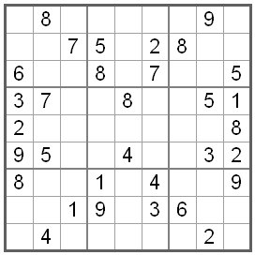
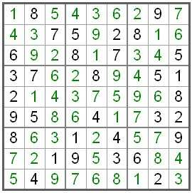

2. State chart:

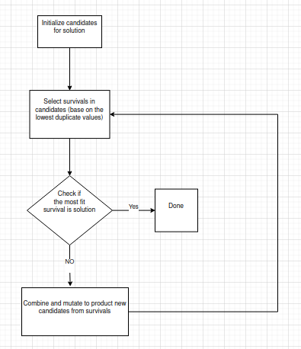

3.Result:

