SUNA Data Processing and TSP Correction Manual
Prepared by Bofu Zheng | zhengbofuzju@gmail.com
Purpose. This manual describes steps for obtaining high-quality SUNA data, which includes importing raw CTD&SUNA&bottle nutrient data, updating the SUNA calibration file, and running the TSP correction algorithm.

Workflow Overview
- Combine all CTD files into a single dataset.
- Import the discrete bottle nutrient data.
- Combine all SUNA files into a single dataset.
- Edit the raw SUNA calibration file so it is compatible with the shared correction code.
- Run the main processing script.

Step 1. Combine CTD files
Run CTD_combine.m to merge all individual CTD files into a single dataset.
Expected output: a CTD structure containing fields such as time, t, s

Step 2. Import bottle nutrient data
Discrete bottle nutrient data are typically available through the NESLTER API. Use read_bottle_data.m to read these data into MATLAB.

Step 3. Combine SUNA files
Run SUNA_combine.m to merge all individual SUNA files into a single dataset.
Expected output: a SUNA structure containing fields such as time, n, absop_spec

Step 4. Edit the raw SUNA calibration file
To work with the correction code shared by Josh Plant, add the lines below to the raw SUNA calibration file. It is recommended that you first make a copy of the original calibration file and edit the copied version rather than the original.
Lines to add:
H,Pixel base,1,,,
H,Sensor Depth offset,0,,,
H,Br wavelength offset,210,,,
H,Min fit wavelength,,,,
H,Max fit wavelength,,,,
H,Use seawater dark current,No,,,
H,Pressure coef,0.0265,,,

Insert these lines between the last line beginning with H,File format version 3 and the line beginning with H,File creation time 14-Mar-2019 11:28:23.
An example of the modified calibration file is:
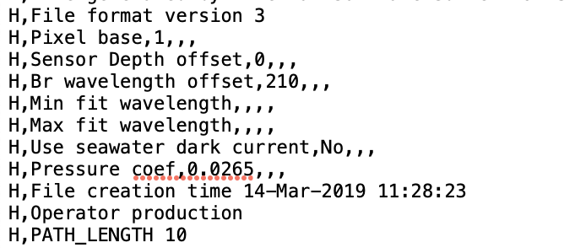
Important note. After making these edits, rename the calibration file by appending _BZ to the filename so the modified version can be easily distinguished from the original.

Step 5. Run the main script
Run main_script.m to complete the SUNA TSP correction workflow.
End of procedure

