SPACESUIT THERMAL SHIELDING KIT
Team Engineering Report
Piyath Vithanage, Elio Krollpfeiffer, Dilan Fernando, and Nuhansee Migelhewage
TUM School of Engineering and Design
Final version — 17 September 2026
Abstract—The SPHERE team designed a classroom experiment that compares four insulation arrangements around a 100 mL warm-water core. Students record 16 temperatures, generate a Newtonian cooling reference curve, and evaluate the difference between measurement and prediction. The worked test ranked the full cotton–bubble-wrap–Mylar package first for heat retention. The report also explains why the water-bath test is not a vacuum or spacesuit qualification test.
Keywords—heat transfer, Newtonian cooling, insulation, classroom experiment, data logging, model validation

Executive Summary and Project Definition
This report presents the SPACESUIT THERMAL SHIELDING KIT. The project was built the project around one engineering question: how much does a chosen layer arrangement reduce the cooling rate of the same 100 mL water-filled core under the same cold-water boundary? The kit combines four physical test articles, a browser-based Mission Control page, manual temperature logging, and a Newtonian cooling model. The project aim was to make heat transfer measurable in one school lesson without requiring specialist data-acquisition hardware.
The four conditions are a bare control, two layers of bubble wrap, a Mylar-only wrap, and a full multilayer package made from cotton, bubble wrap, and Mylar. Students record the core temperature once per minute from 0 to 15 minutes. The website plots the recorded values against a reference curve and calculates residuals and mean absolute error. In the worked data, the full multilayer package retained the most heat. Mylar alone performed poorly in the water-bath setup, which showed why a reflective material cannot be judged without considering contact, convection, wetting, gaps, and closure quality.

Main outcome
The team produced a reusable experiment that links construction, measurement, modelling, and evaluation. The activity does not reproduce vacuum and does not test materials for real spacesuit use. It is a controlled teaching model for comparing cooling behaviour. The final design uses identical glass jars, a target start temperature near 80 °C, a measured ice-water bath, a centred probe, and a 16-point temperature record.
Item | Final project setting
Thermal core | 100 mL water in matched glass jars
Boundary | Measured ice-water bath
Sampling | Every minute from 0 to 15 min
Outputs | Measured curve, model curve, residuals, MAE
Lesson length | About 55-70 min including setup and review

Team scope
The contribution record was checked against the current repository, the earlier engineering report, and the team's final attribution. Git history shows early website and manual development by Elio Krollpfeiffer and later application, telemetry, assessment, resource, and integration work by Piyath Vithanage. The earlier report documents Dilan Fernando's ownership of the thermal model, experiment, analysis, safety, and technical integration. Nuhansee Migelhewage contributed the project principles and theory, the experimental setup, and the practical preparation needed to connect the thermal concepts with the classroom test.

1 Project Context and Requirements

1.1 Context
SPHERE uses human-spaceflight engineering as the setting for classroom activities. Thermal protection was selected because students can see the construction, measure a temperature change, and compare a real curve with a mathematical prediction. The spacesuit story gives the task a clear purpose, but the measured system is a jar in a water bath. This distinction remains visible throughout the manuals and website.

1.2 Engineering requirements
- Produce a visible difference between configurations within a 15-minute test.
- Use parts that a school can replace locally.
- Keep the procedure understandable without prior differential-equation study.
- Run on ordinary laptops and tablets without accounts, pairing, or a native app.
- Keep hot water, cold bath water, and electronic displays separated.
- Use the same variables and test settings in the website, manuals, worksheet, and report.

1.3 Learning requirements
Students should be able to distinguish conduction, convection, and radiation; explain the meaning of an effective cooling constant; collect an ordered time series; compare measurement with prediction; and discuss uncertainty. The design also aimed them to see that an unexpected result is useful evidence. A disagreement should lead to checks of the setup and assumptions, not to editing the data until it matches the model.
Requirement | Design response | Check
Comparable cores | Matched 100 mL jars | Same geometry and fill
Repeatable boundary | Shared ice-water bath | Measure bath temperature
Safe handling | Adult pours hot water | Pre-run safety checklist
Accessible software | Static browser app | No login or driver
Traceable result | 16 raw readings retained | Table and graph agree

1.4 Decisions made during development
The team first considered automatic sensors and wireless transfer. That option was rejected because it would shift attention from the thermal problem to pairing, drivers, and battery faults. Manual entry makes the observation step explicit and is easier for a teacher to recover when something goes wrong. The design question was also changed from a general spacesuit demonstration to a controlled comparison of cooling rate. This change produced measurable inputs, a fair-test procedure, and a result that students could defend.

2 Thermodynamic Model

2.1 Lumped cooling model
The model treats the water as one thermal mass with a uniform temperature. This is an approximation, but it gives a useful reference for a short classroom test. The stored sensible energy change is
Q = m cₚ ΔT.
For 100 mL of water, the mass is approximately 0.10 kg. With a water heat capacity of about 4184 J kg⁻¹ K⁻¹, a 10 K drop represents about 4.18 kJ leaving the water. The jar, probe, and insulation also store energy, so this value is an estimate rather than a complete energy balance.
For a body losing heat to an environment at approximately constant temperature, the team use
m cₚ dT/dt = −hA(T − Tenv),
which gives the reference curve
T(t) = Tenv + (T₀ − Tenv)e⁻ᵏᵗ.
The website uses minutes, so the effective cooling constant k is in min⁻¹. It combines geometry, boundary conditions, thermal mass, and all heat-loss paths. It is not the material conductivity of cotton, bubble wrap, or Mylar.

2.2 Model coefficients
Condition | Reference k (min^-1) | Model T15 for 80/0 °C
Bare control | 0.150 | 8.4 °C
Bubble wrap | 0.040 | 43.9 °C
Mylar only | 0.121 | 13.0 °C
Full MLI | 0.015 | 63.9 °C

2.3 Interpretation
Cotton and bubble wrap reduce direct solid contact and trap low-density regions. Mylar mainly changes radiative exchange when a suitable air gap exists. In a water bath, conduction and convection can dominate, especially if water touches the wrap or enters through the neck. This is why the Mylar-only condition should not be treated as a direct test of spacecraft multilayer insulation.
For runs with different starting temperatures, the team compare the dimensionless temperature above the boundary:
θ(t) = [T(t) − Tenv] / [T₀ − Tenv].

3 Hardware and Test Configurations

3.1 Apparatus
The physical system uses four matched 100 mL glass jars, four digital probe thermometers, a separate bath thermometer, one stable bucket or deep container, insulation materials, a timer, towels, and heat-resistant handling tools. Each probe is suspended near the centre of the water volume. The display and cable connector stay dry and outside the bath.
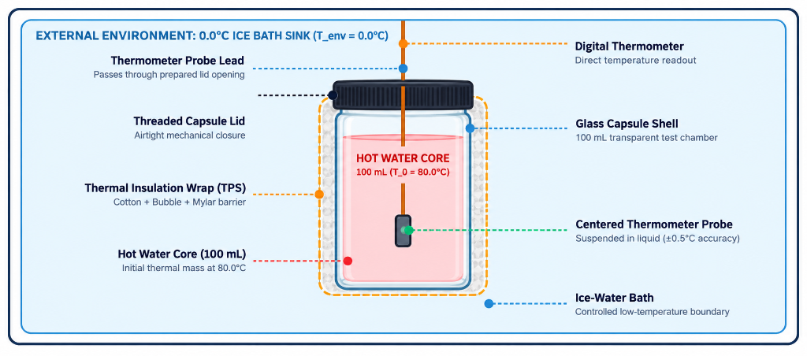
Image A. Final capsule arrangement showing the warm-water core, centred probe, insulation wrap, and ice-water boundary.
Condition | Construction | Purpose
Bare control | Jar with no added insulation | Reference heat-loss path
Bubble wrap | Two even layers with cells uncrushed | Trapped-air layer
Mylar only | One reflective layer, neck closed | Reflective layer by itself
Full MLI | Cotton, bubble wrap, outer Mylar | Combined mechanisms

3.2 Construction controls
Small assembly differences changed the response during development. A probe touching the glass did not represent the bulk water. Tight tape flattened bubble cells. A loose opening around the probe created a direct heat-loss path and could let bath water enter. The team therefore treated probe position, layer compression, closure, and immersion depth as controlled variables.
- Use jars with the same diameter, wall thickness, and fill height.
- Cut insulation pieces to the same nominal size for repeated trials.
- Secure each layer only tightly enough to stop movement.
- Keep the jar neck and probe opening as consistent as possible.
- Record any wetting, gap, leak, or probe movement with the run data.

3.3 Full multilayer package
The full package is built from the core outward: cotton next to the jar, two layers of bubble wrap around the cotton, and Mylar on the outside. The order was chosen so the soft inner layer follows the jar, the bubble layer provides trapped air, and the reflective sheet forms the outer surface. This arrangement is a classroom analogue only. Real spacecraft multilayer insulation uses carefully controlled low-emittance films, spacers, vacuum conditions, and qualification tests.
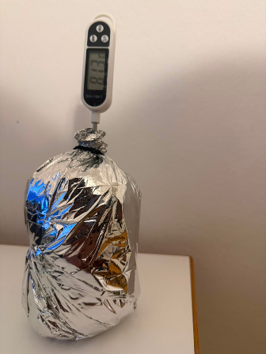
Image B. Completed multilayer test article with the external reflective layer and digital probe.

3.4 Integration with the learning kit
The hardware labels match the configuration names in Mission Control. This prevents a group from choosing one model coefficient while testing another construction. The same four names appear in the manuals, worksheet, result table, and assessment questions.

4 Experimental Method and Safety

4.1 Controlled procedure
- Prepare a stable dry work area. Keep laptops and displays away from the bath.
- Build the assigned insulation and check the jar with cool water.
- Prepare the ice-water bath and record its actual temperature.
- Add 100 mL of water near 80 °C and record the actual starting temperature.
- Centre the probe, close the neck, immerse the jar to the agreed depth, and start the timer.
- Record the core temperature at t = 0 and once per minute through t = 15 min.
- Enter the readings without smoothing them. Calculate drop, residuals, MAE, and an effective k.
- Compare conditions and list the factors that limit the conclusion.

4.2 Fair-test criteria
Every condition should use the same jar geometry, water volume, probe depth, immersion depth, bath location, and timing method. The bath temperature must be measured rather than assumed. If a reading is late, the actual time should be recorded. A complete run contains 16 ordered time-temperature pairs or a written reason for each missing point.

4.3 Safety controls
Hazard | Control
Hot water | Adult or trained supervisor pours; use gloves or tongs
Glass breakage | Inspect jars; use stable secondary containment
Water near electronics | Keep displays, laptops, and connectors dry
Leak or unstable jar | Stop the run immediately
Wet floor | Use towels and clean spills at once

4.4 Data quality
The original readings were kept the original readings, including the unexpected Mylar-only curve. The purpose of the model is to support a comparison, not to force a match. Repeating each configuration at least three times and randomising the run order would improve the evidence. Future trials should also record water mass, bath temperature, probe depth, immersion depth, and construction notes for every run.

5 Software and Data Workflow

5.1 Architecture
Mission Control is a browser-based single-page application built with HTML, CSS, and JavaScript. Chart.js draws prediction and telemetry curves, while KaTeX renders the mathematical notation. Local browser storage keeps the selected model, generated prediction, measurements, quiz state, and fallback leaderboard results. The core laboratory runs without a native installation, Bluetooth link, or device driver. The current project also supports an optional Supabase connection for a shared classroom quiz leaderboard; when it is not configured or cannot be reached, the leaderboard falls back to local storage.

5.2 Workflow
Stage | Website action | Student action
Prediction | Calculates T(t) from T0, Tenv, k, and time | Choose a condition and record assumptions
Measurement | Provides timer and 16-point log | Read and enter one value per minute
Comparison | Overlays measured and predicted curves | Inspect curve shape and residuals
Evaluation | Calculates MAE and feedback score | Explain the disagreement physically
Assessment | Runs a timed ten-question challenge | Review answers and compare team score

5.3 Graphing choices
The prediction and telemetry use the same time axis and configuration colours. Axes include units, and the plotted interval matches the 15-minute procedure. The data table keeps the measured value separate from the predicted value. This makes it clear which numbers came from the physical test and which came from the model.
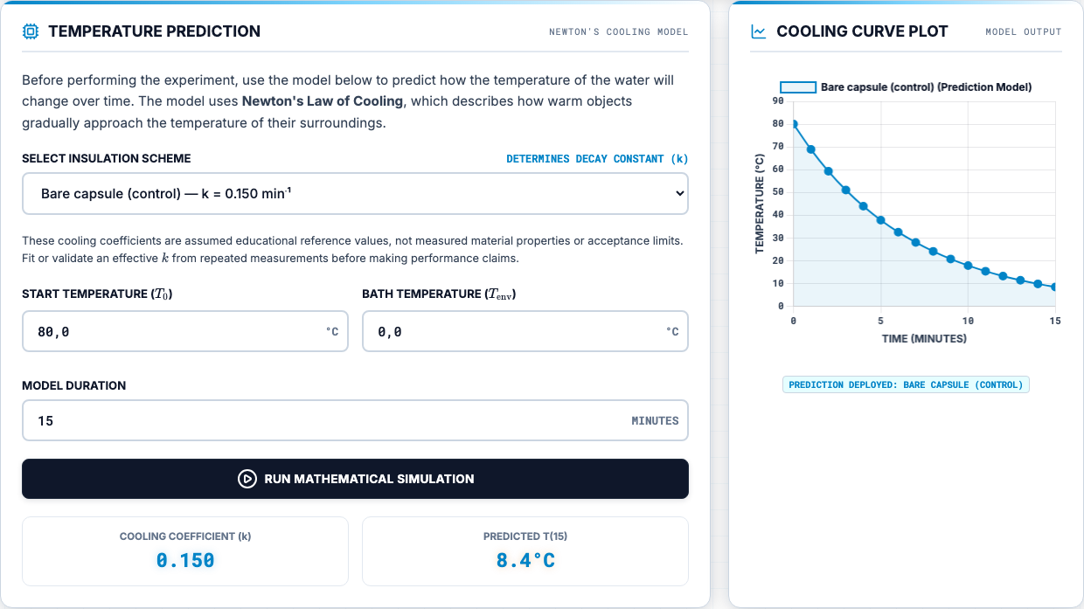
Image C. Current Mission Control prediction interface and 15-minute cooling curve.
The residual at each time is the measured value minus the model value. The analysis uses mean absolute error as a simple summary:
MAE = (1/n) Σᵢ₌₁ⁿ |Tmeas,i − Tmodel,i|.

5.4 Reliability and limitations
The site is easy to publish with GitHub Pages and can be opened from a local web server. The current build still loads several browser libraries and fonts from public content-delivery networks, so complete offline use requires those dependencies to be bundled locally. The optional shared leaderboard needs the supplied Supabase configuration and database setup; otherwise the application clearly reports local mode. CSV export and structured run metadata remain useful future additions. The dashboard score is classroom feedback, not a formal statistical validation result.

5.5 Responsibility
Repository history shows that Elio Krollpfeiffer developed early versions of the website and both manuals. Piyath Vithanage completed later application development and integration, including the model controls, telemetry workflow, graphs, print output, assessment game, leaderboard, and current resource set. Dilan Fernando supplied the thermodynamic and experimental definitions used by the interface.

6 Experimental Results

6.1 Recorded endpoints
The worked dataset contains 16 readings for each condition. The endpoint summary is shown below. Because starting temperatures were not identical, final temperature alone is not enough for a fair comparison; the temperature drop and full curve are more useful.
Condition | T0 | T15 | Drop | Dashboard score
Full MLI | 77.6 °C | 62.7 °C | 14.9 °C | 93%
Bubble wrap | 82.6 °C | 52.6 °C | 30.0 °C | 83%
Bare control | 80.1 °C | 35.2 °C | 44.9 °C | 94%
Mylar only | 80.5 °C | 33.3 °C | 47.2 °C | 3%

6.2 Main result
The full multilayer package had the smallest 15-minute temperature drop and therefore retained the most heat in this run. Bubble wrap ranked second. The bare control and Mylar-only condition cooled much faster. The Mylar-only result does not show that reflective insulation is generally ineffective. It shows that the selected reference coefficient and the physical water-bath construction did not agree for that run.

6.3 Representative telemetry
Time | Full MLI | Bubble | Mylar | Bare
0 min | 77.6 | 82.6 | 80.5 | 80.1
3 min | 75.6 | 72.5 | 55.8 | 59.9
6 min | 73.9 | 65.6 | 44.9 | 47.1
9 min | 70.6 | 60.6 | 38.9 | 40.9
12 min | 67.4 | 56.1 | 35.5 | 37.3
15 min | 62.7 | 52.6 | 33.3 | 35.2

6.4 Fitted cooling constant
A point estimate of k can be calculated when T(t), T0, and Tenv are known:
k = −(1/t) ln([T(t) − Tenv] / [T₀ − Tenv]).
A fit using all usable points is better than a one-point estimate because it uses the curve shape and reduces the influence of one reading. Repeated trials are still needed before reporting material rankings as stable results.

7 Analysis and Model Limitations

7.1 Comparison with the model
The full multilayer package and bare control followed their selected reference curves more closely than the Mylar-only case. The model is useful because it gives the class a common baseline, but k is an effective system value. It changes when the jar, fill, bath, probe, closure, or layer contact changes. A coefficient chosen for one setup should not be presented as a fixed property of a material.

7.2 Likely error sources
Source | Effect on result | Control
Probe touches glass | Biased core reading | Centre probe with a guide
Bath warms | Changing boundary | Measure before and during run
Different start temperatures | Unfair final-temperature ranking | Use drop, theta, or fitted k
Compressed layers | Higher solid conduction | Use repeatable light fastening
Water reaches wrap | Extra conductive path | Improve closure and log wetting
Timing delay | Shifted data point | Record actual timestamp

7.3 Limits of the analogy
A spacesuit operates in vacuum outside the garment, where there is no external air convection. The classroom jar is surrounded by water, so convection and conduction are strong. Real spacesuits also use an active liquid-cooling and ventilation garment. The activity therefore teaches the method of thermal testing and model checking; it does not reproduce the full physics or certify the materials.

7.4 Confidence in the result
The recorded ordering is valid as a description of the worked runs: full MLI, bubble wrap, bare control, then Mylar-only by 15-minute temperature drop. Confidence in a general ranking is limited because the available dataset contains one series per condition and incomplete metadata for some construction details. The available evidence does not support a claim that the same ordering will always occur until repeated trials show the variation.

7.5 Changes for the next campaign
- Run at least three repeats per condition and randomise the order.
- Use a simple probe-position jig and a fixed immersion-depth mark.
- Record bath temperature at the start and end of every run.
- Weigh the water instead of relying only on nominal volume.
- Store construction notes and export all telemetry as CSV.

8 Educational Delivery and Feasibility

8.1 Classroom sequence
The lesson starts with a short briefing on heat transfer and the limits of the spacesuit analogy. Groups then predict which condition will retain the most heat, assemble or inspect their test article, run the 15-minute measurement, and compare the recorded curve with the model. The final discussion asks students to defend a ranking and explain at least one source of disagreement.

8.2 Supporting materials
The current project includes the Mission Control website, student manual, teacher manual and marking guide, three-page task sheet, printable flashcards, illustrated procedure, leaderboard setup guide, and final presentation material. The learning materials use one aligned ten-question framework: written-response questions in the printable set, multiple-choice questions online, and complete solution guidance for students and instructors. The analysis usesd the same configuration names, variables, test duration, and core volume throughout.

8.3 Assessment
Evidence | What it checks
Prediction | Reasoning from heat-transfer mechanisms
Raw data table | Careful measurement and units
Model comparison | Use of k, residuals, and MAE
Evaluation paragraph | Limits, uncertainty, and fair testing
Open response | Explanation in the student's own words

8.4 Practical feasibility
The equipment is reusable, and the core laboratory does not require a paid account. Shared multi-device leaderboard synchronisation is optional and depends on a configured Supabase project; local scoring remains available without it. Exact equipment cost depends on local sourcing, so the earlier EUR 35.20 estimate should remain a draft until quotes are checked. The main preparation load is cutting consistent insulation pieces, checking jars and probes, preparing the bath, and confirming that the chosen browser can load the required libraries.

8.5 Handover
A teacher should receive the full kit, printed safety checklist, spare insulation, towels, and a local copy of the website. The handover notes should state the measured jar volume, probe type, reference coefficients, and known limits. This information is more useful than a polished demonstration alone because it lets another class repeat the test and compare results.

9 Conclusions, Responsibilities, and References

9.1 Conclusion
The team developed a complete classroom engineering activity that connects a physical thermal test with a simple mathematical model. The full multilayer package retained the most heat in the worked data, while the Mylar-only result showed the importance of boundary conditions and construction. The strongest part of the project is the full workflow: students make a prediction, control a test, keep raw data, compare the result with a model, and explain the mismatch.

9.2 Final recommendations
- Repeat all four conditions and report the variation, not only one curve.
- Bundle Chart.js and KaTeX locally for offline use.
- Add CSV export, run identifiers, and metadata fields.
- Use a probe guide and fixed immersion mark.
- Verify the final cost from current supplier quotes.
- Keep the vacuum-versus-water-bath limitation in every student briefing.

9.3 Documented responsibility split
Member | Main contribution
Piyath Vithanage | Current application, telemetry, graphs, quiz, leaderboard, resources, and integration
Elio Krollpfeiffer | Early website development, styling, student manual, teacher manual, and media assets
Dilan Fernando | Thermal model, experiment, analysis, safety, documentation, and technical integration
Nuhansee Migelhewage | Heat-transfer principles and theory, experimental setup, and practical preparation

9.4 Current project verification
The final report was checked against the active project files rather than the older report alone. The current application still uses the four reference configurations and cooling constants, a 100 mL water core, a target start temperature near 80 °C, and a 15-minute measurement interval. The telemetry code stores physical readings separately from the prediction, calculates mean absolute error, preserves the active session in browser storage, and provides a formatted print record.
The assessment system has developed beyond the earlier static question set. The current site runs a timed ten-question team challenge with progress tracking, immediate answer feedback, a final review, score presentation, and a podium display. Leaderboard data is stored locally when the shared service is not available. If the supplied Supabase configuration is completed, scores can be synchronised across classroom devices. This optional connection does not change the thermal experiment or prevent the core activity from running.
The project resources are also aligned with the current application. The student manual, teacher manual and marking guide, task sheet, flashcards, final presentation, and README use the same central model and experimental sequence. The printable and online assessment material follows the same ten topics. Remaining work is clearly separated from completed work: repeated physical trials are still required for validation, current supplier prices still need checking, and the external browser libraries should be bundled before dependable offline deployment.
Verified area | Current implementation
Experiment | Four configurations, 100 mL core, measured bath, 15-minute run
Analysis | Prediction, telemetry overlay, residuals, MAE, and print record
Assessment | Timed ten-question challenge, review, scoring, and podium
Data sharing | Local leaderboard with optional Supabase synchronisation
Resources | Manuals, task sheet, flashcards, README, and presentation aligned

References
[1] NASA, "Spacewalk Spacesuit Basics," Johnson Space Center, accessed 9 Sep. 2026.
[2] NIST, "Water Liquid Phase Heat Capacity," Chemistry WebBook SRD 69, accessed 9 Sep. 2026.
[3] M. M. Finckenor and D. Dooling, Multilayer Insulation Material Guidelines, NASA/TP-1999-209263, 1999.
[4] NASA, Passive Thermal Control Engineering Guidebook, Rev. 4.0, 2023.
Project sources: Mission Control index.html, app.js, and styles.css; student and teacher manuals; task sheet; flashcards; project procedure; and the recorded telemetry dataset.

Individual Contribution
Piyath Vithanage

Role and completed work
Piyath Vithanage's main contribution was the current Mission Control application and the integration of the final project resources. Piyath developed the browser workflow that connects briefing, assembly, prediction, measurement, study material, and assessment. Piyath used HTML for the experiment structure, CSS for the responsive interface, and JavaScript for the model, timer, telemetry, quiz, and leaderboard behaviour.
Piyath connected the configuration selector, starting temperature, bath temperature, duration, and cooling constant to a common application state. Piyath implemented the 15-minute timer and manual telemetry workflow. The page validates entries, stores the active model and data in the browser, overlays measured and predicted curves, calculates mean absolute error, and produces a clean printable telemetry record.

Graphing and analysis
Piyath developed the graphing workflow so students could compare the measured and predicted temperatures on the same time axis. Piyath kept the configuration names and colours consistent across the selector, summary, graph, and result table. Piyath also implemented the residual and mean absolute error calculations. These outputs turn the graph into an analysis task instead of using it only as a visual display.
The implementation keeps calculated and measured data as separate series and restores the current session from local browser storage. Defensive checks were added around optional interface elements so that one missing panel would not stop the main simulator. The printed telemetry view records the selected configuration, model settings, chart, measurement count, and error result in a form that can be attached to the student task sheet.

Assessment and final integration
Piyath developed the timed ten-question classroom challenge, answer review, scoring, winner presentation, and leaderboard. The leaderboard stores results locally by default and can synchronise across devices through the optional Supabase configuration. Piyath also aligned and regenerated the student manual, teacher manual, task sheet, flashcards, presentation material, and README so the published resources match the current experiment and website.
The final integration work included checking the same question topics across online and printable resources, preserving mathematical notation through KaTeX, and maintaining a usable layout on desktop and mobile screens. Recent repository work also covered the three-page task-sheet layout, quiz progress flow, leaderboard fallback behaviour, and consistent naming across the public project pages.

Verification and maintainability
Piyath's later repository work included defensive interface checks, resource reorganisation, regenerated printable PDFs, and repeated layout corrections. These changes were needed because the website, manuals, worksheets, and presentation were developed as one learning system rather than independent files. A setting changed in the experiment had to be checked in the model controls, theory text, task sheet, teacher solution, and result explanation.
The final application keeps the main activity usable when optional services fail. The thermal model and telemetry remain local to the browser. The competitive leaderboard reports its mode and falls back to saved local scores when the shared connection is unavailable. This separation reduces the risk that a network problem stops the laboratory. It also makes the optional database feature easier for another developer or teacher to configure later.
Deliverable | Evidence
Application workflow | index.html, app.js, and styles.css
Prediction and telemetry | Model, timer, chart, MAE, and print functions
Competitive assessment | Timed quiz, answer review, scoring, and podium
Leaderboard | Local fallback and optional Supabase sync
Resource integration | Manuals, task sheet, flashcards, README, and presentation

Piyath coordinated the software variables with the thermal and experimental definitions so the current website, report, and learning resources use the same 100 mL core, 15-minute duration, reference coefficients, and configuration names.

Individual Contribution
Elio Krollpfeiffer

Early website and interface development
Elio Krollpfeiffer's contribution focused on the early development of the SPHERE website and the learning materials that established the project structure. Repository history records 78 commits under Elio's development account. Most of these changes were made to index.html, with additional work in styles.css, the student manual, the teacher manual, and project images.
Elio developed and revised the first versions of the browser interface, organised the main content sections, and helped establish the visual and instructional flow used by the later Mission Control application. This work gave the project a usable web base before the later telemetry, assessment, and leaderboard integration.
The early interface revisions brought together the project introduction, heat-transfer content, experiment instructions, and supporting visuals in one location. Repeated changes to the main page show an iterative development process rather than a single upload. The structure established a clear path from project context to theory and practical activity, which remained the basis of the final site.

Student and teacher documentation
Elio worked repeatedly on the student and teacher manuals. The student material introduced the purpose of the experiment, the sequence of tasks, and the information learners needed while using the website. The teacher material supported lesson preparation and classroom delivery. Elio also added and revised media assets used by these early versions.
The documentation contribution was important because the experiment depends on consistent instructions. The manuals needed to explain what students should build, what teachers should prepare, and how the physical activity related to the website. The early revisions supplied this instructional foundation and gave later versions a source that could be refined and aligned with the final settings.

Development handover
The repository record shows work across interface code, styling, manuals, PDFs, and image assets. This spread of files indicates responsibility for both implementation and communication. The later application development expanded the original platform with telemetry, assessment, and leaderboard functions, while the early navigation and educational structure continued to support the complete workflow.
Elio's contribution can be traced across the early project timeline from June to July 2026. The repeated updates to the main page and both manuals show that the initial system was refined through several cycles of content and layout work. This history is significant because it documents the transition from an initial web concept to a structured educational platform that later team work could extend.
The handover value of this work was the combination of interface structure and instructional content. A new feature could be placed within an existing learning sequence instead of being added as an isolated tool. The teacher and student perspectives were already represented in separate manuals, which allowed later revisions to keep operational instructions, explanations, and assessment guidance directed at the correct audience.

Evidence and handover
Contribution area | Repository evidence
Website content and structure | 34 commits affecting index.html
Student documentation | Updates to user_manual.html and student_manual.html
Teacher documentation | Updates to teacher_manual.html and manual PDFs
Visual presentation | styles.css and image assets

Elio Krollpfeiffer's work formed the first documented implementation layer of the project. Later development retained the same central idea: one browser experience linking thermal theory, construction, measurement, and educational guidance.

Individual Contribution
Dilan Fernando

Role and completed work
Dilan Fernando's main technical responsibility was the thermodynamic definition of the experiment and the interpretation of the physical results. Dilan selected the lumped Newtonian cooling model because it gives students a manageable equation while keeping the relationship between thermal mass, environmental temperature, and cooling rate. Dilan defined k as an effective system coefficient in min⁻¹ and kept it separate from material thermal conductivity.
Dilan set the final test conditions: a 100 mL water core, a starting temperature near 80 °C, a measured ice-water bath, and readings every minute for 15 minutes. Dilan connected those settings to the apparatus and student procedure so the model and the physical experiment referred to the same system.
The thermal formulation also separated the effective cooling constant from material conductivity. This distinction prevented the website values from being presented as fixed properties of cotton, bubble wrap, or reflective film. The selected coefficients were treated as educational reference values for complete configurations and as quantities that should be tested against measured curves.

Experiment and analysis
Dilan planned the four-condition comparison and analysed the worked telemetry using temperature drop, residuals, mean absolute error, and the fitted cooling constant. Dilan treated the unexpected Mylar-only curve as evidence of a model or construction mismatch. Dilan identified likely effects from probe position, closure, wetting, layer compression, bath temperature, and unequal starting temperatures.
The analysis retained the original measurement series rather than smoothing points to improve agreement. This decision preserved the evidence needed to discuss uncertainty. It also supported the recommendation to repeat every condition, randomise the test order, measure the actual bath temperature, and record construction details with each run.

Safety, documentation, and integration
Dilan developed the safety controls for hot water, glass, spills, and electronics. Dilan aligned the terminology and sequence across the student manual, teacher manual, task sheet, procedure, website content, and report. Dilan also completed the remaining technical writing and project integration recorded in the source report.
The technical integration checked that the physical settings, equations, result interpretation, and safety limits did not conflict across documents. This included the 100 mL fill, measured environmental boundary, 15-minute interval, four named configurations, and the limitation that a water bath does not reproduce vacuum heat transfer.

Engineering judgement
Dilan's contribution also established how the results should be reported. Temperature drop, normalised temperature above the boundary, residuals, mean absolute error, and an effective fitted constant answer different questions. Using several measures prevents the final temperature alone from hiding unequal starting conditions. The report therefore separates the observed ranking from the strength of the evidence supporting a general conclusion.
The thermodynamic work provided the acceptance limits for later software and documentation changes. Any interface revision had to retain the correct units, environmental boundary, time base, and meaning of the coefficient. Any educational revision had to preserve the distinction between spacecraft thermal control and the conductive-convective water-bath demonstration. These checks maintained technical consistency while the presentation of the project changed.
Deliverable | Evidence
Thermodynamic model | Model equations and coefficient definitions
Experimental settings | 100 mL, near 80 °C, 15-minute plan
Results analysis | Telemetry comparison and limitations
Safety controls | Teacher and procedure guidance
Document integration | Manuals, task sheet, procedure, report

Dilan Fernando's main lesson from the project was that the boundary and assembly details can dominate a simple material comparison. For that reason, Dilan kept the conclusion limited to the tested system and recommended repeated trials before making a broader ranking.

Individual Contribution
Nuhansee Migelhewage

Principles and theory
Nuhansee Migelhewage's main contribution was the development and explanation of the scientific principles behind the activity. Nuhansee worked on the theory of conduction, convection, radiation, thermal capacity, and transient cooling so that the experiment could be explained at the correct level for students. Nuhansee helped connect the classroom water-bath system to the spacesuit context while keeping the important limitation clear: the experiment is not a reproduction of heat transfer in vacuum.
Nuhansee contributed to the interpretation of the layered insulation system. Cotton and bubble wrap mainly reduce conductive and convective paths in the classroom setup, while the reflective layer addresses radiative exchange when a suitable gap is present. This explanation supported the prediction task and the later discussion of why Mylar alone could perform poorly in a water bath.
The theory contribution also covered thermal capacity and the meaning of the effective cooling constant. The water mass stores sensible energy, while the fitted constant represents the response of the complete core, container, insulation, and boundary. Presenting these ideas separately helped students avoid treating the reference coefficient as a material property.

Experimental setup
Nuhansee contributed to preparing and checking the physical experiment. This included the arrangement of the glass water core, probe position, insulation layers, ice-water bath, and measurement sequence. Nuhansee helped establish the need for equal water volume, comparable jars, repeatable probe depth, consistent immersion depth, and one-minute sampling. These controls were necessary so that differences between configurations could be discussed as engineering results rather than setup differences.
The setup work included checking the layer order for the complete package: cotton next to the jar, bubble wrap as the trapped-air layer, and reflective film on the outside. Particular attention was given to avoiding compressed bubble cells, maintaining a repeatable neck closure, and keeping the probe centred rather than touching the glass wall.

Safety and classroom preparation
Nuhansee also supported the practical preparation of the activity by considering the handling of hot water, stable placement of the bath, leak checks, dry thermometer displays, and the separation of electronics from water. This work linked the theory to a setup that could be demonstrated and repeated in a supervised lesson.
Classroom preparation also required a clear sequence for measuring the bath temperature, adding the warm water, starting the timer, and recording the first reading. Connecting this sequence to the theoretical variables made it easier to explain why each control mattered and how a setup error would affect the curve.

Theory to practice connection
Nuhansee's contribution supported the link between the mathematical model and the physical observations. A steep curve indicates rapid approach to the boundary temperature, while a shallow curve indicates greater heat retention in the tested system. Relating the curve shape to probe placement, water volume, insulation contact, and bath condition gave students a practical way to discuss why measured and predicted values may differ.
The setup and theory work also supported the fair-test requirements used throughout the materials. Each group needs a comparable core, a known starting condition, the same sampling interval, and a recorded environmental temperature. When these controls cannot be held exactly, the deviation must be written down and included in the evaluation. This approach turns the practical activity into an engineering investigation rather than a simple demonstration.
Contribution area | Project outcome
Heat-transfer principles | Clear treatment of conduction, convection, and radiation
Spacesuit analogy | Connection to thermal protection with stated limits
Experiment setup | Repeatable core, probe, bath, layers, and sampling arrangement
Practical preparation | Safety checks and controlled classroom operation

Nuhansee Migelhewage's contribution helped ensure that the experiment had a defensible physical basis and that students could connect each part of the setup to the heat-transfer principles being studied.

