SPHERE
SPACESUIT THERMAL SHIELDING KIT
Comparative Testing and Model Validation of Insulation Configurations Using a Water-Bath Newtonian-Cooling Analogue
Engineering Project Report
Human Spaceflight Technology
TUM School of Engineering and Design
Project team
Piyath Vithanage · Elio Krollpfeiffer · Dilan Fernando · Nuhansee Migelhewage
9 September 2026

Executive Summary
This report documents the SPACESUIT THERMAL SHIELDING KIT: a small, repeatable classroom experiment in which four sealed 100 mL water capsules are cooled inside an ice-water bath under four different insulation conditions. The point of the exercise is not to build a piece of flight hardware. It is to give secondary-school students a hands-on route into transient heat transfer, model validation and measurement uncertainty, using the thermal protection of a spacesuit as the motivating story rather than as something the experiment tries to literally reproduce.
The system brings together four things: a set of physical test capsules built from ordinary classroom materials, a browser-based tool called Mission Control that generates a Newtonian cooling prediction and accepts manually entered readings, a fixed measurement procedure of one reading per minute for fifteen minutes, and a short analysis stage in which the prediction and the measurement are compared using residuals and mean absolute error. Four configurations are tested side by side: an uninsulated glass jar acting as the control, a jar wrapped in bubble wrap, a jar wrapped in a single layer of reflective Mylar film, and a jar wrapped in a full multilayer package of cotton, bubble wrap and Mylar together.
The worked dataset carried in this report shows the full multilayer package losing the least heat over fifteen minutes, and the bubble-wrap jar retaining the second-most. The single Mylar layer, on its own, performed noticeably worse than either of those two, and only slightly better than the bare control. This is a real and reproducible feature of testing a reflective film in direct contact with liquid water rather than across a vacuum gap, and it becomes one of the more useful teaching moments in the whole exercise: it shows students that a material can be excellent at blocking one heat-transfer mechanism (radiation) while doing almost nothing against another (conduction through direct contact), and that the ranking you observe depends heavily on which mechanism actually dominates in your test environment.
All four trials use the same water volume, the same nominal starting temperature of roughly 80 °C, and the same measured ice-water boundary. Because the starting temperatures in the worked dataset are not perfectly identical between conditions, the report is careful to rank the configurations by temperature drop and by the fitted cooling constant, k, rather than by final temperature alone. Every model prediction shown alongside the measured data is clearly labelled as a prediction; the report is written so that a reader cannot mistake the Newtonian reference curve for an actual measurement.

Verified Project Settings
Setting | Current project value | Reason
Thermal core | 100 mL wide-mouth glass jar | Consistent geometry and thermal mass across every trial
Initial temperature | Approximately 80 °C; actual T0 recorded per run | Reproducible, but always kept safely below boiling
Boundary | Measured ice-water bath; nominal 0 °C | The actual Tenv is entered whenever the bath warms
Sampling | Every minute from t = 0 through t = 15 min | Gives sixteen time-temperature pairs per trial
Conditions | Bare, bubble wrap, Mylar-only, full multilayer | A controlled four-way comparison
Analysis | Temperature drop, fitted k, residuals, MAE | Separates what was predicted from what was observed

Work Distribution
Piyath Vithanage was responsible for the Mission Control website and the graphing and data-visualisation workflow described in Section 5. Dilan Fernando defined the thermodynamic model and carried out the remaining project work, including the physical test system, the data analysis, the technical writing, and the integration of the student and teacher materials described in Section 10. Elio Krollpfeiffer and Nuhansee Migelhewage are listed as members of the project team; their contributions are recorded in the team's internal planning notes rather than in a dedicated report section.

Contents
Executive Summary 2
1 Project Context and Objectives 5
2 Thermodynamic Framework 7
3 Hardware and Test Configurations 10
4 Experimental Method 13
5 Software Integration and Data Workflow 17
6 Reference Model and Graphing 20
7 Experimental Results 22
8 Analysis and Model Limitations 25
9 Safety and Financial Feasibility 27
10 Educational Delivery and Documentation 28
11 Individual Contribution — Piyath Vithanage 30
12 Individual Contribution — Dilan Fernando 32
13 Conclusion and Recommendations 34
References 35
Appendix A — Complete Worked Telemetry Dataset 37

1 Project Context and Objectives
The SPHERE project turns a piece of human-spaceflight engineering — keeping an astronaut's body at a safe temperature outside a spacecraft — into an activity that a class of secondary-school students can actually run in a single lesson. The spacesuit gives the module its narrative frame, but the underlying physics is deliberately terrestrial: a warm object loses heat to a cold surroundings, and the rate at which it does so depends on what stands between the two. The aim is not to reproduce a vacuum, which is not realistic in an ordinary classroom, but to let students build a simplified thermal system, measure it, model it, and then critique both the model and their own measurement.

1.1 Learning Objectives
- Distinguish conduction, convection and thermal radiation as they actually appear in a practical, hands-on system.
- Apply Newton's law of cooling and interpret what an effective cooling constant k represents physically.
- Collect a controlled temperature time series and compare it against a model prediction generated before the run.
- Use residuals and mean absolute error (MAE) to judge how well a model actually agrees with what was measured.
- Explain, using a specific example from their own data, how an uncontrolled variable can flip an apparent insulation ranking.

1.2 Scope and Constraints
The activity is built for four groups working in parallel, one group per insulation condition. A full run, including setup, the fifteen-minute measurement window, and post-processing, is expected to take roughly 55 to 70 minutes — comfortably inside a standard double lesson. All of the hardware is reusable between classes, and the software runs in an ordinary web browser rather than as a native application or through a wireless sensor link, which removes an entire category of classroom failure modes.
Several constraints had to be satisfied at once, and they pulled the design in different directions. The setup needed to produce a clearly visible temperature difference between conditions inside a single lesson; it needed to use components a teacher could replace locally without a specialist supplier; and it needed to stay understandable to students who have not yet studied differential equations, which ruled out presenting the cooling law as anything more than an equation to be used rather than derived from first principles in class. Safety controls had to be simple enough for a teacher to enforce without additional training, and the website had to run on whatever laptops or tablets a school already owns, without requiring a user account, a native install, or a paired Bluetooth sensor.

1.3 Educational Engineering Approach
The exercise is deliberately structured to follow the same sequence used in a real engineering test programme: state a requirement, choose a design, commit to a prediction, build a test article, define the controlled variables, collect telemetry, and then compare the outcome against the model. Framing the lesson this way gives every mathematical term in the cooling law a physical object a student can point to — the water mass sets the thermal capacity, the ice bath sets the environmental boundary, and the insulation package changes the effective rate at which energy leaves the core.
The spacesuit narrative supports engagement, but the actual learning objective stays thermal reasoning, and the teacher is expected to make the analogy's limits explicit rather than let it stand unqualified. In vacuum, a spacesuit's external heat exchange with its surroundings is dominated by radiation, because there is no air to carry heat away by convection and no direct medium for conduction. NASA's public description of the spacesuit's Extravehicular Mobility Unit explains that astronaut cooling is instead handled internally, by a Liquid Cooling and Ventilation Garment that circulates chilled water in tubing worn close to the skin [1]. The classroom water bath, by contrast, is a strongly conductive and convective environment. Asking students to identify which parts of the spacesuit analogy hold up and which do not is itself part of the exercise.
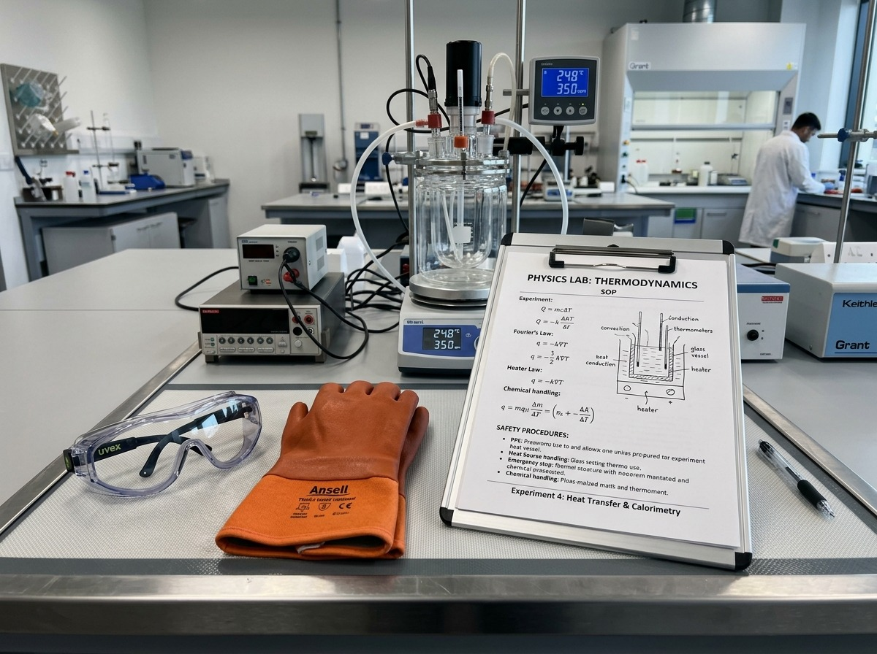
Figure 1. Theory and safety preparation before the physical test.

2 Thermodynamic Framework
The warm water inside each capsule is treated as a single lumped thermal mass rather than as a body with internal temperature gradients. Its stored sensible energy is estimated from Q = m·cp·ΔT, where m is the mass of the water, cp is the specific heat capacity of water, and ΔT is the measured temperature change. For 100 mL of water the mass is approximately 0.10 kg, subject to whatever the actual fill measurement turns out to be on a given day.

2.1 Newtonian Cooling Model
T(t) = Tenv + (T0 − Tenv)·e^{−kt}
The effective cooling constant k has units of min⁻¹. It is not a material property; it bundles together the geometry of the capsule, the thermal mass of the water, the boundary conditions of the bath, and every heat-transfer path acting on the jar at once. A smaller k means a slower approach toward the bath temperature under otherwise comparable conditions, and that is the number the whole exercise is really built around.

2.2 Heat Transfer Interpretation
Mechanism | Classroom system | Spacesuit connection
Conduction | Direct heat flow through the jar wall, the water itself, and any solid insulating layers in contact with it | Layered fabrics and structural contact points inside a real suit create their own conductive paths
Convection | Motion of the bath water and of air trapped within any gaps in the wrap | External convection does not exist in vacuum, but internal garment ventilation is still important
Radiation | Infrared exchange between the warm jar surface and the surrounding materials | Low-emissivity reflective layers are what actually reduce radiative loss in vacuum
The ice-water bath used in class is overwhelmingly a conductive and convective environment, not a radiative one. That single fact explains a result that otherwise looks strange at first glance: a reflective sheet can perform quite poorly when it is the only layer present, especially if the water bath makes direct contact with it through a loose seal or an open neck. The experiment is an analogy for a spacesuit, not a vacuum-qualification test of the insulation materials themselves, and that distinction matters for how the Mylar result should be read.

2.3 Derivation and Parameter Meaning
For a lumped body losing heat to surroundings held at an approximately constant temperature, the energy balance can be written as m·cp·(dT/dt) = −h·A·(T − Tenv). Separating variables and integrating this expression produces the exponential temperature response used throughout the website. The effective coefficient k = hA/(m·cp) collects the convective heat-transfer coefficient h, the exposed surface area A, the water mass m, and the heat capacity cp into a single number. This is also why a larger water volume tends to cool more slowly when the exposed area and boundary conditions are otherwise similar — a larger m sits in the denominator.
The project deliberately uses minutes rather than seconds as its time unit, so k is expressed in min⁻¹ throughout. This point matters more than it might first appear, because textbooks commonly use the same letter k for material thermal conductivity. In this report that quantity is written as λ, in W/(m·K), specifically to avoid the mistake of treating the website's fitted cooling constant as if it were a physical property of Mylar, cotton, or bubble wrap on its own. It is not; it is a property of the whole assembled system under the conditions of a particular run.

2.4 Heat Capacity and Temperature Drop
For 100 mL of water, m is approximately 0.10 kg. Taking cp ≈ 4184 J/(kg·K), a 10 K drop in temperature corresponds to roughly 4.18 kJ of sensible energy leaving the water — a figure consistent with the liquid-water heat-capacity data published in the NIST Chemistry WebBook [2]. The measured temperature history therefore acts as an indirect record of how much energy has left the system. This calculation is necessarily approximate: the jar, the probe, and the insulation itself also store some energy, and the water is not guaranteed to sit at a perfectly uniform temperature throughout the run.

2.5 Layered Thermal Resistance
The full multilayer package combines several mechanisms at once. The cotton and bubble wrap create low-density regions that both reduce direct conductive contact with the jar wall and restrict the movement of any trapped air, which limits convection inside the wrap. The reflective outer layer then reduces radiative exchange, but only where an air gap actually exists between it and the surface it is meant to protect. NASA's engineering guidance on spacecraft multilayer insulation describes exactly this dependency: MLI works as a stack of low-emittance films separated by low-conductance spacers, and its performance degrades sharply if those spacers are compressed or if residual gas pressure allows conduction and convection to bridge the gaps [3, 4]. The classroom layers follow the same rule and are deliberately not compressed tightly. Around the probe opening in particular, a poorly sealed closure can create a thermal short circuit that dominates the behaviour of the entire package, regardless of how good the rest of the wrap is.
It is possible to write a simple series-resistance model, Rtotal = R1 + R2 + R3 + …, for the layered package, but this should be treated cautiously rather than as a precise predictive tool. Contact resistance between layers, wetting of the insulation, irregular geometry, and genuinely multidimensional heat flow all make the physical capsule considerably more complicated than an idealised one-dimensional wall. For teaching purposes, the single effective cooling constant k is more useful and more honest than assigning a separate, precisely calculated resistance to each improvised layer.
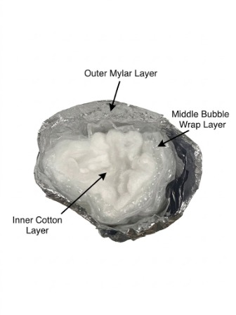
Figure 2. Cross-section of the full multilayer package: inner cotton layer, middle bubble-wrap layer, and outer Mylar layer.

3 Hardware and Test Configurations
Every trial uses the same basic hardware: a 100 mL glass core, a centred temperature probe, a threaded closure, an insulation wrap specific to the condition being tested, and an external ice-water bath that provides the cold boundary. The four physical builds differ only in what is wrapped around the jar, which is exactly what makes the comparison meaningful.
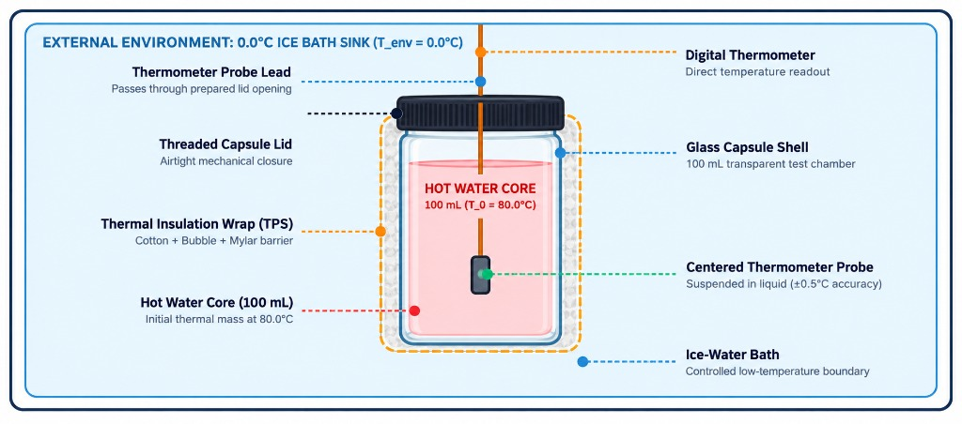
Figure 3. Current hardware arrangement — glass core, centred probe, closure, insulation wrap, and external water bath.

3.1 Apparatus
Qty | Item | Function
4 | Identical 100 mL glass jars with probe access | Provide four parallel, geometrically matched thermal cores
4 | Digital probe thermometers | Measure core temperature once per minute
1+ | Separate bath thermometer | Calibrates the boundary temperature independently of the core probes
1 | Stable bucket or deep container | Holds the cold bath and provides secondary containment
1 set | Cotton, bubble wrap, Mylar, tape or bands | Builds the four insulation configurations
1 | Timer | Enforces the one-minute sampling interval

3.2 Layer Construction
Condition | Construction | Reference k
Bare control | Uninsulated jar, consistent probe depth | 0.150 min⁻¹
Bubble wrap | Two even layers, air cells left uncrushed | 0.040 min⁻¹
Mylar only | One reflective layer, neck closed as tightly as possible | 0.121 min⁻¹
Full MLI | Cotton inner layer, bubble wrap middle, Mylar outer | 0.015 min⁻¹

3.3 Hardware Integration
The probe has to measure the bulk water rather than the temperature of the jar wall, so it is suspended near the vertical and horizontal centre of the 100 mL core in every trial. The closure supports the probe cable and limits water exchange with the bath while keeping the digital display outside the water entirely. Before every run the jar is inspected for cracks, and the closure is checked with a small amount of cool water before the hot fill goes in. If liquid ever reaches the display or the cable connector during a run, the trial is stopped immediately.
Using four genuinely identical jars turned out to matter more than choosing any particular brand of jar. Differences in diameter, wall thickness, lid geometry, or fill height all change the surface-area-to-volume ratio, and that ratio is baked directly into the effective cooling constant through the exposed area term. Parallel groups therefore receive matched cores, probes with comparable response times, and insulation pieces cut to the same nominal area, so that any difference in the results can be attributed to the insulation and not to a mismatch in the jars themselves.

3.4 Construction of the Four Conditions
The bare control establishes the fastest reference path in the set and reveals how the jar and probe behave with no added insulation at all — effectively the experiment's baseline. The bubble-wrap condition uses two even layers with the air cells left intact and uncrushed, since crushing them would remove the trapped-air gap that gives bubble wrap its insulating value in the first place. The Mylar-only condition uses one complete reflective sheet with the neck closed as consistently as the team could manage between builds. The full multilayer condition places cotton directly against the jar, wraps bubble wrap around the cotton, and finishes with Mylar on the outside. Tape and elastic bands are used only tightly enough to stop the layers moving, never tightly enough to compress them.
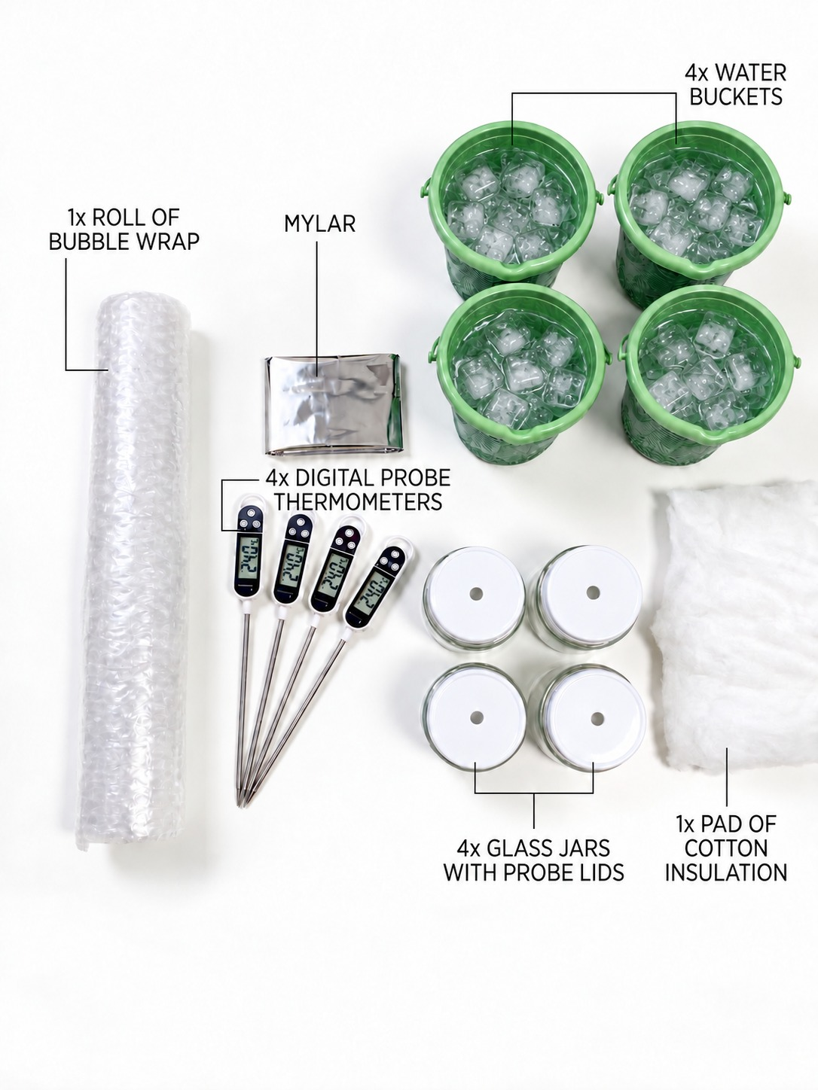
Figure 4. Toolkit components prepared for the four parallel test conditions: bubble wrap, Mylar sheet, cotton padding, glass jars with probe lids, digital thermometers, and water containers.
The full multilayer stack is assembled from the core outward in a fixed order — cotton, then bubble wrap, then a reflective Mylar outer layer — with each layer secured independently so that fitting one does not crush the air trapped in another. Probe position and neck closure are kept consistent across every test so that this condition can be compared fairly against the other three.

4 Experimental Method

4.1 Controlled Procedure
Step | Action
1 | Prepare a stable, dry work area and keep laptops and displays well away from any water.
2 | Measure and record the actual bath temperature, Tenv.
3 | Fill each thermal core with 100 mL of water near 80 °C and record its actual starting temperature, T0.
4 | Centre the probe at a repeatable depth and check the closure for leaks.
5 | Apply the assigned insulation without compressing the cotton or the bubble-wrap cells.
6 | Place the core in the bath, start the timer immediately, and record t = 0.
7 | Record the core temperature every minute through t = 15 minutes.
8 | Calculate the temperature drop, fit or select k, compute the residuals and MAE, and discuss the uncertainty.
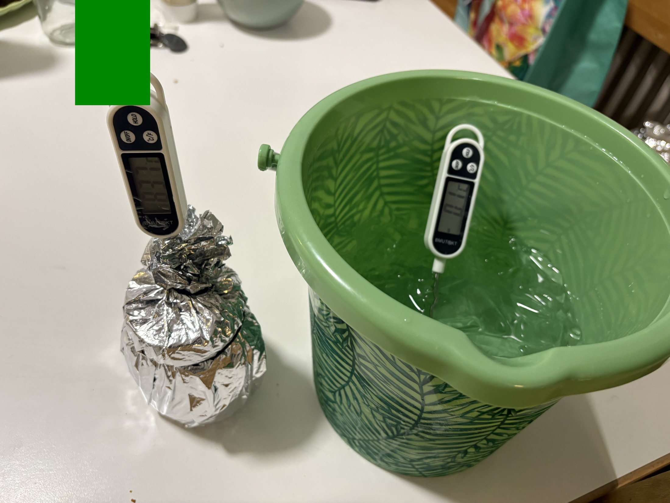
Figure 5. Physical setup immediately before immersion and the start of timed measurement.

4.2 Fair-Test Requirements
Every condition should use the same jar geometry, water volume, probe depth, sampling interval, bath location and starting-temperature tolerance. Where the starting temperatures do end up differing slightly between trials, as they do in the worked dataset in Section 7, designs should be ranked using the temperature drop, the normalised heat retained above the measured boundary, or the fitted cooling constant — never by final temperature alone, since a jar that simply started colder will reach a lower T15 regardless of how good its insulation is.

4.3 Measurement Plan
Each trial produces sixteen ordered time-temperature pairs, from t = 0 through t = 15 minutes. The operator reads the displayed temperature at the scheduled minute and records the actual value to one decimal place wherever the instrument allows it. If a reading is taken late, the actual timestamp is recorded rather than silently rounding it onto the nominal minute, so that the model is always evaluated against the same time coordinate that was actually measured.
The bath temperature is checked before the first run of the day and again if the ice visibly starts to melt. A nominal value of 0 °C is only acceptable while an ice-water mixture is genuinely still present and the measured boundary supports that assumption; during a longer class session the bath can realistically drift up to 4.5 °C or 5 °C. Entering the actual measured Tenv into Mission Control, rather than leaving the default in place, stops the software from comparing the experiment against the wrong boundary condition.
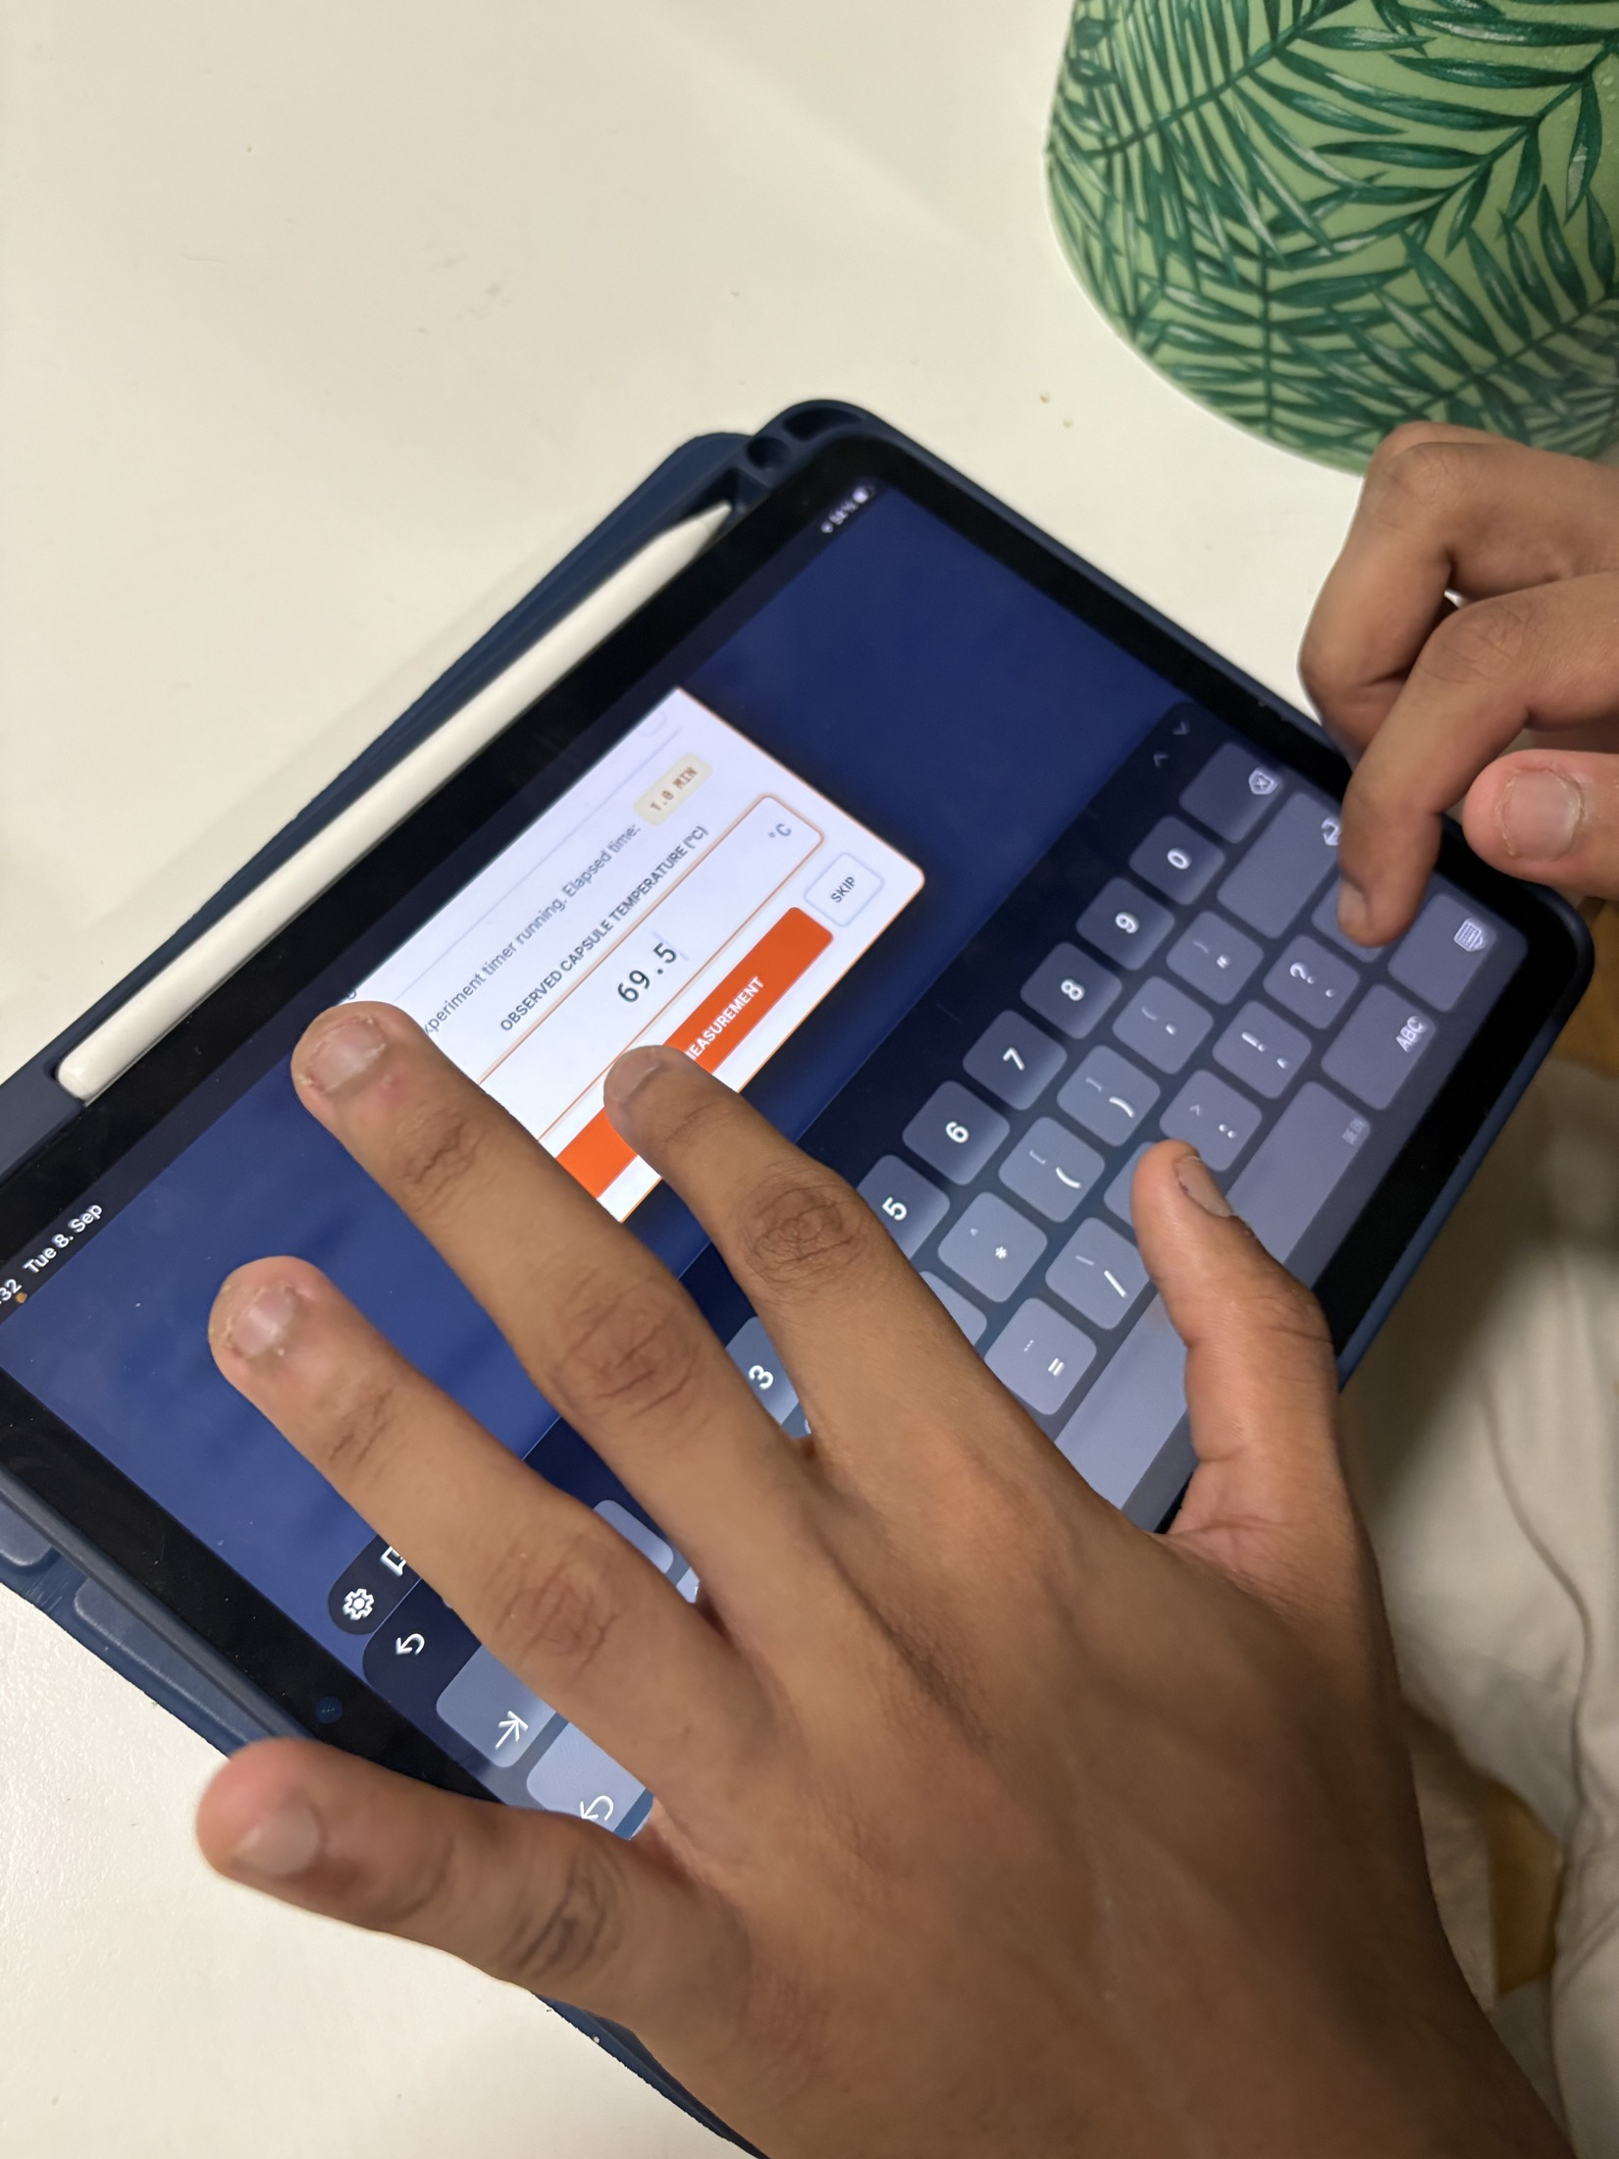
Figure 6. Recording a reading on the tablet during the timed run.

4.4 Post Processing
Analysis begins with the raw temperature drop, T0 − T15. Students then plot the measured and predicted curves on the same axes and calculate the residual at each minute. MAE summarises the average absolute disagreement across the whole run in a single number. A fitted k can be estimated from a single point, but it is far more reliable when it comes from several points at once — and repeated runs are what actually let a class separate ordinary random variation from a real, consistent effect of how a layer was built.

4.5 Acceptance Criteria
- Every trial contains all sixteen time-temperature pairs, or records the specific reason for any missing point.
- The same water volume, probe depth, immersion depth and timing method are used across all four conditions.
- Both the bath temperature and the initial temperature are documented from an actual measurement rather than assumed.
- Photographs or written notes identify the actual layer order used and flag any visible gap, compression, or wetting.
- Conclusions state both the observed ranking and the specific limitations of that particular comparison.

4.6 Physical Configuration Images
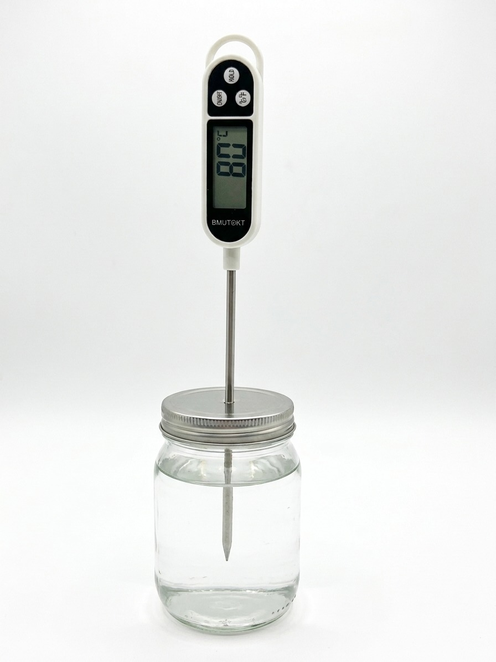
Bare control
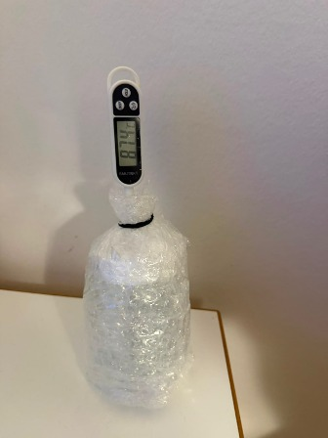
Bubble wrap
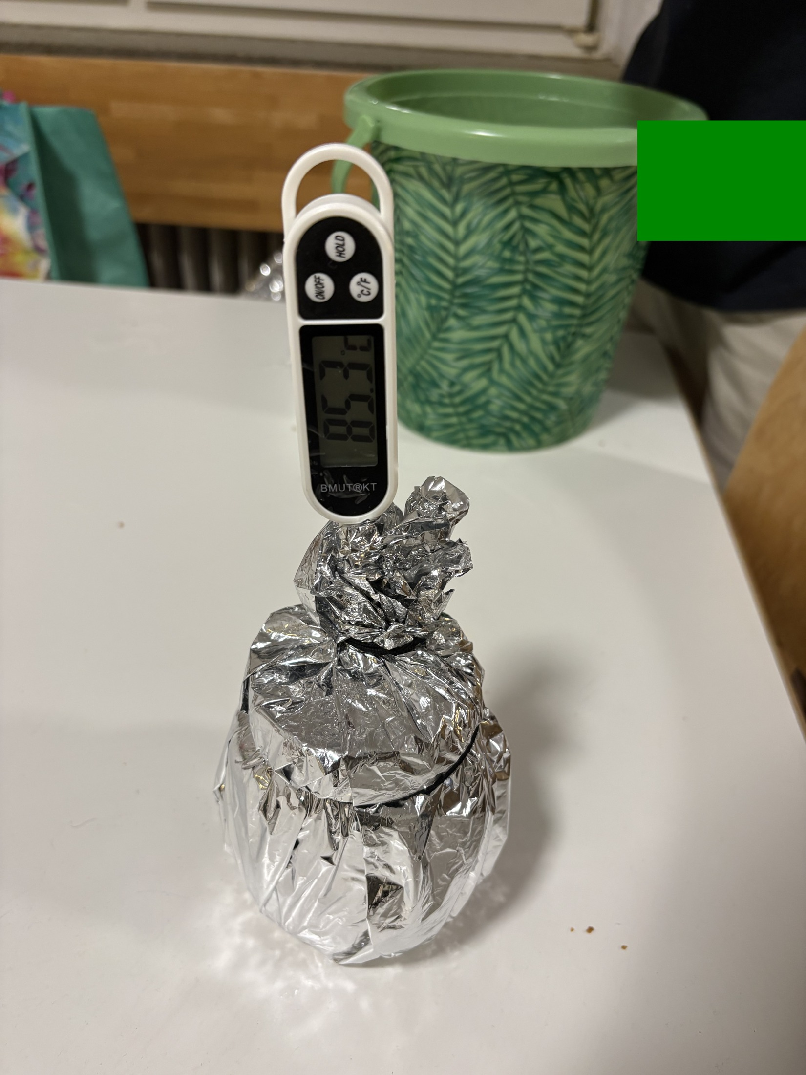
Mylar only
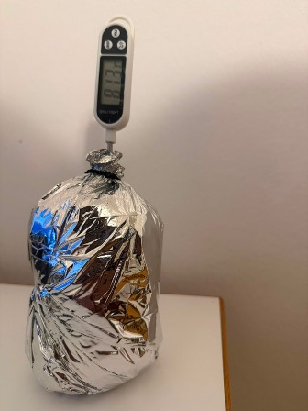
Figure 7. The four physical configurations used during the worked test: bare control, bubble wrap, Mylar only, and full multilayer package.

5 Software Integration and Data Workflow
The Mission Control website is a client-side application built with HTML, CSS and JavaScript, hosted at hsp-mc.github.io [7]. It runs in a standard browser, walks students through the theory and assembly sequence, calculates a Newtonian reference curve from the chosen configuration, accepts manually entered temperature readings, and plots the measured values against the model on shared axes. Chart.js handles the dynamic plotting [5], KaTeX renders the equations in-browser [6], and the active prediction and telemetry are cached in local browser storage so a page reload during a lesson does not immediately discard an in-progress exercise.
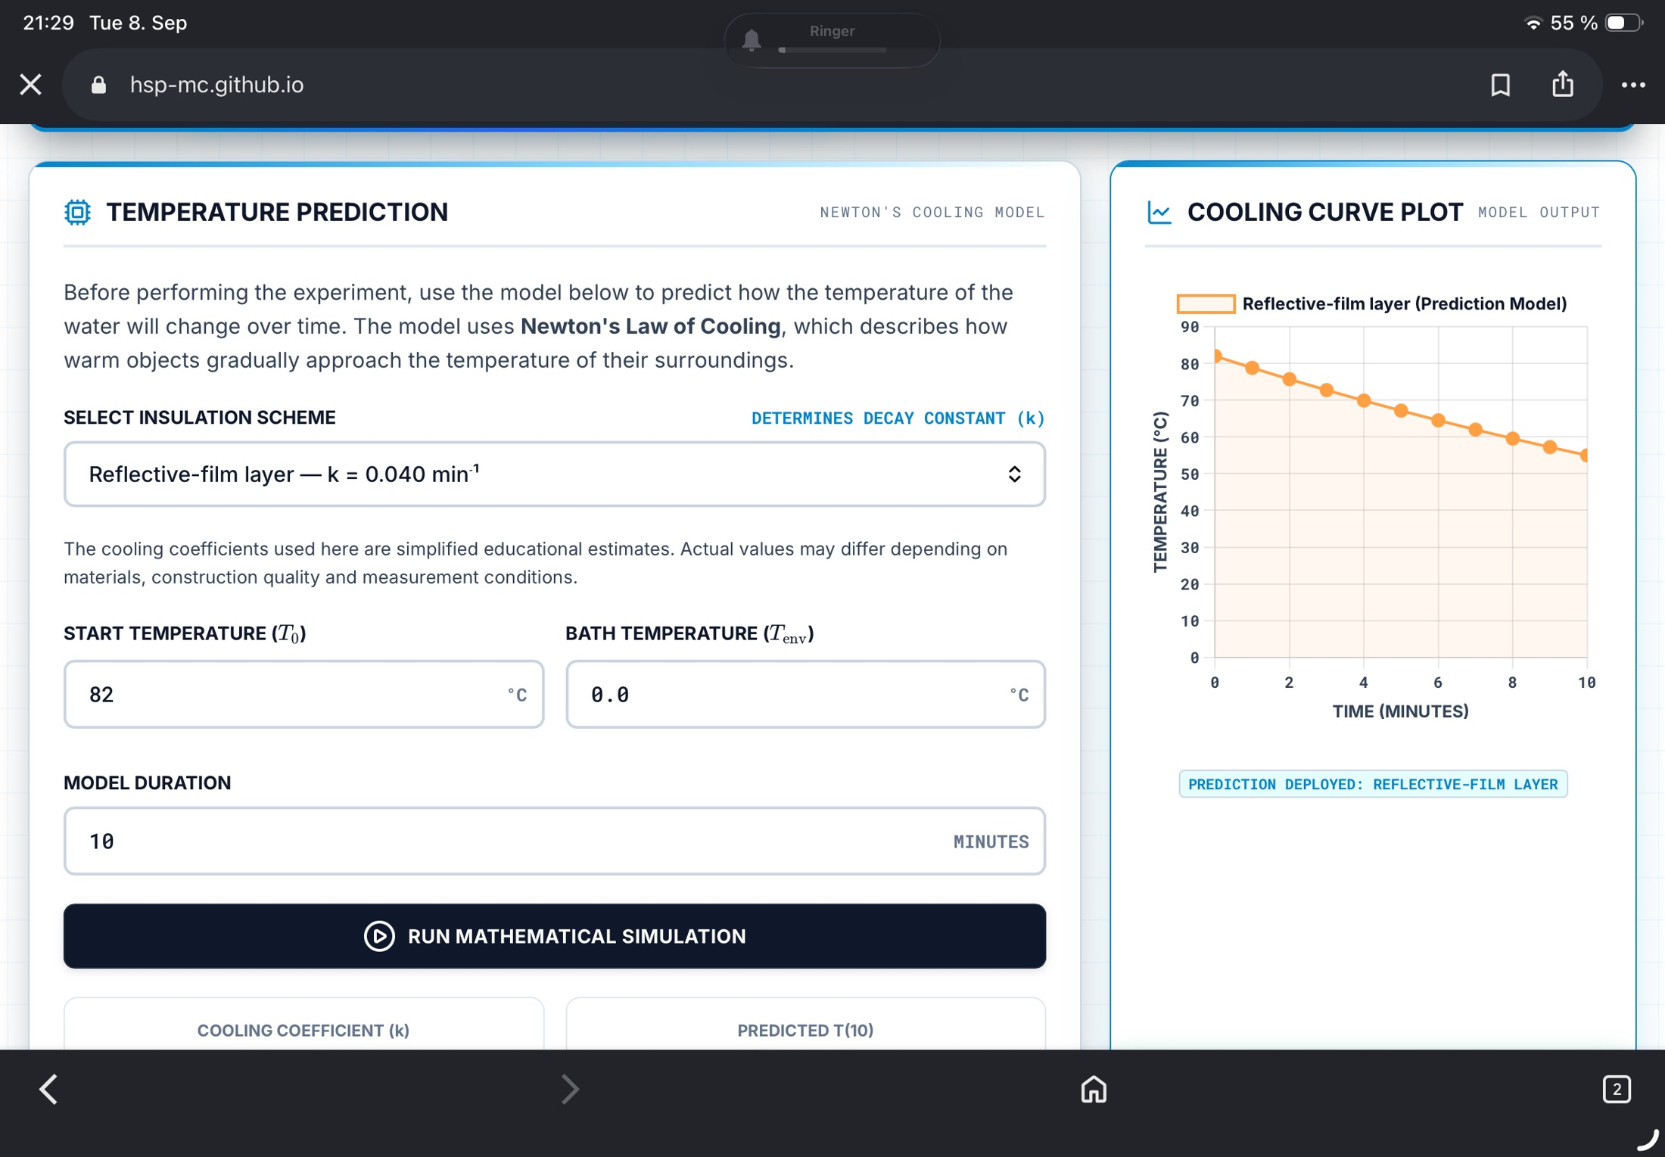
Figure 8. Mission Control's prediction interface, showing the editable start temperature, bath temperature, model duration, and cooling constant.

5.1 Measurement and Analysis Flow
Stage | Website function | Student action
Prediction | Generates T(t) from T0, Tenv, k, and duration | Selects a configuration and records the assumptions made
Acquisition | Runs the timer and the 16-point manual log | Reads the physical display and enters a value every minute
Comparison | Overlays the measurement on top of the prediction | Inspects the residuals and the overall shape of the two curves
Evaluation | Computes MAE and a correlation-style score | Explains any disagreement in terms of physical mechanisms

5.2 Software Architecture
The application is a static single-page site. The HTML defines the mission sections and input forms, the stylesheet provides the responsive dashboard layout, and a single JavaScript file holds the cooling model, the timer, the chart logic, the telemetry handling, the assessment logic, and the browser-storage calls. None of this requires a database or a server-side runtime, so a teacher can host the files on a static web service, or simply run them from a local web server on a school network with no internet access at all.
External libraries — Chart.js for the graphs [5], KaTeX for the equations [6], and Lucide for the interface icons — are loaded from public content-delivery networks by default. This keeps the project's own repository small, but it does mean that fully offline operation requires those three assets to be bundled locally ahead of time. The project's README documents this dependency explicitly, so that a teacher planning to use the tool on a restricted school network knows to prepare for it in advance.

5.3 Application State and Validation
The software keeps track of the selected configuration, the generated prediction curve, every telemetry point entered so far, the timer status, and a small set of interface preferences. Numeric inputs are parsed and bounded before a simulation is generated, so an obviously invalid entry cannot silently produce a nonsensical curve. The prediction curve is cached in local browser storage purely so that an accidental page reload during a live exercise does not throw away an active session; that storage is a convenience for a single classroom sitting, not a substitute for a proper, permanent scientific data repository.
The telemetry table itself shows the measured temperature, the predicted temperature, and their signed difference at each recorded minute, and a chart overlays both series for a quick visual check. A print function turns the active table and the run's settings into a portable record that can be attached to a student's worksheet, and a clear function lets a group restart cleanly after an invalid run. The instructor access screen that gates some of the teacher-facing content is a simple client-side classroom convenience, and the project makes no claim that it functions as a real security boundary.

5.4 Manual Logging as a Design Choice
An automated Bluetooth or wired sensor link would reduce transcription error, but it would also introduce a hardware interface, device permissions, and pairing failures — exactly the kind of fragile dependency the project was trying to avoid in a classroom setting. Mission Control deliberately keeps the digital thermometer physically separate from the website. Students have to read the display themselves, recognise the correct minute, and type the value in. That small piece of friction keeps attention on the experiment during the fifteen-minute run, and it means the origin of every single point on the final graph is visible and traceable back to a specific, human-made observation.
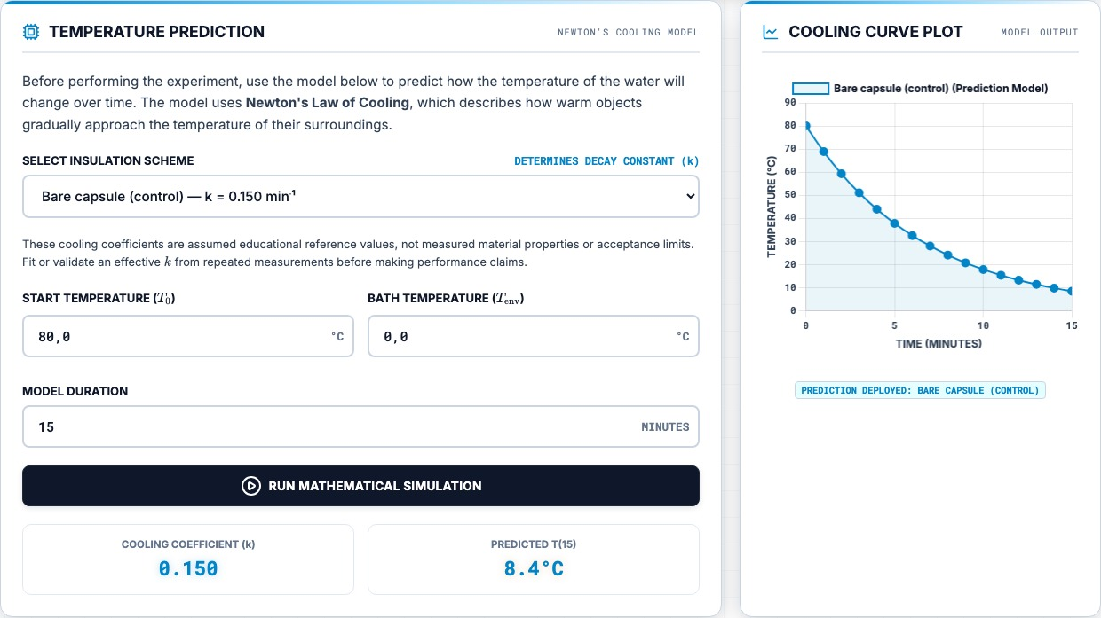
Figure 9. Prediction panel and cooling-curve output for the bare-control configuration in Mission Control.

6 Reference Model and Graphing
The website ships with a set of educational reference coefficients for a common starting point of T0 = 80 °C and Tenv = 0 °C. These coefficients are model settings chosen for teaching purposes, not guaranteed material properties and not a validated universal result, so they have to be adjusted whenever the geometry, the water mass, the bath temperature, or the construction of a layer actually changes.
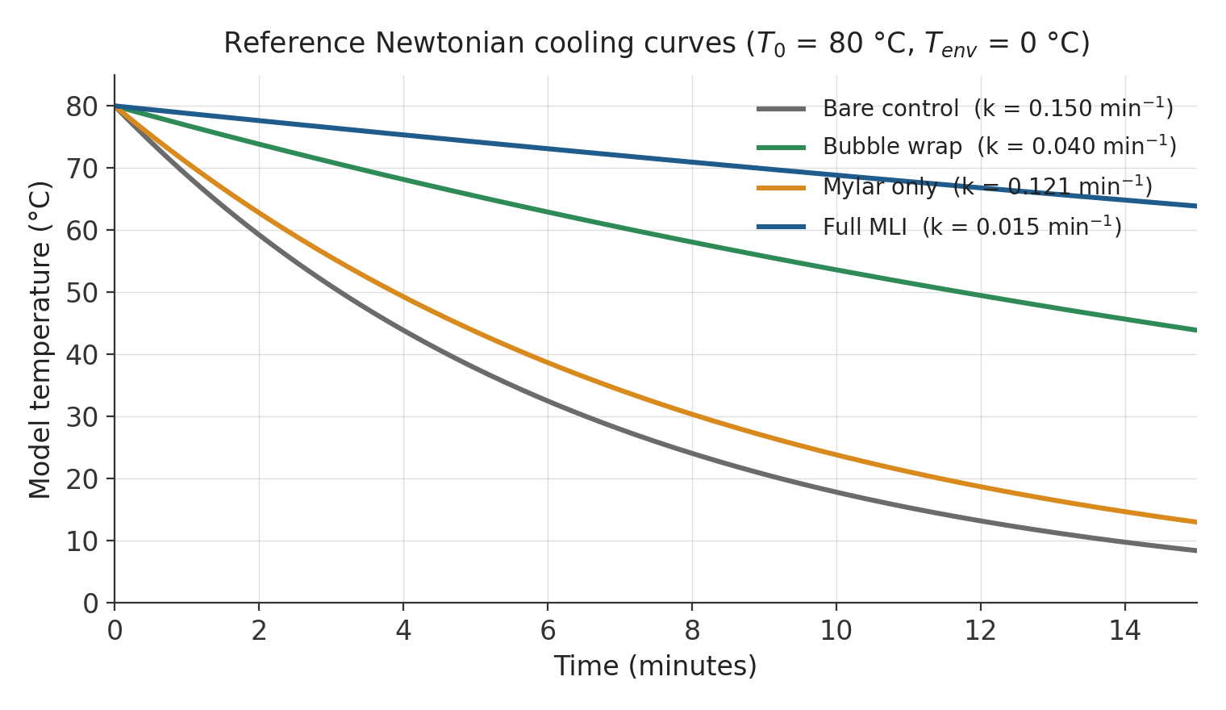
Figure 10. Reference Newtonian cooling curves generated from the website's current coefficients.
Configuration | k (min⁻¹) | Model T15 at 80/0 °C | Interpretation
Bare control | 0.150 | 8.4 °C | Fast reference decay
Bubble wrap | 0.040 | 43.9 °C | Moderate retention
Mylar only | 0.121 | 13.0 °C | Weak on its own in this bath model
Full MLI | 0.015 | 63.9 °C | Slowest model decay
At t = 15 minutes, the reference equations predict approximately 8.4 °C for the bare control, 43.9 °C for bubble wrap, 13.0 °C for Mylar-only, and 63.9 °C for the full multilayer package. These four numbers follow directly from the selected coefficients and the 80/0 °C boundary pair chosen for the reference case — they should never be presented to students as measurements unless an actual physical run produced them.

6.1 Graph Design
Every curve in the project uses the same time axis and the same temperature scale, so that slope and separation between configurations can be read directly off the plot without any mental rescaling. Colour is used consistently to distinguish the four configurations, and each label retains both the configuration's name and its k value. The measured-results figure in Section 7 follows exactly the same visual ordering and colour scheme, which is a small design choice but one that removes a genuine source of confusion: students can compare the mathematical prediction with their own experiment without having to translate between two differently designed graphs.

7 Experimental Results
The dataset below was transcribed from the project's telemetry records and is used here as a single worked example; it is not a substitute for a class actually running and recording its own measurements. Because the starting temperature T0 differs somewhat between the four trials, final temperature on its own is not a fully controlled ranking metric, and the discussion that follows leans on temperature drop and the fitted cooling constant instead.
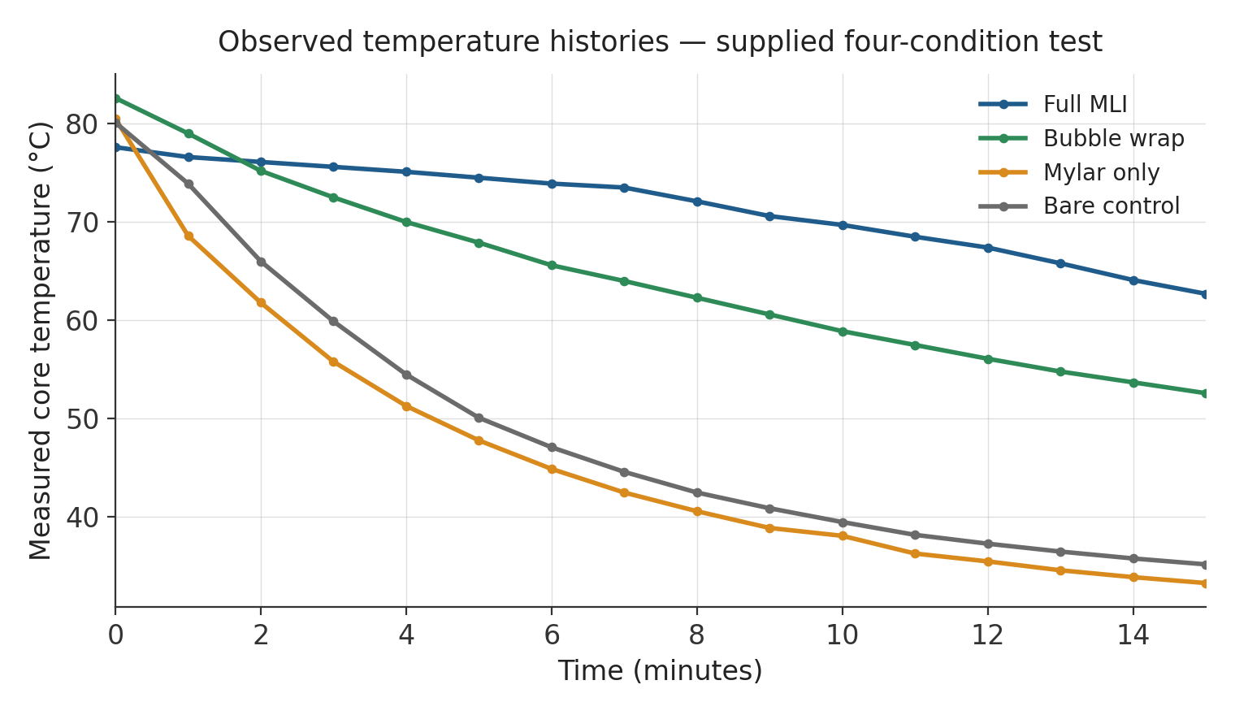
Figure 11. Observed temperature histories from the supplied four-condition test.
Condition | T0 | T15 | Drop | Dashboard score
Full MLI | 77.6 °C | 62.7 °C | 14.9 °C | 93%
Bubble wrap | 82.6 °C | 52.6 °C | 30.0 °C | 83%
Bare control | 80.1 °C | 35.2 °C | 44.9 °C | 94%
Mylar only | 80.5 °C | 33.3 °C | 47.2 °C | 3%
The full multilayer package shows the smallest measured drop of the four. Bubble wrap comes in second. The Mylar-only jar actually cooled slightly more than the bare control in this particular run, and its very low dashboard score signals that the observed curve disagreed strongly with the reference model chosen for it — this is a model mismatch, not simply a noisy reading.

7.1 Result Interpretation
The full MLI core fell 14.9 °C from a starting value of 77.6 °C. Bubble wrap fell 30.0 °C from 82.6 °C. The bare control and Mylar-only conditions fell 44.9 °C and 47.2 °C respectively. The gap between the full MLI curve and the two fastest-cooling curves is visible within the first few minutes of the run and persists all the way through to t = 15.
Because the starting temperatures were not identical across the four jars, the result should not be reduced to a straightforward comparison of T15 values. A normalised measure of temperature retained relative to the boundary gives a fairer comparison, and repeating each condition several times would be necessary before quoting a formal uncertainty figure or claiming any kind of population-level difference between materials. As it stands, this dataset supports one worked classroom analysis — it does not certify the materials involved for anything beyond that.

7.2 Comparison with the Reference Model
The full MLI and bare-control dashboard scores, 93% and 94% respectively, indicate that the selected exponential curves tracked the overall shape of those two measured series reasonably closely under the website's scoring method. Bubble wrap scored 83%. The Mylar-only trial scored just 3%, which signals a severe mismatch between the observed curve and its intended reference model rather than an ordinary small measurement error.
Several physical explanations are consistent with that Mylar-only mismatch. The reflective sheet may have let a small amount of water in at the neck, the film itself may have been in direct liquid contact rather than separated by an air gap, or the probe and starting conditions may simply have differed from what the reference coefficient assumed. Because Mylar's main strength is blocking radiation, and radiation is not the dominant loss path in a liquid bath, a construction with a strong direct-contact route can cool considerably faster than a coefficient chosen for a well-formed reflective enclosure with a proper air gap.

7.3 What the Dataset Establishes
This worked dataset establishes that the complete layered package performed best in this particular test, that bubble wrap on its own provided substantial heat retention, and that the Mylar-only construction did not behave the way its assigned reference curve predicted. It does not establish exact material properties, long-term repeatability, or how any of these materials would perform in an actual vacuum. Answering those broader questions properly would need calibrated sensors, several repeated trials per condition, tightly controlled geometry, and a genuinely different test environment.
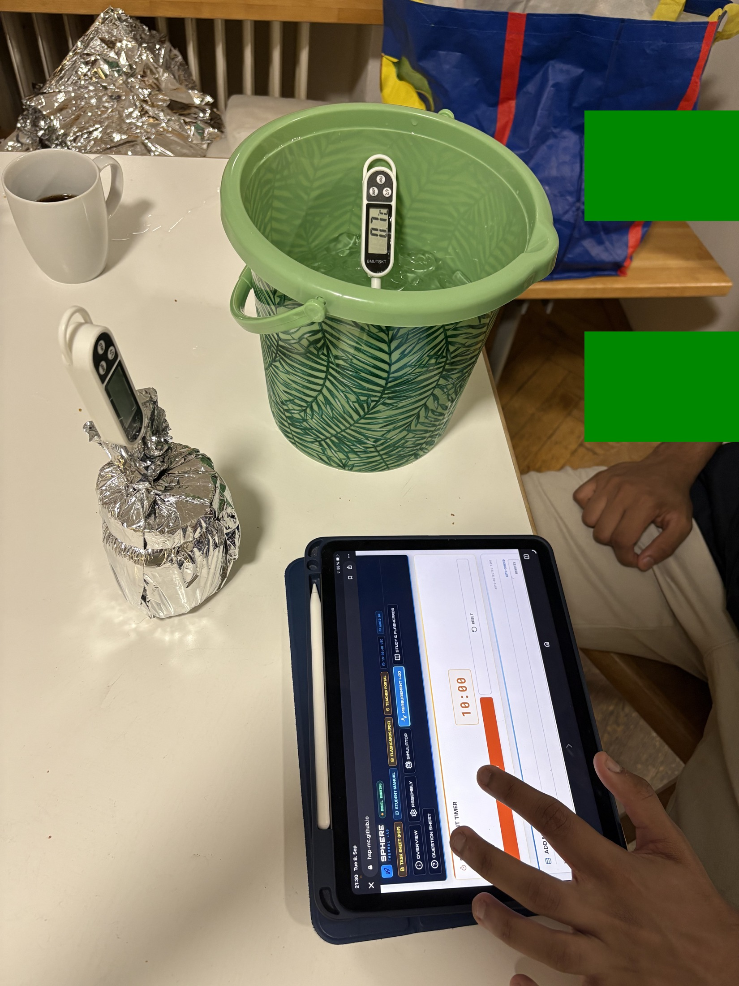
Figure 12. Manual measurement entry during one of the physical test runs.

8 Analysis and Model Limitations

8.1 Error Metrics
The residual at each recorded minute is Residual_i = T_measured,i − T_model,i, and the mean absolute error over the whole run is MAE = (1/n)·Σ|Residual_i|. A cooling constant can also be estimated directly from a single point, using k = −ln[(T(t) − Tenv)/(T0 − Tenv)] / t, provided the ratio inside the logarithm is positive and the boundary has stayed approximately constant over the interval used.

8.2 Main Sources of Uncertainty
- The probe tip touching the jar wall rather than staying centred in the bulk water.
- A leak, or an incompletely closed neck, that opens up a strong extra convective path.
- Thermal stratification inside the core, and inconsistent mixing from one trial to the next.
- The ice bath warming above 0 °C, or different jars sitting at slightly different immersion depths.
- Genuinely different starting temperatures, water masses, wrap areas, or amounts of compression between builds.
- The lumped model's own assumption of a uniform core temperature and a constant effective k, which is only ever an approximation.

8.3 Interpretation of Mylar
Mylar is genuinely effective at reflecting infrared radiation, which is exactly why it matters for spacecraft thermal control in vacuum. What this experiment shows is that a single thin reflective layer does very little against direct liquid conduction, and can be comprehensively defeated by even a small amount of convective leakage at a seam or an opening. The weak result for the Mylar-only condition is therefore best read as evidence of a boundary-condition and construction issue specific to this water-bath test — it does not, on its own, show that reflective insulation is ineffective for real spacecraft thermal control.

8.4 Recommended Improvements
A more rigorous validation campaign would repeat every condition at least three times, randomise the order the four jars are run in, use a single calibrated bath probe for all trials, and record the actual mass of water used rather than relying on the nominal 100 mL fill volume. Photographs documenting probe depth and neck closure immediately before immersion would make it much easier to explain any outlier after the fact. Fitting a single regression line to every point in a run, rather than calculating k from one endpoint, would also give a noticeably more stable estimate.
On the software side, the next sensible step would be to let students export their telemetry as a CSV file and attach run metadata — group name, configuration, water mass, probe identifier, and bath temperature — to each export. Bundling Chart.js, KaTeX, Lucide, and the project's fonts into an offline package would also make deployment noticeably more reliable in schools where the internet connection is filtered or unreliable.

9 Safety and Financial Feasibility

9.1 Mandatory Safety Controls
- An instructor or another adult prepares and handles the near-80 °C water; boiling water is never used.
- Eye protection and heat-resistant gloves or tongs are worn throughout, and the bath is kept below waist height on a stable surface.
- Only undamaged, heat-safe containers are used, and every closure is leak-tested before immersion.
- Displays, cable connectors, laptops and power supplies are kept dry at all times; only the intended probe ever enters the water.
- A run is stopped immediately if a probe slips, the insulation wets through, the container leaks, or T0 falls outside the agreed tolerance.

9.2 Current Bill of Materials
Item | Quantity | Function
100 mL glass thermal cores | 4 | Comparable test vessels across all four conditions
Digital probe thermometers | 4 + 1 bath probe | Core and boundary temperature measurement
Bucket or deep container | 1 | Cold bath and secondary containment
Cotton, bubble wrap, Mylar | 1 set | Builds the four layer configurations
Tape or elastic bands | As needed | Repeatable, non-destructive assembly
Gloves or tongs, towels, timer | 1 set | Safe handling and accurate timing
All of this hardware is reusable between classes, and the browser-based application requires no installation on any school device. The exact procurement cost depends heavily on local sourcing and on what a school already has on hand; an earlier internal estimate of roughly €35 should be treated only as a draft planning figure rather than a verified current price, and any teacher intending to reproduce the kit should re-quote it locally before relying on that number.

9.3 Risk Management
The single most credible hazard in this activity is scalding, either during preparation of the hot water or while transferring it into the test jars. Administrative controls place all hot-water preparation under direct adult supervision and keep it physically separated from the laptops and tablets. Engineering controls include a stable secondary container for the bath, heat-safe jars, a properly supported probe, and low-voltage digital thermometers throughout. The procedure is designed to stop the moment containment or measurement integrity becomes uncertain, since continuing a leaking run would create both a safety problem and a set of invalid data at the same time — there is no version of that trade-off worth making.

10 Educational Delivery and Documentation
The project repository holds a student manual, a teacher manual, a two-page task sheet, a set of printable flashcards, an illustrated procedure, and the Mission Control website itself. All of these materials follow the same sequence, so that a student encounters exactly the same variables and the same terminology in the briefing, the physical procedure, the simulation, the worksheet, and the assessment. Keeping that sequence consistent removes a surprisingly common failure mode in classroom kits, where one document ends up quietly describing a slightly different test from another.

10.1 Student Materials
The student manual explains the physical analogy, identifies each piece of apparatus, introduces Newtonian cooling, and walks through the complete test from start to finish. The task sheet leaves space for predictions, raw readings, calculations, and a final evaluation. The flashcards support review of the three heat-transfer mechanisms, the physical meaning of k, thermal equilibrium, and experimental uncertainty in general. The website links all of these resources directly from its main navigation, so a student never has to hunt for the right document mid-lesson.

10.2 Teacher Materials
The teacher manual supplies lesson timing, safety expectations, discussion prompts, and assessment guidance. It also spells out the difference between a spacecraft's external vacuum environment and the liquid boundary used in the classroom test, specifically to prevent the demonstration from reinforcing a common misconception — that space is cold because objects there are surrounded by cold air. Space has essentially no air to be cold; the loss mechanism at play is radiation into an extremely cold background, not convection into a chilly atmosphere.

10.3 Assessment
The assessment framework combines prediction, calculation, interpretation and evaluation. Students are expected to identify the heat-transfer mechanisms at play, apply the exponential model correctly, explain what a smaller k means physically, calculate the error between their prediction and their measurement, and account for why construction quality changed their result. One open-ended response requires instructor review; the remaining items are structured so they can be checked automatically and give a student immediate feedback.
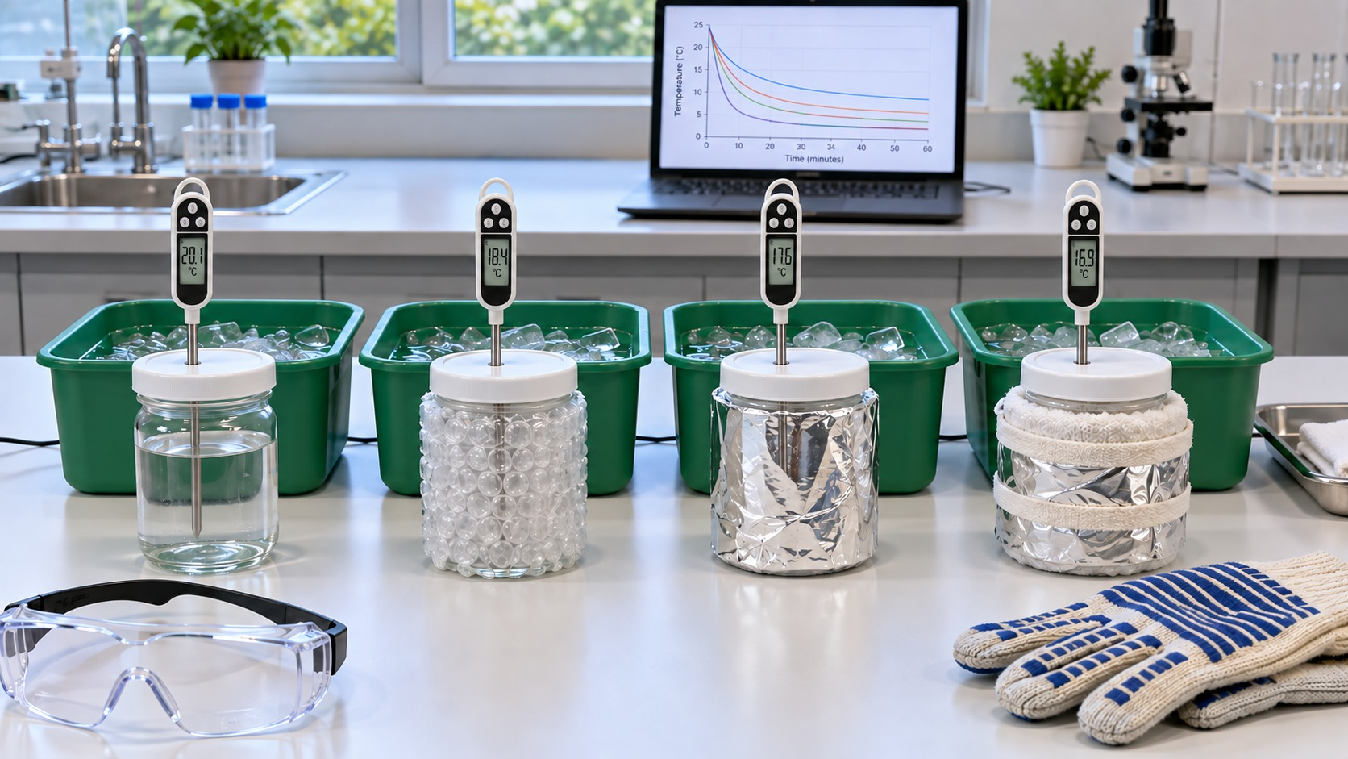
Figure 13. The complete classroom system: four parallel test articles alongside the digital interface.

11 Individual Contribution — Piyath Vithanage

11.1 Website Architecture and Implementation
My main contribution to this project was the design and implementation of the Mission Control website. I organised the whole thing as a single-page browser experience, so a student could move from the briefing, through assembly, simulation, measurement, study material and finally assessment, without ever having to install anything. The build uses HTML for the experiment's structure, CSS for the responsive interface, and JavaScript for the underlying model and all of the interactive behaviour.
I connected every page control to one shared application state. The configuration a student selects determines both the reference coefficient used and the colour assigned to that curve on the graph. Inputs for T0, Tenv and the model duration all feed directly into the simulation. The timer supports the fifteen-minute measurement sequence, while the telemetry controls validate and store each manually entered point as it comes in. Browser storage preserves the generated curve and the recorded data for the length of an active session, so an accidental refresh doesn't wipe out a group's work.
I also had to design the interface to work sensibly on both a full desktop screen and a much smaller tablet, since that is what most of the target schools actually have available. Navigation collapses down on mobile devices, control labels stay clearly attached to their inputs, and the measurement buttons use plain text rather than relying purely on icons that a first-time user might not immediately recognise. The dark, mission-control-style visual language supports the spacesuit narrative, while high-contrast panels keep the instructions, the numeric inputs, the graphs, and the status feedback visually separate from one another.

11.2 Classroom Reliability
I deliberately avoided building a native mobile app or wiring up Bluetooth data acquisition, because both would introduce failure modes a teacher has no realistic way to fix in the middle of a lesson. The static site can be hosted with no server-side database at all, and can equally well be reviewed from a local web server if a school's internet access is restricted. GitHub Pages supports publishing HTML, CSS and JavaScript directly from a repository [7], which keeps the whole deployment simple and low-maintenance, and keeps the experiment usable on ordinary school laptops and tablets rather than depending on specialist equipment.

11.3 Graphing and Data Visualisation
I built the graphing workflow so predicted and measured temperatures could always be compared on the same time base. The reference graph evaluates the Newtonian equation at each successive minute; the telemetry graph then overlays the student's actual physical readings on top of it, while keeping the visual distinction between a calculated value and a genuine observation clear. A supporting table lists both values side by side along with their signed difference.
Keeping the graphs visually consistent across the whole project was a deliberate choice on my part, not an afterthought. The same configuration names and the same colours are reused in the selector, the summary badge, the prediction curve, the telemetry overlay, and every figure in this report. Every axis carries proper units, the time range always matches the fifteen-minute procedure, and the temperature scale stays legible across all four configurations. None of that is decoration — it is what actually makes the graph useful for analysis rather than just a nice-looking picture.

11.4 Error Feedback and the Printed Record
I implemented the residual and MAE calculations to turn a visual side-by-side comparison into something a student can actually put a number on. The website works out the absolute difference at every recorded point and summarises the whole series into one score. The correlation-style score gives immediate classroom feedback, but the report is explicit that it is a teaching indicator and not a formal statistical validation metric — I did not want a strong or weak score to be over-interpreted.
The print view converts the active telemetry table and the run's settings into a record that can be attached directly to the student worksheet. That makes it possible to go back after the live session has ended and review exactly which k was selected, what the environmental and initial temperatures were, what points were actually recorded, and how far the model and the measurement disagreed.

12 Individual Contribution — Dilan Fernando

12.1 Thermodynamic Model
My main technical responsibility on this project was defining the thermodynamics of the experiment and interpreting the physical results once they came in. I chose the lumped Newtonian cooling model specifically because it gives secondary-school students a manageable equation while still keeping the essential relationship between thermal mass, environmental temperature, and cooling rate intact. I defined k explicitly as a system coefficient in min⁻¹, and made a point of separating it clearly from material thermal conductivity, which is a genuinely different quantity that happens to share the same letter in most textbooks.
I settled on the current test settings — 100 mL of water, a starting temperature of roughly 80 °C, and a fifteen-minute window — after some trial and error. The water volume gives enough thermal capacity to produce a gradual, readable curve while still allowing a clearly measurable separation between the four configurations inside a single class period. The ice-water bath gives a repeatable boundary condition, but only if its actual temperature is measured and entered into the model whenever it drifts away from 0 °C.
I also worked out how to present the three heat-transfer modes in a way that connects the classroom system back to the spacesuit context honestly. Cotton and bubble wrap mainly interrupt conductive and convective paths in our system, while Mylar is really addressing radiation. Since the water bath does not recreate a vacuum, I made sure the report documents clearly why a Mylar-only layer can behave poorly in this particular test even though reflective layers are genuinely important in real spacecraft thermal design — the two facts are not in tension once you separate the mechanisms properly.

12.2 Experimental Analysis
I compared the measured series against the reference curves using temperature drop, residuals, MAE, and the fitted cooling constant. The worked data show the full multilayer package retaining the most heat of the four. I treated the Mylar-only disagreement as evidence of a model or construction mismatch specific to this test, and worked through the likely physical causes, rather than presenting it as a general conclusion about the material itself.

12.3 Hardware and Remaining Project Work
I integrated the thermodynamic requirements with the physical test arrangement — the matched glass cores, the 100 mL fill, the centred probe position, the cold-bath immersion, and the repeatable layer construction. I connected all of these settings directly to the student procedure, so that the assumptions built into the model and the instructions in the physical lab actually refer to the same system rather than drifting apart over time.
My remaining work on the project covered test planning, the safety controls described in Section 9, result interpretation, the technical writing in this report, and integrating the student and teacher manuals with the website. I documented the requirement for adult handling of the hot water, the need for a stable secondary container, keeping electronic displays dry, pre-test leak checks, and stopping immediately on any leaking or unstable run.

12.4 Documentation and Educational Integration
I aligned the terminology and the sequence of steps across the student manual, teacher manual, task sheet, illustrated procedure, and this report. Every one of those documents now uses the same core volume, the same start-temperature target, the same bath boundary, the same sampling interval, and the same four configurations. I also made sure the website's educational reference coefficients were kept clearly separate from the observed telemetry throughout, so a reader can reproduce every calculation in this report without ever mistaking a model prediction for an actual measurement.
The project team consists of Piyath Vithanage, Elio Krollpfeiffer, Dilan Fernando and Nuhansee Migelhewage. Piyath completed the website and the graphing work described in Section 11; I completed the thermodynamics and the remaining project work described above.

13 Conclusion and Recommendations
The SPACESUIT THERMAL SHIELDING KIT gives students a reusable, hands-on route into transient heat transfer and engineering validation, built entirely around materials and equipment an ordinary school can obtain. The report, the website, the manuals, the printed procedure and the photographs all describe exactly the same experimental settings, so there is no gap between what a teacher reads and what a student actually does at the bench. The worked example carried in this report shows the full multilayer package retaining heat the best of the four configurations, while the analysis throughout keeps model assumptions clearly separated from measured evidence and states plainly where the terrestrial water-bath analogy stops being a fair stand-in for a real spacecraft environment.
Combining a physical capsule, a visible prediction, and a manually recorded curve gives students a complete engineering cycle inside a single school lesson: state a prediction, build something, measure it, and then explain the gap between the two. The present system is well suited to comparative classroom teaching once a school applies the safety and control requirements set out in Section 9. It is not a vacuum simulation, and it does not qualify any of the improvised materials used here for actual aerospace use.

13.1 Recommendations for the Next Test Campaign
- Repeat every configuration at least three times, and randomise the order the four jars are run in.
- Measure and record water mass, probe depth, bath temperature, and immersion depth for every single run.
- Fit k using every usable point in a run rather than a single endpoint, and report the variability seen across repeats.
- Bundle the browser libraries locally, so offline classroom operation is dependable on restricted school networks.
- Add CSV export and per-run metadata to the Mission Control website.

References
[1] National Aeronautics and Space Administration, “Spacewalk spacesuit basics,” NASA Johnson Space Center. [Online]. Available: https://www.nasa.gov/centers-and-facilities/johnson/spacewalk-spacesuit-basics/ (accessed Sep. 9, 2026).
[2] National Institute of Standards and Technology, “Water, liquid phase heat capacity,” NIST Chemistry WebBook, SRD 69. [Online]. Available: https://webbook.nist.gov/cgi/cbook.cgi?ID=C7732185&Table=on&Type=JANAFL (accessed Sep. 9, 2026).
[3] M. M. Finckenor and D. Dooling, “Multilayer insulation material guidelines,” NASA Marshall Space Flight Center, Huntsville, AL, USA, Tech. Rep. NASA/TP-1999-209263, 1999.
[4] National Aeronautics and Space Administration, Passive Thermal Control Engineering Guidebook, Rev. 4.0, 2023. [Online]. Available: https://ntrs.nasa.gov/api/citations/20230013900/downloads/NASA%20Thermal%20Control%20Engineering%20Guidebook%20v4.pdf
[5] Chart.js Contributors, “Chart.js documentation.” [Online]. Available: https://www.chartjs.org/docs/latest/ (accessed Sep. 9, 2026).
[6] Khan Academy and KaTeX contributors, “KaTeX API documentation.” [Online]. Available: https://katex.org/docs/api.html (accessed Sep. 9, 2026).
[7] SPHERE Project Team, “Mission Control: interactive Newtonian-cooling prediction and telemetry tool.” [Online]. Available: https://hsp-mc.github.io/ (accessed Sep. 9, 2026).
[8] GitHub, Inc., “What is GitHub Pages,” GitHub Docs. [Online]. Available: https://docs.github.com/en/pages/getting-started-with-github-pages/what-is-github-pages (accessed Sep. 9, 2026).
[9] T. K.-H. Schwarz, “Experimental toolkit procedure: thermal insulation and cooling rates for spacecraft thermal protection,” Standard Operating Procedure, TUM School of Engineering and Design, Munich, Germany, Sep. 9, 2026.
A note on sourcing.
A domain, sphere-project.eu, was suggested as a possible reference for this report. On inspection it belongs to an unrelated European research project concerned with BIM-based digital twins for buildings, and has no connection to spacesuit thermal insulation or to this project's Mission Control tool. It has therefore not been cited here; including it would have reduced, rather than improved, the accuracy of this reference list.

Project Sources
- SPHERE Mission Control website (index.html, app.js, styles.css), published at hsp-mc.github.io.
- SPHERE student manual, teacher manual, task sheet, and flashcards.
- Experimental Toolkit Procedure: Thermal Insulation and Cooling Rates for Spacecraft Thermal Protection — internal SOP, issued 9 September 2026.
- Project photographs and diagrams from the team's images directory.
Safety note: this classroom experiment does not certify any material for aerospace, pressure-vessel, fire-protection, or personal-protective use.

Appendix A — Complete Worked Telemetry Dataset
Time | Full MLI | Bubble wrap | Mylar only | Bare control
0 min | 77.6 °C | 82.6 °C | 80.5 °C | 80.1 °C
1 min | 76.6 °C | 79.0 °C | 68.6 °C | 73.9 °C
2 min | 76.1 °C | 75.2 °C | 61.8 °C | 66.0 °C
3 min | 75.6 °C | 72.5 °C | 55.8 °C | 59.9 °C
4 min | 75.1 °C | 70.0 °C | 51.3 °C | 54.5 °C
5 min | 74.5 °C | 67.9 °C | 47.8 °C | 50.1 °C
6 min | 73.9 °C | 65.6 °C | 44.9 °C | 47.1 °C
7 min | 73.5 °C | 64.0 °C | 42.5 °C | 44.6 °C
8 min | 72.1 °C | 62.3 °C | 40.6 °C | 42.5 °C
9 min | 70.6 °C | 60.6 °C | 38.9 °C | 40.9 °C
10 min | 69.7 °C | 58.9 °C | 38.1 °C | 39.5 °C
11 min | 68.5 °C | 57.5 °C | 36.3 °C | 38.2 °C
12 min | 67.4 °C | 56.1 °C | 35.5 °C | 37.3 °C
13 min | 65.8 °C | 54.8 °C | 34.6 °C | 36.5 °C
14 min | 64.1 °C | 53.7 °C | 33.9 °C | 35.8 °C
15 min | 62.7 °C | 52.6 °C | 33.3 °C | 35.2 °C

Appendix Notes
The values listed above are the complete sixteen-point series used throughout the worked figures in this report. They were transcribed from the project's own telemetry records and should be kept together with their original units and timestamps; they should not be substituted for a new group's own measurements in a future run.
For comparison across trials with unequal starting temperatures, students may calculate the normalised temperature remaining above the boundary as (T(t) − Tenv)/(T0 − Tenv). Where the bath temperature was not independently measured, any normalised result calculated this way inherits some uncertainty from the assumed boundary condition.

